LOCATION.--Lat 41°32'13.3", long 93°15'32.3" referenced to North American Datum of 1983, in NW 1/4 NW 1/4 NE 1/4 sec.27, T.78 N., R.21 W., Jasper County, IA, Hydrologic Unit 07100008, on right bank on downstream side of bridge on South 112th Avenue West, and 2.4 mi east of Vandalia.

DRAINAGE AREA.--20.3 mi².

PERIOD OF RECORD.--Discharge records from October 1994 to September 2005.

GAGE.--Water-stage recorder and concrete control. Datum of gage is 785.15 ft above National Geodetic Vertical Datum of 1929.

REMARKS.--Records good except for estimated daily discharges, which are poor.

A summary of all available data for this streamgage is provided through the USGS National Water Information System web interface (NWISWeb). The following link provides access to current/historical observations, daily data, daily statistics, monthly statistics, annual statistics, peak streamflow, field measurements, field/lab water-quality samples, and the latest water-year summaries. Data can be filtered by parameter and/or dates, and can be output in various tabular and graphical formats.
http://waterdata.usgs.gov/nwis/inventory/?site_no=05487550

The USGS WaterWatch Toolkit is available at:
http://waterwatch.usgs.gov/?id=ww_toolkit
Tools for summarizing streamflow information include the duration hydrograph builder, the cumulative streamflow hydrograph builder, the streamgage statistics retrieval tool, the rating curve builder, the flood tracking chart builder, the National Weather Service Advanced Hydrologic Prediction Service (AHPS) river forecast hydrograph builder, and the raster-hydrograph builder. Entering the above number for this streamgage into these toolkit webpages will provide streamflow information specific to this streamgage.

A description of the statistics presented for this streamgage is available in the main body of the report at:
http://dx.doi.org/10.3133/ofr20151214
A link to other streamgages included in this report, a map showing the location of the streamgages, information on the programs used to compute the statistical analyses, and references are included in the main body of the report.

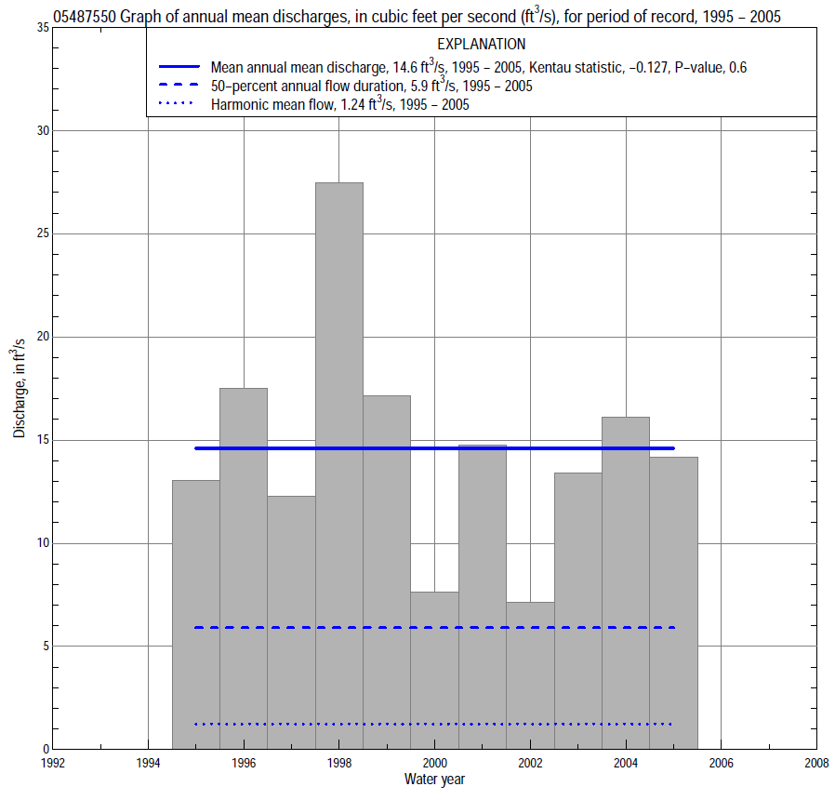

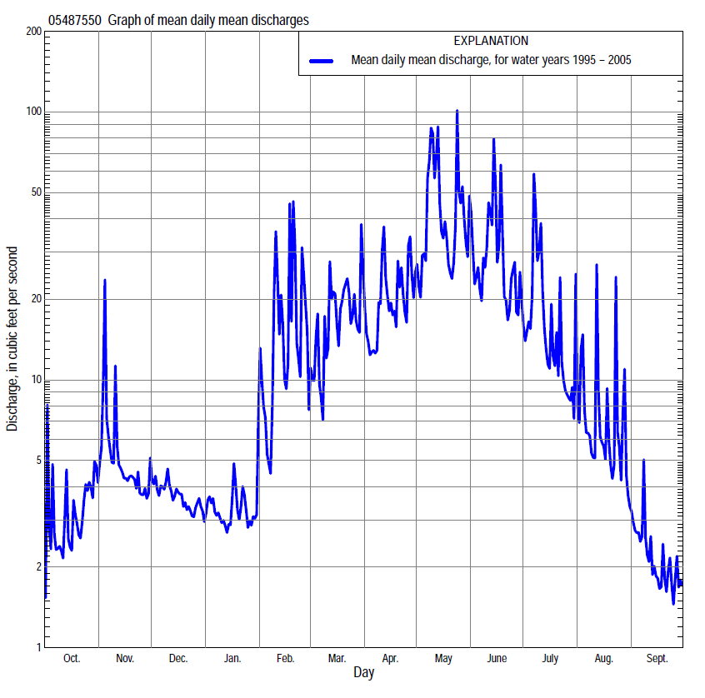

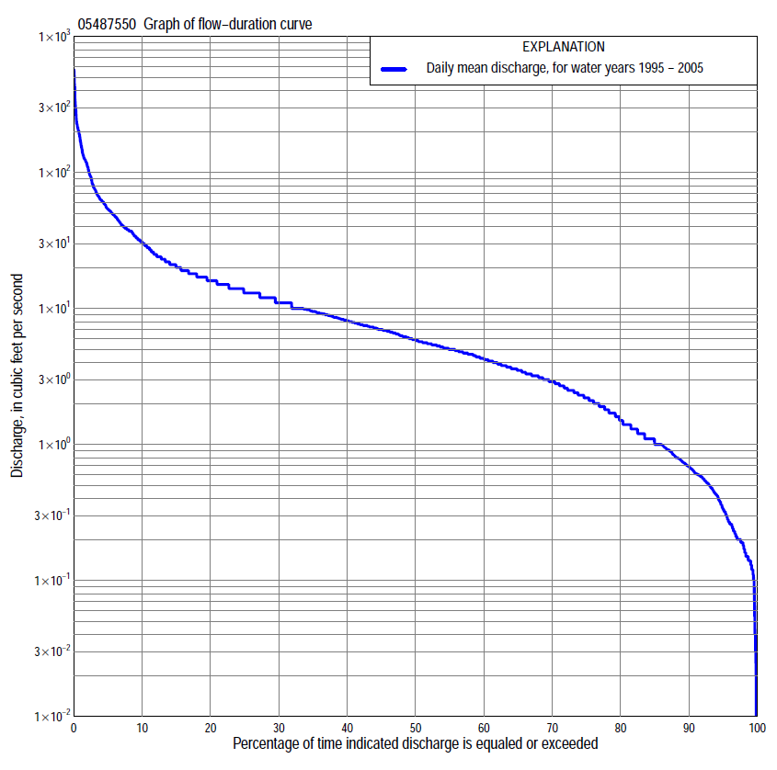

Statistics Based on the Entire Streamflow Period of Record
05487550 Monthly and annual flow durations, based on 1995–2005 period of record (11 years)
Percentage of days discharge equaled or exceeded |  |  |  |  | Discharge (cubic feet per second) |  |  |  |  |  |  |  |  | Annual flow durations
 | Oct | Nov | Dec | Jan | Feb | Mar | Apr | May | June | July | Aug | Sept | Annual | Kentau statistic | P-value
99 | 0.12 | 0.15 | 0.11 | 0.26 | 0.59 | 0.91 | 2.8 | 5.3 | 7.5 | 3.7 | 0.24 | 0.01 | 0.14 | -0.036 | 0.874
98 | 0.12 | 0.19 | 0.14 | 0.33 | 0.69 | 1.2 | 3.0 | 5.9 | 8.6 | 4.0 | 0.27 | 0.02 | 0.18 | -0.036 | 0.874
95 | 0.15 | 0.24 | 0.17 | 0.48 | 0.86 | 1.5 | 3.2 | 6.9 | 9.6 | 4.9 | 0.56 | 0.07 | 0.33 | -0.091 | 0.640
90 | 0.20 | 0.67 | 0.33 | 0.60 | 1.1 | 3.0 | 3.6 | 9.3 | 11 | 5.4 | 0.94 | 0.17 | 0.68 | 0.000 | 1.000
85 | 0.25 | 1.1 | 0.55 | 0.74 | 1.3 | 3.4 | 4.2 | 11 | 12 | 6.2 | 1.3 | 0.28 | 1.0 | 0.109 | 0.680
80 | 0.33 | 1.5 | 0.89 | 0.86 | 1.9 | 4.2 | 5.4 | 12 | 13 | 6.8 | 1.8 | 0.44 | 1.5 | 0.091 | 0.745
75 | 0.45 | 1.9 | 1.1 | 0.95 | 2.3 | 4.8 | 6.1 | 13 | 13 | 7.4 | 2.3 | 0.52 | 2.2 | 0.164 | 0.520
70 | 0.54 | 2.1 | 1.3 | 1.0 | 2.7 | 5.1 | 7.1 | 14 | 14 | 8.0 | 2.7 | 0.64 | 2.9 | 0.164 | 0.520
65 | 0.61 | 2.3 | 1.6 | 1.1 | 3.4 | 5.5 | 8.2 | 16 | 15 | 8.6 | 3.1 | 0.72 | 3.5 | 0.164 | 0.520
60 | 0.74 | 2.6 | 1.8 | 1.4 | 4.3 | 5.8 | 9.8 | 17 | 16 | 9.0 | 3.3 | 0.82 | 4.3 | 0.200 | 0.408
55 | 1.1 | 2.8 | 2.0 | 1.7 | 5.0 | 7.0 | 11 | 19 | 17 | 9.5 | 3.7 | 1.0 | 5.0 | 0.164 | 0.520
50 | 1.9 | 3.3 | 2.5 | 2.0 | 5.6 | 8.2 | 14 | 21 | 18 | 10 | 4.1 | 1.1 | 5.9 | 0.073 | 0.808
45 | 2.5 | 3.7 | 3.3 | 2.5 | 7.0 | 9.5 | 15 | 24 | 19 | 11 | 4.8 | 1.4 | 7.0 | 0.055 | 0.872
40 | 3.0 | 4.6 | 3.9 | 3.0 | 7.6 | 11 | 16 | 29 | 21 | 11 | 5.3 | 1.9 | 8.1 | 0.109 | 0.669
35 | 3.5 | 5.0 | 4.5 | 3.5 | 8.5 | 12 | 19 | 36 | 23 | 12 | 5.8 | 2.4 | 9.5 | -0.018 | 1.000
30 | 4.0 | 5.9 | 5.2 | 4.0 | 10 | 13 | 21 | 43 | 25 | 14 | 6.4 | 2.6 | 11 | -0.018 | 1.000
25 | 4.6 | 6.6 | 6.2 | 4.4 | 12 | 15 | 24 | 49 | 30 | 15 | 7.3 | 3.1 | 13 | 0.018 | 1.000
20 | 4.8 | 7.4 | 6.9 | 5.1 | 15 | 18 | 30 | 58 | 35 | 17 | 8.5 | 3.8 | 16 | -0.018 | 1.000
15 | 5.6 | 8.6 | 7.6 | 6.2 | 18 | 27 | 38 | 68 | 41 | 20 | 11 | 4.4 | 20 | -0.036 | 0.938
10 | 7.0 | 10 | 8.4 | 7.6 | 29 | 41 | 44 | 101 | 55 | 26 | 13 | 5.4 | 31 | -0.255 | 0.306
5 | 9.5 | 13 | 9.0 | 9.2 | 76 | 61 | 57 | 157 | 90 | 50 | 19 | 7.0 | 54 | -0.200 | 0.436
2 | 17 | 18 | 9.9 | 14 | 188 | 118 | 82 | 228 | 134 | 120 | 37 | 9.6 | 110 | -0.236 | 0.350
1 | 22 | 34 | 11 | 17 | 217 | 147 | 123 | 314 | 229 | 203 | 74 | 11 | 167 | -0.327 | 0.184

05487550 Annual exceedance probability of instantaneous peak discharges, in cubic feet per second (ft³/s), based on the Weighted Independent Estimates method,
Annual exceed-ance probability | Recur-rence interval (years) | Discharge (ft³/s) | 95-percent lower confi-dence interval (ft³/s) | 95-percent upper confi-dence interval (ft³/s)
0.500 | 2 | 795 | 610 | 1,030
0.200 | 5 | 1,290 | 1,010 | 1,650
0.100 | 10 | 1,810 | 1,410 | 2,320
0.040 | 25 | 2,640 | 2,030 | 3,430
0.020 | 50 | 3,190 | 2,400 | 4,240
0.010 | 100 | 3,680 | 2,690 | 5,030
0.005 | 200 | 4,350 | 3,070 | 6,170
0.002 | 500 | 4,770 | 3,220 | 7,060
and based on the expected moments algorithm/multiple Grubbs-Beck analysis computed using a historical period length of 11 years (1995–2005)
0.500 | 2 | 781 | 555 | 1,030
0.200 | 5 | 1,130 | 851 | 1,620
0.100 | 10 | 1,340 | 1,020 | 2,130
0.040 | 25 | 1,600 | 1,200 | 2,950
0.020 | 50 | 1,770 | 1,310 | 3,690
0.010 | 100 | 1,940 | 1,400 | 4,540
0.005 | 200 | 2,110 | 1,470 | 5,510
0.002 | 500 | 2,310 | 1,560 | 7,030
Kentau statistic |  | -0.055
P-value |  | 0.876
Begin year |  | 1995
End year |  | 2005
Number of peaks |  | 11

05487550 Annual exceedance probability of high discharges, based on 1995–2005 period of record (11 years)
Annual exceedance probability | Recur-rence interval (years) | Maximum average discharge (ft³/s) for indicated number of consecutive days
 |  | 1 | 3 | 7 | 15 | 30
0.990 | 1.01 | 93 | 50 | 32 | 21 | 17
0.950 | 1.05 | 138 | 80 | 50 | 33 | 26
0.900 | 1.11 | 168 | 100 | 62 | 42 | 32
0.800 | 1.25 | 212 | 128 | 80 | 54 | 41
0.500 | 2 | 321 | 192 | 124 | 84 | 62
0.200 | 5 | 468 | 266 | 184 | 120 | 88
0.100 | 10 | 562 | 305 | 222 | 140 | 103
0.040 | 25 | 675 | 346 | 268 | 163 | 120
0.020 | 50 | 755 | 372 | 300 | 178 | 131
0.010 | 100 | 833 | 393 | 330 | 190 | 142
0.005 | 200 | 907 | 412 | 360 | 202 | 151
0.002 | 500 | 1,000 | 433 | 397 | 216 | 163
Kentau statistic |  | -0.200 | -0.164 | -0.127 | -0.164 | -0.309
P-value |  | 0.436 | 0.533 | 0.640 | 0.533 | 0.213

 | 05487550 Annual nonexceedance probability of low discharges, based on April 1995 to March 2005 period of record (10 years)
Annual nonexceed-ance probability | Recur-rence interval (years) | Minimum average discharge (cubic feet per second) for indicated number of consecutive days
 |  | 1 | 3 | 7 | 14 | 30 | 60 | 90 | 120 | 183
0.01 | 100 | 0.01 | 0.02 | 0.04 | 0.08 | 0.16 | 0.33 | 0.44 | 0.55 | 0.79
0.02 | 50 | 0.02 | 0.03 | 0.05 | 0.09 | 0.18 | 0.35 | 0.49 | 0.64 | 0.94
0.05 | 20 | 0.04 | 0.05 | 0.07 | 0.13 | 0.23 | 0.41 | 0.61 | 0.82 | 1.2
0.10 | 10 | 0.07 | 0.08 | 0.11 | 0.17 | 0.28 | 0.47 | 0.73 | 1.0 | 1.5
0.20 | 5 | 0.12 | 0.13 | 0.17 | 0.24 | 0.38 | 0.58 | 0.99 | 1.4 | 2.0
0.50 | 2 | 0.30 | 0.35 | 0.41 | 0.51 | 0.71 | 0.98 | 1.6 | 2.4 | 3.3
0.80 | 1.25 | 0.76 | 0.90 | 0.99 | 1.1 | 1.5 | 2.0 | 2.9 | 4.5 | 5.5
0.90 | 1.11 | 1.3 | 1.4 | 1.6 | 1.8 | 2.2 | 3.1 | 4.3 | 6.2 | 7.0
0.96 | 1.04 | 2.1 | 2.4 | 2.6 | 3.0 | 3.6 | 5.4 | 7.0 | 9.0 | 9.2
0.98 | 1.02 | 3.0 | 3.2 | 3.5 | 4.1 | 4.9 | 7.9 | 10 | 12 | 11
0.99 | 1.01 | 4.1 | 4.3 | 4.7 | 5.6 | 6.7 | 11 | 13 | 14 | 13
Kentau statistic |  | -0.133 | -0.111 | -0.067 | 0.111 | 0.111 | -0.067 | -0.156 | 0.156 | 0.200
P-value |  | 0.653 | 0.721 | 0.858 | 0.721 | 0.721 | 0.858 | 0.592 | 0.592 | 0.474

05487550 Annual nonexceedance probability of seasonal low discharges, based on October 1994 to September 2005 period of record (11 years)
Annual nonexceed-ance probability | Recur-rence interval (years) | Minimum average discharge (cubic feet per second) for indicated number of consecutive days
 |  | 1 | 7 | 14 | 30 |  | 1 | 7 | 14 | 30
 |  | January-February-March |  |  |  |  | April-May-June
0.01 | 100 | 0.08 | 0.17 | 0.30 | 0.39 |  | 1.3 | 1.5 | 1.5 | 3.1
0.02 | 50 | 0.10 | 0.21 | 0.36 | 0.47 |  | 1.6 | 1.8 | 1.9 | 3.7
0.05 | 20 | 0.14 | 0.28 | 0.47 | 0.62 |  | 2.1 | 2.4 | 2.7 | 4.8
0.10 | 10 | 0.20 | 0.37 | 0.60 | 0.80 |  | 2.6 | 3.2 | 3.6 | 6.0
0.20 | 5 | 0.30 | 0.53 | 0.83 | 1.1 |  | 3.5 | 4.3 | 5.0 | 7.8
0.50 | 2 | 0.71 | 1.2 | 1.6 | 2.2 |  | 6.1 | 7.5 | 9.2 | 13
0.80 | 1.25 | 1.9 | 2.8 | 3.5 | 4.4 |  | 11 | 13 | 16 | 21
0.90 | 1.11 | 3.3 | 4.7 | 5.4 | 6.4 |  | 14 | 17 | 21 | 27
0.96 | 1.04 | 6.1 | 8.3 | 8.8 | 9.9 |  | 19 | 22 | 27 | 36
0.98 | 1.02 | 9.3 | 11 | 12 | 13 |  | 24 | 25 | 31 | 42
0.99 | 1.01 | 14 | 16 | 17 | 17 |  | 28 | 29 | 36 | 49
Kentau statistic |  | 0.000 | -0.164 | -0.091 | -0.055 |  | 0.182 | 0.200 | -0.055 | 0.127
P-value |  | 1.000 | 0.533 | 0.756 | 0.876 |  | 0.482 | 0.436 | 0.876 | 0.640
 |  | July-August-September |  |  |  |  | October-November-December
0.01 | 100 | 0.00 | 0.00 | 0.01 | 0.07 |  | 0.05 | 0.05 | 0.05 | 0.07
0.02 | 50 | 0.01 | 0.01 | 0.02 | 0.10 |  | 0.06 | 0.06 | 0.07 | 0.09
0.05 | 20 | 0.02 | 0.02 | 0.06 | 0.19 |  | 0.08 | 0.10 | 0.10 | 0.15
0.10 | 10 | 0.04 | 0.05 | 0.13 | 0.31 |  | 0.10 | 0.13 | 0.16 | 0.23
0.20 | 5 | 0.10 | 0.15 | 0.29 | 0.55 |  | 0.15 | 0.19 | 0.26 | 0.39
0.50 | 2 | 0.48 | 0.74 | 1.1 | 1.5 |  | 0.33 | 0.47 | 0.73 | 1.1
0.80 | 1.25 | 1.8 | 2.3 | 2.7 | 3.4 |  | 0.80 | 1.3 | 2.1 | 3.2
0.90 | 1.11 | 3.1 | 3.4 | 3.9 | 5.0 |  | 1.3 | 2.3 | 3.8 | 5.5
0.96 | 1.04 | 4.7 | 4.8 | 5.3 | 7.3 |  | 2.2 | 4.6 | 7.2 | 10
0.98 | 1.02 | 5.6 | 5.7 | 6.1 | 9.1 |  | 3.2 | 7.3 | 11 | 15
0.99 | 1.01 | 6.4 | 6.5 | 6.9 | 11 |  | 4.5 | 11 | 16 | 21
Kentau statistic |  | -0.145 | -0.091 | -0.018 | 0.018 |  | 0.255 | 0.309 | 0.200 | 0.164
P-value |  | 0.585 | 0.756 | 1.000 | 1.000 |  | 0.310 | 0.213 | 0.436 | 0.533

