LOCATION.--Lat 41°14'47.9", long 93°17'24.6" referenced to North American Datum of 1983, in NW 1/4 NW 1/4 NW 1/4 sec.04, T.74 N., R.21 W., Marion County, IA, Hydrologic Unit 07100008, on right bank on upstream side of bridge on 30th Avenue, 2.3 mi northwest of Dallas, 1.0 mi upstream from Kirk Branch, and 22.0 mi upstream from mouth.

DRAINAGE AREA.--333 mi².

PERIOD OF RECORD.--Discharge records from October 1962 to current year.

GAGE.--Water-stage recorder. Datum of gage is 762.83 ft above National Geodetic Vertical Datum of 1929. Prior to October 29, 2008, at site 1.4 mi downstream at datum 3.62 ft lower.

EXTREMES OUTSIDE PERIOD OF RECORD.--Flood of June 11, 1962, reached a stage of 28.87 ft, from high-water mark, at datum then in use, discharge about 12,000 ft³/s. Flood of June 6, 1947, may have been slightly higher.

A summary of all available data for this streamgage is provided through the USGS National Water Information System web interface (NWISWeb). The following link provides access to current/historical observations, daily data, daily statistics, monthly statistics, annual statistics, peak streamflow, field measurements, field/lab water-quality samples, and the latest water-year summaries. Data can be filtered by parameter and/or dates, and can be output in various tabular and graphical formats.
http://waterdata.usgs.gov/nwis/inventory/?site_no=05487980

The USGS WaterWatch Toolkit is available at:
http://waterwatch.usgs.gov/?id=ww_toolkit
Tools for summarizing streamflow information include the duration hydrograph builder, the cumulative streamflow hydrograph builder, the streamgage statistics retrieval tool, the rating curve builder, the flood tracking chart builder, the National Weather Service Advanced Hydrologic Prediction Service (AHPS) river forecast hydrograph builder, and the raster-hydrograph builder. Entering the above number for this streamgage into these toolkit webpages will provide streamflow information specific to this streamgage.

A description of the statistics presented for this streamgage is available in the main body of the report at:
http://dx.doi.org/10.3133/ofr20151214
A link to other streamgages included in this report, a map showing the location of the streamgages, information on the programs used to compute the statistical analyses, and references are included in the main body of the report.

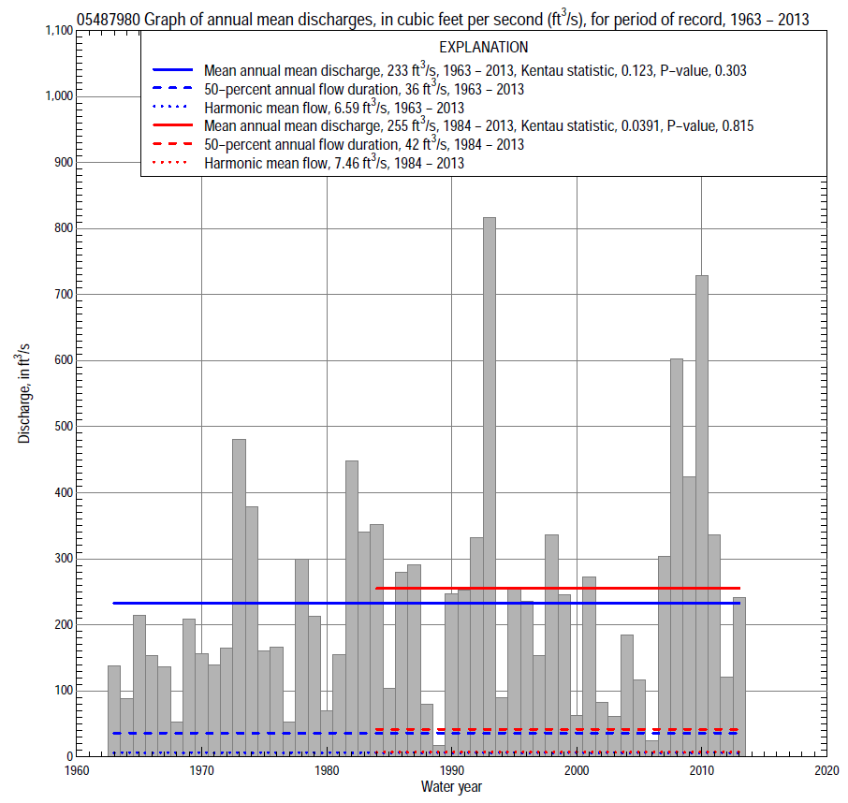

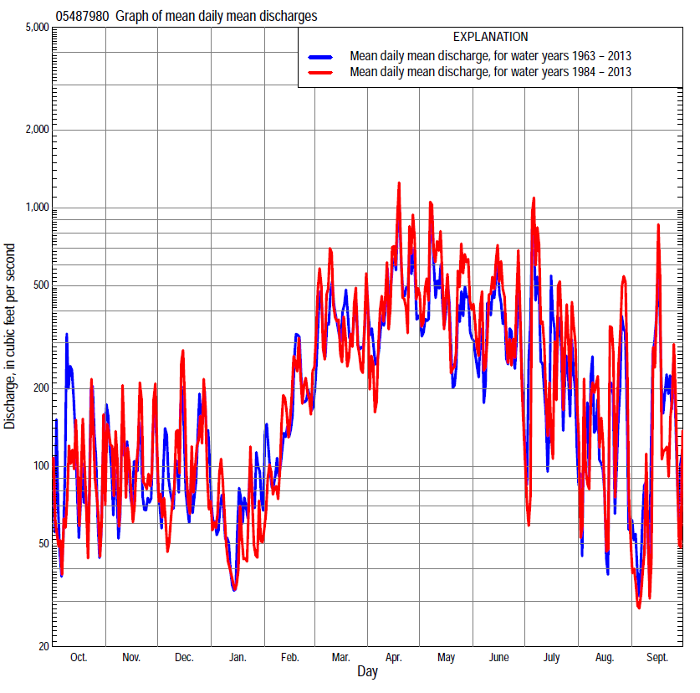

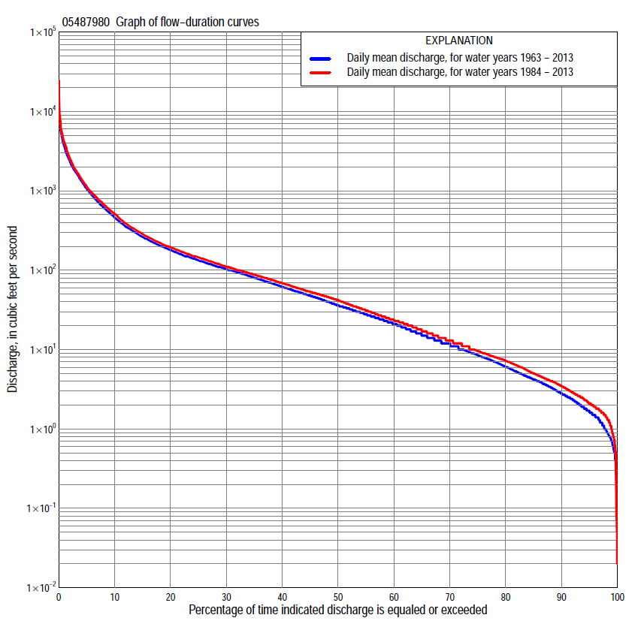

Statistics Based on the Entire Streamflow Period of Record
05487980 Monthly and annual flow durations, based on 1963–2013 period of record (51 years)
Percentage of days discharge equaled or exceeded |  |  |  |  | Discharge (cubic feet per second) |  |  |  |  |  |  |  |  | Annual flow durations
 | Oct | Nov | Dec | Jan | Feb | Mar | Apr | May | June | July | Aug | Sept | Annual | Kentau statistic | P-value
99 | 0.25 | 0.70 | 0.73 | 0.50 | 1.4 | 2.6 | 3.3 | 4.6 | 2.3 | 0.88 | 0.13 | 0.53 | 0.70 | 0.223 | 0.018
98 | 0.50 | 0.80 | 0.82 | 0.57 | 1.5 | 4.4 | 4.9 | 5.5 | 2.7 | 1.1 | 0.73 | 0.77 | 0.97 | 0.235 | 0.013
95 | 0.86 | 1.5 | 1.2 | 1.2 | 1.9 | 6.9 | 10 | 8.2 | 4.0 | 1.9 | 1.4 | 1.1 | 1.7 | 0.243 | 0.011
90 | 1.4 | 2.2 | 2.0 | 2.7 | 3.3 | 12 | 20 | 15 | 6.3 | 3.1 | 2.1 | 1.5 | 2.8 | 0.230 | 0.017
85 | 1.8 | 3.0 | 3.3 | 3.8 | 7.4 | 21 | 32 | 24 | 10 | 4.4 | 2.7 | 1.9 | 4.2 | 0.217 | 0.024
80 | 2.6 | 4.5 | 4.6 | 6.0 | 10 | 34 | 39 | 34 | 16 | 5.7 | 3.5 | 2.4 | 6.0 | 0.192 | 0.047
75 | 3.4 | 6.0 | 7.5 | 8.3 | 13 | 50 | 49 | 43 | 22 | 7.5 | 4.2 | 2.9 | 8.5 | 0.151 | 0.118
70 | 4.2 | 8.8 | 10 | 9.8 | 18 | 61 | 64 | 54 | 28 | 9.3 | 5.1 | 3.5 | 12 | 0.106 | 0.276
65 | 5.0 | 12 | 13 | 11 | 27 | 74 | 84 | 66 | 37 | 12 | 6.4 | 4.2 | 15 | 0.092 | 0.346
60 | 6.0 | 15 | 17 | 14 | 31 | 85 | 101 | 81 | 47 | 14 | 7.7 | 5.1 | 21 | 0.084 | 0.389
55 | 7.6 | 19 | 23 | 16 | 40 | 99 | 120 | 97 | 60 | 18 | 8.9 | 6.6 | 28 | 0.072 | 0.460
50 | 10 | 25 | 27 | 19 | 50 | 111 | 144 | 114 | 74 | 22 | 11 | 7.8 | 36 | 0.056 | 0.564
45 | 13 | 30 | 33 | 23 | 63 | 128 | 168 | 134 | 90 | 30 | 14 | 10 | 48 | 0.056 | 0.569
40 | 19 | 38 | 41 | 28 | 78 | 148 | 200 | 160 | 110 | 38 | 17 | 15 | 62 | 0.064 | 0.510
35 | 23 | 48 | 48 | 34 | 95 | 182 | 238 | 187 | 141 | 53 | 22 | 22 | 80 | 0.077 | 0.431
30 | 30 | 59 | 62 | 45 | 111 | 229 | 302 | 235 | 180 | 73 | 29 | 31 | 103 | 0.077 | 0.431
25 | 44 | 77 | 80 | 54 | 148 | 292 | 362 | 301 | 249 | 98 | 41 | 45 | 133 | 0.104 | 0.284
20 | 64 | 98 | 101 | 65 | 185 | 416 | 500 | 447 | 372 | 133 | 56 | 71 | 180 | 0.106 | 0.276
15 | 98 | 135 | 135 | 92 | 240 | 635 | 734 | 649 | 562 | 209 | 94 | 114 | 263 | 0.107 | 0.273
10 | 171 | 197 | 190 | 120 | 350 | 950 | 1,190 | 1,080 | 896 | 389 | 190 | 200 | 460 | 0.080 | 0.412
5 | 350 | 396 | 420 | 230 | 650 | 1,710 | 2,150 | 2,210 | 1,730 | 1,300 | 569 | 628 | 1,070 | 0.089 | 0.359
2 | 1,200 | 968 | 988 | 550 | 1,400 | 2,680 | 4,020 | 3,850 | 2,850 | 2,970 | 1,420 | 1,690 | 2,380 | 0.118 | 0.226
1 | 2,190 | 1,700 | 1,810 | 1,000 | 1,840 | 3,680 | 5,580 | 4,820 | 3,880 | 5,980 | 3,850 | 3,060 | 3,640 | 0.155 | 0.111

05487980 Annual exceedance probability of instantaneous peak discharges, in cubic feet per second (ft³/s), based on the Weighted Independent Estimates method,
Annual exceed-ance probability | Recur-rence interval (years) | Discharge (ft³/s) | 95-percent lower confi-dence interval (ft³/s) | 95-percent upper confi-dence interval (ft³/s)
0.500 | 2 | 7,330 | 6,390 | 8,410
0.200 | 5 | 11,800 | 10,100 | 13,700
0.100 | 10 | 15,100 | 12,700 | 17,900
0.040 | 25 | 19,700 | 15,900 | 24,400
0.020 | 50 | 23,400 | 18,200 | 29,900
0.010 | 100 | 27,200 | 20,500 | 36,000
0.005 | 200 | 31,100 | 22,700 | 42,700
0.002 | 500 | 36,400 | 25,300 | 52,400
and based on the expected moments algorithm/multiple Grubbs-Beck analysis computed using a historical period length of 68 years (1946–2013)ª
0.500 | 2 | 7,360 | 6,380 | 8,500
0.200 | 5 | 11,800 | 10,200 | 14,100
0.100 | 10 | 15,200 | 12,800 | 18,900
0.040 | 25 | 19,800 | 16,300 | 26,900
0.020 | 50 | 23,600 | 18,800 | 34,400
0.010 | 100 | 27,600 | 21,400 | 43,400
0.005 | 200 | 31,900 | 23,800 | 54,200
0.002 | 500 | 38,000 | 27,100 | 71,800
Kentau statistic |  | 0.249
P-value |  | 0.011
Begin year |  | 1963
End year |  | 2013
Number of peaks |  | 50
ªAnalysis includes interval annual-peak discharges (1946–61) from streamgage 05488000 White Breast Creek near Knoxville.

05487980 Annual exceedance probability of high discharges, based on 1963–2013 period of record (51 years)
[ND, not determined]
Annual exceedance probability | Recur-rence interval (years) | Maximum average discharge (ft³/s) for indicated number of consecutive days
 |  | 1 | 3 | 7 | 15 | 30
0.990 | 1.01 | ND | 920 | 449 | 268 | 152
0.950 | 1.05 | ND | 1,360 | 737 | 464 | 286
0.900 | 1.11 | ND | 1,680 | 952 | 610 | 388
0.800 | 1.25 | ND | 2,200 | 1,290 | 834 | 548
0.500 | 2 | ND | 3,720 | 2,230 | 1,440 | 981
0.200 | 5 | ND | 6,460 | 3,760 | 2,320 | 1,590
0.100 | 10 | ND | 8,710 | 4,870 | 2,910 | 1,970
0.040 | 25 | ND | 12,100 | 6,350 | 3,630 | 2,420
0.020 | 50 | ND | 15,000 | 7,510 | 4,150 | 2,720
0.010 | 100 | ND | 18,200 | 8,700 | 4,650 | 3,000
0.005 | 200 | ND | 21,800 | 9,920 | 5,130 | 3,260
0.002 | 500 | ND | 27,300 | 11,600 | 5,750 | 3,570
Kentau statistic |  | 0.161 | 0.103 | 0.109 | 0.070 | 0.128
P-value |  | 0.098 | 0.291 | 0.262 | 0.475 | 0.188

 | 05487980 Annual nonexceedance probability of low discharges, based on April 1963 to March 2013 period of record (50 years)
Annual nonexceed-ance probability | Recur-rence interval (years) | Minimum average discharge (ft³/s) for indicated number of consecutive days
 |  | 1 | 3 | 7 | 14 | 30 | 60 | 90 | 120 | 183
0.01 | 100 | 0.03 | 0.05 | 0.08 | 0.12 | 0.29 | 0.39 | 0.50 | 0.53 | 0.83
0.02 | 50 | 0.06 | 0.09 | 0.13 | 0.18 | 0.40 | 0.56 | 0.72 | 0.81 | 1.3
0.05 | 20 | 0.13 | 0.18 | 0.24 | 0.33 | 0.64 | 0.87 | 1.2 | 1.5 | 2.7
0.10 | 10 | 0.26 | 0.33 | 0.42 | 0.56 | 1.0 | 1.6 | 2.0 | 2.7 | 5.0
0.20 | 5 | 0.57 | 0.66 | 0.80 | 1.1 | 1.6 | 2.7 | 3.7 | 5.3 | 10
0.50 | 2 | 2.2 | 2.3 | 2.6 | 3.3 | 4.6 | 7.8 | 13 | 19 | 37
0.80 | 1.25 | 6.6 | 6.9 | 7.9 | 10 | 13 | 27 | 48 | 72 | 123
0.90 | 1.11 | 11 | 12 | 14 | 16 | 24 | 54 | 98 | 142 | 224
0.96 | 1.04 | 18 | 20 | 24 | 29 | 44 | 121 | 214 | 295 | 414
0.98 | 1.02 | 24 | 28 | 33 | 41 | 67 | 210 | 361 | 473 | 607
0.99 | 1.01 | 30 | 37 | 45 | 55 | 97 | 350 | 582 | 724 | 850
Kentau statistic |  | 0.238 | 0.234 | 0.220 | 0.202 | 0.151 | 0.096 | 0.066 | 0.071 | 0.025
P-value |  | 0.015 | 0.017 | 0.024 | 0.040 | 0.124 | 0.332 | 0.503 | 0.472 | 0.802

05487980 Annual nonexceedance probability of seasonal low discharges, based on October 1962 to September 2013 period of record (51 years)
Annual nonexceed-ance probability | Recur-rence interval (years) | Minimum average discharge (cubic feet per second) for indicated number of consecutive days
 |  | 1 | 7 | 14 | 30 |  | 1 | 7 | 14 | 30
 |  | January-February-March |  |  |  |  | April-May-June
0.01 | 100 | 0.15 | 0.23 | 0.33 | 0.54 |  | 0.34 | 0.75 | 1.1 | 1.6
0.02 | 50 | 0.26 | 0.38 | 0.53 | 0.88 |  | 0.60 | 1.2 | 1.7 | 2.8
0.05 | 20 | 0.57 | 0.79 | 1.1 | 1.8 |  | 1.3 | 2.2 | 3.2 | 5.9
0.10 | 10 | 1.1 | 1.5 | 1.9 | 3.2 |  | 2.4 | 3.8 | 5.6 | 11
0.20 | 5 | 2.4 | 3.0 | 3.7 | 6.4 |  | 4.8 | 7.0 | 11 | 23
0.50 | 2 | 8.9 | 11 | 12 | 21 |  | 15 | 20 | 33 | 80
0.80 | 1.25 | 28 | 32 | 36 | 60 |  | 37 | 51 | 92 | 235
0.90 | 1.11 | 47 | 54 | 62 | 100 |  | 55 | 79 | 149 | 384
0.96 | 1.04 | 79 | 91 | 104 | 164 |  | 78 | 121 | 242 | 620
0.98 | 1.02 | 107 | 124 | 144 | 222 |  | 95 | 156 | 325 | 823
0.99 | 1.01 | 139 | 162 | 190 | 287 |  | 111 | 194 | 419 | 1,040
Kentau statistic |  | 0.111 | 0.140 | 0.157 | 0.040 |  | 0.263 | 0.227 | 0.255 | 0.192
P-value |  | 0.255 | 0.148 | 0.106 | 0.685 |  | 0.007 | 0.019 | 0.008 | 0.048
 |  | July-August-September |  |  |  |  | October-November-December
0.01 | 100 | 0.07 | 0.15 | 0.20 | 0.40 |  | 0.04 | 0.10 | 0.17 | 0.35
0.02 | 50 | 0.12 | 0.21 | 0.29 | 0.53 |  | 0.08 | 0.17 | 0.27 | 0.53
0.05 | 20 | 0.24 | 0.37 | 0.48 | 0.83 |  | 0.21 | 0.35 | 0.54 | 1.0
0.10 | 10 | 0.43 | 0.60 | 0.76 | 1.3 |  | 0.44 | 0.66 | 1.0 | 1.7
0.20 | 5 | 0.84 | 1.1 | 1.4 | 2.2 |  | 1.0 | 1.4 | 2.0 | 3.3
0.50 | 2 | 2.8 | 3.3 | 4.2 | 7.0 |  | 4.5 | 5.4 | 7.3 | 11
0.80 | 1.25 | 8.0 | 10 | 13 | 26 |  | 16 | 19 | 25 | 38
0.90 | 1.11 | 13 | 18 | 25 | 54 |  | 28 | 36 | 47 | 71
0.96 | 1.04 | 22 | 33 | 50 | 125 |  | 50 | 68 | 90 | 137
0.98 | 1.02 | 29 | 49 | 77 | 220 |  | 69 | 101 | 136 | 209
0.99 | 1.01 | 38 | 71 | 116 | 374 |  | 92 | 144 | 195 | 305
Kentau statistic |  | 0.197 | 0.194 | 0.192 | 0.112 |  | 0.082 | 0.057 | 0.043 | 0.049
P-value |  | 0.042 | 0.046 | 0.047 | 0.249 |  | 0.403 | 0.559 | 0.661 | 0.615

Statistics Based on the 1984–2013 Streamflow Period of Record
05487980 Monthly and annual flow durations, based on 1984–2013 period of record (30 years)
Percentage of days discharge equaled or exceeded |  |  |  |  | Discharge (cubic feet per second) |  |  |  |  |  |  |  |  | Annual flow durations
 | Oct | Nov | Dec | Jan | Feb | Mar | Apr | May | June | July | Aug | Sept | Annual | Kentau statistic | P-value
99 | 0.50 | 1.6 | 1.5 | 2.2 | 1.5 | 4.1 | 2.7 | 5.2 | 2.5 | 0.77 | 0.07 | 0.70 | 0.97 | 0.120 | 0.353
98 | 0.70 | 1.8 | 1.8 | 2.4 | 1.7 | 5.5 | 4.0 | 6.0 | 2.9 | 0.94 | 0.26 | 0.81 | 1.4 | 0.159 | 0.213
95 | 1.2 | 2.1 | 2.1 | 2.9 | 2.2 | 7.9 | 7.8 | 8.1 | 4.1 | 1.4 | 1.7 | 1.3 | 2.1 | 0.034 | 0.801
90 | 1.7 | 2.8 | 2.8 | 3.9 | 6.0 | 13 | 17 | 15 | 6.9 | 2.6 | 3.0 | 1.8 | 3.5 | 0.030 | 0.830
85 | 2.2 | 4.3 | 3.9 | 6.5 | 9.0 | 25 | 31 | 26 | 13 | 4.8 | 3.9 | 2.3 | 5.0 | 0.064 | 0.628
80 | 2.9 | 5.1 | 5.4 | 8.8 | 12 | 43 | 38 | 36 | 19 | 7.0 | 4.9 | 2.9 | 7.3 | 0.018 | 0.900
75 | 3.5 | 6.6 | 8.0 | 10 | 16 | 55 | 48 | 50 | 27 | 8.9 | 6.0 | 3.5 | 9.6 | -0.014 | 0.929
70 | 4.2 | 10 | 11 | 13 | 25 | 67 | 63 | 65 | 37 | 11 | 7.1 | 4.0 | 13 | -0.037 | 0.789
65 | 5.1 | 13 | 14 | 14 | 34 | 78 | 82 | 81 | 50 | 13 | 8.2 | 4.7 | 17 | -0.037 | 0.789
60 | 6.3 | 17 | 20 | 16 | 44 | 89 | 98 | 98 | 64 | 16 | 9.6 | 5.8 | 24 | -0.034 | 0.803
55 | 7.7 | 22 | 24 | 18 | 54 | 101 | 118 | 116 | 81 | 21 | 11 | 7.0 | 31 | -0.037 | 0.789
50 | 9.4 | 27 | 30 | 21 | 62 | 113 | 139 | 140 | 99 | 27 | 14 | 7.8 | 42 | -0.046 | 0.734
45 | 12 | 32 | 40 | 25 | 75 | 128 | 162 | 161 | 122 | 35 | 18 | 10 | 53 | -0.030 | 0.830
40 | 18 | 38 | 47 | 31 | 90 | 150 | 188 | 190 | 150 | 43 | 23 | 14 | 69 | -0.023 | 0.872
35 | 22 | 47 | 54 | 40 | 101 | 183 | 230 | 233 | 191 | 58 | 30 | 20 | 88 | -0.028 | 0.844
30 | 28 | 61 | 70 | 48 | 130 | 235 | 298 | 291 | 249 | 77 | 42 | 26 | 111 | -0.023 | 0.872
25 | 46 | 85 | 87 | 56 | 160 | 285 | 369 | 400 | 353 | 103 | 57 | 35 | 145 | 0.016 | 0.915
20 | 68 | 105 | 110 | 64 | 199 | 391 | 517 | 573 | 496 | 148 | 94 | 55 | 194 | 0.030 | 0.830
15 | 102 | 140 | 139 | 80 | 249 | 627 | 777 | 870 | 668 | 230 | 160 | 88 | 286 | 0.025 | 0.858
10 | 182 | 234 | 190 | 110 | 372 | 921 | 1,200 | 1,530 | 923 | 462 | 281 | 148 | 511 | 0.039 | 0.775
5 | 360 | 501 | 382 | 180 | 650 | 1,680 | 2,230 | 2,760 | 1,840 | 1,600 | 749 | 347 | 1,130 | 0.046 | 0.735
2 | 1,030 | 1,100 | 826 | 354 | 1,280 | 3,280 | 4,640 | 4,170 | 3,170 | 3,560 | 2,240 | 1,230 | 2,550 | 0.129 | 0.326
1 | 1,670 | 1,700 | 1,220 | 712 | 1,660 | 4,710 | 5,890 | 5,600 | 4,500 | 7,800 | 4,440 | 2,420 | 4,020 | 0.152 | 0.246

05487980 Annual exceedance probability of high discharges, based on 1984–2013 period of record (30 years)
Annual exceedance probability | Recur-rence interval (years) | Maximum average discharge (ft³/s) for indicated number of consecutive days
 |  | 1 | 3 | 7 | 15 | 30
0.990 | 1.01 | 1,170 | 686 | 320 | 192 | 103
0.950 | 1.05 | 1,870 | 1,140 | 594 | 370 | 229
0.900 | 1.11 | 2,420 | 1,490 | 814 | 513 | 336
0.800 | 1.25 | 3,290 | 2,060 | 1,170 | 745 | 513
0.500 | 2 | 5,940 | 3,850 | 2,270 | 1,430 | 1,030
0.200 | 5 | 10,800 | 7,210 | 4,170 | 2,530 | 1,810
0.100 | 10 | 14,700 | 10,000 | 5,610 | 3,300 | 2,310
0.040 | 25 | 20,600 | 14,200 | 7,590 | 4,290 | 2,880
0.020 | 50 | 25,600 | 17,900 | 9,140 | 5,020 | 3,270
0.010 | 100 | 31,100 | 21,900 | 10,700 | 5,740 | 3,620
0.005 | 200 | 37,200 | 26,500 | 12,400 | 6,450 | 3,940
0.002 | 500 | 46,300 | 33,200 | 14,700 | 7,370 | 4,310
Kentau statistic |  | 0.129 | 0.085 | 0.136 | 0.085 | 0.094
P-value |  | 0.326 | 0.521 | 0.301 | 0.521 | 0.475

 | 05487980 Annual nonexceedance probability of low discharges, based on April 1983 to March 2013 period of record (30 years)
Annual nonexceed-ance probability | Recur-rence interval (years) | Minimum average discharge (ft³/s) for indicated number of consecutive days
 |  | 1 | 3 | 7 | 14 | 30 | 60 | 90 | 120 | 183
0.01 | 100 | 0.03 | 0.07 | 0.08 | 0.10 | 0.34 | 0.79 | 0.85 | 1.0 | 1.3
0.02 | 50 | 0.07 | 0.11 | 0.14 | 0.17 | 0.48 | 1.0 | 1.1 | 1.3 | 1.9
0.05 | 20 | 0.18 | 0.25 | 0.30 | 0.37 | 0.80 | 1.5 | 1.7 | 2.2 | 3.6
0.10 | 10 | 0.39 | 0.48 | 0.56 | 0.69 | 1.3 | 2.1 | 2.6 | 3.5 | 6.1
0.20 | 5 | 0.89 | 1.0 | 1.1 | 1.4 | 2.1 | 3.3 | 4.4 | 6.3 | 12
0.50 | 2 | 3.2 | 3.2 | 3.5 | 4.4 | 5.7 | 8.6 | 13 | 20 | 38
0.80 | 1.25 | 7.9 | 8.2 | 9.2 | 11 | 14 | 26 | 44 | 66 | 115
0.90 | 1.11 | 11 | 12 | 14 | 16 | 23 | 48 | 87 | 128 | 201
0.96 | 1.04 | 15 | 18 | 21 | 24 | 37 | 97 | 188 | 262 | 358
0.98 | 1.02 | 17 | 23 | 26 | 29 | 51 | 156 | 315 | 423 | 514
0.99 | 1.01 | 19 | 27 | 31 | 35 | 66 | 244 | 508 | 653 | 707
Kentau statistic |  | 0.152 | 0.138 | 0.129 | 0.113 | -0.002 | 0.021 | -0.002 | 0.030 | -0.034
P-value |  | 0.246 | 0.292 | 0.326 | 0.392 | 1.000 | 0.887 | 1.000 | 0.830 | 0.803

05487980 Annual nonexceedance probability of seasonal low discharges, based on October 1983 to September 2013 period of record (30 years)
Annual nonexceed-ance probability | Recur-rence interval (years) | Minimum average discharge (cubic feet per second) for indicated number of consecutive days
 |  | 1 | 7 | 14 | 30 |  | 1 | 7 | 14 | 30
 |  | January-February-March |  |  |  |  | April-May-June
0.01 | 100 | 0.49 | 0.68 | 0.88 | 1.1 |  | 0.72 | 0.81 | 0.81 | 1.2
0.02 | 50 | 0.74 | 1.0 | 1.3 | 1.7 |  | 1.1 | 1.4 | 1.4 | 2.2
0.05 | 20 | 1.3 | 1.8 | 2.3 | 2.9 |  | 2.2 | 2.7 | 3.2 | 5.6
0.10 | 10 | 2.2 | 2.9 | 3.6 | 4.8 |  | 3.7 | 4.8 | 6.2 | 12
0.20 | 5 | 4.0 | 5.1 | 6.2 | 8.4 |  | 6.8 | 9.1 | 13 | 27
0.50 | 2 | 11 | 14 | 16 | 23 |  | 19 | 27 | 46 | 108
0.80 | 1.25 | 29 | 34 | 39 | 55 |  | 48 | 66 | 128 | 321
0.90 | 1.11 | 45 | 52 | 58 | 85 |  | 72 | 99 | 201 | 515
0.96 | 1.04 | 71 | 80 | 88 | 129 |  | 108 | 144 | 309 | 792
0.98 | 1.02 | 94 | 103 | 113 | 167 |  | 137 | 179 | 395 | 1,010
0.99 | 1.01 | 119 | 130 | 140 | 209 |  | 167 | 215 | 483 | 1,230
Kentau statistic |  | -0.108 | -0.062 | -0.044 | -0.007 |  | 0.149 | 0.149 | 0.223 | 0.145
P-value |  | 0.412 | 0.643 | 0.748 | 0.972 |  | 0.253 | 0.254 | 0.087 | 0.269
 |  | July-August-September |  |  |  |  | October-November-December
0.01 | 100 | 0.06 | 0.10 | 0.11 | 0.33 |  | 0.04 | 0.14 | 0.30 | 0.60
0.02 | 50 | 0.10 | 0.16 | 0.18 | 0.46 |  | 0.07 | 0.22 | 0.44 | 0.83
0.05 | 20 | 0.23 | 0.32 | 0.38 | 0.80 |  | 0.20 | 0.43 | 0.78 | 1.4
0.10 | 10 | 0.44 | 0.58 | 0.71 | 1.3 |  | 0.45 | 0.76 | 1.3 | 2.2
0.20 | 5 | 0.95 | 1.2 | 1.5 | 2.4 |  | 1.1 | 1.5 | 2.4 | 3.9
0.50 | 2 | 3.4 | 4.1 | 5.3 | 8.2 |  | 5.1 | 5.5 | 7.6 | 12
0.80 | 1.25 | 10 | 13 | 17 | 30 |  | 17 | 19 | 24 | 38
0.90 | 1.11 | 17 | 23 | 30 | 59 |  | 29 | 36 | 45 | 71
0.96 | 1.04 | 27 | 41 | 52 | 126 |  | 47 | 71 | 85 | 141
0.98 | 1.02 | 35 | 58 | 73 | 208 |  | 62 | 108 | 130 | 220
0.99 | 1.01 | 44 | 79 | 99 | 328 |  | 77 | 158 | 189 | 331
Kentau statistic |  | 0.131 | 0.126 | 0.120 | 0.011 |  | 0.034 | 0.025 | -0.021 | -0.034
P-value |  | 0.318 | 0.335 | 0.363 | 0.943 |  | 0.803 | 0.858 | 0.887 | 0.803

