LOCATION.--Lat 41°21'38", long 92°58'23" referenced to North American Datum of 1927, in SW 1/4 SW 1/4 SE 1/4 sec.19, T.76 N., R.18 W., Marion County, IA, Hydrologic Unit 07100009, on right bank 0.4 mi downstream from outlet of Red Rock Reservoir, 2.0 mi southwest of Pella, 2.6 mi upstream from Lake Creek, and 138.7 mi upstream from mouth.

DRAINAGE AREA.--12,330 mi².

PERIOD OF RECORD.--Discharge records from October 1992 to current year.

GAGE.--Water-stage recorder. Datum of gage is 600.00 ft above National Geodetic Vertical Datum of 1929.

REMARKS.--Flow regulated by Lake Red Rock (station 05488100), 0.4 mi upstream.

A summary of all available data for this streamgage is provided through the USGS National Water Information System web interface (NWISWeb). The following link provides access to current/historical observations, daily data, daily statistics, monthly statistics, annual statistics, peak streamflow, field measurements, field/lab water-quality samples, and the latest water-year summaries. Data can be filtered by parameter and/or dates, and can be output in various tabular and graphical formats.
http://waterdata.usgs.gov/nwis/inventory/?site_no=05488110

The USGS WaterWatch Toolkit is available at:
http://waterwatch.usgs.gov/?id=ww_toolkit
Tools for summarizing streamflow information include the duration hydrograph builder, the cumulative streamflow hydrograph builder, the streamgage statistics retrieval tool, the rating curve builder, the flood tracking chart builder, the National Weather Service Advanced Hydrologic Prediction Service (AHPS) river forecast hydrograph builder, and the raster-hydrograph builder. Entering the above number for this streamgage into these toolkit webpages will provide streamflow information specific to this streamgage.

A description of the statistics presented for this streamgage is available in the main body of the report at:
http://dx.doi.org/10.3133/ofr20151214
A link to other streamgages included in this report, a map showing the location of the streamgages, information on the programs used to compute the statistical analyses, and references are included in the main body of the report.

Statistics Based on the Regulated Streamflow Period of Record
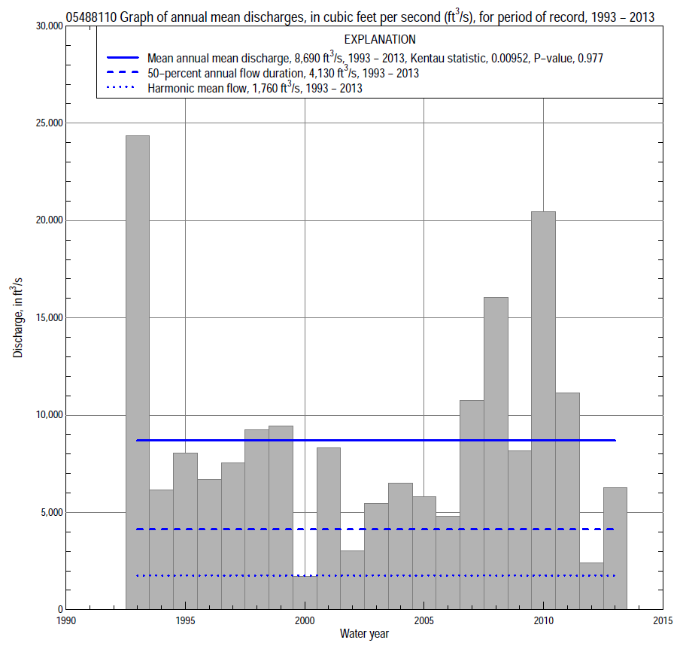

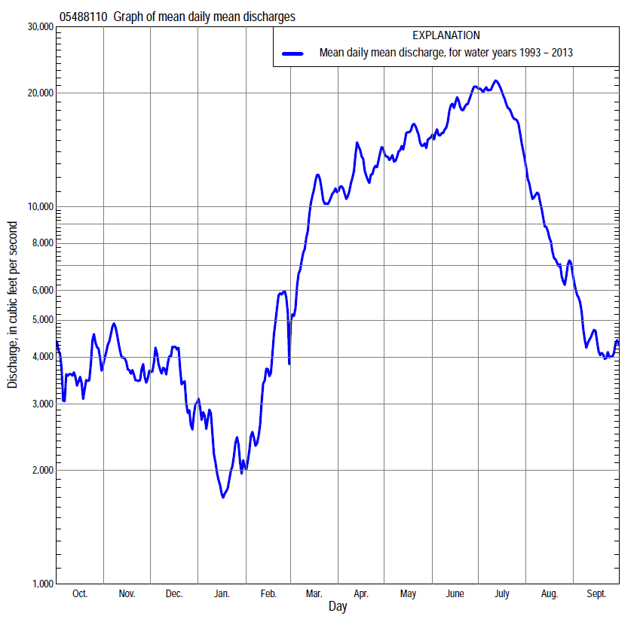

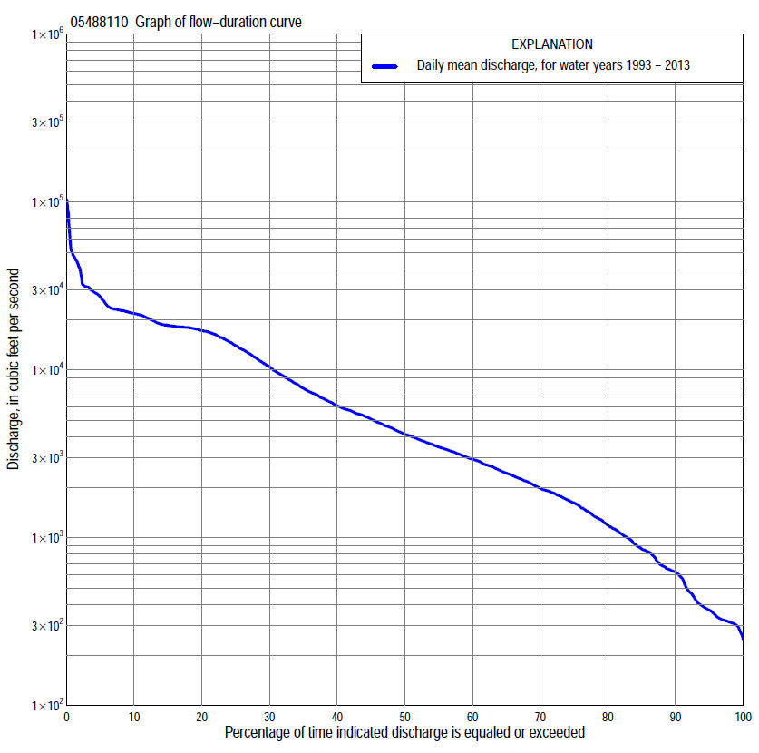

Statistics Based on the Regulated Streamflow Period of Record
05488110 Monthly and annual flow durations, based on 1993–2013 regulated period of record (21 years)
Percentage of days discharge equaled or exceeded |  |  |  |  | Discharge (cubic feet per second) |  |  |  |  |  |  |  |  | Annual flow durations
 | Oct | Nov | Dec | Jan | Feb | Mar | Apr | May | June | July | Aug | Sept | Annual | Kentau statistic | P-value
99 | 257 | 290 | 347 | 319 | 328 | 452 | 634 | 482 | 935 | 398 | 339 | 266 | 301 | -0.086 | 0.608
98 | 269 | 297 | 360 | 329 | 453 | 557 | 708 | 714 | 2,970 | 588 | 383 | 276 | 314 | -0.086 | 0.608
95 | 306 | 306 | 494 | 489 | 482 | 880 | 1,470 | 3,230 | 3,940 | 1,140 | 569 | 306 | 370 | -0.071 | 0.672
90 | 316 | 347 | 681 | 630 | 633 | 1,680 | 2,720 | 5,190 | 4,870 | 1,990 | 814 | 318 | 625 | -0.029 | 0.880
85 | 334 | 386 | 886 | 672 | 710 | 2,190 | 3,400 | 6,390 | 5,850 | 3,260 | 1,110 | 337 | 859 | -0.033 | 0.856
80 | 371 | 503 | 1,080 | 777 | 973 | 2,660 | 4,120 | 7,290 | 7,240 | 4,230 | 1,440 | 405 | 1,190 | -0.076 | 0.651
75 | 390 | 821 | 1,430 | 886 | 1,200 | 3,100 | 4,890 | 8,280 | 9,020 | 5,900 | 1,650 | 504 | 1,610 | -0.105 | 0.526
70 | 485 | 1,130 | 1,810 | 1,090 | 1,470 | 3,280 | 5,500 | 10,300 | 11,600 | 8,370 | 1,880 | 731 | 1,970 | -0.076 | 0.651
65 | 633 | 1,630 | 2,020 | 1,160 | 1,770 | 3,670 | 6,020 | 12,300 | 13,900 | 11,100 | 2,140 | 845 | 2,420 | -0.062 | 0.717
60 | 1,040 | 1,880 | 2,250 | 1,290 | 1,930 | 4,130 | 7,120 | 14,600 | 15,700 | 13,500 | 2,470 | 992 | 2,940 | -0.029 | 0.880
55 | 1,580 | 1,960 | 2,540 | 1,420 | 2,250 | 5,180 | 8,480 | 15,900 | 17,000 | 16,700 | 2,800 | 1,070 | 3,470 | -0.057 | 0.740
50 | 2,090 | 2,300 | 2,900 | 1,630 | 2,470 | 6,120 | 9,680 | 16,800 | 18,000 | 17,700 | 3,130 | 1,250 | 4,130 | -0.038 | 0.833
45 | 2,420 | 2,650 | 3,230 | 1,930 | 2,930 | 7,210 | 11,500 | 17,500 | 18,300 | 17,900 | 3,580 | 1,400 | 5,090 | -0.038 | 0.833
40 | 2,880 | 3,050 | 3,510 | 2,220 | 3,400 | 8,260 | 13,300 | 18,000 | 20,000 | 18,000 | 4,430 | 1,600 | 6,120 | -0.029 | 0.880
35 | 3,270 | 3,700 | 3,840 | 2,410 | 3,840 | 9,540 | 15,500 | 18,300 | 21,000 | 18,300 | 4,980 | 1,800 | 7,760 | -0.029 | 0.880
30 | 3,710 | 4,220 | 4,220 | 2,650 | 4,240 | 11,600 | 17,800 | 18,500 | 21,500 | 21,000 | 5,900 | 2,220 | 10,400 | -0.005 | 1.000
25 | 4,480 | 5,160 | 4,640 | 2,970 | 5,060 | 13,800 | 20,200 | 18,700 | 21,800 | 22,500 | 8,010 | 2,670 | 13,900 | 0.014 | 0.952
20 | 5,830 | 6,280 | 5,220 | 3,360 | 5,600 | 15,800 | 21,700 | 19,100 | 22,300 | 23,200 | 12,500 | 3,720 | 17,100 | 0.062 | 0.717
15 | 7,270 | 8,000 | 5,790 | 3,800 | 6,650 | 19,000 | 23,500 | 21,200 | 22,800 | 28,700 | 18,100 | 7,360 | 18,400 | 0.052 | 0.763
10 | 10,500 | 10,000 | 7,110 | 4,350 | 8,690 | 23,100 | 26,300 | 22,500 | 23,800 | 40,700 | 26,100 | 17,000 | 21,700 | 0.057 | 0.739
5 | 15,800 | 15,100 | 8,760 | 5,920 | 12,000 | 27,100 | 29,300 | 23,100 | 31,600 | 51,100 | 44,000 | 27,900 | 27,200 | 0.033 | 0.856
2 | 17,100 | 17,800 | 13,900 | 8,690 | 17,400 | 30,900 | 31,200 | 31,800 | 59,000 | 87,000 | 47,100 | 32,800 | 39,800 | 0.062 | 0.717
1 | 17,900 | 17,900 | 16,600 | 10,400 | 20,600 | 31,300 | 31,400 | 32,000 | 85,800 | 94,600 | 49,700 | 39,800 | 48,000 | 0.033 | 0.856

05488110 Annual exceedance probability of instantaneous peak discharges, in cubic feet per second (ft³/s), based on U.S. Army Corps of Engineers regulated flow frequency studyª, analysis computed using a record length of 92 years (1917-2008)
USACE Regulated Flow Frequency Analysis
[ND, not determined]
Annual exceedance probability | Recurrence interval (years) | Discharge (ft³/s) | 95-percent lower confi-dence interval (ft³/s) | 95-percent upper confi-dence interval (ft³/s)
0.500 | 2 | 25,700 | ND | ND
0.200 | 5 | ND | ND | ND
0.100 | 10 | 31,000 | ND | ND
0.040 | 25 | ND | ND | ND
0.020 | 50 | 68,700 | ND | ND
0.010 | 100 | 93,600 | ND | ND
0.005 | 200 | 137,000 | ND | ND
0.002 | 500 | 137,000 | ND | ND
ªU.S. Army Corps of Engineers, 2010, Des Moines River regulated flow frequency study: Rock Island District, 82 p., accessed September 9, 2014, at http://www.mvr.usace.army.mil/Portals/48/docs/FRM/DMRRFFS/DMRRFFS-FinalReport.pdf.
USGS Kendall's Tau Trend Analysis
Kentau statistic |  | 0.029
P-value |  | 0.880
Begin year |  | ^{b}1993
End year |  | ^{b}2013
Number of peaks |  | 21
^{b}Kendall's tau trend analysis computed using the regulated period of record which is not the same period of record used for the above regulated flow frequency analysis.

05488110 Annual exceedance probability of high discharges, based on 1993–2013 regulated period of recordª (21 years)
[ND, not determined]
Annual exceedance probability | Recur-rence interval (years) | Maximum average discharge (cubic feet per second) for indicated number of consecutive days
 |  | 1 | 3 | 7 | 15 | 30
0.990 | 1.01 | ND | ND | ND | ND | ND
0.950 | 1.05 | ND | ND | ND | ND | ND
0.900 | 1.11 | ND | ND | ND | ND | ND
0.800 | 1.25 | ND | ND | ND | ND | ND
0.500 | 2 | ND | ND | ND | ND | ND
0.200 | 5 | ND | ND | ND | ND | ND
0.100 | 10 | ND | ND | ND | ND | ND
0.040 | 25 | ND | ND | ND | ND | ND
0.020 | 50 | ND | ND | ND | ND | ND
0.010 | 100 | ND | ND | ND | ND | ND
0.005 | 200 | ND | ND | ND | ND | ND
0.002 | 500 | ND | ND | ND | ND | ND
Kentau statistic |  | 0.033 | 0.038 | 0.048 | 0.038 | 0.019
P-value |  | 0.856 | 0.833 | 0.786 | 0.833 | 0.928
ªContact the U.S. Army Corps of Engineers, Rock Island District, for the annual exceedance probability of high discharges.

 | 05488110 Annual nonexceedance probability of low discharges, based on April 1993 to March 2013 regulated period of record (20 years)
Annual nonexceed-ance probability | Recur-rence interval (years) | Minimum average discharge (cubic feet per second) for indicated number of consecutive days
 |  | 1 | 3 | 7 | 14 | 30 | 60 | 90 | 120 | 183
0.01 | 100 | 135 | 135 | 136 | 136 | 137 | 138 | 153 | 198 | 248
0.02 | 50 | 159 | 160 | 160 | 161 | 161 | 163 | 212 | 270 | 327
0.05 | 20 | 214 | 219 | 219 | 219 | 229 | 253 | 337 | 422 | 492
0.10 | 10 | 248 | 256 | 272 | 282 | 311 | 366 | 496 | 614 | 699
0.20 | 5 | 302 | 315 | 350 | 384 | 447 | 562 | 769 | 941 | 1,060
0.50 | 2 | 459 | 490 | 585 | 689 | 877 | 1,190 | 1,630 | 1,970 | 2,250
0.80 | 1.25 | 744 | 816 | 1,020 | 1,240 | 1,670 | 2,320 | 3,080 | 3,730 | 4,570
0.90 | 1.11 | 983 | 1,100 | 1,380 | 1,680 | 2,310 | 3,180 | 4,130 | 5,010 | 6,490
0.96 | 1.04 | 1,350 | 1,530 | 1,930 | 2,320 | 3,240 | 4,340 | 5,470 | 6,680 | 9,300
0.98 | 1.02 | 1,680 | 1,930 | 2,420 | 2,860 | 4,010 | 5,250 | 6,460 | 7,940 | 11,600
0.99 | 1.01 | 2,060 | 2,390 | 2,970 | 3,450 | 4,840 | 6,170 | 7,420 | 9,180 | 14,200
Kentau statistic |  | 0.021 | 0.032 | 0.063 | 0.053 | -0.011 | 0.063 | 0.053 | 0.063 | 0.042
P-value |  | 0.922 | 0.871 | 0.721 | 0.770 | 0.974 | 0.721 | 0.770 | 0.721 | 0.820

05488110 Annual nonexceedance probability of seasonal low discharges, based on October 1992 to September 2013 regulated period of record (21 years)
Annual nonexceed-ance probability | Recur-rence interval (years) | Minimum average discharge (cubic feet per second) for indicated number of consecutive days
 |  | 1 | 7 | 14 | 30 |  | 1 | 7 | 14 | 30
 |  | January-February-March |  |  |  |  | April-May-June
0.01 | 100 | 222 | 228 | 228 | 229 |  | 352 | 381 | 472 | 634
0.02 | 50 | 261 | 280 | 280 | 286 |  | 523 | 562 | 702 | 974
0.05 | 20 | 332 | 379 | 392 | 415 |  | 893 | 966 | 1,220 | 1,750
0.10 | 10 | 411 | 492 | 520 | 568 |  | 1,350 | 1,490 | 1,900 | 2,790
0.20 | 5 | 532 | 667 | 723 | 815 |  | 2,070 | 2,400 | 3,100 | 4,550
0.50 | 2 | 877 | 1,160 | 1,290 | 1,530 |  | 3,830 | 5,080 | 6,730 | 9,530
0.80 | 1.25 | 1,450 | 1,960 | 2,170 | 2,680 |  | 5,570 | 8,920 | 12,100 | 15,700
0.90 | 1.11 | 1,880 | 2,530 | 2,780 | 3,480 |  | 6,270 | 11,200 | 15,400 | 18,800
0.96 | 1.04 | 2,500 | 3,290 | 3,570 | 4,510 |  | 6,820 | 13,600 | 19,000 | 21,700
0.98 | 1.02 | 3,000 | 3,890 | 4,150 | 5,270 |  | 7,060 | 15,100 | 21,300 | 23,200
0.99 | 1.01 | 3,530 | 4,490 | 4,730 | 6,030 |  | 7,210 | 16,300 | 23,200 | 24,300
Kentau statistic |  | -0.024 | -0.029 | -0.019 | -0.076 |  | -0.105 | -0.038 | -0.010 | 0.010
P-value |  | 0.904 | 0.880 | 0.928 | 0.651 |  | 0.526 | 0.833 | 0.976 | 0.976
 |  | July-August-September |  |  |  |  | October-November-December
0.01 | 100 | 261 | 262 | 263 | 264 |  | 116 | 117 | 118 | 119
0.02 | 50 | 262 | 267 | 268 | 288 |  | 147 | 148 | 150 | 151
0.05 | 20 | 266 | 291 | 292 | 342 |  | 206 | 211 | 215 | 234
0.10 | 10 | 275 | 310 | 327 | 414 |  | 254 | 287 | 300 | 374
0.20 | 5 | 300 | 357 | 402 | 556 |  | 333 | 409 | 460 | 637
0.50 | 2 | 464 | 621 | 775 | 1,210 |  | 593 | 829 | 1,030 | 1,590
0.80 | 1.25 | 1,250 | 1,810 | 2,300 | 3,600 |  | 1,150 | 1,730 | 2,270 | 3,490
0.90 | 1.11 | 2,770 | 4,040 | 4,950 | 7,320 |  | 1,670 | 2,580 | 3,420 | 5,010
0.96 | 1.04 | 8,160 | 11,700 | 13,200 | 17,400 |  | 2,560 | 3,990 | 5,270 | 7,110
0.98 | 1.02 | 18,800 | 26,100 | 27,200 | 32,600 |  | 3,430 | 5,320 | 6,960 | 8,760
0.99 | 1.01 | 43,600 | 55,500 | 55,600 | 59,800 |  | 4,510 | 6,910 | 8,910 | 10,400
Kentau statistic |  | 0.029 | 0.019 | -0.038 | -0.124 |  | -0.133 | -0.114 | -0.095 | -0.105
P-value |  | 0.880 | 0.928 | 0.833 | 0.450 |  | 0.415 | 0.487 | 0.566 | 0.526

