LOCATION.--Lat 41°18'02", long 93°02'43" referenced to North American Datum of 1927, in NE 1/4 NE 1/4 SE 1/4 sec.16, T.75 N., R.19 W., Marion County, IA, Hydrologic Unit 07100009, on left bank 5 ft upstream from bridge on State Highway 92, 3.0 mi east of Knoxville, and 12.7 mi upstream from mouth.

DRAINAGE AREA.--90.1 mi².

PERIOD OF RECORD.--Discharge records from July 1985 to current year.

GAGE.--Water-stage recorder. Datum of gage is 721.79 ft above National Geodetic Vertical Datum of 1929.

EXTREMES OUTSIDE PERIOD OF RECORD.--Flood of July 16, 1982, reached a stage of 30.28 ft, discharge 28,000 ft³/s, from contracted-opening indirect computations.

A summary of all available data for this streamgage is provided through the USGS National Water Information System web interface (NWISWeb). The following link provides access to current/historical observations, daily data, daily statistics, monthly statistics, annual statistics, peak streamflow, field measurements, field/lab water-quality samples, and the latest water-year summaries. Data can be filtered by parameter and/or dates, and can be output in various tabular and graphical formats.
http://waterdata.usgs.gov/nwis/inventory/?site_no=05488200

The USGS WaterWatch Toolkit is available at:
http://waterwatch.usgs.gov/?id=ww_toolkit
Tools for summarizing streamflow information include the duration hydrograph builder, the cumulative streamflow hydrograph builder, the streamgage statistics retrieval tool, the rating curve builder, the flood tracking chart builder, the National Weather Service Advanced Hydrologic Prediction Service (AHPS) river forecast hydrograph builder, and the raster-hydrograph builder. Entering the above number for this streamgage into these toolkit webpages will provide streamflow information specific to this streamgage.

A description of the statistics presented for this streamgage is available in the main body of the report at:
http://dx.doi.org/10.3133/ofr20151214
A link to other streamgages included in this report, a map showing the location of the streamgages, information on the programs used to compute the statistical analyses, and references are included in the main body of the report.

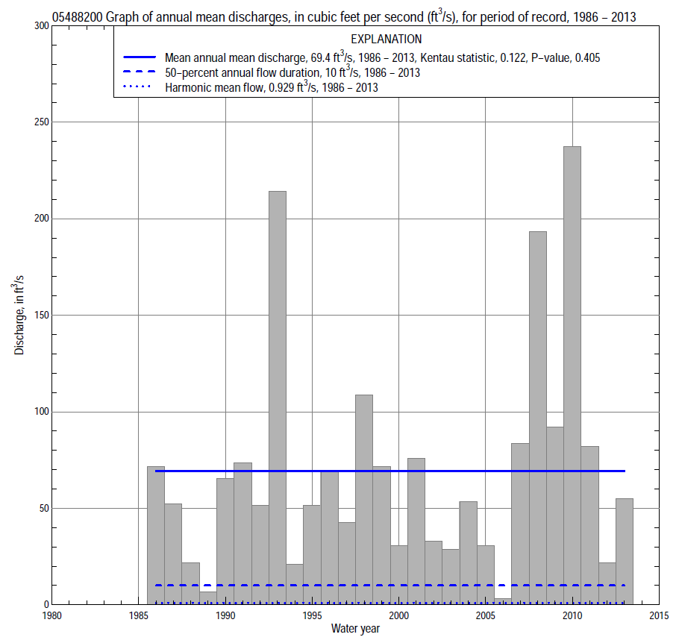

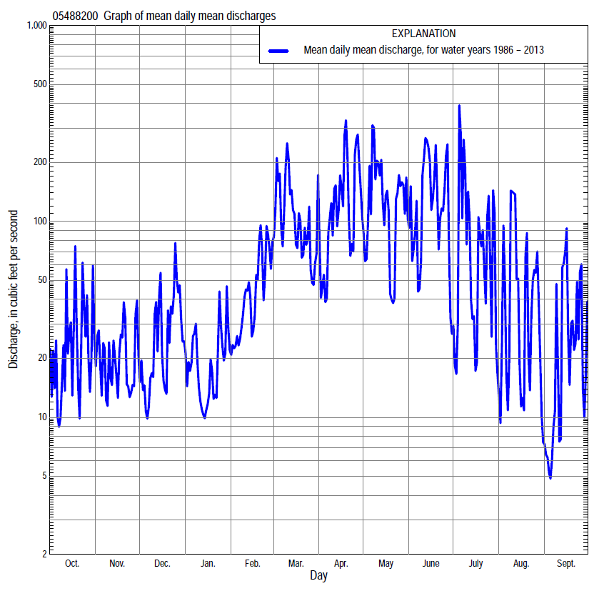

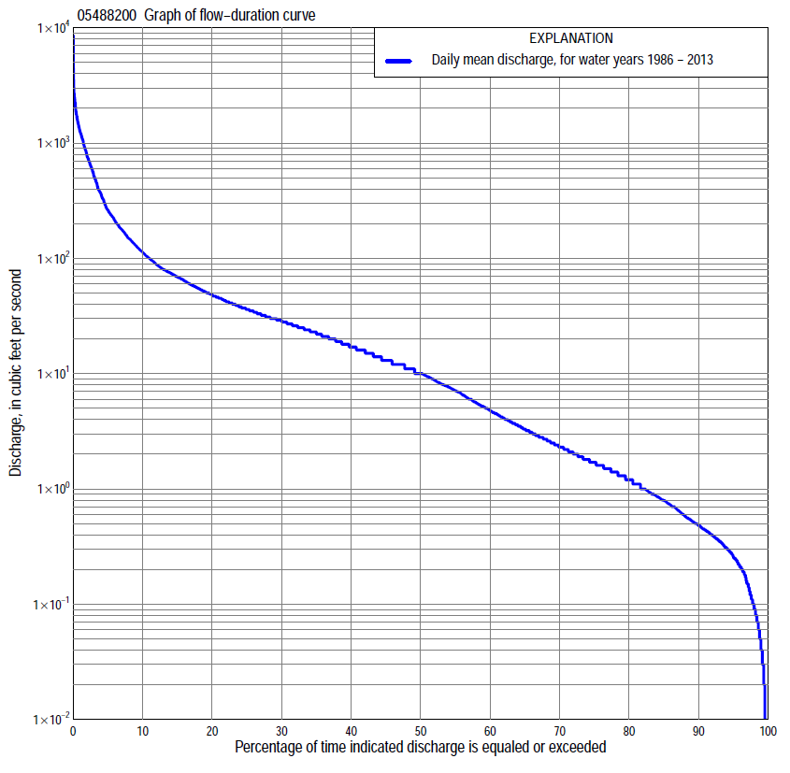

Statistics Based on the Entire Streamflow Period of Record
05488200 Monthly and annual flow durations, based on 1986–2013 period of record (28 years)
Percentage of days discharge equaled or exceeded |  |  |  |  | Discharge (cubic feet per second) |  |  |  |  |  |  |  |  | Annual flow durations
 | Oct | Nov | Dec | Jan | Feb | Mar | Apr | May | June | July | Aug | Sept | Annual | Kentau statistic | P-value
99 | 0.01 | 0.15 | 0.19 | 0.20 | 0.09 | 0.90 | 0.59 | 0.35 | 0.38 | 0.05 | 0.01 | 0.00 | 0.04 | 0.127 | 0.125
98 | 0.04 | 0.28 | 0.21 | 0.24 | 0.17 | 1.2 | 0.89 | 0.68 | 0.43 | 0.07 | 0.02 | 0.00 | 0.09 | 0.127 | 0.125
95 | 0.11 | 0.46 | 0.35 | 0.34 | 0.49 | 1.8 | 1.6 | 1.8 | 0.64 | 0.14 | 0.07 | 0.04 | 0.27 | 0.172 | 0.076
90 | 0.22 | 0.70 | 0.56 | 0.69 | 0.88 | 3.1 | 5.8 | 3.0 | 1.2 | 0.32 | 0.20 | 0.12 | 0.50 | 0.077 | 0.516
85 | 0.30 | 0.95 | 0.90 | 0.85 | 1.9 | 7.9 | 8.7 | 7.1 | 2.3 | 0.51 | 0.35 | 0.25 | 0.80 | 0.108 | 0.401
80 | 0.40 | 1.2 | 1.3 | 1.3 | 2.6 | 12 | 11 | 10 | 4.0 | 0.89 | 0.53 | 0.34 | 1.2 | 0.116 | 0.379
75 | 0.50 | 1.5 | 1.6 | 1.6 | 4.0 | 16 | 14 | 14 | 6.0 | 1.4 | 0.79 | 0.41 | 1.7 | 0.101 | 0.456
70 | 0.70 | 1.8 | 2.0 | 2.1 | 6.4 | 19 | 17 | 19 | 8.7 | 1.9 | 0.99 | 0.49 | 2.4 | 0.085 | 0.529
65 | 0.91 | 2.1 | 2.5 | 2.6 | 8.0 | 23 | 21 | 24 | 11 | 2.6 | 1.2 | 0.59 | 3.4 | 0.040 | 0.779
60 | 1.2 | 2.6 | 3.1 | 3.2 | 11 | 26 | 25 | 28 | 14 | 3.7 | 1.5 | 0.74 | 4.9 | 0.034 | 0.811
55 | 1.4 | 3.4 | 4.2 | 3.9 | 14 | 29 | 30 | 33 | 19 | 5.1 | 2.0 | 0.90 | 7.3 | 0.024 | 0.874
50 | 1.8 | 4.3 | 5.5 | 4.8 | 17 | 32 | 34 | 37 | 23 | 6.5 | 2.3 | 1.2 | 10 | -0.008 | 0.968
45 | 2.5 | 5.5 | 7.8 | 6.0 | 20 | 36 | 42 | 43 | 28 | 8.3 | 3.1 | 1.6 | 13 | -0.024 | 0.874
40 | 3.3 | 7.8 | 9.7 | 7.7 | 25 | 42 | 51 | 49 | 33 | 11 | 3.9 | 2.5 | 17 | -0.034 | 0.812
35 | 4.8 | 10 | 12 | 10 | 31 | 50 | 59 | 58 | 43 | 13 | 5.3 | 3.6 | 23 | 0.024 | 0.874
30 | 9.0 | 14 | 16 | 12 | 38 | 61 | 71 | 69 | 56 | 19 | 7.0 | 4.6 | 29 | 0.016 | 0.921
25 | 13 | 17 | 19 | 15 | 46 | 78 | 86 | 82 | 72 | 26 | 10 | 7.7 | 37 | 0.042 | 0.767
20 | 20 | 23 | 25 | 19 | 57 | 104 | 117 | 115 | 95 | 34 | 16 | 13 | 49 | 0.066 | 0.635
15 | 26 | 31 | 32 | 26 | 76 | 158 | 160 | 166 | 149 | 58 | 28 | 21 | 70 | 0.061 | 0.664
10 | 43 | 44 | 42 | 34 | 110 | 259 | 269 | 276 | 272 | 110 | 51 | 34 | 114 | 0.079 | 0.567
5 | 102 | 82 | 95 | 62 | 169 | 561 | 644 | 766 | 756 | 332 | 133 | 67 | 264 | 0.069 | 0.621
2 | 306 | 173 | 267 | 184 | 297 | 1,070 | 1,240 | 1,270 | 1,440 | 1,230 | 640 | 253 | 776 | 0.116 | 0.396
1 | 475 | 242 | 429 | 293 | 570 | 1,490 | 1,920 | 1,620 | 1,900 | 1,720 | 1,260 | 636 | 1,260 | 0.069 | 0.621

05488200 Annual exceedance probability of instantaneous peak discharges, in cubic feet per second (ft³/s), based on the Weighted Independent Estimates method,
Annual exceed-ance probability | Recur-rence interval (years) | Discharge (ft³/s) | 95-percent lower confi-dence interval (ft³/s) | 95-percent upper confi-dence interval (ft³/s)
0.500 | 2 | 2,960 | 2,410 | 3,650
0.200 | 5 | 6,010 | 4,850 | 7,450
0.100 | 10 | 8,450 | 6,670 | 10,700
0.040 | 25 | 12,100 | 9,160 | 15,900
0.020 | 50 | 15,000 | 11,000 | 20,500
0.010 | 100 | 18,100 | 12,700 | 25,700
0.005 | 200 | 21,300 | 14,500 | 31,400
0.002 | 500 | 25,500 | 16,400 | 39,800
and based on the expected moments algorithm/multiple Grubbs-Beck analysis computed using a historical period length of 66 years (1948–2013)
0.500 | 2 | 2,960 | 2,100 | 4,130
0.200 | 5 | 5,980 | 4,280 | 8,660
0.100 | 10 | 8,560 | 5,960 | 13,000
0.040 | 25 | 12,500 | 8,240 | 20,700
0.020 | 50 | 15,800 | 10,000 | 28,500
0.010 | 100 | 19,500 | 11,800 | 38,700
0.005 | 200 | 23,700 | 13,500 | 51,900
0.002 | 500 | 29,800 | 15,900 | 75,300
Kentau statistic |  | 0.161
P-value |  | 0.236
Begin year |  | 1986
End year |  | 2013
Number of peaks |  | 28

05488200 Annual exceedance probability of high discharges, based on 1986–2013 period of record (28 years)
Annual exceedance probability | Recur-rence interval (years) | Maximum average discharge (ft³/s) for indicated number of consecutive days
 |  | 1 | 3 | 7 | 15 | 30
0.990 | 1.01 | 204 | 114 | 57 | 31 | 18
0.950 | 1.05 | 501 | 291 | 151 | 82 | 52
0.900 | 1.11 | 756 | 446 | 236 | 129 | 84
0.800 | 1.25 | 1,170 | 701 | 377 | 209 | 140
0.500 | 2 | 2,280 | 1,380 | 762 | 443 | 307
0.200 | 5 | 3,610 | 2,180 | 1,230 | 762 | 533
0.100 | 10 | 4,270 | 2,570 | 1,460 | 939 | 656
0.040 | 25 | 4,890 | 2,920 | 1,670 | 1,120 | 776
0.020 | 50 | 5,220 | 3,100 | 1,780 | 1,220 | 843
0.010 | 100 | 5,470 | 3,240 | 1,860 | 1,310 | 895
0.005 | 200 | 5,660 | 3,330 | 1,920 | 1,370 | 936
0.002 | 500 | 5,840 | 3,430 | 1,980 | 1,440 | 977
Kentau statistic |  | 0.188 | 0.101 | 0.132 | 0.138 | 0.101
P-value |  | 0.167 | 0.465 | 0.333 | 0.314 | 0.465

 | 05488200 Annual nonexceedance probability of low discharges, based on April 1986 to March 2013 period of record (27 years)
Annual nonexceed-ance probability | Recur-rence interval (years) | Minimum average discharge (cubic feet per second) for indicated number of consecutive days
 |  | 1 | 3 | 7 | 14 | 30 | 60 | 90 | 120 | 183
0.01 | 100 | 0.00 | 0.00 | 0.00 | 0.00 | 0.01 | 0.04 | 0.09 | 0.18 | 0.20
0.02 | 50 | 0.00 | 0.00 | 0.00 | 0.00 | 0.02 | 0.06 | 0.13 | 0.24 | 0.32
0.05 | 20 | 0.00 | 0.00 | 0.00 | 0.01 | 0.05 | 0.12 | 0.23 | 0.39 | 0.61
0.10 | 10 | 0.00 | 0.00 | 0.01 | 0.03 | 0.10 | 0.21 | 0.38 | 0.61 | 1.1
0.20 | 5 | 0.02 | 0.04 | 0.06 | 0.08 | 0.22 | 0.44 | 0.71 | 1.1 | 2.1
0.50 | 2 | 0.22 | 0.26 | 0.33 | 0.42 | 0.86 | 1.7 | 2.4 | 3.5 | 7.6
0.80 | 1.25 | 1.0 | 1.1 | 1.6 | 1.8 | 3.0 | 6.3 | 8.8 | 13 | 25
0.90 | 1.11 | 2.1 | 2.2 | 2.8 | 3.4 | 5.3 | 13 | 18 | 26 | 46
0.96 | 1.04 | 4.3 | 4.7 | 5.4 | 6.2 | 9.4 | 26 | 38 | 57 | 87
0.98 | 1.02 | 6.7 | 7.8 | 8.4 | 9.0 | 13 | 41 | 64 | 98 | 129
0.99 | 1.01 | 10 | 11 | 12 | 13 | 18 | 63 | 101 | 161 | 184
Kentau statistic |  | 0.359 | 0.368 | 0.390 | 0.339 | 0.162 | 0.134 | 0.083 | 0.071 | -0.020
P-value |  | 0.009 | 0.008 | 0.005 | 0.014 | 0.243 | 0.338 | 0.559 | 0.617 | 0.900

05488200 Annual nonexceedance probability of seasonal low discharges, based on July 1985 to September 2013 period of record (28–29 years)
Annual nonexceed-ance probability | Recur-rence interval (years) | Minimum average discharge (cubic feet per second) for indicated number of consecutive days
 |  | 1 | 7 | 14 | 30 |  | 1 | 7 | 14 | 30
 |  | January-February-March |  |  |  |  | April-May-June
0.01 | 100 | 0.01 | 0.04 | 0.07 | 0.13 |  | 0.06 | 0.10 | 0.12 | 0.26
0.02 | 50 | 0.02 | 0.07 | 0.11 | 0.20 |  | 0.10 | 0.17 | 0.22 | 0.50
0.05 | 20 | 0.06 | 0.16 | 0.23 | 0.41 |  | 0.25 | 0.40 | 0.53 | 1.2
0.10 | 10 | 0.15 | 0.32 | 0.44 | 0.74 |  | 0.51 | 0.80 | 1.1 | 2.6
0.20 | 5 | 0.43 | 0.69 | 0.90 | 1.5 |  | 1.1 | 1.7 | 2.5 | 6.0
0.50 | 2 | 2.2 | 2.7 | 3.3 | 5.2 |  | 4.4 | 6.3 | 9.9 | 24
0.80 | 1.25 | 7.5 | 8.9 | 10 | 17 |  | 14 | 18 | 30 | 76
0.90 | 1.11 | 12 | 15 | 18 | 29 |  | 23 | 29 | 49 | 125
0.96 | 1.04 | 19 | 27 | 31 | 52 |  | 36 | 44 | 76 | 199
0.98 | 1.02 | 24 | 37 | 43 | 74 |  | 48 | 57 | 98 | 261
0.99 | 1.01 | 28 | 48 | 57 | 101 |  | 60 | 69 | 121 | 325
Kentau statistic |  | -0.090 | -0.034 | -0.048 | -0.085 |  | 0.278 | 0.270 | 0.238 | 0.233
P-value |  | 0.514 | 0.813 | 0.737 | 0.540 |  | 0.040 | 0.046 | 0.079 | 0.086
 |  | July-August-September |  |  |  |  | October-November-December
0.01 | 100 | 0.00 | 0.00 | 0.01 | 0.02 |  | 0.00 | 0.00 | 0.01 | 0.09
0.02 | 50 | 0.00 | 0.00 | 0.01 | 0.03 |  | 0.00 | 0.01 | 0.02 | 0.13
0.05 | 20 | 0.00 | 0.00 | 0.02 | 0.07 |  | 0.00 | 0.03 | 0.05 | 0.22
0.10 | 10 | 0.00 | 0.01 | 0.04 | 0.12 |  | 0.04 | 0.06 | 0.12 | 0.38
0.20 | 5 | 0.05 | 0.07 | 0.10 | 0.27 |  | 0.12 | 0.18 | 0.28 | 0.71
0.50 | 2 | 0.24 | 0.40 | 0.50 | 1.2 |  | 0.62 | 1.1 | 1.4 | 2.5
0.80 | 1.25 | 1.3 | 2.4 | 2.6 | 5.0 |  | 3.0 | 4.9 | 6.1 | 8.9
0.90 | 1.11 | 3.5 | 5.5 | 6.1 | 11 |  | 7.0 | 9.9 | 13 | 18
0.96 | 1.04 | 11 | 13 | 15 | 24 |  | 18 | 22 | 27 | 37
0.98 | 1.02 | 22 | 25 | 28 | 39 |  | 32 | 37 | 43 | 61
0.99 | 1.01 | 45 | 47 | 49 | 61 |  | 57 | 60 | 64 | 94
Kentau statistic |  | 0.236 | 0.300 | 0.266 | 0.116 |  | 0.101 | 0.127 | 0.127 | 0.085
P-value |  | 0.074 | 0.023 | 0.045 | 0.388 |  | 0.464 | 0.353 | 0.353 | 0.540

