LOCATION.--Lat 41°16'53", long 92°51'40.7" referenced to North American Datum of 1927, in SE 1/4 NE 1/4 SW 1/4 sec.19, T.75 N., R.17 W., Mahaska County, IA, Hydrologic Unit 07100009, on right bank 250 ft upstream from abandoned Bellefountaine bridge, 0.8 mi east of Tracy, 3.8 mi downstream from bridge on State Highway 92, 3.1 mi upstream from Cedar Creek, 6.4 mi downstream from English Creek, and 127.5 mi upstream from mouth.

DRAINAGE AREA.--12,479 mi².

PERIOD OF RECORD.--Discharge records from March 1920 to current year. Prior to March 1940, monthly mean discharge for some periods published in WSP 1308.

GAGE.--Water-stage recorder. Datum of gage is 670.91 ft above National Geodetic Vertical Datum of 1929. Prior to June 27, 1940, and June 30, 1952, to November 4, 1960, non-recording gage at site 250 ft downstream at same datum; June 27, 1940, to June 29, 1952, water-stage recorder at site 250 ft downstream at same datum.

REMARKS.--Flow regulated by Lake Red Rock (station 05488100), 11.9 mi upstream, since March 12, 1969.

EXTREMES OUTSIDE PERIOD OF RECORD.--Since at least 1851, no flood outside the period of record exceeded the June 14, 1947, stage of 26.50 ft. Flood of May 31, 1903, reached a stage of about 25 ft, discharge about 130,000 ft³/s. Minimum daily discharge since at least 1910, occurred January 21-31, 1940, 45 ft³/s.

A summary of all available data for this streamgage is provided through the USGS National Water Information System web interface (NWISWeb). The following link provides access to current/historical observations, daily data, daily statistics, monthly statistics, annual statistics, peak streamflow, field measurements, field/lab water-quality samples, and the latest water-year summaries. Data can be filtered by parameter and/or dates, and can be output in various tabular and graphical formats.
http://waterdata.usgs.gov/nwis/inventory/?site_no=05488500

The USGS WaterWatch Toolkit is available at:
http://waterwatch.usgs.gov/?id=ww_toolkit
Tools for summarizing streamflow information include the duration hydrograph builder, the cumulative streamflow hydrograph builder, the streamgage statistics retrieval tool, the rating curve builder, the flood tracking chart builder, the National Weather Service Advanced Hydrologic Prediction Service (AHPS) river forecast hydrograph builder, and the raster-hydrograph builder. Entering the above number for this streamgage into these toolkit webpages will provide streamflow information specific to this streamgage.

A description of the statistics presented for this streamgage is available in the main body of the report at:
http://dx.doi.org/10.3133/ofr20151214
A link to other streamgages included in this report, a map showing the location of the streamgages, information on the programs used to compute the statistical analyses, and references are included in the main body of the report.

Statistics Based on the Pre-regulated Streamflow Period of Record

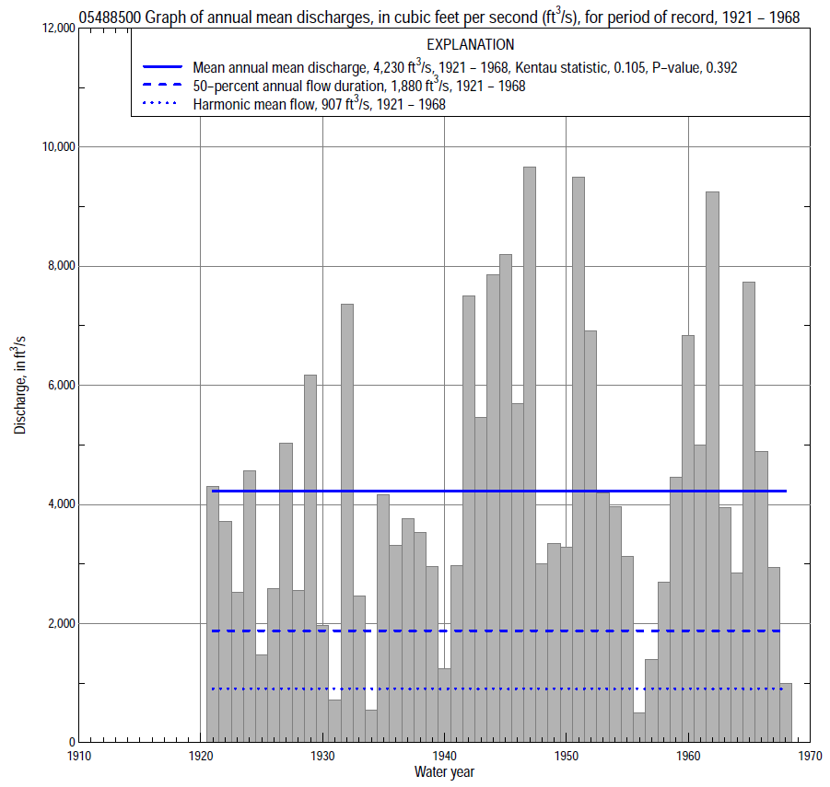

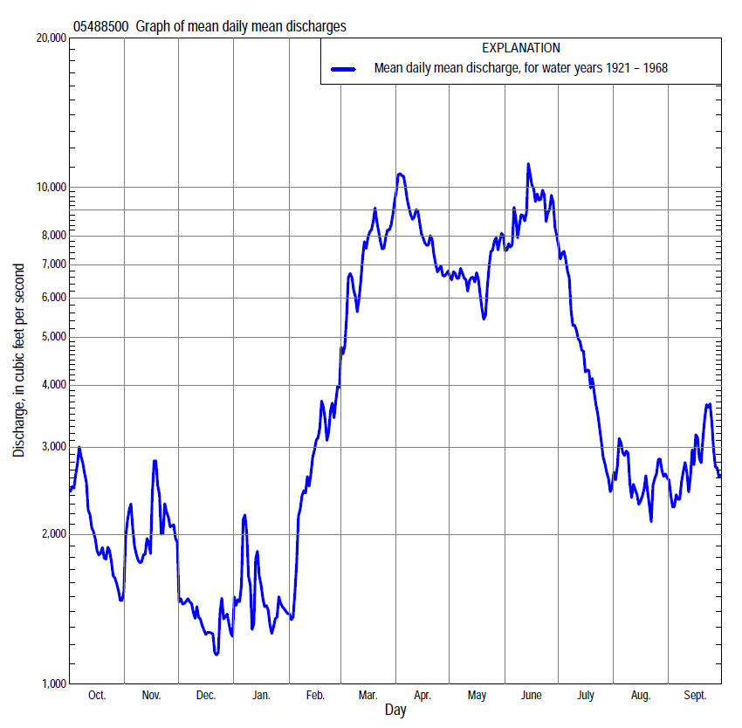

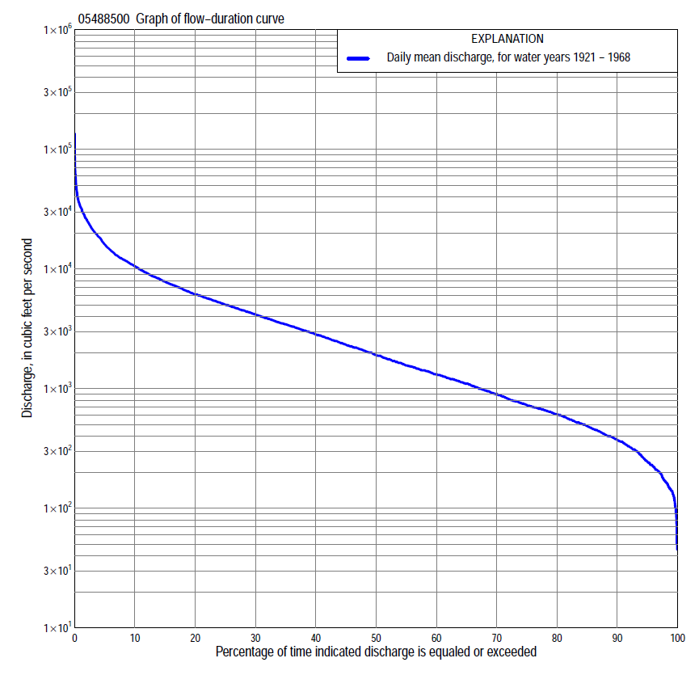

Statistics Based on the Pre-regulated Streamflow Period of Record
05488500 Monthly and annual flow durations, based on 1921–68 pre-regulated period of record (48 years)
Percentage of days discharge equaled or exceeded |  |  |  |  | Discharge (cubic feet per second) |  |  |  |  |  |  |  |  | Annual flow durations
 | Oct | Nov | Dec | Jan | Feb | Mar | Apr | May | June | July | Aug | Sept | Annual | Kentau statistic | P-value
99 | 139 | 165 | 125 | 74 | 84 | 310 | 442 | 313 | 362 | 262 | 164 | 195 | 140 | -0.088 | 0.384
98 | 149 | 205 | 130 | 100 | 105 | 350 | 520 | 440 | 522 | 314 | 182 | 215 | 165 | -0.107 | 0.286
95 | 230 | 230 | 170 | 140 | 170 | 393 | 785 | 520 | 710 | 458 | 304 | 265 | 245 | -0.103 | 0.307
90 | 324 | 324 | 220 | 180 | 305 | 605 | 1,130 | 770 | 1,190 | 762 | 527 | 394 | 370 | -0.103 | 0.307
85 | 362 | 388 | 260 | 220 | 365 | 819 | 1,540 | 1,170 | 1,420 | 1,020 | 669 | 460 | 480 | -0.076 | 0.450
80 | 402 | 442 | 314 | 245 | 455 | 1,400 | 1,880 | 1,640 | 1,880 | 1,200 | 750 | 538 | 605 | -0.096 | 0.342
75 | 459 | 505 | 379 | 310 | 540 | 1,760 | 2,360 | 2,070 | 2,380 | 1,460 | 864 | 592 | 720 | -0.077 | 0.445
70 | 521 | 581 | 422 | 400 | 640 | 2,220 | 2,940 | 2,510 | 2,830 | 1,710 | 980 | 675 | 881 | -0.087 | 0.389
65 | 630 | 670 | 500 | 540 | 760 | 2,790 | 3,290 | 2,960 | 3,510 | 2,010 | 1,060 | 780 | 1,080 | -0.060 | 0.552
60 | 710 | 755 | 580 | 610 | 965 | 3,320 | 3,710 | 3,440 | 4,120 | 2,270 | 1,190 | 896 | 1,300 | -0.067 | 0.505
55 | 800 | 930 | 680 | 680 | 1,170 | 3,760 | 4,200 | 3,970 | 4,670 | 2,540 | 1,330 | 1,010 | 1,540 | -0.033 | 0.749
50 | 950 | 1,030 | 790 | 750 | 1,390 | 4,390 | 4,630 | 4,570 | 5,320 | 2,870 | 1,480 | 1,160 | 1,880 | -0.014 | 0.894
45 | 1,220 | 1,190 | 920 | 810 | 1,800 | 4,990 | 5,140 | 5,250 | 6,020 | 3,280 | 1,640 | 1,390 | 2,260 | -0.001 | 1.000
40 | 1,470 | 1,440 | 1,050 | 940 | 2,300 | 5,760 | 5,840 | 5,920 | 6,960 | 3,710 | 1,840 | 1,640 | 2,780 | 0.041 | 0.689
35 | 1,670 | 1,660 | 1,150 | 1,110 | 2,900 | 6,580 | 6,930 | 6,640 | 8,100 | 4,180 | 2,070 | 1,970 | 3,360 | 0.060 | 0.552
30 | 2,170 | 1,940 | 1,320 | 1,230 | 3,300 | 7,800 | 8,370 | 7,430 | 9,380 | 4,830 | 2,500 | 2,430 | 4,060 | 0.084 | 0.403
25 | 2,630 | 2,250 | 1,460 | 1,420 | 4,100 | 9,300 | 10,200 | 8,340 | 10,900 | 5,630 | 3,010 | 2,960 | 4,960 | 0.093 | 0.355
20 | 3,360 | 2,830 | 1,770 | 1,800 | 4,990 | 11,400 | 12,100 | 9,160 | 12,800 | 6,580 | 3,900 | 3,770 | 6,050 | 0.126 | 0.210
15 | 4,000 | 3,390 | 2,320 | 2,200 | 6,000 | 13,800 | 15,200 | 11,000 | 16,200 | 7,840 | 4,900 | 5,000 | 7,650 | 0.137 | 0.174
10 | 5,370 | 4,290 | 3,100 | 2,700 | 7,380 | 18,300 | 19,200 | 13,600 | 21,300 | 9,910 | 6,200 | 6,480 | 10,300 | 0.146 | 0.145
5 | 6,920 | 7,080 | 4,720 | 5,000 | 9,100 | 24,000 | 28,100 | 20,800 | 31,900 | 12,900 | 8,590 | 10,600 | 15,800 | 0.143 | 0.155
2 | 11,600 | 12,900 | 7,440 | 11,900 | 11,600 | 31,700 | 40,800 | 30,900 | 43,300 | 21,600 | 12,500 | 19,500 | 25,800 | 0.155 | 0.122
1 | 13,700 | 22,000 | 8,640 | 20,900 | 12,300 | 36,000 | 53,400 | 38,400 | 54,700 | 30,100 | 13,800 | 23,500 | 33,000 | 0.158 | 0.116

05488500 Annual exceedance probability of instantaneous peak discharges, in cubic feet per second (ft³/s), for the pre-regulated period of record based on the expected moments algorithm/multiple Grubbs-Beck analysis computed using a historical period length of 117 years (1852–1968)ª
Annual exceed-ance probability | Recur-rence interval (years) | Discharge (ft³/s) | 95-percent lower confi-dence interval (ft³/s) | 95-percent upper confi-dence interval (ft³/s)
0.500 | 2 | 32,900 | 27,500 | 39,200
0.200 | 5 | 53,300 | 44,700 | 64,100
0.100 | 10 | 67,800 | 56,300 | 82,600
0.040 | 25 | 86,800 | 70,600 | 109,000
0.020 | 50 | 101,000 | 80,800 | 132,000
0.010 | 100 | 116,000 | 90,400 | 158,000
0.005 | 200 | 131,000 | 99,600 | 189,000
0.002 | 500 | 152,000 | 111,000 | 236,000
Kentau statistic |  | 0.141
P-value |  | 0.155
Begin year |  | 1920
End year |  | 1968
Number of peaks |  | 49
ªWeighted Independent Estimates were not computed because regional regression equations are not applicable due to size of drainage area.
Note: The above discharges are for the pre-regulated period of record and they are not applicable for flood-plain management regulation or for design purposes.

05488500 Annual exceedance probability of high discharges, based on 1921–68 pre-regulated period of record (48 years)
Annual exceed-ance probability | Recur-rence interval (years) | Maximum average discharge (cubic feet per second) for indicated number of consecutive days
 |  | 1 | 3 | 7 | 15 | 30
0.990 | 1.01 | 4,310 | 3,440 | 2,320 | 1,820 | 1,230
0.950 | 1.05 | 8,690 | 7,440 | 5,540 | 4,100 | 2,900
0.900 | 1.11 | 12,200 | 10,700 | 8,280 | 6,030 | 4,350
0.800 | 1.25 | 17,600 | 15,800 | 12,800 | 9,210 | 6,760
0.500 | 2 | 32,100 | 29,600 | 24,900 | 18,200 | 13,700
0.200 | 5 | 51,500 | 47,500 | 40,100 | 30,900 | 23,400
0.100 | 10 | 62,900 | 57,500 | 48,200 | 38,500 | 29,100
0.040 | 25 | 75,400 | 67,900 | 56,100 | 46,900 | 35,300
0.020 | 50 | 83,400 | 74,200 | 60,600 | 52,300 | 39,100
0.010 | 100 | 90,400 | 79,500 | 64,200 | 56,900 | 42,400
0.005 | 200 | 96,500 | 83,900 | 67,000 | 60,900 | 45,200
0.002 | 500 | 103,000 | 88,600 | 69,900 | 65,500 | 48,200
Kentau statistic |  | 0.163 | 0.163 | 0.144 | 0.131 | 0.184
P-value |  | 0.104 | 0.104 | 0.152 | 0.191 | 0.066
Note: The above discharges are for the pre-regulated period of record and they are not applicable for flood-plain management regulation or for design purposes.

 | 05488500 Annual nonexceedance probability of low discharges, based on April 1920 to March 1969 pre-regulated period of record (49 years)
Annual nonexceed-ance probability | Recur-rence interval (years) | Minimum average discharge (cubic feet per second) for indicated number of consecutive days
 |  | 1 | 3 | 7 | 14 | 30 | 60 | 90 | 120 | 183
0.01 | 100 | 46 | 46 | 49 | 51 | 62 | 78 | 102 | 111 | 133
0.02 | 50 | 60 | 60 | 63 | 67 | 81 | 101 | 131 | 144 | 176
0.05 | 20 | 87 | 88 | 92 | 98 | 118 | 148 | 189 | 211 | 266
0.10 | 10 | 119 | 121 | 127 | 136 | 163 | 205 | 261 | 294 | 379
0.20 | 5 | 170 | 175 | 183 | 199 | 238 | 299 | 380 | 435 | 574
0.50 | 2 | 317 | 332 | 350 | 386 | 464 | 588 | 756 | 886 | 1,220
0.80 | 1.25 | 551 | 582 | 621 | 699 | 850 | 1,100 | 1,450 | 1,730 | 2,460
0.90 | 1.11 | 715 | 757 | 815 | 928 | 1,140 | 1,480 | 2,000 | 2,420 | 3,470
0.96 | 1.04 | 924 | 980 | 1,070 | 1,230 | 1,530 | 2,020 | 2,790 | 3,410 | 4,940
0.98 | 1.02 | 1,080 | 1,150 | 1,260 | 1,460 | 1,830 | 2,440 | 3,440 | 4,220 | 6,160
0.99 | 1.01 | 1,230 | 1,310 | 1,440 | 1,690 | 2,130 | 2,880 | 4,130 | 5,100 | 7,470
Kentau statistic |  | -0.077 | -0.034 | -0.043 | -0.057 | -0.065 | -0.056 | -0.056 | -0.071 | -0.058
P-value |  | 0.443 | 0.737 | 0.673 | 0.569 | 0.518 | 0.575 | 0.575 | 0.474 | 0.564

05488500 Annual nonexceedance probability of seasonal low discharges, based on April 1920 to March 1969 pre-regulated period of record (49 years)
Annual nonexceed-ance probability | Recur-rence interval (years) | Minimum average discharge (cubic feet per second) for indicated number of consecutive days
 |  | 1 | 7 | 14 | 30 |  | 1 | 7 | 14 | 30
 |  | January-February-March |  |  |  |  | April-May-June
0.01 | 100 | 48 | 48 | 51 | 66 |  | 141 | 174 | 193 | 240
0.02 | 50 | 64 | 64 | 68 | 88 |  | 195 | 241 | 268 | 334
0.05 | 20 | 96 | 99 | 106 | 134 |  | 313 | 385 | 430 | 541
0.10 | 10 | 136 | 145 | 155 | 194 |  | 468 | 572 | 642 | 815
0.20 | 5 | 204 | 225 | 243 | 304 |  | 745 | 903 | 1,020 | 1,310
0.50 | 2 | 440 | 504 | 556 | 702 |  | 1,690 | 2,010 | 2,300 | 3,030
0.80 | 1.25 | 932 | 1,070 | 1,210 | 1,590 |  | 3,540 | 4,100 | 4,740 | 6,470
0.90 | 1.11 | 1,370 | 1,550 | 1,790 | 2,420 |  | 5,030 | 5,750 | 6,680 | 9,300
0.96 | 1.04 | 2,050 | 2,270 | 2,680 | 3,770 |  | 7,160 | 8,040 | 9,400 | 13,400
0.98 | 1.02 | 2,660 | 2,880 | 3,460 | 5,000 |  | 8,870 | 9,850 | 11,600 | 16,700
0.99 | 1.01 | 3,340 | 3,550 | 4,320 | 6,440 |  | 10,700 | 11,700 | 13,800 | 20,300
Kentau statistic |  | -0.118 | -0.081 | -0.085 | -0.071 |  | 0.065 | 0.110 | 0.121 | 0.121
P-value |  | 0.234 | 0.418 | 0.393 | 0.474 |  | 0.518 | 0.270 | 0.224 | 0.224
 |  | July-August-September |  |  |  |  | October-November-December
0.01 | 100 | 102 | 110 | 122 | 158 |  | 66 | 76 | 85 | 102
0.02 | 50 | 126 | 136 | 150 | 194 |  | 81 | 93 | 103 | 125
0.05 | 20 | 172 | 185 | 206 | 265 |  | 112 | 126 | 141 | 171
0.10 | 10 | 227 | 245 | 273 | 351 |  | 149 | 167 | 186 | 228
0.20 | 5 | 318 | 345 | 385 | 498 |  | 211 | 236 | 264 | 326
0.50 | 2 | 609 | 668 | 753 | 988 |  | 411 | 470 | 531 | 665
0.80 | 1.25 | 1170 | 1310 | 1500 | 2010 |  | 806 | 966 | 1,110 | 1,420
0.90 | 1.11 | 1650 | 1870 | 2150 | 2940 |  | 1,150 | 1,430 | 1,670 | 2,150
0.96 | 1.04 | 2380 | 2740 | 3190 | 4440 |  | 1,680 | 2,180 | 2,600 | 3,380
0.98 | 1.02 | 3020 | 3520 | 4120 | 5820 |  | 2,140 | 2,890 | 3,480 | 4,580
0.99 | 1.01 | 3740 | 4420 | 5200 | 7440 |  | 2,670 | 3,740 | 4,560 | 6,030
Kentau statistic |  | -0.022 | -0.010 | -0.012 | 0.026 |  | -0.071 | -0.029 | -0.019 | -0.033
P-value |  | 0.829 | 0.924 | 0.911 | 0.803 |  | 0.474 | 0.776 | 0.856 | 0.743

Statistics Based on the Regulated Streamflow Period of Record

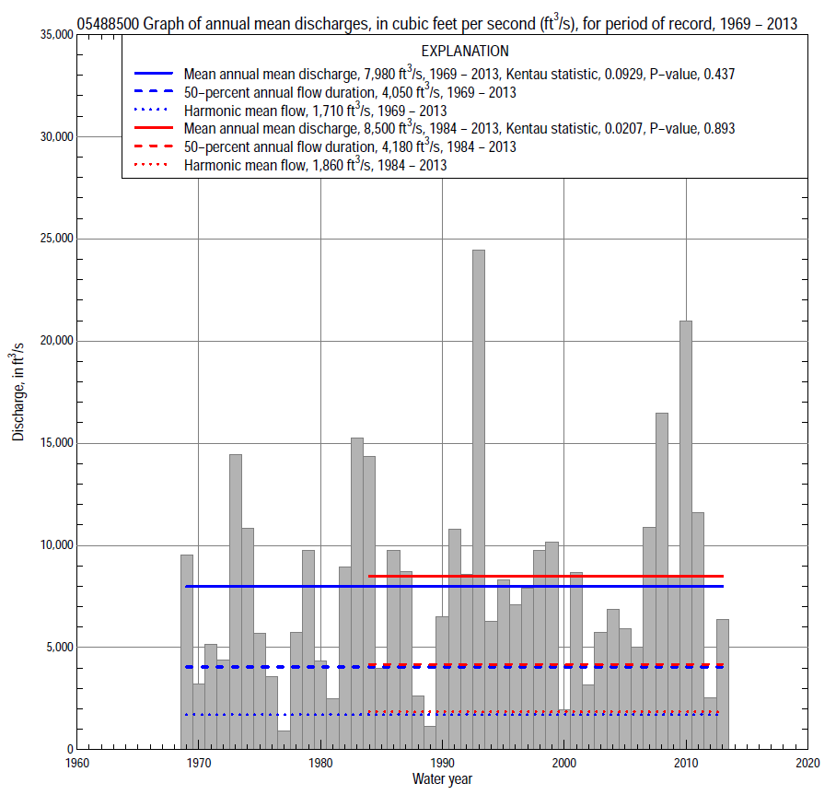

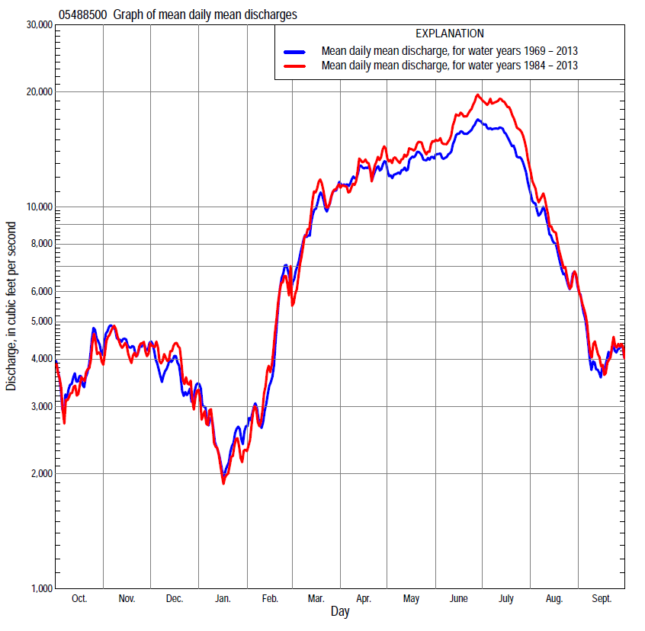

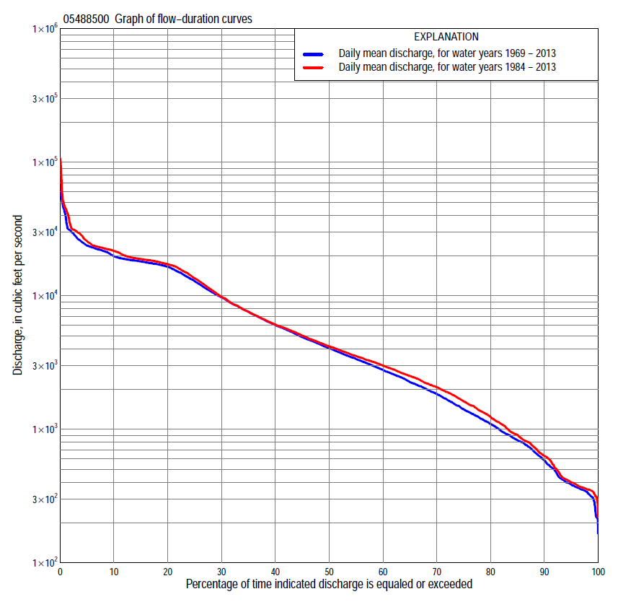

Statistics Based on the Regulated Streamflow Period of Record

05488500 Monthly and annual flow durations, based on 1969–2013 regulated period of record (45 years)
Percentage of days discharge equaled or exceeded |  |  |  |  | Discharge (cubic feet per second) |  |  |  |  |  |  |  |  | Annual flow durations
 | Oct | Nov | Dec | Jan | Feb | Mar | Apr | May | June | July | Aug | Sept | Annual | Kentau statistic | P-value
99 | 277 | 314 | 325 | 295 | 290 | 262 | 613 | 359 | 225 | 216 | 228 | 326 | 309 | 0.006 | 0.961
98 | 311 | 329 | 350 | 330 | 315 | 486 | 661 | 506 | 329 | 218 | 356 | 339 | 339 | 0.037 | 0.725
95 | 323 | 345 | 370 | 382 | 400 | 733 | 1,070 | 1,230 | 1,790 | 740 | 390 | 351 | 384 | 0.041 | 0.696
90 | 364 | 399 | 610 | 520 | 583 | 1,300 | 1,920 | 2,880 | 3,280 | 1,250 | 552 | 372 | 581 | 0.065 | 0.538
85 | 397 | 580 | 818 | 610 | 703 | 1,910 | 3,070 | 4,250 | 3,960 | 1,730 | 861 | 421 | 825 | 0.045 | 0.667
80 | 451 | 839 | 1,020 | 728 | 780 | 2,610 | 3,830 | 5,220 | 4,820 | 2,510 | 1,060 | 534 | 1,100 | 0.031 | 0.769
75 | 531 | 1,060 | 1,280 | 825 | 899 | 3,220 | 4,700 | 6,200 | 5,790 | 3,370 | 1,350 | 758 | 1,410 | 0.031 | 0.769
70 | 649 | 1,310 | 1,500 | 920 | 1,070 | 3,700 | 5,470 | 7,340 | 7,120 | 4,580 | 1,630 | 844 | 1,840 | 0.034 | 0.747
65 | 913 | 1,640 | 1,790 | 1,050 | 1,320 | 4,200 | 6,050 | 8,430 | 9,060 | 6,450 | 2,030 | 973 | 2,260 | 0.037 | 0.725
60 | 1,210 | 1,910 | 2,010 | 1,170 | 1,560 | 4,810 | 7,030 | 10,400 | 11,500 | 8,830 | 2,520 | 1,150 | 2,780 | 0.038 | 0.717
55 | 1,630 | 2,140 | 2,230 | 1,310 | 1,840 | 5,640 | 8,440 | 12,500 | 14,000 | 11,200 | 2,980 | 1,380 | 3,360 | 0.033 | 0.754
50 | 2,060 | 2,490 | 2,550 | 1,460 | 2,160 | 6,350 | 9,870 | 14,600 | 16,400 | 13,800 | 3,480 | 1,580 | 4,050 | 0.022 | 0.837
45 | 2,380 | 2,800 | 2,920 | 1,730 | 2,500 | 7,360 | 11,500 | 16,500 | 17,300 | 16,500 | 4,370 | 1,920 | 4,900 | 0.025 | 0.814
40 | 2,680 | 3,340 | 3,290 | 2,100 | 2,900 | 8,420 | 13,300 | 17,300 | 17,700 | 17,600 | 5,320 | 2,260 | 6,010 | 0.043 | 0.681
35 | 3,200 | 3,930 | 3,710 | 2,400 | 3,660 | 9,740 | 15,400 | 17,900 | 18,300 | 18,400 | 7,040 | 2,650 | 7,570 | 0.030 | 0.777
30 | 3,650 | 4,780 | 4,280 | 2,800 | 4,100 | 11,600 | 17,500 | 18,300 | 19,100 | 18,800 | 9,450 | 3,120 | 9,710 | 0.086 | 0.411
25 | 4,430 | 6,030 | 4,740 | 3,110 | 4,730 | 14,000 | 18,900 | 18,500 | 21,200 | 19,200 | 13,300 | 3,710 | 12,900 | 0.093 | 0.373
20 | 5,830 | 7,320 | 5,470 | 3,600 | 5,770 | 16,700 | 21,800 | 19,000 | 22,100 | 21,500 | 17,000 | 5,720 | 16,500 | 0.154 | 0.140
15 | 7,480 | 9,240 | 6,300 | 4,200 | 7,410 | 19,500 | 24,200 | 19,800 | 22,700 | 23,000 | 17,700 | 8,850 | 18,100 | 0.201 | 0.053
10 | 10,400 | 12,300 | 8,170 | 5,530 | 10,800 | 23,000 | 26,100 | 21,400 | 23,400 | 28,300 | 18,600 | 13,700 | 19,800 | 0.213 | 0.040
5 | 16,500 | 16,700 | 11,500 | 8,280 | 17,500 | 26,100 | 28,600 | 23,000 | 30,700 | 39,900 | 24,800 | 17,400 | 23,800 | 0.139 | 0.180
2 | 18,300 | 18,900 | 15,000 | 11,200 | 25,200 | 29,200 | 31,100 | 25,600 | 41,800 | 52,700 | 45,000 | 29,500 | 30,600 | 0.158 | 0.129
1 | 19,000 | 19,500 | 16,600 | 16,100 | 25,900 | 31,000 | 31,300 | 31,200 | 59,600 | 88,800 | 47,000 | 32,400 | 40,400 | 0.151 | 0.148

05488500 Annual exceedance probability of instantaneous peak discharges, in cubic feet per second (ft³/s), based on U.S. Army Corps of Engineers regulated flow frequency studyª, analysis computed using a record length of 92 years (1917–2008)
USACE Regulated Flow Frequency Analysis
[ND, not determined]
Annual exceedance probability | Recurrence interval (years) | Discharge (ft³/s) | 95-percent lower confidence interval (ft³/s) | 95-percent upper confidence interval (ft³/s)
0.500 | 2 | 25,700 | ND | ND
0.200 | 5 | ND | ND | ND
0.100 | 10 | 31,000 | ND | ND
0.040 | 25 | ND | ND | ND
0.020 | 50 | 68,700 | ND | ND
0.010 | 100 | 93,600 | ND | ND
0.005 | 200 | 137,000 | ND | ND
0.002 | 500 | 137,000 | ND | ND
ªU.S. Army Corps of Engineers, 2010, Des Moines River regulated flow frequency study: Rock Island District, 82 p., accessed September 9, 2014, at http://www.mvr.usace.army.mil/Portals/48/docs/FRM/DMRRFFS/DMRRFFS-FinalReport.pdf.
USGS Kendall's Tau Trend Analysis
Kentau statistic |  | 0.121
P-value |  | 0.244
Begin year |  | ^{b}1969
End year |  | ^{b}2013
Number of peaks |  | 45
^{b}Kendall's tau trend analysis computed using the regulated period of record which is not the same period of record used for the above regulated flow frequency analysis.

05488500 Annual exceedance probability of high discharges, based on 1969–2013 regulated period of recordª (45 years)
[ND, not determined]
Annual exceedance probability | Recur-rence interval (years) | Maximum average discharge (cubic feet per second) for indicated number of consecutive days
 |  | 1 | 3 | 7 | 15 | 30
0.990 | 1.01 | ND | ND | ND | ND | ND
0.950 | 1.05 | ND | ND | ND | ND | ND
0.900 | 1.11 | ND | ND | ND | ND | ND
0.800 | 1.25 | ND | ND | ND | ND | ND
0.500 | 2 | ND | ND | ND | ND | ND
0.200 | 5 | ND | ND | ND | ND | ND
0.100 | 10 | ND | ND | ND | ND | ND
0.040 | 25 | ND | ND | ND | ND | ND
0.020 | 50 | ND | ND | ND | ND | ND
0.010 | 100 | ND | ND | ND | ND | ND
0.005 | 200 | ND | ND | ND | ND | ND
0.002 | 500 | ND | ND | ND | ND | ND
Kentau statistic |  | 0.145 | 0.147 | 0.153 | 0.158 | 0.176
P-value |  | 0.162 | 0.156 | 0.142 | 0.129 | 0.091
ªContact the U.S. Army Corps of Engineers, Rock Island District, for the annual exceedance probability of high discharges.

 | 05488500 Annual nonexceedance probability of low discharges, based on April 1969 to March 2013 regulated period of record (44 years)
Annual nonexceed-ance probability | Recur-rence interval (years) | Minimum average discharge (cubic feet per second) for indicated number of consecutive days
 |  | 1 | 3 | 7 | 14 | 30 | 60 | 90 | 120 | 183
0.01 | 100 | 146 | 146 | 146 | 147 | 147 | 148 | 168 | 187 | 248
0.02 | 50 | 174 | 175 | 176 | 177 | 178 | 188 | 221 | 251 | 329
0.05 | 20 | 205 | 208 | 217 | 231 | 238 | 268 | 331 | 387 | 498
0.10 | 10 | 241 | 247 | 265 | 291 | 312 | 370 | 473 | 562 | 714
0.20 | 5 | 299 | 310 | 344 | 389 | 439 | 549 | 724 | 873 | 1,090
0.50 | 2 | 479 | 515 | 603 | 706 | 883 | 1,190 | 1,610 | 1,950 | 2,390
0.80 | 1.25 | 839 | 944 | 1,140 | 1,360 | 1,890 | 2,610 | 3,490 | 4,160 | 5,020
0.90 | 1.11 | 1,170 | 1,350 | 1,660 | 1,960 | 2,880 | 3,990 | 5,190 | 6,060 | 7,290
0.96 | 1.04 | 1,710 | 2,050 | 2,520 | 2,940 | 4,600 | 6,290 | 7,860 | 8,930 | 10,700
0.98 | 1.02 | 2,220 | 2,720 | 3,350 | 3,860 | 6,300 | 8,470 | 10,300 | 11,400 | 13,700
0.99 | 1.01 | 2,840 | 3,570 | 4,380 | 4,970 | 8,420 | 11,100 | 13,000 | 14,100 | 16,900
Kentau statistic |  | 0.055 | 0.038 | 0.052 | 0.042 | 0.038 | 0.042 | 0.042 | 0.047 | 0.015
P-value |  | 0.606 | 0.723 | 0.627 | 0.693 | 0.723 | 0.693 | 0.693 | 0.664 | 0.895

05488500 Annual nonexceedance probability of seasonal low discharges, based on April 1969 to September 2013 regulated period of record (44–45 years)
Annual nonexceed-ance probability | Recur-rence interval (years) | Minimum average discharge (cubic feet per second) for indicated number of consecutive days
 |  | 1 | 7 | 14 | 30 |  | 1 | 7 | 14 | 30
 |  | January-February-March |  |  |  |  | April-May-June
0.01 | 100 | 189 | 204 | 206 | 206 |  | 204 | 235 | 275 | 333
0.02 | 50 | 222 | 243 | 247 | 249 |  | 313 | 363 | 431 | 545
0.05 | 20 | 284 | 319 | 330 | 344 |  | 571 | 668 | 809 | 1,070
0.10 | 10 | 359 | 411 | 431 | 462 |  | 929 | 1,100 | 1,350 | 1,840
0.20 | 5 | 483 | 565 | 602 | 666 |  | 1,580 | 1,910 | 2,360 | 3,280
0.50 | 2 | 888 | 1,080 | 1,190 | 1,380 |  | 3,740 | 4,680 | 5,860 | 8,010
0.80 | 1.25 | 1,730 | 2,190 | 2,470 | 2,980 |  | 7,230 | 9,490 | 11,800 | 15,100
0.90 | 1.11 | 2,520 | 3,230 | 3,710 | 4,510 |  | 9,510 | 12,800 | 15,900 | 19,200
0.96 | 1.04 | 3,830 | 4,980 | 5,810 | 7,120 |  | 12,100 | 16,800 | 20,600 | 23,500
0.98 | 1.02 | 5,070 | 6,650 | 7,840 | 9,630 |  | 13,800 | 19,600 | 23,800 | 26,000
0.99 | 1.01 | 6,570 | 8,690 | 10,300 | 12,700 |  | 15,300 | 22,100 | 26,600 | 27,900
Kentau statistic |  | 0.154 | 0.137 | 0.129 | 0.109 |  | 0.035 | 0.051 | 0.065 | 0.129
P-value |  | 0.142 | 0.192 | 0.221 | 0.302 |  | 0.739 | 0.632 | 0.538 | 0.214
 |  | July-August-September |  |  |  |  | October-November-December
0.01 | 100 | 232 | 232 | 233 | 233 |  | 135 | 135 | 141 | 141
0.02 | 50 | 251 | 251 | 252 | 252 |  | 165 | 165 | 178 | 178
0.05 | 20 | 289 | 293 | 293 | 315 |  | 212 | 225 | 252 | 277
0.10 | 10 | 308 | 330 | 347 | 420 |  | 265 | 299 | 347 | 411
0.20 | 5 | 349 | 400 | 450 | 614 |  | 355 | 427 | 514 | 656
0.50 | 2 | 554 | 719 | 883 | 1410 |  | 661 | 880 | 1,120 | 1,560
0.80 | 1.25 | 1300 | 1820 | 2270 | 3760 |  | 1,350 | 1,910 | 2,510 | 3,600
0.90 | 1.11 | 2430 | 3460 | 4200 | 6680 |  | 2,030 | 2,930 | 3,880 | 5,500
0.96 | 1.04 | 5520 | 7800 | 8880 | 12900 |  | 3,230 | 4,700 | 6,240 | 8,550
0.98 | 1.02 | 10200 | 14200 | 15200 | 20300 |  | 4,430 | 6,430 | 8,530 | 11,300
0.99 | 1.01 | 18900 | 25500 | 25600 | 31100 |  | 5,950 | 8,580 | 11,300 | 14,500
Kentau statistic |  | 0.008 | -0.010 | -0.014 | -0.051 |  | -0.035 | -0.039 | -0.082 | -0.025
P-value |  | 0.945 | 0.930 | 0.899 | 0.632 |  | 0.746 | 0.716 | 0.436 | 0.816

Statistics Based on the 1984–2013 Regulated Streamflow Period of Record
05488500 Monthly and annual flow durations, based on 1984–2013 regulated period of record (30 years)
Percentage of days discharge equaled or exceeded |  |  |  |  | Discharge (cubic feet per second) |  |  |  |  |  |  |  |  | Annual flow durations
 | Oct | Nov | Dec | Jan | Feb | Mar | Apr | May | June | July | Aug | Sept | Annual | Kentau statistic | P-value
99 | 286 | 312 | 342 | 366 | 430 | 501 | 675 | 658 | 959 | 388 | 359 | 296 | 341 | -0.009 | 0.957
98 | 314 | 331 | 354 | 372 | 492 | 610 | 685 | 818 | 1,200 | 422 | 363 | 343 | 354 | -0.034 | 0.803
95 | 326 | 347 | 370 | 408 | 600 | 948 | 1,190 | 2,090 | 2,450 | 855 | 395 | 353 | 400 | -0.032 | 0.817
90 | 365 | 372 | 597 | 630 | 690 | 1,770 | 2,430 | 4,180 | 3,540 | 1,500 | 516 | 373 | 632 | -0.025 | 0.858
85 | 397 | 430 | 818 | 743 | 800 | 2,560 | 3,140 | 5,310 | 4,330 | 2,010 | 907 | 416 | 907 | -0.041 | 0.762
80 | 431 | 627 | 1,130 | 850 | 1,050 | 3,080 | 3,810 | 6,160 | 5,200 | 3,080 | 1,230 | 508 | 1,230 | -0.067 | 0.617
75 | 512 | 966 | 1,420 | 930 | 1,320 | 3,380 | 4,700 | 7,190 | 6,240 | 4,200 | 1,580 | 681 | 1,620 | -0.067 | 0.617
70 | 634 | 1,310 | 1,830 | 1,120 | 1,520 | 3,810 | 5,520 | 7,920 | 8,060 | 5,910 | 1,910 | 816 | 2,070 | -0.062 | 0.643
65 | 850 | 1,630 | 2,120 | 1,260 | 1,810 | 4,280 | 6,040 | 9,450 | 10,800 | 8,930 | 2,220 | 917 | 2,500 | -0.044 | 0.748
60 | 1,140 | 1,920 | 2,400 | 1,390 | 2,040 | 4,950 | 7,030 | 11,800 | 13,300 | 12,600 | 2,680 | 1,060 | 3,000 | -0.011 | 0.943
55 | 1,510 | 2,130 | 2,700 | 1,600 | 2,400 | 5,770 | 8,500 | 14,200 | 16,000 | 15,200 | 3,060 | 1,190 | 3,530 | -0.030 | 0.830
50 | 2,080 | 2,440 | 3,100 | 1,900 | 2,630 | 6,620 | 9,960 | 16,300 | 17,700 | 17,500 | 3,510 | 1,430 | 4,180 | -0.053 | 0.695
45 | 2,380 | 2,620 | 3,440 | 2,100 | 2,910 | 7,480 | 11,500 | 17,500 | 18,600 | 18,300 | 4,210 | 1,590 | 5,030 | -0.041 | 0.762
40 | 2,630 | 3,090 | 3,750 | 2,370 | 3,540 | 8,420 | 13,300 | 18,200 | 19,500 | 18,800 | 4,890 | 1,870 | 6,090 | -0.030 | 0.830
35 | 3,180 | 3,630 | 4,240 | 2,700 | 3,930 | 9,560 | 15,500 | 18,500 | 21,100 | 19,000 | 6,220 | 2,220 | 7,570 | -0.044 | 0.748
30 | 3,560 | 4,380 | 4,610 | 2,950 | 4,310 | 11,400 | 18,100 | 18,700 | 22,000 | 20,700 | 8,220 | 2,650 | 9,830 | 0.000 | 1.000
25 | 4,350 | 5,400 | 5,200 | 3,200 | 4,950 | 13,900 | 20,000 | 19,200 | 22,400 | 22,300 | 12,300 | 3,310 | 13,500 | 0.018 | 0.901
20 | 5,570 | 6,780 | 5,800 | 3,590 | 5,680 | 16,700 | 22,300 | 19,800 | 22,900 | 23,500 | 16,900 | 4,890 | 17,200 | 0.083 | 0.532
15 | 6,650 | 8,990 | 6,700 | 4,080 | 6,800 | 18,900 | 24,300 | 20,500 | 23,400 | 28,300 | 18,000 | 8,720 | 18,800 | 0.099 | 0.453
10 | 9,210 | 12,500 | 7,990 | 4,590 | 8,870 | 23,000 | 26,200 | 22,100 | 27,000 | 30,900 | 19,800 | 16,200 | 21,700 | 0.117 | 0.372
5 | 15,900 | 17,700 | 10,200 | 6,620 | 14,800 | 26,400 | 29,800 | 23,000 | 35,000 | 48,900 | 41,800 | 19,200 | 25,600 | 0.085 | 0.521
2 | 18,400 | 19,300 | 14,400 | 8,260 | 22,000 | 29,800 | 31,200 | 30,800 | 53,600 | 75,800 | 46,000 | 31,300 | 33,000 | 0.106 | 0.422
1 | 19,400 | 19,500 | 16,600 | 9,920 | 25,200 | 31,300 | 31,600 | 31,600 | 67,000 | 94,100 | 49,400 | 36,000 | 45,000 | 0.094 | 0.475

05488500 Annual exceedance probability of high discharges, based on 1984–2013 regulated period of recordª (30 years)
[ND, not determined]
Annual exceedance probability | Recur-rence interval (years) | Maximum average discharge (cubic feet per second) for indicated number of consecutive days
 |  | 1 | 3 | 7 | 15 | 30
0.990 | 1.01 | ND | ND | ND | ND | ND
0.950 | 1.05 | ND | ND | ND | ND | ND
0.900 | 1.11 | ND | ND | ND | ND | ND
0.800 | 1.25 | ND | ND | ND | ND | ND
0.500 | 2 | ND | ND | ND | ND | ND
0.200 | 5 | ND | ND | ND | ND | ND
0.100 | 10 | ND | ND | ND | ND | ND
0.040 | 25 | ND | ND | ND | ND | ND
0.020 | 50 | ND | ND | ND | ND | ND
0.010 | 100 | ND | ND | ND | ND | ND
0.005 | 200 | ND | ND | ND | ND | ND
0.002 | 500 | ND | ND | ND | ND | ND
Kentau statistic |  | 0.069 | 0.076 | 0.085 | 0.131 | 0.136
P-value |  | 0.605 | 0.568 | 0.521 | 0.318 | 0.301
ªContact the U.S. Army Corps of Engineers, Rock Island District, for the annual exceedance probability of high discharges.

 | 05488500 Annual nonexceedance probability of low discharges, based on April 1983 to March 2013 regulated period of record (30 years)
Annual nonexceed-ance probability | Recur-rence interval (years) | Minimum average discharge (cubic feet per second) for indicated number of consecutive days
 |  | 1 | 3 | 7 | 14 | 30 | 60 | 90 | 120 | 183
0.01 | 100 | 147 | 148 | 149 | 150 | 151 | 152 | 182 | 208 | 263
0.02 | 50 | 196 | 197 | 198 | 199 | 200 | 201 | 246 | 286 | 354
0.05 | 20 | 234 | 235 | 248 | 252 | 264 | 303 | 381 | 450 | 545
0.10 | 10 | 271 | 272 | 297 | 318 | 352 | 428 | 550 | 660 | 788
0.20 | 5 | 328 | 332 | 376 | 423 | 498 | 641 | 841 | 1,020 | 1,210
0.50 | 2 | 500 | 524 | 624 | 748 | 967 | 1,310 | 1,780 | 2,180 | 2,590
0.80 | 1.25 | 823 | 914 | 1,120 | 1,360 | 1,870 | 2,520 | 3,460 | 4,230 | 5,180
0.90 | 1.11 | 1,100 | 1,280 | 1,570 | 1,880 | 2,650 | 3,450 | 4,760 | 5,760 | 7,230
0.96 | 1.04 | 1,540 | 1,890 | 2,310 | 2,680 | 3,830 | 4,740 | 6,520 | 7,790 | 10,100
0.98 | 1.02 | 1,950 | 2,480 | 3,000 | 3,390 | 4,860 | 5,750 | 7,900 | 9,350 | 12,500
0.99 | 1.01 | 2,420 | 3,200 | 3,840 | 4,200 | 6,020 | 6,800 | 9,320 | 10,900 | 14,900
Kentau statistic |  | 0.064 | 0.044 | 0.018 | -0.016 | -0.076 | -0.034 | -0.044 | -0.057 | -0.085
P-value |  | 0.630 | 0.748 | 0.901 | 0.915 | 0.568 | 0.803 | 0.748 | 0.669 | 0.521

05488500 Annual nonexceedance probability of seasonal low discharges, based on October 1983 to September 2013 regulated period of record (30 years)
Annual nonexceed-ance probability | Recur-rence interval (years) | Minimum average discharge (cubic feet per second) for indicated number of consecutive days
 |  | 1 | 7 | 14 | 30 |  | 1 | 7 | 14 | 30
 |  | January-February-March |  |  |  |  | April-May-June
0.01 | 100 | 245 | 246 | 259 | 260 |  | 344 | 359 | 447 | 611
0.02 | 50 | 293 | 301 | 318 | 319 |  | 487 | 519 | 644 | 896
0.05 | 20 | 377 | 407 | 431 | 453 |  | 791 | 870 | 1,080 | 1,530
0.10 | 10 | 472 | 529 | 563 | 615 |  | 1,180 | 1,330 | 1,660 | 2,370
0.20 | 5 | 618 | 721 | 774 | 879 |  | 1,830 | 2,150 | 2,690 | 3,830
0.50 | 2 | 1,040 | 1,280 | 1,400 | 1,660 |  | 3,790 | 4,740 | 6,080 | 8,380
0.80 | 1.25 | 1,730 | 2,220 | 2,480 | 2,960 |  | 6,750 | 9,010 | 12,000 | 15,500
0.90 | 1.11 | 2,270 | 2,920 | 3,320 | 3,920 |  | 8,650 | 11,900 | 16,200 | 20,100
0.96 | 1.04 | 3,020 | 3,890 | 4,500 | 5,210 |  | 10,800 | 15,500 | 21,600 | 25,400
0.98 | 1.02 | 3,630 | 4,670 | 5,460 | 6,200 |  | 12,300 | 18,000 | 25,600 | 28,900
0.99 | 1.01 | 4,290 | 5,490 | 6,480 | 7,200 |  | 13,700 | 20,300 | 29,300 | 32,000
Kentau statistic |  | -0.009 | -0.025 | -0.034 | -0.051 |  | 0.007 | 0.057 | 0.062 | 0.090
P-value |  | 0.957 | 0.858 | 0.803 | 0.708 |  | 0.972 | 0.669 | 0.643 | 0.498
 |  | July-August-September |  |  |  |  | October-November-December
0.01 | 100 | 314 | 322 | 323 | 324 |  | 129 | 135 | 144 | 150
0.02 | 50 | 315 | 326 | 328 | 330 |  | 166 | 172 | 174 | 180
0.05 | 20 | 319 | 338 | 350 | 376 |  | 224 | 234 | 248 | 272
0.10 | 10 | 327 | 358 | 370 | 459 |  | 276 | 308 | 344 | 415
0.20 | 5 | 351 | 407 | 451 | 615 |  | 363 | 435 | 510 | 675
0.50 | 2 | 508 | 666 | 828 | 1,280 |  | 655 | 870 | 1,090 | 1,600
0.80 | 1.25 | 1,190 | 1,720 | 2,200 | 3,460 |  | 1,290 | 1,830 | 2,330 | 3,450
0.90 | 1.11 | 2,370 | 3,510 | 4,340 | 6,510 |  | 1,920 | 2,760 | 3,480 | 4,990
0.96 | 1.04 | 6,070 | 8,960 | 10,300 | 13,900 |  | 3,010 | 4,340 | 5,340 | 7,220
0.98 | 1.02 | 12,500 | 18,200 | 19,400 | 24,000 |  | 4,090 | 5,860 | 7,050 | 9,040
0.99 | 1.01 | 26,100 | 35,000 | 36,100 | 40,500 |  | 5,460 | 7,730 | 9,040 | 11,000
Kentau statistic |  | 0.108 | 0.016 | -0.025 | -0.076 |  | -0.062 | -0.060 | -0.122 | -0.048
P-value |  | 0.412 | 0.915 | 0.858 | 0.568 |  | 0.643 | 0.656 | 0.354 | 0.721

