LOCATION.--Lat 41°13'08.4", long 92°54'30" referenced to North American Datum of 1927, in SW 1/4 SW 1/4 SW 1/4 sec.11, T.74 N., R.18 W., Marion County, IA, Hydrologic Unit 07100009, on left bank 10 ft downstream from bridge on State Highway 156, 1.6 mi northwest of Bussey, 0.8 mi downstream from North Cedar Creek, 3.0 mi upstream from Honey Creek, and 8.8 mi upstream from mouth.

DRAINAGE AREA.--374 mi².

PERIOD OF RECORD.--Discharge records from October 1947 to current year.

GAGE.--Water stage recorder. Datum of gage is 682.15 ft above National Geodetic Vertical Datum of 1929 (levels by U.S. Army Corps of Engineers). Prior to February 21, 1949, non-recording gage at same site and datum.

EXTREMES OUTSIDE PERIOD OF RECORD.--Flood in June 1946 reached a stage of 28.45 ft on upstream side and 28.05 ft on downstream side of bridge, levels to high-water marks by U.S. Army Corps of Engineers, discharge 31,500 ft³/s.

A summary of all available data for this streamgage is provided through the USGS National Water Information System web interface (NWISWeb). The following link provides access to current/historical observations, daily data, daily statistics, monthly statistics, annual statistics, peak streamflow, field measurements, field/lab water-quality samples, and the latest water-year summaries. Data can be filtered by parameter and/or dates, and can be output in various tabular and graphical formats.
http://waterdata.usgs.gov/nwis/inventory/?site_no=05489000

The USGS WaterWatch Toolkit is available at:
http://waterwatch.usgs.gov/?id=ww_toolkit
Tools for summarizing streamflow information include the duration hydrograph builder, the cumulative streamflow hydrograph builder, the streamgage statistics retrieval tool, the rating curve builder, the flood tracking chart builder, the National Weather Service Advanced Hydrologic Prediction Service (AHPS) river forecast hydrograph builder, and the raster-hydrograph builder. Entering the above number for this streamgage into these toolkit webpages will provide streamflow information specific to this streamgage.

A description of the statistics presented for this streamgage is available in the main body of the report at:
http://dx.doi.org/10.3133/ofr20151214
A link to other streamgages included in this report, a map showing the location of the streamgages, information on the programs used to compute the statistical analyses, and references are included in the main body of the report.

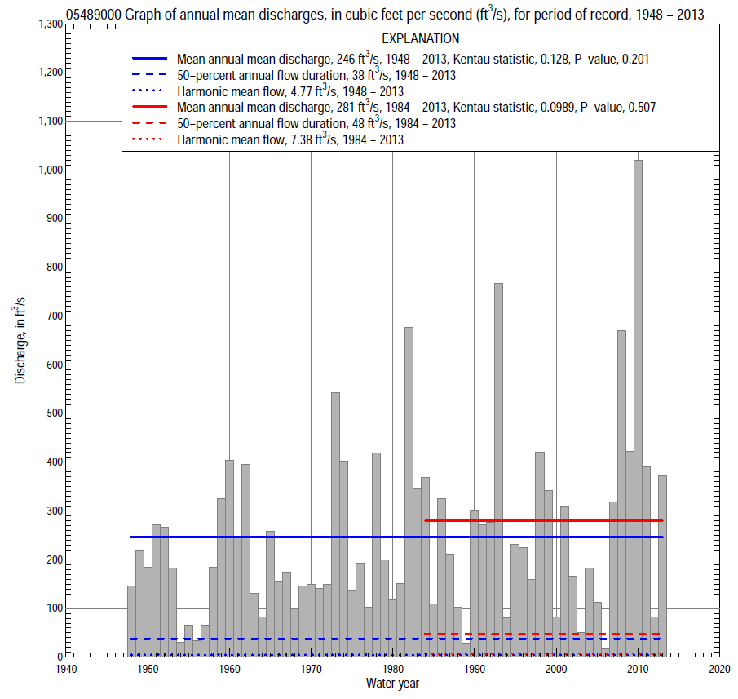

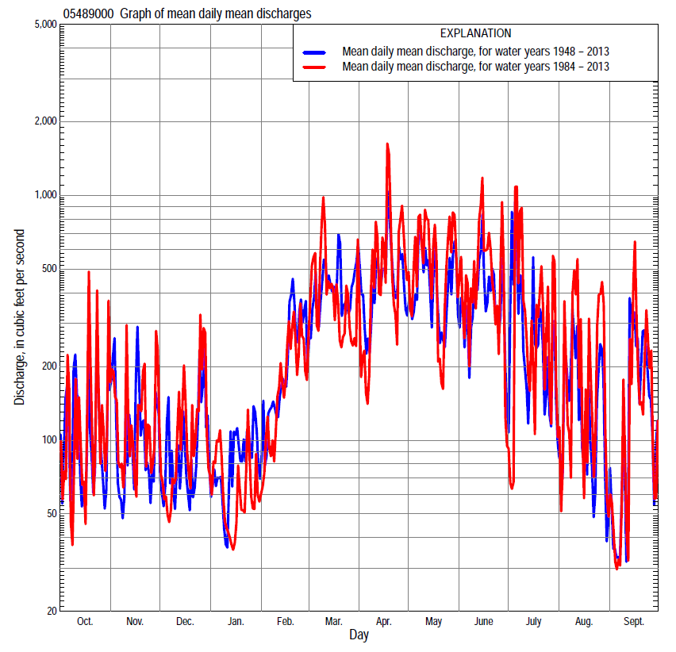

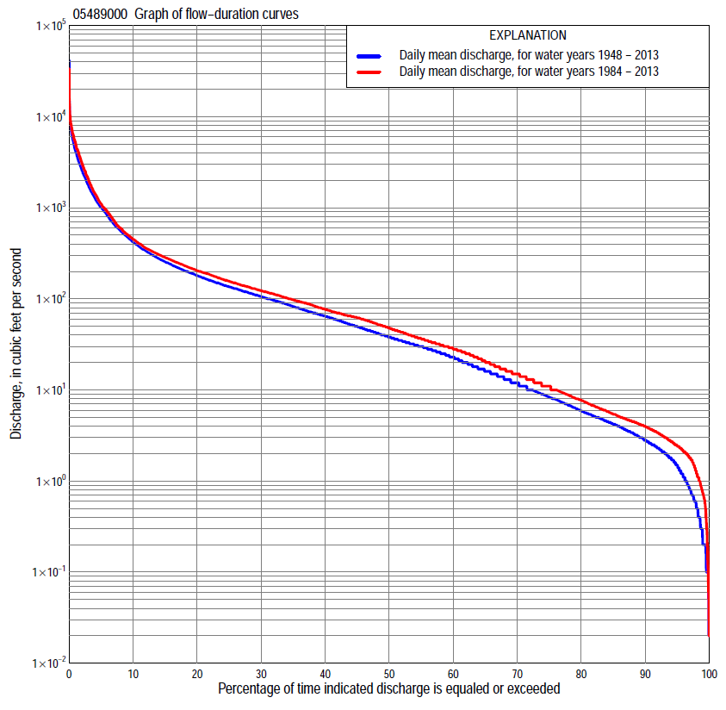

Statistics Based on the Entire Streamflow Period of Record
05489000 Monthly and annual flow durations, based on 1948–2013 period of record (66 years)
Percentage of days discharge equaled or exceeded |  |  |  |  | Discharge (cubic feet per second) |  |  |  |  |  |  |  |  | Annual flow durations
 | Oct | Nov | Dec | Jan | Feb | Mar | Apr | May | June | July | Aug | Sept | Annual | Kentau statistic | P-value
99 | 0.10 | 0.30 | 0.40 | 0.16 | 0.10 | 1.8 | 0.80 | 0.40 | 1.0 | 0.31 | 0.29 | 0.12 | 0.20 | 0.166 | 0.044
98 | 0.20 | 0.40 | 0.70 | 0.20 | 0.30 | 2.3 | 4.0 | 3.6 | 2.1 | 0.59 | 0.90 | 0.29 | 0.50 | 0.177 | 0.033
95 | 0.60 | 1.0 | 1.2 | 0.80 | 1.8 | 7.0 | 10 | 9.9 | 4.6 | 1.8 | 1.8 | 0.75 | 1.5 | 0.193 | 0.021
90 | 1.1 | 2.5 | 2.1 | 2.4 | 3.5 | 16 | 28 | 20 | 7.6 | 4.2 | 2.7 | 1.5 | 2.8 | 0.203 | 0.016
85 | 1.7 | 3.3 | 3.0 | 3.7 | 5.9 | 30 | 40 | 29 | 10 | 6.1 | 3.4 | 2.1 | 4.2 | 0.195 | 0.020
80 | 2.2 | 4.2 | 4.1 | 5.1 | 9.8 | 42 | 50 | 36 | 16 | 8.0 | 4.4 | 2.9 | 5.9 | 0.209 | 0.013
75 | 2.7 | 4.9 | 5.2 | 7.0 | 14 | 53 | 59 | 47 | 23 | 9.9 | 5.6 | 3.6 | 8.4 | 0.205 | 0.015
70 | 3.1 | 6.0 | 7.8 | 8.6 | 19 | 69 | 77 | 59 | 30 | 12 | 6.7 | 4.3 | 12 | 0.189 | 0.025
65 | 3.7 | 8.3 | 10 | 11 | 25 | 80 | 94 | 72 | 38 | 15 | 8.1 | 5.0 | 16 | 0.177 | 0.036
60 | 4.5 | 12 | 14 | 13 | 32 | 99 | 110 | 85 | 48 | 18 | 9.3 | 5.6 | 23 | 0.161 | 0.057
55 | 5.7 | 17 | 19 | 16 | 42 | 114 | 127 | 101 | 60 | 23 | 11 | 6.5 | 30 | 0.146 | 0.084
50 | 8.4 | 24 | 23 | 19 | 59 | 132 | 144 | 119 | 72 | 26 | 14 | 7.7 | 38 | 0.143 | 0.090
45 | 13 | 30 | 28 | 24 | 76 | 151 | 169 | 137 | 88 | 32 | 17 | 9.5 | 50 | 0.148 | 0.080
40 | 19 | 36 | 34 | 30 | 95 | 177 | 197 | 158 | 108 | 40 | 20 | 13 | 65 | 0.144 | 0.088
35 | 28 | 45 | 43 | 36 | 114 | 212 | 229 | 184 | 137 | 51 | 26 | 19 | 82 | 0.138 | 0.102
30 | 36 | 55 | 52 | 47 | 140 | 265 | 270 | 216 | 170 | 68 | 33 | 27 | 106 | 0.143 | 0.091
25 | 51 | 70 | 68 | 64 | 180 | 347 | 328 | 282 | 226 | 90 | 44 | 40 | 136 | 0.133 | 0.116
20 | 68 | 94 | 90 | 76 | 234 | 458 | 425 | 362 | 307 | 128 | 62 | 60 | 180 | 0.121 | 0.153
15 | 97 | 127 | 117 | 100 | 310 | 655 | 599 | 519 | 458 | 192 | 97 | 88 | 255 | 0.105 | 0.215
10 | 150 | 182 | 153 | 150 | 494 | 969 | 955 | 907 | 847 | 300 | 161 | 153 | 420 | 0.063 | 0.458
5 | 313 | 398 | 300 | 262 | 1,000 | 1,890 | 2,100 | 2,260 | 1,940 | 977 | 443 | 442 | 1,000 | 0.061 | 0.472
2 | 1,080 | 1,070 | 750 | 846 | 2,070 | 3,550 | 4,000 | 4,580 | 3,840 | 3,420 | 1,760 | 1,540 | 2,580 | 0.134 | 0.112
1 | 2,850 | 1,700 | 1,500 | 1,310 | 2,770 | 5,280 | 6,250 | 5,890 | 4,990 | 6,070 | 3,770 | 3,010 | 4,240 | 0.187 | 0.026

05489000 Annual exceedance probability of instantaneous peak discharges, in cubic feet per second (ft³/s), based on the Weighted Independent Estimates method,
Annual exceed-ance probability | Recur-rence interval (years) | Discharge (ft³/s) | 95-percent lower confi-dence interval (ft³/s) | 95-percent upper confi-dence interval (ft³/s)
0.500 | 2 | 9,000 | 7,960 | 10,200
0.200 | 5 | 16,900 | 14,900 | 19,300
0.100 | 10 | 23,300 | 20,100 | 27,100
0.040 | 25 | 32,600 | 27,100 | 39,300
0.020 | 50 | 40,200 | 32,300 | 50,200
0.010 | 100 | 48,400 | 37,500 | 62,400
0.005 | 200 | 57,000 | 42,600 | 76,100
0.002 | 500 | 68,900 | 49,100 | 96,700
and based on the expected moments algorithm/multiple Grubbs-Beck analysis computed using a historical period length of 162 years (1852–2013)
0.500 | 2 | 9,020 | 7,420 | 11,000
0.200 | 5 | 17,000 | 13,900 | 21,200
0.100 | 10 | 23,600 | 18,900 | 30,400
0.040 | 25 | 33,400 | 25,700 | 46,000
0.020 | 50 | 41,700 | 31,000 | 61,000
0.010 | 100 | 51,000 | 36,200 | 79,700
0.005 | 200 | 61,100 | 41,600 | 103,000
0.002 | 500 | 76,200 | 48,600 | 141,000
Kentau statistic |  | 0.089
P-value |  | 0.296
Begin year |  | 1948
End year |  | 2013
Number of peaks |  | 66

05489000 Annual exceedance probability of high discharges, based on 1948–2013 period of record (66 years)
Annual exceedance probability | Recur-rence interval (years) | Maximum average discharge (ft³/s) for indicated number of consecutive days
 |  | 1 | 3 | 7 | 15 | 30
0.990 | 1.01 | 884 | 492 | 284 | 167 | 101
0.950 | 1.05 | 1,760 | 1,030 | 597 | 365 | 235
0.900 | 1.11 | 2,460 | 1,480 | 851 | 528 | 348
0.800 | 1.25 | 3,600 | 2,210 | 1,260 | 793 | 533
0.500 | 2 | 6,860 | 4,320 | 2,410 | 1,530 | 1,040
0.200 | 5 | 11,800 | 7,450 | 4,050 | 2,530 | 1,710
0.100 | 10 | 15,100 | 9,470 | 5,070 | 3,130 | 2,080
0.040 | 25 | 19,200 | 11,900 | 6,220 | 3,770 | 2,460
0.020 | 50 | 22,000 | 13,500 | 6,980 | 4,180 | 2,680
0.010 | 100 | 24,700 | 15,000 | 7,660 | 4,530 | 2,870
0.005 | 200 | 27,300 | 16,300 | 8,270 | 4,840 | 3,020
0.002 | 500 | 30,400 | 18,000 | 8,980 | 5,180 | 3,180
Kentau statistic |  | 0.127 | 0.107 | 0.123 | 0.100 | 0.156
P-value |  | 0.134 | 0.207 | 0.147 | 0.236 | 0.065

 | 05489000 Annual nonexceedance probability of low discharges, based on April 1948 to March 2013 period of record (65 years)
Annual nonexceed-ance probability | Recur-rence interval (years) | Minimum average discharge (ft³/s) for indicated number of consecutive days
 |  | 1 | 3 | 7 | 14 | 30 | 60 | 90 | 120 | 183
0.01 | 100 | 0.00 | 0.00 | 0.00 | 0.00 | 0.11 | 0.27 | 0.33 | 0.34 | 0.65
0.02 | 50 | 0.00 | 0.01 | 0.03 | 0.05 | 0.18 | 0.41 | 0.53 | 0.57 | 1.1
0.05 | 20 | 0.03 | 0.07 | 0.13 | 0.20 | 0.36 | 0.80 | 1.1 | 1.3 | 2.4
0.10 | 10 | 0.19 | 0.20 | 0.30 | 0.42 | 0.66 | 1.4 | 2.0 | 2.4 | 4.7
0.20 | 5 | 0.52 | 0.53 | 0.69 | 0.90 | 1.4 | 2.7 | 4.0 | 5.2 | 10
0.50 | 2 | 2.2 | 2.5 | 2.7 | 3.3 | 4.8 | 9.4 | 15 | 20 | 38
0.80 | 1.25 | 7.1 | 8.1 | 8.6 | 10 | 15 | 30 | 48 | 67 | 123
0.90 | 1.11 | 12 | 13 | 15 | 18 | 27 | 54 | 87 | 120 | 215
0.96 | 1.04 | 22 | 23 | 25 | 30 | 47 | 98 | 159 | 211 | 375
0.98 | 1.02 | 30 | 32 | 35 | 42 | 67 | 144 | 232 | 299 | 524
0.99 | 1.01 | 41 | 43 | 46 | 56 | 90 | 201 | 322 | 402 | 698
Kentau statistic |  | 0.173 | 0.174 | 0.199 | 0.221 | 0.195 | 0.174 | 0.135 | 0.113 | 0.106
P-value |  | 0.042 | 0.042 | 0.020 | 0.009 | 0.022 | 0.041 | 0.114 | 0.187 | 0.215

05489000 Annual nonexceedance probability of seasonal low discharges, based on October 1947 to September 2013 period of record (66 years)
Annual nonexceed-ance probability | Recur-rence interval (years) | Minimum average discharge (cubic feet per second) for indicated number of consecutive days
 |  | 1 | 7 | 14 | 30 |  | 1 | 7 | 14 | 30
 |  | January-February-March |  |  |  |  | April-May-June
0.01 | 100 | 0.05 | 0.07 | 0.11 | 0.17 |  | 0.27 | 0.47 | 0.52 | 1.1
0.02 | 50 | 0.11 | 0.14 | 0.22 | 0.35 |  | 0.53 | 0.87 | 0.99 | 2.1
0.05 | 20 | 0.32 | 0.40 | 0.57 | 0.95 |  | 1.3 | 2.0 | 2.5 | 5.2
0.10 | 10 | 0.75 | 0.94 | 1.2 | 2.1 |  | 2.7 | 4.0 | 5.1 | 11
0.20 | 5 | 1.9 | 2.4 | 3.0 | 5.2 |  | 5.9 | 8.5 | 11 | 25
0.50 | 2 | 9.2 | 11 | 13 | 23 |  | 20 | 28 | 41 | 94
0.80 | 1.25 | 32 | 37 | 42 | 71 |  | 49 | 67 | 106 | 251
0.90 | 1.11 | 55 | 61 | 70 | 117 |  | 70 | 95 | 156 | 374
0.96 | 1.04 | 89 | 97 | 113 | 182 |  | 94 | 130 | 218 | 529
0.98 | 1.02 | 118 | 126 | 149 | 234 |  | 110 | 153 | 262 | 638
0.99 | 1.01 | 147 | 154 | 186 | 285 |  | 123 | 173 | 301 | 736
Kentau statistic |  | 0.120 | 0.114 | 0.106 | 0.018 |  | 0.214 | 0.206 | 0.193 | 0.171
P-value |  | 0.157 | 0.177 | 0.211 | 0.833 |  | 0.011 | 0.015 | 0.023 | 0.043
 |  | July-August-September |  |  |  |  | October-November-December
0.01 | 100 | 0.00 | 0.00 | 0.00 | 0.45 |  | 0.00 | 0.10 | 0.11 | 0.14
0.02 | 50 | 0.00 | 0.06 | 0.10 | 0.63 |  | 0.06 | 0.16 | 0.19 | 0.25
0.05 | 20 | 0.10 | 0.23 | 0.35 | 1.0 |  | 0.21 | 0.33 | 0.40 | 0.58
0.10 | 10 | 0.29 | 0.49 | 0.70 | 1.6 |  | 0.43 | 0.61 | 0.77 | 1.2
0.20 | 5 | 0.74 | 1.1 | 1.4 | 2.8 |  | 0.92 | 1.3 | 1.7 | 2.6
0.50 | 2 | 3.1 | 3.8 | 4.9 | 8.2 |  | 3.7 | 4.9 | 6.6 | 11
0.80 | 1.25 | 9.9 | 12 | 15 | 26 |  | 14 | 18 | 24 | 37
0.90 | 1.11 | 17 | 21 | 26 | 47 |  | 28 | 35 | 46 | 67
0.96 | 1.04 | 29 | 36 | 46 | 91 |  | 58 | 70 | 89 | 121
0.98 | 1.02 | 40 | 51 | 66 | 140 |  | 93 | 108 | 135 | 173
0.99 | 1.01 | 52 | 68 | 89 | 208 |  | 141 | 160 | 193 | 235
Kentau statistic |  | 0.177 | 0.218 | 0.215 | 0.125 |  | 0.140 | 0.132 | 0.158 | 0.187
P-value |  | 0.036 | 0.010 | 0.011 | 0.138 |  | 0.098 | 0.117 | 0.062 | 0.026

Statistics Based on the 1984–2013 Streamflow Period of Record
05489000 Monthly and annual flow durations, based on 1984–2013 period of record (30 years)
Percentage of days discharge equaled or exceeded |  |  |  |  | Discharge (cubic feet per second) |  |  |  |  |  |  |  |  | Annual flow durations
 | Oct | Nov | Dec | Jan | Feb | Mar | Apr | May | June | July | Aug | Sept | Annual | Kentau statistic | P-value
99 | 0.40 | 0.74 | 1.1 | 1.4 | 0.71 | 5.8 | 4.3 | 3.3 | 2.6 | 0.34 | 0.06 | 0.52 | 0.74 | -0.044 | 0.743
98 | 0.77 | 2.1 | 1.3 | 2.3 | 1.9 | 7.0 | 5.2 | 5.2 | 2.9 | 0.79 | 0.29 | 0.63 | 1.2 | -0.023 | 0.871
95 | 1.2 | 3.0 | 2.5 | 3.0 | 2.6 | 12 | 9.7 | 13 | 5.4 | 1.8 | 2.0 | 0.85 | 2.4 | -0.037 | 0.788
90 | 2.0 | 4.1 | 3.4 | 4.2 | 5.2 | 21 | 28 | 22 | 8.2 | 3.9 | 2.9 | 1.8 | 4.0 | 0.002 | 1.000
85 | 2.5 | 4.6 | 4.3 | 5.3 | 9.0 | 40 | 39 | 32 | 17 | 6.7 | 4.0 | 2.7 | 5.4 | -0.014 | 0.929
80 | 3.0 | 5.5 | 5.5 | 6.5 | 13 | 55 | 48 | 44 | 24 | 9.0 | 5.5 | 3.9 | 7.7 | -0.005 | 0.986
75 | 3.6 | 7.4 | 8.1 | 8.0 | 16 | 71 | 57 | 60 | 32 | 11 | 6.5 | 4.5 | 11 | -0.085 | 0.520
70 | 4.1 | 10 | 11 | 10 | 24 | 88 | 71 | 76 | 42 | 13 | 7.8 | 5.0 | 15 | -0.110 | 0.401
65 | 4.8 | 14 | 14 | 12 | 34 | 102 | 87 | 95 | 56 | 16 | 9.2 | 5.8 | 20 | -0.124 | 0.344
60 | 6.1 | 18 | 20 | 15 | 46 | 115 | 100 | 119 | 65 | 20 | 11 | 6.4 | 28 | -0.124 | 0.344
55 | 8.8 | 26 | 26 | 19 | 60 | 132 | 119 | 137 | 81 | 24 | 13 | 7.6 | 37 | -0.120 | 0.363
50 | 13 | 33 | 30 | 24 | 70 | 148 | 138 | 157 | 99 | 28 | 16 | 9.2 | 48 | -0.126 | 0.335
45 | 17 | 38 | 39 | 30 | 84 | 165 | 174 | 177 | 120 | 34 | 19 | 12 | 62 | -0.117 | 0.372
40 | 25 | 45 | 50 | 35 | 100 | 188 | 203 | 204 | 149 | 43 | 25 | 18 | 77 | -0.120 | 0.363
35 | 35 | 57 | 64 | 46 | 120 | 219 | 232 | 245 | 183 | 56 | 30 | 26 | 98 | -0.094 | 0.475
30 | 47 | 70 | 73 | 60 | 147 | 262 | 282 | 300 | 225 | 75 | 40 | 35 | 123 | -0.060 | 0.656
25 | 62 | 94 | 94 | 65 | 183 | 312 | 350 | 361 | 293 | 97 | 58 | 48 | 156 | -0.039 | 0.775
20 | 77 | 123 | 115 | 74 | 231 | 392 | 441 | 497 | 368 | 135 | 92 | 65 | 204 | 0.002 | 1.000
15 | 117 | 158 | 141 | 95 | 282 | 533 | 623 | 693 | 584 | 215 | 137 | 94 | 285 | 0.007 | 0.972
10 | 195 | 251 | 186 | 130 | 405 | 905 | 1,020 | 1,160 | 1,280 | 383 | 230 | 154 | 452 | -0.016 | 0.915
5 | 381 | 461 | 313 | 204 | 700 | 1,550 | 2,250 | 2,760 | 2,590 | 1,540 | 635 | 400 | 1,100 | 0.067 | 0.617
2 | 1,300 | 1,240 | 752 | 430 | 1,200 | 3,630 | 5,870 | 5,340 | 4,820 | 4,370 | 2,790 | 1,810 | 3,110 | 0.154 | 0.239
1 | 2,870 | 1,890 | 1,630 | 1,000 | 2,260 | 5,770 | 6,930 | 7,080 | 6,350 | 6,350 | 5,140 | 3,120 | 5,150 | 0.202 | 0.121

05489000 Annual exceedance probability of high discharges, based on 1984–2013 period of record (30 years)
Annual exceedance probability | Recur-rence interval (years) | Maximum average discharge (ft³/s) for indicated number of consecutive days
 |  | 1 | 3 | 7 | 15 | 30
0.990 | 1.01 | 455 | 295 | 184 | 99 | 60
0.950 | 1.05 | 1,400 | 851 | 493 | 281 | 185
0.900 | 1.11 | 2,320 | 1,380 | 779 | 455 | 309
0.800 | 1.25 | 3,910 | 2,300 | 1,270 | 760 | 528
0.500 | 2 | 8,290 | 4,960 | 2,700 | 1,660 | 1,170
0.200 | 5 | 13,200 | 8,350 | 4,610 | 2,850 | 1,990
0.100 | 10 | 15,400 | 10,100 | 5,660 | 3,480 | 2,400
0.040 | 25 | 17,200 | 11,700 | 6,700 | 4,090 | 2,770
0.020 | 50 | 18,000 | 12,500 | 7,300 | 4,430 | 2,970
0.010 | 100 | 18,500 | 13,200 | 7,770 | 4,690 | 3,110
0.005 | 200 | 18,900 | 13,700 | 8,140 | 4,890 | 3,210
0.002 | 500 | 19,200 | 14,100 | 8,520 | 5,090 | 3,300
Kentau statistic |  | 0.149 | 0.154 | 0.163 | 0.140 | 0.154
P-value |  | 0.254 | 0.239 | 0.212 | 0.284 | 0.239

 | 05489000 Annual nonexceedance probability of low discharges, based on April 1983 to March 2013 period of record (30 years)
Annual nonexceed-ance probability | Recur-rence interval (years) | Minimum average discharge (ft³/s) for indicated number of consecutive days
 |  | 1 | 3 | 7 | 14 | 30 | 60 | 90 | 120 | 183
0.01 | 100 | 0.00 | 0.01 | 0.03 | 0.06 | 0.23 | 1.0 | 1.0 | 1.3 | 1.7
0.02 | 50 | 0.00 | 0.02 | 0.07 | 0.12 | 0.35 | 1.3 | 1.3 | 1.7 | 2.4
0.05 | 20 | 0.05 | 0.08 | 0.17 | 0.28 | 0.65 | 1.9 | 2.1 | 2.8 | 4.3
0.10 | 10 | 0.21 | 0.22 | 0.38 | 0.58 | 1.1 | 2.7 | 3.3 | 4.3 | 7.0
0.20 | 5 | 0.62 | 0.64 | 0.91 | 1.3 | 2.1 | 4.4 | 5.7 | 7.4 | 13
0.50 | 2 | 2.9 | 3.3 | 3.7 | 4.7 | 6.4 | 11 | 17 | 21 | 41
0.80 | 1.25 | 9.4 | 11 | 12 | 13 | 18 | 32 | 52 | 65 | 129
0.90 | 1.11 | 15 | 16 | 18 | 20 | 31 | 58 | 97 | 117 | 235
0.96 | 1.04 | 24 | 25 | 27 | 31 | 52 | 112 | 191 | 225 | 443
0.98 | 1.02 | 31 | 32 | 33 | 39 | 72 | 174 | 299 | 346 | 667
0.99 | 1.01 | 37 | 38 | 40 | 47 | 96 | 261 | 451 | 511 | 963
Kentau statistic |  | 0.028 | 0.028 | 0.051 | 0.076 | 0.025 | 0.021 | 0.002 | -0.007 | -0.044
P-value |  | 0.844 | 0.844 | 0.708 | 0.568 | 0.858 | 0.887 | 1.000 | 0.972 | 0.748

05489000 Annual nonexceedance probability of seasonal low discharges, based on October 1983 to September 2013 period of record (30 years)
Annual nonexceed-ance probability | Recur-rence interval (years) | Minimum average discharge (cubic feet per second) for indicated number of consecutive days
 |  | 1 | 7 | 14 | 30 |  | 1 | 7 | 14 | 30
 |  | January-February-March |  |  |  |  | April-May-June
0.01 | 100 | 0.09 | 0.18 | 0.40 | 1.1 |  | 0.60 | 1.1 | 1.4 | 2.6
0.02 | 50 | 0.18 | 0.33 | 0.66 | 1.5 |  | 1.0 | 1.8 | 2.3 | 4.3
0.05 | 20 | 0.52 | 0.82 | 1.4 | 2.6 |  | 2.2 | 3.6 | 4.7 | 9.1
0.10 | 10 | 1.2 | 1.7 | 2.5 | 4.2 |  | 4.1 | 6.3 | 8.6 | 17
0.20 | 5 | 3.0 | 3.9 | 4.9 | 7.4 |  | 8.1 | 12 | 17 | 35
0.50 | 2 | 13 | 15 | 16 | 21 |  | 25 | 34 | 51 | 116
0.80 | 1.25 | 39 | 43 | 46 | 61 |  | 62 | 80 | 128 | 327
0.90 | 1.11 | 61 | 68 | 73 | 104 |  | 91 | 116 | 191 | 524
0.96 | 1.04 | 90 | 103 | 117 | 182 |  | 130 | 163 | 278 | 826
0.98 | 1.02 | 112 | 129 | 154 | 261 |  | 158 | 198 | 345 | 1,080
0.99 | 1.01 | 132 | 156 | 195 | 359 |  | 186 | 231 | 412 | 1,350
Kentau statistic |  | -0.175 | -0.161 | -0.159 | -0.145 |  | 0.172 | 0.177 | 0.163 | 0.145
P-value |  | 0.181 | 0.218 | 0.225 | 0.269 |  | 0.187 | 0.175 | 0.212 | 0.269
 |  | July-August-September |  |  |  |  | October-November-December
0.01 | 100 | 0.00 | 0.05 | 0.08 | 0.32 |  | 0.09 | 0.23 | 0.27 | 0.49
0.02 | 50 | 0.00 | 0.10 | 0.15 | 0.49 |  | 0.14 | 0.32 | 0.41 | 0.74
0.05 | 20 | 0.06 | 0.24 | 0.36 | 0.90 |  | 0.29 | 0.56 | 0.75 | 1.4
0.10 | 10 | 0.27 | 0.53 | 0.74 | 1.5 |  | 0.54 | 0.91 | 1.3 | 2.3
0.20 | 5 | 0.82 | 1.3 | 1.7 | 2.9 |  | 1.1 | 1.7 | 2.4 | 4.4
0.50 | 2 | 4.1 | 5.3 | 6.8 | 9.9 |  | 4.4 | 5.5 | 8.2 | 14
0.80 | 1.25 | 14 | 18 | 22 | 33 |  | 16 | 19 | 27 | 43
0.90 | 1.11 | 23 | 30 | 37 | 61 |  | 31 | 37 | 50 | 75
0.96 | 1.04 | 38 | 49 | 62 | 118 |  | 61 | 78 | 96 | 135
0.98 | 1.02 | 50 | 66 | 84 | 180 |  | 93 | 126 | 146 | 196
0.99 | 1.01 | 62 | 83 | 108 | 262 |  | 136 | 196 | 213 | 272
Kentau statistic |  | -0.034 | -0.030 | -0.030 | -0.030 |  | -0.053 | -0.014 | -0.021 | -0.055
P-value |  | 0.803 | 0.830 | 0.830 | 0.830 |  | 0.695 | 0.929 | 0.887 | 0.682

