LOCATION.--Lat 40°43'40", long 91°57'34" referenced to North American Datum of 1927, in NE 1/4 SE 1/4 SW 1/4 sec.36, T.69 N., R.10 W., Van Buren County, IA, Hydrologic Unit 07100009, on left bank on downstream side of bridge on State Highway 1 in Keosauqua, 4.0 mi downstream from Chequest Creek, and 49.3 mi upstream from mouth.

DRAINAGE AREA.--14,038 mi².

PERIOD OF RECORD.--Discharge records from May 1903 to July 1906, April to December 1910, August 1911 to current year. Prior to April 1918, monthly mean discharge for some periods published in WSP 1308.

GAGE.--Water-stage recorder. Datum of gage is 547.36 ft above National Geodetic Vertical Datum of 1929. Prior to December 25, 1933, non-recording gage, and December 25, 1933, to September 30, 1972, water-stage recorder, both at same site at datum 10.00 ft higher.

REMARKS.--Prior to December 21, 1958, and since November 30, 1960, minor diurnal fluctuations during periods of low and medium flows due to operations of power plant located 43.3 mi upstream. Flow regulated by Lake Red Rock (station 05488100), 91.0 mi upstream, since March 12, 1969.

EXTREMES OUTSIDE PERIOD OF RECORD.--Flood of June 1, 1851, reached a stage of 24.0 ft, at current datum, discharge not determined.

A summary of all available data for this streamgage is provided through the USGS National Water Information System web interface (NWISWeb). The following link provides access to current/historical observations, daily data, daily statistics, monthly statistics, annual statistics, peak streamflow, field measurements, field/lab water-quality samples, and the latest water-year summaries. Data can be filtered by parameter and/or dates, and can be output in various tabular and graphical formats.
http://waterdata.usgs.gov/nwis/inventory/?site_no=05490500

The USGS WaterWatch Toolkit is available at:
http://waterwatch.usgs.gov/?id=ww_toolkit
Tools for summarizing streamflow information include the duration hydrograph builder, the cumulative streamflow hydrograph builder, the streamgage statistics retrieval tool, the rating curve builder, the flood tracking chart builder, the National Weather Service Advanced Hydrologic Prediction Service (AHPS) river forecast hydrograph builder, and the raster-hydrograph builder. Entering the above number for this streamgage into these toolkit webpages will provide streamflow information specific to this streamgage.

A description of the statistics presented for this streamgage is available in the main body of the report at:
http://dx.doi.org/10.3133/ofr20151214
A link to other streamgages included in this report, a map showing the location of the streamgages, information on the programs used to compute the statistical analyses, and references are included in the main body of the report.

Statistics Based on the Pre-regulated Streamflow Period of Record
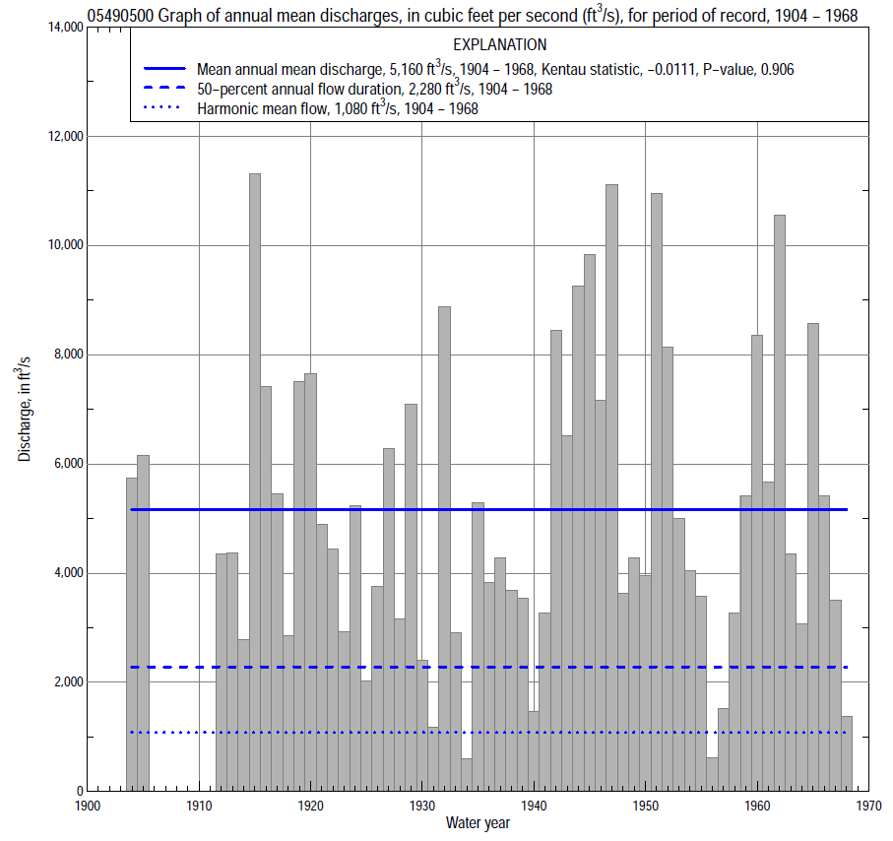

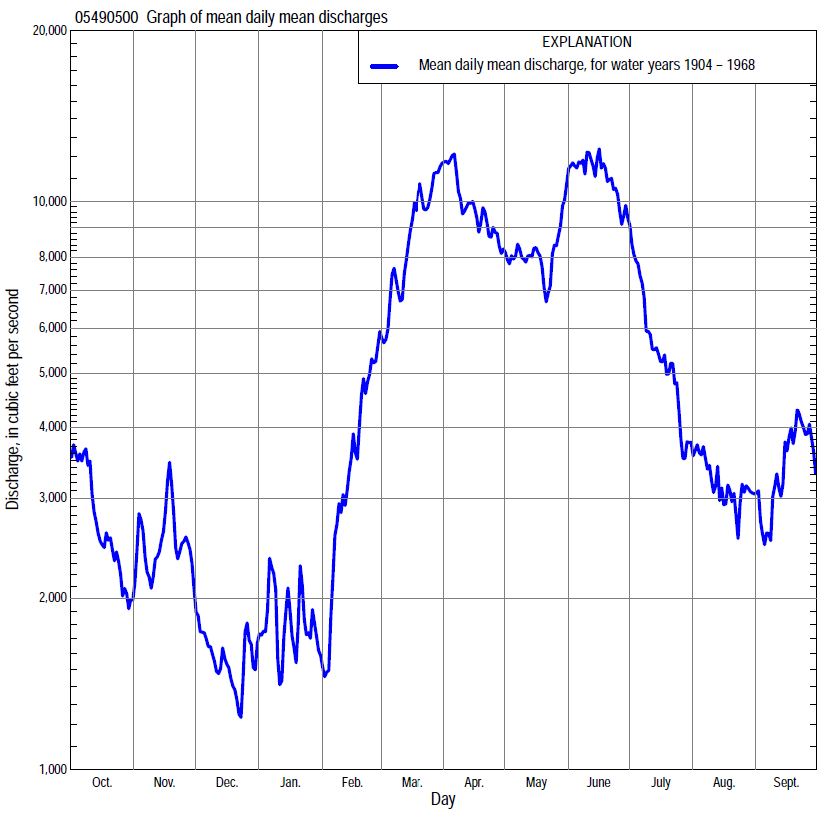

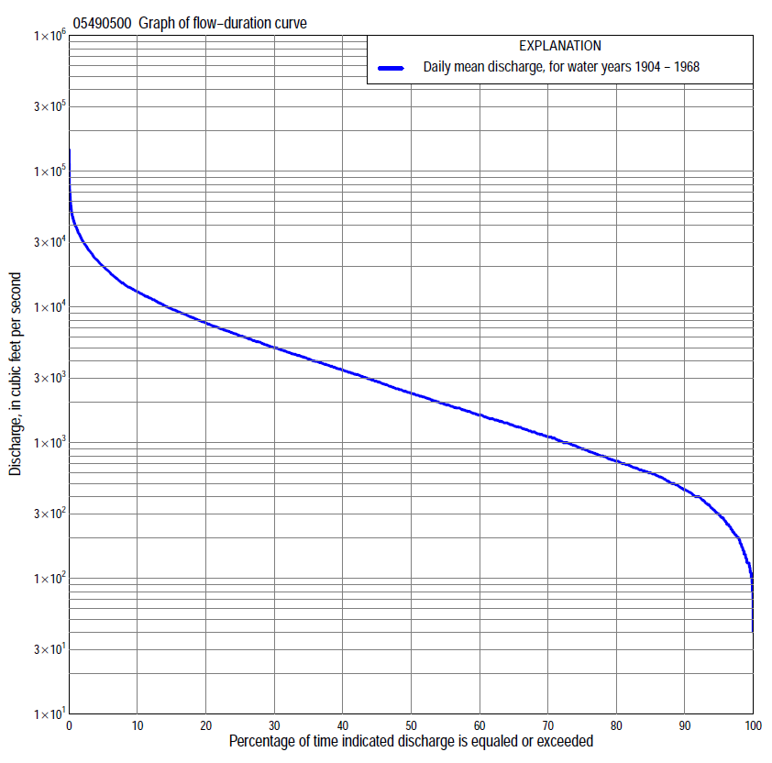

Statistics Based on the Pre-regulated Streamflow Period of Record

05490500 Monthly and annual flow durations, based on 1904–05, 1912–68 pre-regulated period of record (59 years)
Percentage of days discharge equaled or exceeded |  |  |  |  | Discharge (cubic feet per second) |  |  |  |  |  |  |  |  | Annual flow durations
 | Oct | Nov | Dec | Jan | Feb | Mar | Apr | May | June | July | Aug | Sept | Annual | Kentau statistic | P-value
99 | 171 | 180 | 110 | 100 | 110 | 400 | 570 | 444 | 448 | 314 | 160 | 179 | 140 | -0.136 | 0.131
98 | 213 | 211 | 130 | 110 | 130 | 434 | 835 | 514 | 690 | 387 | 212 | 220 | 190 | -0.124 | 0.166
95 | 299 | 282 | 175 | 130 | 230 | 533 | 1,130 | 692 | 1,040 | 605 | 300 | 308 | 297 | -0.095 | 0.289
90 | 390 | 382 | 250 | 200 | 350 | 798 | 1,610 | 1,160 | 1,520 | 920 | 588 | 442 | 450 | -0.081 | 0.370
85 | 460 | 468 | 300 | 250 | 410 | 1,430 | 2,040 | 1,730 | 1,920 | 1,250 | 730 | 570 | 597 | -0.081 | 0.367
80 | 538 | 550 | 390 | 320 | 540 | 1,880 | 2,530 | 2,280 | 2,460 | 1,430 | 835 | 655 | 730 | -0.086 | 0.336
75 | 597 | 610 | 480 | 400 | 630 | 2,390 | 3,200 | 2,680 | 3,120 | 1,640 | 960 | 734 | 900 | -0.093 | 0.301
70 | 690 | 685 | 550 | 500 | 784 | 2,940 | 3,730 | 3,250 | 3,750 | 1,910 | 1,080 | 825 | 1,100 | -0.077 | 0.392
65 | 792 | 786 | 610 | 640 | 1,000 | 3,490 | 4,320 | 3,900 | 4,280 | 2,270 | 1,220 | 930 | 1,320 | -0.075 | 0.403
60 | 922 | 960 | 700 | 720 | 1,150 | 4,000 | 4,980 | 4,490 | 4,760 | 2,540 | 1,370 | 1,070 | 1,600 | -0.078 | 0.384
55 | 1,080 | 1,140 | 800 | 800 | 1,400 | 4,740 | 5,540 | 5,040 | 5,520 | 2,900 | 1,520 | 1,200 | 1,900 | -0.057 | 0.530
50 | 1,260 | 1,300 | 930 | 900 | 1,600 | 5,540 | 6,330 | 5,660 | 6,230 | 3,350 | 1,670 | 1,410 | 2,290 | -0.036 | 0.695
45 | 1,490 | 1,490 | 1,060 | 1,000 | 2,090 | 6,420 | 7,200 | 6,370 | 7,190 | 3,780 | 1,870 | 1,640 | 2,790 | -0.036 | 0.695
40 | 1,750 | 1,800 | 1,200 | 1,100 | 2,460 | 7,450 | 8,030 | 7,130 | 8,230 | 4,380 | 2,110 | 1,940 | 3,380 | -0.020 | 0.824
35 | 2,180 | 2,060 | 1,400 | 1,260 | 3,020 | 8,600 | 9,160 | 7,950 | 9,480 | 4,880 | 2,440 | 2,340 | 4,080 | -0.039 | 0.666
30 | 2,800 | 2,360 | 1,600 | 1,500 | 3,850 | 10,400 | 10,700 | 8,940 | 11,100 | 5,660 | 2,880 | 2,830 | 4,960 | -0.044 | 0.628
25 | 3,460 | 2,810 | 1,900 | 1,800 | 4,610 | 12,200 | 12,500 | 10,000 | 12,900 | 6,780 | 3,420 | 3,430 | 6,070 | -0.049 | 0.592
20 | 4,260 | 3,460 | 2,200 | 2,100 | 5,800 | 14,000 | 14,500 | 11,600 | 15,600 | 8,080 | 4,400 | 4,280 | 7,480 | -0.022 | 0.809
15 | 5,520 | 4,120 | 2,850 | 2,500 | 6,900 | 16,900 | 17,900 | 13,800 | 19,500 | 9,720 | 5,580 | 5,660 | 9,520 | -0.005 | 0.963
10 | 7,200 | 5,140 | 3,420 | 3,280 | 8,600 | 22,300 | 21,800 | 17,500 | 26,200 | 12,000 | 7,200 | 7,650 | 12,700 | -0.013 | 0.886
5 | 9,930 | 8,580 | 5,100 | 5,940 | 12,200 | 27,400 | 31,300 | 25,500 | 37,000 | 17,200 | 10,700 | 12,000 | 19,700 | 0.026 | 0.774
2 | 13,700 | 14,100 | 7,880 | 12,500 | 18,000 | 37,800 | 44,400 | 34,800 | 48,900 | 29,200 | 14,400 | 22,100 | 30,200 | 0.025 | 0.789
1 | 19,100 | 22,800 | 11,300 | 20,000 | 23,900 | 39,400 | 52,200 | 42,400 | 57,600 | 33,800 | 18,200 | 27,200 | 38,800 | 0.012 | 0.901

05490500 Annual exceedance probability of instantaneous peak discharges, in cubic feet per second (ft³/s), for the pre-regulated period of record based on the expected moments algorithm/multiple Grubbs-Beck analysis computed using a historical period length of 117 years (1852–1968)ª
Annual exceed-ance probability | Recur-rence interval (years) | Discharge (ft³/s) | 95-percent lower confi-dence interval (ft³/s) | 95-percent upper confi-dence interval (ft³/s)
0.500 | 2 | 38,200 | 33,200 | 43,700
0.200 | 5 | 58,100 | 50,700 | 67,000
0.100 | 10 | 71,800 | 62,000 | 84,100
0.040 | 25 | 89,400 | 75,700 | 109,000
0.020 | 50 | 103,000 | 85,200 | 130,000
0.010 | 100 | 116,000 | 94,100 | 153,000
0.005 | 200 | 130,000 | 103,000 | 179,000
0.002 | 500 | 148,000 | 113,000 | 218,000
Kentau statistic |  | -0.074
P-value |  | 0.401
Begin year |  | 1903
End year |  | 1968
Number of peaks |  | 61
ªWeighted Independent Estimates were not computed because regional regression equations are not applicable due to size of drainage area.
Note: The above discharges are for the pre-regulated period of record and they are not applicable for flood-plain management regulation or for design purposes.

05490500 Annual exceedance probability of high discharges, based on 1904-05, 1912-68 pre-regulated period of record (59 years)
Annual exceed-ance probability | Recur-rence interval (years) | Maximum average discharge (cubic feet per second) for indicated number of consecutive days
 |  | 1 | 3 | 7 | 15 | 30
0.990 | 1.01 | 9,020 | 6,010 | 4,080 | 3,080 | 2,130
0.950 | 1.05 | 14,300 | 11,300 | 8,450 | 6,190 | 4,430
0.900 | 1.11 | 18,000 | 15,200 | 11,800 | 8,630 | 6,260
0.800 | 1.25 | 23,400 | 21,000 | 17,000 | 12,400 | 9,150
0.500 | 2 | 36,700 | 35,000 | 29,800 | 22,300 | 16,800
0.200 | 5 | 54,500 | 51,400 | 44,500 | 35,000 | 26,800
0.100 | 10 | 65,500 | 60,000 | 52,000 | 42,300 | 32,500
0.040 | 25 | 78,400 | 68,700 | 59,100 | 50,000 | 38,500
0.020 | 50 | 87,300 | 73,800 | 63,100 | 54,800 | 42,200
0.010 | 100 | 95,600 | 78,000 | 66,200 | 58,900 | 45,300
0.005 | 200 | 103,000 | 81,500 | 68,700 | 62,400 | 48,000
0.002 | 500 | 113,000 | 85,200 | 71,200 | 66,300 | 51,000
Kentau statistic |  | -0.033 | -0.022 | -0.001 | 0.022 | 0.011
P-value |  | 0.714 | 0.809 | 1.000 | 0.814 | 0.906
Note: The above discharges are for the pre-regulated period of record and they are not applicable for flood-plain management regulation or for design purposes.

 | 05490500 Annual nonexceedance probability of low discharges, based on April 1904 to March 1906, April 1912 to March 1969 pre-regulated period of record (59 years)
Annual nonexceed-ance probability | Recur-rence interval (years) | Minimum average discharge (cubic feet per second) for indicated number of consecutive days
 |  | 1 | 3 | 7 | 14 | 30 | 60 | 90 | 120 | 183
0.01 | 100 | 34 | 43 | 57 | 63 | 77 | 94 | 118 | 131 | 167
0.02 | 50 | 46 | 57 | 73 | 82 | 98 | 121 | 152 | 171 | 222
0.05 | 20 | 70 | 85 | 106 | 118 | 142 | 175 | 221 | 254 | 336
0.10 | 10 | 100 | 120 | 145 | 163 | 194 | 242 | 306 | 358 | 480
0.20 | 5 | 152 | 179 | 210 | 237 | 282 | 354 | 450 | 535 | 728
0.50 | 2 | 320 | 362 | 408 | 465 | 556 | 716 | 924 | 1,120 | 1,540
0.80 | 1.25 | 629 | 686 | 754 | 862 | 1,050 | 1,400 | 1,840 | 2,240 | 3,070
0.90 | 1.11 | 872 | 932 | 1,020 | 1,170 | 1,450 | 1,950 | 2,610 | 3,160 | 4,290
0.96 | 1.04 | 1,210 | 1,270 | 1,380 | 1,580 | 2,010 | 2,760 | 3,750 | 4,510 | 6,040
0.98 | 1.02 | 1,480 | 1,530 | 1,670 | 1,910 | 2,470 | 3,430 | 4,720 | 5,630 | 7,470
0.99 | 1.01 | 1,760 | 1,800 | 1,970 | 2,260 | 2,960 | 4,160 | 5,780 | 6,850 | 8,990
Kentau statistic |  | -0.148 | -0.096 | -0.066 | -0.074 | -0.066 | -0.061 | -0.065 | -0.100 | -0.061
P-value |  | 0.099 | 0.283 | 0.464 | 0.410 | 0.464 | 0.496 | 0.472 | 0.266 | 0.496

05490500 Annual nonexceedance probability of seasonal low discharges, based on July 1903 to June 1906, April 1910 to December 1910, October 1911 to March 1969 pre-regulated period of record (61–62 years)
Annual nonexceed-ance probability | Recur-rence interval (years) | Minimum average discharge (cubic feet per second) for indicated number of consecutive days
 |  | 1 | 7 | 14 | 30 |  | 1 | 7 | 14 | 30
 |  | January-February-March |  |  |  |  | April-May-June
0.01 | 100 | 37 | 56 | 64 | 80 |  | 134 | 242 | 283 | 343
0.02 | 50 | 52 | 76 | 86 | 106 |  | 199 | 328 | 384 | 469
0.05 | 20 | 86 | 117 | 131 | 163 |  | 348 | 509 | 595 | 739
0.10 | 10 | 132 | 170 | 189 | 237 |  | 550 | 737 | 863 | 1,090
0.20 | 5 | 214 | 263 | 292 | 372 |  | 910 | 1,130 | 1,320 | 1,710
0.50 | 2 | 502 | 578 | 644 | 865 |  | 2,070 | 2,360 | 2,790 | 3,800
0.80 | 1.25 | 1,060 | 1,190 | 1,350 | 1,970 |  | 3,950 | 4,530 | 5,400 | 7,840
0.90 | 1.11 | 1,510 | 1,700 | 1,960 | 3,010 |  | 5,210 | 6,160 | 7,370 | 11,100
0.96 | 1.04 | 2,140 | 2,440 | 2,860 | 4,700 |  | 6,680 | 8,320 | 10,000 | 15,800
0.98 | 1.02 | 2,640 | 3,050 | 3,630 | 6,250 |  | 7,670 | 9,980 | 12,100 | 19,500
0.99 | 1.01 | 3,160 | 3,710 | 4,470 | 8,060 |  | 8,570 | 11,600 | 14,200 | 23,500
Kentau statistic |  | -0.145 | -0.077 | -0.079 | -0.086 |  | 0.001 | 0.028 | 0.013 | 0.023
P-value |  | 0.100 | 0.387 | 0.374 | 0.329 |  | 0.995 | 0.751 | 0.886 | 0.799
 |  | July-August-September |  |  |  |  | October-November-December
0.01 | 100 | 72 | 139 | 158 | 196 |  | 50 | 77 | 95 | 120
0.02 | 50 | 95 | 168 | 192 | 239 |  | 65 | 97 | 117 | 149
0.05 | 20 | 144 | 225 | 257 | 323 |  | 97 | 138 | 163 | 205
0.10 | 10 | 207 | 293 | 337 | 427 |  | 137 | 188 | 219 | 275
0.20 | 5 | 315 | 410 | 472 | 604 |  | 207 | 272 | 314 | 394
0.50 | 2 | 683 | 800 | 925 | 1,210 |  | 442 | 552 | 633 | 800
0.80 | 1.25 | 1,410 | 1,630 | 1,890 | 2,530 |  | 907 | 1,110 | 1,290 | 1,670
0.90 | 1.11 | 2,030 | 2,400 | 2,800 | 3,790 |  | 1,300 | 1,600 | 1,890 | 2,470
0.96 | 1.04 | 2,950 | 3,680 | 4,300 | 5,890 |  | 1,890 | 2,350 | 2,840 | 3,790
0.98 | 1.02 | 3,730 | 4,880 | 5,720 | 7,890 |  | 2,390 | 3,010 | 3,710 | 5,020
0.99 | 1.01 | 4,570 | 6,320 | 7,420 | 10,300 |  | 2,940 | 3,760 | 4,720 | 6,480
Kentau statistic |  | -0.054 | -0.050 | -0.061 | -0.069 |  | -0.138 | -0.068 | -0.052 | -0.063
P-value |  | 0.546 | 0.571 | 0.490 | 0.437 |  | 0.114 | 0.440 | 0.556 | 0.474

Statistics Based on the Regulated Streamflow Period of Record

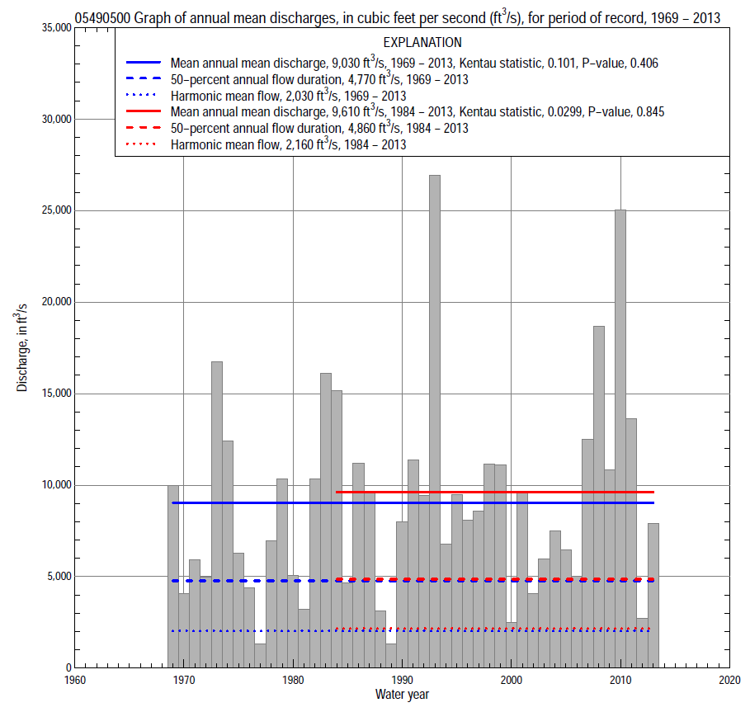

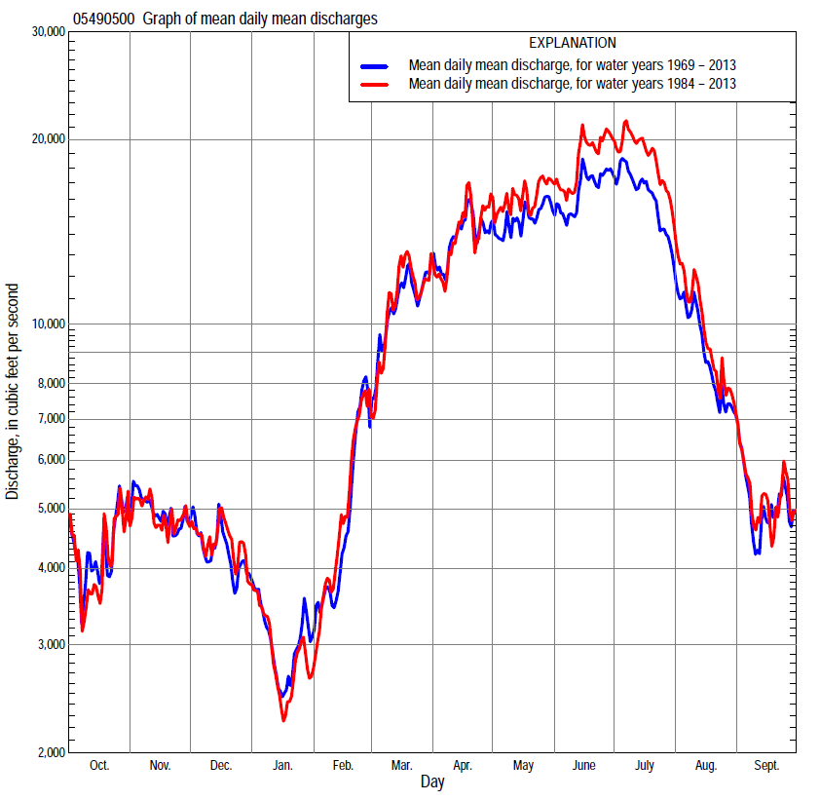

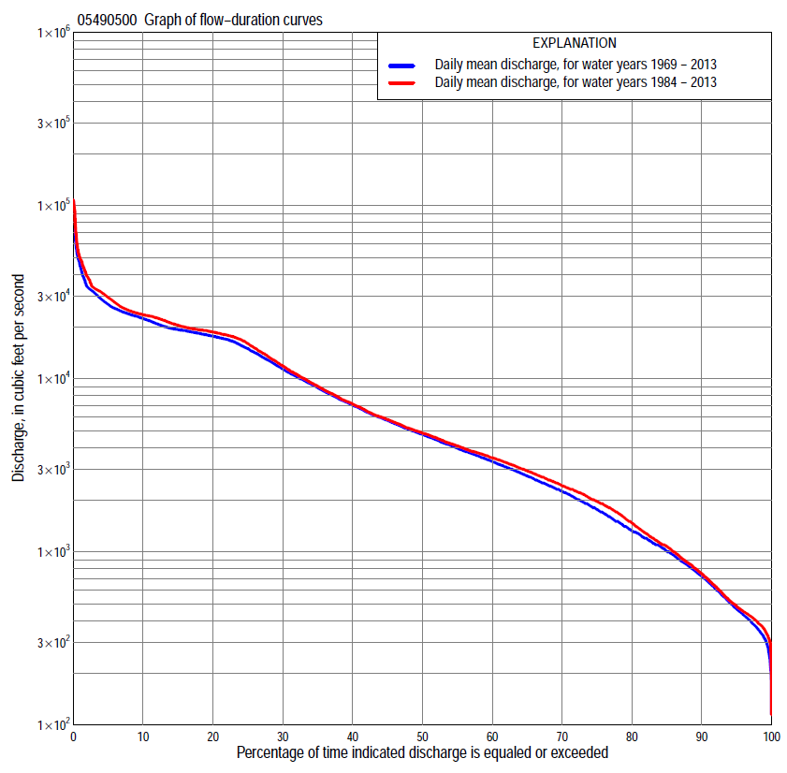

Statistics Based on the Regulated Streamflow Period of Record
05490500 Monthly and annual flow durations, based on 1969–2013 regulated period of record (45 years)
Percentage of days discharge equaled or exceeded |  |  |  |  | Discharge (cubic feet per second) |  |  |  |  |  |  |  |  | Annual flow durations
 | Oct | Nov | Dec | Jan | Feb | Mar | Apr | May | June | July | Aug | Sept | Annual | Kentau statistic | P-value
99 | 312 | 318 | 327 | 280 | 300 | 491 | 633 | 461 | 285 | 207 | 361 | 309 | 315 | 0.023 | 0.830
98 | 333 | 342 | 371 | 318 | 400 | 600 | 748 | 591 | 339 | 316 | 380 | 329 | 360 | 0.009 | 0.938
95 | 368 | 407 | 439 | 475 | 550 | 936 | 1,170 | 1,390 | 2,310 | 807 | 467 | 368 | 468 | 0.065 | 0.538
90 | 422 | 520 | 692 | 630 | 730 | 1,700 | 2,450 | 3,200 | 3,650 | 1,370 | 765 | 447 | 722 | 0.042 | 0.688
85 | 479 | 740 | 1,000 | 740 | 860 | 2,500 | 3,700 | 4,870 | 4,450 | 2,140 | 976 | 548 | 1,010 | 0.040 | 0.703
80 | 564 | 920 | 1,230 | 860 | 1,010 | 3,210 | 4,450 | 5,850 | 5,290 | 2,960 | 1,290 | 674 | 1,320 | 0.026 | 0.807
75 | 684 | 1,160 | 1,550 | 1,000 | 1,210 | 3,810 | 5,300 | 7,270 | 6,130 | 3,770 | 1,640 | 900 | 1,750 | 0.031 | 0.769
70 | 894 | 1,520 | 1,850 | 1,100 | 1,400 | 4,400 | 6,210 | 8,480 | 8,220 | 5,510 | 2,010 | 1,090 | 2,240 | 0.033 | 0.754
65 | 1,180 | 1,870 | 2,100 | 1,250 | 1,750 | 5,000 | 7,120 | 10,100 | 10,600 | 7,490 | 2,550 | 1,280 | 2,740 | 0.036 | 0.732
60 | 1,570 | 2,150 | 2,350 | 1,410 | 2,110 | 5,780 | 8,420 | 12,300 | 13,500 | 10,300 | 3,090 | 1,470 | 3,320 | 0.032 | 0.762
55 | 1,940 | 2,440 | 2,660 | 1,600 | 2,500 | 6,600 | 9,890 | 14,800 | 16,300 | 12,900 | 3,610 | 1,730 | 3,970 | 0.025 | 0.814
50 | 2,370 | 2,820 | 3,100 | 1,860 | 2,830 | 7,700 | 11,500 | 16,700 | 17,300 | 15,500 | 4,400 | 2,020 | 4,770 | 0.016 | 0.883
45 | 2,740 | 3,200 | 3,500 | 2,200 | 3,160 | 8,800 | 13,100 | 17,600 | 18,000 | 17,300 | 5,160 | 2,420 | 5,740 | 0.020 | 0.853
40 | 3,130 | 3,810 | 3,820 | 2,500 | 3,690 | 10,100 | 15,100 | 18,300 | 19,000 | 18,200 | 6,350 | 2,830 | 7,020 | 0.045 | 0.667
35 | 3,600 | 4,590 | 4,300 | 2,900 | 4,300 | 11,800 | 17,100 | 18,900 | 19,500 | 18,900 | 8,210 | 3,380 | 8,870 | 0.041 | 0.696
30 | 4,120 | 5,450 | 4,880 | 3,300 | 5,000 | 13,600 | 18,600 | 19,500 | 21,300 | 19,400 | 11,300 | 4,120 | 11,400 | 0.094 | 0.368
25 | 5,130 | 6,690 | 5,500 | 3,750 | 5,800 | 16,400 | 21,400 | 20,200 | 22,600 | 21,200 | 15,200 | 5,450 | 14,900 | 0.134 | 0.196
20 | 6,570 | 8,020 | 6,300 | 4,370 | 6,890 | 19,100 | 24,200 | 21,100 | 23,400 | 22,700 | 17,400 | 7,320 | 17,600 | 0.192 | 0.064
15 | 8,240 | 10,100 | 7,540 | 5,000 | 9,570 | 22,000 | 25,900 | 22,700 | 24,300 | 24,300 | 18,100 | 10,600 | 19,200 | 0.217 | 0.036
10 | 11,800 | 14,000 | 9,460 | 6,480 | 12,500 | 25,100 | 28,100 | 25,000 | 27,500 | 31,300 | 19,500 | 15,300 | 22,300 | 0.212 | 0.041
5 | 18,100 | 17,700 | 13,900 | 10,000 | 20,100 | 28,100 | 32,000 | 29,400 | 33,600 | 44,300 | 28,400 | 21,000 | 26,900 | 0.144 | 0.165
2 | 20,000 | 19,500 | 16,600 | 15,300 | 25,000 | 32,400 | 35,600 | 33,800 | 48,300 | 68,600 | 48,200 | 30,800 | 34,000 | 0.114 | 0.273
1 | 23,900 | 20,500 | 20,000 | 19,000 | 26,200 | 34,000 | 40,300 | 37,700 | 61,300 | 95,000 | 53,300 | 35,900 | 44,600 | 0.164 | 0.115

05490500 Annual exceedance probability of instantaneous peak discharges, in cubic feet per second (ft³/s), based on U.S. Army Corps of Engineers regulated flow frequency studyª, analysis computed using a record length of 92 years (1917–2008)
USACE Regulated Flow Frequency Analysis
[ND, not determined]
Annual exceedance probability | Recurrence interval (years) | Discharge (ft³/s) | 95-percent lower confidence interval (ft³/s) | 95-percent upper confidence interval (ft³/s)
0.500 | 2 | 31,900 | ND | ND
0.200 | 5 | ND | ND | ND
0.100 | 10 | 42,800 | ND | ND
0.040 | 25 | ND | ND | ND
0.020 | 50 | 86,000 | ND | ND
0.010 | 100 | 113,000 | ND | ND
0.005 | 200 | 159,000 | ND | ND
0.002 | 500 | 162,000 | ND | ND
ªU.S. Army Corps of Engineers, 2010, Des Moines River regulated flow frequency study: Rock Island District, 82 p., accessed September 9, 2014, at http://www.mvr.usace.army.mil/Portals/48/docs/FRM/DMRRFFS/DMRRFFS-FinalReport.pdf.
USGS Kendall's Tau Trend Analysis
Kentau statistic |  | 0.160
P-value |  | 0.125
Begin year |  | 1969^{b}
End year |  | 2013^{b}
Number of peaks |  | 45
^{b}Kendall's tau trend analysis computed using the regulated period of record which is not the same period of record used for the above regulated flow frequency analysis.

05490500 Annual exceedance probability of high discharges, based on 1969–2013 regulated period of record (45 years)
[ND, not determined]
Annual exceedance probability | Recur-rence interval (years) | Maximum average discharge (cubic feet per second) for indicated number of consecutive days
 |  | 1 | 3 | 7 | 15 | 30
0.990 | 1.01 | ND | ND | ND | ND | ND
0.950 | 1.05 | ND | ND | ND | ND | ND
0.900 | 1.11 | ND | ND | ND | ND | ND
0.800 | 1.25 | ND | ND | ND | ND | ND
0.500 | 2 | ND | ND | ND | ND | ND
0.200 | 5 | ND | ND | ND | ND | ND
0.100 | 10 | ND | ND | ND | ND | ND
0.040 | 25 | ND | ND | ND | ND | ND
0.020 | 50 | ND | ND | ND | ND | ND
0.010 | 100 | ND | ND | ND | ND | ND
0.005 | 200 | ND | ND | ND | ND | ND
0.002 | 500 | ND | ND | ND | ND | ND
Kentau statistic |  | 0.139 | 0.126 | 0.121 | 0.137 | 0.170
P-value |  | 0.180 | 0.225 | 0.244 | 0.187 | 0.102
ªContact the U.S. Army Corps of Engineers, Rock Island District, for the annual exceedance probability of high discharges.

 | 05490500 Annual nonexceedance probability of low discharges, based on April 1969 to March 2013 regulated period of record (44 years)
Annual nonexceed-ance probability | Recur-rence interval (years) | Minimum average discharge (cubic feet per second) for indicated number of consecutive days
 |  | 1 | 3 | 7 | 14 | 30 | 60 | 90 | 120 | 183
0.01 | 100 | 112 | 141 | 161 | 162 | 163 | 174 | 194 | 222 | 283
0.02 | 50 | 133 | 164 | 200 | 201 | 203 | 224 | 260 | 300 | 384
0.05 | 20 | 173 | 210 | 256 | 266 | 284 | 327 | 399 | 466 | 595
0.10 | 10 | 221 | 263 | 319 | 343 | 384 | 458 | 578 | 680 | 867
0.20 | 5 | 300 | 352 | 422 | 472 | 557 | 689 | 895 | 1,060 | 1,340
0.50 | 2 | 559 | 644 | 761 | 899 | 1,150 | 1,500 | 1,980 | 2,350 | 2,940
0.80 | 1.25 | 1,090 | 1,250 | 1,470 | 1,790 | 2,440 | 3,270 | 4,190 | 4,910 | 6,000
0.90 | 1.11 | 1,580 | 1,820 | 2,140 | 2,620 | 3,650 | 4,910 | 6,070 | 7,040 | 8,500
0.96 | 1.04 | 2,380 | 2,770 | 3,270 | 3,990 | 5,640 | 7,570 | 8,880 | 10,200 | 12,100
0.98 | 1.02 | 3,120 | 3,670 | 4,350 | 5,270 | 7,500 | 10,000 | 11,300 | 12,700 | 15,000
0.99 | 1.01 | 4,010 | 4,770 | 5,660 | 6,800 | 9,700 | 12,900 | 13,900 | 15,500 | 18,100
Kentau statistic |  | 0.042 | 0.042 | 0.032 | 0.055 | 0.070 | 0.044 | 0.038 | 0.025 | -0.004
P-value |  | 0.693 | 0.693 | 0.769 | 0.606 | 0.511 | 0.678 | 0.723 | 0.816 | 0.976

05490500 Annual nonexceedance probability of seasonal low discharges, based on April 1969 to September 2013 regulated period of record (44–45 years)
Annual nonexceed-ance probability | Recur-rence interval (years) | Minimum average discharge (cubic feet per second) for indicated number of consecutive days
 |  | 1 | 7 | 14 | 30 |  | 1 | 7 | 14 | 30
 |  | January-February-March |  |  |  |  | April-May-June
0.01 | 100 | 192 | 229 | 236 | 255 |  | 189 | 238 | 305 | 378
0.02 | 50 | 231 | 278 | 290 | 316 |  | 302 | 375 | 483 | 622
0.05 | 20 | 308 | 373 | 397 | 438 |  | 581 | 707 | 916 | 1,230
0.10 | 10 | 401 | 488 | 526 | 588 |  | 987 | 1,190 | 1,540 | 2,110
0.20 | 5 | 554 | 680 | 745 | 846 |  | 1,760 | 2,100 | 2,710 | 3,780
0.50 | 2 | 1,050 | 1,310 | 1,470 | 1,730 |  | 4,420 | 5,280 | 6,720 | 9,200
0.80 | 1.25 | 2,050 | 2,610 | 2,980 | 3,620 |  | 8,910 | 10,900 | 13,400 | 17,300
0.90 | 1.11 | 2,950 | 3,780 | 4,350 | 5,390 |  | 11,900 | 14,700 | 17,800 | 21,900
0.96 | 1.04 | 4,380 | 5,670 | 6,550 | 8,290 |  | 15,200 | 19,300 | 22,800 | 26,600
0.98 | 1.02 | 5,680 | 7,410 | 8,570 | 11,000 |  | 17,400 | 22,400 | 26,100 | 29,300
0.99 | 1.01 | 7,200 | 9,450 | 10,900 | 14,200 |  | 19,300 | 25,200 | 29,000 | 31,400
Kentau statistic |  | 0.104 | 0.104 | 0.106 | 0.085 |  | 0.032 | 0.053 | 0.075 | 0.133
P-value |  | 0.327 | 0.327 | 0.317 | 0.424 |  | 0.762 | 0.618 | 0.475 | 0.200
 |  | July-August-September |  |  |  |  | October-November-December
0.01 | 100 | 177 | 218 | 219 | 220 |  | 106 | 161 | 163 | 164
0.02 | 50 | 192 | 247 | 248 | 255 |  | 131 | 199 | 209 | 214
0.05 | 20 | 223 | 303 | 309 | 359 |  | 181 | 275 | 304 | 336
0.10 | 10 | 265 | 357 | 388 | 495 |  | 243 | 368 | 424 | 497
0.20 | 5 | 343 | 460 | 532 | 747 |  | 350 | 528 | 634 | 791
0.50 | 2 | 675 | 896 | 1,120 | 1,770 |  | 728 | 1,080 | 1,370 | 1,870
0.80 | 1.25 | 1,740 | 2,300 | 2,880 | 4,650 |  | 1,580 | 2,250 | 2,970 | 4,250
0.90 | 1.11 | 3,210 | 4,230 | 5,130 | 8,020 |  | 2,410 | 3,360 | 4,450 | 6,420
0.96 | 1.04 | 6,780 | 8,950 | 10,100 | 14,800 |  | 3,820 | 5,180 | 6,860 | 9,870
0.98 | 1.02 | 11,600 | 15,300 | 16,400 | 22,400 |  | 5,200 | 6,890 | 9,070 | 13,000
0.99 | 1.01 | 19,500 | 25,900 | 25,900 | 32,900 |  | 6,880 | 8,920 | 11,700 | 16,500
Kentau statistic |  | -0.008 | -0.030 | -0.004 | -0.030 |  | -0.039 | -0.029 | -0.044 | -0.021
P-value |  | 0.945 | 0.777 | 0.977 | 0.777 |  | 0.716 | 0.793 | 0.678 | 0.848

Statistics Based on the 1984–2013 Regulated Streamflow Period of Record
05490500 Monthly and annual flow durations, based on 1984–2013 regulated period of record (30 years)
Percentage of days discharge equaled or exceeded |  |  |  |  | Discharge (cubic feet per second) |  |  |  |  |  |  |  |  | Annual flow durations
 | Oct | Nov | Dec | Jan | Feb | Mar | Apr | May | June | July | Aug | Sept | Annual | Kentau statistic | P-value
99 | 310 | 331 | 340 | 393 | 439 | 612 | 640 | 666 | 1,030 | 380 | 361 | 311 | 355 | 0.000 | 1.000
98 | 333 | 360 | 391 | 439 | 480 | 697 | 867 | 937 | 1,170 | 432 | 376 | 326 | 392 | -0.041 | 0.762
95 | 379 | 421 | 442 | 510 | 620 | 1,180 | 1,330 | 1,940 | 2,900 | 1,040 | 443 | 377 | 486 | -0.021 | 0.887
90 | 432 | 494 | 650 | 672 | 859 | 2,070 | 2,770 | 4,800 | 3,880 | 1,590 | 762 | 447 | 750 | -0.039 | 0.775
85 | 470 | 590 | 880 | 800 | 1,090 | 2,860 | 3,750 | 5,870 | 4,770 | 2,580 | 997 | 535 | 1,080 | -0.032 | 0.817
80 | 535 | 808 | 1,180 | 962 | 1,330 | 3,620 | 4,250 | 7,250 | 5,590 | 3,450 | 1,450 | 652 | 1,470 | -0.051 | 0.708
75 | 680 | 1,020 | 1,620 | 1,100 | 1,630 | 4,000 | 5,170 | 8,300 | 7,280 | 4,860 | 1,840 | 812 | 1,950 | -0.041 | 0.762
70 | 886 | 1,390 | 2,000 | 1,300 | 2,060 | 4,470 | 6,110 | 9,700 | 9,430 | 7,020 | 2,260 | 976 | 2,410 | -0.032 | 0.817
65 | 1,170 | 1,770 | 2,310 | 1,530 | 2,300 | 5,100 | 7,080 | 11,700 | 13,300 | 10,300 | 2,740 | 1,150 | 2,930 | -0.030 | 0.830
60 | 1,450 | 2,070 | 2,590 | 1,820 | 2,760 | 6,000 | 8,260 | 14,700 | 16,600 | 13,900 | 3,210 | 1,350 | 3,500 | -0.016 | 0.915
55 | 1,930 | 2,370 | 3,000 | 2,020 | 3,000 | 6,860 | 9,930 | 17,000 | 18,300 | 17,000 | 3,620 | 1,560 | 4,100 | -0.030 | 0.830
50 | 2,340 | 2,580 | 3,450 | 2,300 | 3,350 | 7,930 | 11,500 | 18,200 | 19,100 | 17,800 | 4,260 | 1,780 | 4,860 | -0.048 | 0.721
45 | 2,700 | 3,000 | 3,750 | 2,570 | 3,720 | 8,890 | 13,000 | 18,800 | 19,700 | 18,700 | 4,810 | 1,990 | 5,810 | -0.041 | 0.762
40 | 3,050 | 3,510 | 4,120 | 2,860 | 4,200 | 10,100 | 14,800 | 19,400 | 21,600 | 19,100 | 5,780 | 2,310 | 7,140 | -0.025 | 0.858
35 | 3,520 | 4,220 | 4,650 | 3,190 | 4,780 | 11,500 | 17,500 | 19,900 | 22,800 | 19,500 | 7,430 | 2,720 | 9,060 | -0.016 | 0.915
30 | 4,010 | 5,110 | 5,190 | 3,510 | 5,410 | 13,300 | 19,800 | 20,500 | 23,300 | 22,000 | 10,700 | 3,340 | 11,900 | 0.032 | 0.817
25 | 5,050 | 6,090 | 5,760 | 3,820 | 6,000 | 15,900 | 22,300 | 21,200 | 23,800 | 23,100 | 14,500 | 4,120 | 16,000 | 0.060 | 0.656
20 | 6,180 | 7,780 | 6,620 | 4,300 | 6,890 | 18,400 | 24,300 | 22,400 | 24,600 | 24,500 | 18,000 | 5,730 | 18,600 | 0.122 | 0.354
15 | 7,880 | 10,200 | 7,640 | 4,820 | 9,100 | 21,700 | 26,100 | 23,400 | 27,000 | 30,400 | 19,100 | 10,800 | 20,400 | 0.161 | 0.218
10 | 11,500 | 14,500 | 9,120 | 5,710 | 11,700 | 25,000 | 28,300 | 26,300 | 31,800 | 34,300 | 21,200 | 18,300 | 23,400 | 0.138 | 0.292
5 | 17,800 | 18,600 | 12,400 | 7,520 | 17,000 | 28,600 | 32,200 | 30,900 | 39,000 | 52,500 | 43,200 | 26,300 | 29,400 | 0.115 | 0.382
2 | 20,600 | 19,700 | 16,500 | 10,100 | 23,300 | 33,200 | 36,800 | 34,300 | 56,100 | 93,100 | 51,700 | 33,900 | 38,900 | 0.074 | 0.580
1 | 24,700 | 20,700 | 20,300 | 12,100 | 24,200 | 34,500 | 40,300 | 38,400 | 68,200 | 99,100 | 56,800 | 39,200 | 49,500 | 0.131 | 0.318

05490500 Annual exceedance probability of high discharges, based on 1984–2013 regulated period of record (30 years)
[ND, not determined]
Annual exceedance probability | Recur-rence interval (years) | Maximum average discharge (cubic feet per second) for indicated number of consecutive days
 |  | 1 | 3 | 7 | 15 | 30
0.990 | 1.01 | ND | ND | ND | ND | ND
0.950 | 1.05 | ND | ND | ND | ND | ND
0.900 | 1.11 | ND | ND | ND | ND | ND
0.800 | 1.25 | ND | ND | ND | ND | ND
0.500 | 2 | ND | ND | ND | ND | ND
0.200 | 5 | ND | ND | ND | ND | ND
0.100 | 10 | ND | ND | ND | ND | ND
0.040 | 25 | ND | ND | ND | ND | ND
0.020 | 50 | ND | ND | ND | ND | ND
0.010 | 100 | ND | ND | ND | ND | ND
0.005 | 200 | ND | ND | ND | ND | ND
0.002 | 500 | ND | ND | ND | ND | ND
Kentau statistic |  | 0.080 | 0.094 | 0.076 | 0.113 | 0.126
P-value |  | 0.544 | 0.475 | 0.568 | 0.392 | 0.335
ªContact the U.S. Army Corps of Engineers, Rock Island District, for the annual exceedance probability of high discharges.

 | 05490500 Annual nonexceedance probability of low discharges, based on April 1983 to March 2013 regulated period of record (30 years)
Annual nonexceed-ance probability | Recur-rence interval (years) | Minimum average discharge (cubic feet per second) for indicated number of consecutive days
 |  | 1 | 3 | 7 | 14 | 30 | 60 | 90 | 120 | 183
0.01 | 100 | 103 | 147 | 180 | 181 | 182 | 191 | 212 | 229 | 291
0.02 | 50 | 127 | 175 | 230 | 231 | 232 | 254 | 290 | 318 | 397
0.05 | 20 | 175 | 226 | 294 | 305 | 332 | 384 | 453 | 508 | 624
0.10 | 10 | 230 | 286 | 362 | 393 | 453 | 546 | 661 | 752 | 914
0.20 | 5 | 320 | 382 | 472 | 534 | 652 | 819 | 1,020 | 1,180 | 1,420
0.50 | 2 | 588 | 674 | 804 | 968 | 1,280 | 1,680 | 2,150 | 2,550 | 3,080
0.80 | 1.25 | 1,060 | 1,220 | 1,420 | 1,770 | 2,420 | 3,200 | 4,130 | 4,960 | 6,150
0.90 | 1.11 | 1,420 | 1,670 | 1,950 | 2,430 | 3,330 | 4,360 | 5,610 | 6,760 | 8,540
0.96 | 1.04 | 1,940 | 2,360 | 2,750 | 3,420 | 4,630 | 5,940 | 7,560 | 9,140 | 11,800
0.98 | 1.02 | 2,360 | 2,970 | 3,470 | 4,260 | 5,710 | 7,170 | 9,050 | 10,900 | 14,400
0.99 | 1.01 | 2,800 | 3,650 | 4,290 | 5,210 | 6,850 | 8,430 | 10,500 | 12,700 | 17,100
Kentau statistic |  | 0.025 | 0.025 | -0.030 | -0.021 | 0.002 | -0.048 | -0.057 | -0.062 | -0.090
P-value |  | 0.858 | 0.858 | 0.830 | 0.887 | 1.000 | 0.721 | 0.669 | 0.643 | 0.498

05490500 Annual nonexceedance probability of seasonal low discharges, based on October 1983 to September 2013 regulated period of record (30 years)
Annual nonexceed-ance probability | Recur-rence interval (years) | Minimum average discharge (cubic feet per second) for indicated number of consecutive days
 |  | 1 | 7 | 14 | 30 |  | 1 | 7 | 14 | 30
 |  | January-February-March |  |  |  |  | April-May-June
0.01 | 100 | 195 | 244 | 259 | 275 |  | 288 | 371 | 475 | 653
0.02 | 50 | 247 | 310 | 332 | 361 |  | 430 | 539 | 696 | 967
0.05 | 20 | 347 | 440 | 477 | 534 |  | 754 | 915 | 1,190 | 1,680
0.10 | 10 | 465 | 592 | 649 | 742 |  | 1,190 | 1,420 | 1,860 | 2,630
0.20 | 5 | 654 | 834 | 924 | 1,080 |  | 1,970 | 2,310 | 3,060 | 4,310
0.50 | 2 | 1,210 | 1,530 | 1,730 | 2,060 |  | 4,450 | 5,290 | 7,010 | 9,670
0.80 | 1.25 | 2,140 | 2,630 | 3,010 | 3,600 |  | 8,400 | 10,500 | 13,800 | 18,200
0.90 | 1.11 | 2,830 | 3,410 | 3,930 | 4,670 |  | 11,000 | 14,200 | 18,600 | 23,900
0.96 | 1.04 | 3,750 | 4,420 | 5,120 | 6,000 |  | 13,900 | 19,000 | 24,600 | 30,500
0.98 | 1.02 | 4,470 | 5,180 | 6,010 | 6,980 |  | 15,900 | 22,400 | 28,800 | 34,900
0.99 | 1.01 | 5,210 | 5,940 | 6,900 | 7,920 |  | 17,600 | 25,700 | 32,800 | 38,800
Kentau statistic |  | -0.007 | -0.016 | -0.030 | -0.044 |  | 0.030 | 0.071 | 0.076 | 0.108
P-value |  | 0.972 | 0.915 | 0.830 | 0.748 |  | 0.830 | 0.592 | 0.568 | 0.412
 |  | July-August-September |  |  |  |  | October-November-December
0.01 | 100 | 236 | 285 | 286 | 287 |  | 98 | 168 | 169 | 170
0.02 | 50 | 244 | 306 | 307 | 316 |  | 123 | 208 | 217 | 220
0.05 | 20 | 263 | 351 | 354 | 406 |  | 172 | 287 | 315 | 349
0.10 | 10 | 292 | 390 | 418 | 523 |  | 232 | 383 | 438 | 518
0.20 | 5 | 352 | 470 | 539 | 741 |  | 337 | 546 | 649 | 822
0.50 | 2 | 632 | 847 | 1,060 | 1,660 |  | 695 | 1,090 | 1,350 | 1,880
0.80 | 1.25 | 1,650 | 2,230 | 2,820 | 4,490 |  | 1,460 | 2,190 | 2,750 | 4,040
0.90 | 1.11 | 3,220 | 4,380 | 5,350 | 8,220 |  | 2,180 | 3,180 | 3,950 | 5,850
0.96 | 1.04 | 7,560 | 10,400 | 11,700 | 16,700 |  | 3,340 | 4,760 | 5,770 | 8,530
0.98 | 1.02 | 14,200 | 19,600 | 20,700 | 27,400 |  | 4,430 | 6,180 | 7,350 | 10,800
0.99 | 1.01 | 26,500 | 35,500 | 36,000 | 43,800 |  | 5,720 | 7,840 | 9,100 | 13,200
Kentau statistic |  | -0.002 | -0.067 | -0.002 | -0.021 |  | -0.030 | -0.074 | -0.067 | -0.048
P-value |  | 1.000 | 0.617 | 1.000 | 0.887 |  | 0.830 | 0.580 | 0.617 | 0.721

