LOCATION.--Lat 40°26'48", long 91°29'05" referenced to North American Datum of 1927, in NW 1/4 SE 1/4 NW 1/4 sec.07, T.65 N., R.5 W., Lee County, IA, Hydrologic Unit 07100009, on left bank 15 ft downstream from bridge on County Highway W62, 3.0 mi northwest of Keokuk, 3.6 mi downstream from Barlean Creek, and 4.9 mi upstream from mouth.

DRAINAGE AREA.--105 mi².

PERIOD OF RECORD.--Discharge records from March 1922 to September 1931, August 1958 to October 1973. Monthly discharges only for some periods published in WSP 1308.

GAGE.--Water-stage recorder. Datum of gage is 510.20 ft above National Geodetic Vertical Datum of 1929. Prior to June 25, 1923, and November 28, 1928 to September 30, 1931, non-recording gage; June 25, 1923, to November 27, 1928, and August 29, 1958, to September 30, 1967, water-stage recorder; all at site of former bridge on old channel, 0.5 mi downstream at same datum. October 1, 1967, to March 11, 1968, non-recording gage at same site and datum.

A summary of all available data for this streamgage is provided through the USGS National Water Information System web interface (NWISWeb). The following link provides access to current/historical observations, daily data, daily statistics, monthly statistics, annual statistics, peak streamflow, field measurements, field/lab water-quality samples, and the latest water-year summaries. Data can be filtered by parameter and/or dates, and can be output in various tabular and graphical formats.
http://waterdata.usgs.gov/nwis/inventory/?site_no=05491000

The USGS WaterWatch Toolkit is available at:
http://waterwatch.usgs.gov/?id=ww_toolkit
Tools for summarizing streamflow information include the duration hydrograph builder, the cumulative streamflow hydrograph builder, the streamgage statistics retrieval tool, the rating curve builder, the flood tracking chart builder, the National Weather Service Advanced Hydrologic Prediction Service (AHPS) river forecast hydrograph builder, and the raster-hydrograph builder. Entering the above number for this streamgage into these toolkit webpages will provide streamflow information specific to this streamgage.

A description of the statistics presented for this streamgage is available in the main body of the report at:
http://dx.doi.org/10.3133/ofr20151214
A link to other streamgages included in this report, a map showing the location of the streamgages, information on the programs used to compute the statistical analyses, and references are included in the main body of the report.

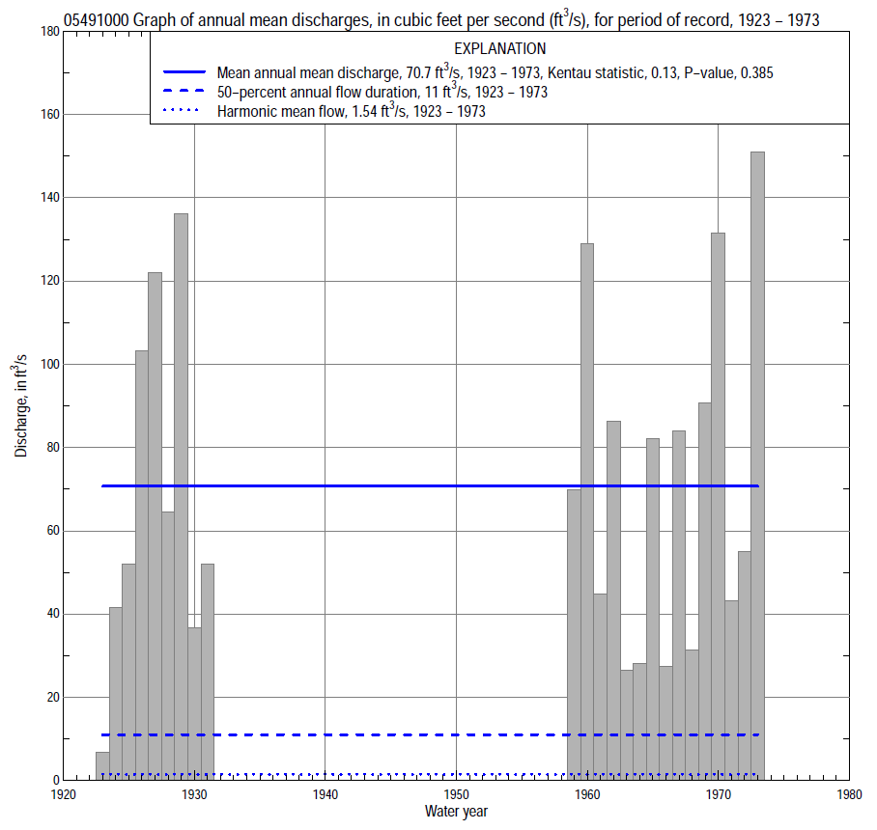

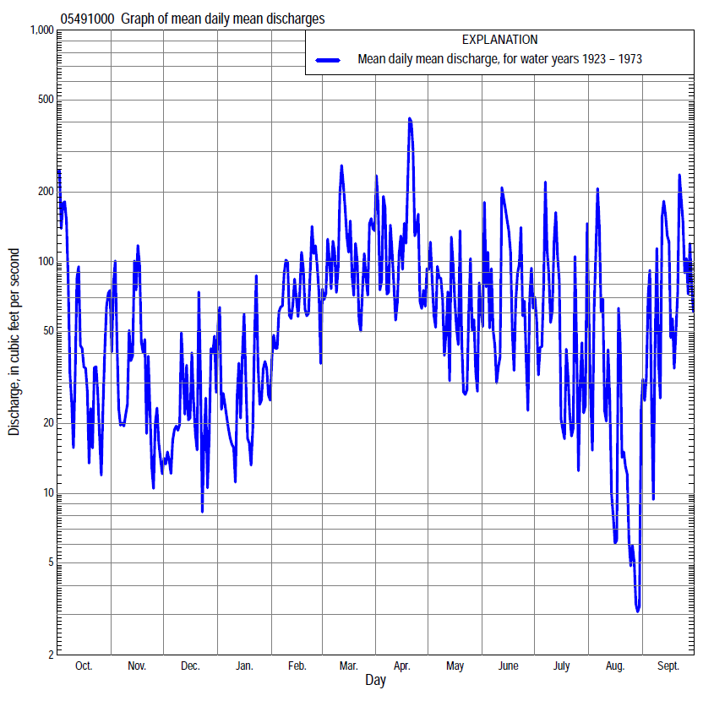

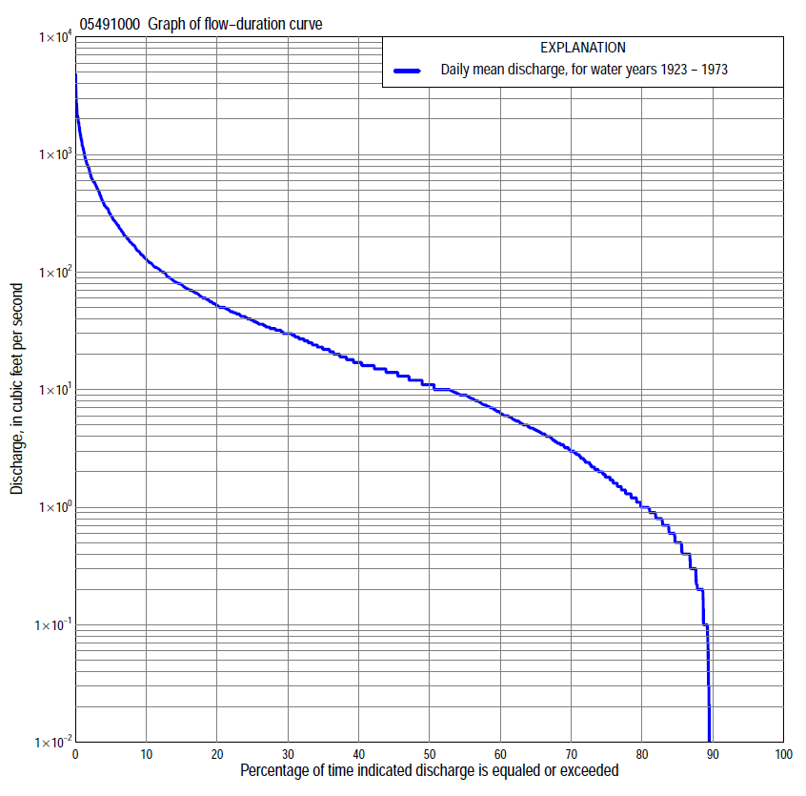

Statistics Based on the Entire Streamflow Period of Record
05491000 Monthly and annual flow durations, based on 1923–31, 1959–73 period of record (24 years)
Percentage of days discharge equaled or exceeded |  |  |  |  | Discharge (cubic feet per second) |  |  |  |  |  |  |  |  | Annual flow durations
 | Oct | Nov | Dec | Jan | Feb | Mar | Apr | May | June | July | Aug | Sept | Annual | Kentau statistic | P-value
99 | 0.00 | 0.00 | 0.00 | 0.00 | 0.00 | 3.5 | 0.90 | 0.60 | 0.00 | 0.00 | 0.00 | 0.00 | 0.00 | -0.163 | 0.090
98 | 0.00 | 0.00 | 0.00 | 0.00 | 0.00 | 4.8 | 1.7 | 0.70 | 0.00 | 0.00 | 0.00 | 0.00 | 0.00 | -0.105 | 0.322
95 | 0.00 | 0.00 | 0.00 | 0.00 | 0.00 | 7.2 | 3.4 | 1.0 | 0.40 | 0.00 | 0.00 | 0.00 | 0.00 | -0.040 | 0.742
90 | 0.00 | 0.00 | 0.00 | 0.10 | 1.5 | 10 | 6.5 | 2.2 | 1.2 | 0.40 | 0.00 | 0.00 | 0.00 | -0.105 | 0.404
85 | 0.00 | 0.20 | 0.40 | 0.50 | 4.0 | 12 | 7.9 | 3.5 | 1.7 | 0.90 | 0.00 | 0.00 | 0.60 | -0.011 | 0.957
80 | 0.00 | 0.60 | 0.70 | 0.92 | 6.4 | 14 | 10 | 4.8 | 2.7 | 1.4 | 0.00 | 0.00 | 1.1 | 0.051 | 0.740
75 | 0.07 | 0.80 | 1.1 | 1.2 | 8.8 | 16 | 14 | 6.1 | 4.2 | 1.9 | 0.30 | 0.00 | 2.0 | 0.047 | 0.763
70 | 0.70 | 1.0 | 1.8 | 2.3 | 11 | 19 | 18 | 7.5 | 5.4 | 2.4 | 0.70 | 0.20 | 3.2 | 0.025 | 0.881
65 | 1.0 | 1.3 | 2.5 | 4.0 | 13 | 24 | 21 | 9.4 | 6.7 | 3.2 | 1.0 | 0.50 | 4.7 | 0.022 | 0.901
60 | 1.6 | 2.3 | 3.3 | 6.0 | 16 | 30 | 25 | 11 | 8.4 | 4.0 | 1.5 | 0.90 | 6.5 | -0.007 | 0.980
55 | 2.6 | 4.2 | 4.1 | 7.2 | 20 | 33 | 30 | 13 | 11 | 5.1 | 1.9 | 1.6 | 9.0 | -0.029 | 0.862
50 | 3.7 | 6.2 | 5.0 | 10 | 25 | 37 | 34 | 15 | 15 | 7.2 | 2.5 | 2.4 | 11 | -0.029 | 0.862
45 | 6.4 | 8.9 | 7.4 | 10 | 30 | 42 | 42 | 17 | 21 | 10 | 3.4 | 3.8 | 14 | -0.007 | 0.980
40 | 9.5 | 11 | 9.0 | 11 | 40 | 47 | 49 | 22 | 27 | 15 | 4.6 | 5.6 | 17 | -0.004 | 1.000
35 | 13 | 14 | 10 | 13 | 50 | 58 | 60 | 26 | 36 | 19 | 5.9 | 8.7 | 23 | 0.000 | 1.000
30 | 17 | 16 | 12 | 16 | 62 | 72 | 73 | 33 | 49 | 26 | 8.0 | 13 | 30 | 0.022 | 0.901
25 | 22 | 19 | 14 | 20 | 75 | 90 | 97 | 39 | 58 | 32 | 11 | 18 | 39 | 0.043 | 0.785
20 | 35 | 27 | 19 | 30 | 100 | 120 | 128 | 50 | 72 | 37 | 14 | 27 | 52 | 0.040 | 0.804
15 | 56 | 42 | 32 | 40 | 140 | 173 | 191 | 76 | 106 | 49 | 19 | 50 | 79 | 0.116 | 0.442
10 | 104 | 63 | 50 | 66 | 204 | 275 | 309 | 125 | 180 | 84 | 32 | 120 | 129 | 0.192 | 0.197
5 | 267 | 190 | 117 | 107 | 350 | 430 | 646 | 297 | 487 | 226 | 100 | 487 | 300 | 0.217 | 0.143
2 | 820 | 582 | 202 | 210 | 500 | 966 | 1,470 | 753 | 820 | 711 | 506 | 1,150 | 717 | 0.123 | 0.413
1 | 1,370 | 582 | 400 | 450 | 600 | 1,400 | 1,890 | 1,060 | 1,320 | 1,490 | 923 | 2,060 | 1,180 | 0.022 | 0.901

05491000 Annual exceedance probability of instantaneous peak discharges, in cubic feet per second (ft³/s), based on the Weighted Independent Estimates method,
Annual exceed-ance probability | Recur-rence interval (years) | Discharge (ft³/s) | 95-percent lower confi-dence interval (ft³/s) | 95-percent upper confi-dence interval (ft³/s)
0.500 | 2 | 3,360 | 2,870 | 3,920
0.200 | 5 | 6,190 | 5,280 | 7,260
0.100 | 10 | 8,330 | 6,980 | 9,930
0.040 | 25 | 11,400 | 9,210 | 14,100
0.020 | 50 | 13,800 | 10,800 | 17,600
0.010 | 100 | 16,300 | 12,300 | 21,600
0.005 | 200 | 18,900 | 13,800 | 25,900
0.002 | 500 | 22,400 | 15,500 | 32,300
and based on the expected moments algorithm/multiple Grubbs-Beck analysis computed using a historical period length of 94 years (1899–1992)
0.500 | 2 | 3,360 | 2,390 | 4,640
0.200 | 5 | 6,180 | 4,490 | 8,920
0.100 | 10 | 8,370 | 5,940 | 12,700
0.040 | 25 | 11,400 | 7,720 | 18,700
0.020 | 50 | 13,900 | 8,960 | 24,300
0.010 | 100 | 16,500 | 10,100 | 31,100
0.005 | 200 | 19,300 | 11,200 | 39,200
0.002 | 500 | 23,200 | 12,500 | 52,400
Kentau statistic |  | 0.024
P-value |  | 0.895
Begin year |  | 1923
End year |  | 1973
Number of peaks |  | 23

05491000 Annual exceedance probability of high discharges, based on 1923-31, 1959–73 period of record (24 years)
Annual exceedance probability | Recur-rence interval (years) | Maximum average discharge (ft³/s) for indicated number of consecutive days
 |  | 1 | 3 | 7 | 15 | 30
0.990 | 1.01 | 263 | 198 | 126 | 75 | 50
0.950 | 1.05 | 556 | 365 | 219 | 130 | 88
0.900 | 1.11 | 790 | 492 | 288 | 172 | 116
0.800 | 1.25 | 1,160 | 691 | 395 | 237 | 159
0.500 | 2 | 2,110 | 1,230 | 688 | 419 | 274
0.200 | 5 | 3,310 | 2,010 | 1,120 | 697 | 439
0.100 | 10 | 3,960 | 2,520 | 1,410 | 890 | 546
0.040 | 25 | 4,620 | 3,120 | 1,770 | 1,140 | 675
0.020 | 50 | 5,010 | 3,540 | 2,030 | 1,320 | 767
0.010 | 100 | 5,330 | 3,930 | 2,280 | 1,500 | 853
0.005 | 200 | 5,600 | 4,300 | 2,520 | 1,680 | 936
0.002 | 500 | 5,880 | 4,760 | 2,830 | 1,910 | 1,040
Kentau statistic |  | 0.131 | 0.144 | 0.146 | 0.146 | 0.152
P-value |  | 0.143 | 0.107 | 0.103 | 0.103 | 0.089

 | 05491000 Annual nonexceedance probability of low discharges, based on April 1922 to March 1931, April 1959 March 1973 period of record (23 years)
Annual nonexceed-ance probability | Recur-rence interval (years) | Minimum average discharge (cubic feet per second) for indicated number of consecutive days
 |  | 1 | 3 | 7 | 14 | 30 | 60 | 90 | 120 | 183
0.01 | 100 | 0.00 | 0.00 | 0.00 | 0.00 | 0.00 | 0.00 | 0.00 | 0.00 | 0.00
0.02 | 50 | 0.00 | 0.00 | 0.00 | 0.00 | 0.00 | 0.00 | 0.00 | 0.00 | 0.00
0.05 | 20 | 0.00 | 0.00 | 0.00 | 0.00 | 0.00 | 0.02 | 0.15 | 0.23 | 0.25
0.10 | 10 | 0.00 | 0.00 | 0.00 | 0.00 | 0.00 | 0.12 | 0.54 | 1.1 | 1.4
0.20 | 5 | 0.00 | 0.00 | 0.00 | 0.00 | 0.00 | 0.39 | 1.2 | 2.6 | 3.7
0.50 | 2 | 0.00 | 0.00 | 0.00 | 0.00 | 0.46 | 2.3 | 4.5 | 9.4 | 15
0.80 | 1.25 | 0.55 | 0.73 | 1.0 | 1.6 | 3.1 | 8.8 | 16 | 26 | 49
0.90 | 1.11 | 0.86 | 1.0 | 1.5 | 2.5 | 6.9 | 16 | 30 | 42 | 84
0.96 | 1.04 | 1.1 | 1.3 | 1.9 | 3.7 | 14 | 30 | 59 | 70 | 141
0.98 | 1.02 | 1.3 | 1.4 | 2.1 | 4.6 | 21 | 43 | 92 | 120 | 193
0.99 | 1.01 | 1.4 | 1.4 | 2.2 | 5.6 | 31 | 58 | 137 | 170 | 253
Kentau statistic |  | 0.126 | 0.107 | 0.083 | 0.020 | 0.008 | -0.028 | -0.028 | -0.146 | -0.067
P-value |  | 0.363 | 0.446 | 0.558 | 0.907 | 0.979 | 0.874 | 0.874 | 0.342 | 0.673

05491000 Annual nonexceedance probability of seasonal low discharges, based on April 1922 to September 1931, September 1958 to September 1973 period of record (24–25 years)
Annual nonexceed-ance probability | Recur-rence interval (years) | Minimum average discharge (cubic feet per second) for indicated number of consecutive days
 |  | 1 | 7 | 14 | 30 |  | 1 | 7 | 14 | 30
 |  | January-February-March |  |  |  |  | April-May-June
0.01 | 100 | 0.00 | 0.00 | 0.00 | 0.00 |  | 0.00 | 0.00 | 0.01 | 0.29
0.02 | 50 | 0.00 | 0.00 | 0.00 | 0.00 |  | 0.00 | 0.00 | 0.03 | 0.45
0.05 | 20 | 0.00 | 0.00 | 0.00 | 0.03 |  | 0.00 | 0.00 | 0.10 | 0.89
0.10 | 10 | 0.00 | 0.00 | 0.00 | 0.40 |  | 0.00 | 0.15 | 0.28 | 1.6
0.20 | 5 | 0.00 | 0.00 | 0.48 | 1.6 |  | 0.42 | 0.68 | 0.89 | 3.2
0.50 | 2 | 2.6 | 2.9 | 3.8 | 9.6 |  | 2.3 | 3.3 | 5.4 | 12
0.80 | 1.25 | 6.3 | 7.9 | 12 | 32 |  | 7.9 | 12 | 20 | 41
0.90 | 1.11 | 9.3 | 13 | 18 | 51 |  | 15 | 21 | 34 | 77
0.96 | 1.04 | 14 | 20 | 25 | 76 |  | 28 | 39 | 53 | 147
0.98 | 1.02 | 17 | 27 | 40 | 93 |  | 44 | 57 | 80 | 223
0.99 | 1.01 | 20 | 35 | 70 | 108 |  | 65 | 79 | 150 | 322
Kentau statistic |  | -0.076 | -0.051 | 0.014 | 0.036 |  | 0.247 | 0.260 | 0.233 | 0.180
P-value |  | 0.618 | 0.746 | 0.941 | 0.823 |  | 0.087 | 0.072 | 0.107 | 0.216
 |  | July-August-September |  |  |  |  | October-November-December
0.01 | 100 | 0.00 | 0.00 | 0.00 | 0.00 |  | 0.00 | 0.00 | 0.00 | 0.00
0.02 | 50 | 0.00 | 0.00 | 0.00 | 0.00 |  | 0.00 | 0.00 | 0.00 | 0.00
0.05 | 20 | 0.00 | 0.00 | 0.00 | 0.00 |  | 0.00 | 0.00 | 0.00 | 0.00
0.10 | 10 | 0.00 | 0.00 | 0.00 | 0.00 |  | 0.00 | 0.00 | 0.00 | 0.00
0.20 | 5 | 0.00 | 0.00 | 0.00 | 0.07 |  | 0.00 | 0.00 | 0.00 | 0.05
0.50 | 2 | 0.06 | 0.12 | 0.38 | 1.1 |  | 0.54 | 0.56 | 1.3 | 2.7
0.80 | 1.25 | 1.1 | 2.1 | 2.7 | 6.7 |  | 3.6 | 5.5 | 9.4 | 18
0.90 | 1.11 | 2.3 | 3.9 | 5.0 | 13 |  | 6.6 | 9.4 | 19 | 37
0.96 | 1.04 | 4.5 | 6.0 | 8.9 | 23 |  | 12 | 14 | 34 | 71
0.98 | 1.02 | 6.9 | 8.0 | 12 | 38 |  | 16 | 20 | 47 | 102
0.99 | 1.01 | 10 | 12 | 16 | 54 |  | 21 | 35 | 59 | 137
Kentau statistic |  | 0.083 | 0.077 | 0.023 | 0.017 |  | -0.022 | -0.022 | -0.043 | -0.051
P-value |  | 0.551 | 0.590 | 0.883 | 0.926 |  | 0.898 | 0.898 | 0.784 | 0.746

