LOCATION.--Lat 40°46'10", long 92°25'07" referenced to North American Datum of 1927, in SW 1/4 SW 1/4 SE 1/4 sec.13, T.69 N., R.14 W., Davis County, IA, Hydrologic Unit 07110001, on right bank 10 ft downstream from bridge on Lilac Avenue, 1.3 mi north of the Davis County Courthouse in Bloomfield, and 8.8 mi downstream from North Fox Creek.

DRAINAGE AREA.--87.7 mi².

PERIOD OF RECORD.--Discharge records from October 1957 to September 1973, May 1997 to current year.

GAGE.--Water-stage recorder. Datum of gage is 755.57 ft above National Geodetic Vertical Datum of 1929.

EXTREMES OUTSIDE PERIOD OF RECORD.--Flood of June 9, 1905, and June 18, 1946, exceeded all other known floods at this location, gage height and discharge not determined.

A summary of all available data for this streamgage is provided through the USGS National Water Information System web interface (NWISWeb). The following link provides access to current/historical observations, daily data, daily statistics, monthly statistics, annual statistics, peak streamflow, field measurements, field/lab water-quality samples, and the latest water-year summaries. Data can be filtered by parameter and/or dates, and can be output in various tabular and graphical formats.
http://waterdata.usgs.gov/nwis/inventory/?site_no=05494300

The USGS WaterWatch Toolkit is available at:
http://waterwatch.usgs.gov/?id=ww_toolkit
Tools for summarizing streamflow information include the duration hydrograph builder, the cumulative streamflow hydrograph builder, the streamgage statistics retrieval tool, the rating curve builder, the flood tracking chart builder, the National Weather Service Advanced Hydrologic Prediction Service (AHPS) river forecast hydrograph builder, and the raster-hydrograph builder. Entering the above number for this streamgage into these toolkit webpages will provide streamflow information specific to this streamgage.

A description of the statistics presented for this streamgage is available in the main body of the report at:
http://dx.doi.org/10.3133/ofr20151214
A link to other streamgages included in this report, a map showing the location of the streamgages, information on the programs used to compute the statistical analyses, and references are included in the main body of the report.

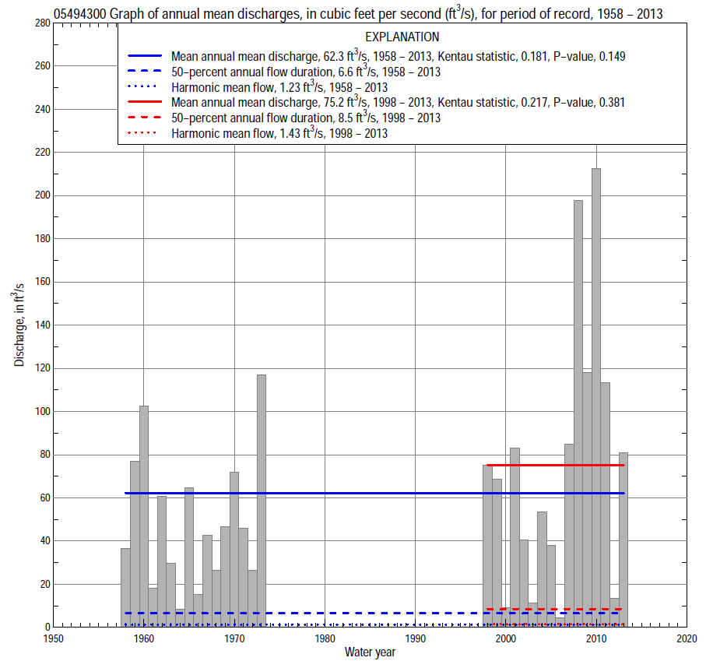

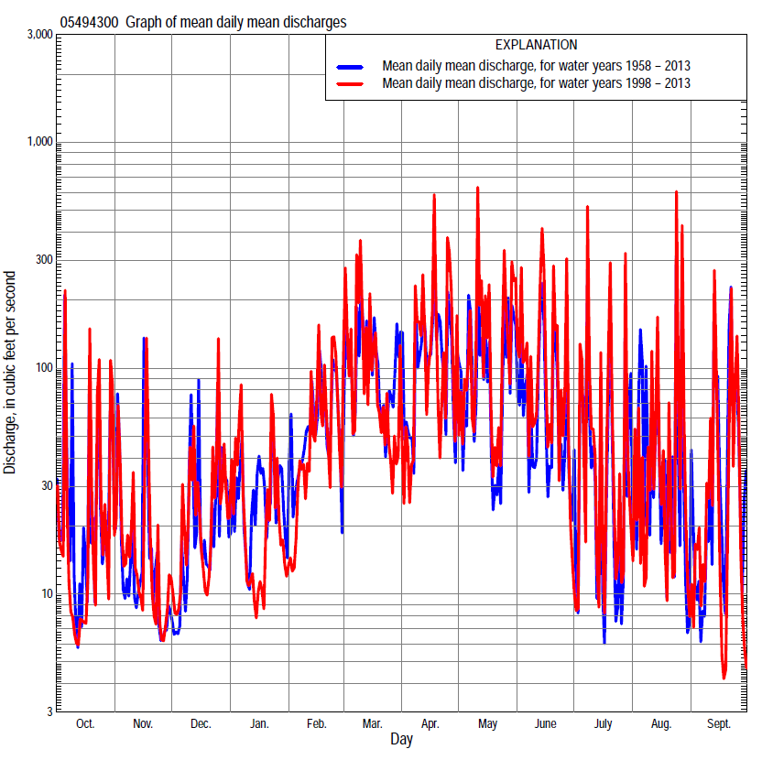

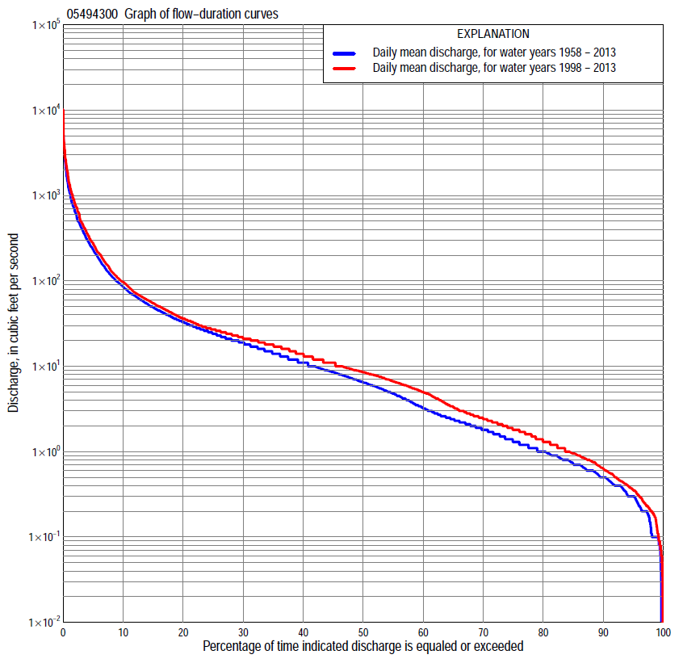

Statistics Based on the Entire Streamflow Period of Record
05494300 Monthly and annual flow durations, based on 1958–73, 1998–2013 period of record (32 years)
Percentage of days discharge equaled or exceeded |  |  |  |  | Discharge (cubic feet per second) |  |  |  |  |  |  |  |  | Annual flow durations
 | Oct | Nov | Dec | Jan | Feb | Mar | Apr | May | June | July | Aug | Sept | Annual | Kentau statistic | P-value
99 | 0.00 | 0.20 | 0.10 | 0.13 | 0.60 | 0.90 | 0.70 | 0.36 | 0.30 | 0.08 | 0.04 | 0.00 | 0.10 | 0.173 | 0.067
98 | 0.06 | 0.21 | 0.10 | 0.27 | 0.60 | 1.0 | 0.90 | 0.50 | 0.40 | 0.10 | 0.10 | 0.08 | 0.11 | 0.206 | 0.037
95 | 0.10 | 0.30 | 0.30 | 0.38 | 0.85 | 1.9 | 2.3 | 1.1 | 0.60 | 0.26 | 0.10 | 0.10 | 0.30 | 0.161 | 0.115
90 | 0.27 | 0.43 | 0.58 | 0.56 | 1.7 | 3.3 | 5.7 | 2.8 | 0.80 | 0.50 | 0.20 | 0.20 | 0.50 | 0.153 | 0.166
85 | 0.37 | 0.60 | 0.78 | 0.80 | 2.1 | 6.0 | 7.1 | 4.6 | 1.1 | 0.63 | 0.30 | 0.26 | 0.72 | 0.224 | 0.050
80 | 0.49 | 0.79 | 0.98 | 0.95 | 3.0 | 8.7 | 8.9 | 6.0 | 1.3 | 0.76 | 0.40 | 0.36 | 1.0 | 0.222 | 0.057
75 | 0.60 | 1.0 | 1.3 | 1.2 | 4.5 | 11 | 11 | 7.4 | 1.8 | 0.90 | 0.50 | 0.45 | 1.3 | 0.236 | 0.050
70 | 0.84 | 1.2 | 1.7 | 1.8 | 5.7 | 13 | 13 | 9.0 | 2.4 | 1.0 | 0.68 | 0.58 | 1.8 | 0.234 | 0.057
65 | 1.2 | 1.6 | 2.0 | 2.2 | 7.0 | 15 | 15 | 10 | 3.0 | 1.2 | 0.87 | 0.69 | 2.4 | 0.234 | 0.059
60 | 1.6 | 2.1 | 2.4 | 2.9 | 9.0 | 17 | 18 | 12 | 4.2 | 1.4 | 1.0 | 0.84 | 3.2 | 0.246 | 0.047
55 | 2.2 | 2.6 | 2.8 | 4.2 | 13 | 20 | 20 | 15 | 5.3 | 1.7 | 1.2 | 1.0 | 4.8 | 0.200 | 0.109
50 | 2.6 | 3.7 | 3.7 | 6.0 | 17 | 24 | 23 | 17 | 7.2 | 1.9 | 1.4 | 1.3 | 6.5 | 0.192 | 0.126
45 | 3.4 | 5.1 | 5.5 | 7.8 | 21 | 28 | 26 | 21 | 9.0 | 2.4 | 1.7 | 1.5 | 8.6 | 0.192 | 0.126
40 | 4.4 | 6.4 | 7.1 | 9.1 | 26 | 33 | 31 | 26 | 12 | 3.1 | 2.1 | 1.9 | 11 | 0.147 | 0.242
35 | 5.4 | 7.9 | 8.9 | 11 | 31 | 41 | 36 | 32 | 16 | 4.0 | 2.5 | 2.4 | 14 | 0.123 | 0.330
30 | 7.1 | 9.0 | 11 | 13 | 39 | 47 | 45 | 40 | 22 | 5.9 | 3.4 | 3.3 | 19 | 0.125 | 0.321
25 | 9.5 | 11 | 14 | 16 | 50 | 60 | 58 | 49 | 31 | 9.2 | 5.2 | 5.0 | 24 | 0.107 | 0.398
20 | 13 | 14 | 18 | 21 | 60 | 88 | 78 | 68 | 43 | 13 | 9.0 | 8.2 | 33 | 0.111 | 0.380
15 | 18 | 20 | 23 | 30 | 80 | 120 | 126 | 100 | 71 | 19 | 21 | 14 | 49 | 0.079 | 0.538
10 | 27 | 27 | 35 | 47 | 130 | 230 | 251 | 188 | 120 | 30 | 48 | 35 | 85 | 0.089 | 0.485
5 | 75 | 51 | 82 | 110 | 250 | 468 | 627 | 424 | 360 | 119 | 116 | 141 | 232 | 0.107 | 0.399
2 | 270 | 148 | 216 | 330 | 480 | 1,010 | 1,170 | 1,240 | 808 | 456 | 530 | 619 | 640 | 0.137 | 0.277
1 | 500 | 313 | 348 | 497 | 800 | 1,630 | 1,630 | 2,260 | 1,240 | 1,520 | 1,040 | 912 | 1,150 | 0.149 | 0.236

05494300 Annual exceedance probability of instantaneous peak discharges, in cubic feet per second (ft³/s), based on the Weighted Independent Estimates method,
Annual exceed-ance probability | Recur-rence interval (years) | Discharge (ft³/s) | 95-percent lower confi-dence interval (ft³/s) | 95-percent upper confi-dence interval (ft³/s)
0.500 | 2 | 3,770 | 3,130 | 4,530
0.200 | 5 | 6,680 | 5,600 | 7,960
0.100 | 10 | 8,700 | 7,210 | 10,500
0.040 | 25 | 11,500 | 9,200 | 14,300
0.020 | 50 | 13,600 | 10,600 | 17,600
0.010 | 100 | 15,900 | 11,900 | 21,200
0.005 | 200 | 18,200 | 13,100 | 25,200
0.002 | 500 | 21,100 | 14,500 | 30,700
and based on the expected moments algorithm/multiple Grubbs-Beck analysis computed using a historical period length of 61 years (1953–2013)
0.500 | 2 | 3,810 | 1,940 | 4,660
0.200 | 5 | 6,700 | 5,340 | 8,660
0.100 | 10 | 8,740 | 6,860 | 12,200
0.040 | 25 | 11,400 | 8,580 | 18,800
0.020 | 50 | 13,300 | 9,770 | 25,900
0.010 | 100 | 15,300 | 10,900 | 35,100
0.005 | 200 | 17,200 | 11,900 | 46,600
0.002 | 500 | 19,700 | 13,100 | 65,300
Kentau statistic |  | 0.356
P-value |  | 0.002
Begin year |  | 1953
End year |  | 2013
Number of peaks |  | 37

05494300 Annual exceedance probability of high discharges, based on 1958–73, 1998–2013 period of record (32 years)
Annual exceedance probability | Recur-rence interval (years) | Maximum average discharge (ft³/s) for indicated number of consecutive days
 |  | 1 | 3 | 7 | 15 | 30
0.990 | 1.01 | 114 | 61 | 39 | 24 | 18
0.950 | 1.05 | 349 | 180 | 103 | 64 | 45
0.900 | 1.11 | 587 | 299 | 164 | 101 | 69
0.800 | 1.25 | 1,030 | 515 | 270 | 166 | 110
0.500 | 2 | 2,490 | 1,200 | 598 | 358 | 232
0.200 | 5 | 4,760 | 2,200 | 1,090 | 631 | 413
0.100 | 10 | 6,150 | 2,780 | 1,380 | 790 | 525
0.040 | 25 | 7,650 | 3,390 | 1,700 | 956 | 650
0.020 | 50 | 8,570 | 3,750 | 1,900 | 1,060 | 731
0.010 | 100 | 9,340 | 4,040 | 2,070 | 1,140 | 801
0.005 | 200 | 9,980 | 4,270 | 2,220 | 1,210 | 862
0.002 | 500 | 10,700 | 4,520 | 2,370 | 1,280 | 931
Kentau statistic |  | 0.061 | 0.040 | 0.042 | 0.043 | 0.036
P-value |  | 0.493 | 0.653 | 0.642 | 0.632 | 0.685

 | 05494300 Annual nonexceedance probability of low discharges, based on April 1958 to March 1973, April 1998 to March 2013 period of record (30 years)
Annual nonexceed-ance probability | Recur-rence interval (years) | Minimum average discharge (cubic feet per second) for indicated number of consecutive days
 |  | 1 | 3 | 7 | 14 | 30 | 60 | 90 | 120 | 183
0.01 | 100 | 0.00 | 0.00 | 0.01 | 0.04 | 0.10 | 0.13 | 0.14 | 0.15 | 0.17
0.02 | 50 | 0.00 | 0.00 | 0.02 | 0.05 | 0.12 | 0.20 | 0.21 | 0.22 | 0.26
0.05 | 20 | 0.00 | 0.00 | 0.03 | 0.07 | 0.15 | 0.29 | 0.34 | 0.38 | 0.50
0.10 | 10 | 0.00 | 0.02 | 0.05 | 0.10 | 0.20 | 0.37 | 0.51 | 0.63 | 0.90
0.20 | 5 | 0.04 | 0.06 | 0.10 | 0.16 | 0.30 | 0.54 | 0.88 | 1.2 | 1.9
0.50 | 2 | 0.19 | 0.24 | 0.31 | 0.44 | 0.72 | 1.4 | 2.8 | 4.3 | 7.5
0.80 | 1.25 | 0.77 | 0.87 | 1.1 | 1.4 | 2.2 | 4.5 | 11 | 17 | 31
0.90 | 1.11 | 1.6 | 1.7 | 2.0 | 2.6 | 4.3 | 9.4 | 23 | 35 | 65
0.96 | 1.04 | 3.6 | 3.7 | 4.2 | 5.2 | 9.3 | 23 | 55 | 80 | 145
0.98 | 1.02 | 5.9 | 6.0 | 6.7 | 8.5 | 16 | 43 | 100 | 138 | 246
0.99 | 1.01 | 9.3 | 9.4 | 10 | 13 | 27 | 79 | 175 | 227 | 394
Kentau statistic |  | 0.260 | 0.184 | 0.207 | 0.166 | 0.140 | 0.076 | 0.099 | 0.113 | 0.057
P-value |  | 0.045 | 0.158 | 0.112 | 0.205 | 0.284 | 0.568 | 0.454 | 0.392 | 0.669

05494300 Annual nonexceedance probability of seasonal low discharges, based on October 1957 to September 2013 period of record (32–33 years)
Annual nonexceed-ance probability | Recur-rence interval (years) | Minimum average discharge (cubic feet per second) for indicated number of consecutive days
 |  | 1 | 7 | 14 | 30 |  | 1 | 7 | 14 | 30
 |  | January-February-March |  |  |  |  | April-May-June
0.01 | 100 | 0.02 | 0.06 | 0.11 | 0.21 |  | 0.00 | 0.12 | 0.14 | 0.15
0.02 | 50 | 0.03 | 0.09 | 0.16 | 0.31 |  | 0.00 | 0.17 | 0.22 | 0.27
0.05 | 20 | 0.08 | 0.17 | 0.28 | 0.56 |  | 0.12 | 0.27 | 0.39 | 0.61
0.10 | 10 | 0.17 | 0.30 | 0.45 | 0.95 |  | 0.24 | 0.42 | 0.65 | 1.2
0.20 | 5 | 0.38 | 0.58 | 0.81 | 1.8 |  | 0.47 | 0.72 | 1.2 | 2.8
0.50 | 2 | 1.6 | 2.0 | 2.6 | 5.8 |  | 1.4 | 2.1 | 3.7 | 12
0.80 | 1.25 | 5.2 | 6.7 | 8.6 | 18 |  | 4.3 | 6.2 | 11 | 47
0.90 | 1.11 | 9.1 | 13 | 16 | 33 |  | 7.7 | 11 | 19 | 91
0.96 | 1.04 | 16 | 24 | 33 | 61 |  | 14 | 21 | 33 | 176
0.98 | 1.02 | 21 | 37 | 52 | 91 |  | 22 | 32 | 46 | 265
0.99 | 1.01 | 28 | 54 | 79 | 129 |  | 31 | 47 | 64 | 377
Kentau statistic |  | 0.107 | 0.123 | 0.121 | 0.048 |  | 0.363 | 0.339 | 0.347 | 0.282
P-value |  | 0.399 | 0.331 | 0.339 | 0.709 |  | 0.004 | 0.007 | 0.006 | 0.024
 |  | July-August-September |  |  |  |  | October-November-December
0.01 | 100 | 0.00 | 0.01 | 0.05 | 0.14 |  | 0.00 | 0.00 | 0.00 | 0.10
0.02 | 50 | 0.00 | 0.02 | 0.07 | 0.15 |  | 0.00 | 0.00 | 0.00 | 0.14
0.05 | 20 | 0.00 | 0.04 | 0.09 | 0.19 |  | 0.03 | 0.05 | 0.08 | 0.23
0.10 | 10 | 0.03 | 0.06 | 0.13 | 0.24 |  | 0.07 | 0.12 | 0.18 | 0.36
0.20 | 5 | 0.07 | 0.12 | 0.19 | 0.35 |  | 0.18 | 0.28 | 0.39 | 0.64
0.50 | 2 | 0.29 | 0.41 | 0.54 | 1.0 |  | 0.74 | 1.0 | 1.4 | 2.0
0.80 | 1.25 | 1.1 | 1.4 | 1.9 | 4.2 |  | 2.5 | 3.4 | 4.6 | 6.7
0.90 | 1.11 | 2.0 | 2.6 | 3.9 | 11 |  | 4.6 | 6.2 | 8.4 | 13
0.96 | 1.04 | 4.0 | 5.1 | 9.4 | 37 |  | 8.5 | 12 | 16 | 26
0.98 | 1.02 | 6.2 | 8.0 | 17 | 88 |  | 12 | 17 | 24 | 43
0.99 | 1.01 | 9.1 | 12 | 31 | 205 |  | 17 | 24 | 34 | 66
Kentau statistic |  | 0.161 | 0.112 | 0.127 | 0.049 |  | 0.153 | 0.173 | 0.137 | 0.105
P-value |  | 0.192 | 0.369 | 0.306 | 0.698 |  | 0.223 | 0.168 | 0.277 | 0.408

Statistics Based on the 1984–2013 Streamflow Period of Record
05494300 Monthly and annual flow durations, based on 1998–2013 period of record (16 years)
Percentage of days discharge equaled or exceeded |  |  |  |  | Discharge (cubic feet per second) |  |  |  |  |  |  |  |  | Annual flow durations
 | Oct | Nov | Dec | Jan | Feb | Mar | Apr | May | June | July | Aug | Sept | Annual | Kentau statistic | P-value
99 | 0.08 | 0.20 | 0.24 | 0.11 | 0.95 | 1.8 | 0.75 | 0.25 | 0.24 | 0.06 | 0.03 | 0.10 | 0.12 | 0.117 | 0.496
98 | 0.11 | 0.22 | 0.31 | 0.23 | 1.2 | 1.8 | 0.90 | 0.36 | 0.40 | 0.08 | 0.08 | 0.13 | 0.20 | 0.117 | 0.512
95 | 0.23 | 0.30 | 0.49 | 0.34 | 1.6 | 2.6 | 1.4 | 1.0 | 0.80 | 0.24 | 0.26 | 0.19 | 0.36 | 0.117 | 0.512
90 | 0.38 | 0.56 | 0.80 | 0.57 | 1.8 | 3.8 | 5.3 | 4.0 | 1.8 | 0.67 | 0.40 | 0.22 | 0.63 | 0.092 | 0.627
85 | 0.48 | 0.80 | 0.96 | 0.80 | 2.2 | 6.6 | 7.5 | 6.2 | 2.5 | 0.90 | 0.48 | 0.29 | 0.95 | 0.042 | 0.852
80 | 0.69 | 1.0 | 1.3 | 1.2 | 3.9 | 8.8 | 9.7 | 8.0 | 3.5 | 1.0 | 0.59 | 0.38 | 1.3 | 0.083 | 0.674
75 | 0.89 | 1.2 | 1.8 | 2.0 | 5.5 | 11 | 11 | 9.7 | 4.9 | 1.3 | 0.79 | 0.47 | 1.8 | 0.083 | 0.677
70 | 1.3 | 1.6 | 2.3 | 2.6 | 6.8 | 13 | 13 | 12 | 6.2 | 1.5 | 0.99 | 0.61 | 2.4 | -0.033 | 0.891
65 | 2.2 | 2.4 | 2.8 | 3.7 | 8.0 | 16 | 17 | 15 | 7.5 | 1.7 | 1.1 | 0.71 | 3.3 | -0.042 | 0.856
60 | 2.8 | 3.1 | 3.8 | 5.3 | 9.9 | 18 | 19 | 19 | 9.5 | 1.9 | 1.3 | 0.85 | 5.0 | -0.050 | 0.821
55 | 3.4 | 4.7 | 5.6 | 6.6 | 14 | 22 | 21 | 22 | 11 | 2.2 | 1.5 | 1.2 | 6.6 | -0.067 | 0.752
50 | 4.2 | 5.4 | 7.5 | 8.1 | 17 | 25 | 23 | 26 | 15 | 2.6 | 1.7 | 1.4 | 8.5 | -0.042 | 0.857
45 | 5.0 | 6.4 | 9.0 | 9.0 | 20 | 30 | 26 | 30 | 19 | 3.2 | 2.1 | 1.7 | 11 | -0.042 | 0.856
40 | 5.6 | 7.9 | 11 | 11 | 23 | 35 | 30 | 35 | 23 | 4.0 | 2.4 | 2.1 | 14 | -0.017 | 0.964
35 | 7.0 | 8.7 | 14 | 12 | 26 | 43 | 37 | 44 | 28 | 5.9 | 3.0 | 2.5 | 18 | -0.042 | 0.857
30 | 9.2 | 10 | 17 | 14 | 33 | 47 | 49 | 55 | 37 | 8.9 | 5.2 | 3.0 | 21 | -0.025 | 0.928
25 | 12 | 12 | 19 | 15 | 40 | 58 | 69 | 71 | 52 | 13 | 8.9 | 4.7 | 27 | 0.008 | 1.000
20 | 15 | 16 | 24 | 18 | 55 | 79 | 93 | 97 | 75 | 18 | 20 | 7.8 | 36 | 0.133 | 0.499
15 | 20 | 22 | 29 | 21 | 66 | 111 | 156 | 148 | 115 | 24 | 35 | 13 | 55 | 0.167 | 0.392
10 | 27 | 29 | 38 | 34 | 102 | 202 | 294 | 281 | 207 | 39 | 65 | 32 | 97 | 0.125 | 0.526
5 | 62 | 51 | 99 | 70 | 220 | 468 | 732 | 703 | 629 | 171 | 129 | 128 | 275 | 0.100 | 0.620
2 | 230 | 120 | 217 | 267 | 492 | 1,220 | 1,330 | 1,930 | 1,030 | 458 | 539 | 500 | 787 | 0.150 | 0.444
1 | 1,110 | 420 | 355 | 462 | 1,010 | 1,680 | 2,170 | 2,380 | 2,090 | 1,690 | 1,040 | 850 | 1,400 | 0.233 | 0.224

05494300 Annual exceedance probability of high discharges, based on 1998–2013 period of record (16 years)
Annual exceedance probability | Recur-rence interval (years) | Maximum average discharge (ft³/s) for indicated number of consecutive days
 |  | 1 | 3 | 7 | 15 | 30
0.990 | 1.01 | 64 | 34 | 23 | 16 | 11
0.950 | 1.05 | 264 | 137 | 82 | 52 | 35
0.900 | 1.11 | 504 | 259 | 147 | 90 | 59
0.800 | 1.25 | 1,010 | 505 | 272 | 161 | 105
0.500 | 2 | 2,900 | 1,370 | 695 | 395 | 257
0.200 | 5 | 6,060 | 2,660 | 1,330 | 736 | 495
0.100 | 10 | 7,980 | 3,360 | 1,680 | 928 | 640
0.040 | 25 | 9,980 | 4,030 | 2,030 | 1,120 | 795
0.020 | 50 | 11,200 | 4,380 | 2,220 | 1,230 | 890
0.010 | 100 | 12,100 | 4,640 | 2,370 | 1,310 | 968
0.005 | 200 | 12,800 | 4,840 | 2,490 | 1,380 | 1,030
0.002 | 500 | 13,600 | 5,020 | 2,600 | 1,440 | 1,100
Kentau statistic |  | 0.600 | 0.593 | 0.584 | 0.593 | 0.570
P-value |  | 0.000 | 0.000 | 0.000 | 0.000 | 0.000

 | 05494300 Annual nonexceedance probability of low discharges, based on April 1998 to March 2013 period of record (15 years)
Annual nonexceed-ance probability | Recur-rence interval (years) | Minimum average discharge (cubic feet per second) for indicated number of consecutive days
 |  | 1 | 3 | 7 | 14 | 30 | 60 | 90 | 120 | 183
0.01 | 100 | 0.00 | 0.00 | 0.01 | 0.03 | 0.06 | 0.09 | 0.10 | 0.11 | 0.11
0.02 | 50 | 0.01 | 0.01 | 0.02 | 0.04 | 0.08 | 0.15 | 0.15 | 0.18 | 0.18
0.05 | 20 | 0.01 | 0.02 | 0.04 | 0.07 | 0.12 | 0.22 | 0.29 | 0.37 | 0.42
0.10 | 10 | 0.03 | 0.04 | 0.06 | 0.12 | 0.19 | 0.33 | 0.51 | 0.69 | 0.86
0.20 | 5 | 0.07 | 0.10 | 0.13 | 0.21 | 0.32 | 0.55 | 1.0 | 1.5 | 2.0
0.50 | 2 | 0.37 | 0.45 | 0.51 | 0.70 | 1.0 | 1.8 | 4.1 | 6.1 | 9.7
0.80 | 1.25 | 1.6 | 1.8 | 1.9 | 2.4 | 3.6 | 7.5 | 17 | 25 | 43
0.90 | 1.11 | 3.3 | 3.4 | 3.9 | 4.7 | 7.4 | 18 | 37 | 51 | 91
0.96 | 1.04 | 6.7 | 6.8 | 8.0 | 9.7 | 16 | 47 | 86 | 108 | 198
0.98 | 1.02 | 10 | 11 | 13 | 16 | 28 | 93 | 150 | 175 | 322
0.99 | 1.01 | 15 | 16 | 20 | 24 | 46 | 178 | 248 | 270 | 496
Kentau statistic |  | 0.029 | 0.048 | 0.067 | 0.124 | 0.124 | 0.105 | 0.048 | 0.067 | 0.105
P-value |  | 0.921 | 0.843 | 0.767 | 0.553 | 0.553 | 0.621 | 0.843 | 0.767 | 0.621

05494300 Annual nonexceedance probability of seasonal low discharges, based on October 1983 to September 2013 period of record (30 years)
Annual nonexceed-ance probability | Recur-rence interval (years) | Minimum average discharge (cubic feet per second) for indicated number of consecutive days
 |  | 1 | 7 | 14 | 30 |  | 1 | 7 | 14 | 30
 |  | January-February-March |  |  |  |  | April-May-June
0.01 | 100 | 0.01 | 0.04 | 0.08 | 0.19 |  | 0.04 | 0.06 | 0.10 | 0.16
0.02 | 50 | 0.02 | 0.07 | 0.14 | 0.30 |  | 0.07 | 0.11 | 0.20 | 0.35
0.05 | 20 | 0.06 | 0.17 | 0.30 | 0.59 |  | 0.18 | 0.27 | 0.52 | 1.0
0.10 | 10 | 0.15 | 0.35 | 0.58 | 1.1 |  | 0.36 | 0.56 | 1.1 | 2.4
0.20 | 5 | 0.42 | 0.79 | 1.2 | 2.0 |  | 0.81 | 1.3 | 2.5 | 6.0
0.50 | 2 | 2.1 | 3.0 | 4.0 | 6.3 |  | 3.1 | 4.7 | 8.6 | 28
0.80 | 1.25 | 6.8 | 8.8 | 11 | 17 |  | 8.9 | 13 | 20 | 90
0.90 | 1.11 | 11 | 14 | 16 | 28 |  | 14 | 20 | 28 | 147
0.96 | 1.04 | 15 | 21 | 24 | 44 |  | 22 | 30 | 35 | 227
0.98 | 1.02 | 18 | 27 | 31 | 59 |  | 28 | 37 | 40 | 289
0.99 | 1.01 | 21 | 33 | 37 | 75 |  | 34 | 44 | 44 | 349
Kentau statistic |  | -0.108 | -0.117 | -0.083 | -0.083 |  | 0.017 | 0.050 | 0.050 | 0.133
P-value |  | 0.589 | 0.558 | 0.685 | 0.685 |  | 0.964 | 0.822 | 0.822 | 0.499
 |  | July-August-September |  |  |  |  | October-November-December
0.01 | 100 | 0.01 | 0.02 | 0.06 | 0.11 |  | 0.02 | 0.03 | 0.05 | 0.11
0.02 | 50 | 0.01 | 0.03 | 0.07 | 0.12 |  | 0.03 | 0.05 | 0.07 | 0.15
0.05 | 20 | 0.02 | 0.05 | 0.10 | 0.16 |  | 0.07 | 0.11 | 0.14 | 0.26
0.10 | 10 | 0.05 | 0.08 | 0.15 | 0.22 |  | 0.13 | 0.20 | 0.25 | 0.43
0.20 | 5 | 0.11 | 0.16 | 0.25 | 0.35 |  | 0.27 | 0.40 | 0.49 | 0.78
0.50 | 2 | 0.48 | 0.56 | 0.77 | 1.2 |  | 1.1 | 1.4 | 1.7 | 2.4
0.80 | 1.25 | 1.8 | 2.1 | 3.1 | 6.5 |  | 3.5 | 4.8 | 5.5 | 7.8
0.90 | 1.11 | 3.4 | 4.2 | 7.1 | 20 |  | 6.1 | 8.6 | 10 | 14
0.96 | 1.04 | 6.5 | 9.0 | 19 | 75 |  | 11 | 16 | 18 | 28
0.98 | 1.02 | 10 | 15 | 37 | 198 |  | 15 | 23 | 27 | 42
0.99 | 1.01 | 13 | 23 | 70 | 502 |  | 20 | 32 | 38 | 62
Kentau statistic |  | 0.000 | -0.037 | -0.029 | -0.044 |  | 0.067 | 0.050 | 0.050 | 0.033
P-value |  | 1.000 | 0.869 | 0.902 | 0.837 |  | 0.752 | 0.822 | 0.822 | 0.893

