LOCATION.--Lat 40°39'33", long 92°03'41" referenced to North American Datum of 1927, in SW 1/4 sec.30, T.68 N., R.10 W., Van Buren County, IA, Hydrologic Unit 07110001, on left bank 5 ft downstream from bridge on State Highway 2, 0.7 mi north of Cantril, and 0.3 mi upstream from Bone Run.

DRAINAGE AREA.--161 mi².

PERIOD OF RECORD.--Discharge records from August 1940 to September 1951.

GAGE.--Water-stage recorder. Datum of gage is 657.98 ft above National Geodetic Vertical Datum of 1929. Prior to November 8, 1940, non-recording gage at same site and datum.

A summary of all available data for this streamgage is provided through the USGS National Water Information System web interface (NWISWeb). The following link provides access to current/historical observations, daily data, daily statistics, monthly statistics, annual statistics, peak streamflow, field measurements, field/lab water-quality samples, and the latest water-year summaries. Data can be filtered by parameter and/or dates, and can be output in various tabular and graphical formats.
http://waterdata.usgs.gov/nwis/inventory/?site_no=05494500

The USGS WaterWatch Toolkit is available at:
http://waterwatch.usgs.gov/?id=ww_toolkit
Tools for summarizing streamflow information include the duration hydrograph builder, the cumulative streamflow hydrograph builder, the streamgage statistics retrieval tool, the rating curve builder, the flood tracking chart builder, the National Weather Service Advanced Hydrologic Prediction Service (AHPS) river forecast hydrograph builder, and the raster-hydrograph builder. Entering the above number for this streamgage into these toolkit webpages will provide streamflow information specific to this streamgage.

A description of the statistics presented for this streamgage is available in the main body of the report at:
http://dx.doi.org/10.3133/ofr20151214
A link to other streamgages included in this report, a map showing the location of the streamgages, information on the programs used to compute the statistical analyses, and references are included in the main body of the report.

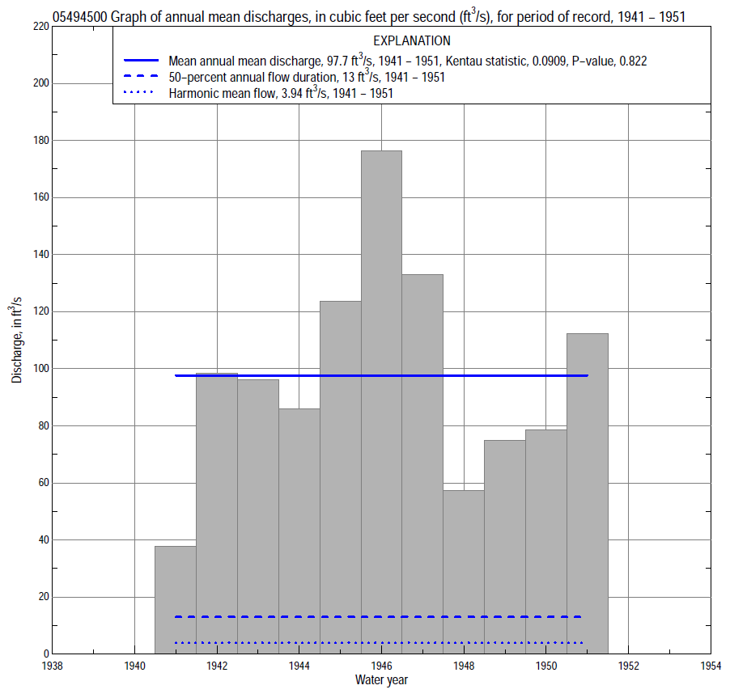

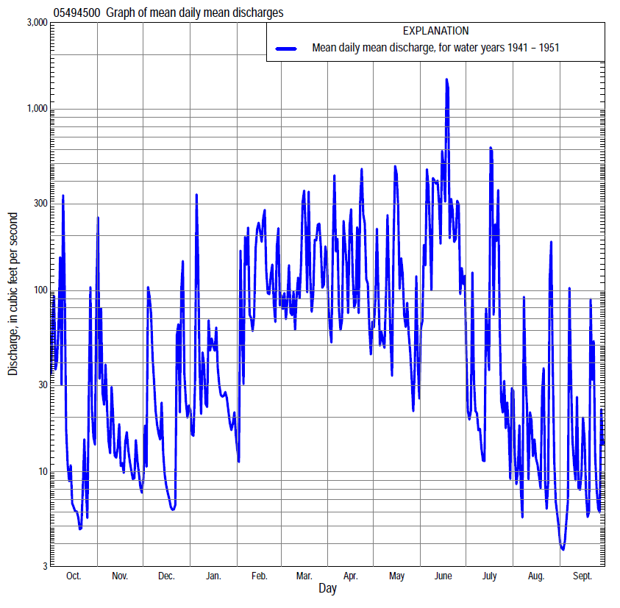

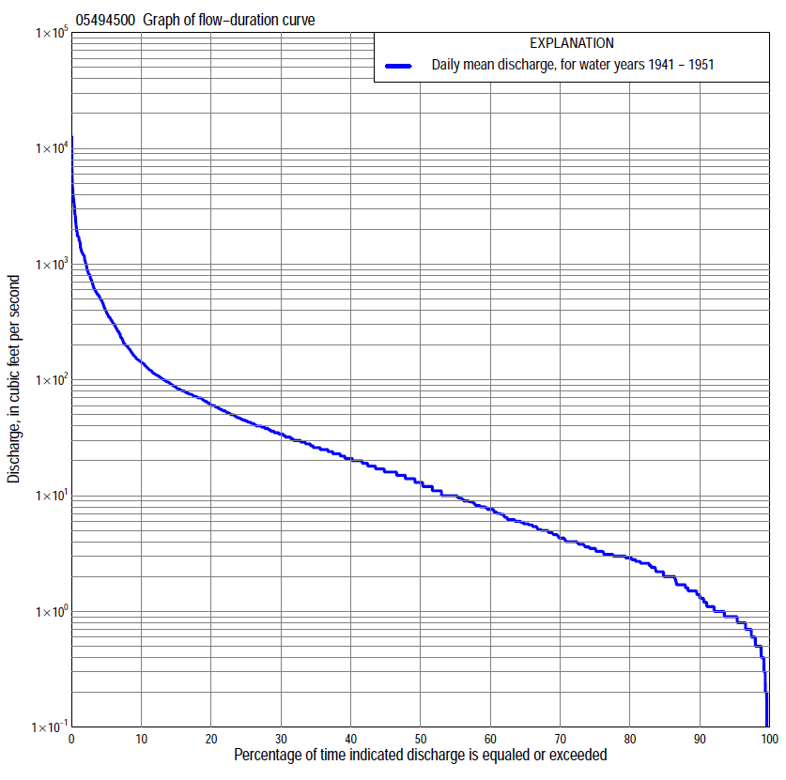

Statistics Based on the Entire Streamflow Period of Record
05494500 Monthly and annual flow durations, based on 1941–51 period of record (11 years)
Percentage of days discharge equaled or exceeded |  |  |  |  | Discharge (cubic feet per second) |  |  |  |  |  |  |  |  | Annual flow durations
 | Oct | Nov | Dec | Jan | Feb | Mar | Apr | May | June | July | Aug | Sept | Annual | Kentau statistic | P-value
99 | 0.50 | 0.80 | 0.50 | 0.30 | 0.60 | 3.0 | 7.6 | 2.4 | 0.20 | 0.50 | 0.00 | 0.00 | 0.40 | 0.200 | 0.361
98 | 0.70 | 0.80 | 0.50 | 0.30 | 0.70 | 5.0 | 8.8 | 3.0 | 1.4 | 0.60 | 0.00 | 0.80 | 0.60 | 0.200 | 0.386
95 | 0.80 | 1.0 | 0.70 | 0.60 | 1.0 | 7.6 | 10 | 5.6 | 2.9 | 0.90 | 0.20 | 0.90 | 0.90 | 0.200 | 0.386
90 | 0.90 | 1.5 | 0.90 | 0.90 | 4.0 | 12 | 15 | 8.6 | 3.3 | 2.4 | 0.90 | 1.1 | 1.5 | 0.127 | 0.631
85 | 1.0 | 1.7 | 1.0 | 1.2 | 6.0 | 16 | 17 | 12 | 6.2 | 3.6 | 1.1 | 1.5 | 2.2 | 0.091 | 0.745
80 | 1.2 | 1.9 | 1.1 | 2.5 | 9.0 | 19 | 21 | 14 | 8.8 | 4.3 | 1.7 | 1.7 | 3.0 | 0.073 | 0.805
75 | 1.5 | 2.6 | 1.5 | 4.0 | 10 | 26 | 26 | 16 | 15 | 5.0 | 2.2 | 2.0 | 3.5 | -0.145 | 0.576
70 | 2.0 | 2.8 | 2.0 | 5.6 | 12 | 34 | 28 | 18 | 17 | 5.6 | 2.6 | 2.4 | 4.6 | -0.218 | 0.377
65 | 2.0 | 3.1 | 2.5 | 7.0 | 16 | 41 | 34 | 21 | 20 | 6.2 | 3.0 | 2.6 | 5.9 | -0.236 | 0.343
60 | 2.6 | 3.3 | 3.0 | 8.2 | 20 | 44 | 36 | 22 | 21 | 7.6 | 3.3 | 3.0 | 7.8 | 0.018 | 1.000
55 | 2.9 | 3.8 | 3.7 | 10 | 29 | 54 | 42 | 25 | 26 | 9.6 | 3.8 | 3.0 | 10 | 0.018 | 1.000
50 | 3.1 | 4.3 | 4.1 | 11 | 35 | 62 | 45 | 28 | 31 | 12 | 4.3 | 3.2 | 13 | -0.018 | 1.000
45 | 3.3 | 5.1 | 5.4 | 14 | 44 | 72 | 51 | 31 | 41 | 14 | 4.7 | 3.5 | 17 | -0.036 | 0.937
40 | 3.9 | 6.2 | 7.0 | 17 | 52 | 76 | 57 | 34 | 58 | 15 | 5.4 | 4.6 | 21 | -0.091 | 0.755
35 | 4.2 | 7.2 | 8.9 | 20 | 62 | 91 | 67 | 40 | 85 | 18 | 6.2 | 5.9 | 26 | -0.018 | 1.000
30 | 5.0 | 9.6 | 10 | 24 | 78 | 106 | 75 | 46 | 116 | 23 | 7.9 | 7.6 | 34 | -0.018 | 1.000
25 | 5.9 | 13 | 14 | 28 | 94 | 118 | 87 | 57 | 151 | 29 | 9.4 | 9.2 | 45 | -0.018 | 1.000
20 | 6.5 | 18 | 19 | 35 | 111 | 146 | 115 | 72 | 306 | 37 | 11 | 12 | 62 | -0.018 | 1.000
15 | 10 | 27 | 25 | 45 | 150 | 204 | 163 | 96 | 500 | 44 | 15 | 17 | 87 | 0.000 | 1.000
10 | 37 | 36 | 47 | 63 | 347 | 324 | 261 | 162 | 794 | 74 | 28 | 23 | 142 | 0.345 | 0.161
5 | 109 | 59 | 128 | 150 | 582 | 613 | 618 | 378 | 1,520 | 196 | 77 | 46 | 388 | 0.273 | 0.276
2 | 568 | 153 | 420 | 288 | 1,370 | 1,000 | 1,630 | 1,210 | 2,780 | 647 | 239 | 223 | 1,030 | 0.164 | 0.533
1 | 1,120 | 311 | 658 | 500 | 1,720 | 1,340 | 2,000 | 2,300 | 4,470 | 1,590 | 380 | 472 | 1,720 | 0.164 | 0.533

05494500 Annual exceedance probability of instantaneous peak discharges, in cubic feet per second (ft³/s), based on the Weighted Independent Estimates method,
Annual exceed-ance probability | Recur-rence interval (years) | Discharge (ft³/s) | 95-percent lower confi-dence interval (ft³/s) | 95-percent upper confi-dence interval (ft³/s)
0.500 | 2 | 5,990 | 4,680 | 7,680
0.200 | 5 | 8,460 | 6,530 | 11,000
0.100 | 10 | 9,880 | 7,460 | 13,100
0.040 | 25 | 12,000 | 8,780 | 16,500
0.020 | 50 | 13,700 | 9,690 | 19,300
0.010 | 100 | 15,400 | 10,600 | 22,400
0.005 | 200 | 17,000 | 11,400 | 25,500
0.002 | 500 | 19,100 | 12,200 | 30,100
and based on the expected moments algorithm/multiple Grubbs-Beck analysis computed using a historical period length of 11 years (1941–1951)
0.500 | 2 | 6,340 | 4,710 | 8,400
0.200 | 5 | 9,080 | 6,940 | 13,400
0.100 | 10 | 10,900 | 8,270 | 18,000
0.040 | 25 | 13,200 | 9,790 | 25,700
0.020 | 50 | 15,000 | 10,800 | 33,000
0.010 | 100 | 16,700 | 11,700 | 41,700
0.005 | 200 | 18,500 | 12,600 | 52,300
0.002 | 500 | 20,800 | 13,600 | 69,700
Kentau statistic |  | 0.364
P-value |  | 0.138
Begin year |  | 1941
End year |  | 1951
Number of peaks |  | 11

05494500 Annual exceedance probability of high discharges, based on 1941–51 period of record (11 years)
Annual exceedance probability | Recur-rence interval (years) | Maximum average discharge (ft³/s) for indicated number of consecutive days
 |  | 1 | 3 | 7 | 15 | 30
0.990 | 1.01 | 882 | 709 | 495 | 293 | 162
0.950 | 1.05 | 1,390 | 908 | 608 | 355 | 220
0.900 | 1.11 | 1,750 | 1,050 | 688 | 399 | 259
0.800 | 1.25 | 2,310 | 1,290 | 812 | 467 | 317
0.500 | 2 | 3,820 | 1,990 | 1,160 | 665 | 469
0.200 | 5 | 6,150 | 3,340 | 1,780 | 1,020 | 700
0.100 | 10 | 7,800 | 4,520 | 2,290 | 1,310 | 866
0.040 | 25 | 9,970 | 6,410 | 3,050 | 1,750 | 1,090
0.020 | 50 | 11,600 | 8,140 | 3,710 | 2,150 | 1,260
0.010 | 100 | 13,300 | 10,200 | 4,470 | 2,600 | 1,450
0.005 | 200 | 15,000 | 12,600 | 5,330 | 3,120 | 1,640
0.002 | 500 | 17,400 | 16,600 | 6,660 | 3,930 | 1,910
Kentau statistic |  | 0.018 | 0.018 | 0.055 | 0.018 | 0.018
P-value |  | 1.000 | 1.000 | 0.876 | 1.000 | 1.000

 | 05494500 Annual nonexceedance probability of low discharges, based on April 1941 to March 1951 period of record (10 years)
Annual nonexceed-ance probability | Recur-rence interval (years) | Minimum average discharge (cubic feet per second) for indicated number of consecutive days
 |  | 1 | 3 | 7 | 14 | 30 | 60 | 90 | 120 | 183
0.01 | 100 | 0.00 | 0.00 | 0.00 | 0.03 | 0.11 | 0.33 | 0.41 | 0.47 | 0.87
0.02 | 50 | 0.00 | 0.00 | 0.00 | 0.05 | 0.17 | 0.46 | 0.56 | 0.66 | 1.3
0.05 | 20 | 0.00 | 0.00 | 0.00 | 0.11 | 0.29 | 0.73 | 0.89 | 1.1 | 2.2
0.10 | 10 | 0.00 | 0.01 | 0.00 | 0.20 | 0.47 | 1.1 | 1.3 | 1.7 | 3.5
0.20 | 5 | 0.17 | 0.25 | 0.37 | 0.40 | 0.78 | 1.7 | 2.2 | 2.9 | 5.9
0.50 | 2 | 0.51 | 0.57 | 0.68 | 1.1 | 1.8 | 3.6 | 5.4 | 8.2 | 15
0.80 | 1.25 | 1.1 | 1.1 | 1.2 | 2.1 | 3.6 | 7.1 | 13 | 23 | 32
0.90 | 1.11 | 1.5 | 1.6 | 1.7 | 2.6 | 4.8 | 9.7 | 21 | 39 | 46
0.96 | 1.04 | 2.0 | 2.2 | 2.5 | 3.1 | 6.3 | 13 | 34 | 68 | 70
0.98 | 1.02 | 2.4 | 2.8 | 3.1 | 3.4 | 7.4 | 16 | 46 | 97 | 110
0.99 | 1.01 | 2.8 | 3.4 | 4.0 | 5.0 | 8.3 | 18 | 60 | 135 | 150
Kentau statistic |  | 0.467 | 0.422 | 0.467 | 0.444 | 0.289 | -0.200 | -0.333 | -0.378 | -0.378
P-value |  | 0.074 | 0.107 | 0.074 | 0.088 | 0.283 | 0.474 | 0.211 | 0.152 | 0.152

05494500 Annual nonexceedance probability of seasonal low discharges, based on October 1940 to September 1951 period of record (11 years)
Annual nonexceed-ance probability | Recur-rence interval (years) | Minimum average discharge (cubic feet per second) for indicated number of consecutive days
 |  | 1 | 7 | 14 | 30 |  | 1 | 7 | 14 | 30
 |  | January-February-March |  |  |  |  | April-May-June
0.01 | 100 | 0.08 | 0.09 | 0.10 | 0.52 |  | 0.02 | 0.19 | 0.95 | 1.7
0.02 | 50 | 0.12 | 0.15 | 0.17 | 0.79 |  | 0.07 | 0.36 | 1.4 | 2.6
0.05 | 20 | 0.22 | 0.29 | 0.36 | 1.4 |  | 0.25 | 0.84 | 2.5 | 4.8
0.10 | 10 | 0.38 | 0.52 | 0.66 | 2.4 |  | 0.67 | 1.6 | 3.8 | 7.8
0.20 | 5 | 0.72 | 1.0 | 1.3 | 4.4 |  | 1.8 | 3.2 | 6.3 | 14
0.50 | 2 | 2.3 | 3.3 | 4.6 | 13 |  | 6.8 | 8.9 | 14 | 33
0.80 | 1.25 | 6.8 | 9.1 | 13 | 34 |  | 13 | 17 | 26 | 68
0.90 | 1.11 | 12 | 15 | 22 | 54 |  | 16 | 22 | 34 | 93
0.96 | 1.04 | 20 | 23 | 35 | 87 |  | 17 | 26 | 43 | 123
0.98 | 1.02 | 29 | 31 | 46 | 116 |  | 18 | 28 | 49 | 145
0.99 | 1.01 | 39 | 39 | 59 | 149 |  | 18 | 29 | 54 | 165
Kentau statistic |  | 0.000 | -0.055 | -0.036 | -0.091 |  | 0.400 | 0.345 | 0.273 | 0.055
P-value |  | 1.000 | 0.876 | 0.938 | 0.756 |  | 0.101 | 0.161 | 0.276 | 0.876
 |  | July-August-September |  |  |  |  | October-November-December
0.01 | 100 | 0.00 | 0.00 | 0.03 | 0.15 |  | 0.23 | 0.27 | 0.39 | 0.55
0.02 | 50 | 0.00 | 0.00 | 0.06 | 0.23 |  | 0.27 | 0.31 | 0.44 | 0.62
0.05 | 20 | 0.00 | 0.00 | 0.15 | 0.42 |  | 0.35 | 0.41 | 0.53 | 0.77
0.10 | 10 | 0.30 | 0.31 | 0.32 | 0.69 |  | 0.44 | 0.52 | 0.65 | 0.96
0.20 | 5 | 0.60 | 0.55 | 0.71 | 1.2 |  | 0.61 | 0.73 | 0.86 | 1.3
0.50 | 2 | 1.2 | 1.5 | 2.2 | 3.0 |  | 1.2 | 1.5 | 1.6 | 2.9
0.80 | 1.25 | 2.3 | 3.0 | 4.5 | 6.3 |  | 2.7 | 3.4 | 3.7 | 7.9
0.90 | 1.11 | 3.5 | 4.7 | 5.6 | 8.7 |  | 4.2 | 5.4 | 6.2 | 15
0.96 | 1.04 | 5.7 | 6.0 | 6.6 | 12 |  | 7.0 | 9.2 | 11 | 31
0.98 | 1.02 | 6.0 | 6.5 | 7.0 | 14 |  | 9.9 | 13 | 17 | 53
0.99 | 1.01 | 7.3 | 7.4 | 7.3 | 16 |  | 14 | 19 | 25 | 89
Kentau statistic |  | 0.382 | 0.382 | 0.491 | 0.382 |  | 0.091 | 0.109 | 0.091 | -0.127
P-value |  | 0.117 | 0.119 | 0.043 | 0.119 |  | 0.754 | 0.696 | 0.756 | 0.640

