LOCATION.--Lat 43°25'22.8", long 96°09'52.5" referenced to North American Datum of 1927, in SW 1/4 NW 1/4 SE 1/4 sec.04, T.99 N., R.45 W., Lyon County, IA, Hydrologic Unit 10170204, on right bank 5 ft downstream from bridge on gravel road in Campbell Park near waterworks lift station, 200 ft east of intersection of Tama Street and South 9th Avenue in Rock Rapids, 1.1 mi downstream from Tom Creek, and 44.8 mi upstream from mouth.

DRAINAGE AREA.--853 mi².

PERIOD OF RECORD.--Discharge records from May 2001 to current year.

GAGE.--Water-stage recorder. Datum of gage is 1,308.57 ft above National Geodetic Vertical Datum of 1929.

EXTREMES OUTSIDE PERIOD OF RECORD.--Flood of April 8, 1969, reached a stage of 10.23 ft, discharge 29,000 ft³/s, at discontinued gaging station 1.4 mi upstream above Tom Creek (station 06483270).

A summary of all available data for this streamgage is provided through the USGS National Water Information System web interface (NWISWeb). The following link provides access to current/historical observations, daily data, daily statistics, monthly statistics, annual statistics, peak streamflow, field measurements, field/lab water-quality samples, and the latest water-year summaries. Data can be filtered by parameter and/or dates, and can be output in various tabular and graphical formats.
http://waterdata.usgs.gov/nwis/inventory/?site_no=06483290

The USGS WaterWatch Toolkit is available at:
http://waterwatch.usgs.gov/?id=ww_toolkit
Tools for summarizing streamflow information include the duration hydrograph builder, the cumulative streamflow hydrograph builder, the streamgage statistics retrieval tool, the rating curve builder, the flood tracking chart builder, the National Weather Service Advanced Hydrologic Prediction Service (AHPS) river forecast hydrograph builder, and the raster-hydrograph builder. Entering the above number for this streamgage into these toolkit webpages will provide streamflow information specific to this streamgage.

A description of the statistics presented for this streamgage is available in the main body of the report at:
http://dx.doi.org/10.3133/ofr20151214
A link to other streamgages included in this report, a map showing the location of the streamgages, information on the programs used to compute the statistical analyses, and references are included in the main body of the report.

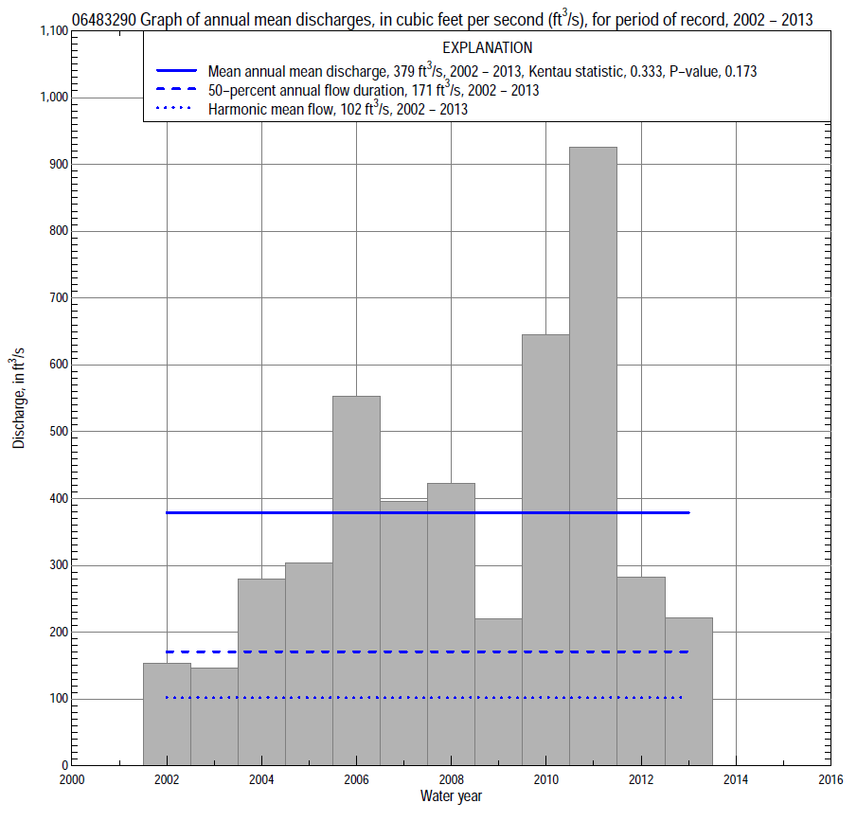

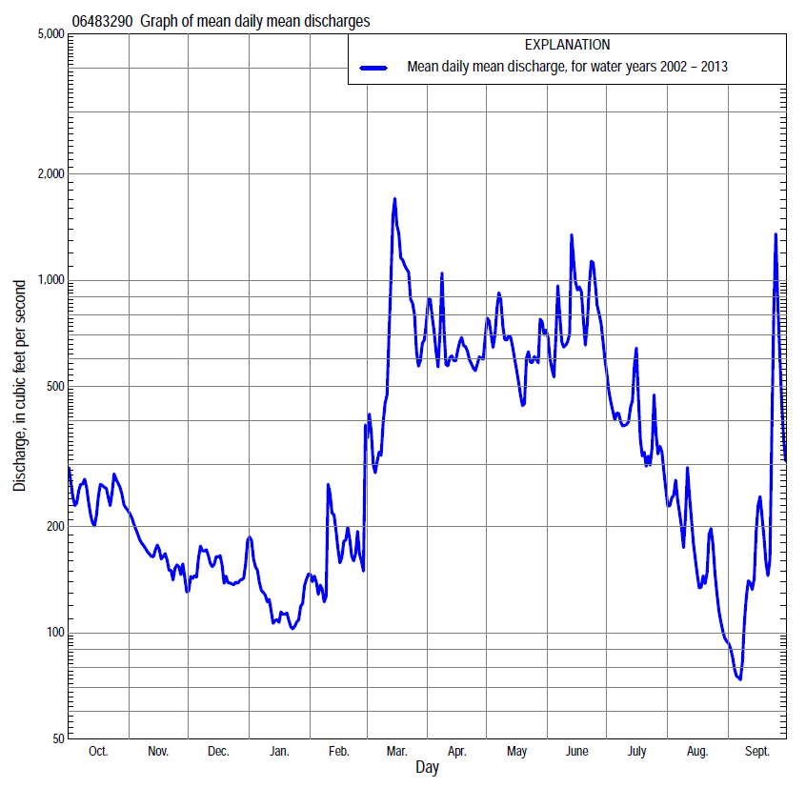

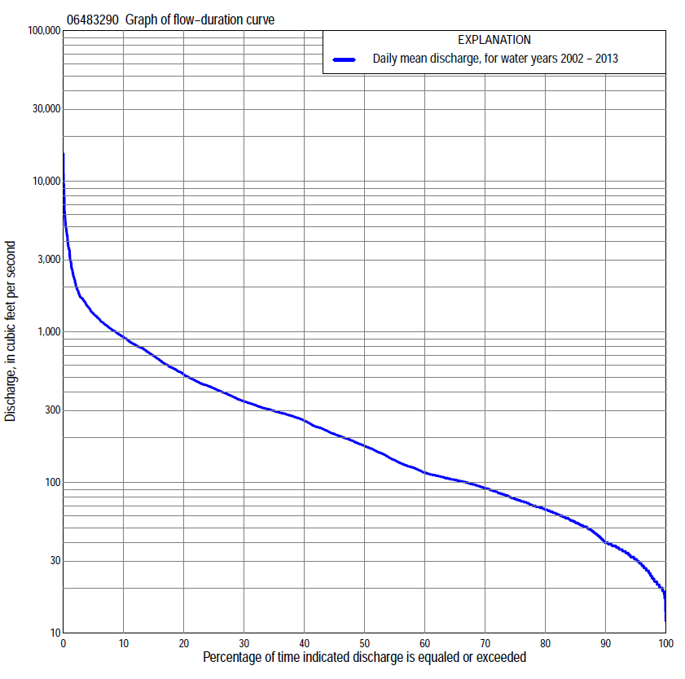

Statistics Based on the Entire Streamflow Period of Record
06483290 Monthly and annual flow durations, based on 2002–2013 period of record (12 years)
Percentage of days discharge equaled or exceeded |  |  |  |  | Discharge (cubic feet per second) |  |  |  |  |  |  |  |  | Annual flow durations
 | Oct | Nov | Dec | Jan | Feb | Mar | Apr | May | June | July | Aug | Sept | Annual | Kentau statistic | P-value
99 | 20 | 29 | 19 | 17 | 17 | 25 | 70 | 107 | 114 | 29 | 24 | 19 | 20 | 0.152 | 0.537
98 | 20 | 32 | 21 | 19 | 19 | 26 | 71 | 132 | 116 | 33 | 26 | 19 | 22 | 0.076 | 0.783
95 | 34 | 36 | 28 | 22 | 23 | 39 | 113 | 173 | 140 | 44 | 30 | 21 | 31 | 0.076 | 0.783
90 | 47 | 39 | 37 | 30 | 27 | 78 | 155 | 200 | 182 | 55 | 35 | 26 | 40 | 0.091 | 0.732
85 | 51 | 56 | 48 | 34 | 31 | 92 | 187 | 237 | 208 | 65 | 40 | 32 | 53 | 0.182 | 0.451
80 | 54 | 61 | 58 | 40 | 36 | 105 | 204 | 271 | 235 | 79 | 46 | 36 | 66 | 0.152 | 0.537
75 | 56 | 77 | 69 | 46 | 49 | 115 | 234 | 310 | 290 | 95 | 56 | 39 | 77 | 0.121 | 0.631
70 | 82 | 93 | 76 | 52 | 63 | 141 | 271 | 347 | 312 | 112 | 66 | 44 | 91 | 0.091 | 0.732
65 | 95 | 99 | 84 | 59 | 72 | 182 | 284 | 372 | 343 | 130 | 73 | 55 | 104 | 0.182 | 0.451
60 | 103 | 102 | 91 | 66 | 77 | 254 | 305 | 399 | 363 | 164 | 82 | 62 | 115 | 0.182 | 0.451
55 | 107 | 106 | 97 | 71 | 87 | 287 | 337 | 430 | 405 | 178 | 89 | 66 | 138 | 0.212 | 0.373
50 | 113 | 112 | 105 | 77 | 94 | 319 | 415 | 455 | 458 | 206 | 102 | 70 | 171 | 0.152 | 0.537
45 | 118 | 128 | 112 | 83 | 103 | 367 | 474 | 490 | 559 | 236 | 115 | 75 | 205 | 0.152 | 0.537
40 | 127 | 159 | 129 | 90 | 111 | 427 | 579 | 537 | 648 | 268 | 135 | 82 | 250 | 0.182 | 0.451
35 | 142 | 190 | 153 | 101 | 125 | 476 | 644 | 627 | 779 | 306 | 155 | 97 | 293 | 0.121 | 0.631
30 | 185 | 211 | 168 | 112 | 139 | 562 | 756 | 700 | 850 | 362 | 185 | 119 | 337 | 0.182 | 0.451
25 | 263 | 228 | 181 | 141 | 178 | 822 | 845 | 777 | 984 | 437 | 210 | 179 | 407 | 0.182 | 0.451
20 | 379 | 251 | 227 | 175 | 251 | 1,070 | 993 | 838 | 1,110 | 520 | 239 | 215 | 500 | 0.227 | 0.336
15 | 566 | 306 | 294 | 295 | 299 | 1,230 | 1,210 | 935 | 1,350 | 702 | 295 | 280 | 662 | 0.258 | 0.271
10 | 710 | 358 | 334 | 320 | 423 | 1,680 | 1,390 | 1,110 | 1,670 | 907 | 406 | 435 | 896 | 0.364 | 0.115
5 | 936 | 433 | 434 | 339 | 658 | 3,470 | 1,680 | 1,490 | 2,290 | 1,230 | 582 | 852 | 1,300 | 0.424 | 0.064
2 | 1,310 | 544 | 538 | 484 | 914 | 5,260 | 2,580 | 2,490 | 3,540 | 1,740 | 954 | 2,370 | 2,000 | 0.455 | 0.047
1 | 1,350 | 583 | 567 | 651 | 1,170 | 6,010 | 3,750 | 2,970 | 4,570 | 2,380 | 1,010 | 3,500 | 3,470 | 0.394 | 0.086

06483290 Annual exceedance probability of instantaneous peak discharges, in cubic feet per second (ft³/s), based on the Weighted Independent Estimates method,
Annual exceed-ance probability | Recur-rence interval (years) | Discharge (ft³/s) | 95-percent lower confi-dence interval (ft³/s) | 95-percent upper confi-dence interval (ft³/s)
0.500 | 2 | 4,410 | 3,500 | 5,550
0.200 | 5 | 10,500 | 8,550 | 13,000
0.100 | 10 | 15,700 | 12,700 | 19,400
0.040 | 25 | 23,400 | 18,500 | 29,600
0.020 | 50 | 28,900 | 22,200 | 37,700
0.010 | 100 | 34,200 | 25,300 | 46,300
0.005 | 200 | 41,800 | 29,600 | 59,100
0.002 | 500 | 47,200 | 31,700 | 70,400
and based on the expected moments algorithm/multiple Grubbs-Beck analysis computed using a historical period length of 87 years (1927–2013)ª
0.500 | 2 | 4,240 | 2,670 | 6,500
0.200 | 5 | 9,790 | 6,570 | 14,900
0.100 | 10 | 14,500 | 9,650 | 22,200
0.040 | 25 | 21,300 | 13,700 | 33,800
0.020 | 50 | 26,800 | 16,700 | 44,900
0.010 | 100 | 32,600 | 19,500 | 58,600
0.005 | 200 | 38,600 | 22,200 | 75,600
0.002 | 500 | 46,900 | 25,300 | 104,000
Kentau statistic |  | 0.273
P-value |  | 0.244
Begin year |  | 2002
End year |  | 2013
Number of peaks |  | 12
ªAnalysis includes interval annual-peak discharges (1960–74) from streamgage 06483270 Rock River at Rock Rapids.

06483290 Annual exceedance probability of high discharges, based on 2002–13 period of record (12 years)
Annual exceedance probability | Recur-rence interval (years) | Maximum average discharge (cubic feet per second) for indicated number of consecutive days
 |  | 1 | 3 | 7 | 15 | 30
0.990 | 1.01 | 438 | 399 | 287 | 193 | 167
0.950 | 1.05 | 850 | 758 | 550 | 386 | 325
0.900 | 1.11 | 1,200 | 1,060 | 767 | 545 | 450
0.800 | 1.25 | 1,800 | 1,560 | 1,130 | 807 | 650
0.500 | 2 | 3,820 | 3,170 | 2,270 | 1,600 | 1,210
0.200 | 5 | 7,860 | 6,170 | 4,300 | 2,900 | 2,030
0.100 | 10 | 11,300 | 8,600 | 5,890 | 3,840 | 2,570
0.040 | 25 | 16,500 | 12,100 | 8,110 | 5,050 | 3,210
0.020 | 50 | 20,900 | 15,000 | 9,880 | 5,950 | 3,660
0.010 | 100 | 25,800 | 18,100 | 11,700 | 6,840 | 4,070
0.005 | 200 | 31,200 | 21,400 | 13,700 | 7,720 | 4,460
0.002 | 500 | 39,100 | 26,100 | 16,400 | 8,870 | 4,940
Kentau statistic |  | 0.273 | 0.364 | 0.409 | 0.424 | 0.424
P-value |  | 0.244 | 0.115 | 0.074 | 0.064 | 0.064

 | 06483290 Annual nonexceedance probability of low discharges, based on April 2002 to March 2013 period of record (11 years)
Annual nonexceed-ance probability | Recur-rence interval (years) | Minimum average discharge (cubic feet per second) for indicated number of consecutive days
 |  | 1 | 3 | 7 | 14 | 30 | 60 | 90 | 120 | 183
0.01 | 100 | 7.6 | 11 | 12 | 13 | 14 | 16 | 18 | 18 | 20
0.02 | 50 | 8.8 | 12 | 13 | 14 | 16 | 18 | 21 | 22 | 24
0.05 | 20 | 11 | 14 | 16 | 17 | 19 | 23 | 26 | 29 | 32
0.10 | 10 | 14 | 17 | 18 | 20 | 22 | 28 | 33 | 37 | 42
0.20 | 5 | 19 | 22 | 23 | 26 | 29 | 38 | 45 | 52 | 59
0.50 | 2 | 34 | 37 | 40 | 44 | 50 | 68 | 82 | 98 | 119
0.80 | 1.25 | 67 | 70 | 76 | 83 | 101 | 136 | 160 | 196 | 261
0.90 | 1.11 | 99 | 102 | 112 | 121 | 154 | 202 | 233 | 286 | 405
0.96 | 1.04 | 154 | 158 | 176 | 188 | 253 | 317 | 355 | 435 | 664
0.98 | 1.02 | 207 | 213 | 240 | 255 | 357 | 431 | 471 | 574 | 927
0.99 | 1.01 | 272 | 283 | 323 | 340 | 496 | 575 | 613 | 740 | 1,260
Kentau statistic |  | 0.309 | 0.273 | 0.255 | 0.164 | 0.200 | 0.127 | 0.091 | 0.127 | 0.127
P-value |  | 0.213 | 0.276 | 0.310 | 0.533 | 0.436 | 0.640 | 0.756 | 0.640 | 0.640

06483290 Annual nonexceedance probability of seasonal low discharges, based on July 2001 to September 2013 period of record (12–13 years)
Annual nonexceed-ance probability | Recur-rence interval (years) | Minimum average discharge (cubic feet per second) for indicated number of consecutive days
 |  | 1 | 7 | 14 | 30 |  | 1 | 7 | 14 | 30
 |  | January-February-March |  |  |  |  | April-May-June
0.01 | 100 | 6.5 | 11 | 13 | 14 |  | 45 | 52 | 65 | 121
0.02 | 50 | 7.9 | 13 | 15 | 17 |  | 51 | 58 | 71 | 130
0.05 | 20 | 11 | 17 | 19 | 21 |  | 61 | 70 | 84 | 148
0.10 | 10 | 14 | 21 | 24 | 27 |  | 72 | 83 | 99 | 168
0.20 | 5 | 21 | 29 | 32 | 36 |  | 91 | 104 | 124 | 201
0.50 | 2 | 44 | 56 | 60 | 68 |  | 152 | 172 | 202 | 301
0.80 | 1.25 | 101 | 117 | 124 | 145 |  | 279 | 311 | 361 | 496
0.90 | 1.11 | 160 | 180 | 189 | 223 |  | 398 | 441 | 510 | 672
0.96 | 1.04 | 267 | 292 | 303 | 365 |  | 598 | 660 | 758 | 958
0.98 | 1.02 | 376 | 406 | 418 | 512 |  | 792 | 871 | 998 | 1,230
0.99 | 1.01 | 516 | 553 | 566 | 702 |  | 1,030 | 1,130 | 1,290 | 1,550
Kentau statistic |  | 0.091 | 0.091 | 0.152 | 0.061 |  | 0.258 | 0.152 | 0.273 | 0.303
P-value |  | 0.732 | 0.732 | 0.537 | 0.837 |  | 0.271 | 0.537 | 0.244 | 0.193
 |  | July-August-September |  |  |  |  | October-November-December
0.01 | 100 | 13 | 13 | 14 | 16 |  | 12 | 15 | 16 | 18
0.02 | 50 | 14 | 15 | 16 | 18 |  | 14 | 17 | 18 | 22
0.05 | 20 | 17 | 18 | 19 | 22 |  | 18 | 23 | 24 | 29
0.10 | 10 | 21 | 22 | 23 | 27 |  | 23 | 29 | 32 | 38
0.20 | 5 | 26 | 27 | 30 | 34 |  | 30 | 39 | 44 | 52
0.50 | 2 | 43 | 46 | 50 | 59 |  | 53 | 70 | 81 | 93
0.80 | 1.25 | 76 | 83 | 90 | 114 |  | 95 | 127 | 145 | 164
0.90 | 1.11 | 105 | 117 | 126 | 169 |  | 129 | 176 | 196 | 220
0.96 | 1.04 | 154 | 173 | 185 | 267 |  | 181 | 250 | 267 | 298
0.98 | 1.02 | 200 | 227 | 239 | 365 |  | 226 | 315 | 325 | 361
0.99 | 1.01 | 255 | 291 | 303 | 491 |  | 276 | 389 | 390 | 429
Kentau statistic |  | 0.064 | 0.000 | 0.026 | 0.000 |  | 0.076 | 0.121 | 0.152 | 0.182
P-value |  | 0.807 | 1.000 | 0.951 | 1.000 |  | 0.783 | 0.631 | 0.537 | 0.451

