LOCATION.--Lat 42°59'47", long 96°28'16" referenced to North American Datum of 1927, in NE 1/4 NE 1/4 NE 1/4 sec.02, T.94 N., R.48 W., Sioux County, IA, Hydrologic Unit 10170203, on left bank 5 ft downstream from bridge on State Highway 10 at eastern edge of Hawarden, and 2.0 mi upstream from mouth.

DRAINAGE AREA.--48.4 mi².

PERIOD OF RECORD.--Discharge records from June 1948 to September 1969.

GAGE.--Water-stage recorder and concrete control. Datum of gage is 1,170.42 ft above National Geodetic Vertical Datum of 1929. Prior to October 30, 1949, non-recording gage at same site and datum.

EXTREMES OUTSIDE PERIOD OF RECORD.--Flood in September 1926 reached a stage of about 18.00 ft and flood in 1934 reached a stage of about 15.80 ft (discharges not determined), from information by State Highway Commission.

A summary of all available data for this streamgage is provided through the USGS National Water Information System web interface (NWISWeb). The following link provides access to current/historical observations, daily data, daily statistics, monthly statistics, annual statistics, peak streamflow, field measurements, field/lab water-quality samples, and the latest water-year summaries. Data can be filtered by parameter and/or dates, and can be output in various tabular and graphical formats.
http://waterdata.usgs.gov/nwis/inventory/?site_no=06484000

The USGS WaterWatch Toolkit is available at:
http://waterwatch.usgs.gov/?id=ww_toolkit
Tools for summarizing streamflow information include the duration hydrograph builder, the cumulative streamflow hydrograph builder, the streamgage statistics retrieval tool, the rating curve builder, the flood tracking chart builder, the National Weather Service Advanced Hydrologic Prediction Service (AHPS) river forecast hydrograph builder, and the raster-hydrograph builder. Entering the above number for this streamgage into these toolkit webpages will provide streamflow information specific to this streamgage.

A description of the statistics presented for this streamgage is available in the main body of the report at:
http://dx.doi.org/10.3133/ofr20151214
A link to other streamgages included in this report, a map showing the location of the streamgages, information on the programs used to compute the statistical analyses, and references are included in the main body of the report.

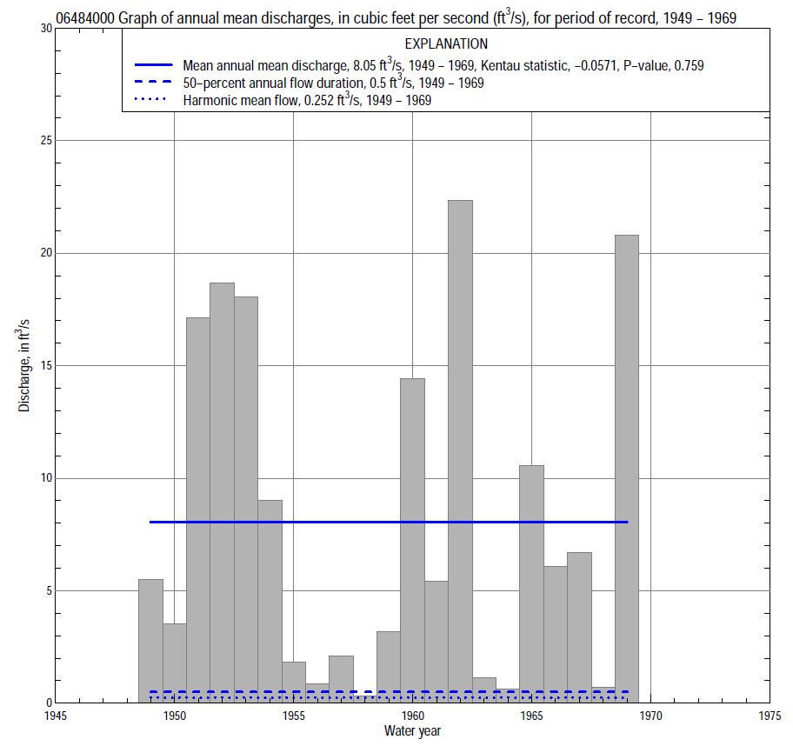

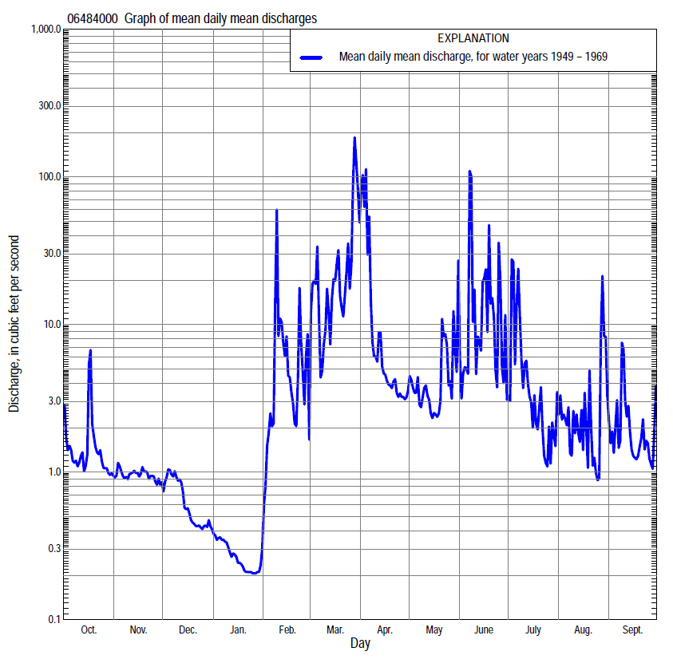

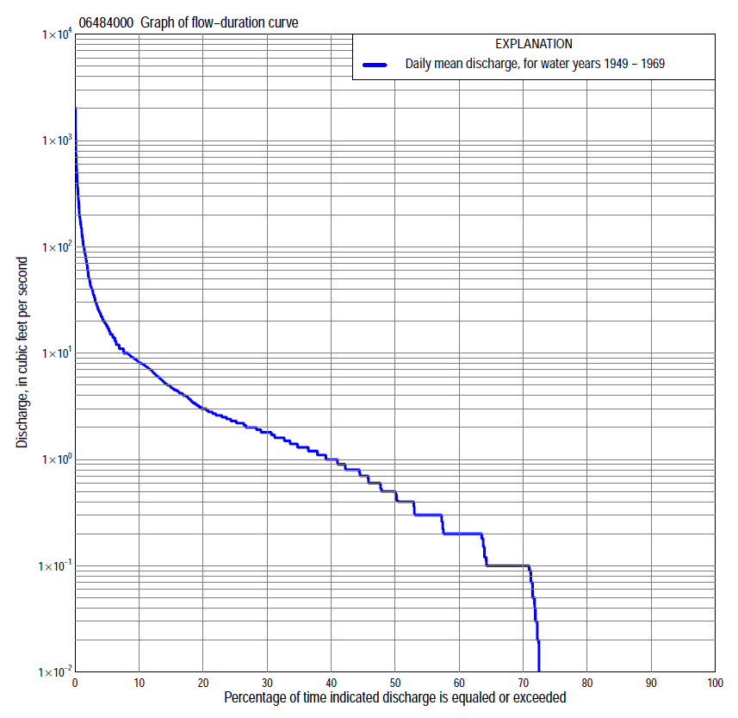

Statistics Based on the Entire Streamflow Period of Record
06484000 Monthly and annual flow durations, based on 1949–69 period of record (21 years)
Percentage of days discharge equaled or exceeded |  |  |  |  | Discharge (cubic feet per second) |  |  |  |  |  |  |  |  | Annual flow durations
 | Oct | Nov | Dec | Jan | Feb | Mar | Apr | May | June | July | Aug | Sept | Annual | Kentau statistic | P-value
99 | 0.00 | 0.00 | 0.00 | 0.00 | 0.00 | 0.00 | 0.00 | 0.00 | 0.00 | 0.00 | 0.00 | 0.00 | 0.00 | -0.124 | 0.134
98 | 0.00 | 0.00 | 0.00 | 0.00 | 0.00 | 0.00 | 0.00 | 0.00 | 0.00 | 0.00 | 0.00 | 0.00 | 0.00 | -0.124 | 0.134
95 | 0.00 | 0.00 | 0.00 | 0.00 | 0.00 | 0.00 | 0.00 | 0.00 | 0.00 | 0.00 | 0.00 | 0.00 | 0.00 | -0.124 | 0.134
90 | 0.00 | 0.00 | 0.00 | 0.00 | 0.00 | 0.00 | 0.20 | 0.10 | 0.00 | 0.00 | 0.00 | 0.00 | 0.00 | -0.124 | 0.134
85 | 0.00 | 0.00 | 0.00 | 0.00 | 0.00 | 0.00 | 0.30 | 0.12 | 0.00 | 0.00 | 0.00 | 0.00 | 0.00 | -0.181 | 0.064
80 | 0.00 | 0.00 | 0.00 | 0.00 | 0.00 | 0.10 | 0.60 | 0.20 | 0.10 | 0.10 | 0.00 | 0.00 | 0.00 | -0.181 | 0.064
75 | 0.00 | 0.09 | 0.00 | 0.00 | 0.00 | 0.26 | 0.80 | 0.40 | 0.30 | 0.20 | 0.00 | 0.00 | 0.00 | -0.181 | 0.064
70 | 0.00 | 0.10 | 0.00 | 0.00 | 0.00 | 0.40 | 0.90 | 0.50 | 0.41 | 0.20 | 0.10 | 0.00 | 0.10 | -0.181 | 0.064
65 | 0.07 | 0.10 | 0.05 | 0.00 | 0.00 | 0.60 | 1.3 | 0.80 | 0.60 | 0.30 | 0.10 | 0.10 | 0.10 | -0.181 | 0.064
60 | 0.10 | 0.20 | 0.10 | 0.00 | 0.00 | 0.90 | 1.8 | 0.90 | 1.0 | 0.40 | 0.20 | 0.20 | 0.20 | -0.181 | 0.064
55 | 0.10 | 0.20 | 0.10 | 0.00 | 0.00 | 1.0 | 2.0 | 1.2 | 1.3 | 0.50 | 0.20 | 0.20 | 0.30 | -0.167 | 0.131
50 | 0.20 | 0.30 | 0.12 | 0.00 | 0.00 | 1.6 | 2.4 | 1.5 | 1.7 | 0.70 | 0.30 | 0.30 | 0.50 | -0.133 | 0.327
45 | 0.30 | 0.40 | 0.20 | 0.00 | 0.00 | 2.3 | 3.0 | 1.7 | 2.0 | 1.1 | 0.50 | 0.50 | 0.70 | -0.157 | 0.279
40 | 0.50 | 0.50 | 0.20 | 0.00 | 0.10 | 3.3 | 3.8 | 2.0 | 2.5 | 1.6 | 0.80 | 0.80 | 1.0 | -0.162 | 0.282
35 | 0.80 | 0.70 | 0.30 | 0.00 | 0.30 | 5.0 | 4.4 | 2.4 | 2.8 | 2.3 | 1.2 | 1.1 | 1.4 | -0.181 | 0.239
30 | 1.3 | 0.80 | 0.41 | 0.10 | 0.50 | 7.0 | 5.5 | 3.1 | 3.5 | 3.0 | 1.6 | 1.3 | 1.8 | -0.162 | 0.297
25 | 1.6 | 1.1 | 0.90 | 0.10 | 1.0 | 10 | 7.1 | 4.2 | 5.5 | 3.7 | 2.0 | 1.9 | 2.3 | -0.157 | 0.317
20 | 1.8 | 1.4 | 1.1 | 0.50 | 2.0 | 18 | 8.8 | 5.2 | 8.1 | 4.6 | 2.3 | 2.4 | 3.0 | -0.114 | 0.476
15 | 2.4 | 1.8 | 1.3 | 0.70 | 4.5 | 25 | 11 | 7.2 | 11 | 5.9 | 2.8 | 2.7 | 4.9 | -0.190 | 0.233
10 | 3.1 | 2.2 | 1.5 | 1.3 | 12 | 60 | 17 | 10 | 16 | 8.1 | 4.6 | 4.3 | 8.4 | -0.148 | 0.360
5 | 7.5 | 3.3 | 2.5 | 1.4 | 35 | 150 | 42 | 14 | 42 | 18 | 11 | 9.2 | 18 | -0.133 | 0.413
2 | 9.7 | 8.2 | 6.0 | 2.1 | 60 | 338 | 136 | 25 | 150 | 40 | 24 | 18 | 60 | -0.014 | 0.952
1 | 14 | 8.6 | 8.6 | 2.2 | 100 | 550 | 400 | 52 | 365 | 69 | 42 | 31 | 150 | -0.090 | 0.587

06484000 Annual exceedance probability of instantaneous peak discharges, in cubic feet per second (ft³/s), based on the Weighted Independent Estimates method,
Annual exceed-ance probability | Recur-rence interval (years) | Discharge (ft³/s) | 95-percent lower confi-dence interval (ft³/s) | 95-percent upper confi-dence interval (ft³/s)
0.500 | 2 | 951 | 676 | 1,340
0.200 | 5 | 2,720 | 1,980 | 3,730
0.100 | 10 | 4,220 | 3,050 | 5,850
0.040 | 25 | 6,430 | 4,490 | 9,200
0.020 | 50 | 8,050 | 5,410 | 12,000
0.010 | 100 | 9,670 | 6,260 | 14,900
0.005 | 200 | 11,200 | 7,020 | 18,000
0.002 | 500 | 13,200 | 7,790 | 22,500
and based on the expected moments algorithm/multiple Grubbs-Beck analysis computed using a historical period length of 57 years (1926–1982)
0.500 | 2 | 853 | 443 | 1,500
0.200 | 5 | 2,550 | 1,430 | 4,480
0.100 | 10 | 4,320 | 2,390 | 7,930
0.040 | 25 | 7,310 | 3,910 | 14,900
0.020 | 50 | 10,100 | 5,200 | 22,900
0.010 | 100 | 13,300 | 6,580 | 34,300
0.005 | 200 | 17,000 | 7,990 | 50,500
0.002 | 500 | 22,600 | 9,880 | 82,600
Kentau statistic |  | 0.105
P-value |  | 0.526
Begin year |  | 1949
End year |  | 1969
Number of peaks |  | 21

06484000 Annual exceedance probability of high discharges, based on 1949–69 period of record (21 years)
Annual exceedance probability | Recur-rence interval (years) | Maximum average discharge (ft³/s) for indicated number of consecutive days
 |  | 1 | 3 | 7 | 15 | 30
0.990 | 1.01 | 6.6 | 4.3 | 2.1 | 1.2 | 0.71
0.950 | 1.05 | 27 | 15 | 7.8 | 4.6 | 2.7
0.900 | 1.11 | 52 | 28 | 15 | 8.8 | 5.2
0.800 | 1.25 | 110 | 58 | 31 | 19 | 11
0.500 | 2 | 388 | 202 | 115 | 66 | 38
0.200 | 5 | 1,090 | 608 | 354 | 193 | 109
0.100 | 10 | 1,710 | 1,020 | 601 | 315 | 176
0.040 | 25 | 2,620 | 1,700 | 1,010 | 506 | 278
0.020 | 50 | 3,350 | 2,310 | 1,370 | 670 | 364
0.010 | 100 | 4,090 | 3,000 | 1,790 | 846 | 455
0.005 | 200 | 4,840 | 3,770 | 2,240 | 1,030 | 551
0.002 | 500 | 5,810 | 4,900 | 2,910 | 1,300 | 683
Kentau statistic |  | 0.062 | -0.038 | -0.010 | 0.010 | 0.000
P-value |  | 0.717 | 0.833 | 0.976 | 0.976 | 1.000

 | 06484000 Annual nonexceedance probability of low discharges, based on April 1949 to March 1969 period of record (20 years)
Annual nonexceed-ance probability | Recur-rence interval (years) | Minimum average discharge (cubic feet per second) for indicated number of consecutive days
 |  | 1 | 3 | 7 | 14 | 30 | 60 | 90 | 120 | 183
0.01 | 100 | 0.00 | 0.16 | 0.00 | 0.00 | 0.00 | 0.00 | 0.00 | 0.00 | 0.00
0.02 | 50 | 0.00 | 0.16 | 0.00 | 0.00 | 0.00 | 0.00 | 0.00 | 0.00 | 0.00
0.05 | 20 | 0.00 | 0.16 | 0.00 | 0.00 | 0.00 | 0.00 | 0.00 | 0.00 | 0.00
0.10 | 10 | 0.00 | 0.16 | 0.00 | 0.00 | 0.00 | 0.00 | 0.00 | 0.00 | 0.01
0.20 | 5 | 0.00 | 0.16 | 0.00 | 0.00 | 0.00 | 0.00 | 0.00 | 0.02 | 0.05
0.50 | 2 | 0.00 | 0.16 | 0.00 | 0.00 | 0.00 | 0.03 | 0.06 | 0.15 | 0.32
0.80 | 1.25 | 0.00 | 0.00 | 0.00 | 0.09 | 0.23 | 0.44 | 0.68 | 0.77 | 1.6
0.90 | 1.11 | 0.26 | 0.56 | 0.60 | 0.70 | 0.74 | 1.2 | 1.6 | 1.8 | 3.6
0.96 | 1.04 | 1.1 | 1.1 | 1.5 | 2.0 | 2.1 | 3.1 | 3.9 | 4.5 | 8.0
0.98 | 1.02 | 1.9 | 2.1 | 2.3 | 2.8 | 3.2 | 5.2 | 5.9 | 8.1 | 13
0.99 | 1.01 | 3.0 | 3.1 | 3.1 | 3.4 | 4.8 | 8.4 | 9.5 | 14 | 20
Kentau statistic |  | -0.200 | -0.284 | -0.284 | -0.268 | -0.121 | -0.232 | -0.205 | -0.237 | -0.137
P-value |  | 0.051 | 0.013 | 0.013 | 0.032 | 0.432 | 0.148 | 0.211 | 0.153 | 0.417

06484000 Annual nonexceedance probability of seasonal low discharges, based on July 1948 to September 1969 period of record (21–22 years)
Annual nonexceed-ance probability | Recur-rence interval (years) | Minimum average discharge (cubic feet per second) for indicated number of consecutive days
 |  | 1 | 7 | 14 | 30 |  | 1 | 7 | 14 | 30
 |  | January-February-March |  |  |  |  | April-May-June
0.01 | 100 | 0.00 | 0.00 | 0.00 | 0.00 |  | 0.00 | 0.00 | 0.00 | 0.00
0.02 | 50 | 0.00 | 0.00 | 0.00 | 0.00 |  | 0.00 | 0.00 | 0.00 | 0.00
0.05 | 20 | 0.00 | 0.00 | 0.00 | 0.00 |  | 0.00 | 0.00 | 0.00 | 0.01
0.10 | 10 | 0.00 | 0.00 | 0.00 | 0.00 |  | 0.00 | 0.00 | 0.00 | 0.02
0.20 | 5 | 0.00 | 0.00 | 0.00 | 0.00 |  | 0.00 | 0.00 | 0.00 | 0.08
0.50 | 2 | 0.00 | 0.00 | 0.00 | 0.00 |  | 0.27 | 0.42 | 0.61 | 0.83
0.80 | 1.25 | 0.00 | 0.00 | 0.06 | 0.16 |  | 1.2 | 1.7 | 2.3 | 3.7
0.90 | 1.11 | 0.76 | 0.76 | 0.79 | 0.60 |  | 2.3 | 3.1 | 4.3 | 5.8
0.96 | 1.04 | 1.6 | 1.6 | 2.0 | 2.0 |  | 4.1 | 5.5 | 7.0 | 13
0.98 | 1.02 | 2.3 | 2.3 | 2.8 | 4.0 |  | 6.0 | 7.8 | 9.7 | 17
0.99 | 1.01 | 3.2 | 3.2 | 3.5 | 7.3 |  | 8.3 | 11 | 13 | 21
Kentau statistic |  | -0.238 | -0.238 | -0.219 | -0.067 |  | -0.238 | -0.224 | -0.219 | -0.243
P-value |  | 0.030 | 0.030 | 0.067 | 0.662 |  | 0.127 | 0.159 | 0.171 | 0.131
 |  | July-August-September |  |  |  |  | October-November-December
0.01 | 100 | 0.00 | 0.00 | 0.00 | 0.00 |  | 0.00 | 0.00 | 0.00 | 0.00
0.02 | 50 | 0.00 | 0.00 | 0.00 | 0.00 |  | 0.00 | 0.00 | 0.00 | 0.00
0.05 | 20 | 0.00 | 0.00 | 0.00 | 0.00 |  | 0.00 | 0.00 | 0.00 | 0.00
0.10 | 10 | 0.00 | 0.00 | 0.00 | 0.00 |  | 0.00 | 0.00 | 0.00 | 0.00
0.20 | 5 | 0.00 | 0.00 | 0.00 | 0.00 |  | 0.00 | 0.00 | 0.00 | 0.00
0.50 | 2 | 0.00 | 0.00 | 0.07 | 0.24 |  | 0.00 | 0.01 | 0.02 | 0.10
0.80 | 1.25 | 0.70 | 0.80 | 1.1 | 1.2 |  | 0.16 | 0.39 | 0.48 | 0.63
0.90 | 1.11 | 1.3 | 1.5 | 2.1 | 2.4 |  | 0.45 | 1.0 | 1.2 | 1.5
0.96 | 1.04 | 2.1 | 2.8 | 3.2 | 5.3 |  | 1.3 | 2.6 | 2.6 | 3.8
0.98 | 1.02 | 2.9 | 4.0 | 6.0 | 8.7 |  | 2.5 | 4.7 | 5.5 | 7.0
0.99 | 1.01 | 3.6 | 5.4 | 9.0 | 14 |  | 4.8 | 7.7 | 10 | 12
Kentau statistic |  | -0.134 | -0.139 | -0.160 | -0.121 |  | 0.014 | -0.100 | -0.100 | -0.081
P-value |  | 0.352 | 0.348 | 0.301 | 0.441 |  | 0.942 | 0.520 | 0.521 | 0.624

