LOCATION.--Lat 42°29'09", long 96°24'49" referenced to North American Datum of 1927, in NW 1/4 SE 1/4 sec.16, T.29 N., R.9 E., Dakota County, NE, Hydrologic Unit 10230001, on right bank on upstream side of bridge on U.S. Highway 20 and 77 in South Sioux City, 1.9 mi downstream from Big Sioux River, and 732.2 mi upstream from mouth.

DRAINAGE AREA.--314,600 mi².

PERIOD OF RECORD.--Discharge records from October 1897 to current year. Prior to October 1928 and October 1931 to September 1938, monthly mean discharge published in WSP 1310. January 1879 to December 1890, monthly mean discharge published in House Document 238, 73rd Congress, 2nd session, Missouri River. Gage-height records collected in this vicinity from September 1878 to December 1899 published in reports of the Missouri River Commission, and since July 1889 in reports of the U.S. National Weather Service.

GAGE.--Water-stage recorder. Datum of gage is 1,056.98 ft above National Geodetic Vertical Datum of 1929. September 2, 1878, to December 31, 1905, non-recording gage at several sites within 1.7 mi of current site at various datums; January 1, 1906, to February 14, 1935, non-recording gage, and February 15, 1935, to September 30, 1969, water-stage recorder, both at site 227 ft downstream at datum 19.98 ft higher; October 1, 1969, to September 30, 1970, water-stage recorder at site 227 ft downstream at datum 20.00 ft higher; October 1, 1970, to January 30, 1981, water-stage recorder at site 227 ft downstream at same datum.

REMARKS.--Flow regulated by upstream main-stem reservoirs. Fort Randall Dam was completed in July 1952, with storage beginning in December 1952. Gavins Point Dam was completed in July 1955, with storage beginning in December 1955.

A summary of all available data for this streamgage is provided through the USGS National Water Information System web interface (NWISWeb). The following link provides access to current/historical observations, daily data, daily statistics, monthly statistics, annual statistics, peak streamflow, field measurements, field/lab water-quality samples, and the latest water-year summaries. Data can be filtered by parameter and/or dates, and can be output in various tabular and graphical formats.
http://waterdata.usgs.gov/nwis/inventory/?site_no=06486000

The USGS WaterWatch Toolkit is available at:
http://waterwatch.usgs.gov/?id=ww_toolkit
Tools for summarizing streamflow information include the duration hydrograph builder, the cumulative streamflow hydrograph builder, the streamgage statistics retrieval tool, the rating curve builder, the flood tracking chart builder, the National Weather Service Advanced Hydrologic Prediction Service (AHPS) river forecast hydrograph builder, and
the raster-hydrograph builder. Entering the above number for this streamgage into these toolkit webpages will provide streamflow information specific to this streamgage.

A description of the statistics presented for this streamgage is available in the main body of the report at:
http://dx.doi.org/10.3133/ofr20151214
A link to other streamgages included in this report, a map showing the location of the streamgages, information on the programs used to compute the statistical analyses, and references are included in the main body of the report.

Statistics Based on the Pre-regulated Streamflow Period of Record

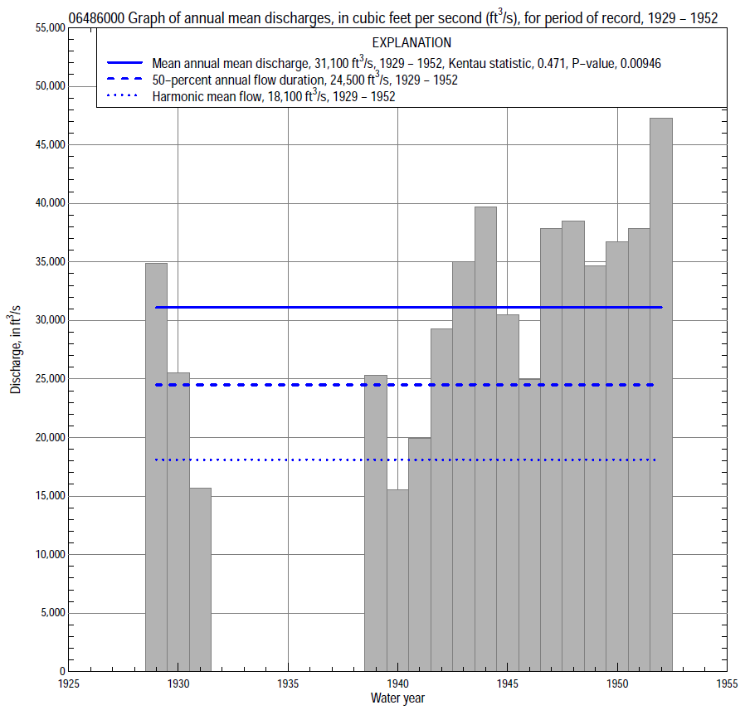

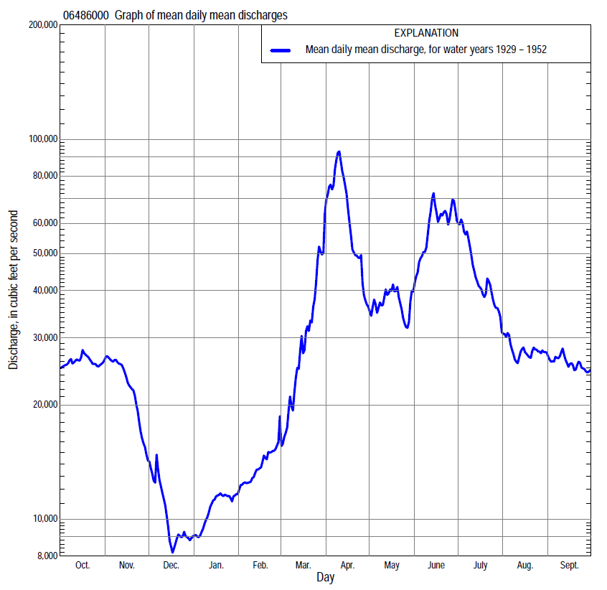

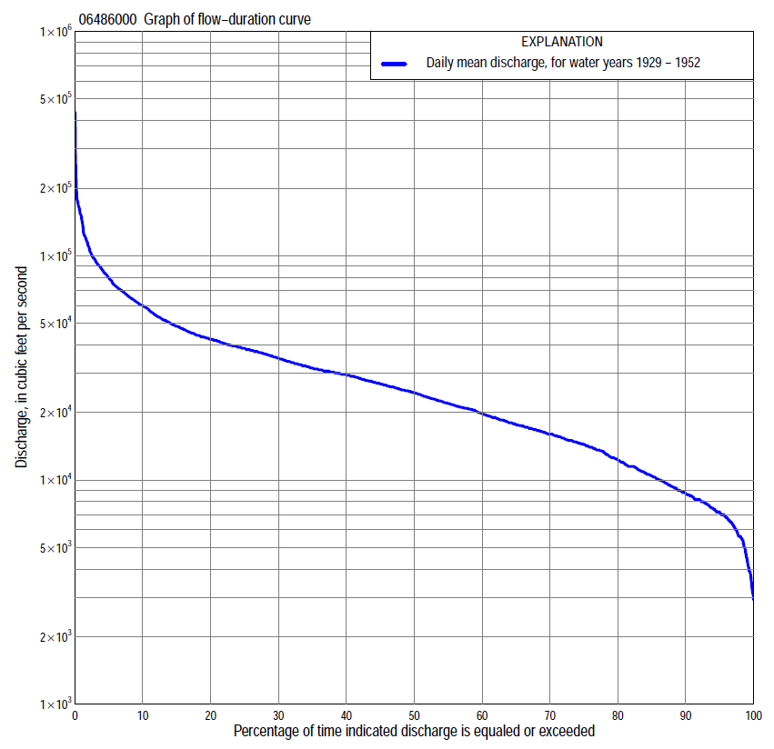

Statistics Based on the Pre-regulated Streamflow Period of Record
06486000 Monthly and annual flow durations, based on 1929–31, 1939–52 pre-regulated period of record (17 years)
Percentage of days discharge equaled or exceeded |  |  |  |  | Discharge (cubic feet per second) |  |  |  |  |  |  |  |  | Annual flow durations
 | Oct | Nov | Dec | Jan | Feb | Mar | Apr | May | June | July | Aug | Sept | Annual | Kentau statistic | P-value
99 | 8,960 | 4,500 | 3,240 | 3,100 | 5,400 | 6,400 | 14,100 | 12,600 | 20,600 | 13,000 | 9,340 | 7,550 | 4,500 | -0.074 | 0.711
98 | 9,660 | 5,400 | 3,700 | 3,400 | 5,500 | 7,300 | 15,100 | 13,800 | 22,600 | 16,400 | 9,800 | 7,690 | 5,600 | -0.029 | 0.902
95 | 10,300 | 7,400 | 4,300 | 4,300 | 5,600 | 8,300 | 18,500 | 15,400 | 25,100 | 18,900 | 12,900 | 8,620 | 7,200 | 0.074 | 0.711
90 | 13,800 | 10,400 | 5,510 | 6,400 | 6,900 | 11,800 | 20,300 | 17,400 | 29,300 | 21,800 | 15,400 | 11,200 | 8,700 | 0.324 | 0.077
85 | 15,900 | 12,100 | 6,000 | 7,000 | 7,800 | 14,000 | 22,000 | 20,500 | 32,600 | 25,500 | 17,600 | 13,600 | 10,400 | 0.382 | 0.035
80 | 16,500 | 14,000 | 6,600 | 7,400 | 8,700 | 15,000 | 24,500 | 21,500 | 35,200 | 28,600 | 19,000 | 15,300 | 12,300 | 0.382 | 0.035
75 | 17,400 | 15,100 | 7,000 | 8,000 | 9,300 | 16,000 | 26,500 | 23,100 | 38,100 | 31,000 | 20,600 | 18,600 | 14,400 | 0.493 | 0.007
70 | 20,100 | 16,600 | 7,400 | 8,370 | 10,000 | 16,700 | 30,600 | 26,400 | 41,100 | 33,000 | 21,700 | 21,200 | 16,000 | 0.544 | 0.003
65 | 21,200 | 17,500 | 8,000 | 8,600 | 10,900 | 17,400 | 34,400 | 29,900 | 43,500 | 35,200 | 22,500 | 22,700 | 17,600 | 0.588 | 0.001
60 | 22,500 | 18,500 | 8,200 | 8,900 | 11,500 | 18,400 | 37,500 | 31,300 | 46,000 | 37,100 | 24,400 | 24,000 | 19,800 | 0.676 | 0.000
55 | 23,800 | 19,300 | 8,640 | 9,400 | 11,500 | 19,300 | 39,800 | 32,300 | 48,600 | 39,000 | 26,000 | 25,500 | 21,900 | 0.654 | 0.000
50 | 25,500 | 20,300 | 9,200 | 10,300 | 12,200 | 20,700 | 43,000 | 33,900 | 51,600 | 40,500 | 27,200 | 27,200 | 24,500 | 0.706 | 0.000
45 | 27,000 | 22,500 | 9,700 | 10,700 | 13,500 | 24,100 | 47,800 | 35,400 | 54,500 | 43,000 | 28,100 | 28,700 | 26,800 | 0.691 | 0.000
40 | 27,700 | 24,100 | 10,100 | 11,500 | 14,400 | 25,200 | 52,900 | 37,400 | 58,300 | 45,700 | 30,000 | 29,300 | 29,300 | 0.588 | 0.001
35 | 29,000 | 25,200 | 10,900 | 12,500 | 15,000 | 28,100 | 60,800 | 39,900 | 62,700 | 48,300 | 31,400 | 29,800 | 31,600 | 0.566 | 0.002
30 | 30,600 | 26,800 | 11,600 | 13,200 | 16,000 | 34,600 | 69,000 | 41,600 | 67,900 | 51,500 | 32,700 | 30,300 | 34,900 | 0.559 | 0.002
25 | 33,400 | 28,700 | 12,300 | 13,700 | 16,900 | 40,000 | 75,300 | 44,200 | 73,600 | 55,400 | 34,200 | 30,900 | 38,600 | 0.471 | 0.009
20 | 36,100 | 30,300 | 13,400 | 14,400 | 18,000 | 44,800 | 89,800 | 48,500 | 80,300 | 60,000 | 36,800 | 31,600 | 42,500 | 0.382 | 0.036
15 | 37,400 | 32,300 | 14,600 | 15,000 | 20,000 | 52,000 | 108,000 | 53,600 | 87,400 | 64,600 | 38,200 | 32,900 | 48,500 | 0.250 | 0.174
10 | 39,400 | 38,200 | 17,300 | 16,200 | 21,700 | 64,800 | 144,000 | 61,400 | 97,200 | 70,200 | 41,000 | 37,200 | 59,800 | 0.206 | 0.266
5 | 43,700 | 42,000 | 21,000 | 17,700 | 26,000 | 85,300 | 174,000 | 71,600 | 120,000 | 87,200 | 45,700 | 42,800 | 80,000 | 0.265 | 0.149
2 | 47,400 | 44,200 | 25,000 | 18,100 | 29,000 | 104,000 | 219,000 | 91,000 | 150,000 | 103,000 | 50,200 | 52,700 | 110,000 | 0.324 | 0.077
1 | 48,800 | 44,600 | 25,200 | 18,300 | 30,600 | 111,000 | 282,000 | 97,600 | 165,000 | 117,000 | 55,600 | 60,300 | 145,000 | 0.338 | 0.064

06486000 Annual exceedance probability of instantaneous peak discharges, in cubic feet per second (ft³/s), for the pre-regulated period of record based on the expected moments algorithm/multiple Grubbs-Beck analysis computed using a historical period length of 72 years (1881–1952)ª
Annual exceed-ance probability | Recur-rence interval (years) | Discharge (ft³/s) | 95-percent lower confi-dence interval (ft³/s) | 95-percent upper confi-dence interval (ft³/s)
0.500 | 2 | 120,000 | 93,000 | 150,000
0.200 | 5 | 185,000 | 148,000 | 235,000
0.100 | 10 | 231,000 | 182,000 | 299,000
0.040 | 25 | 291,000 | 222,000 | 395,000
0.020 | 50 | 337,000 | 251,000 | 482,000
0.010 | 100 | 384,000 | 278,000 | 584,000
0.005 | 200 | 432,000 | 303,000 | 705,000
0.002 | 500 | 498,000 | 335,000 | 901,000
Kentau statistic |  | 0.287
P-value |  | 0.117
Begin year |  | 1929
End year |  | 1952
Number of peaks |  | 17
ªWeighted Independent Estimates were not computed because regional regression equations are not applicable due to watershed extending outside of Iowa flood regions.
Note: The above discharges are for the pre-regulated period of record and they are not applicable for flood-plain management regulation or for design purposes.

06486000 Annual exceedance probability of high discharges, based on 1929-31, 1939-52 pre-regulated period of record (17 years)
[ND, not determined]
Annual exceed-ance probability | Recur-rence interval (years) | Maximum average discharge (cubic feet per second) for indicated number of consecutive days
 |  | 1 | 3 | 7 | 15 | 30
0.990 | 1.01 | ND | ND | 29,700 | 28,200 | 25,000
0.950 | 1.05 | ND | ND | 45,400 | 41,000 | 35,400
0.900 | 1.11 | ND | ND | 56,600 | 49,800 | 42,400
0.800 | 1.25 | ND | ND | 73,200 | 62,600 | 52,300
0.500 | 2 | ND | ND | 117,000 | 95,700 | 77,100
0.200 | 5 | ND | ND | 182,000 | 143,000 | 111,000
0.100 | 10 | ND | ND | 227,000 | 175,000 | 133,000
0.040 | 25 | ND | ND | 285,000 | 216,000 | 161,000
0.020 | 50 | ND | ND | 328,000 | 247,000 | 181,000
0.010 | 100 | ND | ND | 372,000 | 277,000 | 200,000
0.005 | 200 | ND | ND | 416,000 | 308,000 | 220,000
0.002 | 500 | ND | ND | 474,000 | 349,000 | 246,000
Kentau statistic |  | 0.301 | 0.324 | 0.353 | 0.338 | 0.412
P-value |  | 0.099 | 0.077 | 0.053 | 0.064 | 0.023
Note: The above discharges are for the pre-regulated period of record and they are not applicable for flood-plain management regulation or for design purposes.

 | 06486000 Annual nonexceedance probability of low discharges, based on April 1929 to March 1931, April 1939 to March 1952 pre-regulated period of record (15 years)
Annual nonexceed-ance probability | Recur-rence interval (years) | Minimum average discharge (cubic feet per second) for indicated number of consecutive days
 |  | 1 | 3 | 7 | 14 | 30 | 60 | 90 | 120 | 183
0.01 | 100 | 2,250 | 2,390 | 2,730 | 3,040 | 3,430 | 3,980 | 4,750 | 5,740 | 6,370
0.02 | 50 | 2,400 | 2,550 | 2,910 | 3,280 | 3,790 | 4,460 | 5,240 | 6,360 | 7,330
0.05 | 20 | 2,670 | 2,840 | 3,230 | 3,680 | 4,390 | 5,270 | 6,060 | 7,380 | 8,930
0.10 | 10 | 2,960 | 3,150 | 3,570 | 4,110 | 4,990 | 6,060 | 6,890 | 8,380 | 10,500
0.20 | 5 | 3,420 | 3,630 | 4,090 | 4,710 | 5,810 | 7,130 | 8,020 | 9,730 | 12,700
0.50 | 2 | 4,730 | 4,980 | 5,500 | 6,260 | 7,700 | 9,470 | 10,600 | 12,800 | 17,300
0.80 | 1.25 | 7,040 | 7,290 | 7,790 | 8,540 | 10,100 | 12,200 | 14,000 | 16,400 | 22,400
0.90 | 1.11 | 8,940 | 9,150 | 9,560 | 10,200 | 11,600 | 13,700 | 16,100 | 18,500 | 25,100
0.96 | 1.04 | 11,800 | 11,900 | 12,100 | 12,300 | 13,300 | 15,500 | 18,600 | 20,900 | 28,000
0.98 | 1.02 | 14,000 | 14,000 | 14,000 | 14,000 | 14,600 | 16,600 | 20,400 | 22,600 | 29,900
0.99 | 1.01 | 15,800 | 15,800 | 15,800 | 15,800 | 15,800 | 17,700 | 22,100 | 24,200 | 31,500
Kentau statistic |  | 0.105 | 0.029 | 0.029 | 0.010 | 0.162 | 0.371 | 0.448 | 0.467 | 0.657
P-value |  | 0.621 | 0.921 | 0.921 | 1.000 | 0.428 | 0.060 | 0.023 | 0.018 | 0.001

06486000 Annual nonexceedance probability of seasonal low discharges, based on October 1928 to September 1931, October 1938 to September 1952 pre-regulated period of record (17 years)
Annual nonexceed-ance probability | Recur-rence interval (years) | Minimum average discharge (cubic feet per second) for indicated number of consecutive days
 |  | 1 | 7 | 14 | 30 |  | 1 | 7 | 14 | 30
 |  | January-February-March |  |  |  |  | April-May-June
0.01 | 100 | 2,830 | 2,830 | 2,900 | 3,240 |  | 9,640 | 9,900 | 10,700 | 11,200
0.02 | 50 | 3,250 | 3,290 | 3,430 | 3,860 |  | 10,900 | 11,200 | 12,000 | 12,900
0.05 | 20 | 3,920 | 4,080 | 4,340 | 4,930 |  | 13,000 | 13,400 | 14,300 | 15,700
0.10 | 10 | 4,600 | 4,870 | 5,240 | 6,000 |  | 15,000 | 15,600 | 16,600 | 18,500
0.20 | 5 | 5,520 | 5,930 | 6,450 | 7,400 |  | 17,900 | 18,700 | 19,700 | 22,300
0.50 | 2 | 7,560 | 8,230 | 8,990 | 10,300 |  | 24,500 | 25,900 | 27,200 | 30,900
0.80 | 1.25 | 9,950 | 10,700 | 11,600 | 13,100 |  | 32,700 | 35,000 | 36,700 | 40,900
0.90 | 1.11 | 11,300 | 12,100 | 12,800 | 14,400 |  | 37,700 | 40,700 | 42,600 | 46,600
0.96 | 1.04 | 12,800 | 13,500 | 14,100 | 15,600 |  | 43,500 | 47,400 | 49,700 | 53,000
0.98 | 1.02 | 13,800 | 14,300 | 14,800 | 16,200 |  | 47,500 | 52,100 | 54,700 | 57,200
0.99 | 1.01 | 14,700 | 15,100 | 15,300 | 16,700 |  | 51,300 | 56,600 | 59,500 | 61,000
Kentau statistic |  | 0.162 | 0.287 | 0.338 | 0.294 |  | 0.360 | 0.346 | 0.382 | 0.397
P-value |  | 0.386 | 0.117 | 0.064 | 0.108 |  | 0.048 | 0.058 | 0.036 | 0.029
 |  | July-August-September |  |  |  |  | October-November-December
0.01 | 100 | 4,910 | 5,110 | 5,390 | 6,360 |  | 2,290 | 3,090 | 4,050 | 5,770
0.02 | 50 | 5,970 | 6,220 | 6,590 | 7,730 |  | 2,490 | 3,300 | 4,270 | 6,030
0.05 | 20 | 7,890 | 8,210 | 8,730 | 10,200 |  | 2,850 | 3,680 | 4,650 | 6,490
0.10 | 10 | 9,920 | 10,300 | 11,000 | 12,700 |  | 3,230 | 4,070 | 5,050 | 6,960
0.20 | 5 | 12,800 | 13,300 | 14,200 | 16,100 |  | 3,780 | 4,640 | 5,610 | 7,650
0.50 | 2 | 19,700 | 20,400 | 21,400 | 23,700 |  | 5,250 | 6,090 | 7,020 | 9,400
0.80 | 1.25 | 27,900 | 28,900 | 29,700 | 31,800 |  | 7,530 | 8,230 | 9,050 | 12,000
0.90 | 1.11 | 32,600 | 33,600 | 34,100 | 35,800 |  | 9,220 | 9,770 | 10,500 | 13,800
0.96 | 1.04 | 37,600 | 38,700 | 38,700 | 39,800 |  | 11,600 | 11,800 | 12,300 | 16,200
0.98 | 1.02 | 40,900 | 41,000 | 41,500 | 42,100 |  | 13,500 | 13,500 | 13,800 | 18,200
0.99 | 1.01 | 43,700 | 43,800 | 43,900 | 44,000 |  | 15,000 | 15,200 | 15,300 | 20,200
Kentau statistic |  | 0.603 | 0.618 | 0.632 | 0.632 |  | -0.132 | -0.206 | -0.250 | 0.132
P-value |  | 0.001 | 0.001 | 0.000 | 0.000 |  | 0.484 | 0.266 | 0.174 | 0.484

Statistics Based on the Regulated Streamflow Period of Record

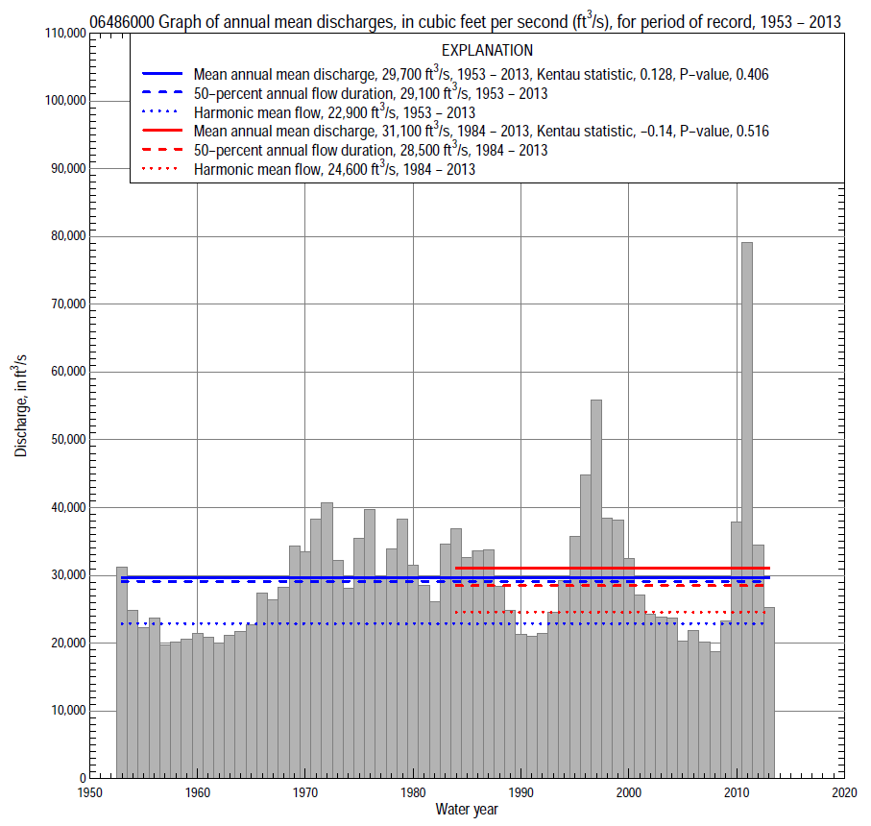

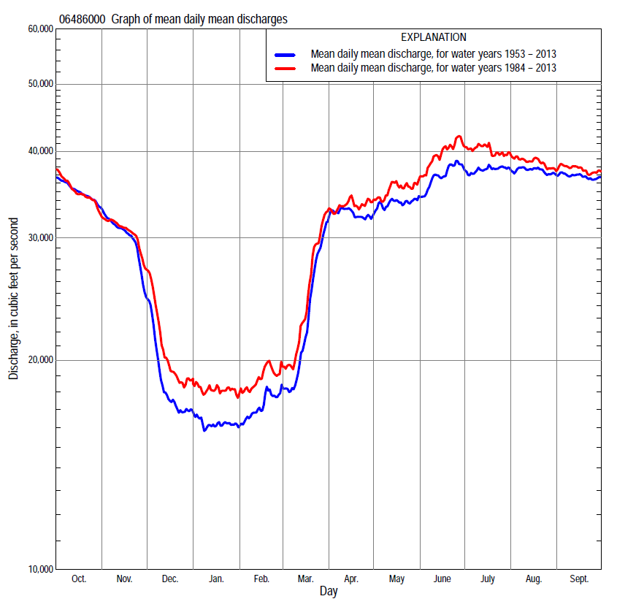

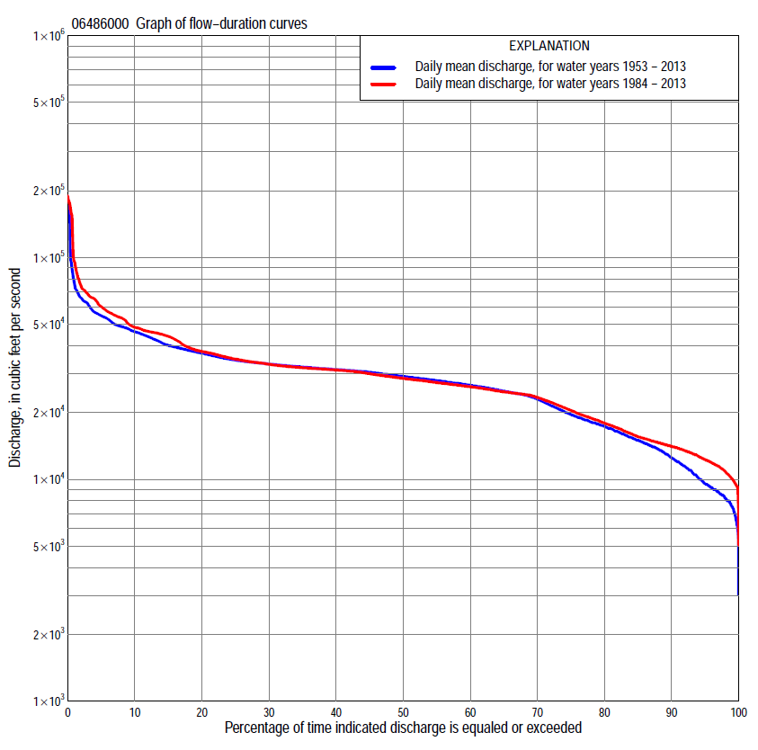
Statistics Based on the Regulated Streamflow Period of Record
06486000 Monthly and annual flow durations, based on 1953–2013 regulated period of record (61 years)
Percentage of days discharge equaled or exceeded |  |  |  |  | Discharge (cubic feet per second) |  |  |  |  |  |  |  |  | Annual flow durations
 | Oct | Nov | Dec | Jan | Feb | Mar | Apr | May | June | July | Aug | Sept | Annual | Kentau statistic | P-value
99 | 10,600 | 7,000 | 6,820 | 6,800 | 6,200 | 6,160 | 15,200 | 19,000 | 19,800 | 19,700 | 21,300 | 20,000 | 7,530 | 0.332 | 0.000
98 | 11,800 | 7,880 | 7,500 | 7,400 | 7,000 | 7,480 | 18,100 | 20,700 | 21,600 | 23,200 | 22,400 | 23,100 | 8,200 | 0.313 | 0.000
95 | 14,700 | 9,180 | 8,100 | 8,200 | 7,810 | 8,800 | 21,300 | 22,800 | 24,200 | 25,200 | 24,700 | 25,300 | 9,550 | 0.275 | 0.002
90 | 23,800 | 10,200 | 9,000 | 9,000 | 8,800 | 10,000 | 23,600 | 24,600 | 25,900 | 26,300 | 26,300 | 27,000 | 12,500 | 0.256 | 0.004
85 | 26,200 | 11,300 | 9,600 | 9,600 | 9,800 | 11,400 | 24,300 | 25,600 | 27,000 | 27,200 | 27,300 | 27,900 | 15,000 | 0.250 | 0.005
80 | 27,900 | 12,100 | 11,000 | 11,000 | 11,200 | 13,000 | 25,100 | 26,600 | 27,700 | 28,100 | 28,400 | 28,800 | 17,300 | 0.237 | 0.007
75 | 28,800 | 13,700 | 12,500 | 12,400 | 12,400 | 14,800 | 25,900 | 27,500 | 28,300 | 29,000 | 29,500 | 29,500 | 19,600 | 0.212 | 0.016
70 | 29,800 | 16,900 | 13,400 | 13,500 | 13,700 | 16,000 | 26,800 | 28,300 | 29,100 | 29,800 | 30,400 | 30,500 | 23,000 | 0.194 | 0.028
65 | 30,600 | 24,000 | 14,200 | 14,100 | 14,600 | 17,400 | 27,600 | 29,200 | 30,000 | 30,900 | 31,100 | 31,100 | 25,000 | 0.101 | 0.252
60 | 31,200 | 27,200 | 15,000 | 14,600 | 15,200 | 18,500 | 28,800 | 29,900 | 30,800 | 31,500 | 31,600 | 31,600 | 26,600 | 0.055 | 0.534
55 | 31,600 | 29,000 | 16,000 | 15,000 | 16,000 | 19,900 | 29,900 | 30,700 | 31,400 | 32,000 | 31,900 | 32,100 | 27,800 | 0.053 | 0.550
50 | 32,200 | 30,700 | 17,000 | 15,700 | 17,000 | 22,000 | 30,600 | 31,300 | 32,000 | 32,800 | 32,400 | 32,700 | 29,100 | 0.049 | 0.580
45 | 33,100 | 31,500 | 17,900 | 16,300 | 17,600 | 23,900 | 31,100 | 31,900 | 32,700 | 33,500 | 32,800 | 33,400 | 30,400 | 0.038 | 0.668
40 | 34,000 | 33,100 | 18,500 | 17,000 | 18,000 | 25,100 | 31,600 | 32,300 | 33,900 | 34,300 | 33,600 | 34,100 | 31,300 | 0.035 | 0.695
35 | 35,200 | 34,300 | 19,200 | 17,700 | 18,800 | 27,100 | 32,300 | 32,900 | 35,300 | 35,100 | 34,800 | 35,000 | 32,100 | 0.044 | 0.623
30 | 37,100 | 37,400 | 20,200 | 18,600 | 19,600 | 29,000 | 33,200 | 34,100 | 36,700 | 37,400 | 37,100 | 36,800 | 33,100 | 0.044 | 0.623
25 | 39,400 | 40,300 | 22,000 | 20,000 | 20,600 | 30,700 | 34,500 | 36,000 | 38,900 | 39,300 | 39,100 | 39,200 | 34,500 | 0.054 | 0.546
20 | 44,000 | 44,700 | 24,700 | 21,100 | 22,600 | 32,300 | 36,900 | 38,100 | 41,700 | 42,000 | 44,300 | 46,000 | 37,000 | 0.068 | 0.440
15 | 48,300 | 46,900 | 26,800 | 22,900 | 24,200 | 33,800 | 39,500 | 40,400 | 44,800 | 46,200 | 48,800 | 49,500 | 40,200 | 0.089 | 0.313
10 | 52,800 | 53,100 | 31,300 | 24,200 | 26,200 | 36,700 | 43,200 | 45,200 | 48,500 | 49,800 | 54,000 | 54,200 | 46,300 | 0.083 | 0.351
5 | 59,400 | 56,900 | 39,500 | 25,600 | 29,400 | 40,500 | 53,500 | 50,100 | 64,500 | 59,800 | 62,900 | 62,900 | 54,600 | 0.082 | 0.354
2 | 64,600 | 63,600 | 46,200 | 27,200 | 30,800 | 51,700 | 74,600 | 77,600 | 91,500 | 67,500 | 67,500 | 69,200 | 65,800 | 0.065 | 0.463
1 | 69,300 | 71,400 | 49,700 | 28,800 | 35,000 | 61,900 | 88,100 | 81,100 | 155,000 | 179,000 | 155,000 | 90,400 | 76,400 | 0.077 | 0.387

06486000 Annual exceedance probability of instantaneous peak discharges, in cubic feet per second (ft³/s), based on U.S. Army Corps of Engineers regulated flow frequency studyª, analysis computed using a record length of 100 years (1898–1997)
USACE Regulated Flow Frequency Analysis
[ND, not determined]
Annual exceedance probability | Recurrence interval (years) | Discharge (ft³/s) | 95-percent lower confi-dence interval (ft³/s) | 95-percent upper confi-dence interval (ft³/s)
0.500 | 2 | 49,500 | ND | ND
0.200 | 5 | 66,800 | ND | ND
0.100 | 10 | 78,300 | ND | ND
0.040 | 25 | ND | ND | ND
0.020 | 50 | 114,000 | ND | ND
0.010 | 100 | 134,000 | ND | ND
0.005 | 200 | 155,000 | ND | ND
0.002 | 500 | 185,000 | ND | ND
ªU.S. Army Corps of Engineers, 2003, Upper Mississippi River System Flow Frequency Study, Hydrology and Hydraulics Appendix F Missouri River, Omaha District: U.S. Army Corps of Engineers, 488 p., accessed September 16, 2014, at http://www.mvr.usace.army.mil/Portals/48/docs/FRM/UpperMissFlowFreq/App.%20F%20Omaha%20Dist.%20Hydrology_Hydraulics%20Report.pdf.
USGS Kendall's Tau Trend Analysis
Kentau statistic |  | 0.071
P-value |  | 0.429
Begin year |  | 1953^{b}
End year |  | 2013^{b}
Number of peaks |  | 60
^{b}Kendall's tau trend analysis computed using the regulated period of record which is not the same period of record used for the above regulated flow frequency analysis.

06486000 Annual exceedance probability of high discharges, based on 1953–2013 regulated period of recordª (61 years)
[ND, not determined]
Annual exceedance probability | Recur-rence interval (years) | Maximum average discharge (cubic feet per second) for indicated number of consecutive days
 |  | 1 | 3 | 7 | 15 | 30
0.990 | 1.01 | ND | ND | ND | ND | ND
0.950 | 1.05 | ND | ND | ND | ND | ND
0.900 | 1.11 | ND | ND | ND | ND | ND
0.800 | 1.25 | ND | ND | ND | ND | ND
0.500 | 2 | ND | ND | ND | ND | ND
0.200 | 5 | ND | ND | ND | ND | ND
0.100 | 10 | ND | ND | ND | ND | ND
0.040 | 25 | ND | ND | ND | ND | ND
0.020 | 50 | ND | ND | ND | ND | ND
0.010 | 100 | ND | ND | ND | ND | ND
0.005 | 200 | ND | ND | ND | ND | ND
0.002 | 500 | ND | ND | ND | ND | ND
Kentau statistic |  | 0.101 | 0.090 | 0.075 | 0.062 | 0.087
P-value |  | 0.252 | 0.307 | 0.394 | 0.482 | 0.322
ªContact the U.S. Army Corps of Engineers, Omaha District, for the annual exceedance probability of high discharges.

 | 06486000 Annual nonexceedance probability of low discharges, based on April 1953 to March 2013 regulated period of record (60 years)
Annual nonexceed-ance probability | Recur-rence interval (years) | Minimum average discharge (cubic feet per second) for indicated number of consecutive days
 |  | 1 | 3 | 7 | 14 | 30 | 60 | 90 | 120 | 183
0.01 | 100 | 3,050 | 4,270 | 4,760 | 4,930 | 5,270 | 5,740 | 6,070 | 6,320 | 9,750
0.02 | 50 | 3,540 | 4,820 | 5,390 | 5,620 | 6,000 | 6,510 | 6,870 | 7,140 | 10,700
0.05 | 20 | 4,410 | 5,760 | 6,460 | 6,800 | 7,250 | 7,820 | 8,220 | 8,560 | 12,300
0.10 | 10 | 5,340 | 6,730 | 7,570 | 8,000 | 8,520 | 9,140 | 9,590 | 10,000 | 13,900
0.20 | 5 | 6,680 | 8,100 | 9,110 | 9,660 | 10,300 | 11,000 | 11,500 | 12,100 | 16,300
0.50 | 2 | 10,000 | 11,500 | 12,800 | 13,500 | 14,300 | 15,100 | 15,900 | 17,000 | 21,900
0.80 | 1.25 | 14,700 | 16,000 | 17,500 | 18,300 | 19,400 | 20,300 | 21,400 | 23,500 | 29,700
0.90 | 1.11 | 17,900 | 19,000 | 20,400 | 21,200 | 22,400 | 23,300 | 24,700 | 27,600 | 34,800
0.96 | 1.04 | 21,700 | 22,700 | 24,000 | 24,600 | 25,900 | 26,900 | 28,700 | 32,600 | 41,400
0.98 | 1.02 | 24,600 | 25,500 | 26,500 | 27,000 | 28,300 | 29,300 | 31,400 | 36,200 | 46,300
0.99 | 1.01 | 27,400 | 28,200 | 29,000 | 29,200 | 30,600 | 31,600 | 34,000 | 39,700 | 51,300
Kentau statistic |  | 0.304 | 0.360 | 0.334 | 0.312 | 0.284 | 0.264 | 0.251 | 0.232 | 0.182
P-value |  | 0.001 | 0.000 | 0.000 | 0.000 | 0.001 | 0.003 | 0.005 | 0.009 | 0.041

06486000 Annual nonexceedance probability of seasonal low discharges, based on October 1952 to September 2013 regulated period of record (61 years)
Annual nonexceed-ance probability | Recur-rence interval (years) | Minimum average discharge (cubic feet per second) for indicated number of consecutive days
 |  | 1 | 7 | 14 | 30 |  | 1 | 7 | 14 | 30
 |  | January-February-March |  |  |  |  | April-May-June
0.01 | 100 | 4,200 | 4,870 | 5,120 | 5,570 |  | 11,700 | 12,900 | 13,800 | 20,100
0.02 | 50 | 4,680 | 5,550 | 5,850 | 6,350 |  | 12,900 | 14,200 | 15,200 | 20,600
0.05 | 20 | 5,530 | 6,700 | 7,100 | 7,670 |  | 14,900 | 16,400 | 17,400 | 21,400
0.10 | 10 | 6,410 | 7,880 | 8,360 | 9,010 |  | 16,900 | 18,500 | 19,500 | 22,400
0.20 | 5 | 7,670 | 9,510 | 10,100 | 10,800 |  | 19,500 | 21,300 | 22,300 | 24,000
0.50 | 2 | 10,900 | 13,300 | 14,000 | 14,900 |  | 25,500 | 27,300 | 28,400 | 28,400
0.80 | 1.25 | 15,400 | 18,100 | 18,800 | 19,800 |  | 32,700 | 34,300 | 35,300 | 35,300
0.90 | 1.11 | 18,600 | 21,000 | 21,600 | 22,700 |  | 37,000 | 38,300 | 39,200 | 40,400
0.96 | 1.04 | 22,700 | 24,400 | 24,800 | 25,900 |  | 42,000 | 42,900 | 43,600 | 47,800
0.98 | 1.02 | 25,800 | 26,700 | 26,900 | 28,000 |  | 45,500 | 45,900 | 46,500 | 53,800
0.99 | 1.01 | 28,900 | 28,900 | 28,900 | 30,000 |  | 48,700 | 48,700 | 49,200 | 60,300
Kentau statistic |  | 0.294 | 0.326 | 0.307 | 0.279 |  | 0.096 | 0.059 | 0.052 | 0.042
P-value |  | 0.001 | 0.000 | 0.000 | 0.002 |  | 0.279 | 0.506 | 0.554 | 0.641
 |  | July-August-September |  |  |  |  | October-November-December
0.01 | 100 | 11,600 | 16,200 | 20,200 | 22,600 |  | 2,950 | 5,130 | 5,510 | 5,680
0.02 | 50 | 13,300 | 17,400 | 20,800 | 22,900 |  | 3,590 | 5,800 | 6,200 | 6,400
0.05 | 20 | 16,100 | 19,300 | 21,900 | 23,700 |  | 4,770 | 6,960 | 7,390 | 7,680
0.10 | 10 | 18,800 | 21,200 | 23,100 | 24,700 |  | 6,050 | 8,170 | 8,630 | 9,030
0.20 | 5 | 22,400 | 23,800 | 25,000 | 26,300 |  | 7,940 | 9,900 | 10,400 | 11,000
0.50 | 2 | 30,000 | 30,200 | 30,400 | 31,200 |  | 12,700 | 14,200 | 14,800 | 16,200
0.80 | 1.25 | 37,900 | 38,800 | 39,100 | 40,200 |  | 19,300 | 20,200 | 20,900 | 24,000
0.90 | 1.11 | 42,000 | 44,600 | 45,900 | 47,500 |  | 23,300 | 24,300 | 25,000 | 29,500
0.96 | 1.04 | 46,100 | 51,800 | 55,400 | 58,500 |  | 28,200 | 29,400 | 30,200 | 37,000
0.98 | 1.02 | 48,700 | 57,200 | 63,400 | 68,000 |  | 31,600 | 33,200 | 34,000 | 42,800
0.99 | 1.01 | 50,900 | 62,700 | 72,100 | 78,700 |  | 34,800 | 37,100 | 37,900 | 48,800
Kentau statistic |  | 0.099 | 0.037 | 0.014 | -0.002 |  | 0.233 | 0.261 | 0.269 | 0.247
P-value |  | 0.263 | 0.681 | 0.876 | 0.985 |  | 0.008 | 0.003 | 0.002 | 0.005

Statistics Based on the 1984–2013 Regulated Streamflow Period of Record
06486000 Monthly and annual flow durations, based on 1984–2013 regulated period of record (30 years)
Percentage of days discharge equaled or exceeded |  |  |  |  | Discharge (cubic feet per second) |  |  |  |  |  |  |  |  | Annual flow durations
 | Oct | Nov | Dec | Jan | Feb | Mar | Apr | May | June | July | Aug | Sept | Annual | Kentau statistic | P-value
99 | 11,200 | 9,480 | 9,230 | 10,400 | 10,300 | 9,360 | 17,400 | 18,100 | 19,300 | 18,100 | 21,000 | 19,100 | 10,100 | -0.032 | 0.817
98 | 11,800 | 9,640 | 9,770 | 11,300 | 10,600 | 9,600 | 19,000 | 19,500 | 22,600 | 21,300 | 21,700 | 20,900 | 10,800 | -0.051 | 0.708
95 | 13,100 | 10,100 | 11,800 | 12,400 | 11,400 | 10,300 | 20,800 | 21,700 | 25,100 | 24,600 | 24,200 | 24,100 | 12,300 | -0.067 | 0.617
90 | 16,800 | 10,900 | 12,800 | 13,200 | 12,300 | 11,900 | 22,700 | 24,200 | 26,300 | 25,700 | 25,300 | 25,500 | 14,100 | -0.085 | 0.521
85 | 23,400 | 11,400 | 13,300 | 13,800 | 13,200 | 13,200 | 24,000 | 25,000 | 27,200 | 26,400 | 26,000 | 27,000 | 15,600 | -0.071 | 0.592
80 | 25,700 | 11,900 | 13,800 | 14,100 | 13,900 | 14,600 | 24,300 | 26,100 | 27,800 | 27,100 | 26,700 | 28,000 | 17,900 | -0.069 | 0.605
75 | 27,900 | 12,300 | 14,200 | 14,400 | 14,500 | 15,900 | 24,900 | 27,100 | 28,300 | 27,700 | 27,100 | 28,900 | 20,400 | -0.074 | 0.580
70 | 28,800 | 13,600 | 14,800 | 14,800 | 14,800 | 17,400 | 25,800 | 27,900 | 29,100 | 28,500 | 27,900 | 29,600 | 23,400 | -0.106 | 0.422
65 | 29,700 | 19,700 | 15,400 | 15,200 | 15,200 | 18,700 | 26,500 | 28,800 | 30,500 | 29,700 | 28,800 | 30,600 | 24,800 | -0.145 | 0.269
60 | 30,700 | 26,200 | 16,200 | 15,500 | 15,800 | 21,100 | 27,400 | 30,000 | 31,400 | 30,900 | 30,400 | 31,100 | 26,100 | -0.189 | 0.148
55 | 31,400 | 28,600 | 16,800 | 16,100 | 16,800 | 23,000 | 29,200 | 31,100 | 31,800 | 31,400 | 31,100 | 31,600 | 27,300 | -0.234 | 0.072
50 | 31,800 | 30,600 | 17,600 | 16,800 | 17,500 | 24,200 | 30,500 | 31,800 | 32,600 | 32,000 | 31,500 | 32,100 | 28,500 | -0.195 | 0.134
45 | 32,500 | 31,400 | 18,600 | 17,600 | 18,000 | 24,900 | 31,000 | 32,300 | 33,700 | 32,800 | 31,800 | 32,900 | 30,000 | -0.172 | 0.187
40 | 33,700 | 33,500 | 19,400 | 18,500 | 18,900 | 26,400 | 31,500 | 33,100 | 34,800 | 33,800 | 32,200 | 33,700 | 31,100 | -0.149 | 0.253
35 | 35,500 | 36,100 | 20,200 | 19,500 | 19,600 | 27,500 | 32,000 | 35,000 | 36,000 | 34,700 | 32,700 | 34,700 | 31,800 | -0.138 | 0.292
30 | 37,400 | 38,900 | 21,800 | 20,700 | 20,800 | 29,200 | 33,400 | 36,200 | 37,500 | 37,300 | 35,000 | 37,300 | 33,000 | -0.129 | 0.326
25 | 44,300 | 45,000 | 24,500 | 21,900 | 22,700 | 31,000 | 35,700 | 37,900 | 40,000 | 41,800 | 39,200 | 44,500 | 34,800 | -0.138 | 0.292
20 | 46,600 | 46,100 | 26,000 | 23,100 | 24,300 | 32,600 | 38,700 | 39,500 | 44,400 | 45,100 | 45,900 | 48,200 | 37,800 | -0.117 | 0.372
15 | 49,400 | 47,600 | 29,600 | 24,100 | 25,700 | 34,300 | 41,900 | 43,600 | 46,200 | 50,300 | 52,900 | 54,000 | 44,100 | -0.108 | 0.412
10 | 55,100 | 53,800 | 34,800 | 25,000 | 28,300 | 37,200 | 47,000 | 48,800 | 57,100 | 58,000 | 57,100 | 57,100 | 48,500 | -0.106 | 0.422
5 | 60,800 | 60,000 | 43,100 | 26,500 | 30,000 | 45,900 | 62,900 | 74,500 | 68,500 | 66,600 | 66,100 | 66,300 | 60,000 | -0.094 | 0.475
2 | 69,300 | 71,400 | 46,400 | 28,800 | 32,700 | 56,500 | 86,800 | 81,100 | 155,000 | 179,000 | 155,000 | 90,400 | 74,300 | -0.032 | 0.817
1 | 70,500 | 71,800 | 51,800 | 31,100 | 35,500 | 64,300 | 91,600 | 85,500 | 170,000 | 182,000 | 160,000 | 95,700 | 95,400 | -0.014 | 0.929

06486000 Annual exceedance probability of high discharges, based on 1984–2013 regulated period of recordª (30 years)
[ND, not determined]
Annual exceedance probability | Recur-rence interval (years) | Maximum average discharge (cubic feet per second) for indicated number of consecutive days
 |  | 1 | 3 | 7 | 15 | 30
0.990 | 1.01 | ND | ND | ND | ND | ND
0.950 | 1.05 | ND | ND | ND | ND | ND
0.900 | 1.11 | ND | ND | ND | ND | ND
0.800 | 1.25 | ND | ND | ND | ND | ND
0.500 | 2 | ND | ND | ND | ND | ND
0.200 | 5 | ND | ND | ND | ND | ND
0.100 | 10 | ND | ND | ND | ND | ND
0.040 | 25 | ND | ND | ND | ND | ND
0.020 | 50 | ND | ND | ND | ND | ND
0.010 | 100 | ND | ND | ND | ND | ND
0.005 | 200 | ND | ND | ND | ND | ND
0.002 | 500 | ND | ND | ND | ND | ND
Kentau statistic |  | -0.005 | -0.011 | -0.025 | -0.085 | -0.113
P-value |  | 0.986 | 0.943 | 0.858 | 0.521 | 0.392
ªContact the U.S. Army Corps of Engineers, Omaha District, for the annual exceedance probability of high discharges.

 | 06486000 Annual nonexceedance probability of low discharges, based on April 1983 to March 2013 regulated period of record (30 years)
Annual nonexceed-ance probability | Recur-rence interval (years) | Minimum average discharge (cubic feet per second) for indicated number of consecutive days
 |  | 1 | 3 | 7 | 14 | 30 | 60 | 90 | 120 | 183
0.01 | 100 | 4,690 | 7,040 | 7,610 | 7,660 | 7,870 | 9,030 | 9,280 | 9,290 | 10,900
0.02 | 50 | 5,200 | 7,500 | 8,170 | 8,300 | 8,540 | 9,660 | 9,980 | 9,990 | 11,800
0.05 | 20 | 6,060 | 8,280 | 9,120 | 9,350 | 9,660 | 10,700 | 11,100 | 11,200 | 13,300
0.10 | 10 | 6,960 | 9,090 | 10,100 | 10,400 | 10,800 | 11,700 | 12,300 | 12,400 | 14,900
0.20 | 5 | 8,250 | 10,200 | 11,400 | 11,800 | 12,300 | 13,200 | 13,700 | 14,100 | 17,100
0.50 | 2 | 11,500 | 13,100 | 14,600 | 15,200 | 15,800 | 16,600 | 17,200 | 18,400 | 22,800
0.80 | 1.25 | 16,100 | 17,300 | 18,800 | 19,500 | 20,400 | 21,100 | 22,200 | 24,500 | 31,000
0.90 | 1.11 | 19,300 | 20,200 | 21,600 | 22,300 | 23,300 | 24,100 | 25,500 | 28,700 | 36,700
0.96 | 1.04 | 23,400 | 24,100 | 25,100 | 25,700 | 26,800 | 27,800 | 29,800 | 34,100 | 44,100
0.98 | 1.02 | 26,600 | 27,100 | 27,800 | 28,200 | 29,300 | 30,600 | 33,100 | 38,400 | 50,000
0.99 | 1.01 | 29,800 | 30,200 | 30,400 | 30,600 | 31,800 | 33,300 | 36,400 | 42,700 | 56,000
Kentau statistic |  | 0.014 | 0.023 | -0.041 | -0.062 | -0.062 | -0.053 | -0.030 | -0.085 | -0.117
P-value |  | 0.929 | 0.872 | 0.762 | 0.643 | 0.643 | 0.695 | 0.830 | 0.521 | 0.372

06486000 Annual nonexceedance probability of seasonal low discharges, based on October 1983 to September 2013 regulated period of record (30 years)
Annual nonexceed-ance probability | Recur-rence interval (years) | Minimum average discharge (cubic feet per second) for indicated number of consecutive days
 |  | 1 | 7 | 14 | 30 |  | 1 | 7 | 14 | 30
 |  | January-February-March |  |  |  |  | April-May-June
0.01 | 100 | 4,840 | 8,000 | 8,300 | 8,810 |  | 16,500 | 17,200 | 18,500 | 19,800
0.02 | 50 | 5,450 | 8,610 | 8,950 | 9,480 |  | 17,000 | 17,700 | 18,900 | 20,200
0.05 | 20 | 6,490 | 9,620 | 10,000 | 10,600 |  | 17,900 | 18,700 | 19,800 | 20,900
0.10 | 10 | 7,560 | 10,600 | 11,100 | 11,700 |  | 18,900 | 19,800 | 20,800 | 21,800
0.20 | 5 | 9,060 | 12,000 | 12,500 | 13,200 |  | 20,500 | 21,500 | 22,400 | 23,400
0.50 | 2 | 12,700 | 15,300 | 15,900 | 16,600 |  | 25,000 | 26,300 | 27,000 | 28,000
0.80 | 1.25 | 17,500 | 19,600 | 20,100 | 20,900 |  | 32,600 | 34,200 | 35,100 | 36,500
0.90 | 1.11 | 20,600 | 22,300 | 22,700 | 23,600 |  | 38,700 | 40,300 | 41,500 | 43,500
0.96 | 1.04 | 24,300 | 25,800 | 25,900 | 26,900 |  | 47,400 | 49,200 | 50,900 | 54,100
0.98 | 1.02 | 27,100 | 28,200 | 28,300 | 29,200 |  | 54,800 | 56,600 | 58,900 | 63,300
0.99 | 1.01 | 29,800 | 30,500 | 30,800 | 31,500 |  | 63,000 | 64,700 | 67,800 | 73,700
Kentau statistic |  | -0.023 | -0.090 | -0.103 | -0.039 |  | -0.218 | -0.255 | -0.255 | -0.269
P-value |  | 0.872 | 0.498 | 0.432 | 0.775 |  | 0.093 | 0.050 | 0.050 | 0.038
 |  | July-August-September |  |  |  |  | October-November-December
0.01 | 100 | 16,100 | 17,600 | 18,800 | 20,800 |  | 5,540 | 7,200 | 7,210 | 7,220
0.02 | 50 | 17,000 | 18,400 | 19,300 | 21,200 |  | 6,130 | 7,920 | 7,930 | 7,940
0.05 | 20 | 18,500 | 19,600 | 20,500 | 22,000 |  | 7,170 | 9,090 | 9,190 | 9,200
0.10 | 10 | 20,100 | 21,100 | 21,800 | 23,100 |  | 8,250 | 10,100 | 10,400 | 10,500
0.20 | 5 | 22,500 | 23,300 | 23,800 | 24,900 |  | 9,810 | 11,700 | 12,000 | 12,500
0.50 | 2 | 28,700 | 29,400 | 29,900 | 30,600 |  | 13,800 | 15,500 | 16,000 | 17,700
0.80 | 1.25 | 38,100 | 39,500 | 40,700 | 41,700 |  | 19,700 | 21,000 | 21,900 | 25,700
0.90 | 1.11 | 44,900 | 47,400 | 49,600 | 51,300 |  | 23,800 | 24,900 | 25,900 | 31,500
0.96 | 1.04 | 54,300 | 58,800 | 62,700 | 66,300 |  | 29,200 | 30,100 | 31,300 | 39,600
0.98 | 1.02 | 61,900 | 68,400 | 74,300 | 80,000 |  | 33,500 | 34,100 | 35,400 | 46,100
0.99 | 1.01 | 70,000 | 79,000 | 87,300 | 95,900 |  | 37,800 | 38,300 | 39,700 | 53,000
Kentau statistic |  | -0.124 | -0.143 | -0.172 | -0.129 |  | -0.051 | -0.048 | -0.062 | -0.067
P-value |  | 0.344 | 0.276 | 0.187 | 0.326 |  | 0.708 | 0.721 | 0.643 | 0.617

