LOCATION.--Lat 42°58'55", long 96°00'03" referenced to North American Datum of 1927, in NW 1/4 NE 1/4 NE 1/4 sec.11, T.94 N., R.44 W., Sioux County, IA, Hydrologic Unit 10230002, on right bank 15 ft downstream from bridge on East Division Street in Alton, 34.3 mi upstream from West Branch Floyd River, and 55.3 mi upstream from mouth.

DRAINAGE AREA.--268 mi².

PERIOD OF RECORD.--Discharge records from October 1955 to current year. Prior to December 1955, monthly mean discharge published in WSP 1730.

GAGE.--Water-stage recorder. Datum of gage is 1,269.55 ft above National Geodetic Vertical Datum of 1929.

EXTREMES OUTSIDE PERIOD OF RECORD.--Flood in June 1953, discharge about 45,500 ft³/s, from information by U.S. Army Corps of Engineers.

A summary of all available data for this streamgage is provided through the USGS National Water Information System web interface (NWISWeb). The following link provides access to current/historical observations, daily data, daily statistics, monthly statistics, annual statistics, peak streamflow, field measurements, field/lab water-quality samples, and the latest water-year summaries. Data can be filtered by parameter and/or dates, and can be output in various tabular and graphical formats.
http://waterdata.usgs.gov/nwis/inventory/?site_no=06600100

The USGS WaterWatch Toolkit is available at:
http://waterwatch.usgs.gov/?id=ww_toolkit
Tools for summarizing streamflow information include the duration hydrograph builder, the cumulative streamflow hydrograph builder, the streamgage statistics retrieval tool, the rating curve builder, the flood tracking chart builder, the National Weather Service Advanced Hydrologic Prediction Service (AHPS) river forecast hydrograph builder, and the raster-hydrograph builder. Entering the above number for this streamgage into these toolkit webpages will provide streamflow information specific to this streamgage.

A description of the statistics presented for this streamgage is available in the main body of the report at:
http://dx.doi.org/10.3133/ofr20151214
A link to other streamgages included in this report, a map showing the location of the streamgages, information on the programs used to compute the statistical analyses, and references are included in the main body of the report.

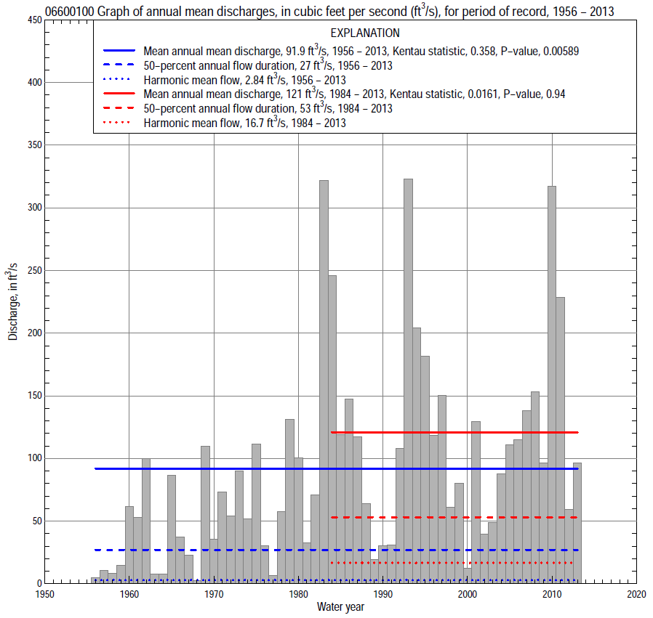

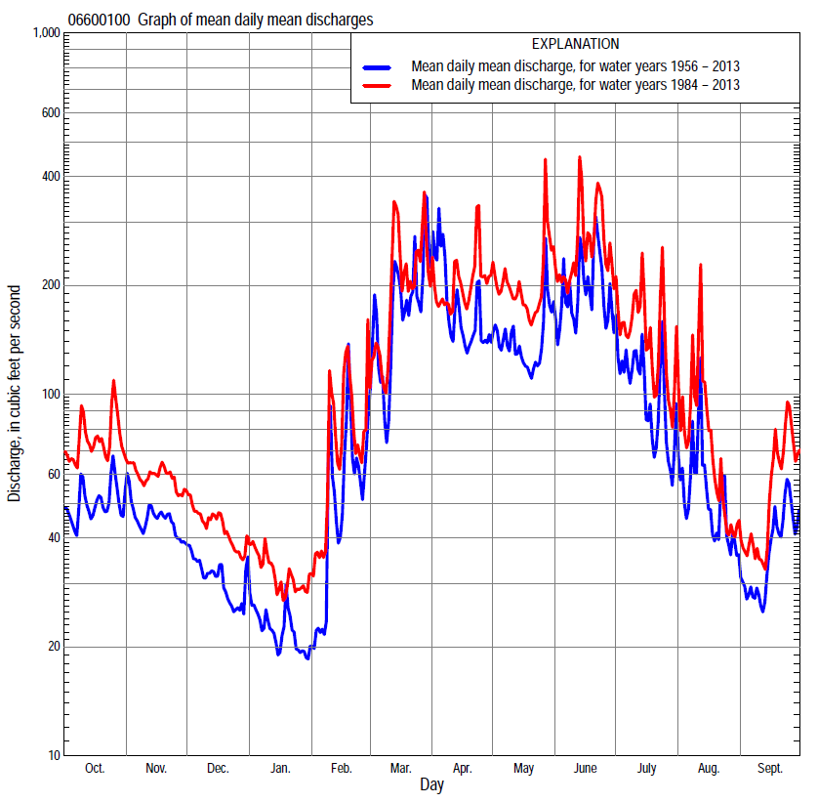

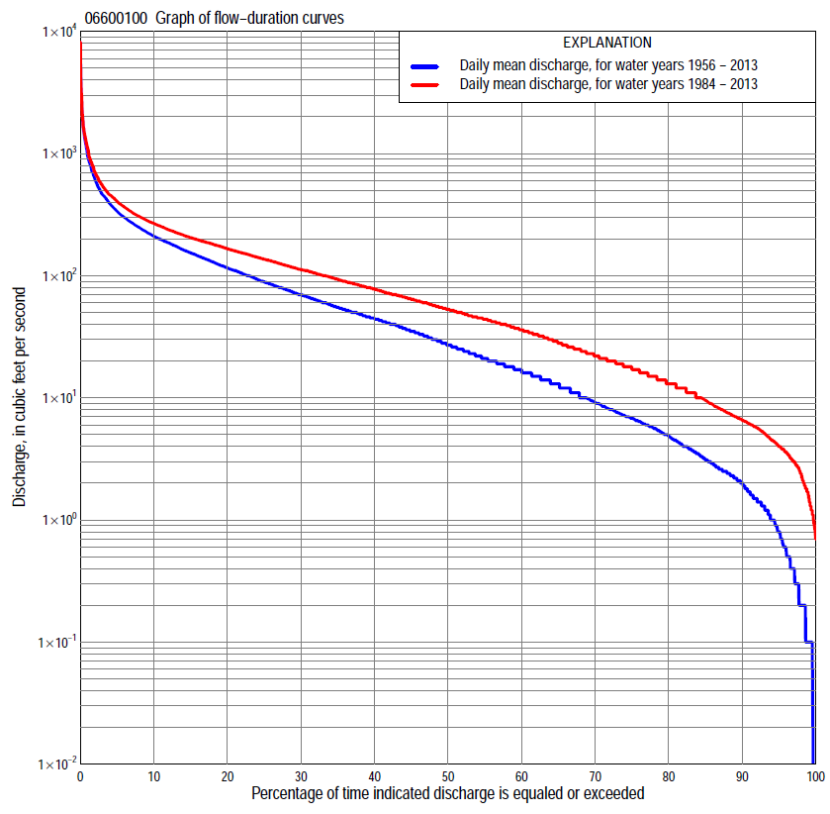

Statistics Based on the Entire Streamflow Period of Record
06600100 Monthly and annual flow durations, based on 1956–2013 period of record (58 years)
Percentage of days discharge equaled or exceeded |  |  |  |  | Discharge (cubic feet per second) |  |  |  |  |  |  |  |  | Annual flow durations
 | Oct | Nov | Dec | Jan | Feb | Mar | Apr | May | June | July | Aug | Sept | Annual | Kentau statistic | P-value
99 | 0.10 | 0.20 | 0.10 | 0.00 | 0.06 | 0.20 | 2.5 | 2.3 | 0.74 | 0.60 | 0.10 | 0.10 | 0.10 | 0.388 | 0.000
98 | 0.10 | 0.60 | 0.20 | 0.10 | 0.10 | 0.40 | 3.8 | 2.7 | 1.5 | 0.90 | 0.30 | 0.10 | 0.20 | 0.402 | 0.000
95 | 0.60 | 1.4 | 0.70 | 0.30 | 0.20 | 1.5 | 6.0 | 4.2 | 2.9 | 2.1 | 1.3 | 0.54 | 0.80 | 0.374 | 0.000
90 | 2.0 | 2.2 | 1.3 | 0.50 | 0.30 | 3.2 | 8.5 | 7.9 | 8.4 | 4.4 | 2.5 | 1.3 | 2.0 | 0.416 | 0.000
85 | 3.0 | 3.3 | 2.4 | 0.80 | 0.70 | 5.4 | 12 | 13 | 17 | 7.0 | 3.1 | 2.0 | 3.1 | 0.453 | 0.000
80 | 4.5 | 5.4 | 3.2 | 1.3 | 1.4 | 10 | 22 | 22 | 27 | 10 | 4.3 | 3.1 | 4.9 | 0.456 | 0.000
75 | 6.2 | 6.7 | 4.1 | 1.6 | 1.9 | 13 | 29 | 29 | 35 | 13 | 5.8 | 4.0 | 6.8 | 0.453 | 0.000
70 | 7.4 | 7.8 | 5.0 | 2.5 | 2.5 | 20 | 39 | 39 | 45 | 17 | 7.5 | 5.1 | 9.2 | 0.447 | 0.000
65 | 8.5 | 9.2 | 6.4 | 3.4 | 3.5 | 28 | 52 | 47 | 55 | 22 | 9.5 | 6.4 | 13 | 0.433 | 0.000
60 | 11 | 12 | 8.0 | 4.5 | 6.0 | 38 | 61 | 61 | 68 | 27 | 12 | 8.1 | 17 | 0.417 | 0.000
55 | 13 | 14 | 10 | 5.6 | 10 | 44 | 68 | 77 | 80 | 32 | 15 | 9.6 | 21 | 0.428 | 0.000
50 | 16 | 17 | 14 | 6.9 | 16 | 52 | 86 | 88 | 97 | 40 | 17 | 12 | 27 | 0.426 | 0.000
45 | 17 | 20 | 17 | 12 | 20 | 61 | 105 | 104 | 110 | 50 | 20 | 15 | 35 | 0.431 | 0.000
40 | 21 | 26 | 21 | 17 | 26 | 74 | 132 | 120 | 125 | 61 | 23 | 18 | 44 | 0.425 | 0.000
35 | 31 | 33 | 29 | 21 | 33 | 93 | 157 | 142 | 147 | 75 | 28 | 21 | 55 | 0.427 | 0.000
30 | 42 | 42 | 37 | 27 | 40 | 120 | 184 | 165 | 174 | 90 | 34 | 25 | 70 | 0.439 | 0.000
25 | 49 | 60 | 46 | 35 | 50 | 153 | 212 | 194 | 203 | 110 | 43 | 31 | 89 | 0.463 | 0.000
20 | 64 | 80 | 56 | 42 | 60 | 196 | 253 | 221 | 247 | 135 | 54 | 43 | 116 | 0.465 | 0.000
15 | 116 | 100 | 70 | 50 | 71 | 279 | 300 | 258 | 311 | 171 | 72 | 64 | 154 | 0.448 | 0.000
10 | 153 | 126 | 87 | 62 | 98 | 431 | 368 | 308 | 434 | 219 | 108 | 103 | 210 | 0.427 | 0.000
5 | 207 | 173 | 112 | 80 | 198 | 712 | 542 | 413 | 692 | 345 | 183 | 152 | 337 | 0.370 | 0.000
2 | 290 | 251 | 144 | 103 | 431 | 1,400 | 870 | 587 | 1,250 | 642 | 352 | 240 | 615 | 0.229 | 0.011
1 | 387 | 298 | 173 | 120 | 841 | 2,100 | 1,630 | 862 | 1,730 | 1,080 | 598 | 432 | 952 | 0.161 | 0.075

06600100 Annual exceedance probability of instantaneous peak discharges, in cubic feet per second (ft³/s), based on the Weighted Independent Estimates method,
Annual exceed-ance probability | Recur-rence interval (years) | Discharge (ft³/s) | 95-percent lower confi-dence interval (ft³/s) | 95-percent upper confi-dence interval (ft³/s)
0.500 | 2 | 1,900 | 1,540 | 2,360
0.200 | 5 | 5,410 | 4,400 | 6,660
0.100 | 10 | 9,080 | 7,310 | 11,300
0.040 | 25 | 15,000 | 11,700 | 19,100
0.020 | 50 | 19,500 | 14,800 | 25,700
0.010 | 100 | 24,100 | 17,600 | 32,900
0.005 | 200 | 30,700 | 21,600 | 43,800
0.002 | 500 | 36,200 | 24,000 | 54,500
and based on the expected moments algorithm/multiple Grubbs-Beck analysis computed using a historical period length of 138 years (1876–2013)
0.500 | 2 | 1,800 | 1,280 | 2,520
0.200 | 5 | 4,950 | 3,540 | 7,100
0.100 | 10 | 8,220 | 5,720 | 12,200
0.040 | 25 | 13,900 | 9,110 | 22,400
0.020 | 50 | 19,400 | 12,000 | 33,600
0.010 | 100 | 25,900 | 15,000 | 49,100
0.005 | 200 | 33,700 | 18,200 | 70,200
0.002 | 500 | 46,000 | 22,600 | 110,000
Kentau statistic |  | 0.039
P-value |  | 0.673
Begin year |  | 1956
End year |  | 2013
Number of peaks |  | 58

06600100 Annual exceedance probability of high discharges, based on 1956–2013 period of record (58 years)
Annual exceedance probability | Recur-rence interval (years) | Maximum average discharge (ft³/s) for indicated number of consecutive days
 |  | 1 | 3 | 7 | 15 | 30
0.990 | 1.01 | 43 | 34 | 22 | 14 | 8.0
0.950 | 1.05 | 138 | 107 | 71 | 46 | 29
0.900 | 1.11 | 242 | 187 | 123 | 82 | 54
0.800 | 1.25 | 459 | 349 | 230 | 153 | 104
0.500 | 2 | 1,350 | 981 | 639 | 428 | 295
0.200 | 5 | 3,330 | 2,280 | 1,450 | 952 | 642
0.100 | 10 | 5,010 | 3,300 | 2,060 | 1,330 | 877
0.040 | 25 | 7,380 | 4,670 | 2,850 | 1,800 | 1,150
0.020 | 50 | 9,240 | 5,690 | 3,420 | 2,130 | 1,320
0.010 | 100 | 11,100 | 6,680 | 3,960 | 2,430 | 1,470
0.005 | 200 | 13,100 | 7,640 | 4,470 | 2,710 | 1,600
0.002 | 500 | 15,600 | 8,860 | 5,090 | 3,030 | 1,750
Kentau statistic |  | 0.064 | 0.090 | 0.176 | 0.220 | 0.256
P-value |  | 0.485 | 0.321 | 0.052 | 0.015 | 0.005

 | 06600100 Annual nonexceedance probability of low discharges, based on April 1956 to March 2013 period of record (57 years)
Annual nonexceed-ance probability | Recur-rence interval (years) | Minimum average discharge (ft³/s) for indicated number of consecutive days
 |  | 1 | 3 | 7 | 14 | 30 | 60 | 90 | 120 | 183
0.01 | 100 | 0.00 | 0.00 | 0.00 | 0.00 | 0.02 | 0.06 | 0.12 | 0.20 | 0.22
0.02 | 50 | 0.00 | 0.00 | 0.00 | 0.00 | 0.04 | 0.11 | 0.22 | 0.35 | 0.40
0.05 | 20 | 0.00 | 0.00 | 0.00 | 0.05 | 0.13 | 0.28 | 0.52 | 0.77 | 0.92
0.10 | 10 | 0.00 | 0.02 | 0.09 | 0.17 | 0.32 | 0.61 | 1.1 | 1.5 | 1.9
0.20 | 5 | 0.34 | 0.35 | 0.44 | 0.57 | 0.88 | 1.5 | 2.4 | 3.2 | 4.1
0.50 | 2 | 2.9 | 3.3 | 3.3 | 3.7 | 4.7 | 6.7 | 10 | 12 | 16
0.80 | 1.25 | 11 | 13 | 14 | 16 | 19 | 25 | 32 | 40 | 52
0.90 | 1.11 | 20 | 22 | 26 | 30 | 34 | 45 | 56 | 68 | 88
0.96 | 1.04 | 33 | 34 | 46 | 53 | 61 | 80 | 95 | 117 | 146
0.98 | 1.02 | 43 | 44 | 63 | 74 | 85 | 113 | 130 | 162 | 198
0.99 | 1.01 | 52 | 53 | 81 | 96 | 111 | 150 | 170 | 213 | 254
Kentau statistic |  | 0.369 | 0.388 | 0.404 | 0.405 | 0.406 | 0.422 | 0.386 | 0.371 | 0.350
P-value |  | 0.000 | 0.000 | 0.000 | 0.000 | 0.000 | 0.000 | 0.000 | 0.000 | 0.000

06600100 Annual nonexceedance probability of seasonal low discharges, based on October 1955 to September 2013 period of record (58 years)
Annual nonexceed-ance probability | Recur-rence interval (years) | Minimum average discharge (cubic feet per second) for indicated number of consecutive days
 |  | 1 | 7 | 14 | 30 |  | 1 | 7 | 14 | 30
 |  | January-February-March |  |  |  |  | April-May-June
0.01 | 100 | 0.00 | 0.00 | 0.00 | 0.03 |  | 0.11 | 0.22 | 0.40 | 0.83
0.02 | 50 | 0.00 | 0.00 | 0.01 | 0.06 |  | 0.25 | 0.47 | 0.79 | 1.5
0.05 | 20 | 0.00 | 0.03 | 0.08 | 0.16 |  | 0.83 | 1.4 | 2.1 | 3.5
0.10 | 10 | 0.12 | 0.16 | 0.25 | 0.39 |  | 2.2 | 3.2 | 4.4 | 7.0
0.20 | 5 | 0.54 | 0.63 | 0.76 | 1.1 |  | 6.0 | 8.1 | 10 | 15
0.50 | 2 | 3.8 | 4.5 | 4.9 | 6.0 |  | 30 | 36 | 41 | 54
0.80 | 1.25 | 17 | 21 | 23 | 27 |  | 95 | 107 | 119 | 149
0.90 | 1.11 | 34 | 43 | 48 | 55 |  | 150 | 168 | 187 | 231
0.96 | 1.04 | 64 | 85 | 98 | 109 |  | 219 | 247 | 279 | 347
0.98 | 1.02 | 93 | 126 | 150 | 165 |  | 266 | 303 | 348 | 437
0.99 | 1.01 | 127 | 174 | 214 | 234 |  | 308 | 355 | 414 | 527
Kentau statistic |  | 0.400 | 0.450 | 0.455 | 0.457 |  | 0.451 | 0.439 | 0.453 | 0.450
P-value |  | 0.000 | 0.000 | 0.000 | 0.000 |  | 0.000 | 0.000 | 0.000 | 0.000
 |  | July-August-September |  |  |  |  | October-November-December
0.01 | 100 | 0.00 | 0.02 | 0.04 | 0.10 |  | 0.00 | 0.00 | 0.03 | 0.07
0.02 | 50 | 0.00 | 0.04 | 0.08 | 0.20 |  | 0.00 | 0.00 | 0.07 | 0.14
0.05 | 20 | 0.00 | 0.14 | 0.23 | 0.49 |  | 0.11 | 0.19 | 0.22 | 0.42
0.10 | 10 | 0.34 | 0.38 | 0.55 | 1.1 |  | 0.43 | 0.63 | 0.60 | 1.0
0.20 | 5 | 1.0 | 1.1 | 1.5 | 2.4 |  | 1.2 | 1.6 | 1.8 | 2.7
0.50 | 2 | 4.8 | 6.3 | 7.2 | 10 |  | 5.8 | 7.3 | 9.7 | 13
0.80 | 1.25 | 18 | 23 | 25 | 32 |  | 21 | 28 | 35 | 43
0.90 | 1.11 | 34 | 38 | 43 | 54 |  | 39 | 53 | 58 | 70
0.96 | 1.04 | 59 | 60 | 69 | 87 |  | 71 | 102 | 103 | 108
0.98 | 1.02 | 75 | 76 | 90 | 115 |  | 103 | 154 | 155 | 156
0.99 | 1.01 | 90 | 91 | 110 | 144 |  | 140 | 220 | 221 | 222
Kentau statistic |  | 0.339 | 0.328 | 0.335 | 0.312 |  | 0.376 | 0.407 | 0.409 | 0.389
P-value |  | 0.000 | 0.000 | 0.000 | 0.001 |  | 0.000 | 0.000 | 0.000 | 0.000

Statistics Based on the 1984–2013 Streamflow Period of Record
06600100 Monthly and annual flow durations, based on 1984–2013 period of record (30 years)
Percentage of days discharge equaled or exceeded |  |  |  |  | Discharge (cubic feet per second) |  |  |  |  |  |  |  |  | Annual flow durations
 | Oct | Nov | Dec | Jan | Feb | Mar | Apr | May | June | July | Aug | Sept | Annual | Kentau statistic | P-value
99 | 2.7 | 1.4 | 0.80 | 0.90 | 1.4 | 3.9 | 6.1 | 6.8 | 8.4 | 6.0 | 2.5 | 1.6 | 1.6 | -0.087 | 0.507
98 | 2.9 | 2.0 | 1.1 | 1.1 | 1.7 | 5.0 | 6.5 | 8.3 | 10 | 7.0 | 3.3 | 1.8 | 2.4 | -0.103 | 0.431
95 | 3.4 | 3.7 | 3.0 | 1.5 | 2.4 | 9.1 | 10 | 15 | 18 | 9.9 | 4.4 | 2.5 | 4.0 | -0.138 | 0.292
90 | 5.1 | 5.7 | 4.5 | 3.4 | 5.1 | 13 | 23 | 43 | 47 | 15 | 6.4 | 3.6 | 6.5 | -0.092 | 0.486
85 | 6.9 | 7.3 | 6.3 | 4.9 | 6.8 | 20 | 33 | 68 | 63 | 20 | 8.1 | 4.4 | 9.5 | -0.071 | 0.592
80 | 8.5 | 9.1 | 8.0 | 6.5 | 9.6 | 31 | 52 | 83 | 77 | 25 | 9.7 | 5.5 | 13 | -0.037 | 0.788
75 | 12 | 12 | 13 | 11 | 12 | 40 | 64 | 94 | 88 | 31 | 12 | 6.5 | 17 | -0.021 | 0.886
70 | 15 | 14 | 16 | 13 | 16 | 45 | 81 | 105 | 101 | 38 | 14 | 8.2 | 22 | -0.032 | 0.817
65 | 18 | 19 | 20 | 16 | 20 | 52 | 100 | 116 | 112 | 48 | 17 | 9.5 | 28 | -0.046 | 0.734
60 | 21 | 25 | 25 | 19 | 24 | 58 | 124 | 129 | 124 | 56 | 19 | 12 | 36 | -0.062 | 0.643
55 | 25 | 32 | 30 | 22 | 29 | 67 | 145 | 143 | 139 | 68 | 22 | 14 | 44 | -0.028 | 0.844
50 | 35 | 38 | 35 | 26 | 35 | 80 | 164 | 159 | 153 | 78 | 25 | 16 | 53 | -0.048 | 0.721
45 | 42 | 44 | 40 | 30 | 40 | 92 | 181 | 178 | 171 | 89 | 29 | 19 | 64 | -0.037 | 0.789
40 | 47 | 57 | 45 | 34 | 46 | 110 | 196 | 192 | 191 | 102 | 34 | 23 | 78 | -0.048 | 0.721
35 | 55 | 71 | 52 | 39 | 53 | 133 | 219 | 208 | 216 | 117 | 41 | 26 | 93 | -0.046 | 0.735
30 | 72 | 80 | 57 | 44 | 60 | 157 | 244 | 226 | 247 | 134 | 48 | 35 | 112 | -0.021 | 0.886
25 | 113 | 90 | 65 | 46 | 70 | 185 | 269 | 248 | 281 | 158 | 61 | 50 | 136 | 0.009 | 0.957
20 | 139 | 102 | 72 | 51 | 79 | 236 | 300 | 276 | 336 | 185 | 77 | 77 | 166 | 0.039 | 0.775
15 | 159 | 115 | 82 | 60 | 99 | 303 | 338 | 310 | 418 | 221 | 105 | 115 | 205 | 0.046 | 0.735
10 | 190 | 134 | 97 | 70 | 150 | 455 | 399 | 375 | 524 | 297 | 150 | 145 | 268 | 0.060 | 0.656
5 | 231 | 173 | 115 | 85 | 236 | 700 | 527 | 487 | 844 | 451 | 235 | 194 | 406 | 0.101 | 0.443
2 | 376 | 253 | 132 | 103 | 465 | 1,400 | 776 | 741 | 1,390 | 908 | 557 | 429 | 700 | 0.069 | 0.605
1 | 481 | 277 | 161 | 111 | 841 | 2,230 | 1,080 | 1,020 | 1,870 | 1,480 | 1,120 | 658 | 1,100 | 0.080 | 0.544

06600100 Annual exceedance probability of high discharges, based on 1984–2013 period of record (30 years)
Annual exceedance probability | Recur-rence interval (years) | Maximum average discharge (ft³/s) for indicated number of consecutive days
 |  | 1 | 3 | 7 | 15 | 30
0.990 | 1.01 | 132 | 106 | 79 | 52 | 37
0.950 | 1.05 | 264 | 220 | 164 | 115 | 83
0.900 | 1.11 | 381 | 319 | 237 | 170 | 123
0.800 | 1.25 | 590 | 491 | 360 | 262 | 190
0.500 | 2 | 1,350 | 1,060 | 741 | 540 | 389
0.200 | 5 | 3,020 | 2,160 | 1,390 | 978 | 689
0.100 | 10 | 4,580 | 3,050 | 1,850 | 1,270 | 879
0.040 | 25 | 7,090 | 4,330 | 2,460 | 1,620 | 1,100
0.020 | 50 | 9,370 | 5,370 | 2,910 | 1,870 | 1,250
0.010 | 100 | 12,000 | 6,480 | 3,360 | 2,090 | 1,380
0.005 | 200 | 15,100 | 7,650 | 3,800 | 2,300 | 1,500
0.002 | 500 | 19,800 | 9,290 | 4,380 | 2,560 | 1,640
Kentau statistic |  | 0.018 | 0.039 | 0.094 | 0.071 | 0.090
P-value |  | 0.901 | 0.775 | 0.475 | 0.592 | 0.498

 | 06600100 Annual nonexceedance probability of low discharges, based on April 1983 to March 2013 period of record (30 years)
Annual nonexceed-ance probability | Recur-rence interval (years) | Minimum average discharge (ft³/s) for indicated number of consecutive days
 |  | 1 | 3 | 7 | 14 | 30 | 60 | 90 | 120 | 183
0.01 | 100 | 0.33 | 0.39 | 0.44 | 0.56 | 0.62 | 0.81 | 1.0 | 1.2 | 1.3
0.02 | 50 | 0.49 | 0.57 | 0.65 | 0.81 | 0.93 | 1.2 | 1.5 | 1.8 | 2.0
0.05 | 20 | 0.88 | 1.0 | 1.1 | 1.4 | 1.7 | 2.3 | 2.8 | 3.3 | 3.7
0.10 | 10 | 1.4 | 1.6 | 1.8 | 2.2 | 2.8 | 3.8 | 4.6 | 5.4 | 6.2
0.20 | 5 | 2.5 | 2.8 | 3.2 | 3.8 | 4.8 | 6.7 | 8.1 | 10 | 11
0.50 | 2 | 6.7 | 7.4 | 8.5 | 10 | 13 | 18 | 21 | 26 | 31
0.80 | 1.25 | 16 | 18 | 21 | 24 | 28 | 40 | 48 | 60 | 76
0.90 | 1.11 | 24 | 27 | 32 | 36 | 41 | 57 | 70 | 88 | 117
0.96 | 1.04 | 36 | 42 | 49 | 54 | 58 | 81 | 101 | 127 | 177
0.98 | 1.02 | 46 | 54 | 63 | 70 | 72 | 99 | 124 | 159 | 227
0.99 | 1.01 | 57 | 68 | 79 | 85 | 86 | 118 | 149 | 192 | 282
Kentau statistic |  | -0.161 | -0.129 | -0.078 | -0.094 | -0.062 | -0.067 | -0.103 | -0.053 | -0.071
P-value |  | 0.218 | 0.326 | 0.556 | 0.475 | 0.643 | 0.617 | 0.432 | 0.695 | 0.592

06600100 Annual nonexceedance probability of seasonal low discharges, based on October 1983 to September 2013 period of record (30 years)
Annual nonexceed-ance probability | Recur-rence interval (years) | Minimum average discharge (cubic feet per second) for indicated number of consecutive days
 |  | 1 | 7 | 14 | 30 |  | 1 | 7 | 14 | 30
 |  | January-February-March |  |  |  |  | April-May-June
0.01 | 100 | 0.38 | 0.44 | 0.50 | 0.57 |  | 2.2 | 2.8 | 3.1 | 3.5
0.02 | 50 | 0.63 | 0.75 | 0.85 | 0.98 |  | 3.6 | 4.6 | 5.3 | 6.2
0.05 | 20 | 1.2 | 1.6 | 1.8 | 2.1 |  | 7.1 | 9.0 | 11 | 13
0.10 | 10 | 2.2 | 2.8 | 3.2 | 3.8 |  | 12 | 16 | 19 | 25
0.20 | 5 | 4.1 | 5.4 | 6.1 | 7.3 |  | 23 | 29 | 35 | 47
0.50 | 2 | 11 | 15 | 17 | 21 |  | 61 | 74 | 88 | 118
0.80 | 1.25 | 26 | 34 | 38 | 45 |  | 130 | 148 | 170 | 215
0.90 | 1.11 | 36 | 47 | 53 | 61 |  | 178 | 196 | 217 | 263
0.96 | 1.04 | 50 | 63 | 70 | 80 |  | 236 | 250 | 265 | 306
0.98 | 1.02 | 60 | 73 | 82 | 92 |  | 275 | 284 | 292 | 327
0.99 | 1.01 | 69 | 83 | 92 | 102 |  | 310 | 313 | 314 | 342
Kentau statistic |  | -0.014 | 0.085 | 0.080 | 0.103 |  | 0.023 | -0.030 | -0.016 | -0.039
P-value |  | 0.929 | 0.521 | 0.544 | 0.432 |  | 0.872 | 0.830 | 0.915 | 0.775
 |  | July-August-September |  |  |  |  | October-November-December
0.01 | 100 | 0.81 | 1.1 | 1.2 | 1.7 |  | 0.29 | 0.37 | 0.56 | 0.89
0.02 | 50 | 1.0 | 1.3 | 1.5 | 2.1 |  | 0.49 | 0.65 | 0.93 | 1.4
0.05 | 20 | 1.5 | 1.8 | 2.1 | 2.9 |  | 1.1 | 1.4 | 1.9 | 2.7
0.10 | 10 | 2.1 | 2.5 | 2.9 | 3.9 |  | 2.0 | 2.7 | 3.4 | 4.7
0.20 | 5 | 3.2 | 3.9 | 4.4 | 5.9 |  | 4.1 | 5.5 | 6.7 | 8.8
0.50 | 2 | 8.4 | 9.7 | 11 | 14 |  | 13 | 18 | 21 | 25
0.80 | 1.25 | 25 | 28 | 32 | 41 |  | 34 | 47 | 52 | 63
0.90 | 1.11 | 48 | 53 | 60 | 75 |  | 51 | 71 | 79 | 95
0.96 | 1.04 | 99 | 107 | 121 | 149 |  | 75 | 105 | 116 | 141
0.98 | 1.02 | 161 | 174 | 197 | 241 |  | 93 | 130 | 146 | 178
0.99 | 1.01 | 256 | 275 | 310 | 376 |  | 111 | 155 | 177 | 217
Kentau statistic |  | -0.147 | -0.126 | -0.117 | -0.085 |  | -0.069 | -0.057 | -0.078 | -0.057
P-value |  | 0.261 | 0.335 | 0.372 | 0.521 |  | 0.604 | 0.669 | 0.556 | 0.669

