LOCATION.--Lat 42°55'26", long 96°10'36" referenced to North American Datum of 1927, in NE 1/4 NE 1/4 NE 1/4 sec.32, T.94 N., R.45 W., Sioux County, IA, Hydrologic Unit 10230002, at bridge on County Highway B62, 0.1 mi west of U.S. Highway 75, and 2.2 mi northeast of Struble.

DRAINAGE AREA.--180 mi².

PERIOD OF RECORD.--Discharge records from October 1955 to March 1995; annual maximum discharge, water years 1996 to current year.

GAGE.--Crest-stage gage.

EXTREMES FOR PERIOD OF RECORD.--Maximum discharge, 8,920 ft³/s, March 4, 1994, and July 30, 2010, gage height, 15.86 ft.

A summary of all available data for this streamgage is provided through the USGS National Water Information System web interface (NWISWeb). The following link provides access to current/historical observations, daily data, daily statistics, monthly statistics, annual statistics, peak streamflow, field measurements, field/lab water-quality samples, and the latest water-year summaries. Data can be filtered by parameter and/or dates, and can be output in various tabular and graphical formats.
http://waterdata.usgs.gov/nwis/inventory/?site_no=06600300

The USGS WaterWatch Toolkit is available at:
http://waterwatch.usgs.gov/?id=ww_toolkit
Tools for summarizing streamflow information include the duration hydrograph builder, the cumulative streamflow hydrograph builder, the streamgage statistics retrieval tool, the rating curve builder, the flood tracking chart builder, the National Weather Service Advanced Hydrologic Prediction Service (AHPS) river forecast hydrograph builder, and the raster-hydrograph builder. Entering the above number for this streamgage into these toolkit webpages will provide streamflow information specific to this streamgage.

A description of the statistics presented for this streamgage is available in the main body of the report at:
http://dx.doi.org/10.3133/ofr20151214
A link to other streamgages included in this report, a map showing the location of the streamgages, information on the programs used to compute the statistical analyses, and references are included in the main body of the report.

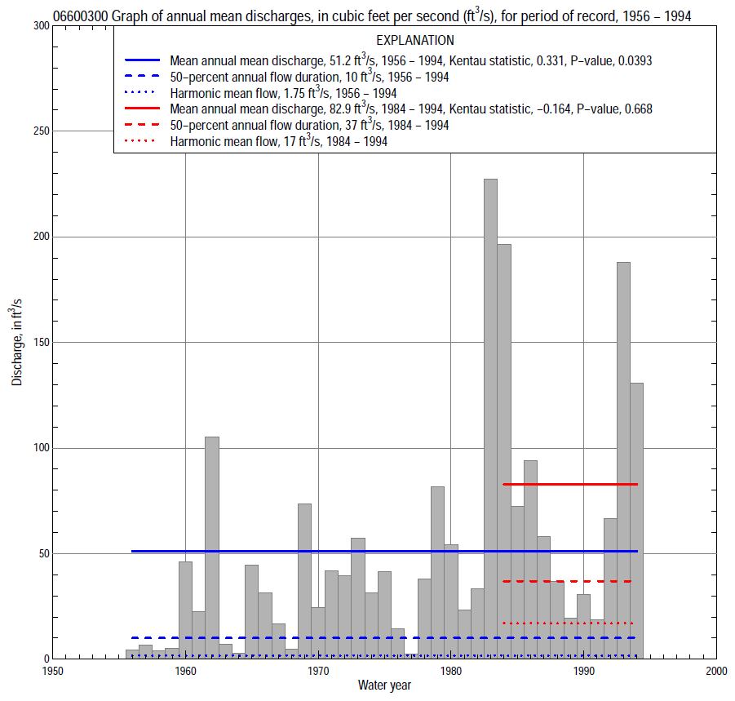

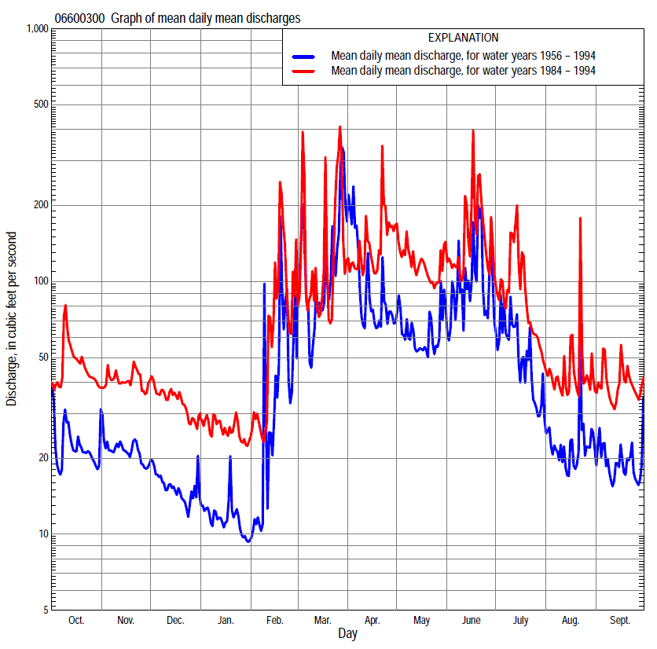

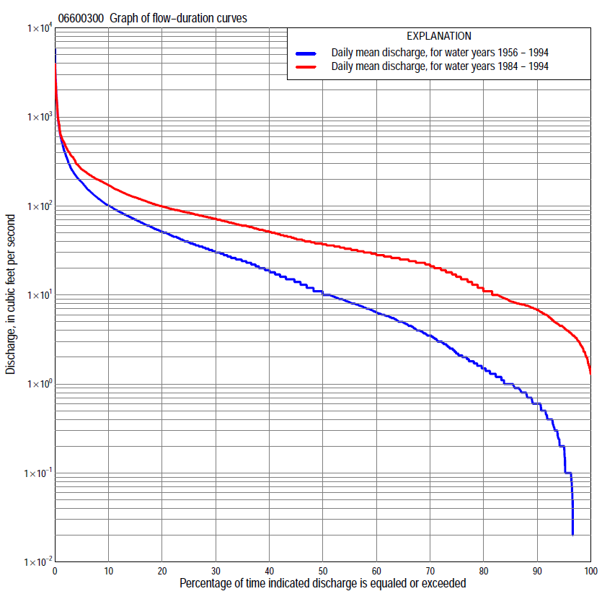

Statistics Based on the Entire Streamflow Period of Record
06600300 Monthly and annual flow durations, based on 1956–94 period of record (39 years)
Percentage of days discharge equaled or exceeded |  |  |  |  | Discharge (cubic feet per second) |  |  |  |  |  |  |  |  | Annual flow durations
 | Oct | Nov | Dec | Jan | Feb | Mar | Apr | May | June | July | Aug | Sept | Annual | Kentau statistic | P-value
99 | 0.20 | 0.20 | 0.00 | 0.00 | 0.00 | 0.00 | 0.70 | 0.50 | 0.49 | 0.30 | 0.14 | 0.10 | 0.00 | 0.497 | 0.000
98 | 0.20 | 0.30 | 0.00 | 0.00 | 0.00 | 0.00 | 0.80 | 0.60 | 0.65 | 0.40 | 0.20 | 0.10 | 0.00 | 0.498 | 0.000
95 | 0.60 | 0.60 | 0.10 | 0.00 | 0.00 | 0.20 | 1.3 | 0.93 | 0.98 | 0.80 | 0.60 | 0.39 | 0.17 | 0.501 | 0.000
90 | 0.90 | 0.90 | 0.40 | 0.00 | 0.00 | 0.58 | 2.2 | 1.9 | 1.8 | 1.4 | 1.2 | 0.61 | 0.60 | 0.484 | 0.000
85 | 1.2 | 1.1 | 0.60 | 0.00 | 0.00 | 1.2 | 3.9 | 3.0 | 3.5 | 2.5 | 1.6 | 1.3 | 1.0 | 0.497 | 0.000
80 | 1.5 | 1.5 | 0.90 | 0.10 | 0.10 | 3.0 | 7.2 | 5.8 | 8.0 | 3.7 | 2.1 | 1.8 | 1.5 | 0.506 | 0.000
75 | 2.2 | 2.1 | 1.2 | 0.40 | 0.20 | 4.0 | 9.9 | 8.2 | 11 | 5.3 | 2.6 | 2.9 | 2.1 | 0.524 | 0.000
70 | 3.3 | 3.5 | 1.6 | 0.60 | 0.37 | 6.5 | 14 | 10 | 14 | 7.1 | 3.7 | 3.9 | 3.4 | 0.517 | 0.000
65 | 4.1 | 4.5 | 2.0 | 0.80 | 0.60 | 9.0 | 17 | 11 | 18 | 9.0 | 5.4 | 4.5 | 4.8 | 0.511 | 0.000
60 | 4.8 | 5.0 | 2.8 | 1.0 | 0.86 | 11 | 20 | 14 | 22 | 13 | 6.8 | 5.3 | 6.2 | 0.538 | 0.000
55 | 5.8 | 5.7 | 3.4 | 1.1 | 1.5 | 15 | 23 | 18 | 28 | 16 | 7.7 | 6.1 | 8.0 | 0.532 | 0.000
50 | 6.5 | 6.4 | 4.0 | 1.5 | 2.6 | 20 | 29 | 25 | 35 | 19 | 9.4 | 7.2 | 10 | 0.545 | 0.000
45 | 7.6 | 8.1 | 5.0 | 2.1 | 6.0 | 30 | 33 | 31 | 42 | 22 | 11 | 8.1 | 14 | 0.547 | 0.000
40 | 9.9 | 9.2 | 5.5 | 3.0 | 9.2 | 37 | 41 | 38 | 50 | 27 | 13 | 9.3 | 18 | 0.528 | 0.000
35 | 13 | 11 | 7.0 | 4.0 | 12 | 49 | 55 | 46 | 56 | 32 | 16 | 11 | 24 | 0.544 | 0.000
30 | 21 | 15 | 9.1 | 8.4 | 15 | 61 | 72 | 58 | 68 | 38 | 20 | 15 | 31 | 0.521 | 0.000
25 | 25 | 19 | 17 | 20 | 23 | 84 | 88 | 71 | 82 | 45 | 25 | 23 | 40 | 0.507 | 0.000
20 | 31 | 31 | 28 | 25 | 30 | 108 | 111 | 104 | 103 | 57 | 30 | 28 | 52 | 0.483 | 0.000
15 | 41 | 51 | 38 | 32 | 40 | 150 | 158 | 140 | 140 | 90 | 40 | 41 | 70 | 0.491 | 0.000
10 | 64 | 77 | 50 | 42 | 61 | 234 | 240 | 177 | 229 | 132 | 61 | 55 | 102 | 0.455 | 0.000
5 | 92 | 100 | 74 | 50 | 164 | 500 | 381 | 227 | 395 | 210 | 92 | 85 | 186 | 0.314 | 0.005
2 | 125 | 120 | 84 | 60 | 500 | 1,390 | 706 | 366 | 761 | 378 | 128 | 113 | 380 | 0.215 | 0.056
1 | 165 | 142 | 90 | 70 | 742 | 2,430 | 1,210 | 506 | 1,400 | 582 | 156 | 142 | 634 | 0.124 | 0.271

06600300 Annual exceedance probability of instantaneous peak discharges, in cubic feet per second (ft³/s), based on the Weighted Independent Estimates method,
Annual exceed-ance probability | Recur-rence interval (years) | Discharge (ft³/s) | 95-percent lower confi-dence interval (ft³/s) | 95-percent upper confi-dence interval (ft³/s)
0.500 | 2 | 2,430 | 1,950 | 3,020
0.200 | 5 | 4,880 | 3,980 | 5,980
0.100 | 10 | 7,020 | 5,690 | 8,650
0.040 | 25 | 10,300 | 8,170 | 13,000
0.020 | 50 | 12,700 | 9,810 | 16,500
0.010 | 100 | 15,100 | 11,200 | 20,300
0.005 | 200 | 18,400 | 13,200 | 25,800
0.002 | 500 | 20,900 | 14,200 | 30,800
and based on the expected moments algorithm/multiple Grubbs-Beck analysis computed using a historical period length of 58 years (1956–2013)
0.500 | 2 | 2,360 | 1,200 | 2,870
0.200 | 5 | 4,580 | 3,690 | 6,010
0.100 | 10 | 6,270 | 4,970 | 9,210
0.040 | 25 | 8,550 | 6,440 | 15,700
0.020 | 50 | 10,300 | 7,480 | 22,800
0.010 | 100 | 12,100 | 8,450 | 32,100
0.005 | 200 | 14,000 | 9,350 | 43,600
0.002 | 500 | 16,400 | 10,500 | 62,100
Kentau statistic |  | 0.026
P-value |  | 0.778
Begin year |  | 1956
End year |  | 2013
Number of peaks |  | 57

06600300 Annual exceedance probability of high discharges, based on 1956–94 period of record (39 years)
Annual exceedance probability | Recur-rence interval (years) | Maximum average discharge (ft³/s) for indicated number of consecutive days
 |  | 1 | 3 | 7 | 15 | 30
0.990 | 1.01 | 45 | 25 | 14 | 8.2 | 5.3
0.950 | 1.05 | 140 | 78 | 43 | 25 | 17
0.900 | 1.11 | 243 | 135 | 76 | 44 | 29
0.800 | 1.25 | 451 | 253 | 143 | 84 | 55
0.500 | 2 | 1,270 | 736 | 423 | 251 | 160
0.200 | 5 | 3,010 | 1,830 | 1,070 | 645 | 395
0.100 | 10 | 4,420 | 2,770 | 1,630 | 999 | 594
0.040 | 25 | 6,340 | 4,130 | 2,460 | 1,530 | 876
0.020 | 50 | 7,820 | 5,230 | 3,140 | 1,960 | 1,100
0.010 | 100 | 9,290 | 6,380 | 3,840 | 2,430 | 1,330
0.005 | 200 | 10,700 | 7,560 | 4,570 | 2,920 | 1,560
0.002 | 500 | 12,600 | 9,140 | 5,560 | 3,590 | 1,870
Kentau statistic |  | 0.154 | 0.177 | 0.161 | 0.193 | 0.228
P-value |  | 0.172 | 0.116 | 0.153 | 0.086 | 0.042

 | 06600300 Annual nonexceedance probability of low discharges, based on April 1956 to March 1995 period of record (39 years)
Annual nonexceed-ance probability | Recur-rence interval (years) | Minimum average discharge (cubic feet per second) for indicated number of consecutive days
 |  | 1 | 3 | 7 | 14 | 30 | 60 | 90 | 120 | 183
0.01 | 100 | 0.00 | 0.00 | 0.00 | 0.00 | 0.00 | 0.00 | 0.01 | 0.05 | 0.11
0.02 | 50 | 0.00 | 0.00 | 0.00 | 0.00 | 0.00 | 0.00 | 0.02 | 0.09 | 0.19
0.05 | 20 | 0.00 | 0.00 | 0.00 | 0.00 | 0.00 | 0.00 | 0.06 | 0.20 | 0.41
0.10 | 10 | 0.00 | 0.00 | 0.00 | 0.00 | 0.00 | 0.04 | 0.15 | 0.40 | 0.79
0.20 | 5 | 0.00 | 0.00 | 0.00 | 0.00 | 0.06 | 0.22 | 0.47 | 0.93 | 1.7
0.50 | 2 | 0.83 | 0.86 | 0.98 | 1.0 | 1.4 | 2.1 | 3.2 | 4.3 | 6.9
0.80 | 1.25 | 6.2 | 6.6 | 7.1 | 7.7 | 9.2 | 12 | 16 | 18 | 25
0.90 | 1.11 | 14 | 15 | 16 | 18 | 21 | 27 | 33 | 36 | 46
0.96 | 1.04 | 32 | 34 | 36 | 42 | 47 | 58 | 65 | 74 | 86
0.98 | 1.02 | 51 | 55 | 58 | 68 | 76 | 92 | 97 | 116 | 127
0.99 | 1.01 | 76 | 82 | 88 | 104 | 113 | 134 | 135 | 172 | 179
Kentau statistic |  | 0.538 | 0.553 | 0.559 | 0.570 | 0.526 | 0.497 | 0.482 | 0.447 | 0.431
P-value |  | 0.000 | 0.000 | 0.000 | 0.000 | 0.000 | 0.000 | 0.000 | 0.000 | 0.000

06600300 Annual nonexceedance probability of seasonal low discharges, based on October 1955 to March 1995 period of record (39–40 years)
Annual nonexceed-ance probability | Recur-rence interval (years) | Minimum average discharge (cubic feet per second) for indicated number of consecutive days
 |  | 1 | 7 | 14 | 30 |  | 1 | 7 | 14 | 30
 |  | January-February-March |  |  |  |  | April-May-June
0.01 | 100 | 0.00 | 0.00 | 0.00 | 0.00 |  | 0.06 | 0.13 | 0.18 | 0.26
0.02 | 50 | 0.00 | 0.00 | 0.00 | 0.00 |  | 0.12 | 0.24 | 0.31 | 0.44
0.05 | 20 | 0.00 | 0.00 | 0.00 | 0.00 |  | 0.31 | 0.55 | 0.69 | 0.97
0.10 | 10 | 0.00 | 0.00 | 0.00 | 0.00 |  | 0.72 | 1.1 | 1.4 | 1.9
0.20 | 5 | 0.00 | 0.00 | 0.00 | 0.04 |  | 1.9 | 2.6 | 3.0 | 4.1
0.50 | 2 | 0.91 | 1.1 | 1.1 | 1.5 |  | 9.3 | 11 | 13 | 17
0.80 | 1.25 | 8.5 | 9.2 | 10 | 12 |  | 37 | 41 | 46 | 58
0.90 | 1.11 | 20 | 21 | 26 | 30 |  | 69 | 78 | 86 | 105
0.96 | 1.04 | 46 | 48 | 62 | 72 |  | 127 | 147 | 161 | 193
0.98 | 1.02 | 74 | 76 | 103 | 123 |  | 182 | 217 | 238 | 280
0.99 | 1.01 | 111 | 114 | 160 | 192 |  | 245 | 304 | 333 | 385
Kentau statistic |  | 0.542 | 0.550 | 0.567 | 0.519 |  | 0.468 | 0.444 | 0.436 | 0.436
P-value |  | 0.000 | 0.000 | 0.000 | 0.000 |  | 0.000 | 0.000 | 0.000 | 0.000
 |  | July-August-September |  |  |  |  | October-November-December
0.01 | 100 | 0.00 | 0.04 | 0.07 | 0.12 |  | 0.00 | 0.00 | 0.00 | 0.04
0.02 | 50 | 0.00 | 0.07 | 0.12 | 0.20 |  | 0.00 | 0.00 | 0.00 | 0.08
0.05 | 20 | 0.10 | 0.18 | 0.26 | 0.40 |  | 0.00 | 0.00 | 0.05 | 0.19
0.10 | 10 | 0.29 | 0.39 | 0.51 | 0.73 |  | 0.00 | 0.12 | 0.18 | 0.39
0.20 | 5 | 0.76 | 0.93 | 1.1 | 1.5 |  | 0.40 | 0.45 | 0.57 | 0.92
0.50 | 2 | 3.6 | 4.2 | 4.6 | 5.6 |  | 2.4 | 2.9 | 3.4 | 4.3
0.80 | 1.25 | 14 | 15 | 16 | 19 |  | 9.7 | 13 | 15 | 18
0.90 | 1.11 | 26 | 28 | 30 | 36 |  | 20 | 27 | 31 | 35
0.96 | 1.04 | 48 | 50 | 54 | 68 |  | 42 | 54 | 62 | 69
0.98 | 1.02 | 70 | 71 | 78 | 101 |  | 68 | 83 | 94 | 105
0.99 | 1.01 | 94 | 95 | 107 | 144 |  | 106 | 120 | 134 | 152
Kentau statistic |  | 0.505 | 0.507 | 0.507 | 0.506 |  | 0.405 | 0.442 | 0.455 | 0.479
P-value |  | 0.000 | 0.000 | 0.000 | 0.000 |  | 0.000 | 0.000 | 0.000 | 0.000

Statistics Based on the 1984–2013 Streamflow Period of Record
06600300 Monthly and annual flow durations, based on 1984–94 period of record (11 years)
Percentage of days discharge equaled or exceeded |  |  |  |  | Discharge (cubic feet per second) |  |  |  |  |  |  |  |  | Annual flow durations
 | Oct | Nov | Dec | Jan | Feb | Mar | Apr | May | June | July | Aug | Sept | Annual | Kentau statistic | P-value
99 | 2.9 | 2.1 | 1.4 | 1.8 | 1.6 | 6.6 | 7.5 | 7.4 | 7.8 | 5.2 | 1.4 | 3.5 | 2.1 | -0.073 | 0.814
98 | 3.2 | 2.3 | 1.6 | 2.0 | 1.7 | 7.3 | 7.6 | 7.8 | 8.0 | 5.8 | 2.1 | 3.7 | 2.7 | -0.127 | 0.636
95 | 3.4 | 3.5 | 2.6 | 2.3 | 3.0 | 8.3 | 7.9 | 10 | 8.5 | 6.8 | 4.7 | 4.0 | 4.1 | -0.182 | 0.482
90 | 4.0 | 4.4 | 4.5 | 3.0 | 5.6 | 10 | 17 | 12 | 12 | 9.2 | 5.8 | 4.5 | 6.6 | -0.164 | 0.531
85 | 4.8 | 6.4 | 6.0 | 3.8 | 6.8 | 14 | 20 | 25 | 22 | 13 | 6.8 | 5.4 | 8.3 | -0.145 | 0.585
80 | 7.0 | 7.8 | 7.2 | 6.6 | 7.8 | 20 | 23 | 30 | 29 | 18 | 8.7 | 7.9 | 11 | -0.127 | 0.640
75 | 8.2 | 9.6 | 9.2 | 8.9 | 9.2 | 28 | 31 | 35 | 39 | 30 | 11 | 9.9 | 18 | -0.091 | 0.755
70 | 21 | 17 | 15 | 14 | 10 | 33 | 40 | 44 | 46 | 32 | 14 | 13 | 23 | -0.055 | 0.876
65 | 24 | 19 | 22 | 17 | 12 | 38 | 52 | 57 | 53 | 37 | 22 | 18 | 26 | -0.036 | 0.938
60 | 27 | 24 | 25 | 21 | 18 | 48 | 62 | 65 | 59 | 39 | 24 | 24 | 30 | -0.018 | 1.000
55 | 32 | 28 | 26 | 23 | 23 | 55 | 73 | 77 | 67 | 41 | 26 | 26 | 34 | -0.018 | 1.000
50 | 35 | 31 | 30 | 26 | 27 | 63 | 83 | 99 | 74 | 46 | 27 | 27 | 39 | -0.055 | 0.876
45 | 36 | 35 | 36 | 29 | 30 | 72 | 97 | 122 | 88 | 52 | 31 | 29 | 45 | -0.055 | 0.876
40 | 43 | 46 | 37 | 33 | 33 | 85 | 119 | 132 | 100 | 60 | 34 | 32 | 54 | -0.073 | 0.815
35 | 53 | 51 | 40 | 37 | 35 | 90 | 146 | 144 | 115 | 75 | 39 | 37 | 62 | -0.109 | 0.696
30 | 62 | 60 | 45 | 39 | 44 | 104 | 165 | 159 | 134 | 94 | 47 | 46 | 74 | -0.127 | 0.640
25 | 72 | 69 | 56 | 42 | 54 | 120 | 197 | 173 | 154 | 114 | 56 | 58 | 86 | -0.091 | 0.755
20 | 78 | 82 | 68 | 43 | 72 | 142 | 227 | 188 | 232 | 126 | 70 | 68 | 101 | -0.109 | 0.696
15 | 87 | 86 | 72 | 47 | 108 | 185 | 254 | 202 | 288 | 158 | 84 | 84 | 127 | -0.091 | 0.755
10 | 101 | 93 | 76 | 50 | 179 | 250 | 310 | 230 | 362 | 203 | 98 | 95 | 176 | -0.127 | 0.640
5 | 120 | 103 | 81 | 60 | 400 | 466 | 440 | 292 | 492 | 321 | 117 | 113 | 264 | -0.127 | 0.640
2 | 165 | 119 | 90 | 66 | 600 | 1,390 | 542 | 441 | 902 | 564 | 153 | 141 | 478 | -0.091 | 0.755
1 | 277 | 139 | 96 | 80 | 1,000 | 2,670 | 883 | 619 | 1,560 | 833 | 236 | 177 | 694 | -0.018 | 1.000

06600300 Annual exceedance probability of high discharges, based on 1984–94 period of record (11 years)
Annual exceedance probability | Recur-rence interval (years) | Maximum average discharge (ft³/s) for indicated number of consecutive days
 |  | 1 | 3 | 7 | 15 | 30
0.990 | 1.01 | 42 | 38 | 34 | 28 | 23
0.950 | 1.05 | 159 | 120 | 89 | 63 | 50
0.900 | 1.11 | 292 | 206 | 142 | 96 | 72
0.800 | 1.25 | 561 | 369 | 235 | 153 | 111
0.500 | 2 | 1,530 | 934 | 542 | 347 | 234
0.200 | 5 | 3,110 | 1,880 | 1,050 | 706 | 454
0.100 | 10 | 4,070 | 2,490 | 1,390 | 984 | 620
0.040 | 25 | 5,070 | 3,180 | 1,790 | 1,360 | 843
0.020 | 50 | 5,660 | 3,620 | 2,070 | 1,650 | 1,020
0.010 | 100 | 6,140 | 4,000 | 2,320 | 1,950 | 1,190
0.005 | 200 | 6,520 | 4,330 | 2,550 | 2,250 | 1,370
0.002 | 500 | 6,900 | 4,690 | 2,820 | 2,650 | 1,600
Kentau statistic |  | 0.127 | 0.018 | -0.091 | -0.055 | -0.091
P-value |  | 0.640 | 1.000 | 0.756 | 0.876 | 0.756

 | 06600300 Annual nonexceedance probability of low discharges, based on April 1983 to March 1995 period of record (12 years)
Annual nonexceed-ance probability | Recur-rence interval (years) | Minimum average discharge (cubic feet per second) for indicated number of consecutive days
 |  | 1 | 3 | 7 | 14 | 30 | 60 | 90 | 120 | 183
0.01 | 100 | 0.32 | 0.34 | 0.42 | 0.61 | 0.84 | 0.94 | 1.1 | 1.2 | 1.6
0.02 | 50 | 0.49 | 0.53 | 0.64 | 0.88 | 1.2 | 1.4 | 1.6 | 1.8 | 2.4
0.05 | 20 | 0.91 | 0.99 | 1.1 | 1.5 | 1.9 | 2.4 | 2.9 | 3.2 | 4.2
0.10 | 10 | 1.5 | 1.7 | 1.9 | 2.4 | 3.0 | 3.7 | 4.6 | 5.2 | 6.7
0.20 | 5 | 2.8 | 3.0 | 3.4 | 4.0 | 5.0 | 6.3 | 7.9 | 8.9 | 11
0.50 | 2 | 8.0 | 8.7 | 9.4 | 11 | 13 | 16 | 20 | 22 | 27
0.80 | 1.25 | 20 | 22 | 24 | 25 | 30 | 37 | 42 | 49 | 58
0.90 | 1.11 | 31 | 33 | 37 | 39 | 47 | 55 | 61 | 71 | 81
0.96 | 1.04 | 48 | 51 | 58 | 61 | 74 | 81 | 85 | 100 | 112
0.98 | 1.02 | 62 | 65 | 76 | 80 | 98 | 102 | 104 | 123 | 136
0.99 | 1.01 | 77 | 81 | 96 | 101 | 123 | 124 | 125 | 147 | 159
Kentau statistic |  | -0.227 | -0.121 | -0.061 | 0.000 | -0.091 | -0.152 | -0.182 | -0.212 | -0.121
P-value |  | 0.334 | 0.631 | 0.837 | 1.000 | 0.732 | 0.537 | 0.451 | 0.373 | 0.631

06600300 Annual nonexceedance probability of seasonal low discharges, based on October 1983 to March 1995 period of record (11-12 years)
Annual nonexceed-ance probability | Recur-rence interval (years) | Minimum average discharge (cubic feet per second) for indicated number of consecutive days
 |  | 1 | 7 | 14 | 30 |  | 1 | 7 | 14 | 30
 |  | January-February-March |  |  |  |  | April-May-June
0.01 | 100 | 0.64 | 0.80 | 0.96 | 0.99 |  | 2.4 | 2.4 | 2.5 | 2.3
0.02 | 50 | 0.94 | 1.2 | 1.4 | 1.5 |  | 3.2 | 3.4 | 3.6 | 3.6
0.05 | 20 | 1.6 | 2.0 | 2.5 | 2.6 |  | 5.1 | 5.6 | 6.1 | 6.7
0.10 | 10 | 2.5 | 3.0 | 3.9 | 4.2 |  | 7.7 | 8.7 | 9.7 | 11
0.20 | 5 | 4.3 | 5.0 | 6.4 | 7.2 |  | 13 | 15 | 17 | 21
0.50 | 2 | 10 | 12 | 15 | 17 |  | 33 | 39 | 45 | 58
0.80 | 1.25 | 22 | 24 | 30 | 36 |  | 85 | 100 | 110 | 140
0.90 | 1.11 | 32 | 34 | 40 | 49 |  | 141 | 160 | 173 | 210
0.96 | 1.04 | 45 | 48 | 53 | 66 |  | 240 | 264 | 272 | 312
0.98 | 1.02 | 55 | 58 | 62 | 78 |  | 339 | 363 | 361 | 395
0.99 | 1.01 | 65 | 68 | 70 | 90 |  | 462 | 481 | 462 | 481
Kentau statistic |  | -0.121 | -0.061 | 0.061 | 0.030 |  | -0.164 | -0.164 | -0.164 | -0.164
P-value |  | 0.630 | 0.837 | 0.837 | 0.945 |  | 0.533 | 0.533 | 0.533 | 0.533
 |  | July-August-September |  |  |  |  | October-November-December
0.01 | 100 | 0.47 | 0.67 | 1.0 | 1.6 |  | 0.36 | 0.41 | 0.60 | 1.0
0.02 | 50 | 0.75 | 1.0 | 1.4 | 2.1 |  | 0.60 | 0.73 | 1.0 | 1.6
0.05 | 20 | 1.5 | 1.9 | 2.4 | 3.3 |  | 1.2 | 1.6 | 2.1 | 2.9
0.10 | 10 | 2.6 | 3.1 | 3.7 | 4.9 |  | 2.2 | 3.0 | 3.8 | 4.8
0.20 | 5 | 4.9 | 5.5 | 6.2 | 7.8 |  | 4.2 | 6.0 | 7.1 | 8.6
0.50 | 2 | 14 | 15 | 16 | 19 |  | 12 | 18 | 20 | 22
0.80 | 1.25 | 35 | 38 | 39 | 47 |  | 29 | 39 | 45 | 48
0.90 | 1.11 | 54 | 57 | 62 | 75 |  | 42 | 54 | 62 | 67
0.96 | 1.04 | 79 | 87 | 97 | 123 |  | 59 | 71 | 83 | 93
0.98 | 1.02 | 100 | 112 | 130 | 171 |  | 71 | 82 | 97 | 111
0.99 | 1.01 | 121 | 140 | 167 | 228 |  | 83 | 92 | 109 | 129
Kentau statistic |  | 0.073 | 0.055 | 0.055 | 0.055 |  | -0.364 | -0.152 | -0.121 | -0.091
P-value |  | 0.815 | 0.876 | 0.876 | 0.876 |  | 0.115 | 0.537 | 0.631 | 0.732

