LOCATION.--Lat 42°34'36", long 96°18'40" referenced to North American Datum of 1927, in SW 1/4 SW 1/4 SW 1/4 sec.29, T.90 N., R.46 W., Plymouth County, IA, Hydrologic Unit 10230002, on left bank on upstream side of bridge on County Highway C70, 0.2 mi east of James, 14.3 mi downstream from West Branch Floyd River, and 8.9 mi upstream from mouth.

DRAINAGE AREA.--886 mi².

PERIOD OF RECORD.--Discharge records from December 1934 to current year.

GAGE.--Water-stage recorder. Datum of gage is 1,092.59 ft above National Geodetic Vertical Datum of 1929. Prior to September 11, 1938, June 9 to November 15, 1953, and October 1, 1955, to May 22, 1957, non-recording gage at same site at datum 10.0 ft higher; May 23, 1957, to September 30, 1970, water-stage recorder at same site at datum 10.0 ft higher.

EXTREMES OUTSIDE PERIOD OF RECORD.--Since at least 1892, no flood outside the period of record exceeded the June 8, 1953, stage of 25.30 ft, discharge 71,500 ft³/s, from information by U.S. Army Corps of Engineers.

A summary of all available data for this streamgage is provided through the USGS National Water Information System web interface (NWISWeb). The following link provides access to current/historical observations, daily data, daily statistics, monthly statistics, annual statistics, peak streamflow, field measurements, field/lab water-quality samples, and the latest water-year summaries. Data can be filtered by parameter and/or dates, and can be output in various tabular and graphical formats.
http://waterdata.usgs.gov/nwis/inventory/?site_no=06600500

The USGS WaterWatch Toolkit is available at:
http://waterwatch.usgs.gov/?id=ww_toolkit
Tools for summarizing streamflow information include the duration hydrograph builder, the cumulative streamflow hydrograph builder, the streamgage statistics retrieval tool, the rating curve builder, the flood tracking chart builder, the National Weather Service Advanced Hydrologic Prediction Service (AHPS) river forecast hydrograph builder, and the raster-hydrograph builder. Entering the above number for this streamgage into these toolkit webpages will provide streamflow information specific to this streamgage.

A description of the statistics presented for this streamgage is available in the main body of the report at:
http://dx.doi.org/10.3133/ofr20151214
A link to other streamgages included in this report, a map showing the location of the streamgages, information on the programs used to compute the statistical analyses, and references are included in the main body of the report.

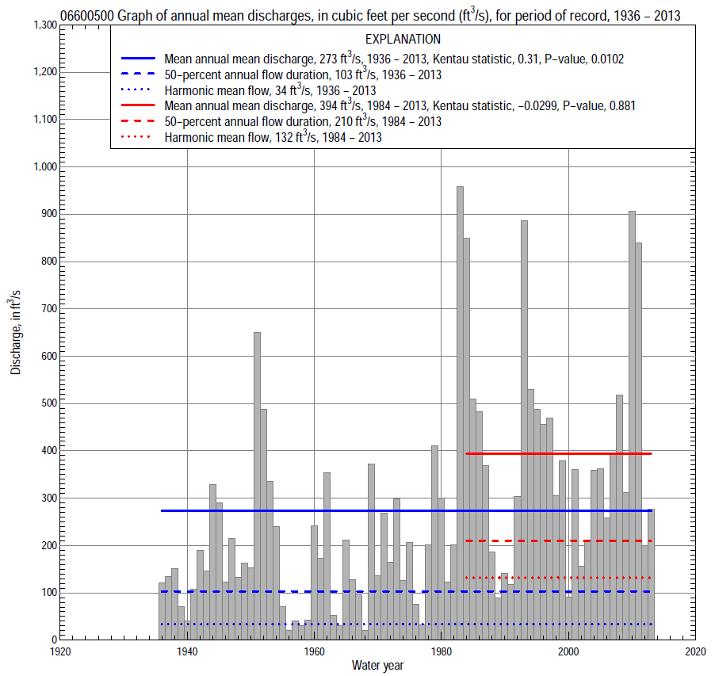

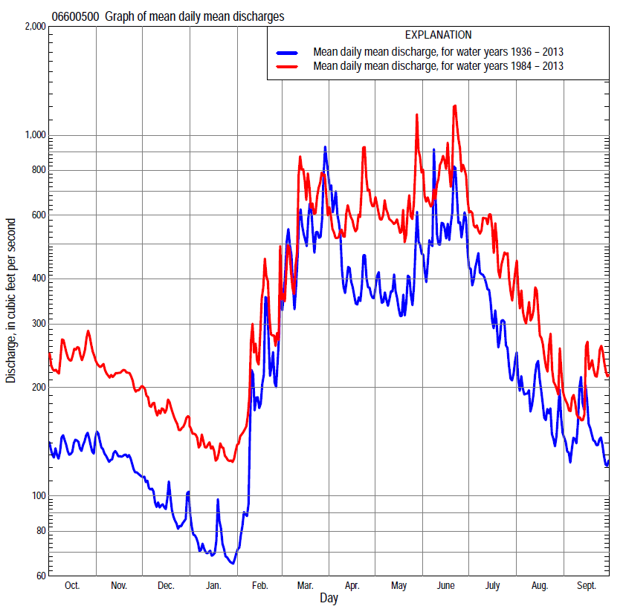

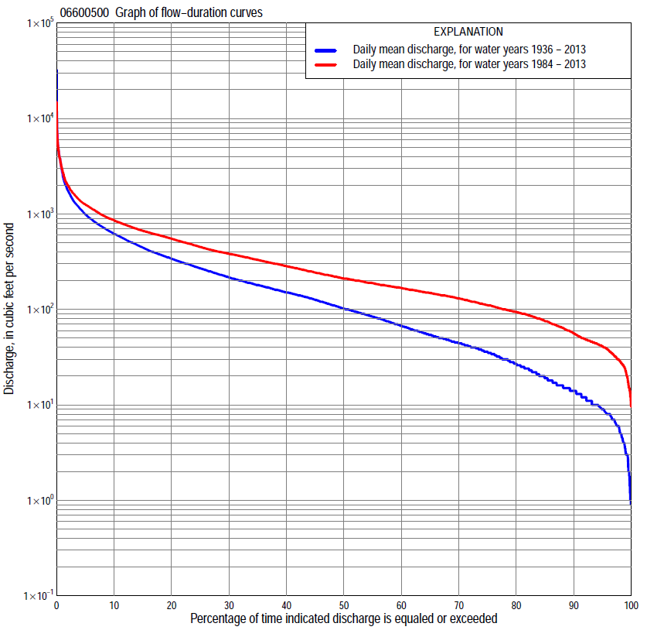

Statistics Based on the Entire Streamflow Period of Record
06600500 Monthly and annual flow durations, based on 1936–2013 period of record (78 years)
Percentage of days discharge equaled or exceeded |  |  |  |  | Discharge (cubic feet per second) |  |  |  |  |  |  |  |  | Annual flow durations
 | Oct | Nov | Dec | Jan | Feb | Mar | Apr | May | June | July | Aug | Sept | Annual | Kentau statistic | P-value
99 | 4.7 | 5.0 | 3.2 | 1.0 | 1.2 | 7.0 | 17 | 13 | 9.0 | 7.0 | 3.0 | 3.7 | 3.3 | 0.459 | 0.000
98 | 5.1 | 7.0 | 3.9 | 1.8 | 2.0 | 7.5 | 19 | 14 | 11 | 10 | 6.1 | 5.0 | 5.2 | 0.467 | 0.000
95 | 10 | 11 | 6.0 | 3.0 | 6.0 | 15 | 27 | 23 | 20 | 15 | 12 | 9.0 | 9.0 | 0.461 | 0.000
90 | 14 | 14 | 9.6 | 6.1 | 8.4 | 25 | 48 | 36 | 35 | 26 | 17 | 14 | 14 | 0.462 | 0.000
85 | 16 | 17 | 14 | 8.0 | 9.4 | 45 | 59 | 50 | 54 | 37 | 24 | 20 | 20 | 0.463 | 0.000
80 | 24 | 26 | 17 | 10 | 10 | 60 | 78 | 67 | 74 | 49 | 31 | 28 | 27 | 0.466 | 0.000
75 | 31 | 34 | 20 | 12 | 14 | 79 | 90 | 81 | 104 | 62 | 40 | 37 | 36 | 0.486 | 0.000
70 | 38 | 38 | 24 | 14 | 20 | 96 | 107 | 96 | 136 | 79 | 49 | 42 | 45 | 0.485 | 0.000
65 | 43 | 42 | 28 | 16 | 25 | 120 | 130 | 122 | 177 | 102 | 60 | 49 | 55 | 0.470 | 0.000
60 | 46 | 46 | 32 | 20 | 32 | 147 | 151 | 156 | 214 | 119 | 73 | 55 | 68 | 0.464 | 0.000
55 | 52 | 51 | 38 | 24 | 40 | 171 | 171 | 191 | 255 | 142 | 86 | 64 | 85 | 0.460 | 0.000
50 | 58 | 60 | 44 | 30 | 60 | 203 | 198 | 224 | 289 | 168 | 99 | 72 | 103 | 0.434 | 0.000
45 | 71 | 67 | 51 | 36 | 80 | 237 | 237 | 259 | 335 | 196 | 114 | 86 | 128 | 0.422 | 0.000
40 | 84 | 82 | 68 | 47 | 100 | 276 | 282 | 297 | 394 | 231 | 132 | 99 | 152 | 0.404 | 0.000
35 | 108 | 97 | 87 | 65 | 125 | 325 | 347 | 354 | 461 | 275 | 154 | 117 | 181 | 0.390 | 0.000
30 | 133 | 113 | 110 | 93 | 150 | 400 | 430 | 423 | 529 | 334 | 175 | 140 | 219 | 0.381 | 0.000
25 | 151 | 143 | 135 | 120 | 180 | 500 | 534 | 529 | 613 | 400 | 203 | 156 | 271 | 0.376 | 0.000
20 | 171 | 205 | 172 | 145 | 210 | 650 | 649 | 628 | 744 | 502 | 239 | 183 | 342 | 0.360 | 0.000
15 | 216 | 300 | 220 | 170 | 280 | 923 | 774 | 728 | 953 | 618 | 286 | 225 | 449 | 0.336 | 0.000
10 | 405 | 350 | 264 | 200 | 385 | 1,290 | 969 | 890 | 1,290 | 790 | 387 | 313 | 622 | 0.300 | 0.000
5 | 511 | 426 | 331 | 230 | 745 | 2,180 | 1,440 | 1,220 | 1,910 | 1,170 | 566 | 493 | 998 | 0.213 | 0.006
2 | 727 | 638 | 400 | 322 | 1,290 | 4,180 | 2,790 | 1,790 | 3,400 | 1,970 | 1,090 | 755 | 1,750 | 0.076 | 0.327
1 | 946 | 820 | 490 | 371 | 2,900 | 5,290 | 4,080 | 2,400 | 4,750 | 2,690 | 1,740 | 1,430 | 2,720 | 0.082 | 0.289

06600500 Annual exceedance probability of instantaneous peak discharges, in cubic feet per second (ft³/s), based on the Weighted Independent Estimates method,
Annual exceed-ance probability | Recur-rence interval (years) | Discharge (ft³/s) | 95-percent lower confi-dence interval (ft³/s) | 95-percent upper confi-dence interval (ft³/s)
0.500 | 2 | 4,180 | 3,570 | 4,890
0.200 | 5 | 9,120 | 7,730 | 10,800
0.100 | 10 | 13,600 | 11,300 | 16,400
0.040 | 25 | 20,800 | 16,500 | 26,100
0.020 | 50 | 26,700 | 20,500 | 34,800
0.010 | 100 | 33,200 | 24,600 | 45,000
0.005 | 200 | 40,100 | 28,600 | 56,300
0.002 | 500 | 49,200 | 33,200 | 73,000
and based on the expected moments algorithm/multiple Grubbs-Beck analysis computed using a historical period length of 138 years (1876–2013)
0.500 | 2 | 4,020 | 3,250 | 4,970
0.200 | 5 | 8,540 | 6,860 | 10,900
0.100 | 10 | 12,600 | 9,900 | 16,900
0.040 | 25 | 19,000 | 14,300 | 27,800
0.020 | 50 | 24,800 | 17,800 | 39,200
0.010 | 100 | 31,400 | 21,500 | 54,000
0.005 | 200 | 38,900 | 25,300 | 73,100
0.002 | 500 | 50,400 | 30,500 | 107,000
Kentau statistic |  | 0.109
P-value |  | 0.155
Begin year |  | 1935
End year |  | 2013
Number of peaks |  | 79

06600500 Annual exceedance probability of high discharges, based on 1936–2013 period of record (78 years)
Annual exceedance probability | Recur-rence interval (years) | Maximum average discharge (ft³/s) for indicated number of consecutive days
 |  | 1 | 3 | 7 | 15 | 30
0.990 | 1.01 | 297 | 171 | 100 | 64 | 42
0.950 | 1.05 | 610 | 410 | 268 | 181 | 125
0.900 | 1.11 | 889 | 635 | 433 | 297 | 207
0.800 | 1.25 | 1,390 | 1,050 | 739 | 513 | 361
0.500 | 2 | 3,170 | 2,530 | 1,810 | 1,250 | 871
0.200 | 5 | 6,980 | 5,510 | 3,800 | 2,530 | 1,700
0.100 | 10 | 10,400 | 7,970 | 5,270 | 3,410 | 2,230
0.040 | 25 | 15,800 | 11,500 | 7,170 | 4,470 | 2,820
0.020 | 50 | 20,500 | 14,300 | 8,560 | 5,190 | 3,210
0.010 | 100 | 25,900 | 17,300 | 9,900 | 5,860 | 3,540
0.005 | 200 | 31,900 | 20,400 | 11,200 | 6,460 | 3,820
0.002 | 500 | 41,000 | 24,600 | 12,800 | 7,180 | 4,140
Kentau statistic |  | 0.069 | 0.067 | 0.088 | 0.110 | 0.170
P-value |  | 0.372 | 0.386 | 0.256 | 0.155 | 0.028

 | 06600500 Annual nonexceedance probability of low discharges, based on April 1935 to March 2013 period of record (78 years)
Annual nonexceed-ance probability | Recur-rence interval (years) | Minimum average discharge (ft³/s) for indicated number of consecutive days
 |  | 1 | 3 | 7 | 14 | 30 | 60 | 90 | 120 | 183
0.01 | 100 | 0.72 | 0.82 | 0.86 | 0.89 | 1.0 | 1.5 | 2.2 | 3.0 | 3.9
0.02 | 50 | 1.1 | 1.2 | 1.3 | 1.3 | 1.5 | 2.2 | 3.1 | 4.1 | 5.5
0.05 | 20 | 2.0 | 2.2 | 2.3 | 2.4 | 2.8 | 3.9 | 5.3 | 6.8 | 9.2
0.10 | 10 | 3.3 | 3.6 | 3.8 | 4.1 | 4.7 | 6.3 | 8.4 | 11 | 14
0.20 | 5 | 6.1 | 6.7 | 7.0 | 7.5 | 8.7 | 11 | 15 | 18 | 25
0.50 | 2 | 19 | 21 | 22 | 23 | 27 | 33 | 41 | 48 | 65
0.80 | 1.25 | 56 | 60 | 64 | 70 | 79 | 94 | 112 | 127 | 163
0.90 | 1.11 | 96 | 103 | 112 | 121 | 135 | 159 | 187 | 211 | 258
0.96 | 1.04 | 168 | 181 | 199 | 214 | 235 | 275 | 318 | 359 | 415
0.98 | 1.02 | 240 | 259 | 288 | 307 | 333 | 389 | 447 | 505 | 560
0.99 | 1.01 | 327 | 356 | 400 | 423 | 453 | 530 | 604 | 686 | 728
Kentau statistic |  | 0.457 | 0.459 | 0.452 | 0.454 | 0.453 | 0.436 | 0.444 | 0.453 | 0.379
P-value |  | 0.000 | 0.000 | 0.000 | 0.000 | 0.000 | 0.000 | 0.000 | 0.000 | 0.000

06600500 Annual nonexceedance probability of seasonal low discharges, based on January 1935 to September 2013 period of record (78–79 years)
Annual nonexceed-ance probability | Recur-rence interval (years) | Minimum average discharge (cubic feet per second) for indicated number of consecutive days
 |  | 1 | 7 | 14 | 30 |  | 1 | 7 | 14 | 30
 |  | January-February-March |  |  |  |  | April-May-June
0.01 | 100 | 0.87 | 0.88 | 0.90 | 1.0 |  | 2.5 | 4.5 | 5.3 | 7.7
0.02 | 50 | 1.3 | 1.3 | 1.4 | 1.5 |  | 4.1 | 6.7 | 7.9 | 11
0.05 | 20 | 2.3 | 2.4 | 2.5 | 2.9 |  | 8.2 | 12 | 14 | 19
0.10 | 10 | 3.8 | 4.0 | 4.2 | 4.9 |  | 15 | 20 | 23 | 30
0.20 | 5 | 7.0 | 7.4 | 7.9 | 9.3 |  | 29 | 35 | 40 | 53
0.50 | 2 | 22 | 24 | 26 | 30 |  | 92 | 102 | 114 | 144
0.80 | 1.25 | 65 | 74 | 80 | 93 |  | 252 | 271 | 299 | 368
0.90 | 1.11 | 115 | 132 | 142 | 162 |  | 405 | 439 | 482 | 587
0.96 | 1.04 | 210 | 242 | 262 | 290 |  | 645 | 719 | 783 | 946
0.98 | 1.02 | 309 | 356 | 386 | 419 |  | 853 | 978 | 1,060 | 1,280
0.99 | 1.01 | 436 | 503 | 544 | 578 |  | 1,080 | 1,280 | 1,380 | 1,660
Kentau statistic |  | 0.434 | 0.448 | 0.450 | 0.430 |  | 0.467 | 0.452 | 0.448 | 0.420
P-value |  | 0.000 | 0.000 | 0.000 | 0.000 |  | 0.000 | 0.000 | 0.000 | 0.000
 |  | July-August-September |  |  |  |  | October-November-December
0.01 | 100 | 1.6 | 2.2 | 2.4 | 3.0 |  | 1.6 | 2.1 | 2.3 | 2.9
0.02 | 50 | 2.4 | 3.2 | 3.5 | 4.5 |  | 2.3 | 2.8 | 3.2 | 4.1
0.05 | 20 | 4.5 | 5.7 | 6.3 | 8.0 |  | 3.7 | 4.6 | 5.2 | 6.6
0.10 | 10 | 7.7 | 9.3 | 10 | 13 |  | 5.8 | 7.1 | 8.0 | 10
0.20 | 5 | 14 | 16 | 18 | 23 |  | 9.9 | 12 | 14 | 17
0.50 | 2 | 41 | 45 | 49 | 62 |  | 28 | 33 | 37 | 45
0.80 | 1.25 | 106 | 113 | 122 | 149 |  | 76 | 93 | 103 | 121
0.90 | 1.11 | 165 | 176 | 189 | 226 |  | 128 | 161 | 176 | 202
0.96 | 1.04 | 257 | 277 | 292 | 338 |  | 224 | 289 | 312 | 347
0.98 | 1.02 | 337 | 366 | 382 | 433 |  | 322 | 424 | 454 | 493
0.99 | 1.01 | 424 | 465 | 481 | 533 |  | 444 | 599 | 636 | 675
Kentau statistic |  | 0.457 | 0.445 | 0.432 | 0.387 |  | 0.438 | 0.448 | 0.452 | 0.470
P-value |  | 0.000 | 0.000 | 0.000 | 0.000 |  | 0.000 | 0.000 | 0.000 | 0.000

Statistics Based on the 1984–2013 Streamflow Period of Record
06600500 Monthly and annual flow durations, based on 1984–2013 period of record (30 years)
Percentage of days discharge equaled or exceeded |  |  |  |  | Discharge (cubic feet per second) |  |  |  |  |  |  |  |  | Annual flow durations
 | Oct | Nov | Dec | Jan | Feb | Mar | Apr | May | June | July | Aug | Sept | Annual | Kentau statistic | P-value
99 | 26 | 23 | 12 | 13 | 18 | 35 | 48 | 60 | 46 | 44 | 36 | 28 | 23 | 0.028 | 0.844
98 | 29 | 27 | 15 | 15 | 20 | 45 | 49 | 65 | 49 | 58 | 40 | 31 | 29 | 0.055 | 0.681
95 | 34 | 39 | 28 | 25 | 28 | 57 | 79 | 74 | 113 | 72 | 48 | 37 | 41 | 0.018 | 0.901
90 | 42 | 46 | 44 | 36 | 35 | 84 | 96 | 182 | 188 | 94 | 58 | 43 | 56 | 0.048 | 0.721
85 | 49 | 60 | 63 | 48 | 45 | 100 | 149 | 216 | 251 | 113 | 80 | 52 | 75 | -0.002 | 1.000
80 | 69 | 73 | 79 | 58 | 64 | 140 | 176 | 253 | 286 | 142 | 97 | 66 | 94 | -0.005 | 0.986
75 | 92 | 89 | 90 | 69 | 75 | 161 | 208 | 287 | 326 | 167 | 108 | 83 | 110 | -0.002 | 1.000
70 | 100 | 98 | 100 | 78 | 90 | 188 | 255 | 323 | 366 | 204 | 123 | 92 | 130 | -0.005 | 0.986
65 | 121 | 109 | 110 | 90 | 109 | 209 | 293 | 374 | 407 | 236 | 138 | 103 | 149 | -0.037 | 0.789
60 | 132 | 120 | 120 | 103 | 120 | 229 | 348 | 411 | 451 | 278 | 156 | 114 | 167 | -0.005 | 0.986
55 | 145 | 138 | 130 | 115 | 140 | 250 | 398 | 468 | 491 | 317 | 171 | 129 | 188 | -0.018 | 0.901
50 | 156 | 148 | 143 | 128 | 156 | 284 | 487 | 540 | 535 | 353 | 184 | 139 | 210 | -0.032 | 0.817
45 | 163 | 174 | 164 | 140 | 170 | 323 | 545 | 587 | 589 | 397 | 197 | 149 | 243 | -0.048 | 0.721
40 | 173 | 218 | 180 | 153 | 185 | 378 | 602 | 628 | 638 | 447 | 213 | 156 | 284 | -0.037 | 0.789
35 | 188 | 270 | 200 | 165 | 200 | 427 | 660 | 662 | 715 | 503 | 234 | 168 | 330 | -0.057 | 0.669
30 | 228 | 303 | 225 | 180 | 225 | 525 | 736 | 713 | 824 | 559 | 257 | 183 | 382 | -0.051 | 0.708
25 | 383 | 322 | 243 | 190 | 255 | 661 | 796 | 779 | 960 | 623 | 286 | 210 | 450 | -0.009 | 0.957
20 | 419 | 351 | 260 | 200 | 292 | 796 | 886 | 867 | 1,130 | 717 | 329 | 253 | 550 | -0.011 | 0.943
15 | 468 | 375 | 292 | 215 | 340 | 1,020 | 995 | 984 | 1,330 | 849 | 392 | 325 | 665 | 0.011 | 0.943
10 | 537 | 407 | 323 | 230 | 503 | 1,310 | 1,200 | 1,180 | 1,670 | 994 | 502 | 435 | 858 | 0.039 | 0.775
5 | 718 | 522 | 369 | 300 | 812 | 2,170 | 1,610 | 1,550 | 2,290 | 1,360 | 749 | 595 | 1,260 | 0.053 | 0.695
2 | 1,040 | 744 | 450 | 357 | 1,480 | 4,100 | 2,200 | 2,100 | 3,590 | 2,170 | 1,640 | 1,110 | 1,990 | 0.023 | 0.872
1 | 1,290 | 846 | 511 | 381 | 3,060 | 5,290 | 3,100 | 2,770 | 4,670 | 3,330 | 2,370 | 1,540 | 2,880 | 0.028 | 0.844

06600500 Annual exceedance probability of high discharges, based on 1984–2013 period of record (30 years)
Annual exceedance probability | Recur-rence interval (years) | Maximum average discharge (ft³/s) for indicated number of consecutive days
 |  | 1 | 3 | 7 | 15 | 30
0.990 | 1.01 | 644 | 453 | 313 | 205 | 152
0.950 | 1.05 | 1,040 | 769 | 562 | 400 | 301
0.900 | 1.11 | 1,350 | 1,020 | 758 | 554 | 418
0.800 | 1.25 | 1,860 | 1,420 | 1,070 | 801 | 604
0.500 | 2 | 3,410 | 2,690 | 2,000 | 1,500 | 1,120
0.200 | 5 | 6,310 | 5,050 | 3,550 | 2,540 | 1,840
0.100 | 10 | 8,720 | 7,000 | 4,700 | 3,220 | 2,300
0.040 | 25 | 12,300 | 9,870 | 6,240 | 4,040 | 2,830
0.020 | 50 | 15,400 | 12,300 | 7,440 | 4,620 | 3,190
0.010 | 100 | 18,900 | 15,000 | 8,660 | 5,160 | 3,510
0.005 | 200 | 22,800 | 18,000 | 9,910 | 5,670 | 3,810
0.002 | 500 | 28,600 | 22,400 | 11,600 | 6,300 | 4,170
Kentau statistic |  | -0.057 | 0.014 | 0.037 | -0.021 | 0.011
P-value |  | 0.669 | 0.929 | 0.789 | 0.887 | 0.943

 | 06600500 Annual nonexceedance probability of low discharges, based on April 1983 to March 2013 period of record (30 years)
Annual nonexceed-ance probability | Recur-rence interval (years) | Minimum average discharge (ft³/s) for indicated number of consecutive days
 |  | 1 | 3 | 7 | 14 | 30 | 60 | 90 | 120 | 183
0.01 | 100 | 5.4 | 6.5 | 7.3 | 8.5 | 10 | 13 | 15 | 17 | 20
0.02 | 50 | 7.8 | 9.2 | 10 | 12 | 14 | 18 | 20 | 22 | 26
0.05 | 20 | 13 | 15 | 16 | 19 | 22 | 27 | 31 | 33 | 38
0.10 | 10 | 20 | 23 | 24 | 27 | 31 | 38 | 43 | 47 | 53
0.20 | 5 | 31 | 35 | 37 | 41 | 46 | 56 | 63 | 68 | 77
0.50 | 2 | 64 | 71 | 75 | 82 | 92 | 107 | 123 | 134 | 152
0.80 | 1.25 | 111 | 121 | 133 | 144 | 160 | 185 | 215 | 241 | 280
0.90 | 1.11 | 140 | 151 | 172 | 184 | 206 | 237 | 278 | 319 | 376
0.96 | 1.04 | 170 | 184 | 218 | 232 | 260 | 299 | 355 | 419 | 506
0.98 | 1.02 | 189 | 205 | 250 | 265 | 298 | 342 | 411 | 495 | 606
0.99 | 1.01 | 206 | 223 | 279 | 295 | 333 | 382 | 464 | 570 | 709
Kentau statistic |  | 0.055 | 0.062 | 0.062 | 0.060 | 0.076 | 0.067 | 0.007 | 0.021 | -0.016
P-value |  | 0.681 | 0.643 | 0.643 | 0.656 | 0.568 | 0.617 | 0.972 | 0.887 | 0.915

06600500 Annual nonexceedance probability of seasonal low discharges, based on October 1983 to September 2013 period of record (30 years)
Annual nonexceed-ance probability | Recur-rence interval (years) | Minimum average discharge (cubic feet per second) for indicated number of consecutive days
 |  | 1 | 7 | 14 | 30 |  | 1 | 7 | 14 | 30
 |  | January-February-March |  |  |  |  | April-May-June
0.01 | 100 | 6.9 | 8.6 | 9.6 | 11 |  | 27 | 28 | 30 | 31
0.02 | 50 | 9.6 | 12 | 13 | 16 |  | 37 | 39 | 41 | 45
0.05 | 20 | 15 | 19 | 21 | 25 |  | 57 | 61 | 67 | 75
0.10 | 10 | 22 | 28 | 31 | 36 |  | 82 | 89 | 99 | 114
0.20 | 5 | 35 | 42 | 47 | 55 |  | 123 | 136 | 152 | 180
0.50 | 2 | 73 | 87 | 96 | 109 |  | 245 | 273 | 308 | 375
0.80 | 1.25 | 136 | 156 | 169 | 188 |  | 436 | 484 | 538 | 658
0.90 | 1.11 | 181 | 203 | 217 | 237 |  | 566 | 624 | 684 | 830
0.96 | 1.04 | 237 | 259 | 274 | 294 |  | 725 | 790 | 849 | 1,020
0.98 | 1.02 | 278 | 298 | 313 | 332 |  | 838 | 906 | 959 | 1,140
0.99 | 1.01 | 317 | 335 | 348 | 366 |  | 944 | 1,010 | 1,060 | 1,240
Kentau statistic |  | 0.011 | 0.071 | 0.055 | 0.057 |  | 0.048 | -0.002 | -0.021 | -0.034
P-value |  | 0.943 | 0.592 | 0.682 | 0.669 |  | 0.721 | 1.000 | 0.887 | 0.803
 |  | July-August-September |  |  |  |  | October-November-December
0.01 | 100 | 18 | 20 | 22 | 26 |  | 5.3 | 7.5 | 9.7 | 14
0.02 | 50 | 22 | 24 | 26 | 30 |  | 8.1 | 11 | 14 | 20
0.05 | 20 | 29 | 31 | 34 | 39 |  | 15 | 19 | 23 | 30
0.10 | 10 | 38 | 40 | 43 | 50 |  | 23 | 30 | 35 | 43
0.20 | 5 | 52 | 55 | 59 | 67 |  | 39 | 49 | 56 | 65
0.50 | 2 | 95 | 100 | 106 | 119 |  | 85 | 107 | 117 | 130
0.80 | 1.25 | 176 | 185 | 196 | 220 |  | 152 | 194 | 209 | 235
0.90 | 1.11 | 242 | 257 | 274 | 307 |  | 191 | 247 | 267 | 306
0.96 | 1.04 | 342 | 367 | 394 | 441 |  | 233 | 305 | 333 | 396
0.98 | 1.02 | 428 | 462 | 500 | 560 |  | 258 | 342 | 376 | 460
0.99 | 1.01 | 523 | 570 | 621 | 697 |  | 278 | 374 | 414 | 521
Kentau statistic |  | -0.064 | -0.071 | -0.090 | -0.085 |  | 0.060 | 0.048 | -0.002 | -0.007
P-value |  | 0.630 | 0.592 | 0.498 | 0.521 |  | 0.655 | 0.721 | 1.000 | 0.972

