LOCATION.--Lat 42°00'26", long 96°14'29" referenced to North American Datum of 1927, in NE 1/4 SW 1/4 sec.36, T.24 N., R.10 E., Burt County, NE, Hydrologic Unit 10230001, on right bank 500 ft upstream from bridge on State Highway 175 in Decatur, and 691.0 mi upstream from mouth.

DRAINAGE AREA.--316,200 mi².

PERIOD OF RECORD.--Discharge records from October 1987 to current year.

GAGE.--Water-stage recorder. Datum of gage is 1,010.00 ft above National Geodetic Vertical Datum of 1929, supplementary adjustment of 1954.

REMARKS.--Flow regulated by upstream main-stem reservoirs. Fort Randall Dam was completed in July 1952, with storage beginning in December 1952. Gavins Point Dam was completed in July 1955, with storage beginning in December 1955.

A summary of all available data for this streamgage is provided through the USGS National Water Information System web interface (NWISWeb). The following link provides access to current/historical observations, daily data, daily statistics, monthly statistics, annual statistics, peak streamflow, field measurements, field/lab water-quality samples, and the latest water-year summaries. Data can be filtered by parameter and/or dates, and can be output in various tabular and graphical formats.
http://waterdata.usgs.gov/nwis/inventory/?site_no=06601200

The USGS WaterWatch Toolkit is available at:
http://waterwatch.usgs.gov/?id=ww_toolkit
Tools for summarizing streamflow information include the duration hydrograph builder, the cumulative streamflow hydrograph builder, the streamgage statistics retrieval tool, the rating curve builder, the flood tracking chart builder, the National Weather Service Advanced Hydrologic Prediction Service (AHPS) river forecast hydrograph builder, and the raster-hydrograph builder. Entering the above number for this streamgage into these toolkit webpages will provide streamflow information specific to this streamgage.

A description of the statistics presented for this streamgage is available in the main body of the report at:
http://dx.doi.org/10.3133/ofr20151214
A link to other streamgages included in this report, a map showing the location of the streamgages, information on the programs used to compute the statistical analyses, and references are included in the main body of the report.

Statistics Based on the Regulated Streamflow Period of Record
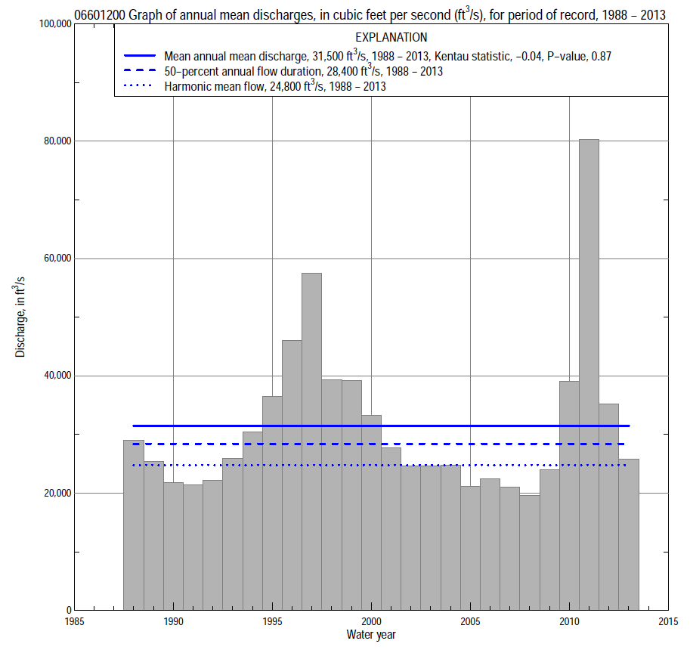

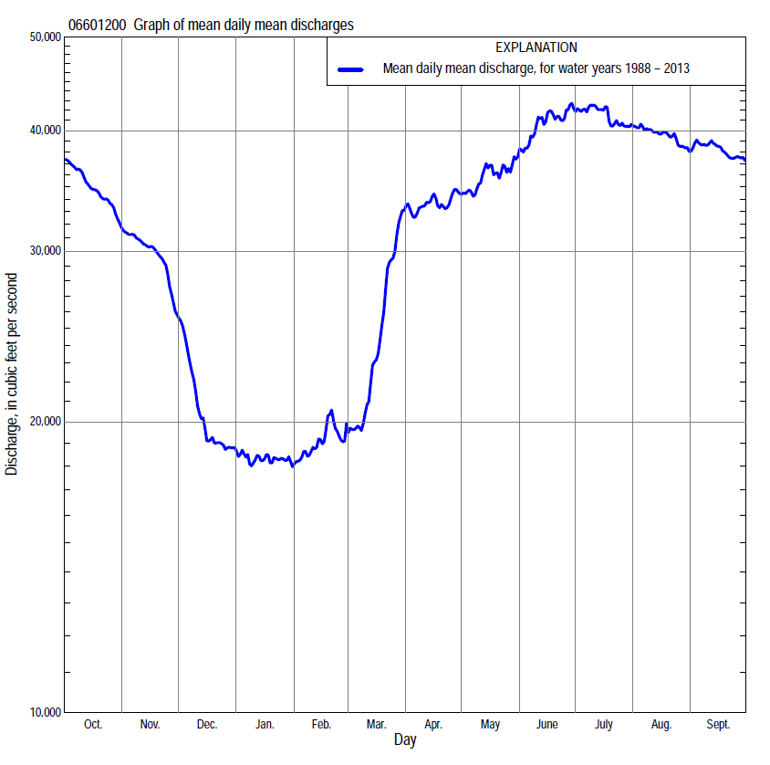

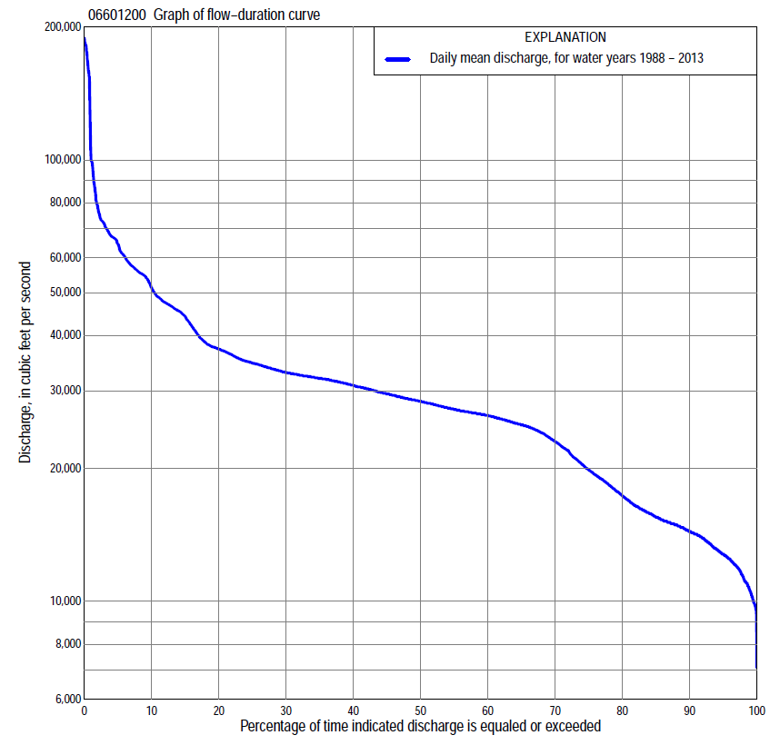

Statistics Based on the Regulated Streamflow Period of Record
06601200 Monthly and annual flow durations, based on 1988–2013 regulated period of record (26 years)
Percentage of days discharge equaled or exceeded |  |  |  |  | Discharge (cubic feet per second) |  |  |  |  |  |  |  |  | Annual flow durations
 | Oct | Nov | Dec | Jan | Feb | Mar | Apr | May | June | July | Aug | Sept | Annual | Kentau statistic | P-value
99 | 12,000 | 9,960 | 9,760 | 11,000 | 11,000 | 9,700 | 17,800 | 19,200 | 21,100 | 19,200 | 22,000 | 20,100 | 10,600 | 0.111 | 0.440
98 | 12,500 | 10,300 | 10,000 | 11,500 | 11,100 | 9,910 | 19,100 | 19,800 | 23,800 | 20,900 | 22,500 | 20,900 | 11,300 | 0.108 | 0.453
95 | 13,700 | 10,800 | 12,100 | 12,900 | 11,900 | 10,600 | 21,700 | 22,300 | 26,200 | 25,200 | 24,300 | 24,000 | 12,800 | 0.077 | 0.597
90 | 16,900 | 11,600 | 13,100 | 13,800 | 12,900 | 11,800 | 23,300 | 24,400 | 26,800 | 26,200 | 25,400 | 26,300 | 14,400 | 0.055 | 0.708
85 | 23,200 | 12,100 | 13,700 | 14,300 | 13,700 | 13,200 | 24,300 | 25,400 | 27,300 | 26,600 | 26,500 | 27,100 | 15,500 | 0.080 | 0.582
80 | 25,600 | 12,400 | 14,200 | 14,600 | 14,300 | 14,300 | 24,900 | 26,000 | 28,200 | 27,100 | 27,000 | 28,100 | 17,300 | 0.062 | 0.675
75 | 26,900 | 12,800 | 14,700 | 14,900 | 14,700 | 15,300 | 25,300 | 26,900 | 29,000 | 27,800 | 27,300 | 28,800 | 19,900 | 0.077 | 0.596
70 | 28,600 | 13,600 | 15,000 | 15,200 | 15,100 | 16,700 | 26,000 | 28,100 | 29,700 | 28,500 | 27,800 | 29,500 | 23,000 | 0.068 | 0.643
65 | 29,200 | 14,600 | 15,400 | 15,500 | 15,400 | 18,100 | 26,600 | 28,800 | 30,400 | 29,400 | 28,500 | 30,300 | 25,100 | 0.022 | 0.895
60 | 30,200 | 21,300 | 16,000 | 15,800 | 15,800 | 19,300 | 27,200 | 29,500 | 31,500 | 30,400 | 29,100 | 31,000 | 26,400 | -0.031 | 0.843
55 | 31,100 | 26,400 | 16,500 | 16,100 | 16,100 | 21,200 | 27,900 | 30,800 | 32,500 | 31,500 | 30,600 | 31,600 | 27,200 | -0.098 | 0.494
50 | 32,000 | 28,600 | 17,000 | 16,500 | 16,900 | 22,900 | 29,700 | 32,000 | 33,100 | 32,400 | 31,700 | 32,500 | 28,400 | -0.071 | 0.628
45 | 32,400 | 30,500 | 18,000 | 17,200 | 17,700 | 24,100 | 31,100 | 32,700 | 34,800 | 33,500 | 32,100 | 33,200 | 29,500 | -0.062 | 0.675
40 | 33,100 | 31,400 | 19,200 | 17,800 | 18,600 | 26,000 | 31,700 | 33,600 | 35,900 | 34,300 | 32,400 | 34,200 | 30,800 | -0.025 | 0.877
35 | 34,300 | 33,800 | 19,900 | 18,700 | 19,200 | 27,300 | 32,100 | 35,700 | 36,900 | 34,900 | 32,900 | 34,700 | 32,000 | 0.000 | 1.000
30 | 35,600 | 35,300 | 20,500 | 20,300 | 20,100 | 28,600 | 32,500 | 37,000 | 38,100 | 36,000 | 33,700 | 35,800 | 33,000 | -0.015 | 0.930
25 | 37,700 | 44,700 | 23,300 | 22,200 | 21,500 | 30,800 | 33,900 | 38,300 | 41,100 | 43,300 | 38,000 | 38,100 | 34,700 | -0.003 | 1.000
20 | 47,300 | 46,500 | 25,900 | 23,600 | 25,000 | 32,600 | 36,900 | 40,200 | 46,300 | 46,200 | 44,800 | 49,300 | 37,300 | 0.009 | 0.965
15 | 53,900 | 48,500 | 28,700 | 24,800 | 28,100 | 35,000 | 42,400 | 44,100 | 48,600 | 54,800 | 55,200 | 56,400 | 44,200 | -0.009 | 0.965
10 | 58,600 | 55,700 | 33,900 | 25,700 | 29,500 | 39,400 | 48,900 | 49,600 | 59,500 | 63,700 | 61,300 | 58,700 | 51,300 | -0.003 | 1.000
5 | 63,700 | 61,300 | 44,500 | 26,900 | 30,900 | 49,500 | 70,400 | 77,100 | 69,200 | 68,100 | 70,700 | 68,000 | 64,500 | 0.018 | 0.912
2 | 70,400 | 72,400 | 48,900 | 27,900 | 35,000 | 58,800 | 89,100 | 84,400 | 155,000 | 182,000 | 159,000 | 96,600 | 78,000 | 0.098 | 0.494
1 | 71,400 | 72,700 | 53,400 | 28,400 | 37,300 | 67,600 | 95,600 | 88,000 | 166,000 | 183,000 | 166,000 | 99,200 | 100,000 | 0.123 | 0.390

06601200 Annual exceedance probability of instantaneous peak discharges, in cubic feet per second (ft³/s), based on U.S. Army Corps of Engineers regulated flow frequency studyª, analysis computed using a record length of 100 years (1898-1997)
USACE Regulated Flow Frequency Analysis
[ND, not determined]
Annual exceedance probability | Recurrence interval (years) | Discharge (ft³/s) | 95-percent lower confidence interval (ft³/s) | 95-percent upper confidence interval (ft³/s)
0.500 | 2 | 52,400 | ND | ND
0.200 | 5 | 70,500 | ND | ND
0.100 | 10 | 87,200 | ND | ND
0.040 | 25 | 102,000 | ND | ND
0.020 | 50 | 121,000 | ND | ND
0.010 | 100 | 142,000 | ND | ND
0.005 | 200 | 165,000 | ND | ND
0.002 | 500 | 198,000 | ND | ND
ªU.S. Army Corps of Engineers, 2003, Upper Mississippi River System Flow Frequency Study, Hydrology and Hydraulics Appendix F Missouri River, Omaha District: U.S. Army Corps of Engineers, 488 p., accessed September 16, 2014, at http://www.mvr.usace.army.mil/Portals/48/docs/FRM/UpperMissFlowFreq/App.%20F%20Omaha%20Dist.%20Hydrology_Hydraulics%20Report.pdf.
USGS Kendall's Tau Trend Analysis
Kentau statistic |  | 0.107
P-value |  | 0.469
Begin year |  | 1988^{b}
End year |  | 2013^{b}
Number of peaks |  | 25
^{b}Kendall's tau trend analysis computed using the regulated period of record which is not the same period of record used for the above regulated flow frequency analysis.

06601200 Annual exceedance probability of high discharges, based on 1988–2013 regulated period of recordª (26 years)
[ND, not determined]
Annual exceedance probability | Recur-rence interval (years) | Maximum average discharge (cubic feet per second) for indicated number of consecutive days
 |  | 1 | 3 | 7 | 15 | 30
0.990 | 1.01 | ND | ND | ND | ND | ND
0.950 | 1.05 | ND | ND | ND | ND | ND
0.900 | 1.11 | ND | ND | ND | ND | ND
0.800 | 1.25 | ND | ND | ND | ND | ND
0.500 | 2 | ND | ND | ND | ND | ND
0.200 | 5 | ND | ND | ND | ND | ND
0.100 | 10 | ND | ND | ND | ND | ND
0.040 | 25 | ND | ND | ND | ND | ND
0.020 | 50 | ND | ND | ND | ND | ND
0.010 | 100 | ND | ND | ND | ND | ND
0.005 | 200 | ND | ND | ND | ND | ND
0.002 | 500 | ND | ND | ND | ND | ND
Kentau statistic |  | 0.160 | 0.169 | 0.120 | 0.083 | 0.009
P-value |  | 0.261 | 0.234 | 0.402 | 0.567 | 0.965
ªContact the U.S. Army Corps of Engineers, Omaha District, for the annual exceedance probability of high discharges.

 | 06601200 Annual nonexceedance probability of low discharges, based on April 1988 to March 2013 regulated period of record (25 years)
Annual nonexceed-ance probability | Recur-rence interval (years) | Minimum average discharge (cubic feet per second) for indicated number of consecutive days
 |  | 1 | 3 | 7 | 14 | 30 | 60 | 90 | 120 | 183
0.01 | 100 | 6,220 | 7,680 | 7,980 | 8,110 | 8,470 | 9,730 | 10,000 | 10,000 | 11,600
0.02 | 50 | 6,680 | 8,120 | 8,500 | 8,670 | 9,030 | 10,200 | 10,600 | 10,600 | 12,300
0.05 | 20 | 7,460 | 8,870 | 9,390 | 9,610 | 9,980 | 11,100 | 11,500 | 11,500 | 13,500
0.10 | 10 | 8,280 | 9,660 | 10,300 | 10,600 | 11,000 | 12,000 | 12,500 | 12,500 | 14,900
0.20 | 5 | 9,470 | 10,800 | 11,600 | 11,900 | 12,300 | 13,200 | 13,700 | 14,000 | 16,800
0.50 | 2 | 12,500 | 13,700 | 14,800 | 15,200 | 15,700 | 16,400 | 17,000 | 17,900 | 22,200
0.80 | 1.25 | 17,000 | 18,100 | 19,300 | 19,800 | 20,400 | 21,100 | 22,100 | 24,200 | 30,600
0.90 | 1.11 | 20,300 | 21,200 | 22,400 | 22,900 | 23,600 | 24,400 | 25,800 | 28,800 | 36,900
0.96 | 1.04 | 24,700 | 25,400 | 26,500 | 26,900 | 27,700 | 28,900 | 30,800 | 35,300 | 45,800
0.98 | 1.02 | 28,200 | 28,700 | 29,600 | 29,900 | 30,900 | 32,400 | 34,900 | 40,600 | 53,200
0.99 | 1.01 | 31,900 | 32,200 | 32,800 | 33,000 | 34,200 | 36,000 | 39,200 | 46,300 | 61,200
Kentau statistic |  | 0.193 | 0.173 | 0.137 | 0.153 | 0.127 | 0.133 | 0.140 | 0.107 | 0.053
P-value |  | 0.183 | 0.234 | 0.350 | 0.293 | 0.388 | 0.362 | 0.338 | 0.469 | 0.726

06601200 Annual nonexceedance probability of seasonal low discharges, based on October 1987 to September 2013 regulated period of record (26 years)
Annual nonexceed-ance probability | Recur-rence interval (years) | Minimum average discharge (cubic feet per second) for indicated number of consecutive days
 |  | 1 | 7 | 14 | 30 |  | 1 | 7 | 14 | 30
 |  | January-February-March |  |  |  |  | April-May-June
0.01 | 100 | 6,640 | 8,510 | 8,760 | 9,270 |  | 17,100 | 17,800 | 19,100 | 20,400
0.02 | 50 | 7,120 | 9,060 | 9,340 | 9,870 |  | 17,600 | 18,200 | 19,500 | 20,700
0.05 | 20 | 7,950 | 9,980 | 10,300 | 10,900 |  | 18,500 | 19,200 | 20,200 | 21,400
0.10 | 10 | 8,820 | 10,900 | 11,300 | 11,900 |  | 19,500 | 20,200 | 21,200 | 22,200
0.20 | 5 | 10,100 | 12,200 | 12,700 | 13,300 |  | 21,200 | 21,900 | 22,700 | 23,700
0.50 | 2 | 13,200 | 15,400 | 15,900 | 16,500 |  | 25,900 | 26,700 | 27,400 | 28,400
0.80 | 1.25 | 17,800 | 19,800 | 20,200 | 20,900 |  | 33,900 | 35,100 | 35,900 | 37,300
0.90 | 1.11 | 21,100 | 22,700 | 23,100 | 23,800 |  | 40,300 | 41,600 | 42,900 | 44,900
0.96 | 1.04 | 25,500 | 26,400 | 26,600 | 27,500 |  | 49,500 | 51,300 | 53,300 | 56,600
0.98 | 1.02 | 28,900 | 29,300 | 29,300 | 30,200 |  | 57,400 | 59,500 | 62,400 | 67,100
0.99 | 1.01 | 32,000 | 32,000 | 32,000 | 32,900 |  | 66,100 | 68,700 | 72,600 | 79,100
Kentau statistic |  | 0.126 | 0.074 | 0.077 | 0.095 |  | -0.234 | -0.222 | -0.212 | -0.194
P-value |  | 0.378 | 0.612 | 0.597 | 0.508 |  | 0.098 | 0.118 | 0.134 | 0.172
 |  | July-August-September |  |  |  |  | October-November-December
0.01 | 100 | 17,200 | 18,200 | 19,500 | 21,300 |  | 6,570 | 8,040 | 8,080 | 8,080
0.02 | 50 | 17,900 | 18,800 | 19,900 | 21,600 |  | 7,180 | 8,610 | 8,670 | 8,670
0.05 | 20 | 19,200 | 19,900 | 20,800 | 22,200 |  | 8,220 | 9,600 | 9,700 | 9,700
0.10 | 10 | 20,600 | 21,200 | 22,000 | 23,200 |  | 9,300 | 10,600 | 10,800 | 10,800
0.20 | 5 | 22,700 | 23,300 | 23,800 | 24,800 |  | 10,900 | 12,100 | 12,300 | 12,500
0.50 | 2 | 28,800 | 29,400 | 29,800 | 30,500 |  | 14,800 | 15,800 | 16,200 | 17,300
0.80 | 1.25 | 38,900 | 40,200 | 41,200 | 42,200 |  | 20,400 | 21,300 | 21,900 | 25,200
0.90 | 1.11 | 46,800 | 49,100 | 51,000 | 52,700 |  | 24,400 | 25,200 | 25,900 | 31,300
0.96 | 1.04 | 58,200 | 62,400 | 66,200 | 69,900 |  | 29,600 | 30,300 | 31,200 | 40,300
0.98 | 1.02 | 68,000 | 74,100 | 80,100 | 86,000 |  | 33,700 | 34,400 | 35,400 | 47,900
0.99 | 1.01 | 78,800 | 87,300 | 96,300 | 105,000 |  | 37,900 | 38,700 | 39,800 | 56,200
Kentau statistic |  | -0.012 | -0.040 | -0.040 | -0.046 |  | 0.015 | 0.095 | 0.095 | 0.095
P-value |  | 0.947 | 0.791 | 0.791 | 0.758 |  | 0.930 | 0.508 | 0.508 | 0.508

