LOCATION.--Lat 42°13'37", long 96°04'40" referenced to North American Datum of 1927, in NE 1/4 NE 1/4 NE 1/4 sec.33, T.86 N., R.45 W., Woodbury County, IA, Hydrologic Unit 10230004, on left bank on upstream side of bridge on State Highway 141, 1.0 mi east of Hornick, and 9.2 mi upstream from Wolf Creek.

DRAINAGE AREA.--403 mi².

PERIOD OF RECORD.--Discharge records from April 1939 to September 1969 (published as "at Holly Springs"), July 1974 to September 2008, January 2010 to current year; annual maximum discharge, water year 2009.

GAGE.--Water-stage recorder. Datum of gage is 1,045.82 ft above National Geodetic Vertical Datum of 1929.

REMARKS.--West Fork Ditch is a dredged channel which diverts the flow of the West Fork Little Sioux River at Hornick south for 5.5 mi, then southeast for 6.5 mi to a point 1.2 mi west of Kennebec, where Wolf Creek enters from the east. From this point, the ditch roughly parallels the Little Sioux River and is known as the Monona-Harrison Ditch.

A summary of all available data for this streamgage is provided through the USGS National Water Information System web interface (NWISWeb). The following link provides access to current/historical observations, daily data, daily statistics, monthly statistics, annual statistics, peak streamflow, field measurements, field/lab water-quality samples, and the latest water-year summaries. Data can be filtered by parameter and/or dates, and can be output in various tabular and graphical formats.
http://waterdata.usgs.gov/nwis/inventory/?site_no=06602020

The USGS WaterWatch Toolkit is available at:
http://waterwatch.usgs.gov/?id=ww_toolkit
Tools for summarizing streamflow information include the duration hydrograph builder, the cumulative streamflow hydrograph builder, the streamgage statistics retrieval tool, the rating curve builder, the flood tracking chart builder, the National Weather Service Advanced Hydrologic Prediction Service (AHPS) river forecast hydrograph builder, and the raster-hydrograph builder. Entering the above number for this streamgage into these toolkit webpages will provide streamflow information specific to this streamgage.

A description of the statistics presented for this streamgage is available in the main body of the report at:
http://dx.doi.org/10.3133/ofr20151214
A link to other streamgages included in this report, a map showing the location of the streamgages, information on the programs used to compute the statistical analyses, and references are included in the main body of the report.

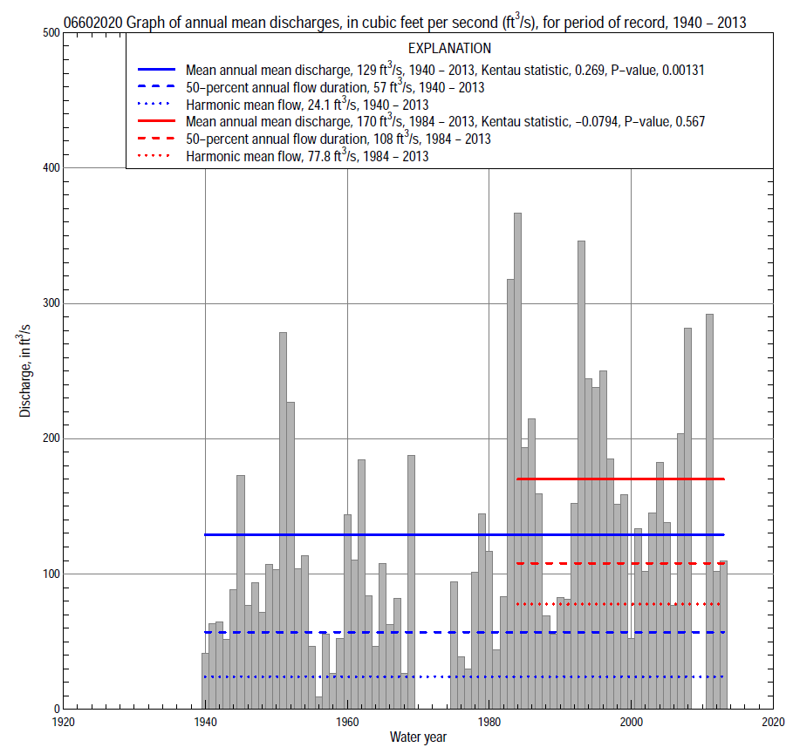

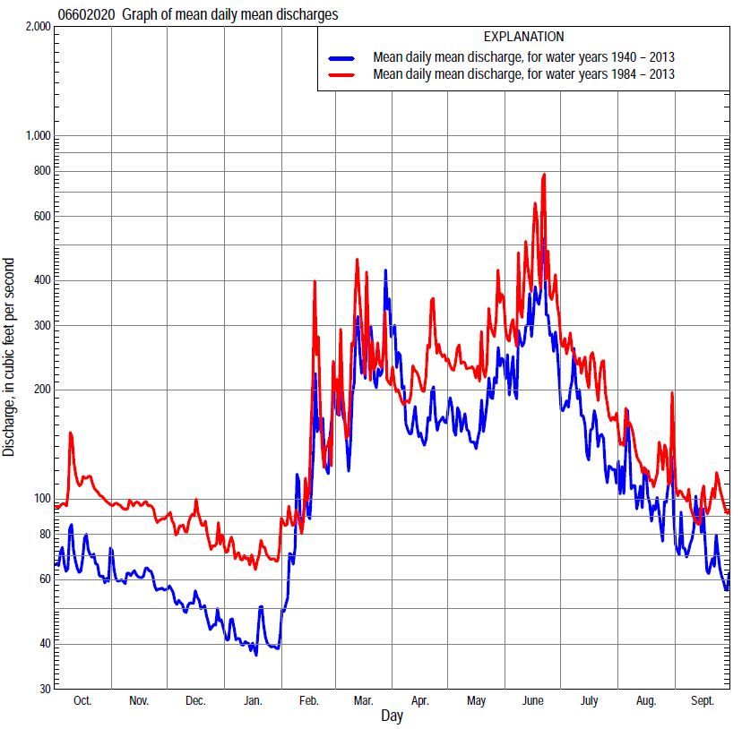

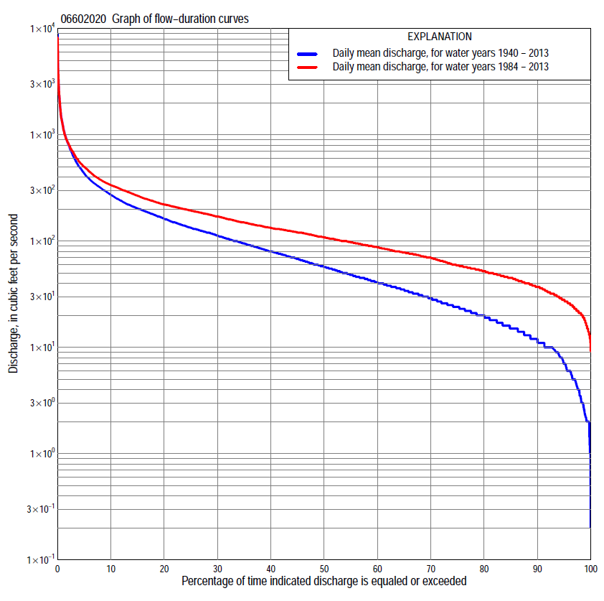

Statistics Based on the Entire Streamflow Period of Record
06602020 Monthly and annual flow durations, based on 1940–69, 1975–2008, 2011–13 period of record (67 years)
Percentage of days discharge equaled or exceeded |  |  |  |  | Discharge (cubic feet per second) |  |  |  |  |  |  |  |  | Annual flow durations
 | Oct | Nov | Dec | Jan | Feb | Mar | Apr | May | June | July | Aug | Sept | Annual | Kentau statistic | P-value
99 | 1.9 | 3.8 | 2.6 | 2.0 | 2.0 | 8.0 | 8.1 | 9.2 | 6.6 | 6.0 | 2.0 | 2.0 | 2.2 | 0.528 | 0.000
98 | 2.2 | 4.2 | 3.0 | 2.0 | 2.1 | 10 | 9.5 | 11 | 11 | 8.0 | 3.4 | 2.9 | 3.5 | 0.535 | 0.000
95 | 6.0 | 6.0 | 4.9 | 3.0 | 4.3 | 15 | 14 | 15 | 16 | 14 | 8.2 | 6.5 | 7.0 | 0.527 | 0.000
90 | 10 | 11 | 7.0 | 5.0 | 8.2 | 22 | 22 | 21 | 27 | 20 | 14 | 12 | 12 | 0.511 | 0.000
85 | 13 | 14 | 10 | 8.0 | 10 | 27 | 27 | 28 | 35 | 24 | 17 | 15 | 15 | 0.494 | 0.000
80 | 16 | 18 | 12 | 10 | 11 | 32 | 36 | 35 | 45 | 33 | 20 | 19 | 20 | 0.497 | 0.000
75 | 19 | 20 | 15 | 11 | 14 | 39 | 44 | 42 | 58 | 39 | 26 | 23 | 24 | 0.507 | 0.000
70 | 22 | 23 | 17 | 13 | 18 | 45 | 50 | 50 | 69 | 45 | 32 | 27 | 29 | 0.507 | 0.000
65 | 25 | 26 | 20 | 15 | 22 | 54 | 60 | 66 | 88 | 53 | 37 | 30 | 35 | 0.502 | 0.000
60 | 28 | 30 | 23 | 18 | 31 | 66 | 74 | 78 | 106 | 62 | 42 | 33 | 41 | 0.483 | 0.000
55 | 32 | 33 | 26 | 20 | 38 | 80 | 91 | 96 | 124 | 74 | 47 | 37 | 49 | 0.466 | 0.000
50 | 36 | 37 | 32 | 24 | 45 | 93 | 103 | 116 | 143 | 89 | 54 | 44 | 58 | 0.443 | 0.000
45 | 46 | 43 | 38 | 30 | 53 | 107 | 125 | 133 | 162 | 103 | 64 | 52 | 68 | 0.420 | 0.000
40 | 54 | 51 | 45 | 38 | 61 | 120 | 142 | 149 | 187 | 120 | 77 | 61 | 80 | 0.394 | 0.000
35 | 60 | 56 | 52 | 46 | 74 | 138 | 167 | 168 | 212 | 143 | 87 | 70 | 95 | 0.381 | 0.000
30 | 74 | 67 | 62 | 56 | 85 | 168 | 186 | 194 | 244 | 174 | 100 | 79 | 113 | 0.372 | 0.000
25 | 82 | 80 | 70 | 64 | 100 | 200 | 210 | 225 | 299 | 209 | 117 | 88 | 134 | 0.365 | 0.000
20 | 103 | 101 | 80 | 72 | 120 | 236 | 250 | 269 | 371 | 249 | 139 | 101 | 162 | 0.353 | 0.000
15 | 130 | 124 | 100 | 85 | 150 | 310 | 315 | 309 | 478 | 302 | 167 | 120 | 203 | 0.295 | 0.000
10 | 157 | 146 | 122 | 100 | 219 | 484 | 367 | 373 | 660 | 365 | 211 | 155 | 273 | 0.233 | 0.005
5 | 211 | 188 | 152 | 120 | 450 | 914 | 500 | 569 | 1,030 | 503 | 325 | 220 | 435 | 0.083 | 0.325
2 | 287 | 218 | 190 | 140 | 900 | 1,700 | 872 | 864 | 1,640 | 797 | 690 | 315 | 824 | -0.029 | 0.733
1 | 394 | 251 | 220 | 160 | 1,130 | 2,940 | 1,580 | 1,420 | 2,570 | 978 | 963 | 472 | 1,230 | -0.048 | 0.570

06602020 Annual exceedance probability of instantaneous peak discharges, in cubic feet per second (ft³/s), based on the Weighted Independent Estimates method,
Annual exceed-ance probability | Recur-rence interval (years) | Discharge (ft³/s) | 95-percent lower confi-dence interval (ft³/s) | 95-percent upper confi-dence interval (ft³/s)
0.500 | 2 | 3,140 | 2,630 | 3,750
0.200 | 5 | 5,880 | 4,970 | 6,970
0.100 | 10 | 7,980 | 6,650 | 9,580
0.040 | 25 | 11,000 | 8,890 | 13,700
0.020 | 50 | 13,400 | 10,400 | 17,200
0.010 | 100 | 16,000 | 12,000 | 21,300
0.005 | 200 | 18,700 | 13,600 | 25,700
0.002 | 500 | 22,000 | 15,100 | 31,900
and based on the expected moments algorithm/multiple Grubbs-Beck analysis computed using a historical period length of 75 years (1939–2013)
0.500 | 2 | 3,020 | 2,490 | 3,640
0.200 | 5 | 5,500 | 4,590 | 6,670
0.100 | 10 | 7,300 | 6,050 | 9,150
0.040 | 25 | 9,670 | 7,810 | 13,000
0.020 | 50 | 11,500 | 8,970 | 16,300
0.010 | 100 | 13,300 | 9,970 | 20,100
0.005 | 200 | 15,100 | 10,800 | 24,300
0.002 | 500 | 17,500 | 11,800 | 30,800
Kentau statistic |  | -0.020
P-value |  | 0.812
Begin year |  | 1939
End year |  | 2013
Number of peaks |  | 70

06602020 Annual exceedance probability of high discharges, based on 1940–69, 1975–2008, 2011–13 period of record (67 years)
Annual exceedance probability | Recur-rence interval (years) | Maximum average discharge (ft³/s) for indicated number of consecutive days
 |  | 1 | 3 | 7 | 15 | 30
0.990 | 1.01 | 218 | 146 | 82 | 50 | 37
0.950 | 1.05 | 461 | 318 | 190 | 123 | 91
0.900 | 1.11 | 670 | 467 | 286 | 187 | 138
0.800 | 1.25 | 1,030 | 720 | 451 | 298 | 218
0.500 | 2 | 2,170 | 1,520 | 970 | 630 | 444
0.200 | 5 | 4,220 | 2,870 | 1,820 | 1,130 | 748
0.100 | 10 | 5,760 | 3,840 | 2,400 | 1,430 | 918
0.040 | 25 | 7,850 | 5,100 | 3,120 | 1,780 | 1,090
0.020 | 50 | 9,450 | 6,020 | 3,630 | 2,000 | 1,190
0.010 | 100 | 11,100 | 6,930 | 4,110 | 2,200 | 1,280
0.005 | 200 | 12,700 | 7,820 | 4,560 | 2,370 | 1,350
0.002 | 500 | 14,900 | 8,960 | 5,110 | 2,560 | 1,420
Kentau statistic |  | -0.055 | -0.056 | -0.032 | 0.014 | 0.061
P-value |  | 0.490 | 0.481 | 0.691 | 0.867 | 0.447

 | 06602020 Annual nonexceedance probability of low discharges, based on April 1940 to March 1969, April 1975 to March 2008, April 2010 to March 2013, period of record (65 years)
Annual nonexceed-ance probability | Recur-rence interval (years) | Minimum average discharge (cubic feet per second) for indicated number of consecutive days
 |  | 1 | 3 | 7 | 14 | 30 | 60 | 90 | 120 | 183
0.01 | 100 | 0.36 | 0.45 | 0.63 | 0.87 | 1.2 | 1.7 | 2.1 | 2.5 | 3.4
0.02 | 50 | 0.63 | 0.75 | 0.98 | 1.3 | 1.7 | 2.4 | 3.0 | 3.5 | 4.8
0.05 | 20 | 1.3 | 1.5 | 1.9 | 2.3 | 2.9 | 4.0 | 5.0 | 5.7 | 7.8
0.10 | 10 | 2.5 | 2.8 | 3.2 | 3.7 | 4.6 | 6.1 | 7.6 | 8.7 | 12
0.20 | 5 | 4.9 | 5.3 | 5.9 | 6.6 | 7.9 | 10 | 13 | 14 | 19
0.50 | 2 | 15 | 16 | 17 | 18 | 21 | 25 | 30 | 34 | 43
0.80 | 1.25 | 36 | 39 | 43 | 46 | 51 | 59 | 68 | 74 | 91
0.90 | 1.11 | 52 | 58 | 65 | 72 | 81 | 90 | 100 | 108 | 128
0.96 | 1.04 | 73 | 84 | 99 | 114 | 128 | 138 | 148 | 159 | 181
0.98 | 1.02 | 88 | 103 | 128 | 151 | 170 | 180 | 188 | 201 | 224
0.99 | 1.01 | 103 | 123 | 158 | 192 | 219 | 229 | 232 | 246 | 268
Kentau statistic |  | 0.499 | 0.522 | 0.521 | 0.528 | 0.524 | 0.502 | 0.464 | 0.450 | 0.362
P-value |  | 0.000 | 0.000 | 0.000 | 0.000 | 0.000 | 0.000 | 0.000 | 0.000 | 0.000

06602020 Annual nonexceedance probability of seasonal low discharges, based on July 1939 to September 1969, July 1974 to September 2008, January 2010 to September 2013 period of record (67–70 years)
Annual nonexceed-ance probability | Recur-rence interval (years) | Minimum average discharge (cubic feet per second) for indicated number of consecutive days
 |  | 1 | 7 | 14 | 30 |  | 1 | 7 | 14 | 30
 |  | January-February-March |  |  |  |  | April-May-June
0.01 | 100 | 0.92 | 0.93 | 1.0 | 1.4 |  | 2.5 | 3.3 | 3.8 | 5.2
0.02 | 50 | 1.4 | 1.4 | 1.5 | 2.0 |  | 3.7 | 4.8 | 5.5 | 7.3
0.05 | 20 | 2.3 | 2.4 | 2.6 | 3.4 |  | 6.5 | 8.2 | 9.4 | 12
0.10 | 10 | 3.7 | 3.9 | 4.2 | 5.3 |  | 11 | 13 | 15 | 19
0.20 | 5 | 6.3 | 6.8 | 7.3 | 9.0 |  | 19 | 22 | 25 | 31
0.50 | 2 | 16 | 19 | 20 | 24 |  | 50 | 55 | 63 | 75
0.80 | 1.25 | 39 | 46 | 50 | 58 |  | 118 | 128 | 144 | 170
0.90 | 1.11 | 58 | 71 | 79 | 91 |  | 178 | 192 | 213 | 254
0.96 | 1.04 | 89 | 110 | 125 | 143 |  | 268 | 288 | 315 | 382
0.98 | 1.02 | 115 | 145 | 166 | 189 |  | 344 | 369 | 400 | 491
0.99 | 1.01 | 143 | 183 | 213 | 242 |  | 425 | 458 | 490 | 610
Kentau statistic |  | 0.471 | 0.502 | 0.512 | 0.477 |  | 0.478 | 0.443 | 0.439 | 0.426
P-value |  | 0.000 | 0.000 | 0.000 | 0.000 |  | 0.000 | 0.000 | 0.000 | 0.000
 |  | July-August-September |  |  |  |  | October-November-December
0.01 | 100 | 0.48 | 0.96 | 1.4 | 2.5 |  | 0.80 | 1.2 | 1.5 | 1.9
0.02 | 50 | 0.93 | 1.6 | 2.2 | 3.7 |  | 1.3 | 1.8 | 2.2 | 2.7
0.05 | 20 | 2.3 | 3.3 | 4.1 | 6.3 |  | 2.4 | 3.2 | 3.8 | 4.6
0.10 | 10 | 4.6 | 6.0 | 6.9 | 9.9 |  | 4.0 | 5.1 | 5.9 | 7.1
0.20 | 5 | 9.9 | 11 | 12 | 17 |  | 7.1 | 8.8 | 10 | 12
0.50 | 2 | 31 | 32 | 33 | 41 |  | 19 | 23 | 26 | 30
0.80 | 1.25 | 69 | 72 | 75 | 88 |  | 44 | 55 | 60 | 68
0.90 | 1.11 | 93 | 100 | 109 | 126 |  | 64 | 83 | 91 | 101
0.96 | 1.04 | 117 | 136 | 154 | 178 |  | 91 | 125 | 137 | 152
0.98 | 1.02 | 131 | 160 | 189 | 218 |  | 112 | 161 | 178 | 195
0.99 | 1.01 | 142 | 182 | 224 | 260 |  | 132 | 200 | 222 | 241
Kentau statistic |  | 0.523 | 0.506 | 0.499 | 0.414 |  | 0.463 | 0.473 | 0.468 | 0.465
P-value |  | 0.000 | 0.000 | 0.000 | 0.000 |  | 0.000 | 0.000 | 0.000 | 0.000

Statistics Based on the 1984–2013 Streamflow Period of Record
06602020 Monthly and annual flow durations, based on 1984–2008, 2011–13 period of record (28 years)
Percentage of days discharge equaled or exceeded |  |  |  |  | Discharge (cubic feet per second) |  |  |  |  |  |  |  |  | Annual flow durations
 | Oct | Nov | Dec | Jan | Feb | Mar | Apr | May | June | July | Aug | Sept | Annual | Kentau statistic | P-value
99 | 20 | 16 | 12 | 13 | 14 | 27 | 24 | 30 | 32 | 28 | 23 | 22 | 17 | -0.098 | 0.476
98 | 21 | 19 | 14 | 15 | 17 | 29 | 26 | 35 | 34 | 31 | 25 | 24 | 21 | -0.069 | 0.621
95 | 23 | 22 | 18 | 19 | 23 | 36 | 45 | 40 | 52 | 42 | 32 | 28 | 28 | -0.050 | 0.722
90 | 27 | 30 | 27 | 25 | 34 | 47 | 56 | 71 | 90 | 52 | 37 | 31 | 37 | -0.019 | 0.906
85 | 33 | 38 | 35 | 33 | 41 | 56 | 85 | 106 | 114 | 67 | 43 | 34 | 45 | -0.034 | 0.812
80 | 46 | 46 | 40 | 39 | 46 | 66 | 94 | 123 | 130 | 84 | 49 | 39 | 52 | -0.050 | 0.722
75 | 49 | 51 | 47 | 43 | 50 | 80 | 103 | 141 | 145 | 98 | 59 | 45 | 59 | -0.048 | 0.737
70 | 54 | 53 | 51 | 47 | 56 | 90 | 121 | 150 | 161 | 107 | 71 | 53 | 70 | -0.074 | 0.594
65 | 58 | 56 | 57 | 52 | 60 | 100 | 131 | 160 | 179 | 120 | 79 | 61 | 78 | -0.050 | 0.722
60 | 71 | 64 | 61 | 57 | 67 | 108 | 144 | 172 | 192 | 132 | 85 | 67 | 87 | -0.058 | 0.678
55 | 76 | 72 | 67 | 61 | 74 | 116 | 164 | 186 | 209 | 150 | 92 | 76 | 97 | -0.034 | 0.812
50 | 78 | 78 | 70 | 65 | 81 | 125 | 176 | 204 | 223 | 172 | 100 | 81 | 108 | -0.087 | 0.527
45 | 84 | 91 | 76 | 70 | 88 | 134 | 195 | 223 | 247 | 195 | 108 | 87 | 121 | -0.108 | 0.429
40 | 100 | 100 | 81 | 75 | 95 | 155 | 207 | 246 | 285 | 217 | 122 | 91 | 133 | -0.119 | 0.385
35 | 112 | 113 | 88 | 81 | 102 | 180 | 228 | 269 | 325 | 241 | 132 | 98 | 150 | -0.101 | 0.465
30 | 127 | 123 | 100 | 88 | 112 | 202 | 256 | 290 | 366 | 265 | 144 | 110 | 170 | -0.071 | 0.607
25 | 140 | 131 | 115 | 94 | 128 | 221 | 300 | 308 | 432 | 291 | 159 | 120 | 194 | -0.032 | 0.828
20 | 154 | 144 | 124 | 100 | 143 | 246 | 332 | 332 | 517 | 328 | 181 | 132 | 221 | -0.008 | 0.968
15 | 177 | 165 | 137 | 106 | 170 | 315 | 365 | 377 | 616 | 366 | 200 | 162 | 267 | 0.003 | 1.000
10 | 207 | 185 | 156 | 120 | 223 | 500 | 418 | 457 | 785 | 435 | 235 | 202 | 337 | 0.029 | 0.843
5 | 252 | 196 | 178 | 135 | 370 | 872 | 529 | 675 | 1,200 | 562 | 320 | 242 | 500 | -0.011 | 0.953
2 | 340 | 219 | 220 | 153 | 802 | 1,430 | 788 | 887 | 2,050 | 836 | 552 | 315 | 836 | -0.058 | 0.678
1 | 455 | 239 | 250 | 173 | 1,130 | 2,850 | 974 | 1,440 | 3,380 | 1,100 | 744 | 373 | 1,220 | -0.111 | 0.418

06602020 Annual exceedance probability of high discharges, based on 1984–2008, 2011–2013 period of record (28 years)
Annual exceedance probability | Recur-rence interval (years) | Maximum average discharge (ft³/s) for indicated number of consecutive days
 |  | 1 | 3 | 7 | 15 | 30
0.990 | 1.01 | 333 | 233 | 160 | 129 | 87
0.950 | 1.05 | 555 | 381 | 262 | 202 | 148
0.900 | 1.11 | 731 | 499 | 341 | 257 | 195
0.800 | 1.25 | 1,030 | 695 | 473 | 346 | 268
0.500 | 2 | 1,990 | 1,340 | 890 | 616 | 477
0.200 | 5 | 3,920 | 2,640 | 1,690 | 1,110 | 812
0.100 | 10 | 5,630 | 3,810 | 2,390 | 1,530 | 1,050
0.040 | 25 | 8,320 | 5,680 | 3,450 | 2,150 | 1,380
0.020 | 50 | 10,800 | 7,380 | 4,380 | 2,680 | 1,620
0.010 | 100 | 13,600 | 9,370 | 5,450 | 3,280 | 1,880
0.005 | 200 | 16,800 | 11,700 | 6,650 | 3,950 | 2,130
0.002 | 500 | 21,800 | 15,300 | 8,490 | 4,950 | 2,480
Kentau statistic |  | -0.193 | -0.202 | -0.193 | -0.161 | -0.124
P-value |  | 0.139 | 0.121 | 0.139 | 0.218 | 0.344

 | 06602020 Annual nonexceedance probability of low discharges, based on April 1983 to March 2008, April 2010 to March 2013, period of record (28 years)
Annual nonexceed-ance probability | Recur-rence interval (years) | Minimum average discharge (cubic feet per second) for indicated number of consecutive days
 |  | 1 | 3 | 7 | 14 | 30 | 60 | 90 | 120 | 183
0.01 | 100 | 6.1 | 7.4 | 8.6 | 9.3 | 11 | 13 | 14 | 14 | 16
0.02 | 50 | 7.6 | 9.1 | 11 | 12 | 13 | 16 | 17 | 18 | 19
0.05 | 20 | 10 | 12 | 14 | 16 | 18 | 21 | 23 | 24 | 26
0.10 | 10 | 14 | 16 | 19 | 21 | 24 | 28 | 30 | 31 | 34
0.20 | 5 | 18 | 22 | 25 | 28 | 32 | 37 | 40 | 42 | 46
0.50 | 2 | 32 | 37 | 42 | 48 | 54 | 60 | 67 | 71 | 79
0.80 | 1.25 | 55 | 61 | 68 | 76 | 85 | 93 | 104 | 112 | 129
0.90 | 1.11 | 71 | 78 | 86 | 94 | 104 | 114 | 127 | 138 | 164
0.96 | 1.04 | 93 | 100 | 109 | 115 | 127 | 138 | 154 | 170 | 209
0.98 | 1.02 | 110 | 116 | 125 | 130 | 143 | 155 | 173 | 192 | 243
0.99 | 1.01 | 127 | 133 | 142 | 144 | 158 | 172 | 191 | 213 | 276
Kentau statistic |  | -0.069 | -0.003 | -0.021 | 0.011 | 0.016 | 0.032 | -0.032 | -0.042 | -0.026
P-value |  | 0.621 | 1.000 | 0.890 | 0.953 | 0.921 | 0.828 | 0.828 | 0.767 | 0.859

06602020 Annual nonexceedance probability of seasonal low discharges, based on October 1983 to September 2008, January 2010 to September 2013 period of record (28–29 years)
Annual nonexceed-ance probability | Recur-rence interval (years) | Minimum average discharge (cubic feet per second) for indicated number of consecutive days
 |  | 1 | 7 | 14 | 30 |  | 1 | 7 | 14 | 30
 |  | January-February-March |  |  |  |  | April-May-June
0.01 | 100 | 7.0 | 10 | 11 | 13 |  | 18 | 18 | 20 | 20
0.02 | 50 | 8.8 | 13 | 14 | 16 |  | 23 | 24 | 26 | 28
0.05 | 20 | 12 | 17 | 19 | 22 |  | 33 | 35 | 39 | 43
0.10 | 10 | 16 | 22 | 25 | 28 |  | 45 | 48 | 54 | 60
0.20 | 5 | 22 | 29 | 33 | 38 |  | 64 | 69 | 77 | 89
0.50 | 2 | 38 | 48 | 55 | 62 |  | 114 | 123 | 137 | 163
0.80 | 1.25 | 61 | 74 | 82 | 94 |  | 182 | 196 | 216 | 259
0.90 | 1.11 | 77 | 90 | 99 | 113 |  | 223 | 239 | 261 | 314
0.96 | 1.04 | 97 | 109 | 118 | 134 |  | 269 | 287 | 309 | 372
0.98 | 1.02 | 112 | 123 | 131 | 149 |  | 300 | 319 | 339 | 407
0.99 | 1.01 | 126 | 136 | 142 | 162 |  | 327 | 347 | 365 | 437
Kentau statistic |  | -0.077 | -0.019 | -0.021 | 0.021 |  | -0.015 | -0.025 | 0.010 | 0.015
P-value |  | 0.580 | 0.906 | 0.890 | 0.890 |  | 0.925 | 0.866 | 0.955 | 0.925
 |  | July-August-September |  |  |  |  | October-November-December
0.01 | 100 | 14 | 16 | 17 | 17 |  | 5.7 | 7.8 | 9.6 | 12
0.02 | 50 | 17 | 19 | 19 | 20 |  | 7.5 | 10 | 12 | 15
0.05 | 20 | 22 | 24 | 25 | 26 |  | 11 | 15 | 17 | 21
0.10 | 10 | 28 | 29 | 30 | 33 |  | 15 | 20 | 23 | 27
0.20 | 5 | 36 | 38 | 39 | 43 |  | 22 | 29 | 33 | 37
0.50 | 2 | 60 | 63 | 65 | 73 |  | 40 | 54 | 59 | 66
0.80 | 1.25 | 100 | 105 | 110 | 124 |  | 69 | 91 | 99 | 110
0.90 | 1.11 | 131 | 138 | 145 | 165 |  | 88 | 117 | 126 | 140
0.96 | 1.04 | 173 | 184 | 196 | 223 |  | 111 | 148 | 161 | 178
0.98 | 1.02 | 207 | 223 | 239 | 272 |  | 128 | 171 | 186 | 206
0.99 | 1.01 | 243 | 265 | 286 | 324 |  | 144 | 193 | 211 | 234
Kentau statistic |  | -0.012 | -0.005 | -0.007 | -0.010 |  | -0.013 | -0.042 | -0.042 | -0.042
P-value |  | 0.940 | 0.985 | 0.970 | 0.955 |  | 0.937 | 0.767 | 0.767 | 0.767

