LOCATION.--Lat 41°57'52", long 95°59'30" referenced to North American Datum of 1927, in NW 1/4 NW 1/4 NE 1/4 sec.32, T.83 N., R.44 W., Monona County, IA, Hydrologic Unit 10230004, on left bank on upstream side of bridge on County Highway E54, 1.0 mi west of gaging station Little Sioux River near Turin (station 06607500), 4.0 mi southwest of Turin, and 12.5 mi upstream from mouth.

DRAINAGE AREA.--900 mi².

PERIOD OF RECORD.--Discharge records from May 1942 to current year. Records for May 1942 to January 1958 are not equivalent owing to diversion from Little Sioux River through equalizer ditch 1.5 mi upstream. Records prior to 1950 are not equivalent owing to diversion to Little Sioux River through diversion ditch 10.2 mi upstream.

GAGE.--Water-stage recorder. Datum of gage is 1,015.00 ft above National Geodetic Vertical Datum of 1929 (U.S. Army Corps of Engineers benchmark). May 7, 1942, to October 13, 1953, non-recording gage, and October 14, 1953, to September 30, 1975, water-stage recorder, both at same site at datum 5.00 ft higher.

REMARKS.--Monona-Harrison Ditch is a dug channel and is a continuation of West Fork Ditch, paralleling the Little Sioux River, and discharging into the Missouri River 1.5 mi upstream from the mouth of the Little Sioux River.

A summary of all available data for this streamgage is provided through the USGS National Water Information System web interface (NWISWeb). The following link provides access to current/historical observations, daily data, daily statistics, monthly statistics, annual statistics, peak streamflow, field measurements, field/lab water-quality samples, and the latest water-year summaries. Data can be filtered by parameter and/or dates, and can be output in various tabular and graphical formats.
http://waterdata.usgs.gov/nwis/inventory/?site_no=06602400

The USGS WaterWatch Toolkit is available at:
http://waterwatch.usgs.gov/?id=ww_toolkit
Tools for summarizing streamflow information include the duration hydrograph builder, the cumulative streamflow hydrograph builder, the streamgage statistics retrieval tool, the rating curve builder, the flood tracking chart builder, the National Weather Service Advanced Hydrologic Prediction Service (AHPS) river forecast hydrograph builder, and the raster-hydrograph builder. Entering the above number for this streamgage into these toolkit webpages will provide streamflow information specific to this streamgage.

A description of the statistics presented for this streamgage is available in the main body of the report at:
http://dx.doi.org/10.3133/ofr20151214
A link to other streamgages included in this report, a map showing the location of the streamgages, information on the programs used to compute the statistical analyses, and references are included in the main body of the report.

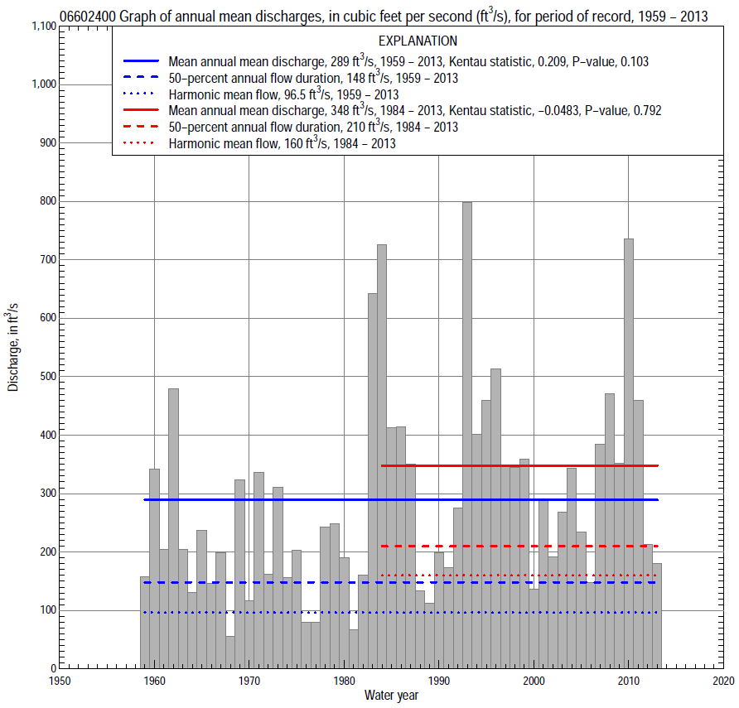

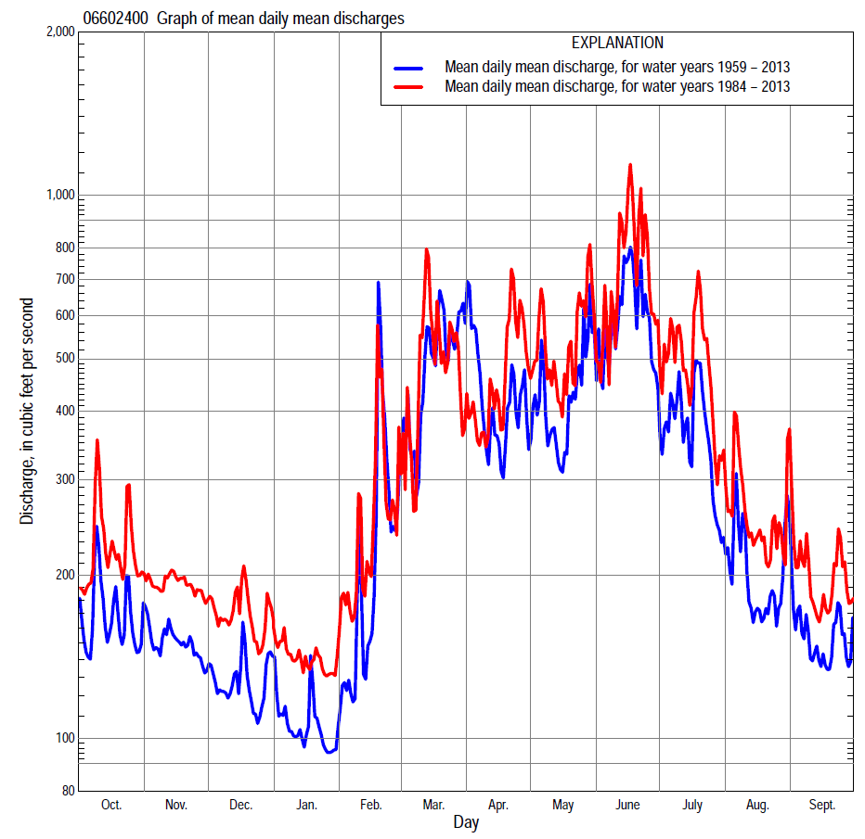

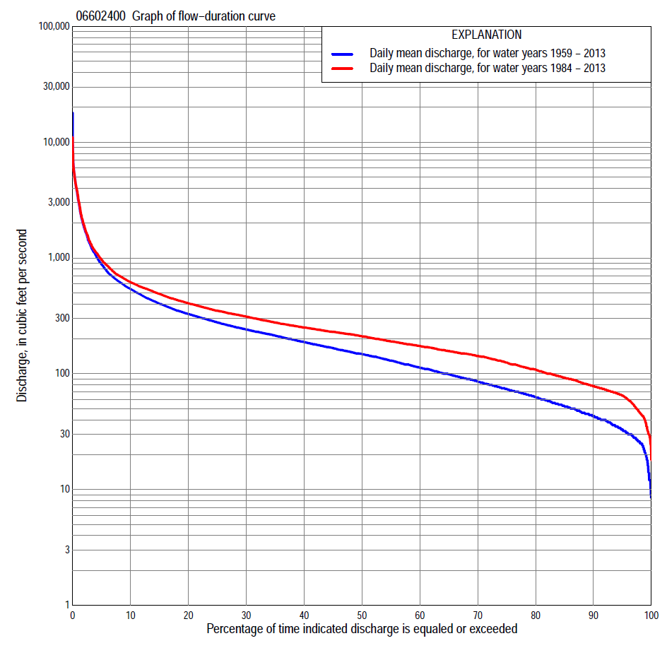
Statistics Based on the Entire Streamflow Period of Record
06602400 Monthly and annual flow durations, based on 1959–2013 period of record (55 years)
Percentage of days discharge equaled or exceeded |  |  |  |  | Discharge (cubic feet per second) |  |  |  |  |  |  |  |  | Annual flow durations
 | Oct | Nov | Dec | Jan | Feb | Mar | Apr | May | June | July | Aug | Sept | Annual | Kentau statistic | P-value
99 | 16 | 19 | 12 | 11 | 12 | 28 | 34 | 31 | 25 | 38 | 26 | 25 | 20 | 0.455 | 0.000
98 | 30 | 22 | 20 | 18 | 17 | 30 | 40 | 36 | 40 | 43 | 30 | 27 | 26 | 0.459 | 0.000
95 | 36 | 34 | 25 | 25 | 25 | 44 | 52 | 53 | 69 | 53 | 38 | 33 | 33 | 0.457 | 0.000
90 | 45 | 42 | 30 | 30 | 31 | 58 | 64 | 72 | 97 | 65 | 46 | 44 | 43 | 0.444 | 0.000
85 | 50 | 50 | 35 | 33 | 40 | 70 | 79 | 94 | 118 | 75 | 54 | 52 | 52 | 0.457 | 0.000
80 | 57 | 56 | 44 | 38 | 42 | 89 | 105 | 117 | 138 | 84 | 64 | 59 | 63 | 0.456 | 0.000
75 | 64 | 64 | 50 | 40 | 45 | 105 | 122 | 139 | 163 | 96 | 76 | 66 | 74 | 0.453 | 0.000
70 | 69 | 73 | 57 | 45 | 58 | 118 | 150 | 161 | 186 | 111 | 83 | 72 | 86 | 0.448 | 0.000
65 | 75 | 82 | 69 | 52 | 71 | 134 | 172 | 200 | 208 | 127 | 91 | 79 | 99 | 0.442 | 0.000
60 | 87 | 94 | 77 | 56 | 90 | 152 | 193 | 225 | 232 | 147 | 102 | 87 | 113 | 0.444 | 0.000
55 | 92 | 105 | 86 | 70 | 100 | 177 | 223 | 245 | 267 | 170 | 111 | 97 | 130 | 0.436 | 0.000
50 | 105 | 118 | 96 | 80 | 110 | 200 | 248 | 270 | 307 | 191 | 129 | 116 | 148 | 0.409 | 0.000
45 | 131 | 130 | 105 | 100 | 120 | 224 | 266 | 296 | 342 | 218 | 149 | 135 | 166 | 0.395 | 0.000
40 | 143 | 148 | 120 | 110 | 140 | 250 | 290 | 325 | 377 | 255 | 166 | 148 | 188 | 0.382 | 0.000
35 | 158 | 161 | 132 | 120 | 160 | 290 | 332 | 362 | 424 | 312 | 189 | 157 | 213 | 0.368 | 0.000
30 | 176 | 177 | 148 | 135 | 180 | 345 | 377 | 422 | 490 | 360 | 214 | 170 | 241 | 0.358 | 0.000
25 | 196 | 197 | 168 | 150 | 200 | 414 | 431 | 476 | 572 | 421 | 238 | 194 | 278 | 0.363 | 0.000
20 | 220 | 235 | 194 | 169 | 225 | 489 | 512 | 550 | 687 | 488 | 263 | 215 | 328 | 0.320 | 0.001
15 | 250 | 277 | 229 | 184 | 276 | 658 | 608 | 656 | 879 | 567 | 297 | 237 | 403 | 0.297 | 0.001
10 | 319 | 313 | 261 | 210 | 372 | 1,020 | 750 | 854 | 1,190 | 687 | 361 | 286 | 540 | 0.201 | 0.031
5 | 440 | 354 | 310 | 250 | 711 | 2,010 | 1,340 | 1,270 | 2,190 | 1,140 | 536 | 398 | 880 | 0.064 | 0.495
2 | 730 | 430 | 376 | 280 | 1,470 | 4,140 | 3,090 | 2,420 | 4,000 | 2,280 | 948 | 577 | 1,810 | 0.005 | 0.965
1 | 1,030 | 504 | 490 | 320 | 2,620 | 5,400 | 4,210 | 3,600 | 5,680 | 3,450 | 1,390 | 752 | 3,120 | -0.119 | 0.204

06602400 Annual exceedance probability of instantaneous peak discharges, in cubic feet per second (ft³/s), based on the expected moments algorithm/multiple Grubbs-Beck analysis computed using a historical period length of 56 years (1958–2013)ª
Annual exceed-ance probability | Recur-rence interval (years) | Discharge (ft³/s) | 95-percent lower confi-dence interval (ft³/s) | 95-percent upper confi-dence interval (ft³/s)
0.500 | 2 | 5,200 | 4,270 | 6,250
0.200 | 5 | 8,800 | 7,360 | 10,700
0.100 | 10 | 11,300 | 9,380 | 14,100
0.040 | 25 | 14,300 | 11,700 | 19,300
0.020 | 50 | 16,500 | 13,000 | 23,600
0.010 | 100 | 18,700 | 14,200 | 28,300
0.005 | 200 | 20,700 | 15,100 | 33,400
0.002 | 500 | 23,400 | 16,200 | 41,100
Kentau statistic |  | -0.232
P-value |  | 0.012
Begin year |  | 1958
End year |  | 2013
Number of peaks |  | 56
ªWeighted Independent Estimates were not computed because regional regression equations are not considered applicable due to diversion from Little Sioux River through upstream equalizer ditch. Statistics computed for record collected since February 1958.

06602400 Annual exceedance probability of high discharges, based on 1959–2013 period of record (55 years)ª
Annual exceed-ance probability | Recur-rence interval (years) | Maximum average discharge (cubic feet per second) for indicated number of consecutive days
 |  | 1 | 3 | 7 | 15 | 30
0.990 | 1.01 | 615 | 419 | 255 | 167 | 127
0.950 | 1.05 | 1,160 | 804 | 487 | 320 | 242
0.900 | 1.11 | 1,590 | 1,110 | 677 | 445 | 334
0.800 | 1.25 | 2,270 | 1,610 | 993 | 652 | 482
0.500 | 2 | 4,200 | 3,080 | 1,980 | 1,300 | 917
0.200 | 5 | 7,120 | 5,430 | 3,730 | 2,440 | 1,620
0.100 | 10 | 9,090 | 7,080 | 5,090 | 3,310 | 2,110
0.040 | 25 | 11,500 | 9,200 | 6,960 | 4,520 | 2,760
0.020 | 50 | 13,300 | 10,800 | 8,460 | 5,470 | 3,230
0.010 | 100 | 14,900 | 12,300 | 10,000 | 6,470 | 3,710
0.005 | 200 | 16,500 | 13,800 | 11,600 | 7,500 | 4,170
0.002 | 500 | 18,600 | 15,800 | 13,900 | 8,910 | 4,780
Kentau statistic |  | -0.209 | -0.152 | -0.130 | -0.092 | -0.038
P-value |  | 0.025 | 0.104 | 0.163 | 0.324 | 0.684
ªStatistics computed for record collected since February 1958.

 | 06602400 Annual nonexceedance probability of low discharges, based on April 1958 to March 2013 period of record (55 years)
Annual nonexceed-ance probability | Recur-rence interval (years) | Minimum average discharge (cubic feet per second) for indicated number of consecutive days
 |  | 1 | 3 | 7 | 14 | 30 | 60 | 90 | 120 | 183
0.01 | 100 | 7.9 | 8.2 | 8.5 | 9.0 | 11 | 12 | 13 | 15 | 17
0.02 | 50 | 9.9 | 10 | 11 | 11 | 13 | 15 | 17 | 19 | 21
0.05 | 20 | 14 | 15 | 15 | 16 | 19 | 21 | 24 | 27 | 30
0.10 | 10 | 18 | 20 | 21 | 22 | 25 | 29 | 32 | 36 | 41
0.20 | 5 | 26 | 28 | 29 | 31 | 36 | 41 | 46 | 51 | 59
0.50 | 2 | 48 | 52 | 56 | 60 | 68 | 77 | 88 | 96 | 112
0.80 | 1.25 | 86 | 95 | 103 | 112 | 125 | 140 | 158 | 172 | 202
0.90 | 1.11 | 115 | 127 | 139 | 153 | 171 | 188 | 211 | 228 | 270
0.96 | 1.04 | 156 | 172 | 191 | 210 | 236 | 255 | 283 | 304 | 361
0.98 | 1.02 | 188 | 209 | 232 | 257 | 289 | 309 | 339 | 363 | 432
0.99 | 1.01 | 222 | 247 | 276 | 307 | 346 | 365 | 397 | 423 | 505
Kentau statistic |  | 0.479 | 0.482 | 0.495 | 0.509 | 0.500 | 0.465 | 0.430 | 0.426 | 0.363
P-value |  | 0.000 | 0.000 | 0.000 | 0.000 | 0.000 | 0.000 | 0.000 | 0.000 | 0.000

06602400 Annual nonexceedance probability of seasonal low discharges, based on April 1958 to September 2013 period of record (55–56 years)
Annual nonexceed-ance probability | Recur-rence interval (years) | Minimum average discharge (cubic feet per second) for indicated number of consecutive days
 |  | 1 | 7 | 14 | 30 |  | 1 | 7 | 14 | 30
 |  | January-February-March |  |  |  |  | April-May-June
0.01 | 100 | 8 | 9 | 9 | 11 |  | 14 | 18 | 21 | 26
0.02 | 50 | 11 | 12 | 12 | 14 |  | 19 | 23 | 27 | 33
0.05 | 20 | 16 | 17 | 18 | 20 |  | 29 | 34 | 39 | 47
0.10 | 10 | 21 | 23 | 24 | 27 |  | 41 | 47 | 54 | 65
0.20 | 5 | 30 | 34 | 35 | 39 |  | 63 | 70 | 78 | 94
0.50 | 2 | 57 | 65 | 69 | 76 |  | 131 | 141 | 156 | 187
0.80 | 1.25 | 99 | 116 | 127 | 140 |  | 250 | 270 | 298 | 357
0.90 | 1.11 | 129 | 153 | 169 | 189 |  | 338 | 372 | 413 | 494
0.96 | 1.04 | 168 | 201 | 226 | 256 |  | 457 | 513 | 577 | 690
0.98 | 1.02 | 198 | 238 | 270 | 310 |  | 548 | 627 | 712 | 852
0.99 | 1.01 | 227 | 275 | 315 | 365 |  | 639 | 746 | 857 | 1,030
Kentau statistic |  | 0.427 | 0.474 | 0.469 | 0.449 |  | 0.423 | 0.413 | 0.408 | 0.399
P-value |  | 0.000 | 0.000 | 0.000 | 0.000 |  | 0.000 | 0.000 | 0.000 | 0.000
 |  | July-August-September |  |  |  |  | October-November-December
0.01 | 100 | 12 | 15 | 16 | 19 |  | 10 | 10 | 11 | 13
0.02 | 50 | 15 | 18 | 20 | 23 |  | 12 | 13 | 14 | 17
0.05 | 20 | 21 | 24 | 26 | 31 |  | 17 | 19 | 21 | 24
0.10 | 10 | 28 | 32 | 34 | 40 |  | 22 | 26 | 28 | 32
0.20 | 5 | 40 | 44 | 47 | 55 |  | 32 | 37 | 40 | 46
0.50 | 2 | 75 | 80 | 86 | 100 |  | 59 | 72 | 78 | 88
0.80 | 1.25 | 138 | 146 | 155 | 181 |  | 106 | 133 | 143 | 163
0.90 | 1.11 | 187 | 198 | 211 | 247 |  | 142 | 179 | 193 | 222
0.96 | 1.04 | 256 | 273 | 293 | 343 |  | 193 | 242 | 262 | 306
0.98 | 1.02 | 312 | 336 | 363 | 424 |  | 233 | 292 | 316 | 374
0.99 | 1.01 | 372 | 404 | 439 | 512 |  | 276 | 344 | 372 | 446
Kentau statistic |  | 0.473 | 0.450 | 0.443 | 0.396 |  | 0.456 | 0.457 | 0.461 | 0.459
P-value |  | 0.000 | 0.000 | 0.000 | 0.000 |  | 0.000 | 0.000 | 0.000 | 0.000

Statistics Based on the 1984–2013 Streamflow Period of Record
06602400 Monthly and annual flow durations, based on 1984–2013 period of record (30 years)
Percentage of days discharge equaled or exceeded |  |  |  |  | Discharge (cubic feet per second) |  |  |  |  |  |  |  |  | Annual flow durations
 | Oct | Nov | Dec | Jan | Feb | Mar | Apr | May | June | July | Aug | Sept | Annual | Kentau statistic | P-value
99 | 45 | 40 | 24 | 27 | 31 | 50 | 60 | 56 | 66 | 49 | 40 | 47 | 38 | 0.113 | 0.391
98 | 49 | 43 | 30 | 30 | 41 | 65 | 66 | 61 | 69 | 60 | 44 | 54 | 46 | 0.106 | 0.422
95 | 65 | 64 | 53 | 35 | 47 | 76 | 85 | 102 | 117 | 78 | 60 | 66 | 65 | 0.094 | 0.475
90 | 71 | 74 | 70 | 56 | 68 | 105 | 127 | 157 | 178 | 99 | 79 | 72 | 78 | 0.060 | 0.655
85 | 79 | 82 | 76 | 71 | 85 | 116 | 163 | 220 | 218 | 123 | 88 | 77 | 92 | 0.051 | 0.708
80 | 89 | 93 | 86 | 81 | 95 | 130 | 185 | 239 | 239 | 155 | 102 | 86 | 109 | 0.032 | 0.817
75 | 96 | 100 | 96 | 93 | 103 | 150 | 211 | 253 | 276 | 174 | 116 | 95 | 125 | 0.051 | 0.708
70 | 127 | 115 | 104 | 100 | 112 | 171 | 240 | 274 | 308 | 189 | 138 | 109 | 142 | 0.055 | 0.682
65 | 139 | 141 | 115 | 109 | 120 | 187 | 252 | 291 | 331 | 210 | 154 | 129 | 157 | 0.067 | 0.617
60 | 146 | 152 | 123 | 115 | 135 | 209 | 266 | 316 | 353 | 234 | 167 | 144 | 173 | 0.055 | 0.681
55 | 157 | 161 | 134 | 121 | 150 | 225 | 283 | 333 | 382 | 278 | 184 | 150 | 190 | 0.057 | 0.668
50 | 172 | 172 | 144 | 132 | 163 | 242 | 314 | 363 | 410 | 324 | 201 | 158 | 210 | 0.021 | 0.887
45 | 186 | 181 | 152 | 140 | 176 | 269 | 350 | 401 | 445 | 349 | 219 | 169 | 230 | 0.007 | 0.972
40 | 195 | 194 | 168 | 150 | 189 | 298 | 385 | 446 | 494 | 393 | 233 | 186 | 250 | -0.023 | 0.872
35 | 210 | 221 | 181 | 160 | 203 | 338 | 422 | 475 | 553 | 431 | 247 | 200 | 277 | -0.016 | 0.915
30 | 223 | 238 | 200 | 170 | 217 | 376 | 476 | 520 | 620 | 485 | 265 | 216 | 311 | -0.014 | 0.929
25 | 248 | 265 | 229 | 185 | 240 | 423 | 524 | 570 | 699 | 535 | 282 | 228 | 350 | 0.018 | 0.901
20 | 274 | 298 | 245 | 200 | 273 | 479 | 590 | 640 | 818 | 586 | 313 | 244 | 405 | -0.009 | 0.957
15 | 323 | 316 | 268 | 220 | 320 | 562 | 661 | 797 | 994 | 668 | 354 | 283 | 489 | -0.009 | 0.957
10 | 379 | 338 | 298 | 236 | 414 | 879 | 800 | 963 | 1,320 | 839 | 436 | 350 | 619 | -0.048 | 0.721
5 | 499 | 373 | 334 | 260 | 722 | 1,910 | 1,240 | 1,460 | 2,460 | 1,460 | 593 | 439 | 965 | -0.087 | 0.509
2 | 824 | 430 | 397 | 285 | 1,360 | 4,100 | 2,040 | 2,590 | 4,240 | 2,880 | 1,010 | 715 | 1,910 | -0.149 | 0.254
1 | 1,290 | 481 | 561 | 300 | 2,070 | 4,940 | 3,520 | 3,800 | 6,170 | 4,360 | 1,500 | 919 | 3,180 | -0.147 | 0.261

06602400 Annual exceedance probability of high discharges, based on 1984–2013 period of record (30 years)
Annual exceedance probability | Recur-rence interval (years) | Maximum average discharge (cubic feet per second) for indicated number of consecutive days
 |  | 1 | 3 | 7 | 15 | 30
0.990 | 1.01 | 555 | 427 | 329 | 265 | 196
0.950 | 1.05 | 1,140 | 833 | 571 | 424 | 319
0.900 | 1.11 | 1,600 | 1,150 | 757 | 544 | 410
0.800 | 1.25 | 2,300 | 1,650 | 1,050 | 734 | 553
0.500 | 2 | 4,110 | 3,020 | 1,920 | 1,300 | 958
0.200 | 5 | 6,330 | 4,960 | 3,360 | 2,280 | 1,620
0.100 | 10 | 7,530 | 6,170 | 4,420 | 3,050 | 2,110
0.040 | 25 | 8,750 | 7,570 | 5,860 | 4,160 | 2,770
0.020 | 50 | 9,470 | 8,510 | 6,980 | 5,080 | 3,290
0.010 | 100 | 10,100 | 9,360 | 8,140 | 6,070 | 3,840
0.005 | 200 | 10,600 | 10,100 | 9,340 | 7,150 | 4,400
0.002 | 500 | 11,100 | 11,100 | 11,000 | 8,700 | 5,180
Kentau statistic |  | -0.255 | -0.195 | -0.159 | -0.154 | -0.122
P-value |  | 0.050 | 0.134 | 0.225 | 0.239 | 0.354

 | 06602400 Annual nonexceedance probability of low discharges, based on April 1983 to March 2013 period of record (30 years)
Annual nonexceed-ance probability | Recur-rence interval (years) | Minimum average discharge (cubic feet per second) for indicated number of consecutive days
 |  | 1 | 3 | 7 | 14 | 30 | 60 | 90 | 120 | 183
0.01 | 100 | 16 | 16 | 19 | 21 | 22 | 26 | 29 | 32 | 37
0.02 | 50 | 20 | 21 | 24 | 27 | 29 | 33 | 36 | 39 | 45
0.05 | 20 | 27 | 30 | 33 | 37 | 40 | 45 | 50 | 53 | 59
0.10 | 10 | 35 | 39 | 44 | 48 | 53 | 59 | 65 | 68 | 75
0.20 | 5 | 47 | 53 | 59 | 65 | 71 | 79 | 86 | 91 | 99
0.50 | 2 | 76 | 87 | 95 | 105 | 117 | 128 | 140 | 148 | 164
0.80 | 1.25 | 115 | 128 | 140 | 153 | 172 | 187 | 208 | 223 | 258
0.90 | 1.11 | 138 | 150 | 165 | 181 | 203 | 220 | 247 | 269 | 322
0.96 | 1.04 | 164 | 174 | 191 | 209 | 236 | 255 | 291 | 322 | 402
0.98 | 1.02 | 182 | 188 | 208 | 228 | 256 | 277 | 320 | 358 | 462
0.99 | 1.01 | 197 | 200 | 223 | 243 | 273 | 296 | 345 | 391 | 520
Kentau statistic |  | 0.172 | 0.147 | 0.168 | 0.152 | 0.126 | 0.108 | 0.053 | 0.062 | 0.025
P-value |  | 0.186 | 0.261 | 0.199 | 0.246 | 0.335 | 0.412 | 0.695 | 0.643 | 0.858

06602400 Annual nonexceedance probability of seasonal low discharges, based on October 1983 to September 2013 period of record (30 years)
Annual nonexceed-ance probability | Recur-rence interval (years) | Minimum average discharge (cubic feet per second) for indicated number of consecutive days
 |  | 1 | 7 | 14 | 30 |  | 1 | 7 | 14 | 30
 |  | January-February-March |  |  |  |  | April-May-June
0.01 | 100 | 19 | 22 | 23 | 23 |  | 38 | 42 | 46 | 51
0.02 | 50 | 24 | 28 | 29 | 30 |  | 49 | 53 | 58 | 66
0.05 | 20 | 32 | 38 | 40 | 43 |  | 70 | 75 | 82 | 94
0.10 | 10 | 41 | 49 | 53 | 57 |  | 93 | 99 | 108 | 126
0.20 | 5 | 54 | 65 | 71 | 78 |  | 128 | 136 | 149 | 176
0.50 | 2 | 85 | 103 | 115 | 128 |  | 216 | 231 | 255 | 305
0.80 | 1.25 | 125 | 147 | 164 | 186 |  | 324 | 359 | 401 | 480
0.90 | 1.11 | 148 | 171 | 191 | 216 |  | 384 | 436 | 492 | 586
0.96 | 1.04 | 174 | 196 | 217 | 246 |  | 447 | 525 | 597 | 707
0.98 | 1.02 | 191 | 211 | 232 | 263 |  | 486 | 585 | 670 | 788
0.99 | 1.01 | 206 | 223 | 245 | 278 |  | 520 | 639 | 736 | 861
Kentau statistic |  | 0.147 | 0.202 | 0.138 | 0.076 |  | 0.014 | 0.002 | 0.011 | 0.021
P-value |  | 0.261 | 0.121 | 0.292 | 0.568 |  | 0.929 | 1.000 | 0.943 | 0.887
 |  | July-August-September |  |  |  |  | October-November-December
0.01 | 100 | 32 | 34 | 36 | 38 |  | 15 | 19 | 23 | 30
0.02 | 50 | 38 | 40 | 42 | 45 |  | 20 | 24 | 29 | 37
0.05 | 20 | 48 | 51 | 53 | 57 |  | 28 | 36 | 41 | 50
0.10 | 10 | 60 | 63 | 65 | 70 |  | 38 | 49 | 55 | 64
0.20 | 5 | 77 | 80 | 84 | 91 |  | 53 | 68 | 76 | 85
0.50 | 2 | 121 | 126 | 132 | 147 |  | 92 | 118 | 128 | 141
0.80 | 1.25 | 184 | 195 | 208 | 237 |  | 142 | 180 | 193 | 221
0.90 | 1.11 | 226 | 243 | 263 | 304 |  | 173 | 215 | 231 | 273
0.96 | 1.04 | 279 | 305 | 335 | 396 |  | 206 | 252 | 272 | 336
0.98 | 1.02 | 319 | 352 | 393 | 469 |  | 228 | 275 | 298 | 382
0.99 | 1.01 | 358 | 400 | 452 | 546 |  | 248 | 295 | 320 | 426
Kentau statistic |  | 0.101 | 0.083 | 0.071 | 0.071 |  | 0.143 | 0.062 | 0.048 | 0.067
P-value |  | 0.443 | 0.532 | 0.592 | 0.592 |  | 0.276 | 0.643 | 0.721 | 0.617

