LOCATION.--Lat 43°07'41", long 95°12'38" referenced to North American Datum of 1927, in SE 1/4 SE 1/4 SE 1/4 sec.16, T.96 N., R.37 W., Clay County, IA, Hydrologic Unit 10230003, on right bank on downstream side of bridge on County Highway M38, 1.0 mi west of Spencer, and 4.9 mi upstream from mouth.

DRAINAGE AREA.--426 mi².

PERIOD OF RECORD.--Discharge records from October 1977 to current year. Occasional low-flow measurements, water years 1957-1961, 1964, 1966-1968, 1970, 1971, 1974-1977.

GAGE.--Water-stage recorder. Datum of gage is 1,311.66 ft above National Geodetic Vertical Datum of 1929.

EXTREMES OUTSIDE PERIOD OF RECORD.--Flood of June 8, 1953, reached a stage of 12.89 ft, discharge 26,000 ft³/s, on basis of contracted-opening measurement of peak flow.

A summary of all available data for this streamgage is provided through the USGS National Water Information System web interface (NWISWeb). The following link provides access to current/historical observations, daily data, daily statistics, monthly statistics, annual statistics, peak streamflow, field measurements, field/lab water-quality samples, and the latest water-year summaries. Data can be filtered by parameter and/or dates, and can be output in various tabular and graphical formats.
http://waterdata.usgs.gov/nwis/inventory/?site_no=06605000

The USGS WaterWatch Toolkit is available at:
http://waterwatch.usgs.gov/?id=ww_toolkit
Tools for summarizing streamflow information include the duration hydrograph builder, the cumulative streamflow hydrograph builder, the streamgage statistics retrieval tool, the rating curve builder, the flood tracking chart builder, the National Weather Service Advanced Hydrologic Prediction Service (AHPS) river forecast hydrograph builder, and the raster-hydrograph builder. Entering the above number for this streamgage into these toolkit webpages will provide streamflow information specific to this streamgage.

A description of the statistics presented for this streamgage is available in the main body of the report at:
http://dx.doi.org/10.3133/ofr20151214
A link to other streamgages included in this report, a map showing the location of the streamgages, information on the programs used to compute the statistical analyses, and references are included in the main body of the report.

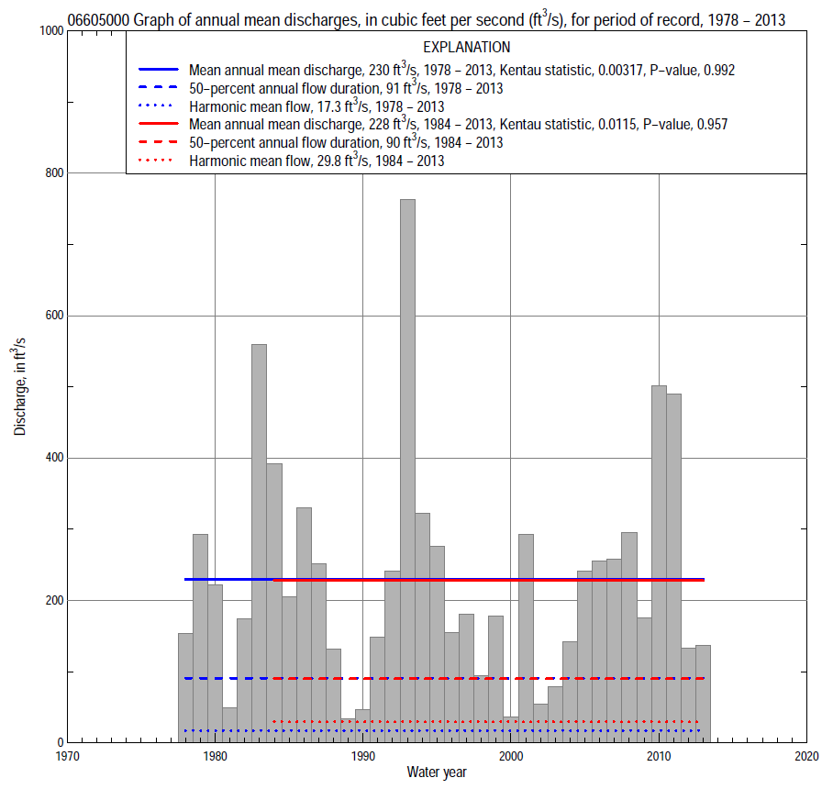

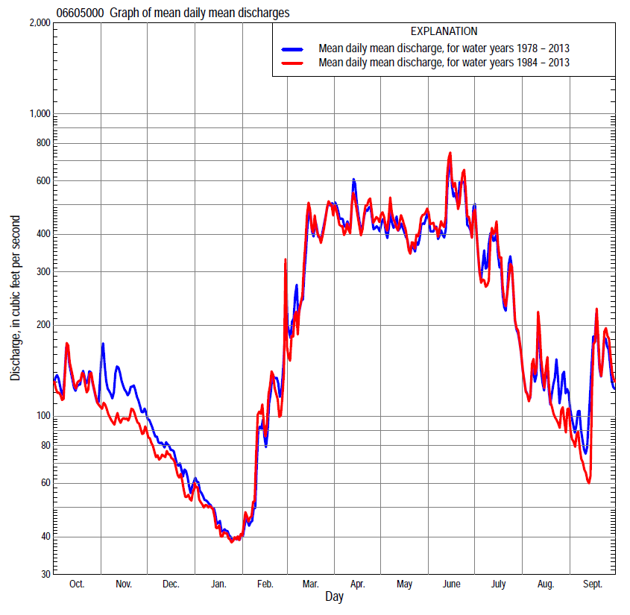

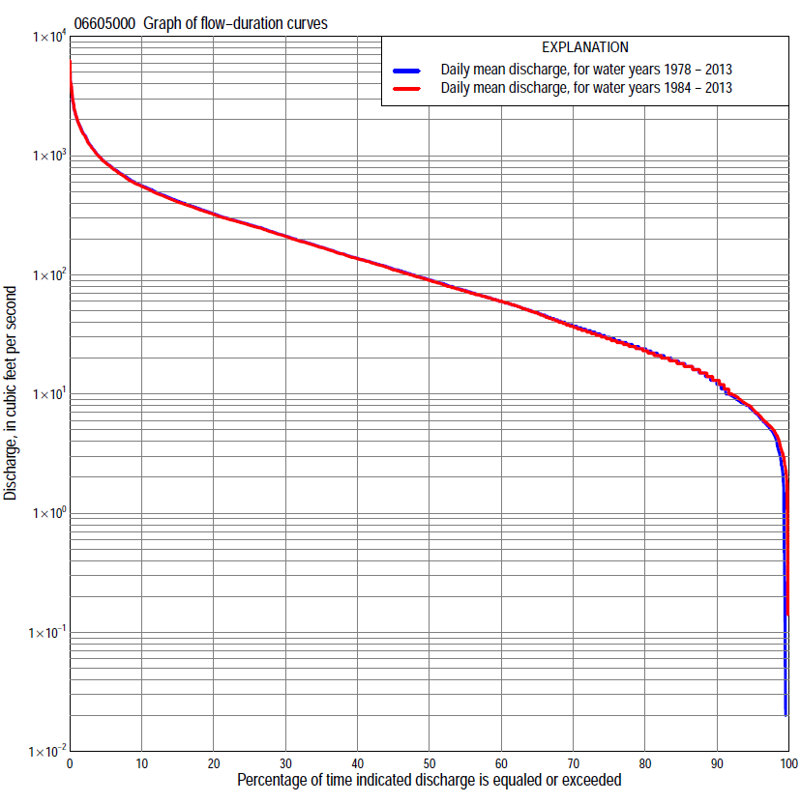

Statistics Based on the Entire Streamflow Period of Record
06605000 Monthly and annual flow durations, based on 1978–2013 period of record (36 years)
Percentage of days discharge equaled or exceeded |  |  |  |  | Discharge (cubic feet per second) |  |  |  |  |  |  |  |  | Annual flow durations
 | Oct | Nov | Dec | Jan | Feb | Mar | Apr | May | June | July | Aug | Sept | Annual | Kentau statistic | P-value
99 | 5.8 | 6.5 | 0.14 | 0.00 | 0.00 | 0.06 | 19 | 19 | 29 | 19 | 11 | 5.7 | 2.5 | 0.014 | 0.913
98 | 6.5 | 7.6 | 2.3 | 0.12 | 0.00 | 4.7 | 20 | 22 | 39 | 22 | 13 | 6.4 | 4.5 | 0.021 | 0.870
95 | 8.1 | 8.9 | 4.8 | 2.5 | 3.3 | 7.6 | 22 | 40 | 64 | 28 | 15 | 8.4 | 7.2 | 0.002 | 1.000
90 | 10 | 13 | 7.3 | 4.2 | 5.8 | 19 | 47 | 75 | 93 | 38 | 19 | 11 | 12 | 0.024 | 0.849
85 | 15 | 15 | 9.6 | 5.0 | 6.7 | 25 | 61 | 105 | 119 | 45 | 25 | 13 | 18 | -0.006 | 0.967
80 | 17 | 19 | 13 | 6.4 | 8.0 | 48 | 97 | 133 | 141 | 53 | 30 | 16 | 24 | -0.027 | 0.827
75 | 18 | 22 | 18 | 8.5 | 9.6 | 62 | 138 | 161 | 163 | 64 | 33 | 19 | 30 | -0.040 | 0.744
70 | 23 | 26 | 22 | 12 | 16 | 72 | 172 | 195 | 183 | 77 | 36 | 21 | 37 | -0.049 | 0.683
65 | 27 | 29 | 27 | 18 | 20 | 86 | 216 | 222 | 204 | 89 | 40 | 23 | 48 | -0.040 | 0.744
60 | 31 | 35 | 31 | 22 | 25 | 100 | 251 | 255 | 230 | 99 | 45 | 26 | 60 | -0.030 | 0.806
55 | 35 | 43 | 37 | 25 | 34 | 125 | 288 | 283 | 260 | 115 | 49 | 29 | 74 | -0.040 | 0.744
50 | 40 | 60 | 47 | 33 | 45 | 140 | 331 | 315 | 287 | 134 | 56 | 33 | 91 | -0.044 | 0.713
45 | 51 | 75 | 57 | 42 | 56 | 175 | 380 | 352 | 319 | 162 | 62 | 38 | 112 | -0.067 | 0.576
40 | 66 | 100 | 69 | 51 | 66 | 215 | 432 | 386 | 356 | 190 | 72 | 46 | 137 | -0.075 | 0.531
35 | 107 | 116 | 85 | 58 | 72 | 255 | 487 | 424 | 394 | 218 | 85 | 61 | 170 | -0.032 | 0.796
30 | 165 | 146 | 96 | 66 | 85 | 310 | 539 | 472 | 440 | 259 | 98 | 80 | 212 | -0.043 | 0.723
25 | 199 | 169 | 113 | 74 | 99 | 397 | 604 | 522 | 507 | 306 | 115 | 110 | 263 | -0.014 | 0.913
20 | 240 | 207 | 130 | 80 | 120 | 500 | 691 | 585 | 617 | 369 | 141 | 150 | 326 | 0.008 | 0.957
15 | 280 | 250 | 155 | 95 | 140 | 643 | 816 | 693 | 777 | 477 | 193 | 216 | 417 | 0.011 | 0.935
10 | 348 | 292 | 180 | 110 | 200 | 854 | 1,010 | 826 | 1,100 | 653 | 288 | 310 | 562 | 0.044 | 0.713
5 | 480 | 378 | 230 | 128 | 320 | 1,450 | 1,450 | 1,130 | 1,700 | 1,090 | 467 | 548 | 875 | 0.029 | 0.817
2 | 660 | 628 | 324 | 155 | 850 | 2,300 | 1,910 | 1,570 | 2,560 | 2,130 | 893 | 1,040 | 1,500 | 0.051 | 0.673
1 | 853 | 812 | 398 | 210 | 1,030 | 3,110 | 2,210 | 1,930 | 3,240 | 3,390 | 1,310 | 1,630 | 2,020 | 0.049 | 0.683

06605000 Annual exceedance probability of instantaneous peak discharges, in cubic feet per second (ft³/s), based on the Weighted Independent Estimates method,
Annual exceed-ance probability | Recur-rence interval (years) | Discharge (ft³/s) | 95-percent lower confi-dence interval (ft³/s) | 95-percent upper confi-dence interval (ft³/s)
0.500 | 2 | 2,630 | 2,230 | 3,100
0.200 | 5 | 5,070 | 4,280 | 6,010
0.100 | 10 | 7,040 | 5,820 | 8,520
0.040 | 25 | 9,850 | 7,800 | 12,400
0.020 | 50 | 12,100 | 9,240 | 15,900
0.010 | 100 | 14,600 | 10,600 | 20,000
0.005 | 200 | 17,200 | 12,000 | 24,600
0.002 | 500 | 20,800 | 13,700 | 31,600
and based on the expected moments algorithm/multiple Grubbs-Beck analysis computed using a historical period length of 98 years (1916–2013)
0.500 | 2 | 2,640 | 1,980 | 3,450
0.200 | 5 | 5,110 | 3,890 | 6,750
0.100 | 10 | 7,120 | 5,340 | 9,690
0.040 | 25 | 10,000 | 7,270 | 14,600
0.020 | 50 | 12,500 | 8,730 | 19,400
0.010 | 100 | 15,100 | 10,200 | 25,300
0.005 | 200 | 17,900 | 11,600 | 32,600
0.002 | 500 | 21,900 | 13,300 | 44,900
Kentau statistic |  | -0.040
P-value |  | 0.744
Begin year |  | 1978
End year |  | 2013
Number of peaks |  | 36

06605000 Annual exceedance probability of high discharges, based on 1978–2013 period of record (36 years)
Annual exceedance probability | Recur-rence interval (years) | Maximum average discharge (ft³/s) for indicated number of consecutive days
 |  | 1 | 3 | 7 | 15 | 30
0.990 | 1.01 | 331 | 258 | 175 | 114 | 81
0.950 | 1.05 | 614 | 488 | 344 | 232 | 172
0.900 | 1.11 | 836 | 670 | 479 | 328 | 248
0.800 | 1.25 | 1,190 | 960 | 695 | 485 | 372
0.500 | 2 | 2,200 | 1,790 | 1,310 | 947 | 728
0.200 | 5 | 3,770 | 3,070 | 2,240 | 1,670 | 1,250
0.100 | 10 | 4,860 | 3,950 | 2,860 | 2,160 | 1,580
0.040 | 25 | 6,230 | 5,040 | 3,610 | 2,760 | 1,960
0.020 | 50 | 7,240 | 5,830 | 4,140 | 3,200 | 2,210
0.010 | 100 | 8,220 | 6,600 | 4,630 | 3,610 | 2,440
0.005 | 200 | 9,190 | 7,340 | 5,100 | 4,000 | 2,650
0.002 | 500 | 10,400 | 8,290 | 5,690 | 4,490 | 2,890
Kentau statistic |  | 0.000 | 0.044 | 0.060 | 0.092 | 0.070
P-value |  | 1.000 | 0.713 | 0.614 | 0.438 | 0.558

 | 06605000 Annual nonexceedance probability of low discharges, based on April 1978 to March 2013 period of record (35 years)
Annual nonexceed-ance probability | Recur-rence interval (years) | Minimum average discharge (cubic feet per second) for indicated number of consecutive days
 |  | 1 | 3 | 7 | 14 | 30 | 60 | 90 | 120 | 183
0.01 | 100 | 0.00 | 0.00 | 0.00 | 0.00 | 0.00 | 0.40 | 0.96 | 1.9 | 2.9
0.02 | 50 | 0.00 | 0.00 | 0.00 | 0.00 | 0.00 | 0.80 | 1.6 | 2.8 | 4.0
0.05 | 20 | 0.00 | 0.00 | 0.00 | 0.00 | 1.1 | 2.1 | 3.2 | 5.0 | 6.7
0.10 | 10 | 2.2 | 2.4 | 2.7 | 3.0 | 3.0 | 4.4 | 5.8 | 8.1 | 11
0.20 | 5 | 4.9 | 5.4 | 6.0 | 6.5 | 6.9 | 8.9 | 11 | 14 | 18
0.50 | 2 | 14 | 16 | 17 | 18 | 22 | 27 | 33 | 39 | 50
0.80 | 1.25 | 33 | 36 | 38 | 41 | 48 | 65 | 82 | 99 | 131
0.90 | 1.11 | 49 | 52 | 56 | 60 | 66 | 94 | 123 | 153 | 215
0.96 | 1.04 | 72 | 75 | 81 | 87 | 88 | 133 | 179 | 238 | 362
0.98 | 1.02 | 91 | 94 | 101 | 109 | 110 | 166 | 223 | 313 | 504
0.99 | 1.01 | 110 | 113 | 122 | 131 | 132 | 199 | 266 | 396 | 677
Kentau statistic |  | -0.061 | -0.037 | -0.012 | -0.013 | -0.008 | 0.002 | -0.035 | -0.035 | -0.045
P-value |  | 0.619 | 0.765 | 0.932 | 0.921 | 0.955 | 1.000 | 0.776 | 0.776 | 0.712

06605000 Annual nonexceedance probability of seasonal low discharges, based on October 1977 to September 2013 period of record (36 years)
Annual nonexceed-ance probability | Recur-rence interval (years) | Minimum average discharge (cubic feet per second) for indicated number of consecutive days
 |  | 1 | 7 | 14 | 30 |  | 1 | 7 | 14 | 30
 |  | January-February-March |  |  |  |  | April-May-June
0.01 | 100 | 0.00 | 0.00 | 0.00 | 0.00 |  | 9.4 | 10 | 12 | 13
0.02 | 50 | 0.00 | 0.00 | 0.00 | 0.00 |  | 13 | 14 | 16 | 18
0.05 | 20 | 0.00 | 0.6 | 1.3 | 1.9 |  | 21 | 23 | 27 | 32
0.10 | 10 | 2.1 | 2.1 | 3.2 | 4.1 |  | 31 | 35 | 40 | 50
0.20 | 5 | 5.1 | 5.6 | 6.8 | 8.3 |  | 49 | 55 | 65 | 84
0.50 | 2 | 17 | 22 | 22 | 25 |  | 108 | 124 | 146 | 196
0.80 | 1.25 | 44 | 55 | 57 | 62 |  | 219 | 250 | 292 | 394
0.90 | 1.11 | 69 | 77 | 88 | 95 |  | 306 | 347 | 403 | 537
0.96 | 1.04 | 108 | 108 | 134 | 144 |  | 425 | 479 | 549 | 718
0.98 | 1.02 | 142 | 142 | 172 | 186 |  | 520 | 581 | 661 | 849
0.99 | 1.01 | 180 | 180 | 213 | 231 |  | 617 | 685 | 771 | 974
Kentau statistic |  | -0.043 | 0.010 | 0.025 | 0.063 |  | -0.014 | 0.000 | 0.010 | 0.076
P-value |  | 0.723 | 0.946 | 0.838 | 0.595 |  | 0.913 | 1.000 | 0.946 | 0.522
 |  | July-August-September |  |  |  |  | October-November-December
0.01 | 100 | 4.2 | 4.5 | 4.9 | 5.8 |  | 0.00 | 0.00 | 0.15 | 1.6
0.02 | 50 | 5.0 | 5.3 | 5.8 | 6.8 |  | 0.00 | 0.00 | 0.39 | 2.4
0.05 | 20 | 6.5 | 7.0 | 7.5 | 8.8 |  | 1.9 | 2.5 | 2.5 | 4.3
0.10 | 10 | 8.4 | 9.0 | 10 | 11 |  | 3.9 | 4.9 | 4.9 | 7.2
0.20 | 5 | 12 | 13 | 14 | 16 |  | 7.5 | 9.3 | 9.3 | 13
0.50 | 2 | 24 | 26 | 28 | 33 |  | 22 | 27 | 27 | 38
0.80 | 1.25 | 53 | 59 | 64 | 80 |  | 60 | 73 | 93 | 102
0.90 | 1.11 | 84 | 94 | 104 | 133 |  | 99 | 121 | 121 | 166
0.96 | 1.04 | 142 | 161 | 181 | 241 |  | 167 | 204 | 2 04 | 271
0.98 | 1.02 | 203 | 232 | 264 | 362 |  | 232 | 284 | 284 | 369
0.99 | 1.01 | 284 | 326 | 376 | 531 |  | 310 | 380 | 380 | 481
Kentau statistic |  | -0.160 | -0.173 | -0.171 | -0.179 |  | -0.024 | -0.027 | -0.025 | -0.013
P-value |  | 0.173 | 0.141 | 0.145 | 0.127 |  | 0.849 | 0.827 | 0.838 | 0.924

Statistics Based on the 1984–2013 Streamflow Period of Record
06605000 Monthly and annual flow durations, based on 1984–2013 period of record (30 years)
Percentage of days discharge equaled or exceeded |  |  |  |  | Discharge (cubic feet per second) |  |  |  |  |  |  |  |  | Annual flow durations
 | Oct | Nov | Dec | Jan | Feb | Mar | Apr | May | June | July | Aug | Sept | Annual | Kentau statistic | P-value
99 | 5.8 | 6.2 | 0.00 | 1.8 | 2.3 | 4.8 | 19 | 18 | 28 | 17 | 11 | 5.5 | 3.3 | -0.069 | 0.604
98 | 6.3 | 7.2 | 1.0 | 2.4 | 2.9 | 6.6 | 20 | 21 | 33 | 21 | 12 | 6.0 | 4.8 | -0.067 | 0.617
95 | 8.0 | 8.4 | 4.7 | 3.2 | 4.8 | 9.4 | 21 | 41 | 66 | 27 | 14 | 8.2 | 7.5 | -0.080 | 0.544
90 | 9.2 | 11 | 7.0 | 4.4 | 5.9 | 20 | 47 | 81 | 96 | 37 | 17 | 9.8 | 13 | -0.067 | 0.617
85 | 13 | 14 | 9.6 | 5.3 | 7.0 | 38 | 60 | 127 | 124 | 44 | 23 | 13 | 18 | -0.074 | 0.580
80 | 16 | 16 | 14 | 7.3 | 9.6 | 54 | 94 | 158 | 144 | 54 | 28 | 14 | 23 | -0.069 | 0.605
75 | 17 | 19 | 21 | 12 | 15 | 65 | 142 | 188 | 164 | 64 | 31 | 17 | 29 | -0.055 | 0.681
70 | 18 | 25 | 26 | 18 | 18 | 72 | 177 | 216 | 188 | 75 | 33 | 19 | 37 | -0.055 | 0.681
65 | 22 | 27 | 28 | 21 | 24 | 85 | 227 | 243 | 212 | 87 | 36 | 21 | 48 | -0.053 | 0.695
60 | 27 | 33 | 34 | 24 | 30 | 100 | 266 | 273 | 242 | 98 | 40 | 23 | 60 | -0.046 | 0.735
55 | 32 | 38 | 43 | 29 | 39 | 125 | 299 | 300 | 273 | 115 | 45 | 26 | 73 | -0.041 | 0.762
50 | 40 | 62 | 54 | 37 | 50 | 141 | 345 | 329 | 302 | 134 | 49 | 28 | 90 | -0.041 | 0.762
45 | 51 | 74 | 60 | 45 | 59 | 182 | 394 | 363 | 338 | 157 | 55 | 32 | 110 | -0.069 | 0.605
40 | 72 | 94 | 74 | 53 | 66 | 217 | 444 | 396 | 372 | 184 | 62 | 36 | 137 | -0.087 | 0.509
35 | 117 | 111 | 86 | 58 | 71 | 257 | 492 | 434 | 413 | 210 | 74 | 44 | 170 | -0.044 | 0.748
30 | 162 | 137 | 94 | 64 | 87 | 308 | 539 | 480 | 466 | 248 | 91 | 79 | 210 | -0.055 | 0.682
25 | 199 | 157 | 108 | 71 | 99 | 387 | 600 | 528 | 546 | 289 | 113 | 107 | 261 | -0.025 | 0.858
20 | 242 | 179 | 120 | 77 | 116 | 486 | 689 | 599 | 661 | 350 | 142 | 140 | 321 | 0.007 | 0.972
15 | 278 | 216 | 137 | 86 | 143 | 625 | 815 | 709 | 848 | 459 | 206 | 201 | 408 | 0.037 | 0.789
10 | 338 | 253 | 160 | 100 | 201 | 833 | 980 | 849 | 1,180 | 622 | 303 | 287 | 549 | 0.085 | 0.521
5 | 458 | 300 | 181 | 118 | 313 | 1,280 | 1,360 | 1,160 | 1,770 | 998 | 446 | 452 | 867 | 0.067 | 0.617
2 | 616 | 345 | 197 | 130 | 598 | 2,200 | 1,910 | 1,660 | 2,680 | 2,350 | 702 | 1,090 | 1,490 | 0.071 | 0.592
1 | 845 | 365 | 212 | 143 | 1,000 | 3,480 | 2,160 | 1,980 | 3,750 | 3,500 | 1,200 | 1,640 | 2,030 | 0.083 | 0.532

06605000 Annual exceedance probability of high discharges, based on 1984–2013 period of record (30 years)
Annual exceedance probability | Recur-rence interval (years) | Maximum average discharge (ft³/s) for indicated number of consecutive days
 |  | 1 | 3 | 7 | 15 | 30
0.990 | 1.01 | 307 | 237 | 162 | 106 | 76
0.950 | 1.05 | 568 | 452 | 321 | 220 | 165
0.900 | 1.11 | 775 | 625 | 450 | 314 | 240
0.800 | 1.25 | 1,110 | 907 | 661 | 470 | 364
0.500 | 2 | 2,100 | 1,740 | 1,280 | 936 | 723
0.200 | 5 | 3,720 | 3,110 | 2,260 | 1,680 | 1,260
0.100 | 10 | 4,900 | 4,100 | 2,940 | 2,200 | 1,600
0.040 | 25 | 6,470 | 5,380 | 3,780 | 2,840 | 2,010
0.020 | 50 | 7,660 | 6,350 | 4,400 | 3,310 | 2,280
0.010 | 100 | 8,860 | 7,310 | 5,000 | 3,760 | 2,520
0.005 | 200 | 10,100 | 8,270 | 5,570 | 4,190 | 2,750
0.002 | 500 | 11,700 | 9,540 | 6,310 | 4,730 | 3,020
Kentau statistic |  | 0.057 | 0.067 | 0.099 | 0.131 | 0.108
P-value |  | 0.669 | 0.617 | 0.454 | 0.318 | 0.412

 | 06605000 Annual nonexceedance probability of low discharges, based on April 1983 to March 2013 period of record (30 years)
Annual nonexceed-ance probability | Recur-rence interval (years) | Minimum average discharge (cubic feet per second) for indicated number of consecutive days
 |  | 1 | 3 | 7 | 14 | 30 | 60 | 90 | 120 | 183
0.01 | 100 | 0.00 | 0.00 | 0.00 | 0.00 | 0.49 | 1.2 | 1.5 | 2.0 | 2.6
0.02 | 50 | 0.00 | 0.00 | 0.00 | 0.00 | 0.90 | 1.9 | 2.4 | 3.0 | 3.8
0.05 | 20 | 1.2 | 1.3 | 1.5 | 1.7 | 2.1 | 3.4 | 4.4 | 5.3 | 6.6
0.10 | 10 | 2.8 | 3.1 | 3.5 | 3.9 | 4.0 | 5.7 | 7.3 | 8.7 | 11
0.20 | 5 | 5.5 | 6.1 | 6.7 | 7.3 | 8.0 | 10 | 13 | 15 | 18
0.50 | 2 | 15 | 16 | 17 | 19 | 23 | 26 | 34 | 40 | 49
0.80 | 1.25 | 32 | 35 | 37 | 40 | 47 | 58 | 76 | 93 | 125
0.90 | 1.11 | 46 | 49 | 53 | 57 | 61 | 82 | 108 | 136 | 197
0.96 | 1.04 | 64 | 67 | 73 | 79 | 80 | 115 | 152 | 198 | 316
0.98 | 1.02 | 78 | 81 | 88 | 96 | 97 | 140 | 186 | 248 | 423
0.99 | 1.01 | 91 | 94 | 103 | 113 | 114 | 164 | 219 | 299 | 547
Kentau statistic |  | -0.103 | -0.071 | -0.041 | -0.048 | -0.039 | -0.025 | -0.067 | -0.048 | -0.030
P-value |  | 0.432 | 0.592 | 0.762 | 0.721 | 0.775 | 0.858 | 0.617 | 0.721 | 0.830

06605000 Annual nonexceedance probability of seasonal low discharges, based on October 1983 to September 2013 period of record (30 years)
Annual nonexceed-ance probability | Recur-rence interval (years) | Minimum average discharge (cubic feet per second) for indicated number of consecutive days
 |  | 1 | 7 | 14 | 30 |  | 1 | 7 | 14 | 30
 |  | January-February-March |  |  |  |  | April-May-June
0.01 | 100 | 0.00 | 0.18 | 0.67 | 1.1 |  | 8.6 | 9.2 | 10 | 11
0.02 | 50 | 0.00 | 0.40 | 1.1 | 1.7 |  | 12 | 13 | 15 | 17
0.05 | 20 | 1.0 | 1.2 | 2.3 | 3.2 |  | 20 | 22 | 26 | 31
0.10 | 10 | 2.8 | 2.8 | 4.2 | 5.4 |  | 31 | 34 | 40 | 51
0.20 | 5 | 5.9 | 6.7 | 8.1 | 9.9 |  | 50 | 56 | 67 | 88
0.50 | 2 | 18 | 24 | 24 | 27 |  | 113 | 130 | 156 | 213
0.80 | 1.25 | 43 | 55 | 58 | 63 |  | 231 | 266 | 315 | 429
0.90 | 1.11 | 64 | 72 | 84 | 90 |  | 322 | 368 | 430 | 577
0.96 | 1.04 | 92 | 92 | 120 | 127 |  | 443 | 502 | 579 | 755
0.98 | 1.02 | 113 | 113 | 146 | 156 |  | 537 | 603 | 687 | 877
0.99 | 1.01 | 135 | 135 | 171 | 183 |  | 631 | 703 | 791 | 988
Kentau statistic |  | -0.103 | -0.039 | -0.030 | 0.021 |  | -0.083 | -0.076 | -0.071 | -0.021
P-value |  | 0.432 | 0.775 | 0.830 | 0.887 |  | 0.532 | 0.568 | 0.592 | 0.887
 |  | July-August-September |  |  |  |  | October-November-December
0.01 | 100 | 4.1 | 4.4 | 4.7 | 5.5 |  | 0.00 | 0.00 | 0.10 | 1.4
0.02 | 50 | 4.7 | 5.0 | 5.4 | 6.3 |  | 0.00 | 0.00 | 0.30 | 2.1
0.05 | 20 | 6.0 | 6.4 | 6.9 | 8.0 |  | 1.7 | 2.1 | 2.1 | 4.1
0.10 | 10 | 7.6 | 8.1 | 8.7 | 10 |  | 4.1 | 5.0 | 5.0 | 7.1
0.20 | 5 | 10 | 11 | 12 | 14 |  | 8.2 | 9.9 | 9.9 | 13
0.50 | 2 | 21 | 23 | 25 | 30 |  | 23 | 28 | 39 | 39
0.80 | 1.25 | 50 | 56 | 62 | 77 |  | 56 | 68 | 86 | 97
0.90 | 1.11 | 84 | 94 | 105 | 135 |  | 84 | 104 | 104 | 149
0.96 | 1.04 | 152 | 171 | 196 | 264 |  | 127 | 158 | 158 | 226
0.98 | 1.02 | 229 | 261 | 302 | 422 |  | 162 | 203 | 203 | 290
0.99 | 1.01 | 339 | 388 | 454 | 657 |  | 200 | 252 | 252 | 357
Kentau statistic |  | -0.078 | -0.087 | -0.099 | -0.097 |  | -0.044 | -0.044 | -0.039 | -0.007
P-value |  | 0.556 | 0.509 | 0.454 | 0.464 |  | 0.748 | 0.748 | 0.775 | 0.972

