LOCATION.--Lat 43°01'06", long 95°02'34" referenced to North American Datum of 1927, in SE 1/4 NW 1/4 sec.25, T.95 N., R.36 W., Clay County, IA, Hydrologic Unit 10230003, on left bank 5 ft downstream from bridge on County Highway B53, at western edge of Gillett Grove, 0.8 mi above Elk Creek, and 164.4 mi upstream from mouth.

DRAINAGE AREA.--1,334 mi².

PERIOD OF RECORD.--Discharge records from June 1958 to October 1973.

GAGE.--Water-stage recorder. Datum of gage is 1,266.84 ft above National Geodetic Vertical Datum of 1929.

A summary of all available data for this streamgage is provided through the USGS National Water Information System web interface (NWISWeb). The following link provides access to current/historical observations, daily data, daily statistics, monthly statistics, annual statistics, peak streamflow, field measurements, field/lab water-quality samples, and the latest water-year summaries. Data can be filtered by parameter and/or dates, and can be output in various tabular and graphical formats.
http://waterdata.usgs.gov/nwis/inventory/?site_no=06605600

The USGS WaterWatch Toolkit is available at:
http://waterwatch.usgs.gov/?id=ww_toolkit
Tools for summarizing streamflow information include the duration hydrograph builder, the cumulative streamflow hydrograph builder, the streamgage statistics retrieval tool, the rating curve builder, the flood tracking chart builder, the National Weather Service Advanced Hydrologic Prediction Service (AHPS) river forecast hydrograph builder, and the raster-hydrograph builder. Entering the above number for this streamgage into these toolkit webpages will provide streamflow information specific to this streamgage.

A description of the statistics presented for this streamgage is available in the main body of the report at:
http://dx.doi.org/10.3133/ofr20151214
A link to other streamgages included in this report, a map showing the location of the streamgages, information on the programs used to compute the statistical analyses, and references are included in the main body of the report.

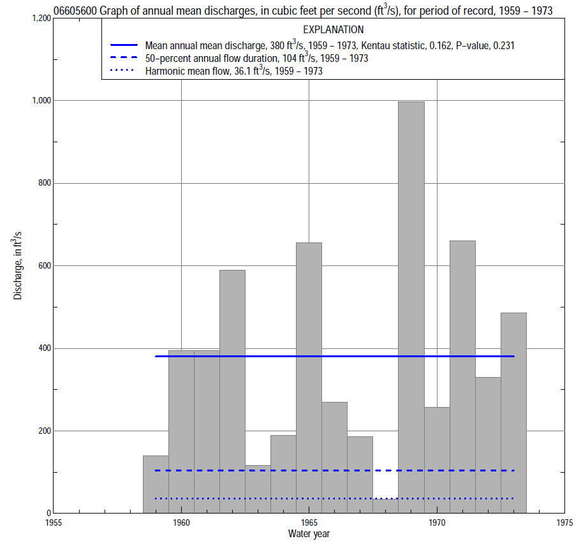

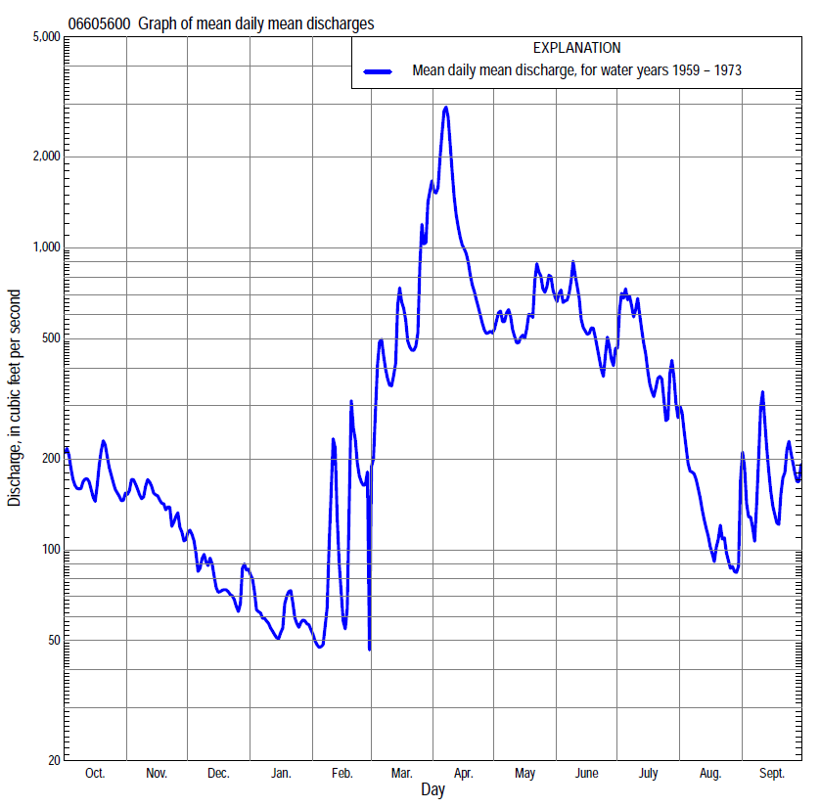

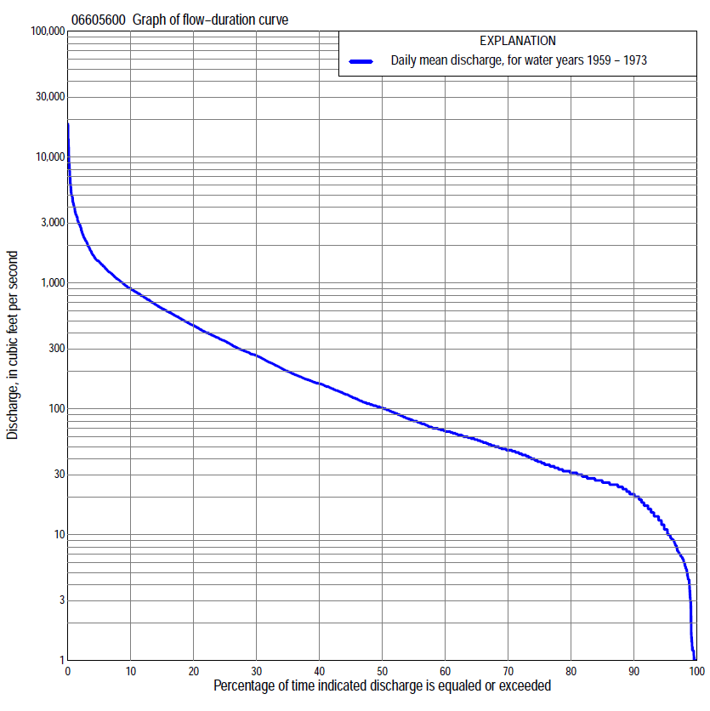

Statistics Based on the Entire Streamflow Period of Record
06605600 Monthly and annual flow durations, based on 1959–73 period of record (15 years)
Percentage of days discharge equaled or exceeded |  |  |  |  | Discharge (cubic feet per second) |  |  |  |  |  |  |  |  | Annual flow durations
 | Oct | Nov | Dec | Jan | Feb | Mar | Apr | May | June | July | Aug | Sept | Annual | Kentau statistic | P-value
99 | 6.4 | 10 | 4.4 | 1.2 | 1.0 | 1.3 | 26 | 22 | 18 | 18 | 8.2 | 13 | 2.8 | 0.314 | 0.113
98 | 8.2 | 12 | 4.6 | 1.3 | 1.0 | 1.6 | 27 | 24 | 20 | 21 | 10 | 14 | 6.6 | 0.305 | 0.125
95 | 11 | 14 | 6.8 | 3.2 | 1.0 | 20 | 31 | 28 | 53 | 31 | 20 | 19 | 13 | 0.333 | 0.092
90 | 21 | 25 | 9.0 | 7.0 | 10 | 26 | 43 | 72 | 70 | 40 | 31 | 23 | 22 | 0.438 | 0.026
85 | 25 | 27 | 21 | 10 | 15 | 29 | 93 | 94 | 87 | 52 | 35 | 25 | 27 | 0.476 | 0.015
80 | 28 | 29 | 25 | 13 | 17 | 34 | 126 | 133 | 131 | 62 | 39 | 27 | 32 | 0.467 | 0.018
75 | 32 | 33 | 30 | 16 | 20 | 40 | 164 | 210 | 173 | 75 | 45 | 33 | 40 | 0.486 | 0.013
70 | 36 | 38 | 33 | 23 | 21 | 52 | 204 | 272 | 240 | 86 | 49 | 38 | 48 | 0.514 | 0.009
65 | 46 | 57 | 44 | 30 | 25 | 70 | 284 | 325 | 274 | 96 | 55 | 43 | 58 | 0.467 | 0.018
60 | 55 | 72 | 47 | 35 | 28 | 104 | 387 | 370 | 325 | 110 | 59 | 49 | 69 | 0.438 | 0.026
55 | 71 | 92 | 58 | 43 | 31 | 150 | 523 | 402 | 364 | 132 | 65 | 54 | 84 | 0.438 | 0.026
50 | 100 | 102 | 66 | 48 | 32 | 229 | 613 | 438 | 404 | 162 | 72 | 60 | 104 | 0.371 | 0.060
45 | 118 | 114 | 71 | 53 | 36 | 274 | 703 | 486 | 450 | 190 | 82 | 67 | 130 | 0.343 | 0.083
40 | 135 | 131 | 80 | 57 | 41 | 310 | 792 | 566 | 506 | 222 | 97 | 77 | 161 | 0.257 | 0.198
35 | 144 | 148 | 88 | 62 | 47 | 407 | 891 | 650 | 553 | 262 | 115 | 93 | 202 | 0.219 | 0.276
30 | 163 | 160 | 102 | 65 | 50 | 538 | 997 | 760 | 630 | 332 | 131 | 108 | 270 | 0.238 | 0.235
25 | 185 | 189 | 112 | 67 | 61 | 700 | 1,240 | 883 | 696 | 465 | 161 | 159 | 352 | 0.238 | 0.235
20 | 249 | 218 | 136 | 70 | 82 | 880 | 1,490 | 1,020 | 822 | 595 | 213 | 194 | 470 | 0.257 | 0.198
15 | 298 | 274 | 159 | 98 | 168 | 1,200 | 1,960 | 1,150 | 959 | 820 | 258 | 300 | 640 | 0.286 | 0.151
10 | 394 | 341 | 184 | 110 | 200 | 1,580 | 2,780 | 1,400 | 1,170 | 1,370 | 395 | 552 | 910 | 0.143 | 0.488
5 | 587 | 444 | 238 | 178 | 300 | 2,380 | 4,880 | 1,900 | 1,870 | 2,450 | 526 | 844 | 1,500 | 0.086 | 0.692
2 | 1,030 | 619 | 290 | 350 | 1,500 | 4,510 | 8,800 | 2,580 | 3,320 | 3,650 | 880 | 1,440 | 2,800 | -0.029 | 0.921
1 | 1,210 | 693 | 355 | 375 | 2,600 | 6,200 | 12,300 | 2,940 | 3,740 | 4,850 | 989 | 1,660 | 4,090 | -0.124 | 0.553

06605600 Annual exceedance probability of instantaneous peak discharges, in cubic feet per second (ft³/s), based on the Weighted Independent Estimates method,
Annual exceed-ance probability | Recur-rence interval (years) | Discharge (ft³/s) | 95-percent lower confi-dence interval (ft³/s) | 95-percent upper confi-dence interval (ft³/s)
0.500 | 2 | 4,300 | 3,650 | 5,070
0.200 | 5 | 8,580 | 7,310 | 10,100
0.100 | 10 | 12,000 | 10,000 | 14,300
0.040 | 25 | 16,700 | 13,400 | 20,700
0.020 | 50 | 20,400 | 15,800 | 26,200
0.010 | 100 | 24,200 | 18,000 | 32,500
0.005 | 200 | 28,200 | 20,100 | 39,600
0.002 | 500 | 33,500 | 22,500 | 49,900
and based on the expected moments algorithm/multiple Grubbs-Beck analysis computed using a historical period length of 119 years (1892–2010)
0.500 | 2 | 4,280 | 2,570 | 6,600
0.200 | 5 | 8,590 | 5,510 | 12,900
0.100 | 10 | 12,000 | 7,620 | 18,000
0.040 | 25 | 16,900 | 10,400 | 25,700
0.020 | 50 | 20,700 | 12,500 | 32,800
0.010 | 100 | 24,800 | 14,700 | 41,600
0.005 | 200 | 29,100 | 16,900 | 52,400
0.002 | 500 | 35,000 | 19,600 | 70,800
Kentau statistic |  | -0.219
P-value |  | 0.276
Begin year |  | 1959
End year |  | 1973
Number of peaks |  | 15

06605600 Annual exceedance probability of high discharges, based on 1959–73 period of record (15 years)
[ND, not determined]
Annual exceedance probability | Recur-rence interval (years) | Maximum average discharge (ft³/s) for indicated number of consecutive days
 |  | 1 | 3 | 7 | 15 | 30
0.990 | 1.01 | ND | ND | 274 | 159 | 79
0.950 | 1.05 | ND | ND | 558 | 368 | 232
0.900 | 1.11 | ND | ND | 808 | 560 | 385
0.800 | 1.25 | ND | ND | 1,250 | 902 | 665
0.500 | 2 | ND | ND | 2,810 | 2,070 | 1,570
0.200 | 5 | ND | ND | 6,070 | 4,280 | 2,990
0.100 | 10 | ND | ND | 8,950 | 6,000 | 3,860
0.040 | 25 | ND | ND | 13,400 | 8,380 | 4,800
0.020 | 50 | ND | ND | 17,300 | 10,200 | 5,390
0.010 | 100 | ND | ND | 21,600 | 12,100 | 5,890
0.005 | 200 | ND | ND | 26,500 | 14,000 | 6,300
0.002 | 500 | ND | ND | 33,700 | 16,600 | 6,760
Kentau statistic |  | -0.219 | -0.200 | -0.162 | -0.067 | 0.010
P-value |  | 0.276 | 0.322 | 0.428 | 0.767 | 1.000

 | 06605600 Annual nonexceedance probability of low discharges, based on April 1959 to March 1973 period of record (14 years)
Annual nonexceed-ance probability | Recur-rence interval (years) | Minimum average discharge (cubic feet per second) for indicated number of consecutive days
 |  | 1 | 3 | 7 | 14 | 30 | 60 | 90 | 120 | 183
0.01 | 100 | 2.8 | 2.8 | 3.0 | 3.3 | 4.5 | 5.4 | 7.4 | 8.5 | 8.9
0.02 | 50 | 3.5 | 3.6 | 3.8 | 4.1 | 5.5 | 6.9 | 9.1 | 11 | 12
0.05 | 20 | 4.9 | 5.0 | 5.3 | 5.8 | 7.6 | 9.8 | 13 | 15 | 17
0.10 | 10 | 6.5 | 6.7 | 7.1 | 7.7 | 10 | 13 | 17 | 19 | 25
0.20 | 5 | 9.3 | 9.5 | 10 | 11 | 14 | 19 | 23 | 27 | 37
0.50 | 2 | 18 | 19 | 19 | 21 | 26 | 35 | 44 | 53 | 76
0.80 | 1.25 | 35 | 36 | 37 | 41 | 48 | 63 | 82 | 103 | 149
0.90 | 1.11 | 49 | 50 | 52 | 57 | 67 | 84 | 113 | 147 | 207
0.96 | 1.04 | 71 | 72 | 74 | 82 | 94 | 112 | 160 | 213 | 290
0.98 | 1.02 | 90 | 91 | 93 | 104 | 117 | 134 | 200 | 272 | 358
0.99 | 1.01 | 110 | 111 | 115 | 127 | 142 | 157 | 243 | 338 | 430
Kentau statistic |  | 0.198 | 0.220 | 0.231 | 0.187 | 0.209 | 0.297 | 0.297 | 0.275 | 0.209
P-value |  | 0.351 | 0.298 | 0.274 | 0.381 | 0.324 | 0.155 | 0.155 | 0.189 | 0.324

06605600 Annual nonexceedance probability of seasonal low discharges, based on July 1958 to September 1973 period of record (15–16 years)
Annual nonexceed-ance probability | Recur-rence interval (years) | Minimum average discharge (cubic feet per second) for indicated number of consecutive days
 |  | 1 | 7 | 14 | 30 |  | 1 | 7 | 14 | 30
 |  | January-February-March |  |  |  |  | April-May-June
0.01 | 100 | 0.55 | 0.56 | 0.58 | 0.63 |  | 5.9 | 7.0 | 8.8 | 9.6
0.02 | 50 | 0.98 | 1.0 | 1.0 | 1.1 |  | 9.3 | 11 | 14 | 15
0.05 | 20 | 2.1 | 2.2 | 2.3 | 2.6 |  | 18 | 21 | 25 | 30
0.10 | 10 | 4.0 | 4.2 | 4.4 | 5.0 |  | 30 | 36 | 42 | 51
0.20 | 5 | 8.0 | 8.4 | 8.8 | 10 |  | 54 | 65 | 74 | 93
0.50 | 2 | 24 | 25 | 27 | 32 |  | 139 | 164 | 188 | 246
0.80 | 1.25 | 52 | 56 | 61 | 76 |  | 295 | 336 | 393 | 532
0.90 | 1.11 | 72 | 76 | 84 | 107 |  | 406 | 452 | 540 | 739
0.96 | 1.04 | 94 | 100 | 112 | 145 |  | 542 | 587 | 721 | 995
0.98 | 1.02 | 108 | 115 | 131 | 171 |  | 636 | 677 | 848 | 1,170
0.99 | 1.01 | 121 | 128 | 147 | 193 |  | 724 | 757 | 966 | 1,340
Kentau statistic |  | 0.410 | 0.381 | 0.371 | 0.371 |  | 0.238 | 0.181 | 0.181 | 0.181
P-value |  | 0.037 | 0.053 | 0.060 | 0.060 |  | 0.235 | 0.373 | 0.373 | 0.373
 |  | July-August-September |  |  |  |  | October-November-December
0.01 | 100 | 2.1 | 3.0 | 3.6 | 5.1 |  | 2.0 | 2.1 | 2.2 | 3.3
0.02 | 50 | 3.2 | 4.1 | 5.0 | 6.5 |  | 3.1 | 3.2 | 3.4 | 4.9
0.05 | 20 | 5.5 | 6.7 | 7.8 | 9.5 |  | 5.5 | 5.9 | 6.3 | 8.5
0.10 | 10 | 8.6 | 10 | 12 | 13 |  | 8.8 | 9.7 | 10 | 14
0.20 | 5 | 14 | 16 | 18 | 20 |  | 15 | 17 | 18 | 23
0.50 | 2 | 34 | 36 | 40 | 46 |  | 34 | 40 | 46 | 56
0.80 | 1.25 | 68 | 75 | 83 | 108 |  | 64 | 77 | 99 | 119
0.90 | 1.11 | 93 | 104 | 118 | 171 |  | 83 | 101 | 139 | 168
0.96 | 1.04 | 124 | 146 | 168 | 281 |  | 104 | 127 | 191 | 234
0.98 | 1.02 | 146 | 178 | 209 | 389 |  | 118 | 145 | 228 | 284
0.99 | 1.01 | 168 | 211 | 253 | 523 |  | 131 | 160 | 265 | 334
Kentau statistic |  | 0.250 | 0.250 | 0.267 | 0.258 |  | 0.371 | 0.390 | 0.429 | 0.410
P-value |  | 0.192 | 0.192 | 0.163 | 0.176 |  | 0.059 | 0.048 | 0.029 | 0.038

