LOCATION.--Lat 42°53'45", long 95°14'35" referenced to North American Datum of 1927, in SW 1/4 SE 1/4 SW 1/4 sec.05, T.93 N., R.37 W., Buena Vista County, IA, Hydrologic Unit 10230003, on right bank 500 ft upstream from concrete dam, 1,300 ft upstream from bridge on County Highway M36 in Linn Grove, and 139.4 mi upstream from mouth.

DRAINAGE AREA.--1,548 mi².

PERIOD OF RECORD.--Discharge records from October 1972 to current year.

GAGE.--Water-stage recorder. Datum of gage is 1,223.60 ft above National Geodetic Vertical Datum of 1929. October 1, 1972, to November 17, 1999, water-stage recorder located 0.25 mi downstream below concrete dam at same datum.

EXTREMES OUTSIDE PERIOD OF RECORD.--Flood of June 10, 1953, reached a stage of 20.96 ft, discharge 22,500 ft³/s.

A summary of all available data for this streamgage is provided through the USGS National Water Information System web interface (NWISWeb). The following link provides access to current/historical observations, daily data, daily statistics, monthly statistics, annual statistics, peak streamflow, field measurements, field/lab water-quality samples, and the latest water-year summaries. Data can be filtered by parameter and/or dates, and can be output in various tabular and graphical formats.
http://waterdata.usgs.gov/nwis/inventory/?site_no=06605850

The USGS WaterWatch Toolkit is available at:
http://waterwatch.usgs.gov/?id=ww_toolkit
Tools for summarizing streamflow information include the duration hydrograph builder, the cumulative streamflow hydrograph builder, the streamgage statistics retrieval tool, the rating curve builder, the flood tracking chart builder, the National Weather Service Advanced Hydrologic Prediction Service (AHPS) river forecast hydrograph builder, and the raster-hydrograph builder. Entering the above number for this streamgage into these toolkit webpages will provide streamflow information specific to this streamgage.

A description of the statistics presented for this streamgage is available in the main body of the report at:
http://dx.doi.org/10.3133/ofr20151214
A link to other streamgages included in this report, a map showing the location of the streamgages, information on the programs used to compute the statistical analyses, and references are included in the main body of the report.

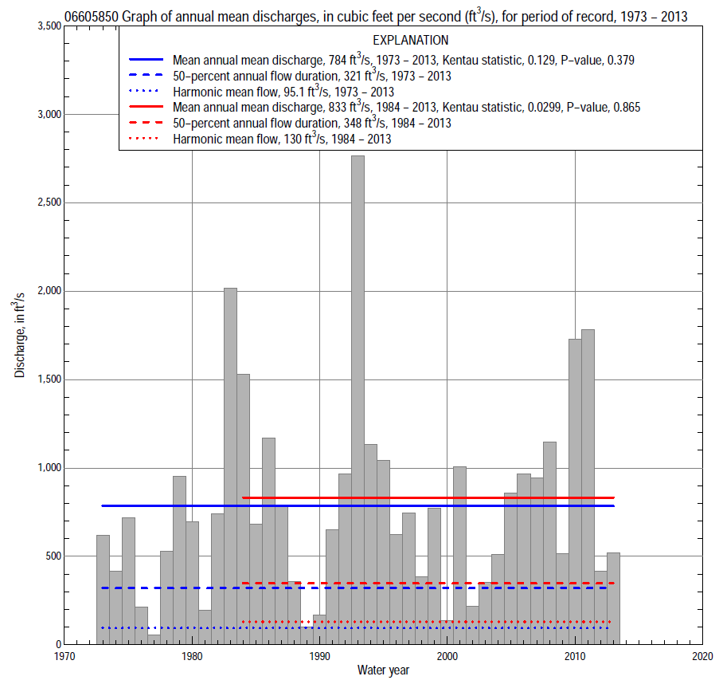

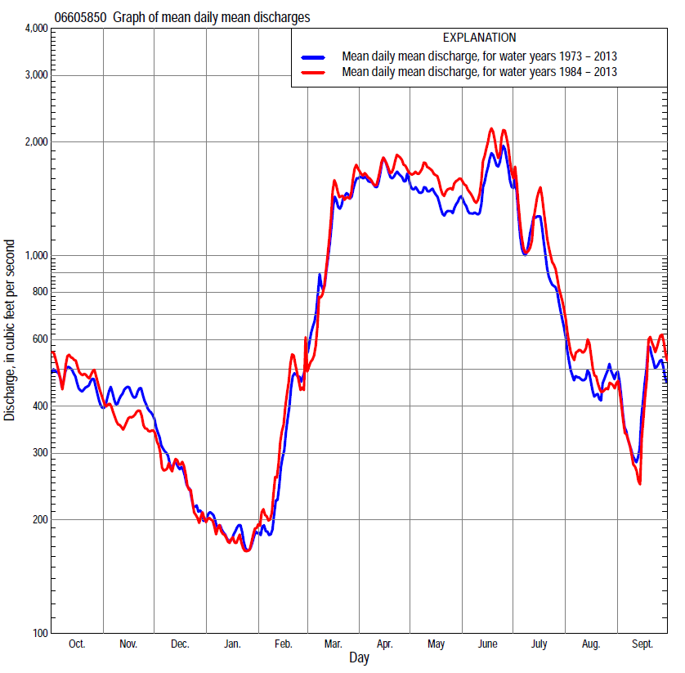

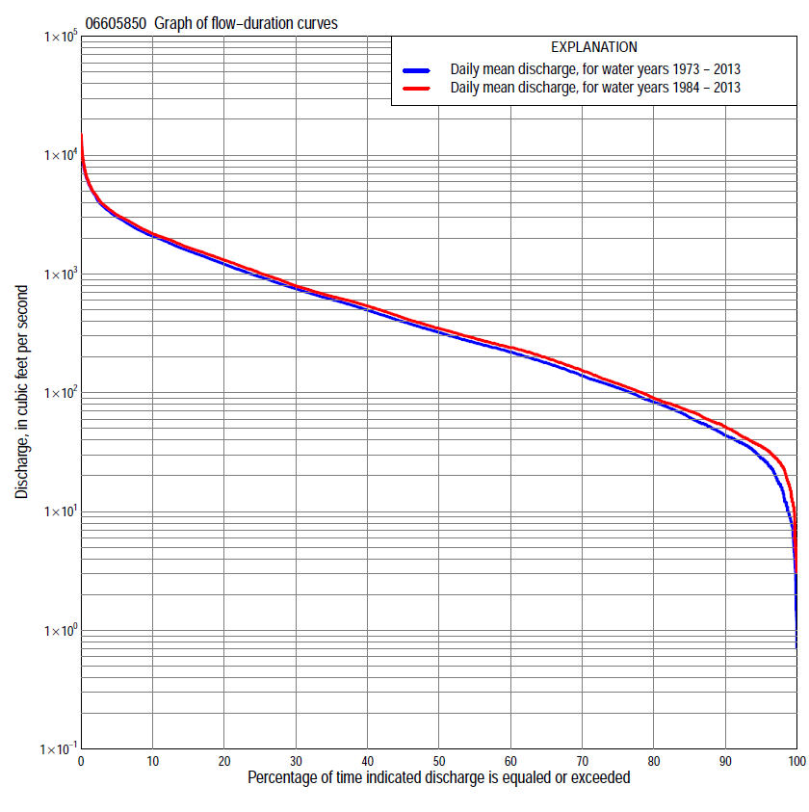

Statistics Based on the Entire Streamflow Period of Record
06605850 Monthly and annual flow durations, based on 1973–2013 period of record (41 years)
Percentage of days discharge equaled or exceeded |  |  |  |  | Discharge (cubic feet per second) |  |  |  |  |  |  |  |  | Annual flow durations
 | Oct | Nov | Dec | Jan | Feb | Mar | Apr | May | June | July | Aug | Sept | Annual | Kentau statistic | P-value
99 | 16 | 17 | 4.3 | 2.0 | 3.1 | 15 | 67 | 56 | 47 | 35 | 14 | 14 | 9.0 | 0.091 | 0.406
98 | 18 | 21 | 7.0 | 4.8 | 8.8 | 26 | 73 | 65 | 80 | 43 | 23 | 21 | 15 | 0.093 | 0.399
95 | 31 | 29 | 11 | 8.9 | 12 | 38 | 100 | 107 | 124 | 63 | 34 | 28 | 28 | 0.107 | 0.328
90 | 38 | 44 | 30 | 18 | 21 | 78 | 169 | 207 | 250 | 97 | 59 | 37 | 44 | 0.122 | 0.266
85 | 45 | 54 | 42 | 27 | 31 | 105 | 244 | 343 | 365 | 136 | 83 | 44 | 62 | 0.090 | 0.412
80 | 56 | 64 | 54 | 36 | 38 | 164 | 386 | 415 | 464 | 171 | 100 | 55 | 83 | 0.054 | 0.629
75 | 70 | 75 | 65 | 44 | 44 | 239 | 586 | 513 | 541 | 207 | 114 | 68 | 110 | 0.034 | 0.762
70 | 82 | 92 | 78 | 53 | 55 | 304 | 720 | 601 | 616 | 247 | 130 | 77 | 140 | 0.032 | 0.779
65 | 103 | 117 | 104 | 70 | 86 | 367 | 793 | 712 | 708 | 294 | 148 | 85 | 179 | 0.055 | 0.621
60 | 122 | 148 | 128 | 88 | 127 | 425 | 913 | 844 | 797 | 345 | 164 | 98 | 220 | 0.043 | 0.703
55 | 135 | 199 | 165 | 107 | 154 | 540 | 1,010 | 1,030 | 905 | 396 | 185 | 113 | 264 | 0.049 | 0.661
50 | 156 | 236 | 196 | 130 | 180 | 600 | 1,140 | 1,180 | 1,050 | 477 | 215 | 127 | 321 | 0.027 | 0.814
45 | 188 | 266 | 230 | 160 | 205 | 668 | 1,380 | 1,350 | 1,160 | 576 | 249 | 148 | 396 | 0.048 | 0.669
40 | 266 | 301 | 260 | 190 | 230 | 761 | 1,600 | 1,500 | 1,300 | 666 | 288 | 189 | 496 | 0.041 | 0.711
35 | 324 | 372 | 290 | 220 | 260 | 947 | 1,820 | 1,640 | 1,470 | 789 | 343 | 217 | 611 | 0.063 | 0.567
30 | 415 | 473 | 330 | 240 | 297 | 1,230 | 2,030 | 1,800 | 1,620 | 985 | 401 | 281 | 750 | 0.090 | 0.412
25 | 565 | 618 | 367 | 260 | 370 | 1,480 | 2,240 | 2,020 | 1,840 | 1,180 | 473 | 395 | 945 | 0.113 | 0.301
20 | 804 | 718 | 420 | 295 | 480 | 1,800 | 2,550 | 2,290 | 2,150 | 1,480 | 572 | 543 | 1,210 | 0.116 | 0.291
15 | 1,000 | 876 | 514 | 344 | 580 | 2,190 | 2,990 | 2,580 | 2,790 | 1,900 | 772 | 682 | 1,570 | 0.123 | 0.261
10 | 1,320 | 1,100 | 649 | 420 | 750 | 2,780 | 3,580 | 2,970 | 3,410 | 2,380 | 1,150 | 1,080 | 2,080 | 0.160 | 0.144
5 | 1,930 | 1,370 | 820 | 525 | 1,290 | 3,880 | 4,810 | 3,740 | 5,460 | 3,790 | 2,090 | 1,930 | 3,010 | 0.173 | 0.113
2 | 2,840 | 1,950 | 1,010 | 810 | 1,990 | 6,240 | 5,880 | 4,640 | 7,430 | 7,010 | 3,300 | 3,050 | 4,550 | 0.177 | 0.106
1 | 3,250 | 2,530 | 1,150 | 940 | 2,650 | 7,890 | 6,670 | 4,970 | 8,680 | 9,550 | 3,590 | 4,310 | 5,880 | 0.159 | 0.147

06605850 Annual exceedance probability of instantaneous peak discharges, in cubic feet per second (ft³/s), based on the Weighted Independent Estimates method,
Annual exceed-ance probability | Recur-rence interval (years) | Discharge (ft³/s) | 95-percent lower confi-dence interval (ft³/s) | 95-percent upper confi-dence interval (ft³/s)
0.500 | 2 | 4,840 | 4,190 | 5,600
0.200 | 5 | 9,010 | 7,810 | 10,400
0.100 | 10 | 12,200 | 10,400 | 14,300
0.040 | 25 | 16,500 | 13,600 | 20,000
0.020 | 50 | 19,900 | 15,800 | 25,000
0.010 | 100 | 23,400 | 18,000 | 30,600
0.005 | 200 | 27,100 | 19,900 | 36,800
0.002 | 500 | 32,000 | 22,300 | 45,900
and based on the expected moments algorithm/multiple Grubbs-Beck analysis computed using a historical period length of 122 years (1892–2013)
0.500 | 2 | 4,830 | 3,750 | 6,130
0.200 | 5 | 8,980 | 7,130 | 11,300
0.100 | 10 | 12,100 | 9,560 | 15,400
0.040 | 25 | 16,500 | 12,700 | 21,600
0.020 | 50 | 19,800 | 14,900 | 27,200
0.010 | 100 | 23,300 | 17,100 | 33,800
0.005 | 200 | 26,900 | 19,100 | 41,600
0.002 | 500 | 31,800 | 21,500 | 53,800
Kentau statistic |  | 0.144
P-value |  | 0.189
Begin year |  | 1973
End year |  | 2013
Number of peaks |  | 41

06605850 Annual exceedance probability of high discharges, based on 1973–2013 period of record (41 years)
Annual exceedance probability | Recur-rence interval (years) | Maximum average discharge (ft³/s) for indicated number of consecutive days
 |  | 1 | 3 | 7 | 15 | 30
0.990 | 1.01 | 636 | 574 | 439 | 288 | 216
0.950 | 1.05 | 1,150 | 1,060 | 869 | 626 | 488
0.900 | 1.11 | 1,560 | 1,450 | 1,220 | 914 | 721
0.800 | 1.25 | 2,220 | 2,090 | 1,790 | 1,400 | 1,110
0.500 | 2 | 4,220 | 4,000 | 3,510 | 2,840 | 2,260
0.200 | 5 | 7,670 | 7,230 | 6,280 | 5,120 | 4,000
0.100 | 10 | 10,300 | 9,630 | 8,250 | 6,660 | 5,100
0.040 | 25 | 13,900 | 12,900 | 10,800 | 8,530 | 6,380
0.020 | 50 | 16,800 | 15,400 | 12,600 | 9,840 | 7,240
0.010 | 100 | 19,800 | 17,900 | 14,500 | 11,100 | 8,010
0.005 | 200 | 22,900 | 20,500 | 16,200 | 12,200 | 8,710
0.002 | 500 | 27,200 | 24,100 | 18,600 | 13,600 | 9,530
Kentau statistic |  | 0.146 | 0.149 | 0.159 | 0.180 | 0.180
P-value |  | 0.181 | 0.174 | 0.147 | 0.099 | 0.099

 | 06605850 Annual nonexceedance probability of low discharges, based on April 1973 to March 2013 period of record (40 years)
Annual nonexceed-ance probability | Recur-rence interval (years) | Minimum average discharge (cubic feet per second) for indicated number of consecutive days
 |  | 1 | 3 | 7 | 14 | 30 | 60 | 90 | 120 | 183
0.01 | 100 | 0.87 | 0.98 | 1.2 | 1.3 | 1.9 | 3.2 | 4.1 | 6.1 | 9.0
0.02 | 50 | 1.7 | 1.9 | 2.2 | 2.5 | 3.3 | 5.3 | 6.6 | 9.4 | 13
0.05 | 20 | 4.2 | 4.6 | 5.2 | 5.6 | 7.2 | 10 | 13 | 17 | 23
0.10 | 10 | 8.6 | 9.3 | 10 | 11 | 13 | 18 | 22 | 29 | 37
0.20 | 5 | 19 | 20 | 21 | 23 | 27 | 34 | 42 | 51 | 64
0.50 | 2 | 60 | 63 | 66 | 71 | 79 | 96 | 122 | 143 | 178
0.80 | 1.25 | 135 | 142 | 151 | 163 | 179 | 224 | 300 | 356 | 462
0.90 | 1.11 | 184 | 193 | 208 | 226 | 250 | 324 | 452 | 546 | 741
0.96 | 1.04 | 234 | 246 | 272 | 299 | 333 | 456 | 667 | 834 | 1,200
0.98 | 1.02 | 264 | 278 | 312 | 345 | 389 | 555 | 838 | 1,080 | 1,630
0.99 | 1.01 | 288 | 304 | 346 | 385 | 437 | 650 | 1,010 | 1,340 | 2,120
Kentau statistic |  | 0.017 | 0.018 | 0.041 | 0.054 | 0.036 | 0.054 | 0.074 | 0.072 | 0.059
P-value |  | 0.889 | 0.880 | 0.718 | 0.633 | 0.753 | 0.633 | 0.507 | 0.522 | 0.600

06605850 Annual nonexceedance probability of seasonal low discharges, based on October 1972 to September 2013 period of record (41 years)
Annual nonexceed-ance probability | Recur-rence interval (years) | Minimum average discharge (cubic feet per second) for indicated number of consecutive days
 |  | 1 | 7 | 14 | 30 |  | 1 | 7 | 14 | 30
 |  | January-February-March |  |  |  |  | April-May-June
0.01 | 100 | 0.92 | 1.3 | 1.4 | 2.0 |  | 19 | 22 | 26 | 32
0.02 | 50 | 1.9 | 2.5 | 2.7 | 3.6 |  | 30 | 34 | 40 | 50
0.05 | 20 | 4.9 | 6.1 | 6.6 | 8.2 |  | 56 | 63 | 74 | 95
0.10 | 10 | 11 | 13 | 13 | 16 |  | 93 | 105 | 123 | 159
0.20 | 5 | 24 | 27 | 29 | 33 |  | 163 | 185 | 215 | 283
0.50 | 2 | 85 | 93 | 99 | 107 |  | 416 | 469 | 544 | 723
0.80 | 1.25 | 207 | 227 | 246 | 267 |  | 883 | 989 | 1,150 | 1,510
0.90 | 1.11 | 290 | 322 | 353 | 390 |  | 1,220 | 1,360 | 1,600 | 2,070
0.96 | 1.04 | 382 | 432 | 481 | 548 |  | 1,650 | 1,830 | 2,160 | 2,760
0.98 | 1.02 | 438 | 504 | 566 | 659 |  | 1,960 | 2,160 | 2,570 | 3,230
0.99 | 1.01 | 485 | 565 | 641 | 763 |  | 2,250 | 2,470 | 2,950 | 3,670
Kentau statistic |  | 0.054 | 0.078 | 0.080 | 0.073 |  | 0.115 | 0.124 | 0.135 | 0.149
P-value |  | 0.629 | 0.479 | 0.465 | 0.508 |  | 0.296 | 0.257 | 0.217 | 0.174
 |  | July-August-September |  |  |  |  | October-November-December
0.01 | 100 | 9.6 | 10 | 11 | 19 |  | 3.1 | 3.5 | 3.7 | 4.8
0.02 | 50 | 12 | 13 | 14 | 22 |  | 4.8 | 5.6 | 6.0 | 7.7
0.05 | 20 | 17 | 18 | 20 | 29 |  | 9.1 | 11 | 12 | 15
0.10 | 10 | 24 | 25 | 28 | 38 |  | 16 | 19 | 21 | 26
0.20 | 5 | 35 | 38 | 43 | 55 |  | 29 | 36 | 40 | 50
0.50 | 2 | 80 | 88 | 98 | 118 |  | 82 | 103 | 118 | 146
0.80 | 1.25 | 192 | 214 | 238 | 289 |  | 204 | 252 | 291 | 365
0.90 | 1.11 | 309 | 346 | 390 | 483 |  | 311 | 379 | 435 | 553
0.96 | 1.04 | 524 | 588 | 672 | 870 |  | 469 | 558 | 637 | 826
0.98 | 1.02 | 745 | 835 | 967 | 1,300 |  | 600 | 700 | 795 | 1,050
0.99 | 1.01 | 1,030 | 1,150 | 1,350 | 1,890 |  | 738 | 845 | 954 | 1,270
Kentau statistic |  | -0.050 | -0.062 | -0.063 | -0.085 |  | 0.005 | 0.020 | 0.010 | 0.037
P-value |  | 0.653 | 0.574 | 0.567 | 0.438 |  | 0.973 | 0.866 | 0.937 | 0.745

Statistics Based on the 1984–2013 Streamflow Period of Record
06605850 Monthly and annual flow durations, based on 1984–2013 period of record (30 years)
Percentage of days discharge equaled or exceeded |  |  |  |  | Discharge (cubic feet per second) |  |  |  |  |  |  |  |  | Annual flow durations
 | Oct | Nov | Dec | Jan | Feb | Mar | Apr | May | June | July | Aug | Sept | Annual | Kentau statistic | P-value
99 | 18 | 17 | 4.0 | 5.7 | 12 | 30 | 66 | 66 | 88 | 62 | 33 | 24 | 16 | -0.076 | 0.568
98 | 20 | 24 | 4.7 | 11 | 14 | 35 | 70 | 79 | 99 | 71 | 37 | 28 | 24 | -0.069 | 0.605
95 | 34 | 36 | 26 | 15 | 22 | 58 | 82 | 164 | 217 | 87 | 52 | 33 | 35 | -0.060 | 0.656
90 | 39 | 44 | 37 | 26 | 30 | 96 | 163 | 341 | 344 | 123 | 72 | 39 | 52 | -0.055 | 0.682
85 | 45 | 54 | 50 | 32 | 38 | 153 | 273 | 486 | 443 | 160 | 94 | 47 | 70 | -0.069 | 0.605
80 | 55 | 63 | 59 | 41 | 48 | 220 | 388 | 595 | 537 | 204 | 109 | 58 | 90 | -0.099 | 0.453
75 | 64 | 74 | 68 | 52 | 56 | 268 | 640 | 686 | 612 | 247 | 124 | 68 | 119 | -0.092 | 0.486
70 | 77 | 88 | 82 | 75 | 85 | 327 | 744 | 801 | 701 | 294 | 140 | 76 | 153 | -0.071 | 0.592
65 | 90 | 118 | 115 | 94 | 120 | 370 | 856 | 973 | 802 | 350 | 153 | 82 | 197 | -0.041 | 0.762
60 | 116 | 146 | 153 | 110 | 150 | 420 | 1,010 | 1,120 | 919 | 398 | 167 | 91 | 240 | -0.064 | 0.630
55 | 137 | 221 | 183 | 130 | 170 | 520 | 1,170 | 1,250 | 1,050 | 480 | 191 | 102 | 287 | -0.057 | 0.669
50 | 171 | 249 | 210 | 153 | 193 | 595 | 1,370 | 1,400 | 1,180 | 575 | 219 | 116 | 348 | -0.071 | 0.592
45 | 232 | 270 | 250 | 190 | 212 | 641 | 1,590 | 1,540 | 1,320 | 654 | 250 | 130 | 427 | -0.044 | 0.748
40 | 302 | 307 | 270 | 210 | 242 | 702 | 1,800 | 1,660 | 1,470 | 748 | 299 | 159 | 538 | -0.076 | 0.568
35 | 363 | 383 | 308 | 230 | 280 | 905 | 1,980 | 1,790 | 1,600 | 891 | 366 | 206 | 648 | -0.044 | 0.748
30 | 503 | 475 | 340 | 240 | 320 | 1,300 | 2,130 | 1,970 | 1,780 | 1,090 | 425 | 291 | 793 | -0.011 | 0.943
25 | 695 | 604 | 369 | 260 | 400 | 1,540 | 2,340 | 2,210 | 2,040 | 1,270 | 506 | 445 | 1,020 | 0.009 | 0.957
20 | 916 | 687 | 410 | 290 | 520 | 1,840 | 2,720 | 2,450 | 2,540 | 1,570 | 603 | 557 | 1,310 | 0.023 | 0.872
15 | 1,100 | 777 | 475 | 320 | 640 | 2,260 | 3,170 | 2,840 | 3,020 | 1,990 | 853 | 678 | 1,670 | 0.037 | 0.789
10 | 1,330 | 938 | 573 | 380 | 843 | 2,800 | 3,610 | 3,170 | 3,790 | 2,420 | 1,240 | 1,010 | 2,180 | 0.090 | 0.498
5 | 1,930 | 1,130 | 709 | 460 | 1,320 | 3,790 | 4,630 | 4,020 | 6,300 | 3,960 | 2,430 | 1,910 | 3,150 | 0.113 | 0.392
2 | 2,940 | 1,310 | 829 | 526 | 1,990 | 5,620 | 5,570 | 4,750 | 8,080 | 7,230 | 3,300 | 3,760 | 4,650 | 0.120 | 0.363
1 | 3,380 | 1,370 | 917 | 576 | 2,400 | 8,210 | 6,160 | 5,020 | 9,180 | 11,100 | 3,720 | 5,170 | 6,100 | 0.108 | 0.412

06605850 Annual exceedance probability of high discharges, based on 1984–2013 period of record (30 years)
Annual exceedance probability | Recur-rence interval (years) | Maximum average discharge (ft³/s) for indicated number of consecutive days
 |  | 1 | 3 | 7 | 15 | 30
0.990 | 1.01 | 720 | 661 | 520 | 352 | 266
0.950 | 1.05 | 1,280 | 1,200 | 997 | 738 | 574
0.900 | 1.11 | 1,710 | 1,610 | 1,380 | 1,060 | 831
0.800 | 1.25 | 2,410 | 2,290 | 2,000 | 1,580 | 1,250
0.500 | 2 | 4,490 | 4,280 | 3,800 | 3,110 | 2,460
0.200 | 5 | 8,020 | 7,590 | 6,670 | 5,440 | 4,240
0.100 | 10 | 10,700 | 10,000 | 8,680 | 6,980 | 5,360
0.040 | 25 | 14,300 | 13,300 | 11,200 | 8,820 | 6,660
0.020 | 50 | 17,100 | 15,800 | 13,100 | 10,100 | 7,520
0.010 | 100 | 20,100 | 18,300 | 15,000 | 11,300 | 8,300
0.005 | 200 | 23,100 | 20,900 | 16,800 | 12,400 | 9,000
0.002 | 500 | 27,300 | 24,400 | 19,100 | 13,700 | 9,820
Kentau statistic |  | 0.103 | 0.097 | 0.099 | 0.126 | 0.090
P-value |  | 0.432 | 0.464 | 0.454 | 0.335 | 0.498

 | 06605850 Annual nonexceedance probability of low discharges, based on April 1983 to March 2013 period of record (30 years)
Annual nonexceed-ance probability | Recur-rence interval (years) | Minimum average discharge (cubic feet per second) for indicated number of consecutive days
 |  | 1 | 3 | 7 | 14 | 30 | 60 | 90 | 120 | 183
0.01 | 100 | 2.6 | 2.9 | 3.3 | 3.7 | 4.5 | 6.6 | 7.8 | 9.1 | 11
0.02 | 50 | 4.1 | 4.6 | 5.2 | 5.8 | 6.9 | 9.8 | 12 | 14 | 16
0.05 | 20 | 8.0 | 8.9 | 9.8 | 11 | 13 | 17 | 21 | 24 | 28
0.10 | 10 | 14 | 15 | 16 | 18 | 21 | 28 | 33 | 39 | 45
0.20 | 5 | 25 | 27 | 29 | 31 | 36 | 46 | 57 | 66 | 77
0.50 | 2 | 65 | 69 | 74 | 79 | 88 | 109 | 140 | 165 | 201
0.80 | 1.25 | 134 | 142 | 152 | 166 | 180 | 220 | 293 | 354 | 479
0.90 | 1.11 | 181 | 191 | 207 | 229 | 245 | 298 | 407 | 500 | 731
0.96 | 1.04 | 237 | 249 | 273 | 306 | 324 | 395 | 554 | 694 | 1,120
0.98 | 1.02 | 274 | 287 | 318 | 361 | 378 | 464 | 662 | 841 | 1,450
0.99 | 1.01 | 306 | 322 | 359 | 412 | 429 | 529 | 767 | 985 | 1,820
Kentau statistic |  | -0.145 | -0.149 | -0.113 | -0.108 | -0.117 | -0.094 | -0.057 | -0.053 | -0.044
P-value |  | 0.269 | 0.254 | 0.392 | 0.412 | 0.372 | 0.475 | 0.669 | 0.695 | 0.748

06605850 Annual nonexceedance probability of seasonal low discharges, based on October 1983 to September 2013 period of record (30 years)
Annual nonexceed-ance probability | Recur-rence interval (years) | Minimum average discharge (cubic feet per second) for indicated number of consecutive days
 |  | 1 | 7 | 14 | 30 |  | 1 | 7 | 14 | 30
 |  | January-February-March |  |  |  |  | April-May-June
0.01 | 100 | 2.6 | 3.4 | 4.0 | 5.5 |  | 31 | 33 | 34 | 39
0.02 | 50 | 4.4 | 5.5 | 6.4 | 8.4 |  | 45 | 48 | 51 | 61
0.05 | 20 | 9.1 | 11 | 12 | 16 |  | 76 | 83 | 92 | 115
0.10 | 10 | 16 | 19 | 21 | 26 |  | 118 | 131 | 150 | 193
0.20 | 5 | 31 | 36 | 40 | 45 |  | 195 | 221 | 258 | 340
0.50 | 2 | 89 | 101 | 109 | 118 |  | 465 | 530 | 633 | 847
0.80 | 1.25 | 202 | 228 | 249 | 264 |  | 983 | 1,110 | 1,320 | 1,720
0.90 | 1.11 | 286 | 321 | 357 | 380 |  | 1,390 | 1,540 | 1,810 | 2,300
0.96 | 1.04 | 391 | 439 | 499 | 537 |  | 1,940 | 2,120 | 2,430 | 2,980
0.98 | 1.02 | 465 | 523 | 604 | 658 |  | 2,370 | 2,550 | 2,880 | 3,440
0.99 | 1.01 | 533 | 601 | 706 | 779 |  | 2,810 | 2,980 | 3,310 | 3,850
Kentau statistic |  | -0.034 | 0.007 | -0.016 | -0.016 |  | -0.046 | -0.044 | -0.037 | 0.007
P-value |  | 0.803 | 0.972 | 0.915 | 0.915 |  | 0.735 | 0.748 | 0.789 | 0.972
 |  | July-August-September |  |  |  |  | October-November-December
0.01 | 100 | 17 | 18 | 20 | 27 |  | 3.1 | 3.8 | 4.2 | 5.8
0.02 | 50 | 19 | 20 | 23 | 29 |  | 5.1 | 6.3 | 7.0 | 9.3
0.05 | 20 | 24 | 25 | 28 | 35 |  | 10 | 13 | 14 | 18
0.10 | 10 | 29 | 31 | 34 | 43 |  | 18 | 23 | 25 | 31
0.20 | 5 | 39 | 42 | 46 | 57 |  | 33 | 43 | 47 | 57
0.50 | 2 | 78 | 86 | 95 | 114 |  | 90 | 116 | 130 | 157
0.80 | 1.25 | 191 | 213 | 237 | 290 |  | 195 | 243 | 283 | 358
0.90 | 1.11 | 331 | 370 | 416 | 519 |  | 269 | 327 | 391 | 515
0.96 | 1.04 | 636 | 712 | 811 | 1,050 |  | 358 | 424 | 521 | 722
0.98 | 1.02 | 1,010 | 1,130 | 1,300 | 1,720 |  | 419 | 486 | 609 | 877
0.99 | 1.01 | 1,560 | 1,750 | 2,030 | 2,780 |  | 473 | 540 | 688 | 1,030
Kentau statistic |  | -0.149 | -0.154 | -0.154 | -0.163 |  | -0.085 | -0.062 | -0.057 | -0.021
P-value |  | 0.253 | 0.239 | 0.239 | 0.212 |  | 0.521 | 0.643 | 0.669 | 0.887

