LOCATION.--Lat 42°28'56.0", long 95°47'33.4" referenced to North American Datum of 1983, in NE 1/4 NE 1/4 SW 1/4 sec.34, T.89 N., R.42 W., Woodbury County, IA, Hydrologic Unit 10230003, on left bank on downstream side of bridge on U.S. Highway 20, at northwestern edge of Correctionville, 150 ft downstream from Pierson Creek, 1.3 mi upstream from Bacon Creek, and 59.8 mi upstream from mouth.

DRAINAGE AREA.--2,500 mi².

PERIOD OF RECORD.--Discharge records from May 1918 to July 1925, October 1928 to July 1932, June 1936 to current year. December 1924 to March 1925, monthly mean discharge published in WSP 1310.

GAGE.--Water-stage recorder. Datum of gage is 1,096.49 ft above National Geodetic Vertical Datum of 1929. May 28, 1918, to July 1, 1925, and October 29, 1928, to July 15, 1929, non-recording gage at site 1.2 mi downstream at datum 1.25 ft lower; July 16, 1929, to July 2, 1932, and June 15, 1936, to November 7, 1938, non-recording gage at site 1.0 mi downstream at same datum; November 8, 1938, to August 18, 2010, water-stage recorder at site 1.0 mi downstream at same datum.

EXTREMES OUTSIDE PERIOD OF RECORD.--Flood of June 23 or 24, 1891, reached a stage of 29.34 ft, at current datum, from levels to high-water mark by U.S. Soil Conservation Service, discharge not determined.

A summary of all available data for this streamgage is provided through the USGS National Water Information System web interface (NWISWeb). The following link provides access to current/historical observations, daily data, daily statistics, monthly statistics, annual statistics, peak streamflow, field measurements, field/lab water-quality samples, and the latest water-year summaries. Data can be filtered by parameter and/or dates, and can be output in various tabular and graphical formats.
http://waterdata.usgs.gov/nwis/inventory/?site_no=06606600

The USGS WaterWatch Toolkit is available at:
http://waterwatch.usgs.gov/?id=ww_toolkit
Tools for summarizing streamflow information include the duration hydrograph builder, the cumulative streamflow hydrograph builder, the streamgage statistics retrieval tool, the rating curve builder, the flood tracking chart builder, the National Weather Service Advanced Hydrologic Prediction Service (AHPS) river forecast hydrograph builder, and the raster-hydrograph builder. Entering the above number for this streamgage into these toolkit webpages will provide streamflow information specific to this streamgage.

A description of the statistics presented for this streamgage is available in the main body of the report at:
http://dx.doi.org/10.3133/ofr20151214
A link to other streamgages included in this report, a map showing the location of the streamgages, information on the programs used to compute the statistical analyses, and references are included in the main body of the report.

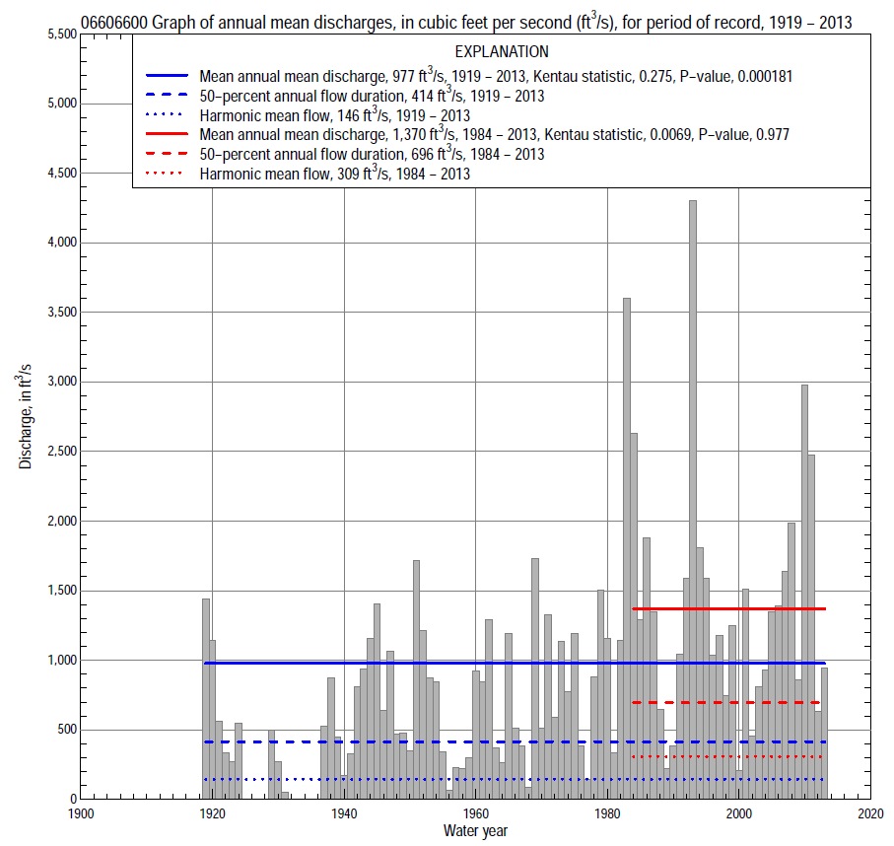

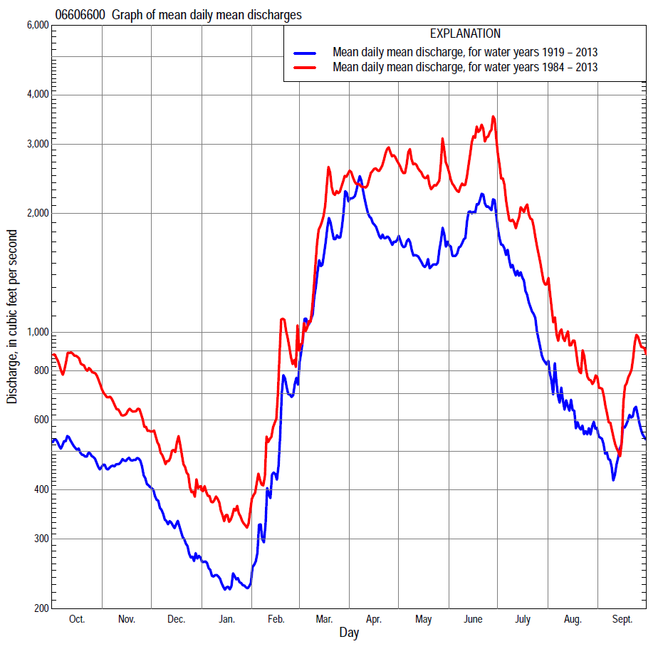

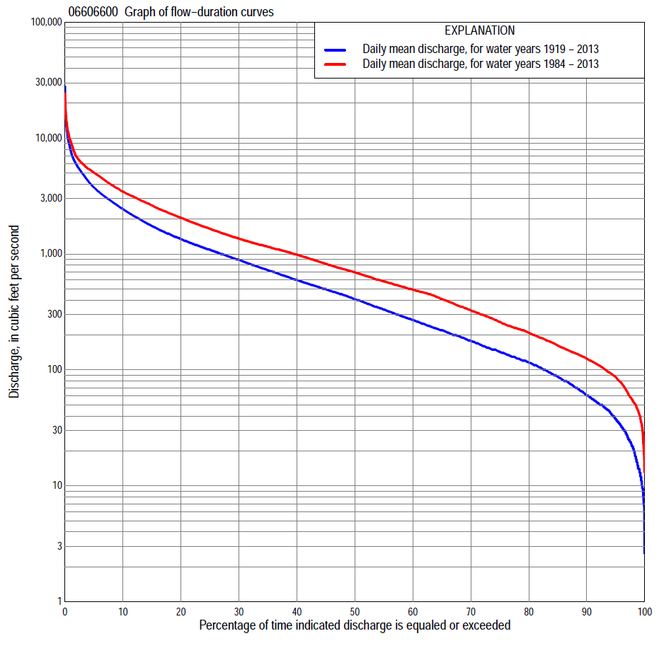

Statistics Based on the Entire Streamflow Period of Record
06606600 Monthly and annual flow durations, based on 1919–24, 1929–31, 1937–2013 period of record (86 years)
Percentage of days discharge equaled or exceeded |  |  |  |  | Discharge (cubic feet per second) |  |  |  |  |  |  |  |  | Annual flow durations
 | Oct | Nov | Dec | Jan | Feb | Mar | Apr | May | June | July | Aug | Sept | Annual | Kentau statistic | P-value
99 | 9.0 | 25 | 14 | 9.5 | 8.0 | 44 | 66 | 56 | 30 | 24 | 16 | 12 | 14 | 0.300 | 0.000
98 | 17 | 33 | 16 | 9.5 | 14 | 50 | 91 | 72 | 50 | 34 | 21 | 14 | 21 | 0.305 | 0.000
95 | 36 | 43 | 25 | 15 | 23 | 79 | 149 | 128 | 136 | 77 | 35 | 31 | 38 | 0.303 | 0.000
90 | 47 | 59 | 39 | 26 | 40 | 120 | 227 | 208 | 214 | 119 | 59 | 50 | 60 | 0.288 | 0.000
85 | 60 | 75 | 50 | 37 | 56 | 175 | 326 | 290 | 316 | 152 | 85 | 66 | 87 | 0.283 | 0.000
80 | 90 | 94 | 66 | 50 | 65 | 240 | 428 | 377 | 437 | 190 | 106 | 84 | 115 | 0.267 | 0.000
75 | 110 | 125 | 90 | 69 | 80 | 350 | 527 | 472 | 548 | 241 | 138 | 101 | 142 | 0.267 | 0.000
70 | 121 | 145 | 110 | 80 | 95 | 470 | 623 | 589 | 662 | 290 | 180 | 123 | 177 | 0.267 | 0.000
65 | 142 | 166 | 125 | 92 | 116 | 558 | 724 | 706 | 797 | 363 | 223 | 142 | 220 | 0.267 | 0.000
60 | 186 | 192 | 144 | 103 | 140 | 650 | 843 | 805 | 912 | 459 | 268 | 170 | 269 | 0.249 | 0.001
55 | 219 | 219 | 167 | 120 | 155 | 755 | 992 | 918 | 1,040 | 563 | 306 | 198 | 330 | 0.244 | 0.001
50 | 237 | 249 | 189 | 130 | 200 | 900 | 1,130 | 1,030 | 1,170 | 666 | 352 | 227 | 406 | 0.255 | 0.001
45 | 264 | 293 | 213 | 150 | 253 | 1,010 | 1,280 | 1,170 | 1,310 | 786 | 404 | 262 | 497 | 0.271 | 0.000
40 | 295 | 342 | 253 | 165 | 350 | 1,170 | 1,450 | 1,360 | 1,470 | 950 | 468 | 308 | 599 | 0.277 | 0.000
35 | 348 | 409 | 300 | 201 | 429 | 1,400 | 1,690 | 1,590 | 1,680 | 1,090 | 535 | 353 | 726 | 0.283 | 0.000
30 | 434 | 471 | 363 | 250 | 481 | 1,590 | 2,030 | 1,840 | 1,930 | 1,300 | 648 | 419 | 895 | 0.288 | 0.000
25 | 552 | 540 | 430 | 310 | 582 | 1,880 | 2,410 | 2,150 | 2,320 | 1,590 | 756 | 519 | 1,090 | 0.296 | 0.000
20 | 692 | 650 | 500 | 419 | 735 | 2,180 | 2,940 | 2,500 | 2,780 | 1,980 | 892 | 658 | 1,350 | 0.281 | 0.000
15 | 871 | 860 | 600 | 500 | 900 | 2,660 | 3,560 | 3,120 | 3,370 | 2,580 | 1,070 | 931 | 1,740 | 0.275 | 0.000
10 | 1,260 | 1,140 | 782 | 615 | 1,200 | 3,510 | 4,730 | 3,720 | 4,590 | 3,120 | 1,380 | 1,310 | 2,440 | 0.258 | 0.000
5 | 2,090 | 1,580 | 1,100 | 800 | 1,960 | 5,200 | 6,540 | 5,040 | 6,260 | 4,380 | 2,130 | 2,270 | 3,760 | 0.247 | 0.001
2 | 3,070 | 2,250 | 1,400 | 1,070 | 3,030 | 8,190 | 9,280 | 6,270 | 9,730 | 7,190 | 4,040 | 3,790 | 5,890 | 0.191 | 0.009
1 | 4,150 | 2,940 | 1,700 | 1,280 | 4,230 | 11,300 | 11,800 | 7,160 | 12,500 | 10,100 | 5,400 | 5,030 | 7,790 | 0.175 | 0.017

06606600 Annual exceedance probability of instantaneous peak discharges, in cubic feet per second (ft³/s), based on the Weighted Independent Estimates method,
Annual exceed-ance probability | Recur-rence interval (years) | Discharge (ft³/s) | 95-percent lower confi-dence interval (ft³/s) | 95-percent upper confi-dence interval (ft³/s)
0.500 | 2 | 6,950 | 6,060 | 7,970
0.200 | 5 | 13,000 | 11,400 | 14,900
0.100 | 10 | 17,900 | 15,500 | 20,700
0.040 | 25 | 25,400 | 21,400 | 30,200
0.020 | 50 | 31,100 | 25,400 | 38,000
0.010 | 100 | 36,700 | 29,100 | 46,200
0.005 | 200 | 43,600 | 33,400 | 56,900
0.002 | 500 | 50,200 | 36,700 | 68,700
and based on the expected moments algorithm/multiple Grubbs-Beck analysis computed using a historical period length of 122 years (1892–2013)
0.500 | 2 | 6,830 | 5,780 | 8,030
0.200 | 5 | 12,300 | 10,500 | 14,600
0.100 | 10 | 16,500 | 14,000 | 19,900
0.040 | 25 | 22,100 | 18,300 | 28,100
0.020 | 50 | 26,600 | 21,500 | 35,400
0.010 | 100 | 31,100 | 24,400 | 43,800
0.005 | 200 | 35,800 | 27,200 | 53,500
0.002 | 500 | 42,300 | 30,500 | 68,400
Kentau statistic |  | 0.120
P-value |  | 0.099
Begin year |  | 1919
End year |  | 2013
Number of peaks |  | 88

06606600 Annual exceedance probability of high discharges, based on 1919–24, 1929–31, 1937–2013 period of record (86 years)
[ND, not determined]
Annual exceed-ance probability | Recur-rence interval (years) | Maximum average discharge (ft³/s) for indicated number of consecutive days
 |  | 1 | 3 | 7 | 15 | 30
0.990 | 1.01 | ND | 624 | 473 | 299 | 212
0.950 | 1.05 | ND | 1,230 | 971 | 688 | 515
0.900 | 1.11 | ND | 1,730 | 1,390 | 1,040 | 790
0.800 | 1.25 | ND | 2,580 | 2,120 | 1,640 | 1,270
0.500 | 2 | ND | 5,280 | 4,450 | 3,600 | 2,800
0.200 | 5 | ND | 10,200 | 8,670 | 6,980 | 5,320
0.100 | 10 | ND | 14,000 | 11,900 | 9,430 | 7,030
0.040 | 25 | ND | 19,300 | 16,400 | 12,600 | 9,120
0.020 | 50 | ND | 23,500 | 20,000 | 14,900 | 10,600
0.010 | 100 | ND | 28,000 | 23,600 | 17,100 | 11,900
0.005 | 200 | ND | 32,600 | 27,400 | 19,300 | 13,200
0.002 | 500 | ND | 39,000 | 32,500 | 22,100 | 14,700
Kentau statistic |  | 0.248 | 0.276 | 0.286 | 0.303 | 0.334
P-value |  | 0.000 | 0.000 | 0.000 | 0.000 | 0.000

 | 06606600 Annual nonexceedance probability of low discharges, based on April 1919 to March 1925, April 1929 to March 1932, April 1937 to March 2013 period of record (85 years)
Annual nonexceed-ance probability | Recur-rence interval (years) | Minimum average discharge (ft³/s) for indicated number of consecutive days
 |  | 1 | 3 | 7 | 14 | 30 | 60 | 90 | 120 | 183
0.01 | 100 | 4.0 | 4.2 | 4.8 | 5.7 | 6.2 | 8.4 | 12 | 15 | 16
0.02 | 50 | 5.8 | 6.2 | 7.0 | 8.0 | 8.9 | 12 | 16 | 20 | 22
0.05 | 20 | 10 | 11 | 12 | 13 | 15 | 19 | 26 | 32 | 37
0.10 | 10 | 16 | 17 | 19 | 20 | 23 | 29 | 39 | 47 | 56
0.20 | 5 | 28 | 29 | 31 | 34 | 39 | 49 | 64 | 76 | 94
0.50 | 2 | 72 | 76 | 80 | 86 | 97 | 121 | 155 | 183 | 236
0.80 | 1.25 | 169 | 181 | 191 | 203 | 230 | 285 | 362 | 423 | 558
0.90 | 1.11 | 254 | 274 | 291 | 310 | 351 | 436 | 555 | 646 | 855
0.96 | 1.04 | 381 | 416 | 447 | 480 | 538 | 676 | 863 | 1,000 | 1,320
0.98 | 1.02 | 488 | 537 | 582 | 630 | 703 | 890 | 1,140 | 1,320 | 1,740
0.99 | 1.01 | 603 | 668 | 733 | 799 | 887 | 1,130 | 1,460 | 1,690 | 2,210
Kentau statistic |  | 0.389 | 0.396 | 0.406 | 0.400 | 0.392 | 0.374 | 0.353 | 0.341 | 0.323
P-value |  | 0.000 | 0.000 | 0.000 | 0.000 | 0.000 | 0.000 | 0.000 | 0.000 | 0.000

06606600 Annual nonexceedance probability of seasonal low discharges, based on July 1918 to June 1925, October 1928 to June 1932, July 1936 to September 2013 (88 years)
Annual nonexceed-ance probability | Recur-rence interval (years) | Minimum average discharge (cubic feet per second) for indicated number of consecutive days
 |  | 1 | 7 | 14 | 30 |  | 1 | 7 | 14 | 30
 |  | January-February-March |  |  |  |  | April-May-June
0.01 | 100 | 6.1 | 6.1 | 6.4 | 6.9 |  | 14 | 20 | 24 | 38
0.02 | 50 | 8.6 | 8.8 | 9.2 | 9.8 |  | 23 | 31 | 37 | 56
0.05 | 20 | 14 | 15 | 16 | 17 |  | 46 | 59 | 68 | 99
0.10 | 10 | 22 | 23 | 24 | 27 |  | 82 | 100 | 115 | 160
0.20 | 5 | 38 | 40 | 41 | 46 |  | 155 | 180 | 206 | 275
0.50 | 2 | 98 | 104 | 109 | 122 |  | 440 | 489 | 554 | 702
0.80 | 1.25 | 237 | 254 | 269 | 308 |  | 1,020 | 1,120 | 1,270 | 1,590
0.90 | 1.11 | 367 | 394 | 422 | 488 |  | 1,470 | 1,610 | 1,840 | 2,320
0.96 | 1.04 | 575 | 617 | 668 | 783 |  | 2,050 | 2,280 | 2,610 | 3,350
0.98 | 1.02 | 761 | 816 | 892 | 1,050 |  | 2,470 | 2,780 | 3,210 | 4,180
0.99 | 1.01 | 973 | 1,040 | 1,150 | 1,360 |  | 2,880 | 3,280 | 3,810 | 5,040
Kentau statistic |  | 0.226 | 0.251 | 0.253 | 0.243 |  | 0.368 | 0.347 | 0.344 | 0.336
P-value |  | 0.002 | 0.001 | 0.000 | 0.001 |  | 0.000 | 0.000 | 0.000 | 0.000
 |  | July-August-September |  |  |  |  | October-November-December
0.01 | 100 | 3.7 | 7.3 | 9.7 | 13 |  | 5.5 | 7.1 | 8.0 | 9.9
0.02 | 50 | 6.1 | 11 | 14 | 18 |  | 8.1 | 10 | 12 | 14
0.05 | 20 | 12 | 19 | 23 | 30 |  | 14 | 18 | 20 | 24
0.10 | 10 | 22 | 30 | 35 | 45 |  | 23 | 28 | 31 | 37
0.20 | 5 | 42 | 52 | 59 | 75 |  | 39 | 48 | 53 | 63
0.50 | 2 | 129 | 139 | 153 | 194 |  | 103 | 124 | 138 | 163
0.80 | 1.25 | 329 | 347 | 379 | 485 |  | 245 | 301 | 335 | 400
0.90 | 1.11 | 501 | 543 | 599 | 771 |  | 370 | 462 | 516 | 624
0.96 | 1.04 | 749 | 854 | 962 | 1,250 |  | 558 | 713 | 802 | 984
0.98 | 1.02 | 948 | 1,130 | 1,300 | 1,700 |  | 717 | 933 | 1,050 | 1,310
0.99 | 1.01 | 1,150 | 1,440 | 1,690 | 2,240 |  | 889 | 1,180 | 1,340 | 1,680
Kentau statistic |  | 0.253 | 0.237 | 0.233 | 0.192 |  | 0.248 | 0.277 | 0.281 | 0.275
P-value |  | 0.000 | 0.001 | 0.001 | 0.008 |  | 0.001 | 0.000 | 0.000 | 0.000

Statistics Based on the 1984–2013 Streamflow Period of Record
06606600 Monthly and annual flow durations, based on 1984–2013 period of record (30 years)
Percentage of days discharge equaled or exceeded |  |  |  |  | Discharge (cubic feet per second) |  |  |  |  |  |  |  |  | Annual flow durations
 | Oct | Nov | Dec | Jan | Feb | Mar | Apr | May | June | July | Aug | Sept | Annual | Kentau statistic | P-value
99 | 44 | 41 | 18 | 27 | 37 | 78 | 146 | 115 | 164 | 119 | 59 | 52 | 42 | -0.074 | 0.580
98 | 47 | 58 | 24 | 32 | 44 | 100 | 160 | 141 | 188 | 138 | 71 | 60 | 54 | -0.071 | 0.592
95 | 56 | 81 | 51 | 45 | 67 | 144 | 177 | 312 | 425 | 171 | 98 | 77 | 87 | -0.067 | 0.617
90 | 100 | 116 | 79 | 61 | 87 | 226 | 389 | 733 | 737 | 245 | 138 | 111 | 125 | -0.044 | 0.748
85 | 126 | 131 | 110 | 89 | 104 | 320 | 579 | 894 | 868 | 335 | 231 | 130 | 163 | -0.060 | 0.656
80 | 139 | 142 | 132 | 97 | 130 | 451 | 771 | 1010 | 1,030 | 443 | 269 | 155 | 210 | -0.106 | 0.422
75 | 152 | 160 | 164 | 122 | 184 | 550 | 1,010 | 1160 | 1,160 | 559 | 298 | 177 | 260 | -0.090 | 0.498
70 | 186 | 189 | 193 | 150 | 223 | 654 | 1,190 | 1300 | 1,260 | 682 | 332 | 194 | 327 | -0.097 | 0.464
65 | 225 | 215 | 225 | 191 | 270 | 737 | 1,330 | 1520 | 1,400 | 776 | 373 | 211 | 410 | -0.067 | 0.617
60 | 247 | 290 | 290 | 230 | 322 | 831 | 1,560 | 1710 | 1,540 | 901 | 419 | 226 | 493 | -0.062 | 0.643
55 | 290 | 358 | 344 | 260 | 373 | 942 | 1,780 | 1,930 | 1,710 | 1,030 | 471 | 240 | 580 | -0.080 | 0.544
50 | 330 | 448 | 395 | 300 | 429 | 1,040 | 2,020 | 2,120 | 1,880 | 1,150 | 521 | 270 | 695 | -0.055 | 0.682
45 | 467 | 519 | 440 | 370 | 478 | 1,200 | 2,310 | 2,330 | 2,120 | 1,270 | 580 | 311 | 822 | -0.048 | 0.721
40 | 616 | 580 | 480 | 440 | 525 | 1,410 | 2,650 | 2,540 | 2,390 | 1,430 | 664 | 361 | 987 | -0.087 | 0.509
35 | 722 | 682 | 550 | 470 | 579 | 1,680 | 2,910 | 2,850 | 2,650 | 1,610 | 741 | 436 | 1,150 | -0.055 | 0.682
30 | 818 | 857 | 607 | 500 | 680 | 1,940 | 3,200 | 3,260 | 2,980 | 1,860 | 825 | 527 | 1,360 | -0.034 | 0.803
25 | 1,030 | 1,040 | 680 | 540 | 839 | 2,240 | 3,500 | 3,550 | 3,450 | 2,210 | 944 | 700 | 1,650 | -0.007 | 0.972
20 | 1,390 | 1,160 | 787 | 590 | 1,040 | 2,800 | 4,110 | 3,960 | 4,090 | 2,620 | 1,100 | 1,020 | 2,060 | -0.014 | 0.929
15 | 1,750 | 1,290 | 928 | 643 | 1,230 | 3,330 | 4,830 | 4,480 | 4,970 | 3,130 | 1,450 | 1,240 | 2,620 | -0.018 | 0.901
10 | 2,170 | 1,450 | 1,050 | 719 | 1,550 | 4,200 | 5,580 | 5,260 | 5,920 | 4,280 | 2,070 | 1,610 | 3,450 | 0.018 | 0.901
5 | 2,940 | 1,810 | 1,200 | 820 | 2,200 | 5,440 | 6,650 | 6,110 | 8,790 | 6,720 | 3,790 | 2,800 | 5,020 | 0.097 | 0.464
2 | 4,570 | 2,050 | 1,350 | 900 | 3,490 | 8,620 | 8,840 | 7,170 | 12,300 | 11,100 | 5,570 | 5,270 | 6,880 | 0.090 | 0.498
1 | 4,850 | 2,190 | 1,480 | 1,050 | 4,470 | 11,600 | 9,640 | 7,880 | 13,900 | 13,200 | 6,310 | 7,410 | 9,280 | 0.120 | 0.363

06606600 Annual exceedance probability of high discharges, based on 1984–2013 period of record (30 years)
Annual exceed-ance probability | Recur-rence interval (years) | Maximum average discharge (ft³/s) for indicated number of consecutive days
 |  | 1 | 3 | 7 | 15 | 30
0.990 | 1.01 | 1,070 | 969 | 750 | 529 | 434
0.950 | 1.05 | 1,890 | 1,780 | 1,500 | 1,170 | 946
0.900 | 1.11 | 2,540 | 2,410 | 2,110 | 1,700 | 1,370
0.800 | 1.25 | 3,590 | 3,440 | 3,080 | 2,570 | 2,050
0.500 | 2 | 6,770 | 6,440 | 5,840 | 4,960 | 3,950
0.200 | 5 | 12,300 | 11,300 | 9,940 | 8,240 | 6,560
0.100 | 10 | 16,700 | 14,800 | 12,600 | 10,200 | 8,110
0.040 | 25 | 22,700 | 19,500 | 15,800 | 12,200 | 9,790
0.020 | 50 | 27,600 | 23,000 | 18,000 | 13,500 | 10,800
0.010 | 100 | 32,800 | 26,500 | 20,000 | 14,700 | 11,800
0.005 | 200 | 38,200 | 30,000 | 21,900 | 15,600 | 12,600
0.002 | 500 | 45,900 | 34,800 | 24,200 | 16,700 | 13,500
Kentau statistic |  | 0.138 | 0.140 | 0.140 | 0.122 | 0.113
P-value |  | 0.292 | 0.284 | 0.284 | 0.354 | 0.392

 | 06606600 Annual nonexceedance probability of low discharges, based on April 1983 to March 2013 period of record (30 years)
Annual nonexceed-ance probability | Recur-rence interval (years) | Minimum average discharge (ft³/s) for indicated number of consecutive days
 |  | 1 | 3 | 7 | 14 | 30 | 60 | 90 | 120 | 183
0.01 | 100 | 10 | 12 | 13 | 15 | 17 | 22 | 24 | 27 | 32
0.02 | 50 | 15 | 17 | 19 | 21 | 24 | 30 | 35 | 38 | 45
0.05 | 20 | 25 | 28 | 32 | 35 | 40 | 49 | 57 | 63 | 72
0.10 | 10 | 38 | 43 | 49 | 53 | 60 | 74 | 85 | 94 | 108
0.20 | 5 | 62 | 70 | 78 | 85 | 95 | 116 | 136 | 150 | 174
0.50 | 2 | 139 | 155 | 171 | 184 | 205 | 247 | 297 | 332 | 403
0.80 | 1.25 | 275 | 298 | 322 | 348 | 383 | 460 | 574 | 654 | 865
0.90 | 1.11 | 373 | 398 | 425 | 461 | 505 | 607 | 771 | 892 | 1,250
0.96 | 1.04 | 498 | 521 | 549 | 599 | 653 | 787 | 1,020 | 1,200 | 1,810
0.98 | 1.02 | 589 | 608 | 636 | 697 | 757 | 914 | 1,200 | 1,430 | 2,270
0.99 | 1.01 | 677 | 691 | 716 | 788 | 854 | 1,030 | 1,380 | 1,660 | 2,760
Kentau statistic |  | -0.106 | -0.145 | -0.122 | -0.159 | -0.154 | -0.131 | -0.085 | -0.057 | -0.094
P-value |  | 0.422 | 0.269 | 0.354 | 0.225 | 0.239 | 0.318 | 0.521 | 0.669 | 0.475

06606600 Annual nonexceedance probability of seasonal low discharges, based on October 1983 to September 2013 (30 years)
Annual nonexceed-ance probability | Recur-rence interval (years) | Minimum average discharge (cubic feet per second) for indicated number of consecutive days
 |  | 1 | 7 | 14 | 30 |  | 1 | 7 | 14 | 30
 |  | January-February-March |  |  |  |  | April-May-June
0.01 | 100 | 12 | 15 | 17 | 19 |  | 67 | 71 | 74 | 87
0.02 | 50 | 18 | 22 | 24 | 27 |  | 99 | 104 | 111 | 133
0.05 | 20 | 31 | 37 | 41 | 46 |  | 168 | 179 | 195 | 237
0.10 | 10 | 48 | 58 | 63 | 70 |  | 261 | 279 | 308 | 380
0.20 | 5 | 80 | 96 | 103 | 114 |  | 422 | 453 | 509 | 635
0.50 | 2 | 189 | 218 | 234 | 259 |  | 923 | 997 | 1,140 | 1,440
0.80 | 1.25 | 384 | 426 | 465 | 512 |  | 1,700 | 1,840 | 2,130 | 2,680
0.90 | 1.11 | 527 | 572 | 631 | 696 |  | 2,210 | 2,390 | 2,760 | 3,450
0.96 | 1.04 | 711 | 753 | 843 | 931 |  | 2,790 | 3,020 | 3,470 | 4,300
0.98 | 1.02 | 846 | 881 | 997 | 1,100 |  | 3,170 | 3,430 | 3,940 | 4,840
0.99 | 1.01 | 975 | 1,000 | 1,140 | 1,270 |  | 3,510 | 3,800 | 4,340 | 5,310
Kentau statistic |  | -0.030 | -0.025 | -0.048 | -0.053 |  | -0.044 | -0.037 | -0.039 | -0.034
P-value |  | 0.830 | 0.858 | 0.721 | 0.695 |  | 0.748 | 0.789 | 0.775 | 0.803
 |  | July-August-September |  |  |  |  | October-November-December
0.01 | 100 | 35 | 42 | 49 | 62 |  | 10 | 13 | 15 | 20
0.02 | 50 | 41 | 49 | 56 | 70 |  | 15 | 19 | 22 | 30
0.05 | 20 | 54 | 62 | 70 | 86 |  | 27 | 35 | 39 | 50
0.10 | 10 | 69 | 78 | 87 | 106 |  | 44 | 57 | 63 | 78
0.20 | 5 | 95 | 106 | 117 | 140 |  | 74 | 98 | 107 | 129
0.50 | 2 | 192 | 208 | 226 | 270 |  | 181 | 237 | 260 | 308
0.80 | 1.25 | 428 | 458 | 500 | 602 |  | 380 | 481 | 536 | 647
0.90 | 1.11 | 679 | 726 | 799 | 975 |  | 528 | 652 | 736 | 910
0.96 | 1.04 | 1,150 | 1,230 | 1,380 | 1,710 |  | 719 | 860 | 989 | 1,260
0.98 | 1.02 | 1,640 | 1,770 | 2,010 | 2,540 |  | 861 | 1,000 | 1,170 | 1,540
0.99 | 1.01 | 2,300 | 2,490 | 2,870 | 3,690 |  | 998 | 1,140 | 1,350 | 1,810
Kentau statistic |  | -0.124 | -0.113 | -0.117 | -0.136 |  | -0.060 | -0.078 | -0.085 | -0.076
P-value |  | 0.344 | 0.392 | 0.372 | 0.301 |  | 0.655 | 0.556 | 0.521 | 0.568

