LOCATION.--Lat 42°04'52", long 96°00'50" referenced to North American Datum of 1927, Monona County, IA, Hydrologic Unit 10230003, on left bank on downstream side of bridge on County Highway, 1.1 mi south of Kennebec, 1.3 mi downstream from Gard Creek, and 22.0 mi upstream from mouth.

DRAINAGE AREA.--2,738 mi².

PERIOD OF RECORD.--Discharge records from April 1939 to September 1969.

GAGE.--Water-stage recorder. Datum of gage is 1,027.02 ft above National Geodetic Vertical Datum of 1929 (Monona County Highway Department benchmark). Prior to May 24, 1950, non-recording gage, and May 24, 1950, to October 12, 1959, water-stage recorder, both at same site at datum 0.87 ft higher.

A summary of all available data for this streamgage is provided through the USGS National Water Information System web interface (NWISWeb). The following link provides access to current/historical observations, daily data, daily statistics, monthly statistics, annual statistics, peak streamflow, field measurements, field/lab water-quality samples, and the latest water-year summaries. Data can be filtered by parameter and/or dates, and can be output in various tabular and graphical formats.
http://waterdata.usgs.gov/nwis/inventory/?site_no=06606700

The USGS WaterWatch Toolkit is available at:
http://waterwatch.usgs.gov/?id=ww_toolkit
Tools for summarizing streamflow information include the duration hydrograph builder, the cumulative streamflow hydrograph builder, the streamgage statistics retrieval tool, the rating curve builder, the flood tracking chart builder, the National Weather Service Advanced Hydrologic Prediction Service (AHPS) river forecast hydrograph builder, and the raster-hydrograph builder. Entering the above number for this streamgage into these toolkit webpages will provide streamflow information specific to this streamgage.

A description of the statistics presented for this streamgage is available in the main body of the report at:
http://dx.doi.org/10.3133/ofr20151214
A link to other streamgages included in this report, a map showing the location of the streamgages, information on the programs used to compute the statistical analyses, and references are included in the main body of the report.

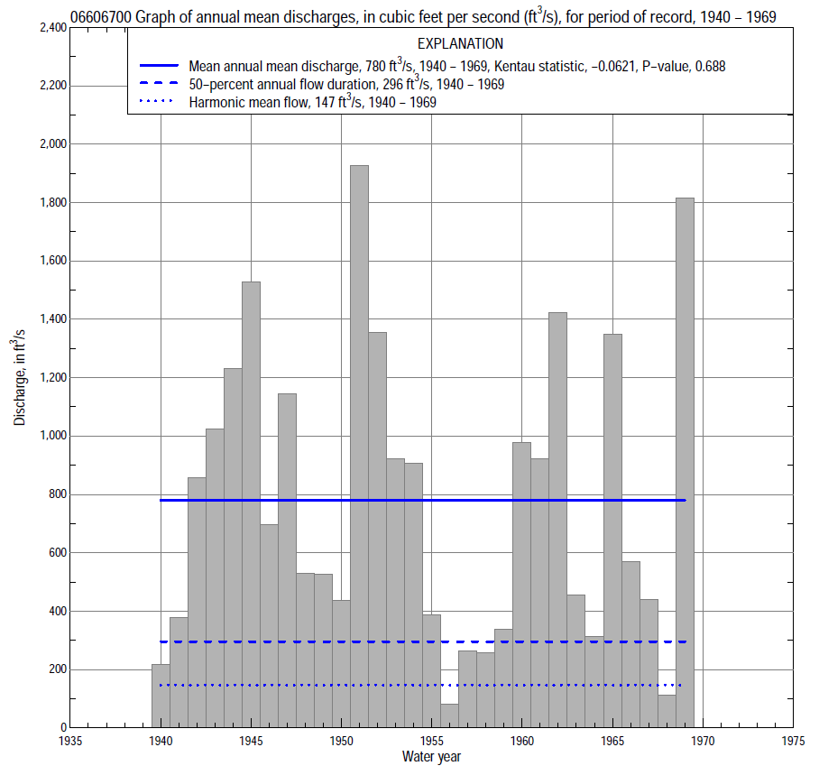

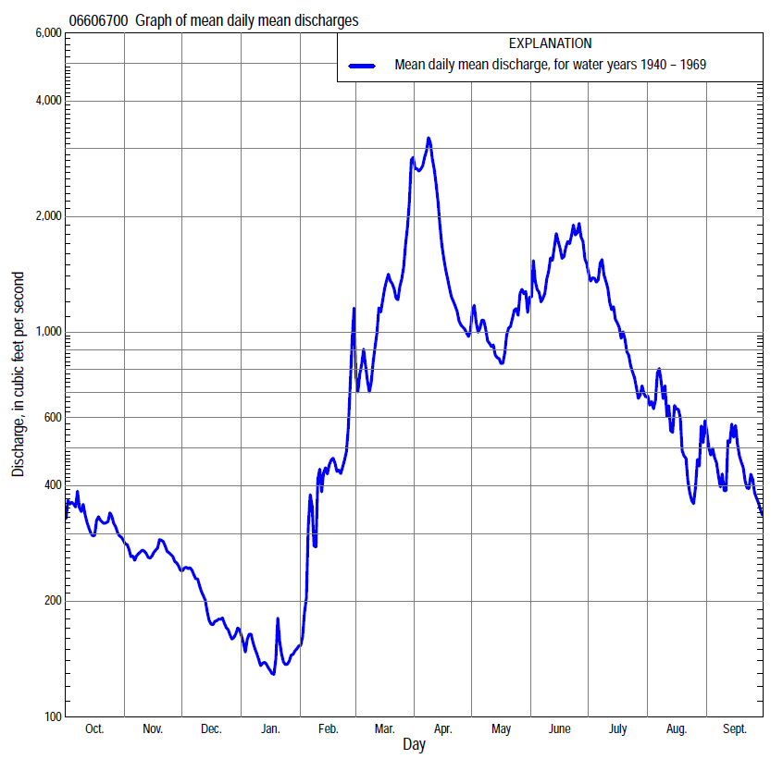

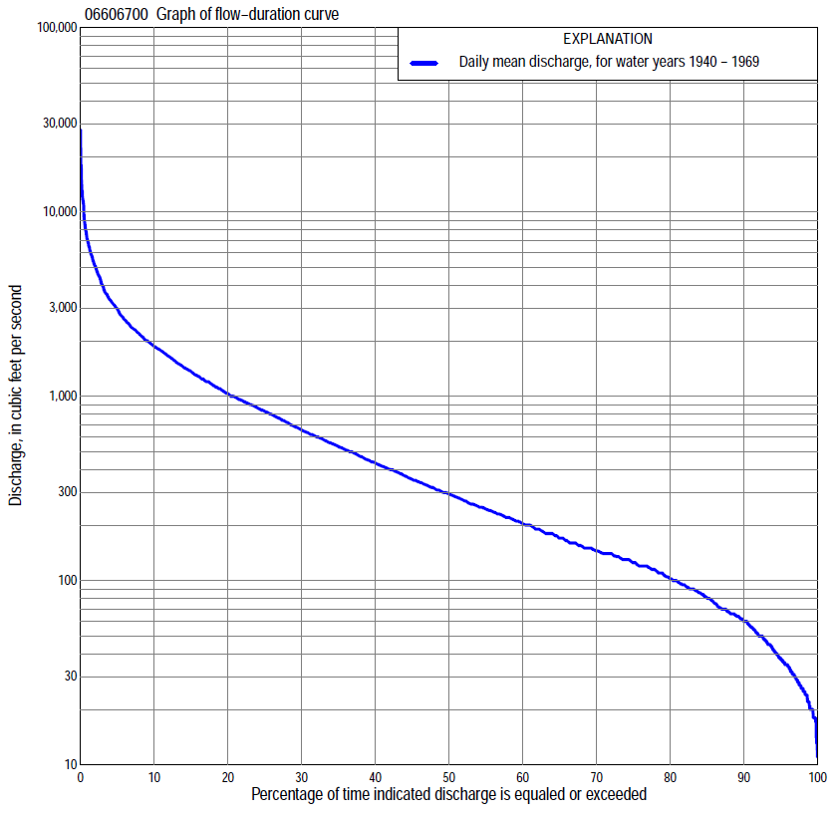

Statistics Based on the Entire Streamflow Period of Record
06606700 Monthly and annual flow durations, based on 1940–69 period of record (30 years)
Percentage of days discharge equaled or exceeded |  |  |  |  | Discharge (cubic feet per second) |  |  |  |  |  |  |  |  | Annual flow durations
 | Oct | Nov | Dec | Jan | Feb | Mar | Apr | May | June | July | Aug | Sept | Annual | Kentau statistic | P-value
99 | 13 | 34 | 22 | 18 | 18 | 50 | 99 | 64 | 43 | 43 | 37 | 23 | 20 | -0.113 | 0.392
98 | 17 | 36 | 24 | 20 | 18 | 60 | 108 | 77 | 58 | 56 | 40 | 25 | 25 | -0.108 | 0.412
95 | 23 | 45 | 35 | 22 | 26 | 75 | 136 | 115 | 163 | 86 | 48 | 30 | 37 | -0.110 | 0.402
90 | 48 | 64 | 45 | 27 | 29 | 110 | 209 | 193 | 226 | 126 | 65 | 45 | 60 | -0.115 | 0.381
85 | 62 | 80 | 55 | 35 | 37 | 125 | 287 | 233 | 260 | 153 | 96 | 71 | 80 | -0.117 | 0.372
80 | 68 | 89 | 65 | 44 | 50 | 175 | 345 | 293 | 312 | 183 | 116 | 84 | 102 | -0.149 | 0.254
75 | 89 | 95 | 71 | 52 | 65 | 210 | 430 | 363 | 396 | 228 | 135 | 102 | 125 | -0.149 | 0.253
70 | 106 | 102 | 82 | 64 | 78 | 270 | 513 | 416 | 509 | 267 | 150 | 118 | 145 | -0.131 | 0.318
65 | 119 | 120 | 100 | 90 | 90 | 390 | 588 | 472 | 618 | 305 | 179 | 130 | 170 | -0.120 | 0.363
60 | 142 | 145 | 120 | 105 | 100 | 500 | 650 | 553 | 722 | 350 | 202 | 146 | 203 | -0.113 | 0.392
55 | 150 | 165 | 140 | 120 | 125 | 587 | 738 | 638 | 832 | 428 | 236 | 167 | 245 | -0.108 | 0.412
50 | 184 | 216 | 150 | 129 | 140 | 700 | 820 | 729 | 960 | 530 | 273 | 201 | 296 | -0.113 | 0.392
45 | 238 | 234 | 167 | 135 | 160 | 900 | 916 | 820 | 1,100 | 640 | 332 | 234 | 355 | -0.122 | 0.354
40 | 261 | 263 | 180 | 140 | 190 | 1,020 | 1,060 | 910 | 1,270 | 796 | 396 | 293 | 436 | -0.140 | 0.284
35 | 307 | 295 | 200 | 150 | 210 | 1,230 | 1,270 | 1,050 | 1,420 | 961 | 455 | 348 | 538 | -0.147 | 0.261
30 | 365 | 333 | 230 | 160 | 290 | 1,460 | 1,510 | 1,200 | 1,680 | 1,150 | 545 | 402 | 664 | -0.159 | 0.225
25 | 439 | 378 | 260 | 170 | 400 | 1,760 | 1,850 | 1,340 | 2,000 | 1,420 | 707 | 509 | 840 | -0.168 | 0.199
20 | 547 | 439 | 300 | 180 | 600 | 2,000 | 2,240 | 1,550 | 2,370 | 1,870 | 872 | 678 | 1,040 | -0.172 | 0.187
15 | 621 | 496 | 350 | 208 | 900 | 2,260 | 2,950 | 1,760 | 3,030 | 2,580 | 1,110 | 890 | 1,380 | -0.136 | 0.301
10 | 768 | 562 | 440 | 290 | 1,260 | 2,570 | 4,580 | 2,130 | 3,600 | 3,100 | 1,360 | 1,200 | 1,880 | -0.103 | 0.432
5 | 1,110 | 705 | 530 | 400 | 1,990 | 3,650 | 7,960 | 3,090 | 5,510 | 3,900 | 1,890 | 1,700 | 3,000 | -0.002 | 1.000
2 | 1,480 | 900 | 635 | 550 | 2,800 | 6,850 | 13,000 | 5,090 | 7,840 | 4,950 | 3,280 | 2,390 | 5,090 | 0.076 | 0.568
1 | 1,750 | 990 | 840 | 760 | 3,600 | 8,220 | 17,300 | 6,020 | 10,800 | 5,900 | 4,430 | 3,870 | 6,950 | 0.129 | 0.326

06606700 Annual exceedance probability of instantaneous peak discharges, in cubic feet per second (ft³/s), based on the Weighted Independent Estimates method,
Annual exceed-ance probability | Recur-rence interval (years) | Discharge (ft³/s) | 95-percent lower confi-dence interval (ft³/s) | 95-percent upper confi-dence interval (ft³/s)
0.500 | 2 | 8,280 | 6,430 | 10,700
0.200 | 5 | 15,200 | 11,900 | 19,300
0.100 | 10 | 20,200 | 15,600 | 26,100
0.040 | 25 | 27,000 | 20,200 | 36,200
0.020 | 50 | 31,600 | 22,800 | 43,700
0.010 | 100 | 36,500 | 25,500 | 52,200
0.005 | 200 | 41,200 | 27,800 | 61,100
0.002 | 500 | 46,900 | 30,000 | 73,100
and based on the expected moments algorithm/multiple Grubbs-Beck analysis computed using a historical period length of 30 years (1940–1969)
0.500 | 2 | 7,610 | 5,660 | 9,910
0.200 | 5 | 13,400 | 10,300 | 18,200
0.100 | 10 | 17,600 | 13,500 | 25,600
0.040 | 25 | 23,000 | 17,100 | 37,400
0.020 | 50 | 27,100 | 19,600 | 48,200
0.010 | 100 | 31,200 | 21,700 | 60,900
0.005 | 200 | 35,300 | 23,600 | 75,900
0.002 | 500 | 40,600 | 25,700 | 100,000
Kentau statistic |  | 0.232
P-value |  | 0.074
Begin year |  | 1940
End year |  | 1969
Number of peaks |  | 30

06606700 Annual exceedance probability of high discharges, based on 1940–69 period of record (30 years)
Annual exceed-ance probability | Recur-rence interval (years) | Maximum average discharge (ft³/s) for indicated number of consecutive days
 |  | 1 | 3 | 7 | 15 | 30
0.990 | 1.01 | 428 | 382 | 329 | 227 | 158
0.950 | 1.05 | 1,150 | 957 | 774 | 552 | 406
0.900 | 1.11 | 1,840 | 1,490 | 1,180 | 858 | 641
0.800 | 1.25 | 3,060 | 2,460 | 1,930 | 1,420 | 1,070
0.500 | 2 | 6,870 | 5,640 | 4,480 | 3,360 | 2,510
0.200 | 5 | 12,700 | 11,200 | 9,330 | 7,100 | 5,090
0.100 | 10 | 16,300 | 15,100 | 13,200 | 10,000 | 6,950
0.040 | 25 | 20,200 | 20,000 | 18,400 | 14,000 | 9,320
0.020 | 50 | 22,700 | 23,500 | 22,500 | 17,100 | 11,000
0.010 | 100 | 24,800 | 26,800 | 26,700 | 20,300 | 12,700
0.005 | 200 | 26,700 | 31,100 | 31,000 | 23,500 | 14,200
0.002 | 500 | 28,700 | 37,000 | 36,700 | 27,700 | 16,200
Kentau statistic |  | 0.191 | 0.159 | 0.131 | 0.117 | 0.062
P-value |  | 0.143 | 0.225 | 0.318 | 0.372 | 0.643

 | 06606700 Annual nonexceedance probability of low discharges, based on April 1940 to March 1969 period of record (29 years)
Annual nonexceed-ance probability | Recur-rence interval (years) | Minimum average discharge (cubic feet per second) for indicated number of consecutive days
 |  | 1 | 3 | 7 | 14 | 30 | 60 | 90 | 120 | 183
0.01 | 100 | 9.6 | 10 | 11 | 11 | 12 | 15 | 16 | 18 | 18
0.02 | 50 | 12 | 12 | 13 | 14 | 15 | 19 | 21 | 24 | 24
0.05 | 20 | 17 | 17 | 18 | 19 | 21 | 26 | 31 | 35 | 38
0.10 | 10 | 22 | 23 | 24 | 25 | 29 | 36 | 43 | 49 | 56
0.20 | 5 | 32 | 32 | 33 | 35 | 41 | 51 | 64 | 72 | 89
0.50 | 2 | 60 | 61 | 63 | 67 | 79 | 99 | 126 | 145 | 197
0.80 | 1.25 | 112 | 116 | 118 | 123 | 145 | 182 | 234 | 274 | 397
0.90 | 1.11 | 154 | 161 | 163 | 168 | 196 | 247 | 315 | 374 | 554
0.96 | 1.04 | 216 | 227 | 229 | 234 | 268 | 336 | 423 | 512 | 768
0.98 | 1.02 | 267 | 283 | 285 | 288 | 326 | 408 | 508 | 622 | 937
0.99 | 1.01 | 322 | 345 | 346 | 347 | 387 | 483 | 593 | 736 | 1,110
Kentau statistic |  | -0.140 | -0.145 | -0.143 | -0.150 | -0.108 | -0.123 | -0.197 | -0.227 | -0.192
P-value |  | 0.293 | 0.276 | 0.285 | 0.260 | 0.420 | 0.358 | 0.138 | 0.088 | 0.149

06606700 Annual nonexceedance probability of seasonal low discharges, based on July 1939 to September 1969 (30–31 years)
Annual nonexceed-ance probability | Recur-rence interval (years) | Minimum average discharge (cubic feet per second) for indicated number of consecutive days
 |  | 1 | 7 | 14 | 30 |  | 1 | 7 | 14 | 30
 |  | January-February-March |  |  |  |  | April-May-June
0.01 | 100 | 11 | 11 | 11 | 12 |  | 25 | 29 | 33 | 48
0.02 | 50 | 14 | 14 | 14 | 15 |  | 35 | 41 | 46 | 65
0.05 | 20 | 20 | 20 | 20 | 22 |  | 57 | 67 | 75 | 102
0.10 | 10 | 27 | 27 | 28 | 30 |  | 86 | 100 | 112 | 150
0.20 | 5 | 38 | 39 | 40 | 44 |  | 138 | 160 | 179 | 234
0.50 | 2 | 73 | 76 | 79 | 90 |  | 315 | 360 | 403 | 513
0.80 | 1.25 | 137 | 141 | 148 | 182 |  | 646 | 725 | 817 | 1,040
0.90 | 1.11 | 186 | 192 | 201 | 260 |  | 904 | 1,000 | 1,140 | 1,470
0.96 | 1.04 | 257 | 262 | 274 | 378 |  | 1,260 | 1,380 | 1,570 | 2,070
0.98 | 1.02 | 314 | 319 | 333 | 480 |  | 1,530 | 1,670 | 1,910 | 2,560
0.99 | 1.01 | 375 | 378 | 394 | 593 |  | 1,820 | 1,960 | 2,250 | 3,070
Kentau statistic |  | -0.113 | -0.136 | -0.143 | -0.103 |  | -0.071 | -0.028 | -0.039 | -0.034
P-value |  | 0.391 | 0.301 | 0.276 | 0.432 |  | 0.592 | 0.844 | 0.775 | 0.803
 |  | July-August-September |  |  |  |  | October-November-December
0.01 | 100 | 11 | 13 | 15 | 21 |  | 9.6 | 10 | 11 | 13
0.02 | 50 | 14 | 17 | 19 | 25 |  | 13 | 14 | 15 | 18
0.05 | 20 | 21 | 24 | 27 | 36 |  | 21 | 22 | 24 | 28
0.10 | 10 | 30 | 34 | 38 | 49 |  | 30 | 32 | 34 | 40
0.20 | 5 | 47 | 52 | 58 | 73 |  | 46 | 49 | 52 | 62
0.50 | 2 | 112 | 121 | 132 | 170 |  | 93 | 103 | 111 | 133
0.80 | 1.25 | 268 | 291 | 322 | 432 |  | 166 | 199 | 216 | 264
0.90 | 1.11 | 425 | 466 | 526 | 730 |  | 214 | 271 | 296 | 367
0.96 | 1.04 | 699 | 780 | 903 | 1,310 |  | 272 | 368 | 404 | 508
0.98 | 1.02 | 966 | 1,100 | 1,290 | 1,950 |  | 312 | 442 | 488 | 621
0.99 | 1.01 | 1,290 | 1,490 | 1,800 | 2,820 |  | 350 | 516 | 573 | 737
Kentau statistic |  | -0.077 | -0.092 | -0.092 | -0.088 |  | 0.009 | -0.011 | -0.007 | -0.030
P-value |  | 0.552 | 0.475 | 0.475 | 0.497 |  | 0.957 | 0.943 | 0.972 | 0.830

