LOCATION.--Lat 42°09'25", long 95°48'35" referenced to North American Datum of 1927, in NW 1/4 SE 1/4 SE 1/4 sec.23, T.85 N., R.43 W., Monona County, IA, Hydrologic Unit 10230005, on right bank on downstream side of bridge on State Highway 175, 1.1 mi southwest of intersection of State Highways 175 and 141 in Mapleton, 1.0 mi downstream from Simmons Creek, 2.1 mi upstream from McCleery Creek, and 16.0 mi upstream from mouth.

DRAINAGE AREA.--669 mi².

PERIOD OF RECORD.--Discharge records from October 1941 to current year.

GAGE.--Water-stage recorder. Datum of gage is 1,080.86 ft above National Geodetic Vertical Datum of 1929. Prior to August 20, 1952, non-recording gage at same site at datum 5.0 ft higher, with supplementary water-stage recorder in operation above 9.5 ft from June 8, 1949, to August 19, 1952; August 20, 1952, to June 20, 1954, water-stage recorder at same site at datum 5.0 ft higher; June 21,1954, to September 6, 1955, non-recording gage at site 1.4 mi upstream at datum 9.05 ft higher; September 7, 1955, to September 20, 1956, non-recording gage, and September 21, 1956, to May 16, 2000, water-stage recorder, both at same site at datum 5.0 ft higher.

A summary of all available data for this streamgage is provided through the USGS National Water Information System web interface (NWISWeb). The following link provides access to current/historical observations, daily data, daily statistics, monthly statistics, annual statistics, peak streamflow, field measurements, field/lab water-quality samples, and the latest water-year summaries. Data can be filtered by parameter and/or dates, and can be output in various tabular and graphical formats.
http://waterdata.usgs.gov/nwis/inventory/?site_no=06607200

The USGS WaterWatch Toolkit is available at:
http://waterwatch.usgs.gov/?id=ww_toolkit
Tools for summarizing streamflow information include the duration hydrograph builder, the cumulative streamflow hydrograph builder, the streamgage statistics retrieval tool, the rating curve builder, the flood tracking chart builder, the National Weather Service Advanced Hydrologic Prediction Service (AHPS) river forecast hydrograph builder, and the raster-hydrograph builder. Entering the above number for this streamgage into these toolkit webpages will provide streamflow information specific to this streamgage.

A description of the statistics presented for this streamgage is available in the main body of the report at:
http://dx.doi.org/10.3133/ofr20151214
A link to other streamgages included in this report, a map showing the location of the streamgages, information on the programs used to compute the statistical analyses, and references are included in the main body of the report.

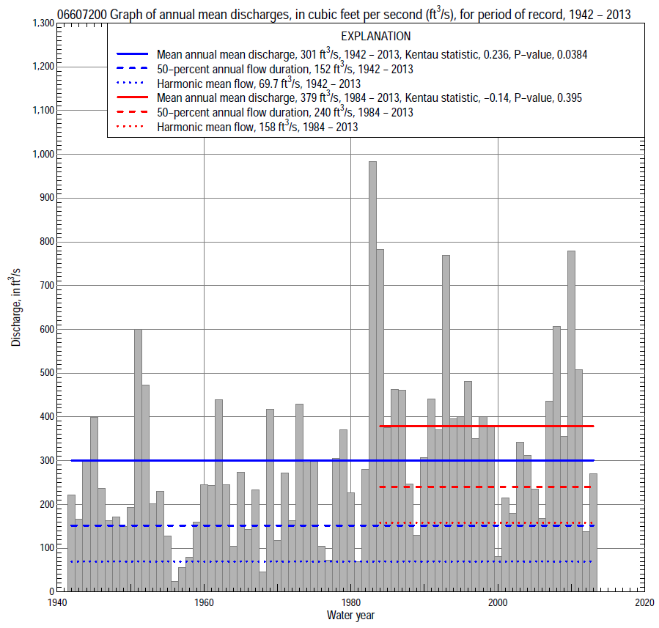

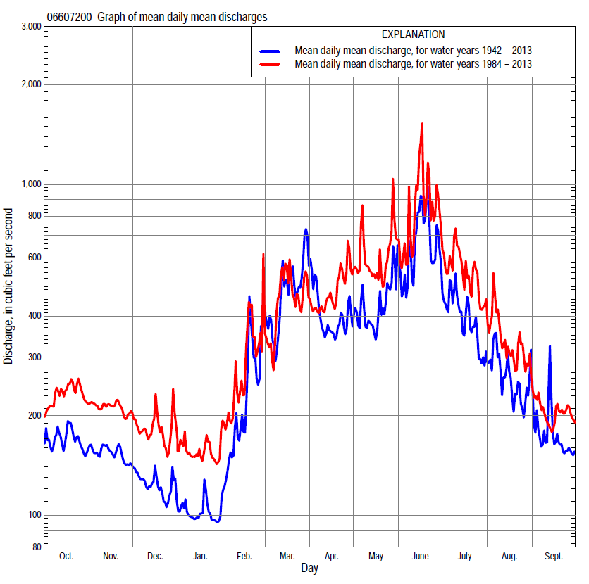

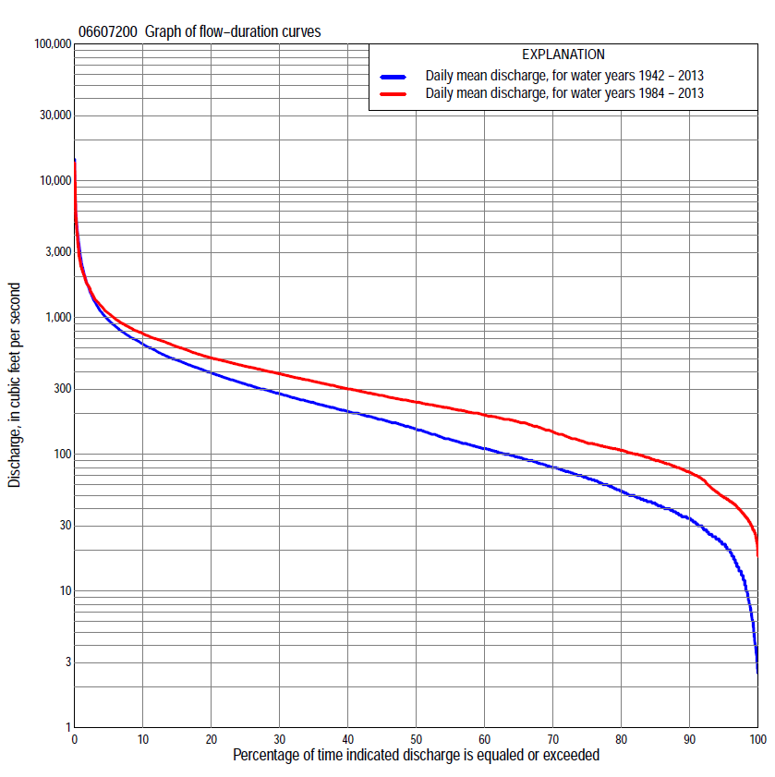

Statistics Based on the Entire Streamflow Period of Record
06607200 Monthly and annual flow durations, based on 1942–2013 period of record (72 years)
Percentage of days discharge equaled or exceeded |  |  |  |  | Discharge (cubic feet per second) |  |  |  |  |  |  |  |  | Annual flow durations
 | Oct | Nov | Dec | Jan | Feb | Mar | Apr | May | June | July | Aug | Sept | Annual | Kentau statistic | P-value
99 | 10 | 13 | 6.2 | 3.4 | 2.8 | 20 | 22 | 15 | 12 | 16 | 11 | 5.4 | 7.0 | 0.348 | 0.000
98 | 14 | 15 | 7.0 | 4.0 | 5.5 | 22 | 27 | 26 | 23 | 36 | 20 | 17 | 12 | 0.352 | 0.000
95 | 24 | 24 | 16 | 8.0 | 10 | 37 | 45 | 39 | 47 | 45 | 30 | 23 | 22 | 0.342 | 0.000
90 | 33 | 36 | 23 | 15 | 19 | 55 | 66 | 59 | 81 | 60 | 40 | 29 | 34 | 0.341 | 0.000
85 | 40 | 42 | 28 | 19 | 26 | 72 | 80 | 80 | 113 | 76 | 50 | 38 | 43 | 0.349 | 0.000
80 | 44 | 47 | 34 | 25 | 35 | 88 | 101 | 100 | 139 | 94 | 61 | 47 | 54 | 0.337 | 0.000
75 | 53 | 53 | 40 | 30 | 41 | 108 | 118 | 126 | 173 | 113 | 77 | 58 | 67 | 0.348 | 0.000
70 | 64 | 64 | 49 | 35 | 52 | 127 | 141 | 159 | 206 | 135 | 92 | 67 | 80 | 0.345 | 0.000
65 | 75 | 75 | 57 | 41 | 65 | 151 | 171 | 181 | 235 | 158 | 104 | 79 | 95 | 0.335 | 0.000
60 | 84 | 84 | 67 | 45 | 79 | 170 | 199 | 208 | 273 | 184 | 120 | 91 | 110 | 0.333 | 0.000
55 | 94 | 94 | 76 | 52 | 90 | 198 | 223 | 238 | 319 | 214 | 136 | 104 | 128 | 0.330 | 0.000
50 | 103 | 104 | 86 | 63 | 105 | 222 | 250 | 275 | 367 | 251 | 155 | 114 | 152 | 0.299 | 0.000
45 | 116 | 114 | 96 | 72 | 136 | 251 | 278 | 322 | 418 | 294 | 175 | 125 | 180 | 0.290 | 0.000
40 | 128 | 129 | 107 | 85 | 160 | 287 | 319 | 376 | 466 | 340 | 199 | 144 | 206 | 0.283 | 0.000
35 | 157 | 150 | 120 | 100 | 181 | 325 | 365 | 431 | 521 | 384 | 224 | 170 | 239 | 0.281 | 0.000
30 | 184 | 178 | 135 | 121 | 210 | 369 | 426 | 485 | 603 | 436 | 253 | 189 | 277 | 0.280 | 0.001
25 | 220 | 217 | 160 | 160 | 240 | 442 | 505 | 550 | 689 | 496 | 291 | 206 | 326 | 0.279 | 0.001
20 | 256 | 253 | 200 | 180 | 280 | 533 | 599 | 644 | 808 | 580 | 343 | 237 | 394 | 0.260 | 0.001
15 | 300 | 302 | 240 | 210 | 357 | 700 | 687 | 764 | 991 | 680 | 415 | 290 | 489 | 0.261 | 0.001
10 | 391 | 370 | 300 | 250 | 500 | 1,010 | 812 | 926 | 1,290 | 819 | 525 | 347 | 639 | 0.225 | 0.005
5 | 510 | 445 | 353 | 300 | 850 | 1,810 | 1,100 | 1,250 | 2,120 | 1,140 | 783 | 508 | 955 | 0.153 | 0.058
2 | 700 | 508 | 431 | 350 | 1,470 | 3,570 | 1,980 | 1,740 | 4,220 | 2,020 | 1,340 | 735 | 1,690 | 0.005 | 0.953
1 | 928 | 562 | 490 | 400 | 2,130 | 4,790 | 2,750 | 2,360 | 5,710 | 2,690 | 2,100 | 1,000 | 2,500 | -0.053 | 0.515

06607200 Annual exceedance probability of instantaneous peak discharges, in cubic feet per second (ft³/s), based on the Weighted Independent Estimates method,
Annual exceed-ance probability | Recur-rence interval (years) | Discharge (ft³/s) | 95-percent lower confi-dence interval (ft³/s) | 95-percent upper confi-dence interval (ft³/s)
0.500 | 2 | 6,720 | 5,700 | 7,930
0.200 | 5 | 11,500 | 9,900 | 13,500
0.100 | 10 | 15,100 | 12,800 | 17,700
0.040 | 25 | 20,000 | 16,600 | 24,100
0.020 | 50 | 23,500 | 19,000 | 29,100
0.010 | 100 | 26,900 | 21,000 | 34,400
0.005 | 200 | 31,400 | 23,700 | 41,600
0.002 | 500 | 34,800 | 25,100 | 48,400
and based on the expected moments algorithm/multiple Grubbs-Beck analysis computed using a historical period length of 72 years (1942–2013)
0.500 | 2 | 6,680 | 4,470 | 7,760
0.200 | 5 | 11,500 | 9,780 | 13,900
0.100 | 10 | 14,700 | 12,400 | 19,100
0.040 | 25 | 18,800 | 15,400 | 27,100
0.020 | 50 | 21,800 | 17,400 | 33,800
0.010 | 100 | 24,800 | 19,100 | 41,000
0.005 | 200 | 27,600 | 20,700 | 48,400
0.002 | 500 | 31,300 | 22,600 | 58,900
Kentau statistic |  | -0.106
P-value |  | 0.188
Begin year |  | 1942
End year |  | 2013
Number of peaks |  | 72

06607200 Annual exceedance probability of high discharges, based on 1942–2013 period of record (72 years)
Annual exceedance probability | Recur-rence interval (years) | Maximum average discharge (ft³/s) for indicated number of consecutive days
 |  | 1 | 3 | 7 | 15 | 30
0.990 | 1.01 | 342 | 226 | 153 | 99 | 74
0.950 | 1.05 | 774 | 533 | 354 | 239 | 180
0.900 | 1.11 | 1,160 | 809 | 535 | 365 | 275
0.800 | 1.25 | 1,830 | 1,300 | 850 | 583 | 438
0.500 | 2 | 4,000 | 2,870 | 1,870 | 1,260 | 919
0.200 | 5 | 7,840 | 5,570 | 3,610 | 2,350 | 1,620
0.100 | 10 | 10,700 | 7,510 | 4,870 | 3,070 | 2,050
0.040 | 25 | 14,400 | 9,980 | 6,470 | 3,920 | 2,520
0.020 | 50 | 17,200 | 11,800 | 7,640 | 4,500 | 2,810
0.010 | 100 | 20,000 | 13,500 | 8,760 | 5,030 | 3,070
0.005 | 200 | 22,700 | 15,200 | 9,850 | 5,510 | 3,290
0.002 | 500 | 26,200 | 17,200 | 11,200 | 6,090 | 3,540
Kentau statistic |  | -0.050 | -0.042 | -0.004 | 0.054 | 0.076
P-value |  | 0.534 | 0.603 | 0.961 | 0.505 | 0.348

 | 06607200 Annual nonexceedance probability of low discharges, based on April 1942 to March 2013 period of record (71 years)
Annual nonexceed-ance probability | Recur-rence interval (years) | Minimum average discharge (ft³/s) for indicated number of consecutive days
 |  | 1 | 3 | 7 | 14 | 30 | 60 | 90 | 120 | 183
0.01 | 100 | 0.00 | 2.3 | 2.3 | 2.4 | 2.8 | 3.9 | 5.3 | 7.5 | 10
0.02 | 50 | 1.7 | 3.4 | 3.4 | 3.6 | 4.1 | 5.6 | 7.6 | 10 | 13
0.05 | 20 | 4.4 | 5.8 | 6.1 | 6.4 | 7.3 | 10 | 13 | 16 | 20
0.10 | 10 | 7.6 | 9.2 | 10 | 10 | 12 | 15 | 19 | 24 | 30
0.20 | 5 | 13 | 16 | 17 | 18 | 21 | 26 | 32 | 37 | 47
0.50 | 2 | 34 | 39 | 43 | 47 | 54 | 64 | 76 | 84 | 103
0.80 | 1.25 | 79 | 88 | 99 | 108 | 122 | 143 | 162 | 178 | 213
0.90 | 1.11 | 116 | 129 | 145 | 160 | 179 | 210 | 232 | 257 | 302
0.96 | 1.04 | 171 | 188 | 211 | 235 | 259 | 304 | 330 | 372 | 429
0.98 | 1.02 | 216 | 236 | 264 | 296 | 324 | 381 | 409 | 468 | 533
0.99 | 1.01 | 265 | 286 | 320 | 360 | 391 | 462 | 490 | 571 | 642
Kentau statistic |  | 0.370 | 0.360 | 0.373 | 0.387 | 0.374 | 0.343 | 0.333 | 0.325 | 0.287
P-value |  | 0.000 | 0.000 | 0.000 | 0.000 | 0.000 | 0.000 | 0.000 | 0.000 | 0.000

06607200 Annual nonexceedance probability of seasonal low discharges, based on October 1941 to September 2013 (72 years)
Annual nonexceed-ance probability | Recur-rence interval (years) | Minimum average discharge (cubic feet per second) for indicated number of consecutive days
 |  | 1 | 7 | 14 | 30 |  | 1 | 7 | 14 | 30
 |  | January-February-March |  |  |  |  | April-May-June
0.01 | 100 | 2.3 | 2.4 | 2.4 | 2.7 |  | 6.3 | 8.3 | 9.8 | 17
0.02 | 50 | 3.4 | 3.6 | 3.7 | 4.1 |  | 9.8 | 12 | 15 | 23
0.05 | 20 | 5.9 | 6.5 | 6.7 | 7.6 |  | 18 | 22 | 25 | 37
0.10 | 10 | 9.4 | 11 | 11 | 13 |  | 30 | 35 | 41 | 55
0.20 | 5 | 16 | 19 | 20 | 23 |  | 53 | 60 | 68 | 87
0.50 | 2 | 42 | 50 | 53 | 62 |  | 133 | 147 | 166 | 197
0.80 | 1.25 | 98 | 116 | 126 | 146 |  | 277 | 310 | 349 | 417
0.90 | 1.11 | 147 | 171 | 188 | 217 |  | 381 | 433 | 488 | 599
0.96 | 1.04 | 219 | 251 | 279 | 319 |  | 509 | 594 | 671 | 864
0.98 | 1.02 | 280 | 315 | 352 | 400 |  | 599 | 715 | 808 | 1,080
0.99 | 1.01 | 345 | 382 | 430 | 485 |  | 683 | 832 | 942 | 1,320
Kentau statistic |  | 0.326 | 0.351 | 0.357 | 0.327 |  | 0.318 | 0.307 | 0.311 | 0.302
P-value |  | 0.000 | 0.000 | 0.000 | 0.000 |  | 0.000 | 0.000 | 0.000 | 0.000
 |  | July-August-September |  |  |  |  | October-November-December
0.01 | 100 | 0.00 | 7.5 | 8.1 | 9.3 |  | 4.1 | 4.8 | 5.3 | 6.9
0.02 | 50 | 4.6 | 10 | 11 | 13 |  | 5.6 | 6.6 | 7.4 | 9.5
0.05 | 20 | 11 | 16 | 18 | 21 |  | 8.8 | 11 | 12 | 15
0.10 | 10 | 19 | 24 | 26 | 31 |  | 13 | 16 | 18 | 23
0.20 | 5 | 32 | 37 | 40 | 48 |  | 21 | 26 | 29 | 36
0.50 | 2 | 75 | 82 | 89 | 106 |  | 47 | 60 | 67 | 82
0.80 | 1.25 | 155 | 166 | 178 | 213 |  | 100 | 127 | 143 | 169
0.90 | 1.11 | 217 | 233 | 248 | 296 |  | 145 | 183 | 205 | 239
0.96 | 1.04 | 302 | 327 | 345 | 409 |  | 211 | 264 | 294 | 338
0.98 | 1.02 | 368 | 401 | 421 | 497 |  | 267 | 331 | 368 | 417
0.99 | 1.01 | 435 | 479 | 500 | 587 |  | 328 | 402 | 445 | 500
Kentau statistic |  | 0.323 | 0.276 | 0.265 | 0.235 |  | 0.307 | 0.329 | 0.340 | 0.328
P-value |  | 0.000 | 0.001 | 0.001 | 0.004 |  | 0.000 | 0.000 | 0.000 | 0.000

Statistics Based on the 1984–2013 Streamflow Period of Record
06607200 Monthly and annual flow durations, based on 1984–2013 period of record (30 years)
Percentage of days discharge equaled or exceeded |  |  |  |  | Discharge (cubic feet per second) |  |  |  |  |  |  |  |  | Annual flow durations
 | Oct | Nov | Dec | Jan | Feb | Mar | Apr | May | June | July | Aug | Sept | Annual | Kentau statistic | P-value
99 | 29 | 35 | 23 | 27 | 29 | 49 | 69 | 56 | 61 | 47 | 35 | 24 | 30 | -0.138 | 0.292
98 | 32 | 38 | 26 | 30 | 33 | 53 | 74 | 65 | 73 | 56 | 39 | 27 | 36 | -0.149 | 0.253
95 | 43 | 47 | 32 | 37 | 43 | 83 | 104 | 97 | 105 | 74 | 44 | 38 | 49 | -0.161 | 0.218
90 | 65 | 64 | 48 | 45 | 55 | 107 | 121 | 172 | 192 | 117 | 67 | 61 | 74 | -0.152 | 0.246
85 | 77 | 75 | 67 | 53 | 79 | 131 | 166 | 217 | 231 | 151 | 99 | 81 | 90 | -0.154 | 0.239
80 | 89 | 86 | 81 | 68 | 85 | 153 | 200 | 246 | 281 | 193 | 120 | 91 | 107 | -0.175 | 0.181
75 | 100 | 101 | 90 | 80 | 97 | 164 | 222 | 278 | 332 | 241 | 145 | 101 | 121 | -0.159 | 0.225
70 | 106 | 111 | 100 | 90 | 110 | 184 | 246 | 316 | 383 | 292 | 169 | 112 | 146 | -0.145 | 0.269
65 | 118 | 120 | 108 | 98 | 135 | 200 | 267 | 360 | 419 | 330 | 186 | 119 | 172 | -0.143 | 0.276
60 | 127 | 130 | 117 | 108 | 159 | 222 | 294 | 404 | 450 | 359 | 203 | 133 | 193 | -0.145 | 0.269
55 | 157 | 143 | 125 | 120 | 172 | 250 | 330 | 436 | 490 | 392 | 224 | 150 | 217 | -0.161 | 0.218
50 | 178 | 178 | 139 | 139 | 185 | 275 | 363 | 470 | 541 | 426 | 245 | 171 | 240 | -0.163 | 0.212
45 | 203 | 201 | 158 | 160 | 201 | 311 | 399 | 513 | 603 | 458 | 267 | 187 | 270 | -0.179 | 0.169
40 | 221 | 232 | 186 | 170 | 220 | 344 | 449 | 556 | 665 | 496 | 291 | 198 | 300 | -0.182 | 0.164
35 | 243 | 254 | 200 | 186 | 240 | 369 | 511 | 624 | 716 | 550 | 321 | 210 | 341 | -0.166 | 0.205
30 | 270 | 278 | 221 | 200 | 260 | 404 | 582 | 683 | 805 | 596 | 358 | 222 | 388 | -0.163 | 0.212
25 | 303 | 302 | 247 | 218 | 289 | 459 | 640 | 747 | 913 | 658 | 398 | 247 | 440 | -0.166 | 0.205
20 | 354 | 335 | 278 | 240 | 330 | 521 | 700 | 815 | 1,040 | 718 | 454 | 290 | 506 | -0.177 | 0.175
15 | 405 | 388 | 309 | 270 | 400 | 631 | 780 | 924 | 1,210 | 820 | 534 | 331 | 611 | -0.113 | 0.392
10 | 465 | 418 | 353 | 290 | 583 | 833 | 909 | 1,100 | 1,520 | 943 | 644 | 422 | 763 | -0.076 | 0.568
5 | 574 | 470 | 400 | 320 | 948 | 1,500 | 1,140 | 1,430 | 2,350 | 1,330 | 919 | 516 | 1,070 | -0.034 | 0.803
2 | 784 | 511 | 483 | 370 | 1,410 | 2,330 | 1,710 | 1,890 | 4,500 | 2,220 | 1,360 | 623 | 1,710 | -0.048 | 0.721
1 | 1000 | 555 | 600 | 430 | 1,890 | 3,530 | 2,050 | 2,410 | 7,050 | 2,950 | 1,870 | 777 | 2,330 | -0.037 | 0.789

06607200 Annual exceedance probability of high discharges, based on 1984–2013 period of record (30 years)
Annual exceedance probability | Recur-rence interval (years) | Maximum average discharge (ft³/s) for indicated number of consecutive days
 |  | 1 | 3 | 7 | 15 | 30
0.990 | 1.01 | 308 | 275 | 228 | 173 | 129
0.950 | 1.05 | 702 | 584 | 457 | 344 | 267
0.900 | 1.11 | 1,060 | 850 | 645 | 481 | 378
0.800 | 1.25 | 1,690 | 1,300 | 958 | 705 | 556
0.500 | 2 | 3,790 | 2,740 | 1,900 | 1,350 | 1,040
0.200 | 5 | 7,670 | 5,250 | 3,470 | 2,360 | 1,720
0.100 | 10 | 10,700 | 7,120 | 4,590 | 3,040 | 2,130
0.040 | 25 | 14,700 | 9,590 | 6,050 | 3,880 | 2,580
0.020 | 50 | 17,800 | 11,500 | 7,130 | 4,480 | 2,870
0.010 | 100 | 21,000 | 13,400 | 8,210 | 5,060 | 3,130
0.005 | 200 | 24,200 | 15,200 | 9,270 | 5,610 | 3,360
0.002 | 500 | 28,400 | 17,700 | 10,600 | 6,300 | 3,620
Kentau statistic |  | -0.018 | 0.034 | -0.002 | 0.002 | 0.002
P-value |  | 0.901 | 0.803 | 1.000 | 1.000 | 1.000

 | 06607200 Annual nonexceedance probability of low discharges, based on April 1983 to March 2013 period of record (30 years)
Annual nonexceed-ance probability | Recur-rence interval (years) | Minimum average discharge (ft³/s) for indicated number of consecutive days
 |  | 1 | 3 | 7 | 14 | 30 | 60 | 90 | 120 | 183
0.01 | 100 | 11 | 12 | 15 | 15 | 17 | 20 | 23 | 24 | 26
0.02 | 50 | 14 | 16 | 19 | 20 | 22 | 26 | 29 | 31 | 33
0.05 | 20 | 20 | 23 | 27 | 29 | 32 | 37 | 41 | 44 | 48
0.10 | 10 | 27 | 31 | 37 | 40 | 44 | 50 | 55 | 59 | 66
0.20 | 5 | 37 | 44 | 51 | 57 | 62 | 70 | 78 | 84 | 95
0.50 | 2 | 67 | 79 | 90 | 102 | 112 | 126 | 139 | 151 | 175
0.80 | 1.25 | 115 | 130 | 146 | 165 | 184 | 209 | 231 | 253 | 296
0.90 | 1.11 | 148 | 164 | 183 | 204 | 230 | 264 | 292 | 321 | 376
0.96 | 1.04 | 190 | 205 | 226 | 249 | 285 | 332 | 368 | 406 | 476
0.98 | 1.02 | 223 | 233 | 256 | 279 | 323 | 380 | 422 | 467 | 546
0.99 | 1.01 | 254 | 260 | 283 | 307 | 358 | 426 | 474 | 526 | 614
Kentau statistic |  | -0.103 | -0.113 | -0.131 | -0.122 | -0.154 | -0.149 | -0.168 | -0.177 | -0.191
P-value |  | 0.432 | 0.392 | 0.318 | 0.354 | 0.239 | 0.254 | 0.199 | 0.175 | 0.143

06607200 Annual nonexceedance probability of seasonal low discharges, based on October 1983 to September 2013 (30 years)
Annual nonexceed-ance probability | Recur-rence interval (years) | Minimum average discharge (cubic feet per second) for indicated number of consecutive days
 |  | 1 | 7 | 14 | 30 |  | 1 | 7 | 14 | 30
 |  | January-February-March |  |  |  |  | April-May-June
0.01 | 100 | 14 | 18 | 20 | 22 |  | 41 | 45 | 47 | 53
0.02 | 50 | 17 | 23 | 25 | 27 |  | 51 | 56 | 60 | 68
0.05 | 20 | 24 | 32 | 35 | 39 |  | 71 | 77 | 84 | 98
0.10 | 10 | 32 | 42 | 46 | 51 |  | 93 | 101 | 113 | 133
0.20 | 5 | 45 | 57 | 64 | 71 |  | 128 | 138 | 157 | 189
0.50 | 2 | 80 | 99 | 112 | 126 |  | 224 | 244 | 281 | 345
0.80 | 1.25 | 134 | 161 | 181 | 207 |  | 367 | 410 | 467 | 583
0.90 | 1.11 | 173 | 202 | 227 | 260 |  | 463 | 528 | 593 | 744
0.96 | 1.04 | 223 | 252 | 284 | 326 |  | 583 | 683 | 750 | 943
0.98 | 1.02 | 260 | 289 | 324 | 372 |  | 670 | 801 | 865 | 1,090
0.99 | 1.01 | 297 | 324 | 362 | 417 |  | 755 | 920 | 976 | 1,230
Kentau statistic |  | -0.179 | -0.149 | -0.163 | -0.166 |  | -0.168 | -0.145 | -0.103 | -0.108
P-value |  | 0.169 | 0.254 | 0.212 | 0.205 |  | 0.199 | 0.269 | 0.432 | 0.412
 |  | July-August-September |  |  |  |  | October-November-December
0.01 | 100 | 20 | 21 | 21 | 23 |  | 11 | 15 | 17 | 22
0.02 | 50 | 25 | 27 | 27 | 30 |  | 14 | 19 | 22 | 28
0.05 | 20 | 36 | 38 | 39 | 43 |  | 21 | 28 | 32 | 39
0.10 | 10 | 48 | 51 | 53 | 58 |  | 28 | 38 | 44 | 53
0.20 | 5 | 68 | 72 | 76 | 84 |  | 41 | 55 | 63 | 74
0.50 | 2 | 125 | 133 | 141 | 160 |  | 79 | 105 | 118 | 137
0.80 | 1.25 | 219 | 232 | 246 | 287 |  | 142 | 184 | 208 | 238
0.90 | 1.11 | 287 | 304 | 321 | 380 |  | 190 | 239 | 272 | 310
0.96 | 1.04 | 377 | 399 | 418 | 504 |  | 254 | 309 | 354 | 405
0.98 | 1.02 | 446 | 472 | 491 | 599 |  | 304 | 361 | 416 | 478
0.99 | 1.01 | 515 | 545 | 564 | 696 |  | 355 | 411 | 477 | 550
Kentau statistic |  | -0.186 | -0.182 | -0.200 | -0.186 |  | -0.046 | -0.117 | -0.161 | -0.122
P-value |  | 0.154 | 0.164 | 0.125 | 0.154 |  | 0.735 | 0.372 | 0.218 | 0.354

