LOCATION.--Lat 41°57'52", long 95°58'21" referenced to North American Datum of 1927, in NE 1/4 NE 1/4 NW 1/4 sec.33, T.83 N., R.44 W., Monona County, IA, Hydrologic Unit 10230003, on left bank on downstream side of bridge on County Highway E54, 3.8 mi south of Turin, 1.0 mi east of gaging station Monona-Harrison Ditch near Turin (station 06602400), 2.5 mi downstream from Maple River, and 13.4 mi upstream from mouth.

DRAINAGE AREA.--3,526 mi².

PERIOD OF RECORD.--Discharge records from May 1942 to September 1957, January 1958 to current year. June 1942 to January 1958, at site 1,200 ft east on old river channel. Records are not equivalent owing to diversion into Monona-Harrison Ditch through equalizer ditch 1.5 mi upstream from 1923 to 1958, and diversion with Monona-Harrison Ditch through diversion ditch 8.3 miles upstream since 1958.

GAGE.--Water-stage recorder. Datum of gage is 1,019.85 ft above National Geodetic Vertical Datum of 1929 (U.S. Army Corps of Engineers benchmark). Prior to July 15, 1958, non-recording gages near current site at different datums; July 15 to September 3, 1958, non-recording gage at same site and datum.

A summary of all available data for this streamgage is provided through the USGS National Water Information System web interface (NWISWeb). The following link provides access to current/historical observations, daily data, daily statistics, monthly statistics, annual statistics, peak streamflow, field measurements, field/lab water-quality samples, and the latest water-year summaries. Data can be filtered by parameter and/or dates, and can be output in various tabular and graphical formats.
http://waterdata.usgs.gov/nwis/inventory/?site_no=06607500

The USGS WaterWatch Toolkit is available at:
http://waterwatch.usgs.gov/?id=ww_toolkit
Tools for summarizing streamflow information include the duration hydrograph builder, the cumulative streamflow hydrograph builder, the streamgage statistics retrieval tool, the rating curve builder, the flood tracking chart builder, the National Weather Service Advanced Hydrologic Prediction Service (AHPS) river forecast hydrograph builder, and the raster-hydrograph builder. Entering the above number for this streamgage into these toolkit webpages will provide streamflow information specific to this streamgage.

A description of the statistics presented for this streamgage is available in the main body of the report at:
http://dx.doi.org/10.3133/ofr20151214
A link to other streamgages included in this report, a map showing the location of the streamgages, information on the programs used to compute the statistical analyses, and references are included in the main body of the report.

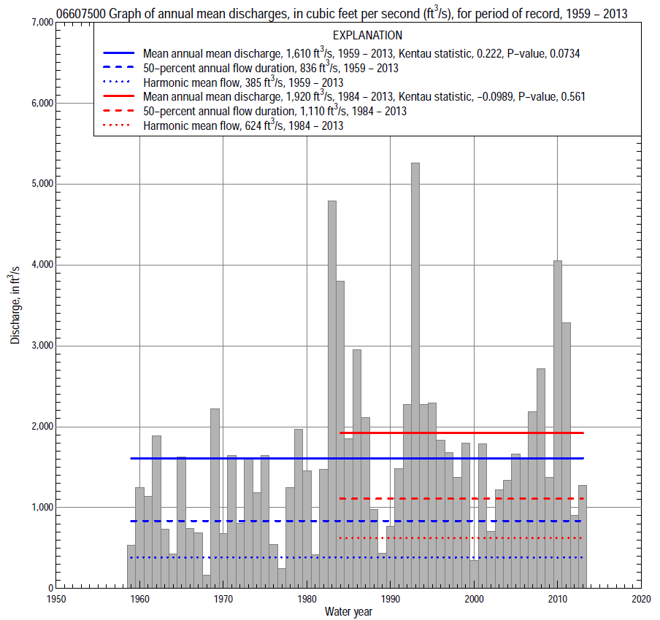

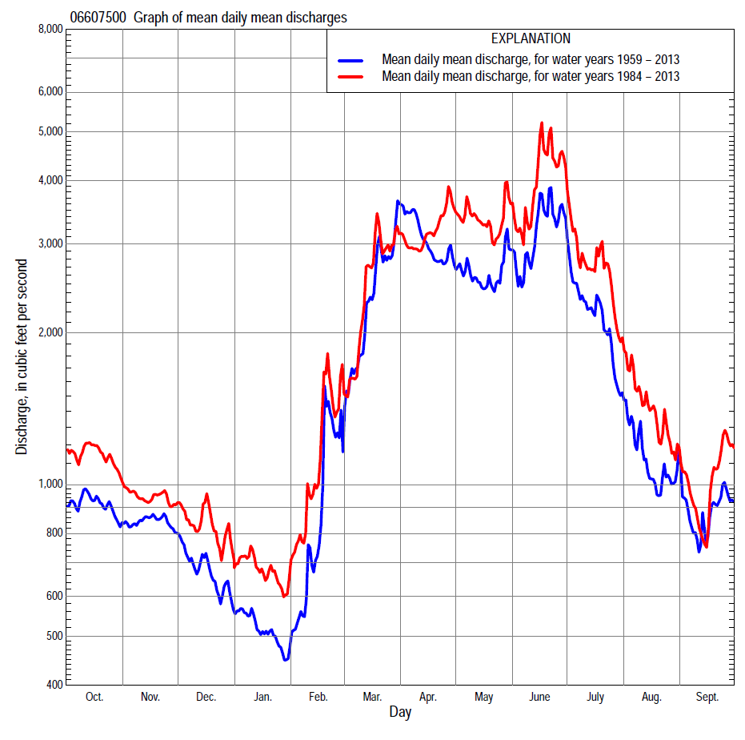

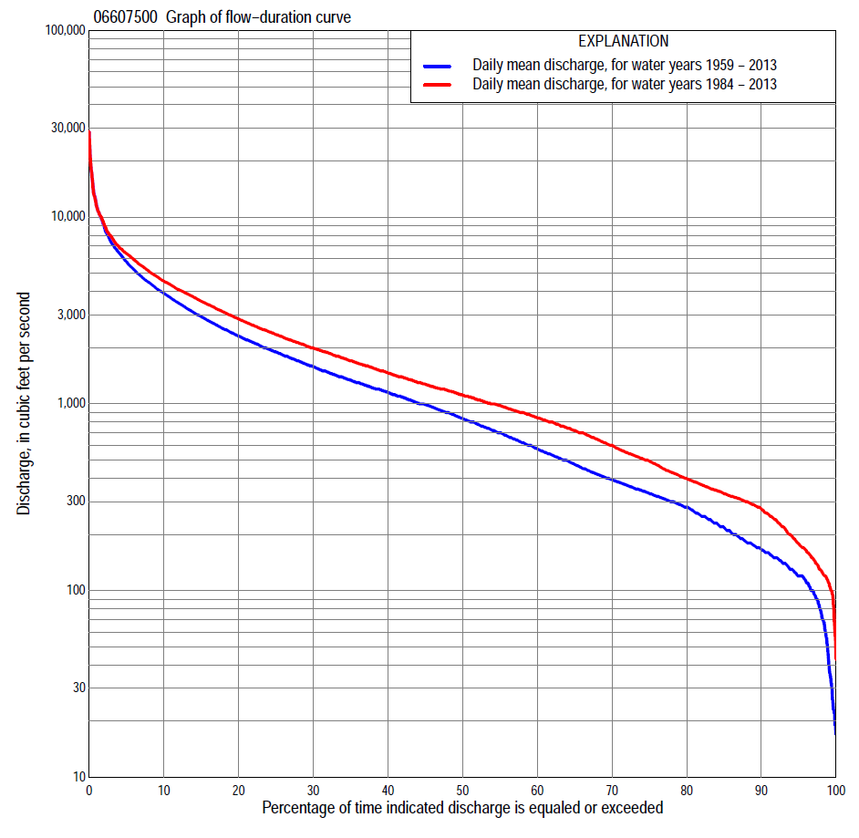

Statistics Based on the Entire Streamflow Period of Record
06607500 Monthly and annual flow durations, based on 1959–2013 period of record (55 years)
Percentage of days discharge equaled or exceeded |  |  |  |  | Discharge (cubic feet per second) |  |  |  |  |  |  |  |  | Annual flow durations
 | Oct | Nov | Dec | Jan | Feb | Mar | Apr | May | June | July | Aug | Sept | Annual | Kentau statistic | P-value
99 | 37 | 49 | 31 | 19 | 22 | 125 | 153 | 119 | 113 | 153 | 96 | 85 | 42 | 0.292 | 0.002
98 | 77 | 80 | 36 | 23 | 25 | 140 | 187 | 158 | 204 | 180 | 116 | 100 | 76 | 0.288 | 0.002
95 | 116 | 126 | 70 | 54 | 68 | 160 | 286 | 230 | 380 | 224 | 165 | 123 | 120 | 0.285 | 0.002
90 | 138 | 163 | 109 | 100 | 118 | 220 | 354 | 422 | 568 | 305 | 202 | 154 | 166 | 0.321 | 0.001
85 | 165 | 210 | 160 | 120 | 135 | 308 | 467 | 709 | 786 | 382 | 244 | 178 | 218 | 0.343 | 0.000
80 | 236 | 262 | 200 | 136 | 150 | 400 | 674 | 884 | 1,000 | 437 | 296 | 216 | 280 | 0.326 | 0.000
75 | 283 | 292 | 220 | 160 | 170 | 549 | 923 | 1,040 | 1,230 | 527 | 367 | 275 | 331 | 0.313 | 0.001
70 | 311 | 312 | 250 | 180 | 203 | 745 | 1,200 | 1,200 | 1,400 | 647 | 432 | 320 | 393 | 0.306 | 0.001
65 | 347 | 336 | 286 | 210 | 260 | 888 | 1,350 | 1,380 | 1,560 | 756 | 495 | 350 | 474 | 0.285 | 0.002
60 | 372 | 362 | 330 | 245 | 320 | 1,000 | 1,510 | 1,500 | 1,720 | 928 | 554 | 387 | 575 | 0.277 | 0.003
55 | 400 | 403 | 380 | 290 | 450 | 1,130 | 1,740 | 1,690 | 1,870 | 1,080 | 606 | 433 | 700 | 0.273 | 0.003
50 | 449 | 481 | 441 | 340 | 510 | 1,350 | 1,980 | 1,940 | 2,050 | 1,300 | 674 | 485 | 836 | 0.267 | 0.004
45 | 548 | 613 | 522 | 400 | 600 | 1,530 | 2,290 | 2,210 | 2,250 | 1,540 | 775 | 530 | 992 | 0.284 | 0.002
40 | 649 | 744 | 620 | 500 | 700 | 1,820 | 2,710 | 2,490 | 2,510 | 1,770 | 890 | 583 | 1,150 | 0.258 | 0.006
35 | 825 | 896 | 760 | 600 | 800 | 2,050 | 3,140 | 2,790 | 2,800 | 2,000 | 1,000 | 688 | 1,340 | 0.251 | 0.007
30 | 997 | 990 | 850 | 680 | 900 | 2,390 | 3,500 | 3,140 | 3,180 | 2,300 | 1,170 | 890 | 1,580 | 0.277 | 0.003
25 | 1,110 | 1,120 | 962 | 740 | 1,100 | 3,000 | 4,090 | 3,640 | 3,660 | 2,720 | 1,320 | 1,040 | 1,900 | 0.284 | 0.002
20 | 1,290 | 1,320 | 1,080 | 840 | 1,260 | 3,640 | 4,760 | 4,250 | 4,440 | 3,260 | 1,530 | 1,210 | 2,310 | 0.266 | 0.004
15 | 1,640 | 1,640 | 1,280 | 1,000 | 1,510 | 4,300 | 5,710 | 4,710 | 5,390 | 3,770 | 1,820 | 1,460 | 2,930 | 0.240 | 0.010
10 | 2,320 | 2,010 | 1,530 | 1,200 | 2,000 | 5,480 | 6,960 | 5,550 | 6,880 | 4,600 | 2,300 | 2,070 | 3,910 | 0.234 | 0.012
5 | 3,150 | 2,520 | 1,940 | 1,400 | 3,000 | 8,000 | 9,760 | 7,350 | 9,790 | 7,320 | 3,760 | 2,950 | 5,770 | 0.166 | 0.075
2 | 4,710 | 3,350 | 2,500 | 1,800 | 5,780 | 13,300 | 13,000 | 9,000 | 14,100 | 11,500 | 6,030 | 4,700 | 8,940 | 0.080 | 0.392
1 | 5,490 | 3,890 | 2,800 | 2,300 | 7,830 | 17,400 | 15,600 | 10,600 | 19,400 | 13,100 | 8,000 | 6,350 | 11,500 | 0.022 | 0.822

06607500 Annual exceedance probability of instantaneous peak discharges, in cubic feet per second (ft³/s), based on the expected moments algorithm/multiple Grubbs-Beck analysis computed using a historical period length of 56 years (1958–2013)ª
Annual exceed-ance probability | Recur-rence interval (years) | Discharge (ft³/s) | 95-percent lower confi-dence interval (ft³/s) | 95-percent upper confi-dence interval (ft³/s)
0.500 | 2 | 13,200 | 8,420 | 15,400
0.200 | 5 | 21,800 | 18,500 | 26,800
0.100 | 10 | 27,600 | 23,000 | 36,500
0.040 | 25 | 34,700 | 28,100 | 51,800
0.020 | 50 | 39,800 | 31,400 | 65,000
0.010 | 100 | 44,700 | 34,300 | 79,100
0.005 | 200 | 49,500 | 36,900 | 94,000
0.002 | 500 | 55,500 | 39,800 | 115,000
Kentau statistic |  | -0.031
P-value |  | 0.740
Begin year |  | 1958
End year |  | 2013
Number of peaks |  | 56
ªWeighted Independent Estimates were not computed because regional regression equations are not considered applicable due to diversion from the Monona-Harrison Ditch through upstream equalizer ditch. Statistics computed for record collected since February 1958.

06607500 Annual exceedance probability of high discharges, based on 1959–2013 period of record (55 years)ª
Annual exceed-ance probability | Recur-rence interval (years) | Maximum average discharge (cubic feet per second) for indicated number of consecutive days
 |  | 1 | 3 | 7 | 15 | 30
0.990 | 1.01 | 1,260 | 1,030 | 806 | 575 | 417
0.950 | 1.05 | 2,540 | 2,120 | 1,700 | 1,280 | 971
0.900 | 1.11 | 3,580 | 3,020 | 2,440 | 1,880 | 1,450
0.800 | 1.25 | 5,290 | 4,520 | 3,680 | 2,890 | 2,260
0.500 | 2 | 10,300 | 8,980 | 7,360 | 5,890 | 4,630
0.200 | 5 | 18,400 | 16,100 | 13,100 | 10,500 | 8,090
0.100 | 10 | 24,000 | 21,100 | 17,000 | 13,600 | 10,200
0.040 | 25 | 31,000 | 27,200 | 21,800 | 17,200 | 12,600
0.020 | 50 | 36,100 | 31,700 | 25,200 | 19,700 | 14,200
0.010 | 100 | 41,000 | 36,000 | 28,400 | 21,900 | 15,500
0.005 | 200 | 45,800 | 40,100 | 31,500 | 24,000 | 16,700
0.002 | 500 | 51,800 | 45,300 | 35,200 | 26,500 | 18,100
Kentau statistic |  | -0.045 | -0.015 | 0.007 | 0.063 | 0.133
P-value |  | 0.632 | 0.873 | 0.942 | 0.504 | 0.155
ªStatistics computed for record collected since February 1958.

 | 06607500 Annual nonexceedance probability of low discharges, based on April 1958 to March 2013 period of record (55 years)
Annual nonexceed-ance probability | Recur-rence interval (years) | Minimum average discharge (cubic feet per second) for indicated number of consecutive days
 |  | 1 | 3 | 7 | 14 | 30 | 60 | 90 | 120 | 183
0.01 | 100 | 15 | 15 | 16 | 17 | 18 | 23 | 30 | 37 | 43
0.02 | 50 | 21 | 22 | 23 | 24 | 27 | 32 | 41 | 51 | 60
0.05 | 20 | 35 | 36 | 38 | 40 | 45 | 54 | 68 | 80 | 95
0.10 | 10 | 53 | 56 | 59 | 62 | 70 | 83 | 102 | 118 | 141
0.20 | 5 | 86 | 91 | 96 | 102 | 114 | 135 | 164 | 186 | 224
0.50 | 2 | 196 | 209 | 222 | 237 | 268 | 315 | 377 | 417 | 508
0.80 | 1.25 | 402 | 428 | 453 | 489 | 554 | 659 | 788 | 869 | 1,070
0.90 | 1.11 | 562 | 595 | 628 | 680 | 772 | 930 | 1,120 | 1,240 | 1,520
0.96 | 1.04 | 779 | 818 | 860 | 937 | 1,060 | 1,300 | 1,580 | 1,780 | 2,180
0.98 | 1.02 | 947 | 988 | 1,030 | 1,130 | 1,280 | 1,590 | 1,940 | 2,220 | 2,720
0.99 | 1.01 | 1,120 | 1,160 | 1,210 | 1,330 | 1,500 | 1,890 | 2,330 | 2,690 | 3,280
Kentau statistic |  | 0.294 | 0.301 | 0.308 | 0.319 | 0.301 | 0.304 | 0.290 | 0.289 | 0.242
P-value |  | 0.002 | 0.001 | 0.001 | 0.001 | 0.001 | 0.001 | 0.002 | 0.002 | 0.009

06607500 Annual nonexceedance probability of seasonal low discharges, based on April 1958 to September 2013 period of record (55–56 years)
Annual nonexceed-ance probability | Recur-rence interval (years) | Minimum average discharge (cubic feet per second) for indicated number of consecutive days
 |  | 1 | 7 | 14 | 30 |  | 1 | 7 | 14 | 30
 |  | January-February-March |  |  |  |  | April-May-June
0.01 | 100 | 16 | 16 | 17 | 18 |  | 63 | 71 | 80 | 92
0.02 | 50 | 24 | 24 | 25 | 27 |  | 90 | 101 | 114 | 133
0.05 | 20 | 40 | 41 | 43 | 47 |  | 149 | 167 | 187 | 224
0.10 | 10 | 62 | 65 | 68 | 75 |  | 227 | 254 | 284 | 346
0.20 | 5 | 104 | 110 | 114 | 127 |  | 366 | 409 | 457 | 566
0.50 | 2 | 250 | 271 | 286 | 318 |  | 837 | 926 | 1,040 | 1,300
0.80 | 1.25 | 537 | 591 | 637 | 706 |  | 1,700 | 1,860 | 2,090 | 2,630
0.90 | 1.11 | 768 | 849 | 926 | 1,020 |  | 2,370 | 2,560 | 2,880 | 3,620
0.96 | 1.04 | 1,090 | 1,210 | 1,340 | 1,470 |  | 3,250 | 3,490 | 3,940 | 4,920
0.98 | 1.02 | 1,350 | 1,490 | 1,670 | 1,820 |  | 3,930 | 4,190 | 4,750 | 5,880
0.99 | 1.01 | 1,610 | 1,780 | 2,010 | 2,190 |  | 4,610 | 4,890 | 5,550 | 6,830
Kentau statistic |  | 0.311 | 0.328 | 0.337 | 0.327 |  | 0.282 | 0.282 | 0.304 | 0.291
P-value |  | 0.001 | 0.000 | 0.000 | 0.000 |  | 0.002 | 0.002 | 0.001 | 0.002
 |  | July-August-September |  |  |  |  | October-November-December
0.01 | 100 | 38 | 45 | 50 | 61 |  | 21 | 25 | 28 | 34
0.02 | 50 | 49 | 56 | 63 | 75 |  | 29 | 35 | 39 | 46
0.05 | 20 | 70 | 80 | 88 | 105 |  | 47 | 56 | 63 | 74
0.10 | 10 | 97 | 109 | 119 | 142 |  | 70 | 84 | 94 | 110
0.20 | 5 | 144 | 159 | 173 | 205 |  | 113 | 134 | 149 | 174
0.50 | 2 | 303 | 326 | 353 | 420 |  | 261 | 309 | 345 | 399
0.80 | 1.25 | 630 | 672 | 726 | 875 |  | 555 | 664 | 738 | 852
0.90 | 1.11 | 920 | 982 | 1,060 | 1,290 |  | 798 | 962 | 1,070 | 1,230
0.96 | 1.04 | 1,370 | 1,470 | 1,600 | 1,970 |  | 1,150 | 1,400 | 1,550 | 1,790
0.98 | 1.02 | 1,780 | 1,910 | 2,080 | 2,600 |  | 1,430 | 1,760 | 1,950 | 2,260
0.99 | 1.01 | 2,240 | 2,420 | 2,640 | 3,340 |  | 1,740 | 2,160 | 2,380 | 2,760
Kentau statistic |  | 0.210 | 0.217 | 0.195 | 0.181 |  | 0.228 | 0.268 | 0.248 | 0.255
P-value |  | 0.022 | 0.019 | 0.034 | 0.050 |  | 0.014 | 0.004 | 0.008 | 0.006

Statistics Based on the 1984–2013 Streamflow Period of Record
06607500 Monthly and annual flow durations, based on 1984–2013 period of record (30 years)
Percentage of days discharge equaled or exceeded |  |  |  |  | Discharge (cubic feet per second) |  |  |  |  |  |  |  |  | Annual flow durations
 | Oct | Nov | Dec | Jan | Feb | Mar | Apr | May | June | July | Aug | Sept | Annual | Kentau statistic | P-value
99 | 108 | 110 | 54 | 78 | 120 | 159 | 262 | 186 | 347 | 202 | 109 | 117 | 110 | -0.092 | 0.486
98 | 115 | 130 | 70 | 95 | 145 | 190 | 280 | 219 | 381 | 261 | 143 | 121 | 128 | -0.090 | 0.498
95 | 128 | 173 | 124 | 120 | 157 | 328 | 318 | 400 | 565 | 344 | 201 | 150 | 178 | -0.080 | 0.544
90 | 206 | 234 | 190 | 155 | 173 | 425 | 579 | 1,080 | 1,100 | 440 | 254 | 223 | 274 | -0.037 | 0.789
85 | 276 | 287 | 236 | 198 | 250 | 575 | 778 | 1,270 | 1,390 | 595 | 382 | 289 | 331 | -0.069 | 0.605
80 | 302 | 312 | 290 | 256 | 311 | 759 | 1,020 | 1,440 | 1,620 | 725 | 466 | 319 | 399 | -0.071 | 0.592
75 | 325 | 330 | 320 | 317 | 450 | 863 | 1,280 | 1,610 | 1,790 | 931 | 523 | 342 | 494 | -0.090 | 0.498
70 | 350 | 366 | 390 | 354 | 500 | 942 | 1,450 | 1,810 | 1,940 | 1,100 | 573 | 361 | 600 | -0.083 | 0.532
65 | 389 | 415 | 432 | 400 | 540 | 1,030 | 1,680 | 2,080 | 2,140 | 1,300 | 629 | 393 | 720 | -0.083 | 0.532
60 | 454 | 481 | 540 | 467 | 640 | 1,140 | 1,960 | 2,300 | 2,350 | 1,540 | 695 | 432 | 842 | -0.080 | 0.544
55 | 577 | 582 | 687 | 570 | 720 | 1,360 | 2,230 | 2,530 | 2,550 | 1,700 | 790 | 481 | 980 | -0.097 | 0.464
50 | 660 | 840 | 771 | 620 | 800 | 1,510 | 2,710 | 2,780 | 2,750 | 1,870 | 905 | 515 | 1,110 | -0.099 | 0.454
45 | 823 | 917 | 820 | 677 | 866 | 1,850 | 3,050 | 3,090 | 3,050 | 2,020 | 1,000 | 561 | 1,270 | -0.076 | 0.568
40 | 989 | 980 | 893 | 719 | 960 | 2,030 | 3,340 | 3,390 | 3,330 | 2,230 | 1,140 | 647 | 1,460 | -0.113 | 0.392
35 | 1,100 | 1,070 | 965 | 760 | 1,100 | 2,350 | 3,610 | 3,790 | 3,720 | 2,500 | 1,280 | 832 | 1,700 | -0.103 | 0.432
30 | 1,210 | 1,210 | 1,050 | 810 | 1,220 | 2,800 | 4,050 | 4,250 | 4,290 | 2,840 | 1,440 | 1,010 | 1,990 | -0.048 | 0.721
25 | 1,410 | 1,430 | 1,140 | 900 | 1,370 | 3,220 | 4,540 | 4,500 | 4,880 | 3,270 | 1,610 | 1,140 | 2,350 | -0.025 | 0.858
20 | 1,700 | 1,610 | 1,260 | 1,000 | 1,570 | 3,830 | 5,170 | 4,880 | 5,620 | 3,680 | 1,860 | 1,310 | 2,850 | -0.044 | 0.748
15 | 2,230 | 1,760 | 1,400 | 1,160 | 1,800 | 4,330 | 5,810 | 5,550 | 6,500 | 4,160 | 2,170 | 1,700 | 3,550 | -0.053 | 0.695
10 | 2,650 | 2,000 | 1,600 | 1,270 | 2,290 | 5,300 | 6,690 | 6,490 | 8,240 | 5,600 | 2,960 | 2,290 | 4,540 | -0.028 | 0.844
5 | 3,770 | 2,400 | 1,900 | 1,400 | 3,450 | 7,020 | 7,700 | 7,950 | 11,000 | 9,370 | 4,940 | 3,450 | 6,380 | 0.064 | 0.630
2 | 5,370 | 2,660 | 2,220 | 2,100 | 5,880 | 12,200 | 10,300 | 9,950 | 17,700 | 12,800 | 7,050 | 6,120 | 9,180 | 0.002 | 1.000
1 | 5,960 | 2,780 | 3,200 | 2,600 | 7,060 | 16,200 | 10,700 | 11,000 | 21,600 | 15,600 | 8,960 | 7,390 | 11,300 | -0.007 | 0.972

06607500 Annual exceedance probability of high discharges, based on 1984–2013 period of record (30 years)
Annual exceed-ance probability | Recur-rence interval (years) | Maximum average discharge (cubic feet per second) for indicated number of consecutive days
 |  | 1 | 3 | 7 | 15 | 30
0.990 | 1.01 | 1,550 | 1,340 | 1,090 | 925 | 724
0.950 | 1.05 | 2,910 | 2,580 | 2,200 | 1,850 | 1,470
0.900 | 1.11 | 3,970 | 3,560 | 3,070 | 2,570 | 2,050
0.800 | 1.25 | 5,670 | 5,120 | 4,440 | 3,700 | 2,960
0.500 | 2 | 10,500 | 9,470 | 8,110 | 6,670 | 5,370
0.200 | 5 | 18,000 | 15,900 | 13,000 | 10,600 | 8,510
0.100 | 10 | 23,100 | 20,100 | 16,000 | 12,800 | 10,300
0.040 | 25 | 29,500 | 25,200 | 19,200 | 15,300 | 12,200
0.020 | 50 | 34,200 | 28,700 | 21,300 | 16,900 | 13,500
0.010 | 100 | 38,700 | 32,100 | 23,100 | 18,200 | 14,500
0.005 | 200 | 43,100 | 35,200 | 24,700 | 19,400 | 15,400
0.002 | 500 | 48,700 | 39,100 | 26,500 | 20,700 | 16,400
Kentau statistic |  | -0.064 | -0.057 | -0.034 | 0.011 | 0.044
P-value |  | 0.630 | 0.669 | 0.803 | 0.943 | 0.748

 | 06607500 Annual nonexceedance probability of low discharges, based on April 1983 to March 2013 period of record (30 years)
Annual nonexceed-ance probability | Recur-rence interval (years) | Minimum average discharge (cubic feet per second) for indicated number of consecutive days
 |  | 1 | 3 | 7 | 14 | 30 | 60 | 90 | 120 | 183
0.01 | 100 | 34 | 37 | 42 | 45 | 49 | 61 | 70 | 75 | 83
0.02 | 50 | 46 | 51 | 57 | 61 | 67 | 82 | 94 | 100 | 111
0.05 | 20 | 72 | 80 | 88 | 95 | 104 | 124 | 142 | 150 | 168
0.10 | 10 | 103 | 115 | 126 | 134 | 148 | 175 | 200 | 212 | 238
0.20 | 5 | 153 | 171 | 186 | 199 | 219 | 257 | 295 | 313 | 355
0.50 | 2 | 296 | 325 | 349 | 375 | 419 | 488 | 566 | 609 | 718
0.80 | 1.25 | 500 | 536 | 570 | 621 | 702 | 823 | 974 | 1,070 | 1,340
0.90 | 1.11 | 627 | 660 | 700 | 769 | 876 | 1,040 | 1,240 | 1,390 | 1,790
0.96 | 1.04 | 772 | 796 | 841 | 934 | 1,070 | 1,280 | 1,560 | 1,780 | 2,400
0.98 | 1.02 | 868 | 882 | 929 | 1,040 | 1,200 | 1,450 | 1,790 | 2,060 | 2,860
0.99 | 1.01 | 953 | 956 | 1,010 | 1,140 | 1,320 | 1,600 | 1,990 | 2,330 | 3,330
Kentau statistic |  | -0.085 | -0.106 | -0.103 | -0.094 | -0.094 | -0.083 | -0.080 | -0.062 | -0.085
P-value |  | 0.521 | 0.422 | 0.432 | 0.475 | 0.475 | 0.532 | 0.544 | 0.643 | 0.521

06607500 Annual nonexceedance probability of seasonal low discharges, based on October 1983 to September 2013 period of record (30 years)
Annual nonexceed-ance probability | Recur-rence interval (years) | Minimum average discharge (cubic feet per second) for indicated number of consecutive days
 |  | 1 | 7 | 14 | 30 |  | 1 | 7 | 14 | 30
 |  | January-February-March |  |  |  |  | April-May-June
0.01 | 100 | 44 | 49 | 54 | 61 |  | 117 | 123 | 131 | 155
0.02 | 50 | 60 | 67 | 72 | 82 |  | 165 | 175 | 189 | 227
0.05 | 20 | 91 | 103 | 111 | 124 |  | 267 | 286 | 314 | 384
0.10 | 10 | 130 | 148 | 158 | 176 |  | 397 | 428 | 476 | 589
0.20 | 5 | 194 | 222 | 236 | 262 |  | 615 | 669 | 751 | 938
0.50 | 2 | 384 | 439 | 470 | 517 |  | 1,270 | 1,390 | 1,570 | 1,980
0.80 | 1.25 | 681 | 769 | 845 | 926 |  | 2,270 | 2,470 | 2,790 | 3,480
0.90 | 1.11 | 883 | 986 | 1,100 | 1,210 |  | 2,920 | 3,150 | 3,540 | 4,380
0.96 | 1.04 | 1,130 | 1,240 | 1,430 | 1,570 |  | 3,690 | 3,940 | 4,390 | 5,360
0.98 | 1.02 | 1,310 | 1,420 | 1,660 | 1,830 |  | 4,210 | 4,470 | 4,940 | 5,970
0.99 | 1.01 | 1,480 | 1,590 | 1,890 | 2,080 |  | 4,680 | 4,940 | 5,430 | 6,500
Kentau statistic |  | -0.046 | -0.044 | -0.044 | -0.044 |  | -0.115 | -0.113 | -0.090 | -0.057
P-value |  | 0.735 | 0.748 | 0.748 | 0.748 |  | 0.382 | 0.392 | 0.498 | 0.669
 |  | July-August-September |  |  |  |  | October-November-December
0.01 | 100 | 80 | 91 | 93 | 111 |  | 31 | 38 | 42 | 56
0.02 | 50 | 94 | 105 | 109 | 129 |  | 44 | 55 | 60 | 77
0.05 | 20 | 121 | 134 | 140 | 163 |  | 72 | 90 | 97 | 120
0.10 | 10 | 153 | 168 | 176 | 204 |  | 109 | 136 | 146 | 175
0.20 | 5 | 207 | 225 | 238 | 274 |  | 172 | 215 | 229 | 269
0.50 | 2 | 388 | 414 | 445 | 510 |  | 368 | 454 | 489 | 562
0.80 | 1.25 | 778 | 825 | 892 | 1,040 |  | 683 | 822 | 915 | 1,060
0.90 | 1.11 | 1,150 | 1,220 | 1,320 | 1,560 |  | 895 | 1,060 | 1,210 | 1,420
0.96 | 1.04 | 1,790 | 1,890 | 2,050 | 2,470 |  | 1,150 | 1,340 | 1,570 | 1,880
0.98 | 1.02 | 2,410 | 2,560 | 2,770 | 3,390 |  | 1,330 | 1,530 | 1,820 | 2,230
0.99 | 1.01 | 3,170 | 3,370 | 3,650 | 4,550 |  | 1,490 | 1,700 | 2,060 | 2,570
Kentau statistic |  | -0.159 | -0.131 | -0.152 | -0.140 |  | -0.078 | -0.048 | -0.076 | -0.053
P-value |  | 0.225 | 0.318 | 0.246 | 0.284 |  | 0.556 | 0.721 | 0.568 | 0.695

