LOCATION.--Lat 41°49'50", long 95°55'52" referenced to North American Datum of 1927, in NE 1/4 SW 1/4 NE 1/4 sec.14, T.81 N., R.44 W., Harrison County, IA, Hydrologic Unit 10230001, on right bank on upstream side of bridge on County Highway F20, at western edge of Pisgah, 0.4 mi downstream from Cobb Creek, 0.4 mi upstream from Mogger Ditch, and 12.3 mi upstream from mouth.

DRAINAGE AREA.--407 mi².

PERIOD OF RECORD.--Discharge records from March 1940 to current year.

GAGE.--Water-stage recorder. Datum of gage is 1,036.53 ft above National Geodetic Vertical Datum of 1929. Prior to February 1, 1954, non-recording gage at site 75 ft upstream at same datum, with supplementary water-stage recorder operating above 8.2 ft gage height from March 2, 1946, to September 24, 1953; February 1, 1954, to October 10, 1954, non-recording gage, and October 11, 1954, to June 21, 1989, water-stage recorder, both at site 25 ft downstream at same datum; June 22, 1989, to August 12, 2010, water-stage recorder at site 75 ft upstream at same datum.

A summary of all available data for this streamgage is provided through the USGS National Water Information System web interface (NWISWeb). The following link provides access to current/historical observations, daily data, daily statistics, monthly statistics, annual statistics, peak streamflow, field measurements, field/lab water-quality samples, and the latest water-year summaries. Data can be filtered by parameter and/or dates, and can be output in various tabular and graphical formats.
http://waterdata.usgs.gov/nwis/inventory/?site_no=06608500

The USGS WaterWatch Toolkit is available at:
http://waterwatch.usgs.gov/?id=ww_toolkit
Tools for summarizing streamflow information include the duration hydrograph builder, the cumulative streamflow hydrograph builder, the streamgage statistics retrieval tool, the rating curve builder, the flood tracking chart builder, the National Weather Service Advanced Hydrologic Prediction Service (AHPS) river forecast hydrograph builder, and the raster-hydrograph builder. Entering the above number for this streamgage into these toolkit webpages will provide streamflow information specific to this streamgage.

A description of the statistics presented for this streamgage is available in the main body of the report at:
http://dx.doi.org/10.3133/ofr20151214
A link to other streamgages included in this report, a map showing the location of the streamgages, information on the programs used to compute the statistical analyses, and references are included in the main body of the report.

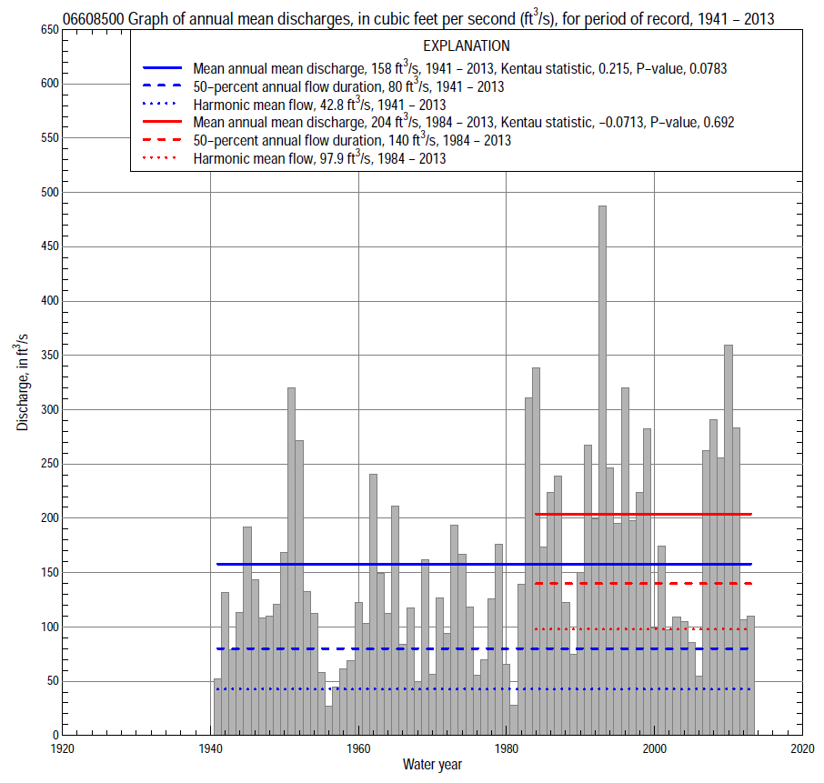

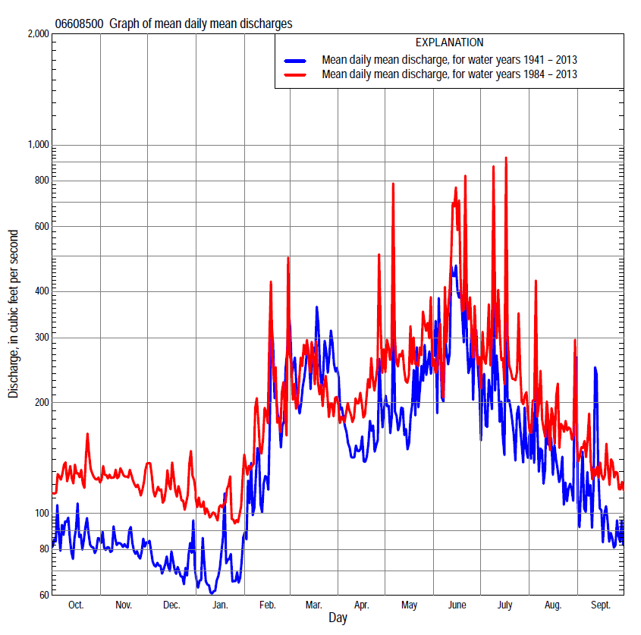

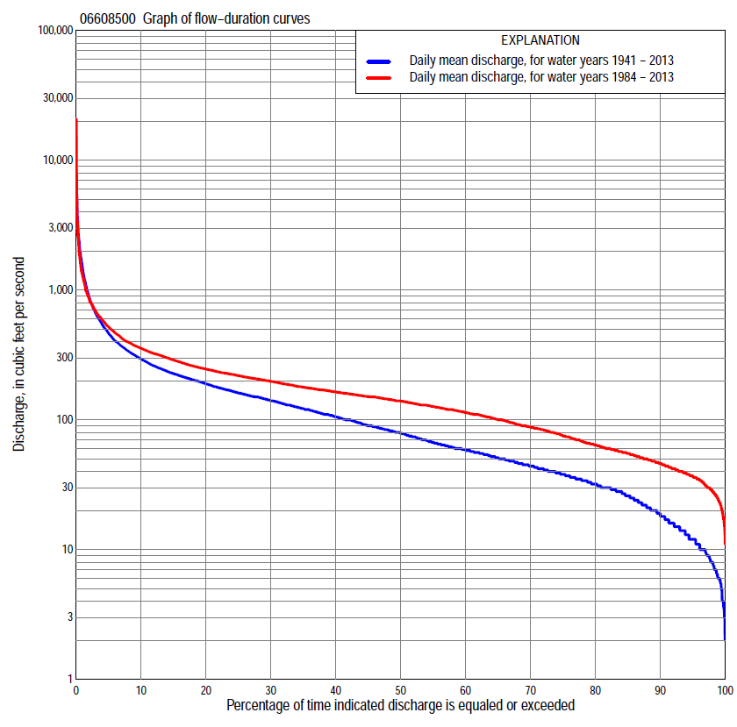

Statistics Based on the Entire Streamflow Period of Record
06608500 Monthly and annual flow durations, based on 1941–2013 period of record (73 years)
Percentage of days discharge equaled or exceeded |  |  |  |  | Discharge (cubic feet per second) |  |  |  |  |  |  |  |  | Annual flow durations
 | Oct | Nov | Dec | Jan | Feb | Mar | Apr | May | June | July | Aug | Sept | Annual | Kentau statistic | P-value
99 | 9.2 | 10 | 5.5 | 3.4 | 4.0 | 20 | 10 | 10 | 7.4 | 10 | 8.0 | 6.0 | 6.0 | 0.412 | 0.000
98 | 10 | 12 | 6.5 | 3.5 | 5.5 | 22 | 14 | 12 | 9.0 | 13 | 9.0 | 8.0 | 8.0 | 0.419 | 0.000
95 | 11 | 14 | 8.8 | 6.0 | 9.0 | 30 | 23 | 18 | 19 | 19 | 12 | 11 | 12 | 0.424 | 0.000
90 | 15 | 19 | 14 | 8.0 | 17 | 42 | 32 | 29 | 34 | 24 | 17 | 15 | 19 | 0.423 | 0.000
85 | 20 | 23 | 17 | 11 | 28 | 50 | 41 | 39 | 42 | 30 | 23 | 20 | 26 | 0.424 | 0.000
80 | 26 | 29 | 21 | 15 | 32 | 59 | 47 | 48 | 52 | 40 | 31 | 27 | 32 | 0.414 | 0.000
75 | 30 | 35 | 27 | 22 | 36 | 66 | 55 | 56 | 63 | 54 | 38 | 30 | 38 | 0.414 | 0.000
70 | 35 | 40 | 31 | 28 | 42 | 77 | 65 | 65 | 83 | 64 | 44 | 34 | 45 | 0.416 | 0.000
65 | 39 | 44 | 35 | 30 | 49 | 87 | 74 | 75 | 102 | 74 | 51 | 39 | 51 | 0.415 | 0.000
60 | 43 | 48 | 40 | 35 | 55 | 100 | 86 | 85 | 118 | 84 | 58 | 44 | 59 | 0.401 | 0.000
55 | 48 | 53 | 46 | 39 | 63 | 114 | 98 | 100 | 133 | 94 | 65 | 51 | 67 | 0.394 | 0.000
50 | 53 | 58 | 52 | 44 | 79 | 129 | 110 | 118 | 151 | 105 | 75 | 58 | 80 | 0.379 | 0.000
45 | 59 | 63 | 59 | 51 | 95 | 146 | 124 | 140 | 170 | 117 | 83 | 66 | 91 | 0.373 | 0.000
40 | 68 | 71 | 65 | 59 | 105 | 160 | 143 | 164 | 194 | 132 | 93 | 77 | 106 | 0.371 | 0.000
35 | 84 | 84 | 74 | 70 | 120 | 176 | 162 | 192 | 217 | 149 | 106 | 90 | 122 | 0.358 | 0.000
30 | 103 | 99 | 81 | 80 | 133 | 195 | 180 | 216 | 242 | 171 | 128 | 111 | 141 | 0.346 | 0.000
25 | 122 | 115 | 95 | 92 | 153 | 217 | 203 | 242 | 288 | 205 | 147 | 132 | 161 | 0.340 | 0.000
20 | 139 | 135 | 112 | 110 | 180 | 257 | 235 | 284 | 343 | 250 | 183 | 153 | 190 | 0.321 | 0.000
15 | 156 | 149 | 130 | 130 | 220 | 340 | 273 | 343 | 439 | 308 | 219 | 172 | 227 | 0.277 | 0.001
10 | 176 | 170 | 160 | 150 | 287 | 502 | 328 | 428 | 604 | 374 | 278 | 213 | 294 | 0.209 | 0.009
5 | 245 | 227 | 205 | 190 | 560 | 1,010 | 454 | 626 | 1,090 | 576 | 403 | 307 | 463 | 0.051 | 0.523
2 | 333 | 265 | 250 | 287 | 1,060 | 1,860 | 678 | 1,040 | 2,040 | 993 | 700 | 484 | 879 | -0.103 | 0.198
1 | 443 | 286 | 300 | 440 | 1,600 | 2,600 | 1,010 | 1,590 | 3,270 | 1,530 | 1,160 | 662 | 1,420 | -0.163 | 0.042

06608500 Annual exceedance probability of instantaneous peak discharges, in cubic feet per second (ft³/s), based on the Weighted Independent Estimates method,
Annual exceed-ance probability | Recur-rence interval (years) | Discharge (ft³/s) | 95-percent lower confi-dence interval (ft³/s) | 95-percent upper confi-dence interval (ft³/s)
0.500 | 2 | 8,280 | 6,960 | 9,850
0.200 | 5 | 14,700 | 12,400 | 17,300
0.100 | 10 | 19,000 | 15,900 | 22,700
0.040 | 25 | 24,600 | 19,900 | 30,400
0.020 | 50 | 28,600 | 22,400 | 36,500
0.010 | 100 | 32,500 | 24,600 | 43,000
0.005 | 200 | 36,400 | 26,600 | 49,800
0.002 | 500 | 41,300 | 28,700 | 59,500
and based on the expected moments algorithm/multiple Grubbs-Beck analysis computed using a historical period length of 74 years (1940–2013)
0.500 | 2 | 8,370 | 4,910 | 9,760
0.200 | 5 | 14,900 | 12,600 | 18,400
0.100 | 10 | 19,600 | 16,400 | 26,400
0.040 | 25 | 25,700 | 20,600 | 40,900
0.020 | 50 | 30,300 | 23,400 | 55,300
0.010 | 100 | 34,800 | 26,100 | 72,400
0.005 | 200 | 39,200 | 28,500 | 91,700
0.002 | 500 | 45,100 | 31,500 | 120,000
Kentau statistic |  | -0.214
P-value |  | 0.007
Begin year |  | 1940
End year |  | 2013
Number of peaks |  | 74

06608500 Annual exceedance probability of high discharges, based on 1941–2013 period of record (73 years)
Annual exceedance probability | Recur-rence interval (years) | Maximum average discharge (ft³/s) for indicated number of consecutive days
 |  | 1 | 3 | 7 | 15 | 30
0.990 | 1.01 | 357 | 204 | 132 | 94 | 67
0.950 | 1.05 | 674 | 393 | 251 | 171 | 121
0.900 | 1.11 | 939 | 550 | 348 | 231 | 163
0.800 | 1.25 | 1,390 | 816 | 510 | 330 | 232
0.500 | 2 | 2,900 | 1,670 | 1,010 | 628 | 435
0.200 | 5 | 5,860 | 3,260 | 1,900 | 1,140 | 779
0.100 | 10 | 8,380 | 4,540 | 2,590 | 1,520 | 1,040
0.040 | 25 | 12,200 | 6,360 | 3,530 | 2,050 | 1,380
0.020 | 50 | 15,400 | 7,860 | 4,290 | 2,470 | 1,660
0.010 | 100 | 19,000 | 9,450 | 5,070 | 2,900 | 1,940
0.005 | 200 | 23,000 | 11,100 | 5,880 | 3,350 | 2,230
0.002 | 500 | 28,800 | 13,500 | 7,010 | 3,960 | 2,620
Kentau statistic |  | -0.104 | -0.094 | -0.058 | -0.022 | 0.005
P-value |  | 0.197 | 0.243 | 0.472 | 0.786 | 0.958

 | 06608500 Annual nonexceedance probability of low discharges, based on April 1940 to March 2013 period of record (73 years)
Annual nonexceed-ance probability | Recur-rence interval (years) | Minimum average discharge (ft³/s) for indicated number of consecutive days
 |  | 1 | 3 | 7 | 14 | 30 | 60 | 90 | 120 | 183
0.01 | 100 | 1.4 | 1.4 | 1.5 | 1.7 | 2.2 | 3.4 | 4.9 | 6.5 | 8.4
0.02 | 50 | 2.1 | 2.1 | 2.1 | 2.4 | 3.2 | 4.7 | 6.5 | 8.4 | 11
0.05 | 20 | 3.5 | 3.6 | 3.7 | 4.2 | 5.4 | 7.5 | 10 | 12 | 16
0.10 | 10 | 5.4 | 5.6 | 5.9 | 6.7 | 8.3 | 11 | 14 | 17 | 21
0.20 | 5 | 9.0 | 10 | 10 | 12 | 14 | 18 | 22 | 25 | 31
0.50 | 2 | 23 | 24 | 27 | 30 | 35 | 42 | 48 | 52 | 62
0.80 | 1.25 | 53 | 58 | 64 | 70 | 79 | 91 | 99 | 105 | 120
0.90 | 1.11 | 80 | 87 | 97 | 106 | 117 | 133 | 141 | 149 | 168
0.96 | 1.04 | 122 | 133 | 147 | 161 | 175 | 195 | 203 | 216 | 238
0.98 | 1.02 | 159 | 173 | 190 | 207 | 223 | 248 | 255 | 272 | 297
0.99 | 1.01 | 201 | 217 | 237 | 257 | 276 | 305 | 312 | 335 | 360
Kentau statistic |  | 0.384 | 0.402 | 0.426 | 0.448 | 0.438 | 0.419 | 0.402 | 0.390 | 0.337
P-value |  | 0.000 | 0.000 | 0.000 | 0.000 | 0.000 | 0.000 | 0.000 | 0.000 | 0.000

06608500 Annual nonexceedance probability of seasonal low discharges, based on April 1940 to September 2013 period of record (73–74 years)
Annual nonexceed-ance probability | Recur-rence interval (years) | Minimum average discharge (cubic feet per second) for indicated number of consecutive days
 |  | 1 | 7 | 14 | 30 |  | 1 | 7 | 14 | 30
 |  | January-February-March |  |  |  |  | April-May-June
0.01 | 100 | 1.6 | 1.6 | 1.7 | 2.6 |  | 3.1 | 4.0 | 5.0 | 6.6
0.02 | 50 | 2.3 | 2.3 | 2.6 | 3.8 |  | 4.6 | 5.8 | 7.2 | 9.5
0.05 | 20 | 4.0 | 4.3 | 4.7 | 6.6 |  | 8.1 | 10 | 12 | 16
0.10 | 10 | 6.4 | 7.0 | 7.7 | 10 |  | 13 | 16 | 19 | 24
0.20 | 5 | 11 | 12 | 14 | 18 |  | 22 | 26 | 32 | 39
0.50 | 2 | 28 | 33 | 36 | 44 |  | 56 | 64 | 74 | 92
0.80 | 1.25 | 64 | 75 | 83 | 96 |  | 121 | 135 | 154 | 192
0.90 | 1.11 | 94 | 111 | 122 | 139 |  | 172 | 191 | 214 | 270
0.96 | 1.04 | 139 | 160 | 177 | 200 |  | 241 | 267 | 294 | 377
0.98 | 1.02 | 175 | 200 | 222 | 248 |  | 294 | 325 | 354 | 461
0.99 | 1.01 | 214 | 240 | 267 | 298 |  | 348 | 384 | 414 | 546
Kentau statistic |  | 0.384 | 0.414 | 0.424 | 0.383 |  | 0.375 | 0.369 | 0.359 | 0.328
P-value |  | 0.000 | 0.000 | 0.000 | 0.000 |  | 0.000 | 0.000 | 0.000 | 0.000
 |  | July-August-September |  |  |  |  | October-November-December
0.01 | 100 | 3.3 | 3.9 | 5.1 | 7.4 |  | 2.8 | 3.1 | 3.5 | 5.1
0.02 | 50 | 4.4 | 5.2 | 6.5 | 9.4 |  | 3.8 | 4.2 | 4.8 | 6.8
0.05 | 20 | 6.8 | 7.8 | 9.6 | 13 |  | 5.8 | 6.7 | 7.6 | 10
0.10 | 10 | 9.9 | 11 | 14 | 18 |  | 8.5 | 9.9 | 11 | 15
0.20 | 5 | 16 | 18 | 20 | 27 |  | 13 | 16 | 18 | 22
0.50 | 2 | 36 | 40 | 45 | 56 |  | 29 | 36 | 40 | 47
0.80 | 1.25 | 84 | 91 | 98 | 116 |  | 63 | 78 | 86 | 97
0.90 | 1.11 | 129 | 139 | 149 | 170 |  | 92 | 113 | 123 | 139
0.96 | 1.04 | 202 | 217 | 231 | 255 |  | 135 | 166 | 178 | 201
0.98 | 1.02 | 271 | 290 | 307 | 331 |  | 172 | 211 | 224 | 253
0.99 | 1.01 | 351 | 374 | 396 | 419 |  | 213 | 259 | 273 | 310
Kentau statistic |  | 0.343 | 0.348 | 0.352 | 0.321 |  | 0.379 | 0.426 | 0.435 | 0.423
P-value |  | 0.000 | 0.000 | 0.000 | 0.000 |  | 0.000 | 0.000 | 0.000 | 0.000

Statistics Based on the 1984–2013 Streamflow Period of Record
06608500 Monthly and annual flow durations, based on 1984–2013 period of record (30 years)
Percentage of days discharge equaled or exceeded |  |  |  |  | Discharge (cubic feet per second) |  |  |  |  |  |  |  |  | Annual flow durations
 | Oct | Nov | Dec | Jan | Feb | Mar | Apr | May | June | July | Aug | Sept | Annual | Kentau statistic | P-value
99 | 29 | 28 | 15 | 20 | 20 | 37 | 42 | 40 | 37 | 19 | 22 | 24 | 24 | -0.131 | 0.317
98 | 30 | 30 | 19 | 25 | 24 | 44 | 44 | 43 | 39 | 24 | 23 | 25 | 28 | -0.103 | 0.432
95 | 35 | 37 | 30 | 32 | 35 | 49 | 52 | 59 | 50 | 33 | 35 | 29 | 37 | -0.083 | 0.532
90 | 39 | 44 | 40 | 38 | 44 | 60 | 67 | 75 | 72 | 63 | 44 | 36 | 46 | -0.099 | 0.453
85 | 42 | 51 | 47 | 44 | 52 | 72 | 81 | 88 | 99 | 74 | 51 | 40 | 55 | -0.101 | 0.443
80 | 52 | 56 | 54 | 48 | 60 | 90 | 90 | 105 | 117 | 89 | 61 | 45 | 64 | -0.074 | 0.580
75 | 56 | 60 | 61 | 52 | 72 | 105 | 101 | 123 | 140 | 107 | 78 | 53 | 75 | -0.076 | 0.568
70 | 62 | 65 | 67 | 60 | 86 | 117 | 113 | 141 | 156 | 123 | 85 | 60 | 88 | -0.051 | 0.708
65 | 69 | 74 | 73 | 70 | 100 | 127 | 133 | 164 | 171 | 136 | 92 | 72 | 100 | -0.071 | 0.592
60 | 86 | 89 | 79 | 79 | 110 | 139 | 152 | 185 | 188 | 149 | 102 | 83 | 114 | -0.092 | 0.486
55 | 101 | 106 | 90 | 87 | 120 | 152 | 163 | 202 | 207 | 160 | 117 | 97 | 127 | -0.085 | 0.521
50 | 116 | 120 | 103 | 93 | 130 | 162 | 172 | 217 | 226 | 176 | 132 | 111 | 140 | -0.094 | 0.475
45 | 127 | 133 | 113 | 100 | 139 | 174 | 183 | 233 | 243 | 197 | 143 | 123 | 151 | -0.087 | 0.509
40 | 140 | 140 | 120 | 110 | 150 | 185 | 196 | 249 | 271 | 222 | 165 | 141 | 164 | -0.051 | 0.708
35 | 149 | 148 | 130 | 120 | 163 | 195 | 214 | 271 | 306 | 248 | 190 | 151 | 178 | -0.051 | 0.708
30 | 157 | 153 | 140 | 130 | 179 | 207 | 243 | 302 | 339 | 281 | 206 | 158 | 198 | -0.078 | 0.556
25 | 165 | 162 | 155 | 134 | 198 | 223 | 268 | 330 | 389 | 315 | 226 | 168 | 219 | -0.085 | 0.521
20 | 174 | 177 | 171 | 150 | 220 | 246 | 296 | 374 | 451 | 345 | 246 | 191 | 246 | -0.080 | 0.544
15 | 192 | 209 | 191 | 169 | 250 | 287 | 331 | 428 | 545 | 387 | 286 | 212 | 289 | -0.055 | 0.681
10 | 240 | 230 | 210 | 181 | 313 | 382 | 384 | 516 | 700 | 467 | 345 | 253 | 355 | -0.074 | 0.580
5 | 297 | 262 | 243 | 210 | 560 | 793 | 487 | 695 | 1,120 | 737 | 456 | 355 | 519 | -0.113 | 0.392
2 | 354 | 283 | 300 | 270 | 988 | 1,200 | 672 | 980 | 2,040 | 1,320 | 700 | 491 | 855 | -0.149 | 0.254
1 | 466 | 305 | 530 | 304 | 1,600 | 1,400 | 896 | 1,450 | 3,610 | 2,240 | 1030 | 566 | 1,280 | -0.143 | 0.276

06608500 Annual exceedance probability of high discharges, based on 1984–2013 period of record (30 years)
Annual exceedance probability | Recur-rence interval (years) | Maximum average discharge (ft³/s) for indicated number of consecutive days
 |  | 1 | 3 | 7 | 15 | 30
0.990 | 1.01 | 257 | 155 | 114 | 92 | 67
0.950 | 1.05 | 494 | 306 | 216 | 164 | 121
0.900 | 1.11 | 706 | 440 | 301 | 222 | 165
0.800 | 1.25 | 1,100 | 680 | 450 | 321 | 238
0.500 | 2 | 2,610 | 1,550 | 961 | 641 | 471
0.200 | 5 | 6,390 | 3,500 | 2,020 | 1,260 | 902
0.100 | 10 | 10,400 | 5,340 | 2,970 | 1,790 | 1,250
0.040 | 25 | 17,500 | 8,350 | 4,450 | 2,590 | 1,760
0.020 | 50 | 24,700 | 11,100 | 5,770 | 3,280 | 2,180
0.010 | 100 | 33,700 | 14,400 | 7,270 | 4,040 | 2,640
0.005 | 200 | 45,100 | 18,200 | 8,980 | 4,900 | 3,140
0.002 | 500 | 64,200 | 24,100 | 11,600 | 6,170 | 3,850
Kentau statistic |  | -0.189 | -0.195 | -0.126 | -0.149 | -0.117
P-value |  | 0.148 | 0.134 | 0.335 | 0.254 | 0.372

 | 06608500 Annual nonexceedance probability of low discharges, based on April 1983 to March 2013 period of record (30 years)
Annual nonexceed-ance probability | Recur-rence interval (years) | Minimum average discharge (ft³/s) for indicated number of consecutive days
 |  | 1 | 3 | 7 | 14 | 30 | 60 | 90 | 120 | 183
0.01 | 100 | 8.2 | 8.8 | 11 | 12 | 13 | 17 | 19 | 20 | 23
0.02 | 50 | 10 | 11 | 14 | 15 | 16 | 21 | 23 | 25 | 28
0.05 | 20 | 14 | 16 | 19 | 21 | 23 | 29 | 31 | 33 | 37
0.10 | 10 | 19 | 21 | 25 | 28 | 31 | 37 | 40 | 42 | 47
0.20 | 5 | 26 | 29 | 35 | 39 | 43 | 51 | 54 | 57 | 62
0.50 | 2 | 47 | 53 | 62 | 69 | 77 | 87 | 93 | 97 | 106
0.80 | 1.25 | 82 | 90 | 101 | 112 | 126 | 140 | 151 | 159 | 173
0.90 | 1.11 | 107 | 116 | 127 | 141 | 158 | 176 | 192 | 203 | 221
0.96 | 1.04 | 142 | 150 | 159 | 175 | 196 | 221 | 244 | 260 | 284
0.98 | 1.02 | 170 | 174 | 182 | 200 | 224 | 254 | 284 | 303 | 333
0.99 | 1.01 | 198 | 199 | 204 | 223 | 250 | 286 | 323 | 346 | 382
Kentau statistic |  | -0.211 | -0.161 | -0.136 | -0.110 | -0.080 | -0.076 | -0.126 | -0.122 | -0.117
P-value |  | 0.104 | 0.218 | 0.301 | 0.402 | 0.544 | 0.568 | 0.335 | 0.354 | 0.372

06608500 Annual nonexceedance probability of seasonal low discharges, based on October 1983 to September 2013 period of record (30 years)
Annual nonexceed-ance probability | Recur-rence interval (years) | Minimum average discharge (cubic feet per second) for indicated number of consecutive days
 |  | 1 | 7 | 14 | 30 |  | 1 | 7 | 14 | 30
 |  | January-February-March |  |  |  |  | April-May-June
0.01 | 100 | 9.5 | 14 | 17 | 20 |  | 19 | 23 | 25 | 27
0.02 | 50 | 12 | 17 | 20 | 24 |  | 24 | 28 | 31 | 35
0.05 | 20 | 17 | 23 | 27 | 32 |  | 33 | 38 | 43 | 49
0.10 | 10 | 22 | 30 | 35 | 40 |  | 44 | 50 | 56 | 65
0.20 | 5 | 30 | 40 | 46 | 53 |  | 61 | 67 | 77 | 91
0.50 | 2 | 55 | 68 | 77 | 87 |  | 105 | 117 | 133 | 163
0.80 | 1.25 | 94 | 110 | 122 | 137 |  | 171 | 193 | 217 | 277
0.90 | 1.11 | 122 | 139 | 152 | 171 |  | 215 | 247 | 274 | 356
0.96 | 1.04 | 160 | 175 | 190 | 214 |  | 269 | 317 | 344 | 458
0.98 | 1.02 | 188 | 202 | 218 | 246 |  | 308 | 370 | 396 | 533
0.99 | 1.01 | 218 | 229 | 246 | 277 |  | 345 | 423 | 446 | 608
Kentau statistic |  | -0.175 | -0.113 | -0.099 | -0.099 |  | -0.156 | -0.136 | -0.103 | -0.126
P-value |  | 0.180 | 0.392 | 0.454 | 0.454 |  | 0.232 | 0.301 | 0.432 | 0.335
 |  | July-August-September |  |  |  |  | October-November-December
0.01 | 100 | 9.3 | 11 | 14 | 16 |  | 9.4 | 12 | 14 | 17
0.02 | 50 | 12 | 14 | 17 | 20 |  | 12 | 15 | 18 | 21
0.05 | 20 | 18 | 21 | 24 | 28 |  | 17 | 22 | 25 | 29
0.10 | 10 | 25 | 28 | 32 | 37 |  | 22 | 30 | 34 | 38
0.20 | 5 | 37 | 41 | 45 | 52 |  | 31 | 42 | 47 | 53
0.50 | 2 | 74 | 81 | 87 | 98 |  | 57 | 74 | 83 | 92
0.80 | 1.25 | 142 | 154 | 164 | 185 |  | 97 | 121 | 132 | 151
0.90 | 1.11 | 196 | 212 | 228 | 258 |  | 125 | 152 | 163 | 192
0.96 | 1.04 | 270 | 295 | 322 | 365 |  | 162 | 189 | 199 | 243
0.98 | 1.02 | 331 | 364 | 402 | 457 |  | 189 | 214 | 224 | 280
0.99 | 1.01 | 394 | 438 | 490 | 558 |  | 217 | 238 | 247 | 317
Kentau statistic |  | -0.101 | -0.092 | -0.090 | -0.099 |  | -0.113 | -0.085 | -0.053 | -0.071
P-value |  | 0.443 | 0.486 | 0.498 | 0.454 |  | 0.391 | 0.521 | 0.695 | 0.592

