LOCATION.--Lat 41°38'29.8", long 95°46'56.0" referenced to North American Datum of 1983, in NE 1/4 SE 1/4 NW 1/4 sec.19, T.79 N., R.42 W., Harrison County, IA, Hydrologic Unit 10230007, on left bank on downstream side of bridge on 8th Street in Logan, 0.5 mi downstream from Elk Grove Creek, 10.4 mi upstream from Willow Creek, and 15.7 mi upstream from mouth.

DRAINAGE AREA.--871 mi².

PERIOD OF RECORD.--Discharge records from May 1918 to July 1925, November 1937 to current year. May 1918 to July 1925, monthly mean discharge for some periods published in WSP 1310.

GAGE.--Water-stage recorder. Datum of gage is 1,009.38 ft above National Geodetic Vertical Datum of 1929 (Chicago and Northwestern Railway Company benchmark). Prior to April 17, 1925, November 4, 1937, to March 16, 1952, and October 1, 1957, to October 18, 1960, non-recording gage at same site and datum; April 17 to July 1, 1925, non-recording gage at site 300 ft downstream at same datum; March 17, 1952, to September 30, 1957, non-recording gage at site 400 ft upstream at bridge on U.S. Highway 30 at same datum. Supplementary water-stage recorder operating above 4.80 ft gage height from October 22, 1946, to October 7, 1954, at site 100 ft upstream, and from October 8, 1954, to October 18, 1960, at same site, both at same datum.

A summary of all available data for this streamgage is provided through the USGS National Water Information System web interface (NWISWeb). The following link provides access to current/historical observations, daily data, daily statistics, monthly statistics, annual statistics, peak streamflow, field measurements, field/lab water-quality samples, and the latest water-year summaries. Data can be filtered by parameter and/or dates, and can be output in various tabular and graphical formats.
http://waterdata.usgs.gov/nwis/inventory/?site_no=06609500

The USGS WaterWatch Toolkit is available at:
http://waterwatch.usgs.gov/?id=ww_toolkit
Tools for summarizing streamflow information include the duration hydrograph builder, the cumulative streamflow hydrograph builder, the streamgage statistics retrieval tool, the rating curve builder, the flood tracking chart builder, the National Weather Service Advanced Hydrologic Prediction Service (AHPS) river forecast hydrograph builder, and the raster-hydrograph builder. Entering the above number for this streamgage into these toolkit webpages will provide streamflow information specific to this streamgage.

A description of the statistics presented for this streamgage is available in the main body of the report at:
http://dx.doi.org/10.3133/ofr20151214
A link to other streamgages included in this report, a map showing the location of the streamgages, information on the programs used to compute the statistical analyses, and references are included in the main body of the report.

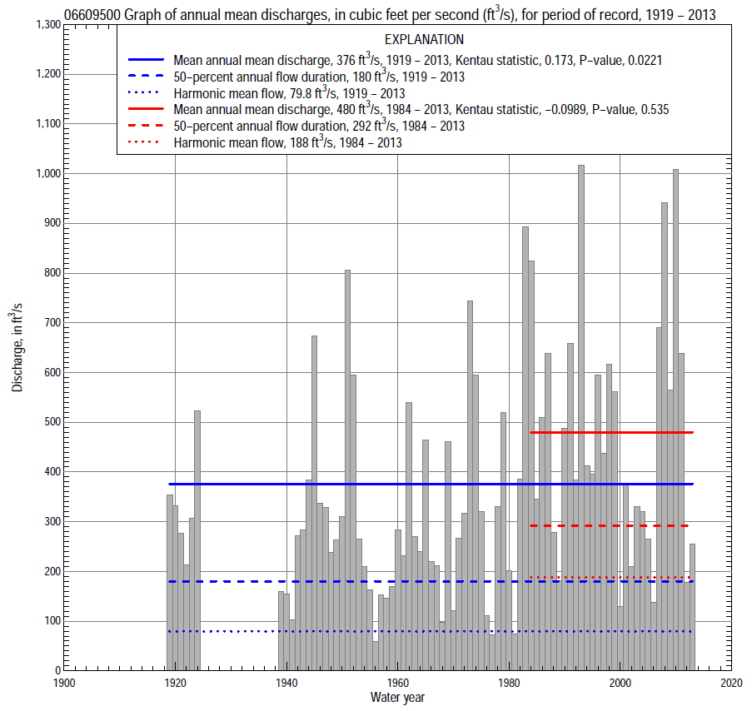

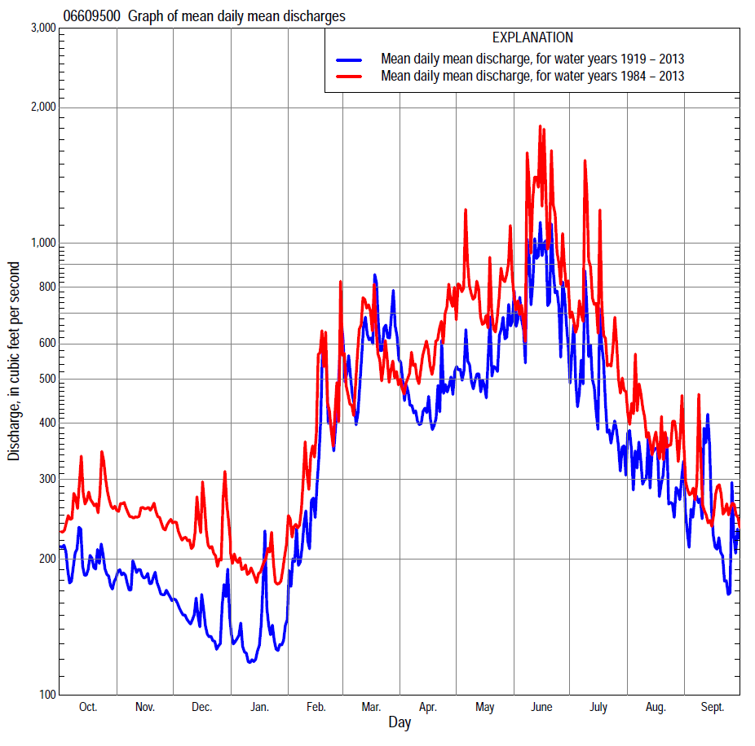

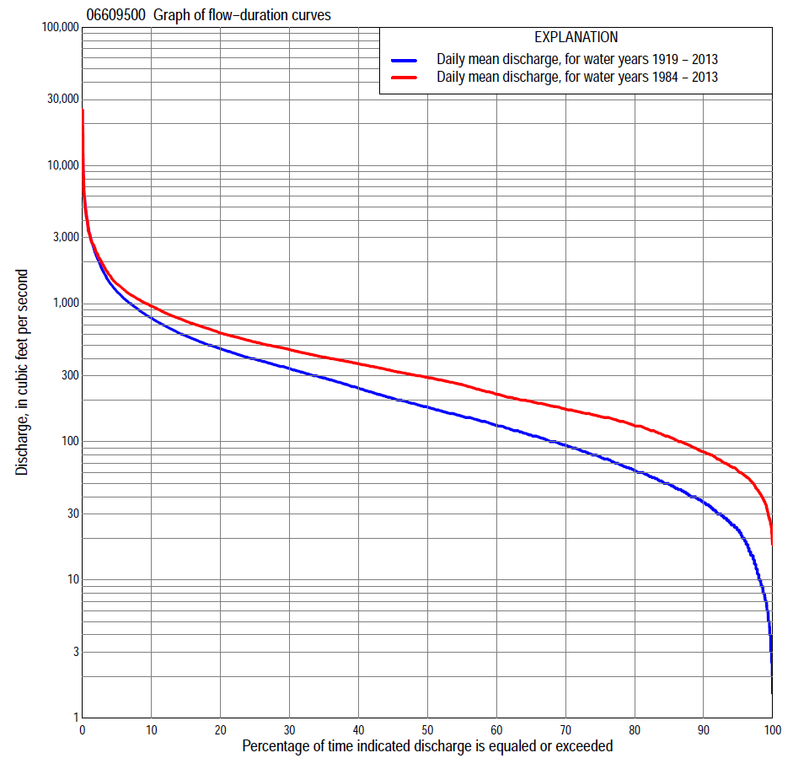

Statistics Based on the Entire Streamflow Period of Record
06609500 Monthly and annual flow durations, based on 1919–24, 1939–2013 period of record (81 years)
Percentage of days discharge equaled or exceeded |  |  |  |  | Discharge (cubic feet per second) |  |  |  |  |  |  |  |  | Annual flow durations
 | Oct | Nov | Dec | Jan | Feb | Mar | Apr | May | June | July | Aug | Sept | Annual | Kentau statistic | P-value
99 | 7.4 | 8.0 | 6.0 | 2.5 | 4.0 | 26 | 17 | 16 | 16 | 13 | 15 | 9.0 | 7.0 | 0.307 | 0.000
98 | 10 | 10 | 9.0 | 4.0 | 5.0 | 35 | 24 | 27 | 22 | 26 | 18 | 11 | 11 | 0.327 | 0.000
95 | 21 | 24 | 14 | 7.0 | 13 | 48 | 44 | 39 | 37 | 43 | 26 | 23 | 23 | 0.324 | 0.000
90 | 28 | 40 | 27 | 15 | 28 | 80 | 68 | 65 | 76 | 61 | 41 | 29 | 37 | 0.319 | 0.000
85 | 39 | 48 | 34 | 24 | 40 | 100 | 93 | 91 | 108 | 78 | 52 | 37 | 50 | 0.296 | 0.000
80 | 49 | 58 | 40 | 30 | 50 | 126 | 118 | 119 | 144 | 98 | 67 | 48 | 62 | 0.299 | 0.000
75 | 56 | 66 | 50 | 35 | 60 | 148 | 136 | 145 | 190 | 129 | 83 | 60 | 78 | 0.298 | 0.000
70 | 67 | 80 | 60 | 43 | 70 | 173 | 156 | 177 | 232 | 151 | 99 | 72 | 95 | 0.299 | 0.000
65 | 77 | 91 | 70 | 51 | 80 | 200 | 180 | 206 | 278 | 180 | 115 | 84 | 112 | 0.302 | 0.000
60 | 88 | 103 | 80 | 60 | 100 | 225 | 205 | 231 | 329 | 209 | 134 | 97 | 132 | 0.288 | 0.000
55 | 100 | 116 | 91 | 70 | 120 | 260 | 229 | 268 | 382 | 243 | 158 | 112 | 153 | 0.269 | 0.000
50 | 119 | 129 | 106 | 82 | 155 | 300 | 264 | 315 | 432 | 282 | 179 | 129 | 179 | 0.266 | 0.000
45 | 141 | 146 | 120 | 98 | 193 | 335 | 304 | 370 | 489 | 322 | 201 | 153 | 207 | 0.257 | 0.001
40 | 161 | 160 | 130 | 110 | 234 | 370 | 355 | 432 | 560 | 364 | 233 | 166 | 245 | 0.252 | 0.001
35 | 189 | 173 | 145 | 125 | 274 | 407 | 405 | 504 | 632 | 410 | 271 | 193 | 290 | 0.252 | 0.001
30 | 208 | 193 | 160 | 140 | 315 | 471 | 472 | 582 | 731 | 475 | 314 | 228 | 340 | 0.258 | 0.001
25 | 249 | 233 | 180 | 165 | 350 | 553 | 552 | 666 | 842 | 556 | 363 | 265 | 397 | 0.252 | 0.001
20 | 294 | 286 | 210 | 210 | 400 | 682 | 658 | 772 | 1,000 | 668 | 437 | 307 | 471 | 0.240 | 0.002
15 | 349 | 338 | 289 | 270 | 483 | 884 | 805 | 957 | 1,260 | 809 | 528 | 382 | 584 | 0.206 | 0.007
10 | 452 | 434 | 350 | 332 | 633 | 1,280 | 966 | 1,200 | 1,740 | 1,020 | 705 | 492 | 787 | 0.139 | 0.066
5 | 604 | 505 | 420 | 400 | 1,170 | 2,220 | 1,360 | 1,670 | 2,880 | 1,400 | 990 | 721 | 1,220 | 0.057 | 0.455
2 | 887 | 576 | 480 | 522 | 2,330 | 4,220 | 2,280 | 2,700 | 4,440 | 2,380 | 1,700 | 1,190 | 2,220 | 0.006 | 0.935
1 | 1,130 | 648 | 580 | 700 | 3,270 | 5,520 | 2,890 | 3,680 | 6,330 | 3,230 | 2,340 | 2,100 | 3,220 | -0.029 | 0.707

06609500 Annual exceedance probability of instantaneous peak discharges, in cubic feet per second (ft³/s), based on the Weighted Independent Estimates method,
Annual exceed-ance probability | Recur-rence interval (years) | Discharge (ft³/s) | 95-percent lower confi-dence interval (ft³/s) | 95-percent upper confi-dence interval (ft³/s)
0.500 | 2 | 11,100 | 10,000 | 12,400
0.200 | 5 | 17,500 | 15,900 | 19,400
0.100 | 10 | 21,600 | 19,400 | 24,100
0.040 | 25 | 26,700 | 23,300 | 30,500
0.020 | 50 | 30,200 | 25,700 | 35,400
0.010 | 100 | 33,500 | 27,700 | 40,400
0.005 | 200 | 36,700 | 29,500 | 45,600
0.002 | 500 | 40,700 | 31,400 | 52,700
and based on the expected moments algorithm/multiple Grubbs-Beck analysis computed using a historical period length of 132 years (1882–2013)
0.500 | 2 | 11,200 | 9,660 | 12,700
0.200 | 5 | 17,600 | 15,500 | 20,200
0.100 | 10 | 21,900 | 19,100 | 25,400
0.040 | 25 | 27,000 | 23,400 | 32,300
0.020 | 50 | 30,800 | 26,200 | 37,600
0.010 | 100 | 34,300 | 28,700 | 43,300
0.005 | 200 | 37,800 | 31,000 | 49,500
0.002 | 500 | 42,200 | 33,700 | 58,300
Kentau statistic |  | -0.063
P-value |  | 0.395
Begin year |  | 1918
End year |  | 2013
Number of peaks |  | 84

06609500 Annual exceedance probability of high discharges, based on 1919–24, 1939–2013 period of record (81 years)
Annual exceedance probability | Recur-rence interval (years) | Maximum average discharge (ft³/s) for indicated number of consecutive days
 |  | 1 | 3 | 7 | 15 | 30
0.990 | 1.01 | 728 | 480 | 340 | 235 | 167
0.950 | 1.05 | 1,380 | 893 | 607 | 411 | 296
0.900 | 1.11 | 1,910 | 1,230 | 818 | 549 | 396
0.800 | 1.25 | 2,800 | 1,780 | 1,160 | 773 | 557
0.500 | 2 | 5,520 | 3,500 | 2,230 | 1,450 | 1,040
0.200 | 5 | 10,300 | 6,560 | 4,140 | 2,650 | 1,850
0.100 | 10 | 13,900 | 8,930 | 5,640 | 3,580 | 2,460
0.040 | 25 | 18,900 | 12,300 | 7,770 | 4,890 | 3,290
0.020 | 50 | 22,800 | 14,900 | 9,510 | 5,960 | 3,950
0.010 | 100 | 26,900 | 17,700 | 11,400 | 7,090 | 4,630
0.005 | 200 | 31,100 | 20,600 | 13,300 | 8,290 | 5,340
0.002 | 500 | 36,800 | 24,700 | 16,100 | 9,990 | 6,310
Kentau statistic |  | 0.185 | 0.222 | 0.244 | 0.255 | 0.271
P-value |  | 0.008 | 0.001 | 0.000 | 0.000 | 0.000

 | 06609500 Annual nonexceedance probability of low discharges, based on April 1919 to March 1924, April 1938 to March 2013 period of record (80 years)
Annual nonexceed-ance probability | Recur-rence interval (years) | Minimum average discharge (ft³/s) for indicated number of consecutive days
 |  | 1 | 3 | 7 | 14 | 30 | 60 | 90 | 120 | 183
0.01 | 100 | 1.5 | 1.6 | 1.9 | 2.2 | 2.9 | 4.7 | 6.5 | 8.7 | 12
0.02 | 50 | 2.5 | 2.6 | 3.0 | 3.5 | 4.5 | 6.9 | 9.3 | 12 | 17
0.05 | 20 | 4.8 | 5.0 | 5.6 | 6.5 | 8.2 | 12 | 16 | 20 | 26
0.10 | 10 | 8.3 | 8.7 | 10 | 11 | 14 | 19 | 24 | 29 | 39
0.20 | 5 | 15 | 16 | 18 | 20 | 24 | 33 | 40 | 47 | 61
0.50 | 2 | 44 | 47 | 50 | 55 | 64 | 81 | 95 | 107 | 133
0.80 | 1.25 | 105 | 112 | 119 | 128 | 147 | 175 | 204 | 221 | 267
0.90 | 1.11 | 155 | 166 | 177 | 188 | 214 | 250 | 292 | 313 | 370
0.96 | 1.04 | 225 | 239 | 259 | 272 | 307 | 353 | 413 | 441 | 510
0.98 | 1.02 | 279 | 297 | 323 | 339 | 379 | 433 | 510 | 543 | 620
0.99 | 1.01 | 333 | 354 | 389 | 406 | 452 | 513 | 609 | 650 | 733
Kentau statistic |  | 0.452 | 0.452 | 0.467 | 0.472 | 0.466 | 0.452 | 0.430 | 0.426 | 0.376
P-value |  | 0.000 | 0.000 | 0.000 | 0.000 | 0.000 | 0.000 | 0.000 | 0.000 | 0.000

06609500 Annual nonexceedance probability of seasonal low discharges, based on July 1918 to June 1925, January 1938 to September 2013 period of record (81–83 years)
Annual nonexceed-ance probability | Recur-rence interval (years) | Minimum average discharge (cubic feet per second) for indicated number of consecutive days
 |  | 1 | 7 | 14 | 30 |  | 1 | 7 | 14 | 30
 |  | January-February-March |  |  |  |  | April-May-June
0.01 | 100 | 1.8 | 1.9 | 2.0 | 2.6 |  | 6.1 | 8.4 | 11 | 16
0.02 | 50 | 2.8 | 3.1 | 3.3 | 4.3 |  | 9.4 | 13 | 16 | 22
0.05 | 20 | 5.5 | 6.0 | 6.5 | 8.3 |  | 17 | 22 | 27 | 37
0.10 | 10 | 9.5 | 11 | 12 | 15 |  | 29 | 36 | 43 | 57
0.20 | 5 | 18 | 20 | 22 | 27 |  | 52 | 61 | 72 | 94
0.50 | 2 | 52 | 59 | 64 | 79 |  | 135 | 154 | 176 | 227
0.80 | 1.25 | 129 | 148 | 161 | 193 |  | 300 | 342 | 391 | 501
0.90 | 1.11 | 195 | 225 | 243 | 287 |  | 427 | 493 | 569 | 731
0.96 | 1.04 | 291 | 335 | 361 | 419 |  | 596 | 704 | 825 | 1,070
0.98 | 1.02 | 369 | 424 | 455 | 522 |  | 723 | 869 | 1,030 | 1,340
0.99 | 1.01 | 449 | 516 | 552 | 626 |  | 847 | 1,040 | 1,250 | 1,640
Kentau statistic |  | 0.320 | 0.324 | 0.326 | 0.289 |  | 0.292 | 0.285 | 0.267 | 0.247
P-value |  | 0.000 | 0.000 | 0.000 | 0.000 |  | 0.000 | 0.000 | 0.000 | 0.001
 |  | July-August-September |  |  |  |  | October-November-December
0.01 | 100 | 0.00 | 3.8 | 5.5 | 10 |  | 4.0 | 4.3 | 6.0 | 7.7
0.02 | 50 | 2.7 | 5.8 | 8.0 | 14 |  | 5.7 | 6.3 | 8.4 | 11
0.05 | 20 | 7.6 | 11 | 14 | 22 |  | 9.5 | 11 | 14 | 17
0.10 | 10 | 14 | 18 | 22 | 33 |  | 15 | 17 | 21 | 26
0.20 | 5 | 27 | 31 | 36 | 52 |  | 24 | 28 | 33 | 42
0.50 | 2 | 75 | 82 | 91 | 117 |  | 59 | 69 | 78 | 96
0.80 | 1.25 | 172 | 188 | 204 | 246 |  | 132 | 157 | 170 | 201
0.90 | 1.11 | 250 | 275 | 299 | 353 |  | 193 | 231 | 248 | 286
0.96 | 1.04 | 355 | 396 | 437 | 507 |  | 282 | 340 | 364 | 405
0.98 | 1.02 | 435 | 492 | 551 | 635 |  | 355 | 431 | 460 | 501
0.99 | 1.01 | 514 | 590 | 670 | 771 |  | 432 | 527 | 564 | 602
Kentau statistic |  | 0.294 | 0.279 | 0.270 | 0.194 |  | 0.325 | 0.340 | 0.321 | 0.310
P-value |  | 0.000 | 0.000 | 0.000 | 0.009 |  | 0.000 | 0.000 | 0.000 | 0.000

Statistics Based on the 1984–2013 Streamflow Period of Record
06609500 Monthly and annual flow durations, based on 1984–2013 period of record (30 years)
Percentage of days discharge equaled or exceeded |  |  |  |  | Discharge (cubic feet per second) |  |  |  |  |  |  |  |  | Annual flow durations
 | Oct | Nov | Dec | Jan | Feb | Mar | Apr | May | June | July | Aug | Sept | Annual | Kentau statistic | P-value
99 | 37 | 42 | 25 | 29 | 43 | 74 | 98 | 69 | 72 | 46 | 27 | 24 | 35 | -0.101 | 0.443
98 | 39 | 48 | 28 | 34 | 50 | 80 | 106 | 77 | 90 | 67 | 40 | 30 | 43 | -0.094 | 0.475
95 | 54 | 59 | 43 | 44 | 60 | 102 | 120 | 101 | 126 | 82 | 51 | 41 | 61 | -0.078 | 0.556
90 | 65 | 71 | 68 | 57 | 70 | 130 | 134 | 199 | 178 | 118 | 74 | 65 | 84 | -0.069 | 0.605
85 | 83 | 97 | 86 | 71 | 84 | 152 | 153 | 228 | 265 | 172 | 108 | 77 | 109 | -0.071 | 0.592
80 | 97 | 113 | 100 | 87 | 100 | 173 | 187 | 258 | 315 | 214 | 132 | 89 | 131 | -0.046 | 0.734
75 | 116 | 137 | 120 | 100 | 130 | 205 | 217 | 299 | 381 | 265 | 161 | 107 | 152 | -0.048 | 0.721
70 | 145 | 152 | 130 | 110 | 154 | 236 | 258 | 364 | 421 | 311 | 179 | 132 | 172 | -0.055 | 0.681
65 | 160 | 160 | 132 | 129 | 180 | 280 | 293 | 434 | 474 | 349 | 194 | 152 | 195 | -0.064 | 0.630
60 | 171 | 170 | 144 | 140 | 208 | 309 | 341 | 489 | 511 | 383 | 218 | 164 | 221 | -0.069 | 0.605
55 | 191 | 178 | 158 | 150 | 230 | 339 | 379 | 544 | 568 | 423 | 249 | 185 | 259 | -0.067 | 0.617
50 | 199 | 190 | 170 | 160 | 250 | 367 | 418 | 590 | 632 | 469 | 283 | 208 | 292 | -0.069 | 0.605
45 | 208 | 202 | 189 | 180 | 275 | 392 | 464 | 650 | 702 | 523 | 314 | 237 | 325 | -0.076 | 0.568
40 | 236 | 240 | 210 | 200 | 300 | 421 | 524 | 699 | 781 | 583 | 343 | 260 | 367 | -0.067 | 0.617
35 | 275 | 290 | 250 | 218 | 327 | 474 | 601 | 753 | 865 | 664 | 385 | 282 | 409 | -0.103 | 0.432
30 | 300 | 316 | 291 | 250 | 360 | 515 | 688 | 838 | 953 | 727 | 439 | 314 | 465 | -0.067 | 0.617
25 | 337 | 359 | 328 | 271 | 406 | 571 | 774 | 956 | 1,070 | 831 | 499 | 353 | 527 | -0.085 | 0.521
20 | 388 | 435 | 360 | 300 | 450 | 654 | 871 | 1,090 | 1,270 | 950 | 558 | 394 | 612 | -0.067 | 0.617
15 | 471 | 474 | 397 | 330 | 536 | 783 | 1,000 | 1,250 | 1,540 | 1,070 | 638 | 443 | 745 | -0.048 | 0.721
10 | 560 | 501 | 428 | 360 | 666 | 1,150 | 1,190 | 1,480 | 2,110 | 1,230 | 800 | 539 | 957 | -0.053 | 0.695
5 | 681 | 545 | 469 | 400 | 1,200 | 2,110 | 1,560 | 1,990 | 3,230 | 1,860 | 1,040 | 720 | 1,390 | -0.016 | 0.915
2 | 990 | 599 | 580 | 478 | 2,300 | 3,120 | 2,430 | 2,800 | 5,410 | 2,830 | 1,510 | 961 | 2,350 | 0.007 | 0.972
1 | 1,170 | 656 | 775 | 580 | 2,770 | 4,450 | 2,880 | 4,110 | 8,510 | 3,370 | 2,150 | 1,070 | 3,220 | -0.032 | 0.817

06609500 Annual exceedance probability of high discharges, based on 1984–2013 period of record (30 years)
Annual exceedance probability | Recur-rence interval (years) | Maximum average discharge (ft³/s) for indicated number of consecutive days
 |  | 1 | 3 | 7 | 15 | 30
0.990 | 1.01 | 438 | 313 | 241 | 205 | 149
0.950 | 1.05 | 931 | 672 | 485 | 379 | 284
0.900 | 1.11 | 1,370 | 991 | 695 | 522 | 395
0.800 | 1.25 | 2,170 | 1,560 | 1,060 | 765 | 581
0.500 | 2 | 4,990 | 3,500 | 2,300 | 1,560 | 1,170
0.200 | 5 | 10,900 | 7,320 | 4,780 | 3,080 | 2,230
0.100 | 10 | 16,200 | 10,500 | 6,860 | 4,360 | 3,060
0.040 | 25 | 24,100 | 15,100 | 9,970 | 6,260 | 4,240
0.020 | 50 | 31,100 | 18,900 | 12,600 | 7,880 | 5,180
0.010 | 100 | 38,700 | 22,900 | 15,500 | 9,660 | 6,180
0.005 | 200 | 47,200 | 27,200 | 18,600 | 11,600 | 7,220
0.002 | 500 | 59,700 | 33,300 | 23,200 | 14,500 | 8,680
Kentau statistic |  | -0.113 | -0.053 | -0.025 | -0.007 | 0.034
P-value |  | 0.392 | 0.695 | 0.858 | 0.972 | 0.803

 | 06609500 Annual nonexceedance probability of low discharges, based on April 1983 to March 2013 period of record (30 years)
Annual nonexceed-ance probability | Recur-rence interval (years) | Minimum average discharge (ft³/s) for indicated number of consecutive days
 |  | 1 | 3 | 7 | 14 | 30 | 60 | 90 | 120 | 183
0.01 | 100 | 12 | 13 | 14 | 16 | 18 | 24 | 28 | 32 | 35
0.02 | 50 | 16 | 17 | 19 | 21 | 24 | 31 | 36 | 40 | 44
0.05 | 20 | 23 | 25 | 28 | 31 | 36 | 45 | 50 | 55 | 62
0.10 | 10 | 32 | 35 | 39 | 43 | 49 | 60 | 67 | 73 | 82
0.20 | 5 | 45 | 50 | 56 | 62 | 71 | 85 | 94 | 101 | 115
0.50 | 2 | 87 | 95 | 106 | 117 | 135 | 154 | 169 | 181 | 207
0.80 | 1.25 | 156 | 169 | 183 | 200 | 232 | 258 | 287 | 306 | 352
0.90 | 1.11 | 208 | 221 | 235 | 257 | 297 | 326 | 370 | 394 | 453
0.96 | 1.04 | 277 | 289 | 300 | 328 | 377 | 411 | 476 | 509 | 582
0.98 | 1.02 | 331 | 340 | 347 | 378 | 434 | 471 | 556 | 595 | 679
0.99 | 1.01 | 385 | 390 | 392 | 427 | 489 | 528 | 635 | 682 | 775
Kentau statistic |  | -0.195 | -0.166 | -0.140 | -0.140 | -0.136 | -0.122 | -0.126 | -0.113 | -0.085
P-value |  | 0.134 | 0.205 | 0.284 | 0.284 | 0.301 | 0.354 | 0.335 | 0.392 | 0.521

06609500 Annual nonexceedance probability of seasonal low discharges, based on October 1983 to September 2013 period of record (30 years)
Annual nonexceed-ance probability | Recur-rence interval (years) | Minimum average discharge (cubic feet per second) for indicated number of consecutive days
 |  | 1 | 7 | 14 | 30 |  | 1 | 7 | 14 | 30
 |  | January-February-March |  |  |  |  | April-May-June
0.01 | 100 | 15 | 19 | 22 | 28 |  | 40 | 43 | 49 | 55
0.02 | 50 | 19 | 24 | 28 | 35 |  | 51 | 55 | 61 | 70
0.05 | 20 | 28 | 34 | 39 | 49 |  | 72 | 78 | 86 | 100
0.10 | 10 | 37 | 46 | 53 | 65 |  | 96 | 105 | 116 | 137
0.20 | 5 | 53 | 65 | 74 | 89 |  | 135 | 150 | 164 | 198
0.50 | 2 | 101 | 121 | 136 | 158 |  | 248 | 284 | 315 | 388
0.80 | 1.25 | 185 | 213 | 234 | 263 |  | 429 | 513 | 585 | 728
0.90 | 1.11 | 250 | 280 | 304 | 336 |  | 558 | 686 | 800 | 996
0.96 | 1.04 | 340 | 369 | 396 | 428 |  | 725 | 923 | 1,110 | 1,370
0.98 | 1.02 | 412 | 438 | 465 | 496 |  | 852 | 1,110 | 1,360 | 1,680
0.99 | 1.01 | 487 | 507 | 535 | 563 |  | 978 | 1,300 | 1,630 | 2,010
Kentau statistic |  | -0.147 | -0.124 | -0.108 | -0.113 |  | -0.094 | -0.113 | -0.094 | -0.080
P-value |  | 0.261 | 0.344 | 0.412 | 0.392 |  | 0.475 | 0.392 | 0.475 | 0.544
 |  | July-August-September |  |  |  |  | October-November-December
0.01 | 100 | 11 | 14 | 17 | 20 |  | 15 | 17 | 19 | 25
0.02 | 50 | 16 | 20 | 23 | 27 |  | 20 | 22 | 25 | 32
0.05 | 20 | 25 | 31 | 35 | 41 |  | 29 | 34 | 38 | 47
0.10 | 10 | 39 | 45 | 50 | 58 |  | 40 | 48 | 53 | 64
0.20 | 5 | 62 | 69 | 77 | 88 |  | 58 | 71 | 78 | 91
0.50 | 2 | 139 | 149 | 162 | 184 |  | 110 | 136 | 149 | 170
0.80 | 1.25 | 277 | 295 | 318 | 366 |  | 192 | 235 | 258 | 296
0.90 | 1.11 | 381 | 407 | 440 | 511 |  | 250 | 301 | 330 | 386
0.96 | 1.04 | 518 | 561 | 610 | 719 |  | 324 | 381 | 417 | 500
0.98 | 1.02 | 622 | 681 | 745 | 888 |  | 378 | 437 | 478 | 586
0.99 | 1.01 | 725 | 805 | 885 | 1,070 |  | 430 | 490 | 536 | 670
Kentau statistic |  | -0.099 | -0.094 | -0.103 | -0.122 |  | -0.062 | -0.085 | -0.085 | -0.062
P-value |  | 0.454 | 0.475 | 0.432 | 0.354 |  | 0.643 | 0.521 | 0.521 | 0.643

