LOCATION.--Lat 41°15'32", long 95°55'20" referenced to North American Datum of 1927, in SE 1/4 NW 1/4 sec.23, T.15 N., R.13 E., Douglas County, NE, Hydrologic Unit 10230006, on right bank on right side of concrete floodwall at foot of Douglas Street, 275 ft downstream from bridge on U.S. Interstate 480 in Omaha, and 615.9 mi upstream from mouth.

DRAINAGE AREA.--322,800 mi².

PERIOD OF RECORD.--Discharge records from September 1928 to current year. Stage-only records from April 1872 to December 1899 in reports of the Missouri River Commission, and since January 1875 in reports of the U.S. National Weather Service.

GAGE.--Water-stage recorder. Datum of gage is 948.24 ft above National Geodetic Vertical Datum of 1929. April 10, 1872, to August 31, 1928, non-recording gage at several sites within 0.6 mi of current site at datum not more than 10.43 ft below current datum; September 1, 1928, to November 30, 1929, non-recording gage attached to Illinois Central Railroad bridge at site 2.0 mi upstream at datum 12.97 ft higher; December 1, 1929, to October 18, 1931, non-recording gage at same site at datum 10.00 ft higher; October 19, 1931, to September 30, 1936, water-stage recorder at site 0.4 mi downstream at datum 10.00 ft higher; October 1, 1936, to September 30, 1982, at same site at datum 10.00 ft higher.

REMARKS.--Flow regulated by upstream main-stem reservoirs. Fort Randall Dam was completed in July 1952, with storage beginning in December 1952. Gavins Point Dam was completed in July 1955, with storage beginning in December 1955.

A summary of all available data for this streamgage is provided through the USGS National Water Information System web interface (NWISWeb). The following link provides access to current/historical observations, daily data, daily statistics, monthly statistics, annual statistics, peak streamflow, field measurements, field/lab water-quality samples, and the latest water-year summaries. Data can be filtered by parameter and/or dates, and can be output in various tabular and graphical formats.
http://waterdata.usgs.gov/nwis/inventory/?site_no=06610000

The USGS WaterWatch Toolkit is available at:
http://waterwatch.usgs.gov/?id=ww_toolkit
Tools for summarizing streamflow information include the duration hydrograph builder, the cumulative streamflow hydrograph builder, the streamgage statistics retrieval tool, the rating curve builder, the flood tracking chart builder, the National Weather Service Advanced Hydrologic Prediction Service (AHPS) river forecast hydrograph builder, and the raster-hydrograph builder. Entering the above number for this streamgage into these toolkit webpages will provide streamflow information specific to this streamgage.

A description of the statistics presented for this streamgage is available in the main body of the report at:
http://dx.doi.org/10.3133/ofr20151214
A link to other streamgages included in this report, a map showing the location of the streamgages, information on the programs used to compute the statistical analyses, and references are included in the main body of the report.

Statistics Based on the Pre-regulated Streamflow Period of Record

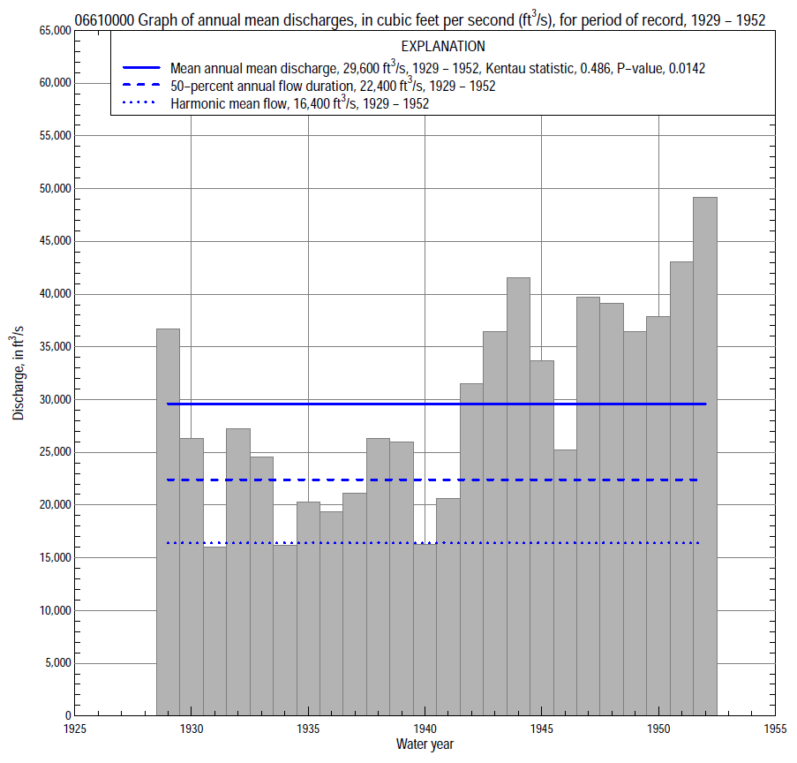

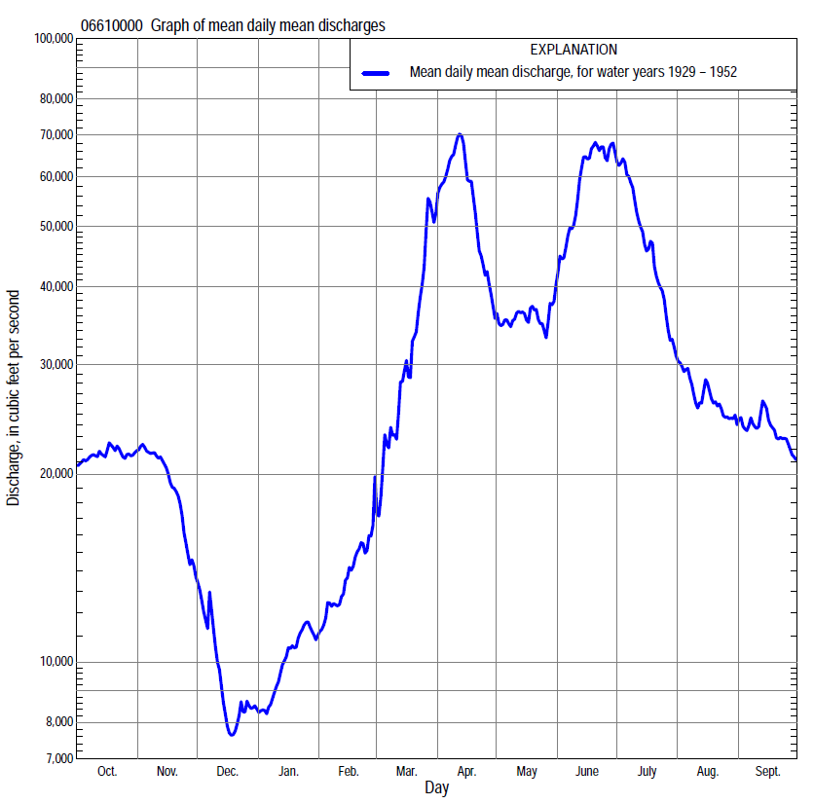

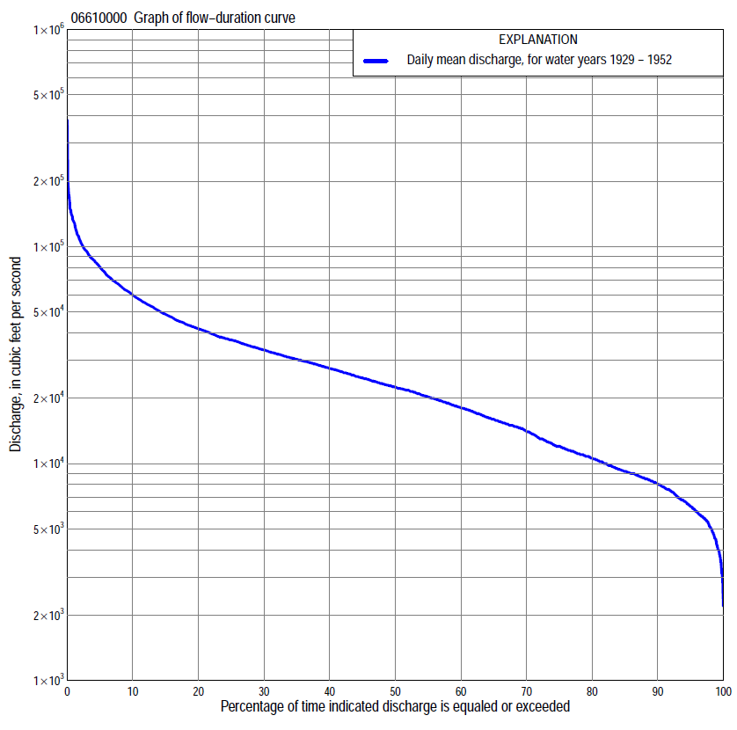

Statistics Based on the Pre-regulated Streamflow Period of Record
06610000 Monthly and annual flow durations, based on 1929–52 pre-regulated period of record (24 years)
Percentage of days discharge equaled or exceeded |  |  |  |  | Discharge (cubic feet per second) |  |  |  |  |  |  |  |  | Annual flow durations
 | Oct | Nov | Dec | Jan | Feb | Mar | Apr | May | June | July | Aug | Sept | Annual | Kentau statistic | P-value
99 | 6,800 | 4,580 | 3,100 | 3,000 | 5,100 | 6,900 | 14,800 | 13,900 | 20,400 | 13,300 | 9,060 | 6,470 | 4,200 | 0.167 | 0.264
98 | 6,980 | 5,440 | 3,500 | 3,200 | 5,100 | 7,500 | 15,200 | 14,100 | 22,000 | 14,900 | 9,600 | 6,800 | 5,100 | 0.185 | 0.215
95 | 8,600 | 7,130 | 4,200 | 4,000 | 5,600 | 9,400 | 17,700 | 15,500 | 25,000 | 17,800 | 10,400 | 8,050 | 6,340 | 0.225 | 0.130
90 | 8,980 | 8,100 | 4,840 | 5,200 | 6,200 | 12,600 | 19,500 | 18,800 | 29,100 | 21,500 | 12,100 | 9,260 | 8,020 | 0.399 | 0.007
85 | 9,510 | 9,680 | 5,500 | 5,930 | 7,400 | 15,000 | 20,400 | 20,700 | 32,500 | 25,100 | 14,700 | 10,400 | 9,200 | 0.391 | 0.008
80 | 10,500 | 10,400 | 5,860 | 6,500 | 8,300 | 15,800 | 22,000 | 21,800 | 35,400 | 28,800 | 16,300 | 12,000 | 10,500 | 0.413 | 0.005
75 | 11,500 | 10,900 | 6,300 | 7,000 | 8,680 | 16,900 | 23,400 | 22,600 | 38,300 | 31,500 | 17,900 | 13,400 | 12,000 | 0.475 | 0.001
70 | 12,000 | 11,500 | 6,600 | 7,630 | 9,200 | 17,900 | 25,300 | 23,400 | 41,000 | 33,500 | 19,500 | 15,000 | 14,000 | 0.478 | 0.001
65 | 13,700 | 12,400 | 6,840 | 8,300 | 9,800 | 18,600 | 27,300 | 24,700 | 43,400 | 35,400 | 20,700 | 16,100 | 15,900 | 0.540 | 0.000
60 | 16,200 | 14,000 | 7,400 | 8,500 | 10,500 | 19,800 | 30,100 | 26,600 | 46,600 | 38,200 | 22,100 | 19,200 | 18,000 | 0.591 | 0.000
55 | 17,600 | 15,600 | 7,720 | 8,930 | 11,000 | 21,800 | 33,200 | 29,900 | 49,700 | 40,900 | 23,900 | 21,300 | 20,200 | 0.569 | 0.000
50 | 20,600 | 17,100 | 8,200 | 9,200 | 11,700 | 23,400 | 37,000 | 31,900 | 52,500 | 43,200 | 25,300 | 23,400 | 22,400 | 0.616 | 0.000
45 | 22,200 | 18,400 | 8,820 | 9,700 | 12,500 | 25,400 | 40,000 | 33,600 | 55,300 | 45,700 | 27,300 | 25,600 | 24,800 | 0.605 | 0.000
40 | 23,800 | 19,800 | 9,310 | 10,200 | 13,600 | 27,700 | 44,400 | 35,800 | 58,200 | 49,100 | 28,600 | 27,400 | 27,500 | 0.554 | 0.000
35 | 26,000 | 21,500 | 10,000 | 11,000 | 14,500 | 30,000 | 51,100 | 37,200 | 63,200 | 53,200 | 30,000 | 28,600 | 30,300 | 0.536 | 0.000
30 | 27,400 | 23,600 | 10,700 | 11,400 | 15,000 | 35,000 | 58,100 | 41,100 | 69,000 | 56,700 | 31,900 | 29,700 | 33,400 | 0.493 | 0.001
25 | 29,400 | 25,900 | 11,500 | 12,500 | 16,400 | 40,300 | 69,500 | 44,200 | 75,000 | 59,900 | 33,900 | 30,700 | 37,200 | 0.449 | 0.002
20 | 31,900 | 28,500 | 12,600 | 13,700 | 18,000 | 48,000 | 79,200 | 47,600 | 81,300 | 63,600 | 36,100 | 31,800 | 42,000 | 0.399 | 0.007
15 | 34,800 | 30,500 | 13,900 | 15,000 | 20,000 | 57,000 | 96,800 | 52,900 | 87,500 | 69,400 | 38,200 | 32,900 | 48,800 | 0.326 | 0.027
10 | 37,200 | 35,800 | 15,800 | 16,200 | 24,000 | 67,700 | 122,000 | 60,600 | 95,600 | 79,500 | 41,600 | 35,800 | 59,900 | 0.261 | 0.078
5 | 40,800 | 39,300 | 20,400 | 18,100 | 28,000 | 87,600 | 148,000 | 70,200 | 116,000 | 95,500 | 46,100 | 44,200 | 80,600 | 0.304 | 0.040
2 | 46,000 | 42,800 | 24,000 | 20,000 | 34,800 | 102,000 | 189,000 | 88,500 | 133,000 | 112,000 | 56,700 | 53,800 | 107,000 | 0.380 | 0.010
1 | 48,200 | 43,800 | 24,800 | 20,500 | 39,000 | 108,000 | 258,000 | 101,000 | 147,000 | 126,000 | 67,100 | 61,900 | 130,000 | 0.366 | 0.013

06610000 Annual exceedance probability of instantaneous peak discharges, in cubic feet per second (ft³/s), for the pre-regulated period of record based on the expected moments algorithm/multiple Grubbs-Beck analysis computed using a historical period length of 71 years (1882–1952)ª
Annual exceed-ance probability | Recur-rence interval (years) | Discharge (ft³/s) | 95-percent lower confi-dence interval (ft³/s) | 95-percent upper confi-dence interval (ft³/s)
0.500 | 2 | 124,000 | 103,000 | 148,000
0.200 | 5 | 176,000 | 147,000 | 215,000
0.100 | 10 | 211,000 | 173,000 | 264,000
0.040 | 25 | 256,000 | 204,000 | 334,000
0.020 | 50 | 290,000 | 225,000 | 395,000
0.010 | 100 | 324,000 | 245,000 | 466,000
0.005 | 200 | 358,000 | 263,000 | 546,000
0.002 | 500 | 405,000 | 286,000 | 672,000
Kentau statistic |  | 0.355
P-value |  | 0.016
Begin year |  | 1929
End year |  | 1952
Number of peaks |  | 24
ªWeighted Independent Estimates were not computed because regional regression equations are not applicable due to watershed extending outside of Iowa flood regions.
Note: The above discharges are for the pre-regulated period of record and they are not applicable for flood-plain management regulation or for design purposes.

06610000 Annual exceedance probability of high discharges, based on 1929–52 pre-regulated period of record (24 years)
[ND, not determined]
Annual exceed-ance probability | Recur-rence interval (years) | Maximum average discharge (cubic feet per second) for indicated number of consecutive days
 |  | 1 | 3 | 7 | 15 | 30
0.990 | 1.01 | ND | ND | 31,100 | 27,200 | 26,000
0.950 | 1.05 | ND | ND | 44,700 | 39,300 | 35,900
0.900 | 1.11 | ND | ND | 54,100 | 47,400 | 42,400
0.800 | 1.25 | ND | ND | 67,800 | 59,200 | 51,700
0.500 | 2 | ND | ND | 103,000 | 89,000 | 74,500
0.200 | 5 | ND | ND | 156,000 | 131,000 | 106,000
0.100 | 10 | ND | ND | 192,000 | 159,000 | 126,000
0.040 | 25 | ND | ND | 239,000 | 194,000 | 151,000
0.020 | 50 | ND | ND | 275,000 | 220,000 | 170,000
0.010 | 100 | ND | ND | 311,000 | 245,000 | 188,000
0.005 | 200 | ND | ND | 348,000 | 271,000 | 206,000
0.002 | 500 | ND | ND | 398,000 | 304,000 | 230,000
Kentau statistic |  | 0.370 | 0.359 | 0.370 | 0.355 | 0.348
P-value |  | 0.012 | 0.015 | 0.012 | 0.016 | 0.018
Note: The above discharges are for the pre-regulated period of record and they are not applicable for flood-plain management regulation or for design purposes.

 | 06610000 Annual nonexceedance probability of low discharges, based on April 1929 to March 1952 pre-regulated period of record (23 years)
Annual nonexceed-ance probability | Recur-rence interval (years) | Minimum average discharge (cubic feet per second) for indicated number of consecutive days
 |  | 1 | 3 | 7 | 14 | 30 | 60 | 90 | 120 | 183
0.01 | 100 | 1,900 | 2,100 | 2,510 | 2,780 | 3,340 | 4,120 | 5,020 | 5,490 | 5,500
0.02 | 50 | 2,090 | 2,290 | 2,690 | 3,010 | 3,650 | 4,490 | 5,360 | 5,930 | 6,050
0.05 | 20 | 2,420 | 2,600 | 3,000 | 3,400 | 4,160 | 5,100 | 5,960 | 6,690 | 7,180
0.10 | 10 | 2,760 | 2,940 | 3,330 | 3,800 | 4,670 | 5,720 | 6,580 | 7,480 | 8,360
0.20 | 5 | 3,250 | 3,430 | 3,810 | 4,360 | 5,380 | 6,590 | 7,470 | 8,600 | 10,100
0.50 | 2 | 4,530 | 4,690 | 5,060 | 5,730 | 7,040 | 8,640 | 9,770 | 11,400 | 14,300
0.80 | 1.25 | 6,420 | 6,600 | 6,940 | 7,640 | 9,200 | 11,400 | 13,200 | 15,500 | 20,300
0.90 | 1.11 | 7,770 | 7,970 | 8,310 | 8,930 | 10,600 | 13,200 | 15,600 | 18,400 | 24,400
0.96 | 1.04 | 9,580 | 9,840 | 10,200 | 10,600 | 12,300 | 15,400 | 18,900 | 22,100 | 29,600
0.98 | 1.02 | 11,000 | 11,300 | 11,700 | 11,900 | 13,500 | 17,100 | 21,500 | 25,100 | 33,600
0.99 | 1.01 | 12,500 | 12,900 | 13,200 | 13,900 | 14,700 | 18,700 | 24,300 | 28,100 | 37,600
Kentau statistic |  | 0.170 | 0.186 | 0.217 | 0.217 | 0.273 | 0.387 | 0.423 | 0.470 | 0.597
P-value |  | 0.267 | 0.224 | 0.154 | 0.154 | 0.073 | 0.010 | 0.005 | 0.002 | 0.000

06610000 Annual nonexceedance probability of seasonal low discharges, based on October 1928 to September 1952 pre-regulated period of record (24 years)
Annual nonexceed-ance probability | Recur-rence interval (years) | Minimum average discharge (cubic feet per second) for indicated number of consecutive days
 |  | 1 | 7 | 14 | 30 |  | 1 | 7 | 14 | 30
 |  | January-February-March |  |  |  |  | April-May-June
0.01 | 100 | 1,930 | 2,420 | 2,890 | 3,640 |  | 10,800 | 11,200 | 11,900 | 13,200
0.02 | 50 | 2,230 | 2,750 | 3,260 | 4,120 |  | 11,500 | 12,000 | 12,900 | 14,400
0.05 | 20 | 2,760 | 3,320 | 3,890 | 4,930 |  | 12,900 | 13,600 | 14,500 | 16,400
0.10 | 10 | 3,320 | 3,920 | 4,530 | 5,730 |  | 14,300 | 15,100 | 16,100 | 18,500
0.20 | 5 | 4,130 | 4,760 | 5,430 | 6,820 |  | 16,400 | 17,400 | 18,500 | 21,500
0.50 | 2 | 6,140 | 6,820 | 7,570 | 9,290 |  | 21,800 | 23,300 | 24,700 | 28,600
0.80 | 1.25 | 8,930 | 9,590 | 10,400 | 12,200 |  | 29,900 | 32,200 | 34,000 | 38,400
0.90 | 1.11 | 10,800 | 11,400 | 12,200 | 13,900 |  | 35,800 | 38,600 | 40,600 | 44,800
0.96 | 1.04 | 13,100 | 13,600 | 14,300 | 15,900 |  | 43,700 | 47,200 | 49,600 | 53,000
0.98 | 1.02 | 14,700 | 15,200 | 15,900 | 17,200 |  | 50,100 | 54,100 | 56,700 | 59,200
0.99 | 1.01 | 16,400 | 16,800 | 17,400 | 18,400 |  | 56,900 | 61,400 | 64,200 | 65,300
Kentau statistic |  | 0.170 | 0.290 | 0.355 | 0.370 |  | 0.373 | 0.355 | 0.333 | 0.355
P-value |  | 0.253 | 0.050 | 0.016 | 0.012 |  | 0.011 | 0.016 | 0.024 | 0.016
 |  | July-August-September |  |  |  |  | October-November-December
0.01 | 100 | 4,400 | 4,490 | 4,780 | 5,450 |  | 2,180 | 2,890 | 3,220 | 4,200
0.02 | 50 | 5,190 | 5,320 | 5,680 | 6,480 |  | 2,400 | 3,120 | 3,520 | 4,580
0.05 | 20 | 6,590 | 6,810 | 7,300 | 8,300 |  | 2,780 | 3,510 | 4,020 | 5,230
0.10 | 10 | 8,110 | 8,430 | 9,040 | 10,200 |  | 3,160 | 3,910 | 4,520 | 5,870
0.20 | 5 | 10,400 | 10,800 | 11,600 | 13,100 |  | 3,700 | 4,460 | 5,180 | 6,750
0.50 | 2 | 16,200 | 17,000 | 18,000 | 20,100 |  | 5,040 | 5,800 | 6,690 | 8,800
0.80 | 1.25 | 24,600 | 25,800 | 26,800 | 29,400 |  | 6,900 | 7,640 | 8,540 | 11,400
0.90 | 1.11 | 30,300 | 31,600 | 32,500 | 35,200 |  | 8,160 | 8,860 | 9,660 | 13,100
0.96 | 1.04 | 37,600 | 39,000 | 39,400 | 42,200 |  | 9,760 | 10,400 | 11,000 | 15,100
0.98 | 1.02 | 43,000 | 44,000 | 44,300 | 47,100 |  | 11,000 | 11,600 | 11,900 | 16,500
0.99 | 1.01 | 48,400 | 48,500 | 49,100 | 51,800 |  | 12,200 | 12,800 | 12,800 | 17,900
Kentau statistic |  | 0.572 | 0.572 | 0.572 | 0.587 |  | 0.069 | 0.123 | 0.145 | 0.341
P-value |  | 0.000 | 0.000 | 0.000 | 0.000 |  | 0.655 | 0.413 | 0.333 | 0.021

Statistics Based on the Regulated Streamflow Period of Record

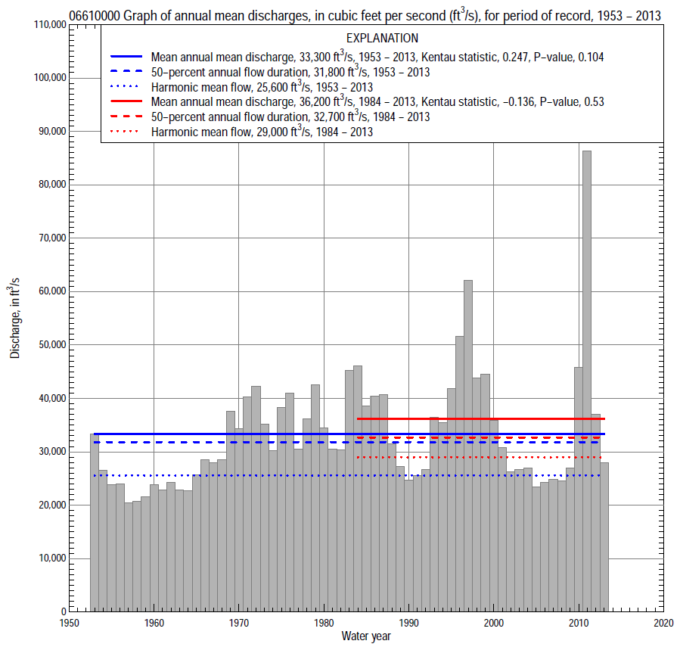

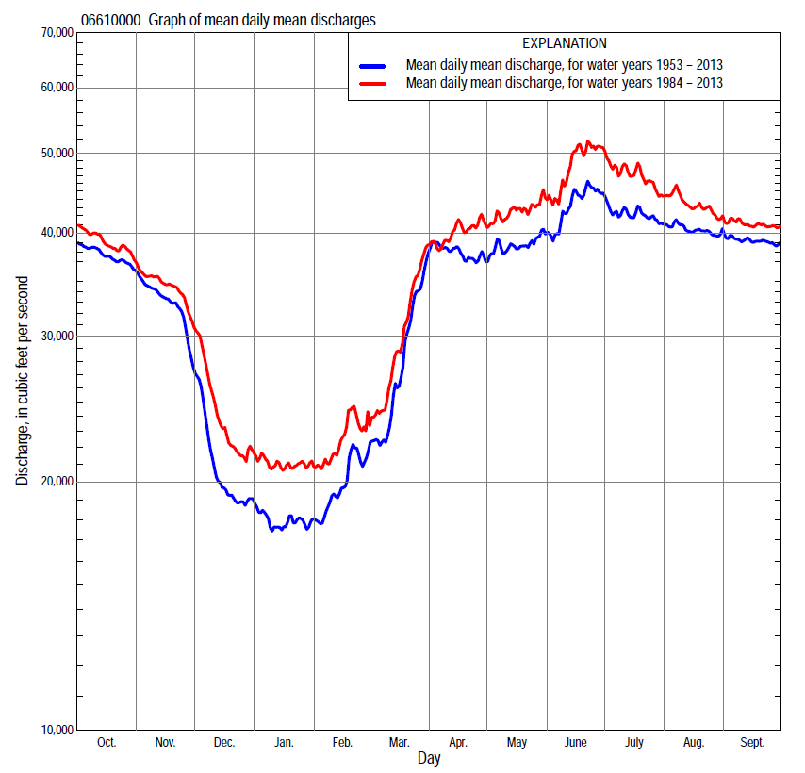

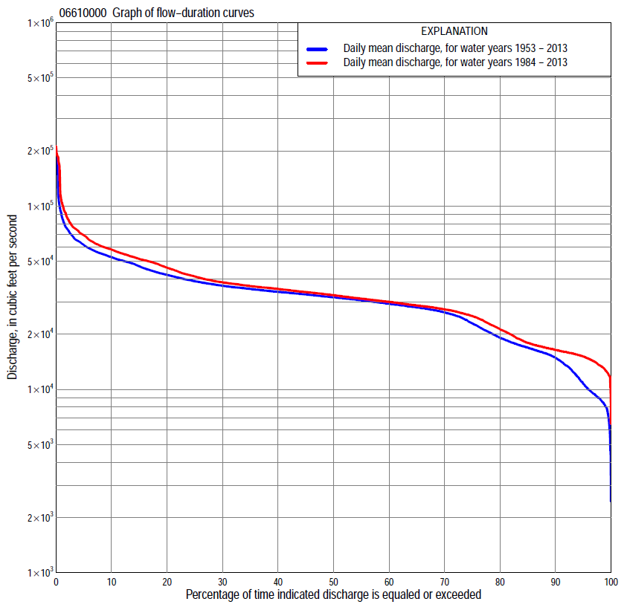
Statistics Based on the Regulated Streamflow Period of Record
06610000 Monthly and annual flow durations, based on 1953–2013 regulated period of record (61 years)
Percentage of days discharge equaled or exceeded |  |  |  |  | Discharge (cubic feet per second) |  |  |  |  |  |  |  |  | Annual flow durations
 | Oct | Nov | Dec | Jan | Feb | Mar | Apr | May | June | July | Aug | Sept | Annual | Kentau statistic | P-value
99 | 12,600 | 8,040 | 4,860 | 5,980 | 7,800 | 7,380 | 12,300 | 24,600 | 25,000 | 24,800 | 24,600 | 24,500 | 8,040 | 0.467 | 0.000
98 | 14,300 | 8,520 | 6,630 | 6,900 | 8,000 | 8,760 | 21,400 | 25,000 | 25,700 | 25,900 | 25,400 | 26,000 | 8,880 | 0.436 | 0.000
95 | 20,600 | 11,100 | 8,520 | 8,400 | 8,800 | 10,400 | 24,800 | 26,000 | 27,700 | 27,300 | 26,800 | 27,700 | 10,700 | 0.356 | 0.000
90 | 27,400 | 13,100 | 9,650 | 9,200 | 9,650 | 12,700 | 26,300 | 27,200 | 29,000 | 28,400 | 28,400 | 28,900 | 14,900 | 0.299 | 0.001
85 | 28,400 | 14,100 | 10,500 | 10,000 | 10,700 | 14,200 | 27,200 | 28,400 | 30,000 | 29,400 | 29,400 | 29,700 | 16,900 | 0.299 | 0.001
80 | 29,700 | 15,700 | 12,200 | 11,200 | 13,300 | 15,700 | 28,000 | 29,400 | 31,000 | 30,200 | 30,300 | 30,400 | 19,100 | 0.270 | 0.002
75 | 30,400 | 17,200 | 13,900 | 13,500 | 15,000 | 17,400 | 28,900 | 30,800 | 32,100 | 31,200 | 31,200 | 31,300 | 22,900 | 0.238 | 0.007
70 | 31,200 | 20,500 | 15,100 | 15,000 | 15,800 | 18,500 | 29,800 | 31,900 | 33,200 | 32,100 | 32,000 | 31,900 | 26,400 | 0.193 | 0.028
65 | 31,800 | 27,400 | 16,000 | 15,600 | 16,400 | 20,200 | 31,000 | 32,700 | 34,100 | 33,200 | 32,700 | 32,700 | 28,000 | 0.164 | 0.062
60 | 32,600 | 29,300 | 16,800 | 16,100 | 17,000 | 22,000 | 32,100 | 33,300 | 34,900 | 34,200 | 33,500 | 33,500 | 29,400 | 0.149 | 0.090
55 | 33,400 | 31,000 | 17,600 | 16,600 | 17,700 | 23,700 | 33,200 | 34,000 | 36,100 | 35,200 | 34,100 | 34,200 | 30,600 | 0.147 | 0.095
50 | 34,200 | 32,000 | 18,500 | 17,000 | 18,400 | 25,900 | 34,100 | 34,800 | 37,300 | 36,000 | 34,700 | 34,900 | 31,800 | 0.164 | 0.062
45 | 35,400 | 33,500 | 19,200 | 17,400 | 19,100 | 27,800 | 35,200 | 36,100 | 39,000 | 37,000 | 35,400 | 35,700 | 33,000 | 0.165 | 0.061
40 | 36,300 | 34,600 | 20,200 | 18,100 | 20,000 | 29,700 | 36,200 | 37,400 | 40,200 | 38,600 | 36,200 | 36,200 | 34,100 | 0.161 | 0.067
35 | 37,200 | 36,600 | 21,800 | 19,100 | 21,100 | 31,400 | 37,700 | 38,800 | 41,600 | 40,400 | 37,400 | 37,300 | 35,300 | 0.174 | 0.048
30 | 39,300 | 39,000 | 23,000 | 20,800 | 22,500 | 32,800 | 39,400 | 40,800 | 43,700 | 42,200 | 39,400 | 39,000 | 36,800 | 0.173 | 0.050
25 | 42,500 | 44,300 | 25,900 | 22,300 | 24,200 | 34,400 | 42,000 | 42,500 | 47,200 | 45,000 | 42,800 | 41,400 | 38,900 | 0.164 | 0.063
20 | 47,500 | 48,700 | 28,100 | 24,700 | 26,000 | 37,300 | 45,500 | 45,100 | 50,800 | 49,300 | 45,900 | 48,600 | 42,200 | 0.190 | 0.031
15 | 50,700 | 53,700 | 31,600 | 26,200 | 28,000 | 40,400 | 49,600 | 48,800 | 55,000 | 52,100 | 51,400 | 51,700 | 47,000 | 0.191 | 0.030
10 | 57,000 | 55,800 | 35,800 | 27,700 | 31,000 | 45,400 | 54,300 | 53,200 | 61,300 | 58,400 | 57,200 | 58,000 | 52,700 | 0.214 | 0.015
5 | 64,000 | 60,400 | 44,500 | 29,900 | 34,600 | 55,200 | 66,600 | 62,200 | 76,600 | 70,400 | 66,300 | 64,600 | 61,400 | 0.203 | 0.021
2 | 70,700 | 67,600 | 51,100 | 31,900 | 42,200 | 67,100 | 84,500 | 84,200 | 106,000 | 96,300 | 90,900 | 71,700 | 75,100 | 0.135 | 0.126
1 | 74,900 | 74,800 | 55,500 | 33,900 | 49,200 | 76,800 | 96,500 | 91,600 | 137,000 | 190,000 | 169,000 | 99,400 | 89,300 | 0.113 | 0.200

06610000 Annual exceedance probability of instantaneous peak discharges, in cubic feet per second (ft³/s), based on U.S. Army Corps of Engineers regulated flow frequency studyª, analysis computed using a record length of 100 years (1898–1997)
USACE Regulated Flow Frequency Analysis
[ND, not determined]
Annual exceed-ance probability | Recurrence interval (years) | Discharge (ft³/s) | 95-percent lower confidence interval (ft³/s) | 95-percent upper confidence interval (ft³/s)
0.500 | 2 | 64,200 | ND | ND
0.200 | 5 | 85,300 | ND | ND
0.100 | 10 | 124,000 | ND | ND
0.040 | 25 | ND | ND | ND
0.020 | 50 | 148,000 | ND | ND
0.010 | 100 | 175,000 | ND | ND
0.005 | 200 | 205,000 | ND | ND
0.002 | 500 | 248,000 | ND | ND
ªU.S. Army Corps of Engineers, 2003, Upper Mississippi River System Flow Frequency Study, Hydrology and Hydraulics Appendix F Missouri River, Omaha District: U.S. Army Corps of Engineers, 488 p., accessed September 16, 2014, at http://www.mvr.usace.army.mil/Portals/48/docs/FRM/UpperMissFlowFreq/App.%20F%20Omaha%20Dist.%20Hydrology_Hydraulics%20Report.pdf.
USGS Kendall's Tau Trend Analysis
Kentau statistic |  | 0.026
P-value |  | 0.775
Begin year |  | 1953^{b}
End year |  | 2013^{b}
Number of peaks |  | 61
^{b}Kendall's tau trend analysis computed using the regulated period of record which is not the same period of record used for the above regulated flow frequency analysis.

06610000 Annual exceedance probability of high discharges, based on 1953–2013 regulated period of recordª (61 years)
[ND, not determined]
Annual exceedance probability | Recur-rence interval (years) | Maximum average discharge (cubic feet per second) for indicated number of consecutive days
 |  | 1 | 3 | 7 | 15 | 30
0.990 | 1.01 | ND | ND | ND | ND | ND
0.950 | 1.05 | ND | ND | ND | ND | ND
0.900 | 1.11 | ND | ND | ND | ND | ND
0.800 | 1.25 | ND | ND | ND | ND | ND
0.500 | 2 | ND | ND | ND | ND | ND
0.200 | 5 | ND | ND | ND | ND | ND
0.100 | 10 | ND | ND | ND | ND | ND
0.040 | 25 | ND | ND | ND | ND | ND
0.020 | 50 | ND | ND | ND | ND | ND
0.010 | 100 | ND | ND | ND | ND | ND
0.005 | 200 | ND | ND | ND | ND | ND
0.002 | 500 | ND | ND | ND | ND | ND
Kentau statistic |  | 0.082 | 0.111 | 0.127 | 0.143 | 0.167
P-value |  | 0.354 | 0.209 | 0.151 | 0.104 | 0.058
ªContact the U.S. Army Corps of Engineers, Omaha District, for the annual exceedance probability of high discharges.

 | 06610000 Annual nonexceedance probability of low discharges, based on April 1953 to March 2013 regulated period of record (60 years)
Annual nonexceed-ance probability | Recur-rence interval (years) | Minimum average discharge (cubic feet per second) for indicated number of consecutive days
 |  | 1 | 3 | 7 | 14 | 30 | 60 | 90 | 120 | 183
0.01 | 100 | 2,080 | 2,300 | 3,410 | 4,990 | 5,650 | 6,250 | 6,530 | 7,020 | 10,900
0.02 | 50 | 2,610 | 2,900 | 4,130 | 5,740 | 6,450 | 7,090 | 7,410 | 7,960 | 12,000
0.05 | 20 | 3,610 | 4,030 | 5,420 | 7,050 | 7,830 | 8,520 | 8,910 | 9,580 | 13,700
0.10 | 10 | 4,740 | 5,290 | 6,810 | 8,400 | 9,250 | 9,980 | 10,500 | 11,300 | 15,600
0.20 | 5 | 6,480 | 7,210 | 8,830 | 10,300 | 11,200 | 12,000 | 12,600 | 13,600 | 18,100
0.50 | 2 | 11,100 | 12,200 | 13,800 | 14,800 | 15,900 | 16,800 | 17,800 | 19,300 | 24,400
0.80 | 1.25 | 17,800 | 19,000 | 20,200 | 20,700 | 21,900 | 22,900 | 24,500 | 26,900 | 33,000
0.90 | 1.11 | 22,200 | 23,200 | 24,100 | 24,400 | 25,600 | 26,700 | 28,700 | 31,800 | 38,700
0.96 | 1.04 | 27,400 | 28,100 | 28,600 | 28,700 | 30,000 | 31,200 | 33,800 | 37,800 | 46,100
0.98 | 1.02 | 31,200 | 31,500 | 31,600 | 31,800 | 33,100 | 34,300 | 37,400 | 42,100 | 51,600
0.99 | 1.01 | 34,400 | 34,400 | 34,400 | 34,700 | 36,000 | 37,300 | 40,900 | 46,400 | 57,200
Kentau statistic |  | 0.459 | 0.484 | 0.479 | 0.427 | 0.371 | 0.344 | 0.298 | 0.281 | 0.245
P-value |  | 0.000 | 0.000 | 0.000 | 0.000 | 0.000 | 0.000 | 0.001 | 0.002 | 0.006

06610000 Annual nonexceedance probability of seasonal low discharges, based on October 1952 to September 2013 regulated period of record (61 years)
Annual nonexceed-ance probability | Recur-rence interval (years) | Minimum average discharge (cubic feet per second) for indicated number of consecutive days
 |  | 1 | 7 | 14 | 30 |  | 1 | 7 | 14 | 30
 |  | January-February-March |  |  |  |  | April-May-June
0.01 | 100 | 3,530 | 4,580 | 5,530 | 6,100 |  | 13,400 | 14,600 | 15,500 | 21,300
0.02 | 50 | 4,110 | 5,310 | 6,300 | 6,920 |  | 15,100 | 16,200 | 17,100 | 22,100
0.05 | 20 | 5,130 | 6,600 | 7,610 | 8,330 |  | 17,700 | 18,900 | 19,800 | 23,500
0.10 | 10 | 6,240 | 7,950 | 8,960 | 9,750 |  | 20,300 | 21,500 | 22,300 | 25,000
0.20 | 5 | 7,860 | 9,850 | 10,800 | 11,700 |  | 23,600 | 24,800 | 25,600 | 27,200
0.50 | 2 | 12,100 | 14,500 | 15,300 | 16,300 |  | 30,600 | 31,800 | 32,600 | 32,800
0.80 | 1.25 | 18,200 | 20,500 | 21,100 | 22,200 |  | 38,000 | 39,300 | 40,400 | 41,000
0.90 | 1.11 | 22,400 | 24,200 | 24,700 | 25,800 |  | 41,900 | 43,400 | 44,700 | 46,900
0.96 | 1.04 | 27,700 | 28,600 | 29,000 | 30,000 |  | 46,000 | 47,600 | 49,300 | 54,700
0.98 | 1.02 | 31,800 | 31,800 | 32,000 | 32,900 |  | 48,600 | 50,400 | 52,300 | 61,000
0.99 | 1.01 | 34,700 | 34,700 | 34,900 | 35,700 |  | 50,900 | 52,800 | 55,100 | 67,500
Kentau statistic |  | 0.455 | 0.489 | 0.439 | 0.397 |  | 0.228 | 0.208 | 0.199 | 0.190
P-value |  | 0.000 | 0.000 | 0.000 | 0.000 |  | 0.010 | 0.018 | 0.024 | 0.031
 |  | July-August-September |  |  |  |  | October-November-December
0.01 | 100 | 14,500 | 18,700 | 22,500 | 24,800 |  | 1,920 | 3,500 | 5,210 | 6,040
0.02 | 50 | 16,100 | 19,700 | 23,100 | 25,200 |  | 2,560 | 4,320 | 6,040 | 6,880
0.05 | 20 | 18,700 | 21,500 | 24,100 | 25,900 |  | 3,850 | 5,810 | 7,500 | 8,360
0.10 | 10 | 21,300 | 23,300 | 25,300 | 26,800 |  | 5,370 | 7,450 | 9,030 | 9,950
0.20 | 5 | 24,800 | 25,900 | 27,200 | 28,400 |  | 7,760 | 9,860 | 11,200 | 12,300
0.50 | 2 | 32,600 | 32,600 | 32,700 | 33,600 |  | 14,200 | 15,900 | 16,700 | 18,300
0.80 | 1.25 | 41,900 | 42,300 | 42,300 | 43,200 |  | 22,800 | 23,700 | 24,000 | 27,400
0.90 | 1.11 | 47,400 | 49,200 | 49,900 | 51,300 |  | 28,000 | 28,500 | 28,800 | 33,800
0.96 | 1.04 | 53,700 | 58,400 | 61,000 | 63,500 |  | 33,600 | 33,900 | 34,600 | 42,200
0.98 | 1.02 | 58,000 | 65,600 | 70,400 | 74,200 |  | 37,300 | 37,600 | 38,800 | 48,800
0.99 | 1.01 | 62,100 | 73,100 | 80,900 | 86,400 |  | 40,500 | 41,000 | 42,900 | 55,500
Kentau statistic |  | 0.143 | 0.114 | 0.118 | 0.110 |  | 0.324 | 0.345 | 0.333 | 0.302
P-value |  | 0.104 | 0.198 | 0.181 | 0.211 |  | 0.000 | 0.000 | 0.000 | 0.001

Statistics Based on the 1984–2013 Regulated Streamflow Period of Record
06610000 Monthly and annual flow durations, based on 1984–2013 regulated period of record (30 years)
Percentage of days discharge equaled or exceeded |  |  |  |  | Discharge (cubic feet per second) |  |  |  |  |  |  |  |  | Annual flow durations
 | Oct | Nov | Dec | Jan | Feb | Mar | Apr | May | June | July | Aug | Sept | Annual | Kentau statistic | P-value
99 | 13,200 | 11,800 | 10,600 | 13,400 | 13,000 | 12,200 | 21,500 | 24,800 | 28,100 | 24,800 | 24,700 | 21,900 | 12,700 | -0.037 | 0.789
98 | 14,100 | 12,200 | 12,000 | 14,000 | 13,300 | 12,400 | 23,800 | 25,300 | 28,400 | 26,800 | 25,400 | 24,500 | 13,500 | -0.053 | 0.695
95 | 17,600 | 13,000 | 13,700 | 14,900 | 14,500 | 13,500 | 25,600 | 26,800 | 29,300 | 27,400 | 26,500 | 26,900 | 15,100 | -0.071 | 0.592
90 | 25,300 | 13,500 | 14,900 | 15,400 | 15,300 | 14,500 | 26,800 | 28,500 | 30,700 | 28,500 | 27,700 | 28,900 | 16,400 | -0.136 | 0.300
85 | 28,300 | 14,400 | 15,500 | 15,900 | 15,800 | 15,700 | 27,800 | 30,000 | 31,800 | 29,100 | 28,800 | 29,900 | 17,900 | -0.113 | 0.392
80 | 30,100 | 15,300 | 16,000 | 16,100 | 16,100 | 17,300 | 28,400 | 31,600 | 33,100 | 30,200 | 29,700 | 30,600 | 21,300 | -0.131 | 0.318
75 | 30,700 | 16,400 | 16,400 | 16,500 | 16,500 | 18,900 | 28,900 | 32,800 | 33,900 | 31,200 | 30,300 | 31,400 | 25,100 | -0.120 | 0.363
70 | 31,400 | 18,100 | 16,800 | 16,800 | 16,900 | 21,200 | 29,800 | 33,700 | 34,700 | 32,500 | 31,200 | 32,100 | 27,300 | -0.143 | 0.276
65 | 32,100 | 27,400 | 17,400 | 17,000 | 17,400 | 22,600 | 31,500 | 34,300 | 36,100 | 33,900 | 32,400 | 33,000 | 28,700 | -0.168 | 0.199
60 | 33,100 | 29,700 | 18,200 | 17,400 | 18,100 | 24,700 | 33,000 | 35,500 | 37,400 | 35,200 | 33,400 | 33,800 | 30,000 | -0.225 | 0.083
55 | 34,500 | 31,400 | 19,000 | 17,800 | 18,800 | 26,700 | 34,100 | 36,900 | 38,900 | 36,000 | 34,100 | 34,800 | 31,300 | -0.255 | 0.050
50 | 35,500 | 32,900 | 20,400 | 18,900 | 20,000 | 28,000 | 35,500 | 38,100 | 39,900 | 37,100 | 34,800 | 35,500 | 32,700 | -0.246 | 0.059
45 | 36,200 | 35,000 | 22,000 | 20,400 | 20,900 | 29,600 | 37,000 | 39,400 | 41,100 | 38,400 | 35,600 | 36,000 | 34,000 | -0.223 | 0.087
40 | 37,000 | 36,100 | 23,000 | 21,400 | 22,300 | 30,900 | 38,700 | 41,200 | 42,700 | 40,000 | 36,300 | 36,700 | 35,300 | -0.221 | 0.090
35 | 37,800 | 38,100 | 24,400 | 23,400 | 23,900 | 32,400 | 40,100 | 42,300 | 45,400 | 42,600 | 37,400 | 37,800 | 36,600 | -0.205 | 0.116
30 | 41,500 | 45,500 | 27,000 | 24,800 | 25,600 | 33,600 | 42,800 | 44,100 | 50,400 | 47,800 | 39,400 | 38,900 | 38,400 | -0.195 | 0.134
25 | 47,700 | 48,900 | 29,400 | 26,000 | 27,200 | 35,800 | 46,500 | 46,500 | 54,000 | 51,000 | 44,100 | 48,800 | 41,300 | -0.193 | 0.138
20 | 50,000 | 52,300 | 32,000 | 26,900 | 28,400 | 38,300 | 49,900 | 51,000 | 56,300 | 54,700 | 51,300 | 51,800 | 46,200 | -0.152 | 0.246
15 | 57,100 | 54,600 | 34,800 | 27,800 | 30,900 | 41,600 | 52,200 | 55,000 | 62,100 | 61,900 | 59,400 | 58,400 | 51,500 | -0.120 | 0.363
10 | 60,800 | 58,000 | 40,800 | 29,000 | 33,500 | 46,000 | 58,200 | 61,600 | 73,400 | 70,200 | 65,400 | 60,700 | 57,900 | -0.108 | 0.412
5 | 66,300 | 63,800 | 48,100 | 30,600 | 35,700 | 56,800 | 74,100 | 81,200 | 92,300 | 88,100 | 81,300 | 70,100 | 69,400 | -0.092 | 0.486
2 | 74,900 | 74,800 | 54,000 | 32,700 | 42,200 | 68,500 | 92,000 | 89,400 | 137,000 | 190,000 | 169,000 | 99,400 | 86,700 | -0.090 | 0.498
1 | 77,100 | 75,300 | 56,300 | 36,700 | 48,800 | 76,300 | 97,300 | 93,000 | 185,000 | 195,000 | 175,000 | 103,000 | 106,000 | -0.087 | 0.509

06610000 Annual exceedance probability of high discharges, based on 1984–2013 regulated period of recordª (30 years)
[ND, not determined]
Annual exceedance probability | Recur-rence interval (years) | Maximum average discharge (cubic feet per second) for indicated number of consecutive days
 |  | 1 | 3 | 7 | 15 | 30
0.990 | 1.01 | ND | ND | ND | ND | ND
0.950 | 1.05 | ND | ND | ND | ND | ND
0.900 | 1.11 | ND | ND | ND | ND | ND
0.800 | 1.25 | ND | ND | ND | ND | ND
0.500 | 2 | ND | ND | ND | ND | ND
0.200 | 5 | ND | ND | ND | ND | ND
0.100 | 10 | ND | ND | ND | ND | ND
0.040 | 25 | ND | ND | ND | ND | ND
0.020 | 50 | ND | ND | ND | ND | ND
0.010 | 100 | ND | ND | ND | ND | ND
0.005 | 200 | ND | ND | ND | ND | ND
0.002 | 500 | ND | ND | ND | ND | ND
Kentau statistic |  | -0.067 | -0.069 | -0.057 | -0.076 | -0.080
P-value |  | 0.617 | 0.605 | 0.669 | 0.568 | 0.544
ªContact the U.S. Army Corps of Engineers, Omaha District, for the annual exceedance probability of high discharges.

 | 06610000 Annual nonexceedance probability of low discharges, based on April 1983 to March 2013 regulated period of record (30 years)
Annual nonexceed-ance probability | Recur-rence interval (years) | Minimum average discharge (cubic feet per second) for indicated number of consecutive days
 |  | 1 | 3 | 7 | 14 | 30 | 60 | 90 | 120 | 183
0.01 | 100 | 6,110 | 7,400 | 8,830 | 9,590 | 9,860 | 10,900 | 11,100 | 11,200 | 13,100
0.02 | 50 | 6,830 | 8,130 | 9,560 | 10,300 | 10,600 | 11,600 | 11,900 | 12,000 | 14,100
0.05 | 20 | 8,050 | 9,360 | 10,800 | 11,500 | 11,900 | 12,700 | 13,100 | 13,300 | 15,800
0.10 | 10 | 9,300 | 10,600 | 12,000 | 12,700 | 13,100 | 13,900 | 14,300 | 14,700 | 17,600
0.20 | 5 | 11,000 | 12,300 | 13,600 | 14,300 | 14,800 | 15,500 | 16,000 | 16,700 | 20,100
0.50 | 2 | 15,100 | 16,200 | 17,400 | 18,000 | 18,700 | 19,400 | 20,300 | 21,600 | 26,300
0.80 | 1.25 | 20,300 | 21,200 | 22,300 | 22,800 | 23,800 | 24,600 | 26,200 | 28,700 | 35,300
0.90 | 1.11 | 23,500 | 24,400 | 25,300 | 25,900 | 27,000 | 28,100 | 30,200 | 33,600 | 41,500
0.96 | 1.04 | 27,500 | 28,200 | 29,000 | 29,600 | 31,000 | 32,400 | 35,400 | 40,000 | 49,700
0.98 | 1.02 | 30,300 | 31,000 | 31,700 | 32,400 | 33,900 | 35,600 | 39,500 | 45,000 | 56,100
0.99 | 1.01 | 33,000 | 33,600 | 34,300 | 35,100 | 36,800 | 38,900 | 43,600 | 50,100 | 62,700
Kentau statistic |  | -0.014 | -0.007 | -0.014 | -0.048 | -0.076 | -0.071 | -0.094 | -0.090 | -0.126
P-value |  | 0.929 | 0.972 | 0.929 | 0.721 | 0.568 | 0.592 | 0.475 | 0.498 | 0.335

06610000 Annual nonexceedance probability of seasonal low discharges, based on October 1983 to September 2013 regulated period of record (30 years)
Annual nonexceed-ance probability | Recur-rence interval (years) | Minimum average discharge (cubic feet per second) for indicated number of consecutive days
 |  | 1 | 7 | 14 | 30 |  | 1 | 7 | 14 | 30
 |  | January-February-March |  |  |  |  | April-May-June
0.01 | 100 | 6,930 | 10,200 | 10,800 | 11,300 |  | 21,000 | 21,600 | 22,200 | 23,100
0.02 | 50 | 7,740 | 10,900 | 11,400 | 12,000 |  | 21,600 | 22,200 | 22,800 | 23,700
0.05 | 20 | 9,090 | 11,900 | 12,500 | 13,100 |  | 22,600 | 23,300 | 24,000 | 24,900
0.10 | 10 | 10,400 | 13,000 | 13,600 | 14,200 |  | 23,800 | 24,500 | 25,200 | 26,200
0.20 | 5 | 12,200 | 14,500 | 15,100 | 15,700 |  | 25,600 | 26,400 | 27,200 | 28,300
0.50 | 2 | 16,400 | 18,100 | 18,600 | 19,300 |  | 30,800 | 31,800 | 32,700 | 34,300
0.80 | 1.25 | 21,400 | 22,800 | 23,300 | 24,100 |  | 39,200 | 40,600 | 42,000 | 44,300
0.90 | 1.11 | 24,300 | 25,900 | 26,300 | 27,200 |  | 45,600 | 47,400 | 49,100 | 52,100
0.96 | 1.04 | 27,800 | 29,700 | 30,100 | 31,200 |  | 54,700 | 57,200 | 59,300 | 63,200
0.98 | 1.02 | 30,100 | 32,600 | 32,900 | 34,100 |  | 62,300 | 65,300 | 67,900 | 72,600
0.99 | 1.01 | 32,400 | 35,400 | 35,700 | 37,100 |  | 70,600 | 74,100 | 77,200 | 82,900
Kentau statistic |  | -0.110 | -0.090 | -0.090 | -0.103 |  | -0.287 | -0.278 | -0.285 | -0.274
P-value |  | 0.402 | 0.498 | 0.498 | 0.432 |  | 0.027 | 0.032 | 0.028 | 0.035
 |  | July-August-September |  |  |  |  | October-November-December
0.01 | 100 | 19,500 | 20,300 | 21,800 | 23,600 |  | 6,990 | 8,800 | 9,420 | 9,430
0.02 | 50 | 20,300 | 21,000 | 22,300 | 24,000 |  | 7,770 | 9,570 | 10,200 | 10,300
0.05 | 20 | 21,700 | 22,400 | 23,400 | 24,900 |  | 9,110 | 10,900 | 11,500 | 11,600
0.10 | 10 | 23,300 | 23,800 | 24,800 | 26,000 |  | 10,500 | 12,200 | 12,800 | 13,000
0.20 | 5 | 25,700 | 26,200 | 26,900 | 28,000 |  | 12,500 | 14,100 | 14,700 | 15,200
0.50 | 2 | 32,400 | 32,900 | 33,400 | 34,200 |  | 17,300 | 18,700 | 19,300 | 21,200
0.80 | 1.25 | 43,300 | 44,500 | 45,300 | 46,300 |  | 24,000 | 25,200 | 26,000 | 30,300
0.90 | 1.11 | 51,800 | 53,800 | 55,200 | 56,700 |  | 28,400 | 29,500 | 30,600 | 36,900
0.96 | 1.04 | 63,900 | 67,600 | 70,200 | 73,000 |  | 34,100 | 35,100 | 36,600 | 45,900
0.98 | 1.02 | 74,100 | 79,400 | 83,400 | 87,800 |  | 38,400 | 39,300 | 41,300 | 53,200
0.99 | 1.01 | 85,400 | 92,700 | 98,600 | 105,000 |  | 42,700 | 43,700 | 46,100 | 60,900
Kentau statistic |  | -0.198 | -0.216 | -0.195 | -0.205 |  | -0.064 | -0.051 | -0.090 | -0.099
P-value |  | 0.129 | 0.097 | 0.134 | 0.116 |  | 0.630 | 0.708 | 0.498 | 0.454

