LOCATION.--Lat 41°17'32", long 95°49'59" referenced to North American Datum of 1927, Pottawattamie County, IA, Hydrologic Unit 10230006, on left bank on downstream side of bridge on State Highway 183 at northern edge of Council Bluffs, and 8.3 mi upstream from mouth.

DRAINAGE AREA.--7.99 mi².

PERIOD OF RECORD.--Discharge records from July 1954 to September 1976.

GAGE.--Water-stage recorder. Datum of gage is 1,038.86 ft above National Geodetic Vertical Datum of 1929 (City of Council Bluffs benchmark). Prior to April 12, 1955, non-recording gage at site 0.2 mi downstream at different datum.

REMARKS.--Flow partly regulated by several small dams completed in 1975. Regulation is limited to pool storage behind dams, the largest of which is the lower dam, located 2.0 mi upstream, with a maximum pool capacity below crest when dry of 460 acre-ft.

EXTREMES OUTSIDE PERIOD OF RECORD.--Flood of June 20, 1942, reached a discharge of 9,200 ft³/s, from information by U.S. Army Corps of Engineers.

A summary of all available data for this streamgage is provided through the USGS National Water Information System web interface (NWISWeb). The following link provides access to current/historical observations, daily data, daily statistics, monthly statistics, annual statistics, peak streamflow, field measurements, field/lab water-quality samples, and the latest water-year summaries. Data can be filtered by parameter and/or dates, and can be output in various tabular and graphical formats.
http://waterdata.usgs.gov/nwis/inventory/?site_no=06610500

The USGS WaterWatch Toolkit is available at:
http://waterwatch.usgs.gov/?id=ww_toolkit
Tools for summarizing streamflow information include the duration hydrograph builder, the cumulative streamflow hydrograph builder, the streamgage statistics retrieval tool, the rating curve builder, the flood tracking chart builder, the National Weather Service Advanced Hydrologic Prediction Service (AHPS) river forecast hydrograph builder, and the raster-hydrograph builder. Entering the above number for this streamgage into these toolkit webpages will provide streamflow information specific to this streamgage.

A description of the statistics presented for this streamgage is available in the main body of the report at:
http://dx.doi.org/10.3133/ofr20151214
A link to other streamgages included in this report, a map showing the location of the streamgages, information on the programs used to compute the statistical analyses, and references are included in the main body of the report.

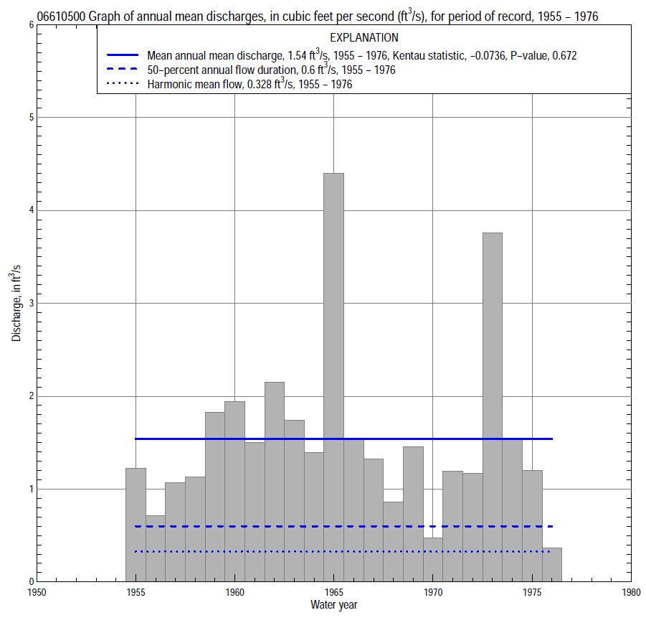

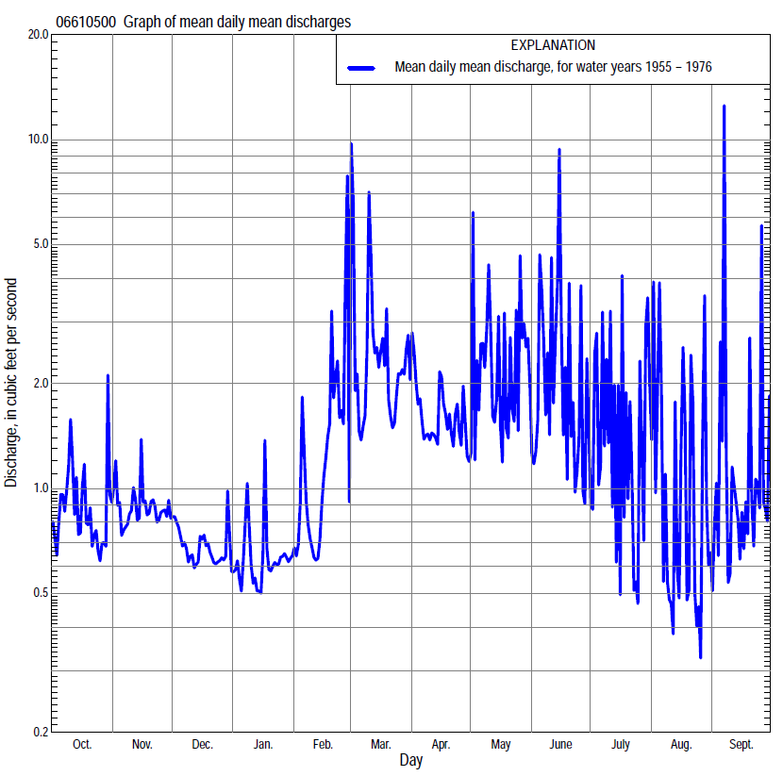

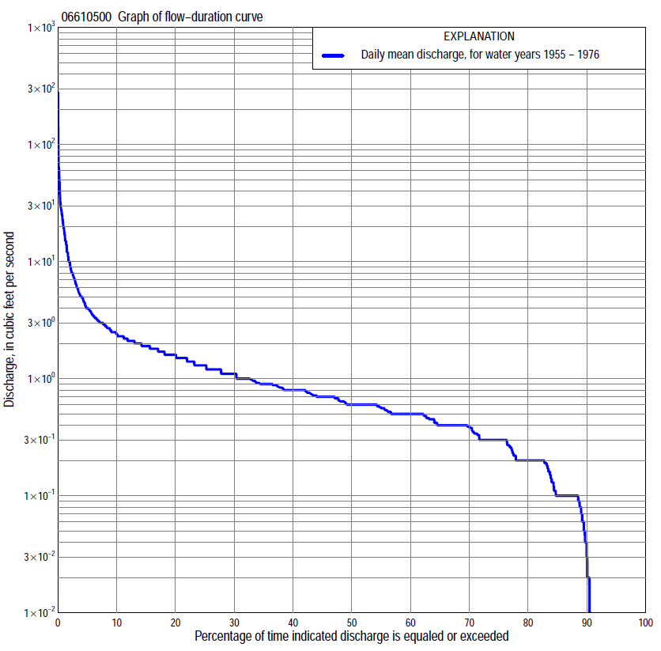

Statistics Based on the Entire Streamflow Period of Record
06610500 Monthly and annual flow durations, based on 1955–76 period of record (22 years)
[ND, not determined]
Percentage of days discharge equaled or exceeded |  |  |  |  | Discharge (cubic feet per second) |  |  |  |  |  |  |  |  | Annual flow durations
 | Oct | Nov | Dec | Jan | Feb | Mar | Apr | May | June | July | Aug | Sept | Annual | Kentau statistic | P-value
99 | 0.00 | 0.00 | 0.00 | 0.00 | 0.00 | 0.00 | 0.10 | 0.00 | 0.00 | 0.00 | 0.00 | 0.00 | 0.00 | 0.000 | ND
98 | 0.00 | 0.00 | 0.00 | 0.00 | 0.00 | 0.10 | 0.18 | 0.10 | 0.00 | 0.00 | 0.00 | 0.00 | 0.00 | 0.000 | ND
95 | 0.00 | 0.00 | 0.00 | 0.00 | 0.00 | 0.20 | 0.20 | 0.10 | 0.01 | 0.00 | 0.00 | 0.00 | 0.00 | 0.000 | ND
90 | 0.00 | 0.12 | 0.10 | 0.00 | 0.05 | 0.40 | 0.33 | 0.20 | 0.10 | 0.00 | 0.00 | 0.00 | 0.06 | 0.000 | ND
85 | 0.10 | 0.20 | 0.20 | 0.02 | 0.10 | 0.50 | 0.40 | 0.30 | 0.20 | 0.04 | 0.01 | 0.00 | 0.13 | 0.000 | ND
80 | 0.20 | 0.20 | 0.20 | 0.10 | 0.10 | 0.54 | 0.50 | 0.40 | 0.26 | 0.10 | 0.09 | 0.07 | 0.20 | 0.065 | 0.270
75 | 0.30 | 0.30 | 0.30 | 0.10 | 0.20 | 0.60 | 0.60 | 0.50 | 0.40 | 0.19 | 0.16 | 0.17 | 0.30 | 0.065 | 0.270
70 | 0.33 | 0.40 | 0.40 | 0.20 | 0.30 | 0.70 | 0.68 | 0.60 | 0.50 | 0.20 | 0.22 | 0.20 | 0.40 | 0.139 | 0.077
65 | 0.40 | 0.45 | 0.40 | 0.30 | 0.35 | 0.72 | 0.74 | 0.70 | 0.60 | 0.30 | 0.30 | 0.30 | 0.42 | 0.108 | 0.251
60 | 0.40 | 0.52 | 0.50 | 0.30 | 0.40 | 0.80 | 0.84 | 0.86 | 0.70 | 0.30 | 0.39 | 0.38 | 0.50 | 0.108 | 0.252
55 | 0.50 | 0.60 | 0.50 | 0.40 | 0.50 | 0.90 | 0.90 | 1.0 | 0.83 | 0.40 | 0.40 | 0.42 | 0.58 | 0.108 | 0.252
50 | 0.52 | 0.68 | 0.54 | 0.40 | 0.60 | 1.0 | 1.1 | 1.2 | 0.93 | 0.50 | 0.46 | 0.50 | 0.60 | 0.074 | 0.533
45 | 0.60 | 0.75 | 0.60 | 0.50 | 0.60 | 1.1 | 1.3 | 1.3 | 1.1 | 0.60 | 0.50 | 0.54 | 0.70 | 0.022 | 0.893
40 | 0.64 | 0.80 | 0.65 | 0.50 | 0.70 | 1.3 | 1.5 | 1.4 | 1.2 | 0.70 | 0.50 | 0.60 | 0.80 | 0.056 | 0.693
35 | 0.76 | 0.90 | 0.72 | 0.60 | 0.86 | 1.6 | 1.6 | 1.5 | 1.3 | 0.80 | 0.60 | 0.63 | 0.90 | 0.134 | 0.331
30 | 0.90 | 0.99 | 0.80 | 0.70 | 0.99 | 1.9 | 1.8 | 1.6 | 1.5 | 0.90 | 0.60 | 0.73 | 1.1 | 0.160 | 0.255
25 | 1.1 | 1.1 | 0.91 | 0.80 | 1.1 | 2.2 | 1.9 | 1.9 | 1.7 | 1.0 | 0.68 | 0.80 | 1.3 | 0.247 | 0.086
20 | 1.3 | 1.5 | 1.0 | 0.84 | 1.7 | 2.9 | 2.1 | 2.3 | 2.0 | 1.2 | 0.80 | 0.92 | 1.6 | 0.216 | 0.139
15 | 1.6 | 1.8 | 1.2 | 1.0 | 2.1 | 3.5 | 2.3 | 3.0 | 2.7 | 1.4 | 0.92 | 1.2 | 1.9 | 0.121 | 0.422
10 | 2.0 | 2.0 | 1.5 | 1.5 | 2.6 | 5.5 | 3.2 | 4.0 | 3.3 | 1.8 | 1.4 | 1.7 | 2.4 | 0.160 | 0.295
5 | 2.7 | 2.3 | 1.7 | 2.1 | 4.0 | 8.5 | 4.6 | 7.3 | 8.0 | 5.1 | 2.3 | 4.0 | 4.0 | -0.052 | 0.752
2 | 3.5 | 2.7 | 2.0 | 2.5 | 8.0 | 15 | 6.8 | 19 | 22 | 22 | 14 | 8.2 | 10 | -0.394 | 0.011
1 | 7.1 | 3.2 | 2.1 | 3.0 | 15 | 20 | 9.5 | 28 | 29 | 29 | 23 | 18 | 20 | -0.437 | 0.005

06610500 Annual exceedance probability of instantaneous peak discharges, in cubic feet per second (ft³/s), based on the Weighted Independent Estimates method,
Annual exceed-ance probability | Recur-rence interval (years) | Discharge (ft³/s) | 95-percent lower confi-dence interval (ft³/s) | 95-percent upper confi-dence interval (ft³/s)
0.500 | 2 | 562 | 416 | 758
0.200 | 5 | 1,560 | 1,180 | 2,070
0.100 | 10 | 2,450 | 1,830 | 3,290
0.040 | 25 | 3,810 | 2,740 | 5,310
0.020 | 50 | 4,900 | 3,380 | 7,090
0.010 | 100 | 6,040 | 4,010 | 9,090
0.005 | 200 | 7,230 | 4,620 | 11,300
0.002 | 500 | 8,800 | 5,300 | 14,600
and based on the expected moments algorithm/multiple Grubbs-Beck analysis computed using a historical period length of 72 years (1942–2013)
0.500 | 2 | 550 | 288 | 980
0.200 | 5 | 1,580 | 890 | 2,870
0.100 | 10 | 2,610 | 1,450 | 4,930
0.040 | 25 | 4,340 | 2,300 | 8,750
0.020 | 50 | 5,910 | 3,000 | 12,800
0.010 | 100 | 7,720 | 3,730 | 18,100
0.005 | 200 | 9,760 | 4,480 | 25,200
0.002 | 500 | 12,800 | 5,480 | 38,600
Kentau statistic |  | -0.351
P-value |  | 0.024
Begin year |  | 1955
End year |  | 1976
Number of peaks |  | 22

06610500 Annual exceedance probability of high discharges, based on 1955–76 period of record (22 years)
Annual exceedance probability | Recur-rence interval (years) | Maximum average discharge (ft³/s) for indicated number of consecutive days
 |  | 1 | 3 | 7 | 15 | 30
0.990 | 1.01 | 4.8 | 2.0 | 1.0 | 0.63 | 0.56
0.950 | 1.05 | 10 | 4.6 | 2.4 | 1.5 | 1.3
0.900 | 1.11 | 14 | 6.8 | 3.7 | 2.4 | 1.8
0.800 | 1.25 | 21 | 11 | 5.9 | 3.8 | 2.8
0.500 | 2 | 45 | 23 | 13 | 8.0 | 5.4
0.200 | 5 | 91 | 44 | 23 | 14 | 9.1
0.100 | 10 | 129 | 59 | 29 | 18 | 11
0.040 | 25 | 184 | 77 | 36 | 23 | 14
0.020 | 50 | 229 | 91 | 41 | 25 | 15
0.010 | 100 | 278 | 104 | 46 | 28 | 17
0.005 | 200 | 330 | 116 | 49 | 30 | 18
0.002 | 500 | 404 | 132 | 54 | 32 | 19
Kentau statistic |  | -0.364 | -0.342 | -0.385 | -0.463 | -0.368
P-value |  | 0.019 | 0.028 | 0.013 | 0.003 | 0.018

 | 06610500 Annual nonexceedance probability of low discharges, based on April 1955 to March 1976 period of record (21 years)
Annual nonexceed-ance probability | Recur-rence interval (years) | Minimum average discharge (cubic feet per second) for indicated number of consecutive days
 |  | 1 | 3 | 7 | 14 | 30 | 60 | 90 | 120 | 183
0.01 | 100 | 0.00 | 0.00 | 0.00 | 0.00 | 0.00 | 0.00 | 0.00 | 0.00 | 0.09
0.02 | 50 | 0.00 | 0.00 | 0.00 | 0.00 | 0.00 | 0.00 | 0.00 | 0.00 | 0.12
0.05 | 20 | 0.00 | 0.00 | 0.00 | 0.00 | 0.00 | 0.02 | 0.05 | 0.06 | 0.17
0.10 | 10 | 0.00 | 0.00 | 0.00 | 0.00 | 0.00 | 0.07 | 0.13 | 0.15 | 0.23
0.20 | 5 | 0.00 | 0.00 | 0.00 | 0.00 | 0.04 | 0.12 | 0.19 | 0.24 | 0.33
0.50 | 2 | 0.00 | 0.00 | 0.02 | 0.08 | 0.16 | 0.28 | 0.39 | 0.48 | 0.62
0.80 | 1.25 | 0.16 | 0.21 | 0.23 | 0.25 | 0.38 | 0.61 | 0.75 | 0.88 | 1.1
0.90 | 1.11 | 0.28 | 0.33 | 0.39 | 0.44 | 0.55 | 0.89 | 1.1 | 1.2 | 1.5
0.96 | 1.04 | 0.44 | 0.50 | 0.61 | 0.74 | 0.77 | 1.3 | 1.5 | 1.6 | 2.0
0.98 | 1.02 | 0.57 | 0.60 | 0.77 | 1.0 | 1.2 | 1.7 | 1.9 | 2.0 | 2.5
0.99 | 1.01 | 0.69 | 0.80 | 0.93 | 1.4 | 1.7 | 2.1 | 2.3 | 2.5 | 2.9
Kentau statistic |  | 0.129 | 0.138 | 0.157 | 0.133 | 0.124 | 0.190 | 0.190 | 0.219 | 0.152
P-value |  | 0.380 | 0.345 | 0.312 | 0.411 | 0.449 | 0.239 | 0.239 | 0.174 | 0.349

06610500 Annual nonexceedance probability of seasonal low discharges, based on July 1954 to September 1976 period of record (22–23 years)
Annual nonexceed-ance probability | Recur-rence interval (years) | Minimum average discharge (cubic feet per second) for indicated number of consecutive days
 |  | 1 | 7 | 14 | 30 |  | 1 | 7 | 14 | 30
 |  | January-February-March |  |  |  |  | April-May-June
0.01 | 100 | 0.00 | 0.00 | 0.00 | 0.00 |  | 0.00 | 0.00 | 0.00 | 0.01
0.02 | 50 | 0.00 | 0.00 | 0.00 | 0.00 |  | 0.00 | 0.00 | 0.00 | 0.03
0.05 | 20 | 0.00 | 0.00 | 0.00 | 0.01 |  | 0.00 | 0.00 | 0.04 | 0.07
0.10 | 10 | 0.00 | 0.00 | 0.00 | 0.05 |  | 0.00 | 0.02 | 0.12 | 0.14
0.20 | 5 | 0.00 | 0.00 | 0.03 | 0.10 |  | 0.01 | 0.11 | 0.21 | 0.29
0.50 | 2 | 0.00 | 0.09 | 0.15 | 0.33 |  | 0.31 | 0.39 | 0.51 | 0.86
0.80 | 1.25 | 0.50 | 0.54 | 0.60 | 0.87 |  | 0.85 | 0.99 | 1.1 | 1.7
0.90 | 1.11 | 0.86 | 1.0 | 1.1 | 1.4 |  | 1.2 | 1.5 | 1.7 | 2.2
0.96 | 1.04 | 1.4 | 1.8 | 1.9 | 2.2 |  | 1.5 | 2.2 | 2.5 | 2.7
0.98 | 1.02 | 1.8 | 2.4 | 2.8 | 3.0 |  | 1.6 | 2.8 | 3.2 | 3.5
0.99 | 1.01 | 2.3 | 3.1 | 3.7 | 3.8 |  | 1.7 | 3.5 | 3.9 | 4.1
Kentau statistic |  | 0.359 | 0.316 | 0.368 | 0.385 |  | 0.290 | 0.238 | 0.242 | 0.216
P-value |  | 0.013 | 0.039 | 0.018 | 0.013 |  | 0.062 | 0.128 | 0.121 | 0.167
 |  | July-August-September |  |  |  |  | October-November-December
0.01 | 100 | 0.00 | 0.00 | 0.00 | 0.00 |  | 0.00 | 0.00 | 0.00 | 0.00
0.02 | 50 | 0.00 | 0.00 | 0.00 | 0.00 |  | 0.00 | 0.00 | 0.00 | 0.00
0.05 | 20 | 0.00 | 0.00 | 0.00 | 0.00 |  | 0.00 | 0.00 | 0.00 | 0.00
0.10 | 10 | 0.00 | 0.00 | 0.00 | 0.00 |  | 0.00 | 0.00 | 0.00 | 0.05
0.20 | 5 | 0.00 | 0.00 | 0.01 | 0.08 |  | 0.00 | 0.00 | 0.08 | 0.17
0.50 | 2 | 0.09 | 0.18 | 0.19 | 0.37 |  | 0.13 | 0.28 | 0.33 | 0.46
0.80 | 1.25 | 0.33 | 0.42 | 0.49 | 0.75 |  | 0.47 | 0.65 | 0.75 | 0.90
0.90 | 1.11 | 0.46 | 0.53 | 0.67 | 0.95 |  | 0.80 | 0.90 | 1.1 | 1.2
0.96 | 1.04 | 0.58 | 0.62 | 0.84 | 1.1 |  | 1.1 | 1.2 | 1.4 | 1.6
0.98 | 1.02 | 0.66 | 0.7 | 0.94 | 1.2 |  | 1.3 | 1.4 | 1.7 | 1.8
0.99 | 1.01 | 0.7 | 0.8 | 1.0 | 1.3 |  | 1.5 | 1.6 | 2.0 | 2.1
Kentau statistic |  | 0.111 | 0.115 | 0.095 | -0.126 |  | 0.247 | 0.251 | 0.277 | 0.316
P-value |  | 0.459 | 0.457 | 0.541 | 0.412 |  | 0.107 | 0.105 | 0.076 | 0.042

