LOCATION.--Lat 40°53'05", long 95°44'45" referenced to North American Datum of 1927, Fremont County, IA, Hydrologic Unit 10240001, on downstream side of bridge on County Highway J10, 2.2 mi east of Bartlett, and 3.8 mi upstream from mouth.

DRAINAGE AREA.--30.4 mi².

PERIOD OF RECORD.--Discharge records from January 1946 to September 1969.

GAGE.--Water-stage recorder. Datum of gage is 936.96 ft above National Geodetic Vertical Datum of 1929. Prior to June 16, 1951, non-recording gage, and January 1, 1946, to May 8, 1950, supplementary high-stage recorder, both at same site and datum.

A summary of all available data for this streamgage is provided through the USGS National Water Information System web interface (NWISWeb). The following link provides access to current/historical observations, daily data, daily statistics, monthly statistics, annual statistics, peak streamflow, field measurements, field/lab water-quality samples, and the latest water-year summaries. Data can be filtered by parameter and/or dates, and can be output in various tabular and graphical formats.
http://waterdata.usgs.gov/nwis/inventory/?site_no=06806000

The USGS WaterWatch Toolkit is available at:
http://waterwatch.usgs.gov/?id=ww_toolkit
Tools for summarizing streamflow information include the duration hydrograph builder, the cumulative streamflow hydrograph builder, the streamgage statistics retrieval tool, the rating curve builder, the flood tracking chart builder, the National Weather Service Advanced Hydrologic Prediction Service (AHPS) river forecast hydrograph builder, and the raster-hydrograph builder. Entering the above number for this streamgage into these toolkit webpages will provide streamflow information specific to this streamgage.

A description of the statistics presented for this streamgage is available in the main body of the report at:
http://dx.doi.org/10.3133/ofr20151214
A link to other streamgages included in this report, a map showing the location of the streamgages, information on the programs used to compute the statistical analyses, and references are included in the main body of the report.

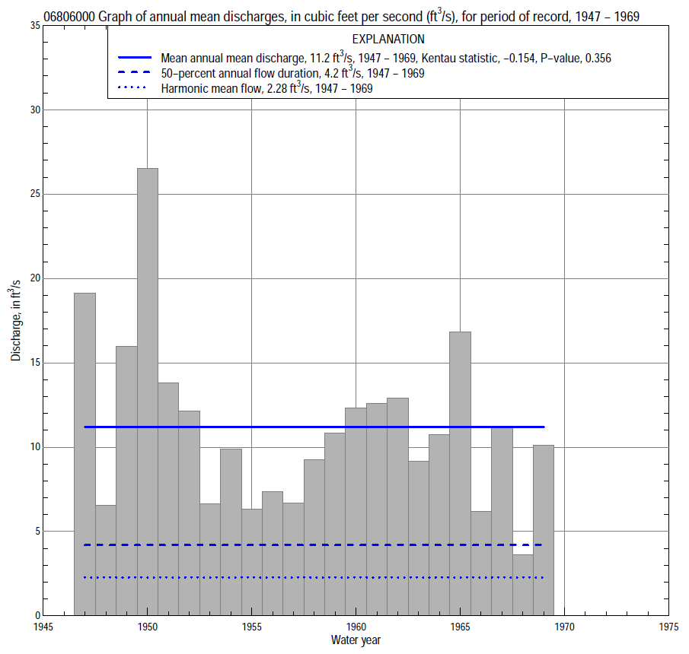

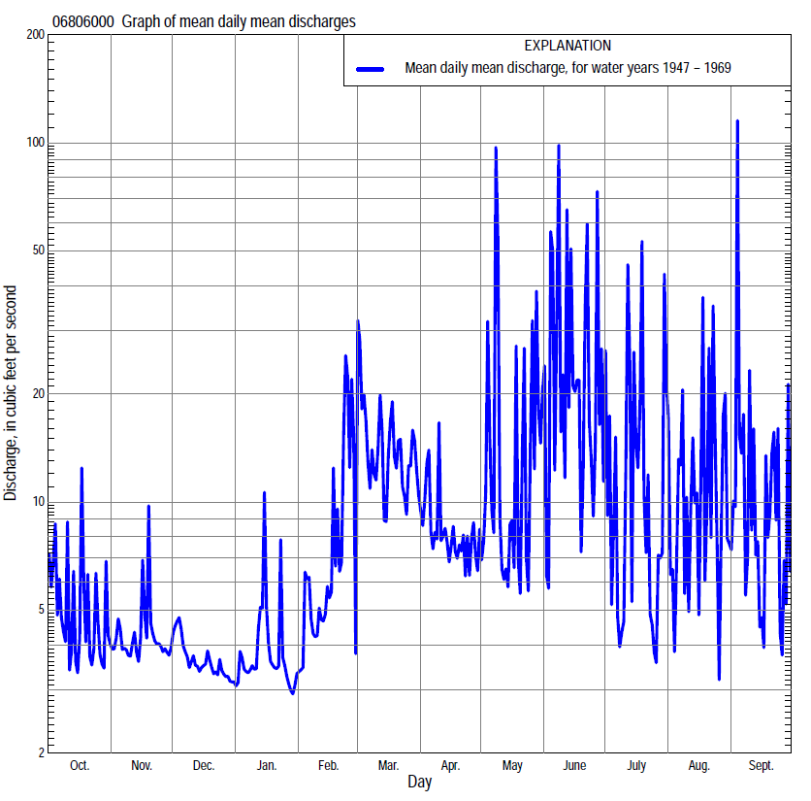

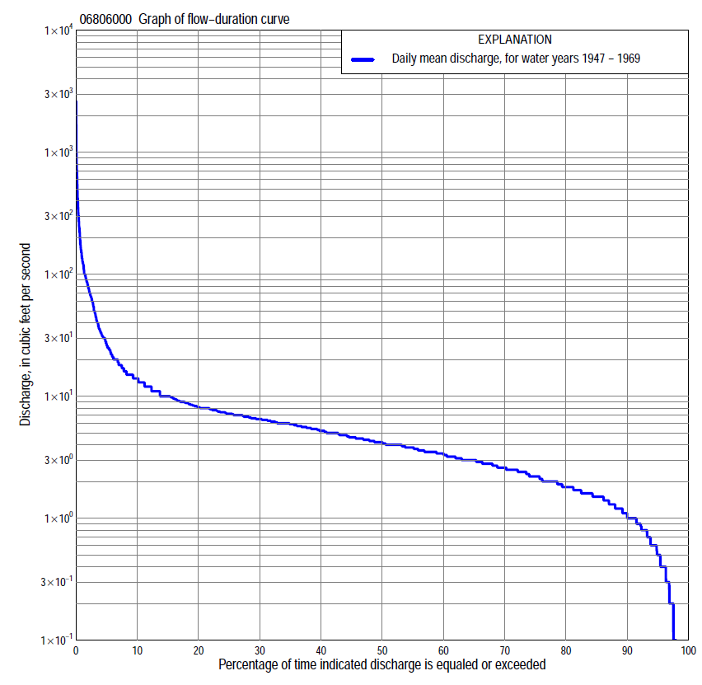

Statistics Based on the Entire Streamflow Period of Record
06806000 Monthly and annual flow durations, based on 1947–69 period of record (23 years)
Percentage of days discharge equaled or exceeded |  |  |  |  | Discharge (cubic feet per second) |  |  |  |  |  |  |  |  | Annual flow durations
 | Oct | Nov | Dec | Jan | Feb | Mar | Apr | May | June | July | Aug | Sept | Annual | Kentau statistic | P-value
99 | 0.00 | 0.40 | 0.20 | 0.10 | 0.00 | 1.7 | 1.4 | 1.0 | 0.00 | 0.00 | 0.00 | 0.00 | 0.00 | 0.194 | 0.151
98 | 0.00 | 0.40 | 0.40 | 0.10 | 0.10 | 2.0 | 1.5 | 1.1 | 0.00 | 0.00 | 0.00 | 0.00 | 0.00 | 0.213 | 0.119
95 | 0.30 | 0.60 | 0.70 | 0.50 | 0.30 | 2.3 | 2.0 | 1.6 | 0.40 | 0.20 | 0.00 | 0.00 | 0.60 | 0.206 | 0.151
90 | 1.0 | 1.3 | 1.0 | 0.70 | 1.0 | 2.6 | 2.8 | 2.2 | 1.0 | 0.50 | 1.0 | 0.80 | 1.1 | 0.174 | 0.237
85 | 1.3 | 1.6 | 1.4 | 1.0 | 1.6 | 3.0 | 3.2 | 2.5 | 1.5 | 0.70 | 1.3 | 1.2 | 1.6 | 0.107 | 0.480
80 | 1.6 | 2.0 | 1.6 | 1.1 | 1.9 | 3.8 | 3.6 | 3.1 | 2.0 | 1.3 | 1.7 | 1.5 | 1.8 | 0.130 | 0.385
75 | 1.8 | 2.4 | 1.8 | 1.4 | 2.2 | 4.4 | 3.8 | 3.5 | 3.0 | 1.7 | 1.9 | 1.7 | 2.2 | 0.107 | 0.482
70 | 2.0 | 2.6 | 2.0 | 1.5 | 2.5 | 5.0 | 4.2 | 3.9 | 3.5 | 2.2 | 2.2 | 2.0 | 2.6 | 0.079 | 0.609
65 | 2.2 | 2.8 | 2.2 | 1.8 | 2.6 | 5.8 | 4.6 | 4.2 | 4.2 | 2.9 | 2.4 | 2.4 | 3.0 | 0.134 | 0.370
60 | 2.6 | 3.0 | 2.5 | 2.0 | 3.0 | 6.4 | 5.0 | 4.7 | 4.5 | 3.5 | 2.6 | 2.8 | 3.4 | 0.091 | 0.555
55 | 2.8 | 3.1 | 2.9 | 2.5 | 3.8 | 7.0 | 5.6 | 5.2 | 5.0 | 3.8 | 2.9 | 3.1 | 3.8 | 0.071 | 0.648
50 | 3.1 | 3.4 | 3.0 | 3.0 | 4.4 | 7.7 | 6.0 | 5.8 | 5.6 | 4.3 | 3.5 | 3.5 | 4.2 | 0.146 | 0.333
45 | 3.5 | 3.6 | 3.2 | 3.3 | 5.0 | 8.0 | 6.5 | 6.3 | 6.2 | 4.7 | 3.8 | 3.8 | 4.6 | 0.075 | 0.629
40 | 4.0 | 4.0 | 3.5 | 3.5 | 5.5 | 9.0 | 7.0 | 7.0 | 7.0 | 5.1 | 4.3 | 4.4 | 5.2 | 0.059 | 0.708
35 | 4.4 | 4.4 | 4.0 | 4.0 | 6.0 | 10 | 7.8 | 7.5 | 8.3 | 5.5 | 5.2 | 4.9 | 6.0 | 0.063 | 0.689
30 | 4.8 | 4.8 | 4.4 | 4.0 | 7.0 | 12 | 8.6 | 8.1 | 9.4 | 6.0 | 5.9 | 5.7 | 6.5 | 0.040 | 0.811
25 | 5.4 | 5.6 | 5.0 | 5.0 | 7.2 | 14 | 9.8 | 8.9 | 12 | 6.8 | 6.5 | 6.4 | 7.2 | 0.032 | 0.852
20 | 5.9 | 6.2 | 6.0 | 6.0 | 8.0 | 15 | 11 | 10 | 15 | 8.0 | 7.8 | 7.7 | 8.2 | -0.020 | 0.915
15 | 6.5 | 6.6 | 6.7 | 6.5 | 9.9 | 19 | 13 | 12 | 20 | 10 | 11 | 9.0 | 10 | -0.043 | 0.791
10 | 7.2 | 7.4 | 7.3 | 7.2 | 15 | 29 | 15 | 17 | 34 | 12 | 18 | 12 | 14 | -0.028 | 0.873
5 | 11 | 9.1 | 8.5 | 8.8 | 28 | 47 | 24 | 36 | 87 | 32 | 55 | 41 | 27 | -0.107 | 0.491
2 | 31 | 12 | 9.8 | 12 | 90 | 100 | 32 | 88 | 294 | 173 | 100 | 88 | 79 | -0.300 | 0.048
1 | 65 | 14 | 10 | 20 | 120 | 150 | 41 | 313 | 546 | 269 | 165 | 135 | 135 | -0.257 | 0.091

0680600 Annual exceedance probability of instantaneous peak discharges, in cubic feet per second (ft³/s), based on the Weighted Independent Estimates method,
Annual exceed-ance probability | Recur-rence interval (years) | Discharge (ft³/s) | 95-percent lower confi-dence interval (ft³/s) | 95-percent upper confi-dence interval (ft³/s)
0.500 | 2 | 2,630 | 2,060 | 3,350
0.200 | 5 | 4,820 | 3,760 | 6,180
0.100 | 10 | 6,340 | 4,840 | 8,300
0.040 | 25 | 8,520 | 6,260 | 11,600
0.020 | 50 | 10,200 | 7,270 | 14,400
0.010 | 100 | 12,100 | 8,250 | 17,600
0.005 | 200 | 13,900 | 9,200 | 21,000
0.002 | 500 | 16,400 | 10,300 | 26,300
and based on the expected moments algorithm/multiple Grubbs-Beck analysis computed using a historical period length of 39 years (1943–1981)
0.500 | 2 | 2,800 | 1,940 | 3,840
0.200 | 5 | 5,330 | 3,840 | 7,640
0.100 | 10 | 7,410 | 5,230 | 11,400
0.040 | 25 | 10,500 | 7,130 | 18,200
0.020 | 50 | 13,000 | 8,610 | 25,300
0.010 | 100 | 15,800 | 10,100 | 34,700
0.005 | 200 | 18,900 | 11,600 | 47,000
0.002 | 500 | 23,400 | 13,500 | 69,300
Kentau statistic |  | -0.406
P-value |  | 0.006
Begin year |  | 1946
End year |  | 1969
Number of peaks |  | 24

06806000 Annual exceedance probability of high discharges, based on 1947–69 period of record (23 years)
Annual exceedance probability | Recur-rence interval (years) | Maximum average discharge (ft³/s) for indicated number of consecutive days
 |  | 1 | 3 | 7 | 15 | 30
0.990 | 1.01 | 46 | 22 | 12 | 6.3 | 4.8
0.950 | 1.05 | 95 | 44 | 24 | 14 | 9.8
0.900 | 1.11 | 137 | 64 | 34 | 20 | 14
0.800 | 1.25 | 209 | 96 | 50 | 31 | 21
0.500 | 2 | 441 | 199 | 103 | 64 | 42
0.200 | 5 | 860 | 380 | 200 | 121 | 77
0.100 | 10 | 1,180 | 516 | 277 | 162 | 102
0.040 | 25 | 1,630 | 699 | 384 | 215 | 133
0.020 | 50 | 1,980 | 839 | 470 | 255 | 156
0.010 | 100 | 2,340 | 982 | 560 | 294 | 178
0.005 | 200 | 2,700 | 1,130 | 654 | 333 | 200
0.002 | 500 | 3,200 | 1,320 | 785 | 383 | 229
Kentau statistic |  | -0.154 | -0.202 | -0.233 | -0.202 | -0.154
P-value |  | 0.316 | 0.187 | 0.126 | 0.187 | 0.316

 | 06806000 Annual nonexceedance probability of low discharges, based on April 1946 to March 1969 period of record (23 years)
Annual nonexceed-ance probability | Recur-rence interval (years) | Minimum average discharge (cubic feet per second) for indicated number of consecutive days
 |  | 1 | 3 | 7 | 14 | 30 | 60 | 90 | 120 | 183
0.01 | 100 | 0.00 | 0.00 | 0.00 | 0.00 | 0.00 | 0.03 | 0.26 | 0.36 | 0.59
0.02 | 50 | 0.00 | 0.00 | 0.00 | 0.00 | 0.00 | 0.06 | 0.38 | 0.50 | 0.80
0.05 | 20 | 0.00 | 0.00 | 0.00 | 0.00 | 0.00 | 0.18 | 0.62 | 0.78 | 1.2
0.10 | 10 | 0.00 | 0.00 | 0.00 | 0.02 | 0.15 | 0.41 | 0.93 | 1.1 | 1.7
0.20 | 5 | 0.00 | 0.06 | 0.09 | 0.19 | 0.58 | 0.92 | 1.4 | 1.7 | 2.5
0.50 | 2 | 0.65 | 0.73 | 0.86 | 1.0 | 1.7 | 2.7 | 2.9 | 3.2 | 4.5
0.80 | 1.25 | 1.7 | 2.0 | 2.2 | 2.7 | 3.4 | 4.5 | 4.9 | 5.4 | 6.9
0.90 | 1.11 | 2.6 | 2.9 | 3.1 | 3.9 | 4.6 | 5.1 | 6.0 | 6.7 | 8.1
0.96 | 1.04 | 3.9 | 3.9 | 4.1 | 5.2 | 6.0 | 6.2 | 7.2 | 8.1 | 9.4
0.98 | 1.02 | 4.5 | 4.5 | 4.8 | 6.1 | 6.9 | 7.3 | 8.0 | 9.0 | 10
0.99 | 1.01 | 5.0 | 5.0 | 5.5 | 6.8 | 7.8 | 8.1 | 8.6 | 9.8 | 11
Kentau statistic |  | 0.103 | 0.130 | 0.146 | 0.174 | 0.119 | 0.186 | 0.154 | 0.130 | 0.028
P-value |  | 0.505 | 0.397 | 0.340 | 0.256 | 0.444 | 0.224 | 0.316 | 0.398 | 0.874

06806000 Annual nonexceedance probability of seasonal low discharges, based on April 1946 to September 1969 period of record (23–24 years)
Annual nonexceed-ance probability | Recur-rence interval (years) | Minimum average discharge (cubic feet per second) for indicated number of consecutive days
 |  | 1 | 7 | 14 | 30 |  | 1 | 7 | 14 | 30
 |  | January-February-March |  |  |  |  | April-May-June
0.01 | 100 | 0.00 | 0.00 | 0.02 | 0.11 |  | 0.00 | 0.00 | 0.07 | 0.26
0.02 | 50 | 0.00 | 0.00 | 0.03 | 0.18 |  | 0.00 | 0.00 | 0.13 | 0.41
0.05 | 20 | 0.00 | 0.04 | 0.10 | 0.34 |  | 0.00 | 0.10 | 0.31 | 0.75
0.10 | 10 | 0.10 | 0.20 | 0.22 | 0.58 |  | 0.30 | 0.46 | 0.62 | 1.2
0.20 | 5 | 0.42 | 0.46 | 0.53 | 1.0 |  | 0.80 | 1.1 | 1.3 | 2.0
0.50 | 2 | 1.4 | 1.5 | 1.8 | 2.6 |  | 2.1 | 2.9 | 3.4 | 4.6
0.80 | 1.25 | 3.1 | 3.4 | 4.0 | 5.1 |  | 3.9 | 5.2 | 6.3 | 8.2
0.90 | 1.11 | 4.5 | 4.8 | 5.1 | 6.8 |  | 5.2 | 6.3 | 7.7 | 10
0.96 | 1.04 | 6.3 | 6.5 | 6.6 | 8.6 |  | 6.8 | 7.3 | 8.8 | 12
0.98 | 1.02 | 7.6 | 7.6 | 7.8 | 9.7 |  | 7.8 | 7.8 | 9.3 | 14
0.99 | 1.01 | 8.7 | 8.7 | 9.0 | 11 |  | 8.1 | 8.1 | 9.6 | 15
Kentau statistic |  | 0.119 | 0.123 | 0.099 | 0.138 |  | -0.018 | -0.004 | 0.072 | 0.029
P-value |  | 0.442 | 0.428 | 0.526 | 0.369 |  | 0.921 | 1.000 | 0.637 | 0.862
 |  | July-August-September |  |  |  |  | October-November-December
0.01 | 100 | 0.00 | 0.00 | 0.00 | 0.00 |  | 0.00 | 0.00 | 0.00 | 0.05
0.02 | 50 | 0.00 | 0.00 | 0.00 | 0.00 |  | 0.00 | 0.00 | 0.00 | 0.10
0.05 | 20 | 0.00 | 0.00 | 0.00 | 0.12 |  | 0.00 | 0.17 | 0.26 | 0.28
0.10 | 10 | 0.00 | 0.00 | 0.07 | 0.53 |  | 0.22 | 0.48 | 0.59 | 0.60
0.20 | 5 | 0.00 | 0.26 | 0.43 | 1.2 |  | 0.68 | 0.84 | 1.1 | 1.3
0.50 | 2 | 0.99 | 1.5 | 1.8 | 3.4 |  | 1.7 | 1.9 | 2.3 | 3.2
0.80 | 1.25 | 2.5 | 3.4 | 4.4 | 6.5 |  | 3.2 | 3.6 | 4.0 | 4.8
0.90 | 1.11 | 3.5 | 4.6 | 6.1 | 8.2 |  | 4.0 | 4.7 | 5.1 | 5.2
0.96 | 1.04 | 4.8 | 5.7 | 8.1 | 9.9 |  | 5.0 | 6.1 | 6.5 | 6.7
0.98 | 1.02 | 5.7 | 6.4 | 9.4 | 11 |  | 5.6 | 7.1 | 7.4 | 7.7
0.99 | 1.01 | 6.5 | 6.9 | 11 | 12 |  | 6.2 | 8.0 | 8.3 | 8.7
Kentau statistic |  | 0.065 | 0.105 | 0.091 | -0.007 |  | 0.166 | 0.233 | 0.324 | 0.265
P-value |  | 0.671 | 0.487 | 0.552 | 0.980 |  | 0.277 | 0.126 | 0.032 | 0.081

