LOCATION.--Lat 40°40'55", long 95°50'48" referenced to North American Datum of 1927, in NE 1/4 NW 1/4 NE 1/4 sec.09, T.8 N., R.14 E., Otoe County, NE, Hydrologic Unit 10240001, on right bank 0.7 mi upstream from bridge on State Highway 2 in Nebraska City, and 562.6 mi upstream from mouth.

DRAINAGE AREA.--410,000 mi².

PERIOD OF RECORD.--Discharge records from August 1929 to current year. Stage-only records collected in this vicinity from August 1878 to December 1899 in reports of Missouri River Commission.

GAGE.--Water-stage recorder. Datum of gage is 905.36 ft above National Geodetic Vertical Datum of 1929, supplementary adjustment of 1954. August 1, 1878, to October 30, 1888, non-recording gage at site 1.2 mi downstream at datum 493.22 ft lower (St. Louis directrix); October 31, 1888, to December 31, 1899, non-recording gage at site 0.7 mi downstream at datum 493.22 ft lower (St. Louis directrix); August 12, 1929, to October 21, 1931, non-recording gage, and October 22, 1931, to March 31, 1963, water-stage recorder, both at site 0.7 mi downstream at datum 1.42 ft lower.

REMARKS.--Flow regulated by upstream main-stem reservoirs. Fort Randall Dam was completed in July 1952, with storage beginning in December 1952. Gavins Point Dam was completed in July 1955, with storage beginning in December 1955.

A summary of all available data for this streamgage is provided through the USGS National Water Information System web interface (NWISWeb). The following link provides access to current/historical observations, daily data, daily statistics, monthly statistics, annual statistics, peak streamflow, field measurements, field/lab water-quality samples, and the latest water-year summaries. Data can be filtered by parameter and/or dates, and can be output in various tabular and graphical formats.
http://waterdata.usgs.gov/nwis/inventory/?site_no=06807000

The USGS WaterWatch Toolkit is available at:
http://waterwatch.usgs.gov/?id=ww_toolkit
Tools for summarizing streamflow information include the duration hydrograph builder, the cumulative streamflow hydrograph builder, the streamgage statistics retrieval tool, the rating curve builder, the flood tracking chart builder, the National Weather Service Advanced Hydrologic Prediction Service (AHPS) river forecast hydrograph builder, and the raster-hydrograph builder. Entering the above number for this streamgage into these toolkit webpages will provide streamflow information specific to this streamgage.

A description of the statistics presented for this streamgage is available in the main body of the report at:
http://dx.doi.org/10.3133/ofr20151214
A link to other streamgages included in this report, a map showing the location of the streamgages, information on the programs used to compute the statistical analyses, and references are included in the main body of the report.

Statistics Based on the Pre-regulated Streamflow Period of Record
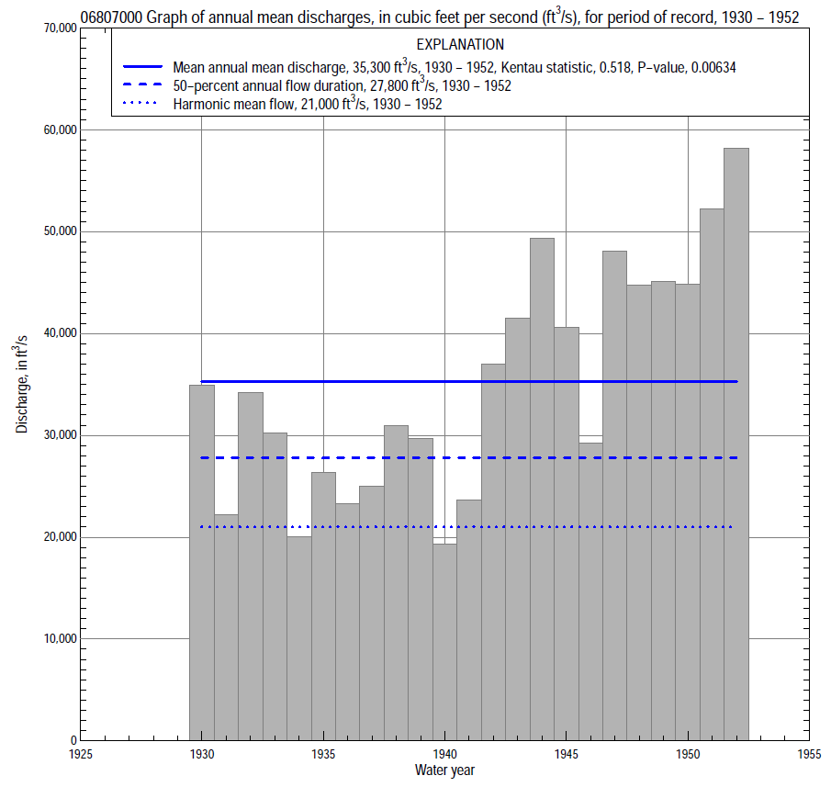

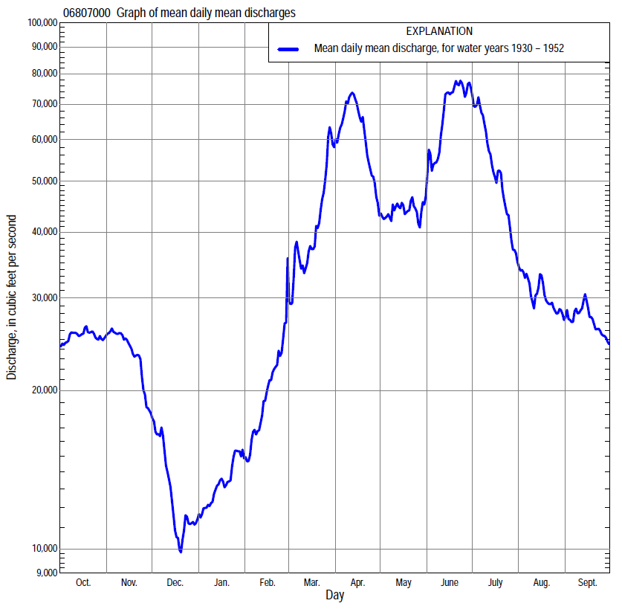

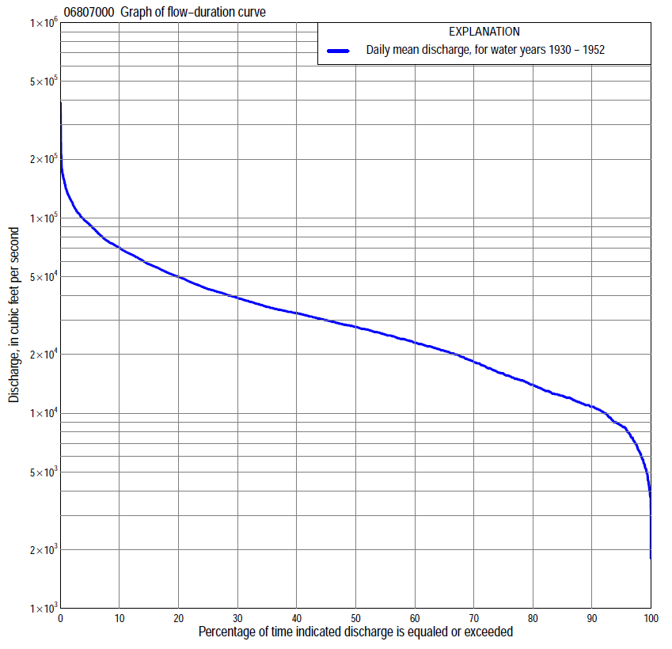

Statistics Based on the Pre-regulated Streamflow Period of Record
06807000 Monthly and annual flow durations, based on 1930–52 pre-regulated period of record (23 years)
Percentage of days discharge equaled or exceeded |  |  |  |  | Discharge (cubic feet per second) |  |  |  |  |  |  |  |  | Annual flow durations
 | Oct | Nov | Dec | Jan | Feb | Mar | Apr | May | June | July | Aug | Sept | Annual | Kentau statistic | P-value
99 | 8,600 | 6,690 | 3,800 | 3,800 | 7,000 | 12,000 | 18,600 | 18,000 | 24,700 | 14,600 | 10,800 | 8,740 | 5,240 | 0.206 | 0.178
98 | 9,200 | 8,520 | 4,300 | 4,200 | 7,200 | 13,200 | 19,800 | 19,300 | 26,600 | 15,700 | 11,200 | 8,900 | 6,350 | 0.257 | 0.091
95 | 10,600 | 10,800 | 5,000 | 5,500 | 7,800 | 15,700 | 21,800 | 20,600 | 30,000 | 19,400 | 12,000 | 10,300 | 8,600 | 0.455 | 0.003
90 | 11,000 | 12,100 | 5,810 | 6,400 | 8,500 | 19,400 | 23,700 | 22,700 | 34,400 | 24,000 | 13,700 | 11,200 | 10,800 | 0.462 | 0.002
85 | 11,800 | 12,800 | 7,000 | 7,240 | 9,100 | 20,700 | 25,200 | 24,700 | 37,500 | 27,900 | 17,300 | 12,800 | 12,200 | 0.510 | 0.001
80 | 12,400 | 13,300 | 8,000 | 8,500 | 10,800 | 22,200 | 27,200 | 26,300 | 40,900 | 30,900 | 19,100 | 14,800 | 13,900 | 0.518 | 0.001
75 | 13,900 | 14,300 | 8,700 | 8,900 | 11,500 | 23,600 | 28,600 | 27,700 | 44,700 | 34,100 | 20,800 | 16,900 | 15,800 | 0.506 | 0.001
70 | 15,600 | 14,800 | 9,300 | 9,600 | 12,600 | 24,900 | 30,400 | 28,700 | 49,200 | 36,500 | 22,200 | 18,700 | 18,300 | 0.534 | 0.000
65 | 16,600 | 15,600 | 9,900 | 10,500 | 13,600 | 26,200 | 32,400 | 30,300 | 51,800 | 39,600 | 23,800 | 20,700 | 21,000 | 0.553 | 0.000
60 | 19,400 | 17,100 | 10,500 | 11,200 | 14,700 | 28,500 | 35,300 | 32,100 | 54,900 | 41,900 | 25,300 | 23,300 | 23,200 | 0.577 | 0.000
55 | 23,400 | 19,800 | 11,100 | 11,900 | 15,500 | 30,400 | 39,600 | 34,600 | 57,800 | 46,100 | 26,900 | 26,000 | 25,400 | 0.597 | 0.000
50 | 24,500 | 21,600 | 11,900 | 12,300 | 16,600 | 32,900 | 42,800 | 37,600 | 62,800 | 49,400 | 28,900 | 28,300 | 27,800 | 0.601 | 0.000
45 | 26,000 | 23,500 | 12,400 | 12,900 | 18,000 | 34,700 | 46,100 | 42,200 | 65,600 | 52,400 | 30,600 | 29,800 | 30,100 | 0.553 | 0.000
40 | 27,600 | 26,000 | 13,100 | 13,800 | 20,000 | 38,000 | 51,600 | 45,100 | 70,000 | 55,800 | 32,700 | 31,700 | 32,600 | 0.545 | 0.000
35 | 29,400 | 27,700 | 14,000 | 15,000 | 21,400 | 41,500 | 58,200 | 48,800 | 74,000 | 59,300 | 34,200 | 32,700 | 35,200 | 0.538 | 0.000
30 | 31,000 | 29,300 | 14,800 | 16,000 | 22,500 | 45,600 | 66,600 | 51,700 | 80,200 | 63,000 | 36,400 | 33,400 | 39,200 | 0.498 | 0.001
25 | 33,600 | 31,200 | 15,700 | 17,000 | 24,700 | 53,100 | 75,400 | 55,900 | 85,400 | 66,800 | 38,900 | 34,200 | 43,400 | 0.498 | 0.001
20 | 36,300 | 32,600 | 17,400 | 18,100 | 27,000 | 61,200 | 90,600 | 59,600 | 91,600 | 73,200 | 41,200 | 35,400 | 50,200 | 0.451 | 0.003
15 | 38,600 | 34,600 | 19,000 | 20,000 | 30,000 | 69,800 | 111,000 | 66,800 | 96,600 | 78,700 | 43,000 | 37,600 | 58,100 | 0.379 | 0.012
10 | 41,000 | 40,600 | 21,400 | 22,000 | 34,000 | 81,400 | 133,000 | 73,300 | 105,000 | 91,600 | 46,700 | 41,400 | 70,500 | 0.399 | 0.008
5 | 49,400 | 43,500 | 26,200 | 23,800 | 41,800 | 99,900 | 156,000 | 88,000 | 127,000 | 107,000 | 56,900 | 50,400 | 92,200 | 0.447 | 0.003
2 | 56,200 | 49,000 | 29,600 | 27,000 | 55,000 | 111,000 | 182,000 | 103,000 | 154,000 | 123,000 | 69,600 | 62,000 | 120,000 | 0.510 | 0.001
1 | 60,700 | 50,800 | 31,400 | 28,600 | 64,500 | 121,000 | 242,000 | 114,000 | 161,000 | 132,000 | 77,500 | 74,200 | 140,000 | 0.490 | 0.001

06807000 Annual exceedance probability of instantaneous peak discharges, in cubic feet per second (ft³/s), for the pre-regulated period of record based on the expected moments algorithm/multiple Grubbs-Beck analysis computed using a historical period length of 71 years (1882–1952)ª
Annual exceed-ance probability | Recur-rence interval (years) | Discharge (ft³/s) | 95-percent lower confi-dence interval (ft³/s) | 95-percent upper confi-dence interval (ft³/s)
0.500 | 2 | 133,000 | 111,000 | 158,000
0.200 | 5 | 184,000 | 155,000 | 224,000
0.100 | 10 | 219,000 | 181,000 | 273,000
0.040 | 25 | 263,000 | 211,000 | 342,000
0.020 | 50 | 296,000 | 232,000 | 402,000
0.010 | 100 | 329,000 | 251,000 | 471,000
0.005 | 200 | 363,000 | 268,000 | 550,000
0.002 | 500 | 408,000 | 290,000 | 672,000
Kentau statistic |  | 0.470
P-value |  | 0.002
Begin year |  | 1930
End year |  | 1952
Number of peaks |  | 23
ªWeighted Independent Estimates were not computed because regional regression equations are not applicable due to watershed extending outside of Iowa flood regions.
Note: The above discharges are for the pre-regulated period of record and they are not applicable for flood-plain management regulation or for design purposes.

06807000 Annual exceedance probability of high discharges, based on 1930-52 pre-regulated period of record (23 years)
[ND, not determined]
Annual exceed-ance probability | Recur-rence interval (years) | Maximum average discharge (cubic feet per second) for indicated number of consecutive days
 |  | 1 | 3 | 7 | 15 | 30
0.990 | 1.01 | ND | ND | 39,100 | 32,200 | 29,900
0.950 | 1.05 | ND | ND | 52,900 | 44,900 | 40,500
0.900 | 1.11 | ND | ND | 62,100 | 53,400 | 47,500
0.800 | 1.25 | ND | ND | 75,600 | 65,600 | 57,400
0.500 | 2 | ND | ND | 110,000 | 96,200 | 82,000
0.200 | 5 | ND | ND | 161,000 | 139,000 | 116,000
0.100 | 10 | ND | ND | 196,000 | 167,000 | 138,000
0.040 | 25 | ND | ND | 243,000 | 203,000 | 167,000
0.020 | 50 | ND | ND | 278,000 | 230,000 | 188,000
0.010 | 100 | ND | ND | 315,000 | 256,000 | 209,000
0.005 | 200 | ND | ND | 353,000 | 283,000 | 230,000
0.002 | 500 | ND | ND | 405,000 | 318,000 | 258,000
Kentau statistic |  | 0.514 | 0.494 | 0.486 | 0.470 | 0.462
P-value |  | 0.001 | 0.001 | 0.001 | 0.002 | 0.002
Note: The above discharges are for the pre-regulated period of record and they are not applicable for flood-plain management regulation or for design purposes.

 | 06807000 Annual nonexceedance probability of low discharges, based on April 1930 to March 1952 pre-regulated period of record (22 years)
Annual nonexceed-ance probability | Recur-rence interval (years) | Minimum average discharge (cubic feet per second) for indicated number of consecutive days
 |  | 1 | 3 | 7 | 14 | 30 | 60 | 90 | 120 | 183
0.01 | 100 | 1,720 | 2,430 | 2,950 | 3,410 | 4,420 | 5,230 | 6,900 | 7,290 | 7,290
0.02 | 50 | 2,010 | 2,680 | 3,210 | 3,750 | 4,900 | 5,850 | 7,450 | 7,960 | 8,020
0.05 | 20 | 2,510 | 3,100 | 3,660 | 4,320 | 5,680 | 6,870 | 8,360 | 9,080 | 9,530
0.10 | 10 | 3,040 | 3,540 | 4,110 | 4,880 | 6,440 | 7,870 | 9,280 | 10,200 | 11,100
0.20 | 5 | 3,800 | 4,170 | 4,760 | 5,660 | 7,430 | 9,200 | 10,600 | 11,800 | 13,300
0.50 | 2 | 5,630 | 5,780 | 6,350 | 7,440 | 9,540 | 12,100 | 13,600 | 15,700 | 18,600
0.80 | 1.25 | 8,040 | 8,100 | 8,590 | 9,700 | 11,900 | 15,400 | 17,800 | 20,900 | 25,700
0.90 | 1.11 | 9,530 | 9,730 | 10,100 | 11,100 | 13,200 | 17,200 | 20,500 | 24,300 | 30,300
0.96 | 1.04 | 11,300 | 11,900 | 12,100 | 12,800 | 14,600 | 19,200 | 24,000 | 28,700 | 36,000
0.98 | 1.02 | 12,600 | 13,500 | 13,600 | 14,000 | 15,500 | 20,600 | 26,600 | 31,900 | 40,200
0.99 | 1.01 | 13,800 | 15,200 | 15,200 | 15,200 | 16,300 | 21,800 | 29,200 | 35,200 | 44,400
Kentau statistic |  | 0.177 | 0.165 | 0.247 | 0.299 | 0.290 | 0.385 | 0.394 | 0.472 | 0.628
P-value |  | 0.259 | 0.297 | 0.114 | 0.055 | 0.063 | 0.013 | 0.011 | 0.002 | 0.000

06807000 Annual nonexceedance probability of seasonal low discharges, based on October 1929 to September 1952 pre-regulated period of record (23 years)
Annual nonexceed-ance probability | Recur-rence interval (years) | Minimum average discharge (cubic feet per second) for indicated number of consecutive days
 |  | 1 | 7 | 14 | 30 |  | 1 | 7 | 14 | 30
 |  | January-February-March |  |  |  |  | April-May-June
0.01 | 100 | 2,390 | 3,090 | 3,630 | 4,480 |  | 12,900 | 13,900 | 14,800 | 17,200
0.02 | 50 | 2,810 | 3,560 | 4,150 | 5,150 |  | 13,800 | 14,900 | 15,800 | 18,500
0.05 | 20 | 3,520 | 4,350 | 5,020 | 6,270 |  | 15,400 | 16,500 | 17,600 | 20,700
0.10 | 10 | 4,250 | 5,160 | 5,900 | 7,400 |  | 17,100 | 18,300 | 19,400 | 22,900
0.20 | 5 | 5,260 | 6,270 | 7,090 | 8,910 |  | 19,500 | 20,900 | 22,200 | 26,200
0.50 | 2 | 7,570 | 8,780 | 9,770 | 12,200 |  | 26,000 | 27,800 | 29,600 | 34,500
0.80 | 1.25 | 10,300 | 11,800 | 12,900 | 16,000 |  | 35,800 | 38,600 | 41,500 | 46,800
0.90 | 1.11 | 11,800 | 13,500 | 14,700 | 18,100 |  | 43,000 | 46,800 | 50,400 | 55,600
0.96 | 1.04 | 13,500 | 15,500 | 16,700 | 20,300 |  | 52,800 | 58,100 | 63,100 | 67,400
0.98 | 1.02 | 14,600 | 16,800 | 18,100 | 21,800 |  | 60,800 | 67,400 | 73,600 | 76,700
0.99 | 1.01 | 15,600 | 18,000 | 19,300 | 23,100 |  | 69,300 | 77,500 | 85,000 | 86,600
Kentau statistic |  | 0.182 | 0.328 | 0.344 | 0.336 |  | 0.411 | 0.415 | 0.399 | 0.399
P-value |  | 0.234 | 0.030 | 0.023 | 0.027 |  | 0.007 | 0.006 | 0.008 | 0.008
 |  | July-August-September |  |  |  |  | October-November-December
0.01 | 100 | 5,370 | 5,520 | 6,010 | 7,310 |  | 1,720 | 3,080 | 3,900 | 5,940
0.02 | 50 | 6,300 | 6,530 | 7,090 | 8,500 |  | 2,050 | 3,450 | 4,370 | 6,510
0.05 | 20 | 7,960 | 8,330 | 9,000 | 10,600 |  | 2,620 | 4,070 | 5,140 | 7,440
0.10 | 10 | 9,730 | 10,200 | 11,000 | 12,700 |  | 3,210 | 4,690 | 5,880 | 8,360
0.20 | 5 | 12,300 | 13,000 | 13,900 | 15,800 |  | 4,050 | 5,530 | 6,850 | 9,570
0.50 | 2 | 18,900 | 19,900 | 21,000 | 23,300 |  | 6,010 | 7,440 | 8,900 | 12,200
0.80 | 1.25 | 28,000 | 29,200 | 30,300 | 33,200 |  | 8,390 | 9,770 | 11,100 | 15,400
0.90 | 1.11 | 34,100 | 35,200 | 36,100 | 39,400 |  | 9,760 | 11,200 | 12,300 | 17,200
0.96 | 1.04 | 41,600 | 42,300 | 42,900 | 46,900 |  | 11,300 | 12,800 | 13,600 | 19,300
0.98 | 1.02 | 47,000 | 47,400 | 47,700 | 52,200 |  | 12,300 | 13,900 | 14,400 | 20,700
0.99 | 1.01 | 52,200 | 52,200 | 52,300 | 57,200 |  | 13,200 | 14,900 | 15,100 | 22,000
Kentau statistic |  | 0.589 | 0.589 | 0.589 | 0.573 |  | 0.134 | 0.091 | 0.059 | 0.352
P-value |  | 0.000 | 0.000 | 0.000 | 0.000 |  | 0.383 | 0.561 | 0.712 | 0.020

Statistics Based on the Regulated Streamflow Period of Record

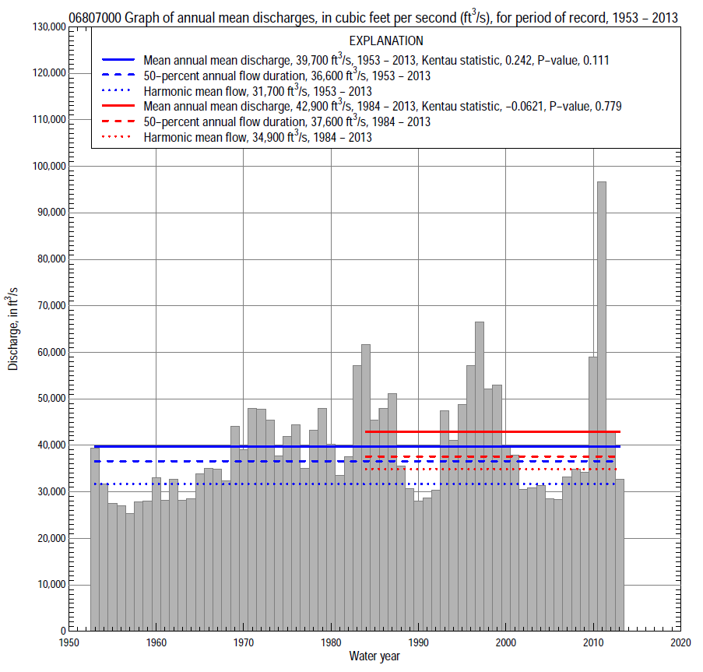

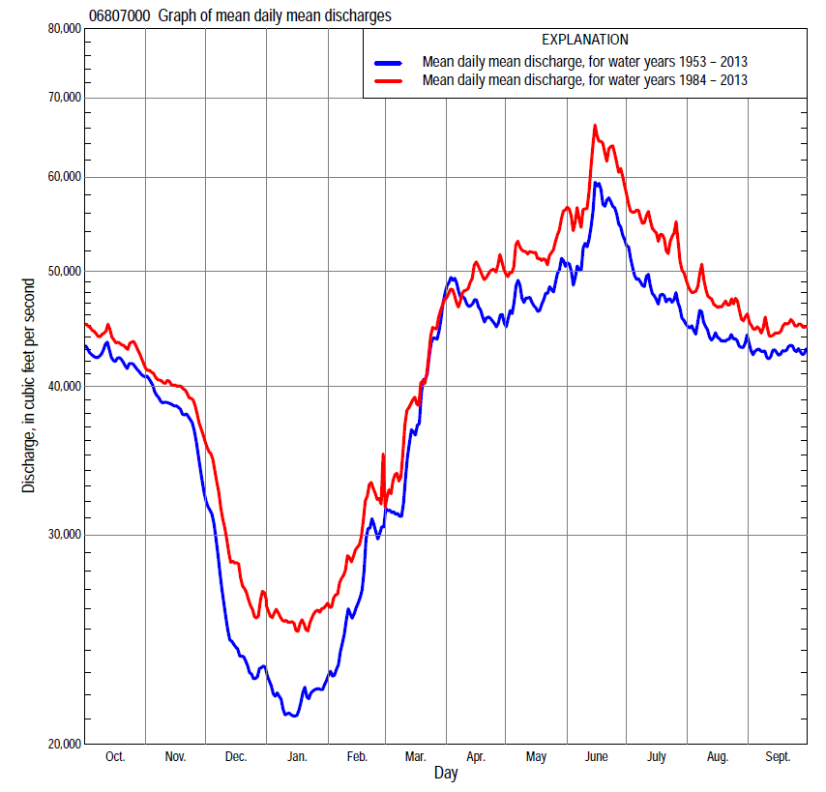

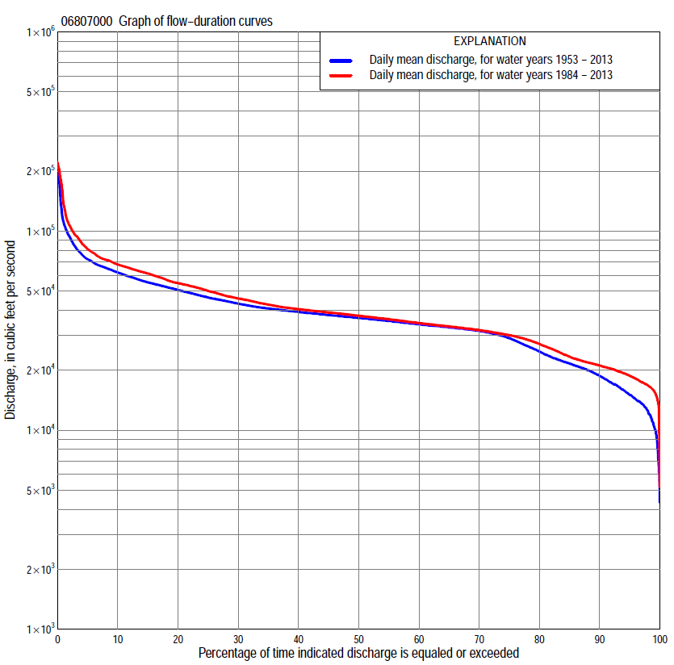

Statistics Based on the Regulated Streamflow Period of Record
06807000 Monthly and annual flow durations, based on 1953–2013 regulated period of record (61 years)
Percentage of days discharge equaled or exceeded |  |  |  |  | Discharge (cubic feet per second) |  |  |  |  |  |  |  |  | Annual flow durations
 | Oct | Nov | Dec | Jan | Feb | Mar | Apr | May | June | July | Aug | Sept | Annual | Kentau statistic | P-value
99 | 16,900 | 11,900 | 6,090 | 7,000 | 10,500 | 13,100 | 18,200 | 30,500 | 30,600 | 28,700 | 26,800 | 28,900 | 10,500 | 0.468 | 0.000
98 | 18,400 | 13,700 | 7,200 | 8,500 | 11,700 | 13,900 | 28,400 | 31,100 | 31,300 | 29,400 | 28,300 | 29,600 | 12,500 | 0.455 | 0.000
95 | 25,400 | 14,900 | 10,900 | 10,200 | 13,200 | 16,300 | 30,100 | 32,000 | 32,600 | 30,700 | 30,000 | 30,800 | 15,000 | 0.414 | 0.000
90 | 31,500 | 16,800 | 13,500 | 12,000 | 14,600 | 18,700 | 32,000 | 32,800 | 34,100 | 32,000 | 31,400 | 31,900 | 18,700 | 0.354 | 0.000
85 | 32,400 | 18,200 | 14,600 | 13,600 | 15,900 | 20,700 | 33,000 | 34,100 | 35,200 | 33,000 | 32,400 | 32,800 | 21,600 | 0.305 | 0.001
80 | 32,900 | 20,000 | 15,600 | 14,900 | 17,400 | 22,400 | 34,000 | 35,400 | 36,400 | 34,000 | 33,600 | 33,400 | 24,800 | 0.258 | 0.003
75 | 33,700 | 22,900 | 17,000 | 16,200 | 19,300 | 24,600 | 35,100 | 36,400 | 38,000 | 35,000 | 34,100 | 33,900 | 29,000 | 0.222 | 0.012
70 | 34,900 | 26,600 | 18,400 | 17,400 | 20,500 | 26,500 | 36,100 | 37,400 | 40,100 | 35,900 | 34,900 | 34,600 | 31,500 | 0.179 | 0.042
65 | 35,900 | 32,400 | 19,900 | 18,600 | 21,200 | 28,400 | 37,100 | 38,400 | 41,700 | 36,600 | 35,800 | 35,600 | 32,800 | 0.158 | 0.073
60 | 36,800 | 33,800 | 20,800 | 19,500 | 22,100 | 30,100 | 38,400 | 39,600 | 42,800 | 37,500 | 36,400 | 36,600 | 34,100 | 0.146 | 0.097
55 | 37,800 | 35,700 | 21,900 | 20,500 | 23,000 | 32,800 | 39,500 | 41,200 | 44,200 | 38,700 | 37,200 | 37,400 | 35,400 | 0.132 | 0.134
50 | 38,600 | 37,400 | 23,000 | 21,000 | 24,300 | 34,800 | 40,700 | 42,700 | 45,800 | 40,000 | 38,200 | 38,000 | 36,600 | 0.156 | 0.077
45 | 39,600 | 38,500 | 23,900 | 21,600 | 25,600 | 36,400 | 42,500 | 44,200 | 47,700 | 41,400 | 39,000 | 38,800 | 37,900 | 0.158 | 0.072
40 | 40,300 | 39,900 | 25,200 | 22,300 | 26,700 | 38,200 | 44,600 | 45,900 | 49,800 | 43,100 | 39,800 | 39,500 | 39,300 | 0.169 | 0.054
35 | 41,100 | 41,000 | 26,600 | 23,200 | 27,900 | 40,200 | 46,300 | 48,300 | 52,400 | 45,400 | 41,200 | 40,800 | 40,900 | 0.191 | 0.030
30 | 44,200 | 43,700 | 28,500 | 24,900 | 29,900 | 42,600 | 49,000 | 50,800 | 54,900 | 48,500 | 44,700 | 42,700 | 43,300 | 0.203 | 0.021
25 | 50,000 | 49,600 | 31,100 | 26,700 | 32,600 | 44,800 | 52,000 | 53,900 | 59,000 | 52,200 | 48,200 | 47,200 | 46,400 | 0.210 | 0.017
20 | 52,900 | 54,400 | 33,700 | 29,300 | 35,500 | 46,900 | 55,500 | 58,200 | 65,000 | 55,600 | 51,700 | 51,700 | 50,600 | 0.217 | 0.014
15 | 56,200 | 59,400 | 37,900 | 31,500 | 37,600 | 52,500 | 61,300 | 63,100 | 71,900 | 60,700 | 55,900 | 55,900 | 55,200 | 0.218 | 0.013
10 | 62,000 | 62,000 | 43,300 | 33,200 | 40,400 | 60,200 | 71,000 | 70,400 | 83,900 | 68,200 | 61,500 | 62,300 | 62,000 | 0.199 | 0.023
5 | 67,600 | 66,600 | 52,200 | 36,600 | 47,600 | 72,800 | 87,700 | 84,500 | 107,000 | 84,100 | 70,600 | 68,900 | 72,300 | 0.129 | 0.144
2 | 75,300 | 71,700 | 58,100 | 38,900 | 60,600 | 92,700 | 102,000 | 96,900 | 142,000 | 131,000 | 101,000 | 81,100 | 93,800 | 0.071 | 0.422
1 | 79,300 | 78,800 | 61,100 | 43,900 | 69,500 | 110,000 | 110,000 | 101,000 | 170,000 | 205,000 | 179,000 | 105,000 | 111,000 | 0.038 | 0.672

06807000 Annual exceedance probability of instantaneous peak discharges, in cubic feet per second (ft³/s), based on U.S. Army Corps of Engineers regulated flow frequency studyª, analysis computed using a record length of 100 years (1898–1997)
USACE Regulated Flow Frequency Analysis
[ND, not determined]
Annual exceedance probability | Recurrence interval (years) | Discharge (ft³/s) | 95-percent lower confidence interval (ft³/s) | 95-percent upper confidence interval (ft³/s)
0.500 | 2 | 88,000 | ND | ND
0.200 | 5 | 119,000 | ND | ND
0.100 | 10 | 150,000 | ND | ND
0.040 | 25 | ND | ND | ND
0.020 | 50 | 206,000 | ND | ND
0.010 | 100 | 237,000 | ND | ND
0.005 | 200 | 276,000 | ND | ND
0.002 | 500 | 345,000 | ND | ND
ªU.S. Army Corps of Engineers, 2003, Upper Mississippi River System Flow Frequency Study, Hydrology and Hydraulics Appendix F Missouri River, Omaha District: U.S. Army Corps of Engineers, 488 p., accessed September 16, 2014, at http://www.mvr.usace.army.mil/Portals/48/docs/FRM/UpperMissFlowFreq/App.%20F%20Omaha%20Dist.%20Hydrology_Hydraulics%20Report.pdf.
USGS Kendall's Tau Trend Analysis
Kentau statistic |  | -0.017
P-value |  | 0.852
Begin year |  | 1953^{b}
End year |  | 2013^{b}
Number of peaks |  | 61
^{b}Kendall's tau trend analysis computed using the regulated period of record which is not the same period of record used for the above regulated flow frequency analysis.

06807000 Annual exceedance probability of high discharges, based on 1953–2013 regulated period of recordª (61 years)
[ND, not determined]
Annual exceedance probability | Recur-rence interval (years) | Maximum average discharge (cubic feet per second) for indicated number of consecutive days
 |  | 1 | 3 | 7 | 15 | 30
0.990 | 1.01 | ND | ND | ND | ND | ND
0.950 | 1.05 | ND | ND | ND | ND | ND
0.900 | 1.11 | ND | ND | ND | ND | ND
0.800 | 1.25 | ND | ND | ND | ND | ND
0.500 | 2 | ND | ND | ND | ND | ND
0.200 | 5 | ND | ND | ND | ND | ND
0.100 | 10 | ND | ND | ND | ND | ND
0.040 | 25 | ND | ND | ND | ND | ND
0.020 | 50 | ND | ND | ND | ND | ND
0.010 | 100 | ND | ND | ND | ND | ND
0.005 | 200 | ND | ND | ND | ND | ND
0.002 | 500 | ND | ND | ND | ND | ND
Kentau statistic |  | 0.036 | 0.045 | 0.081 | 0.103 | 0.127
P-value |  | 0.690 | 0.614 | 0.360 | 0.245 | 0.151
ªContact the U.S. Army Corps of Engineers, Omaha District, for the annual exceedance probability of high discharges.

 | 06807000 Annual nonexceedance probability of low discharges, based on April 1953 to March 2013 regulated period of record (60 years)
Annual nonexceed-ance probability | Recur-rence interval (years) | Minimum average discharge (cubic feet per second) for indicated number of consecutive days
 |  | 1 | 3 | 7 | 14 | 30 | 60 | 90 | 120 | 183
0.01 | 100 | 3,210 | 3,500 | 4,350 | 6,400 | 8,100 | 8,950 | 9,520 | 10,500 | 14,800
0.02 | 50 | 3,810 | 4,170 | 5,150 | 7,260 | 9,000 | 9,910 | 10,500 | 11,600 | 15,900
0.05 | 20 | 4,920 | 5,370 | 6,590 | 8,740 | 10,500 | 11,500 | 12,300 | 13,500 | 17,900
0.10 | 10 | 6,130 | 6,680 | 8,120 | 10,300 | 12,100 | 13,200 | 14,000 | 15,500 | 20,000
0.20 | 5 | 7,960 | 8,640 | 10,300 | 12,400 | 14,200 | 15,500 | 16,500 | 18,200 | 22,800
0.50 | 2 | 12,900 | 13,800 | 15,900 | 17,600 | 19,300 | 20,800 | 22,400 | 24,600 | 29,600
0.80 | 1.25 | 20,400 | 21,300 | 23,300 | 24,500 | 26,100 | 27,800 | 30,200 | 33,200 | 38,900
0.90 | 1.11 | 25,600 | 26,500 | 28,000 | 28,800 | 30,400 | 32,300 | 35,200 | 38,800 | 45,100
0.96 | 1.04 | 32,500 | 33,000 | 33,700 | 34,200 | 35,700 | 37,700 | 41,500 | 45,700 | 53,000
0.98 | 1.02 | 37,700 | 37,700 | 37,700 | 38,000 | 39,600 | 41,600 | 46,000 | 50,700 | 59,000
0.99 | 1.01 | 41,500 | 41,500 | 41,500 | 41,800 | 43,400 | 45,400 | 50,500 | 55,700 | 65,000
Kentau statistic |  | 0.455 | 0.468 | 0.478 | 0.484 | 0.434 | 0.388 | 0.328 | 0.293 | 0.247
P-value |  | 0.000 | 0.000 | 0.000 | 0.000 | 0.000 | 0.000 | 0.000 | 0.001 | 0.005

06807000 Annual nonexceedance probability of seasonal low discharges, based on October 1952 to September 2013 regulated period of record (61 years)
Annual nonexceed-ance probability | Recur-rence interval (years) | Minimum average discharge (cubic feet per second) for indicated number of consecutive days
 |  | 1 | 7 | 14 | 30 |  | 1 | 7 | 14 | 30
 |  | January-February-March |  |  |  |  | April-May-June
0.01 | 100 | 3,150 | 4,440 | 6,550 | 8,260 |  | 20,000 | 21,000 | 22,100 | 26,600
0.02 | 50 | 3,780 | 5,240 | 7,420 | 9,160 |  | 21,300 | 22,400 | 23,500 | 27,500
0.05 | 20 | 4,930 | 6,660 | 8,890 | 10,700 |  | 23,600 | 24,800 | 25,800 | 29,000
0.10 | 10 | 6,190 | 8,160 | 10,400 | 12,200 |  | 25,900 | 27,000 | 28,100 | 30,600
0.20 | 5 | 8,060 | 10,300 | 12,500 | 14,300 |  | 28,900 | 30,100 | 31,200 | 33,000
0.50 | 2 | 12,900 | 15,500 | 17,300 | 19,100 |  | 35,800 | 37,200 | 38,400 | 39,500
0.80 | 1.25 | 19,900 | 22,400 | 23,500 | 25,300 |  | 44,500 | 46,100 | 47,600 | 49,300
0.90 | 1.11 | 24,500 | 26,600 | 27,300 | 29,100 |  | 50,000 | 51,700 | 53,400 | 56,500
0.96 | 1.04 | 30,300 | 31,600 | 31,800 | 33,700 |  | 56,500 | 58,500 | 60,700 | 66,300
0.98 | 1.02 | 34,500 | 35,100 | 35,100 | 37,000 |  | 61,300 | 63,400 | 65,900 | 74,200
0.99 | 1.01 | 38,600 | 38,600 | 38,600 | 40,100 |  | 65,900 | 68,200 | 71,200 | 82,500
Kentau statistic |  | 0.482 | 0.502 | 0.496 | 0.449 |  | 0.233 | 0.201 | 0.209 | 0.202
P-value |  | 0.000 | 0.000 | 0.000 | 0.000 |  | 0.008 | 0.022 | 0.018 | 0.022
 |  | July-August-September |  |  |  |  | October-November-December
0.01 | 100 | 17,100 | 21,500 | 25,700 | 27,800 |  | 3,060 | 4,770 | 6,950 | 8,490
0.02 | 50 | 18,800 | 22,500 | 26,200 | 28,200 |  | 3,870 | 5,750 | 7,960 | 9,530
0.05 | 20 | 21,500 | 24,400 | 27,200 | 28,900 |  | 5,390 | 7,520 | 9,730 | 11,300
0.10 | 10 | 24,200 | 26,300 | 28,400 | 29,900 |  | 7,110 | 9,430 | 11,600 | 13,200
0.20 | 5 | 27,800 | 29,000 | 30,300 | 31,500 |  | 9,740 | 12,200 | 14,200 | 16,000
0.50 | 2 | 36,000 | 36,000 | 36,000 | 36,900 |  | 16,700 | 19,100 | 20,500 | 22,900
0.80 | 1.25 | 45,900 | 46,000 | 46,000 | 47,000 |  | 26,400 | 28,100 | 29,100 | 32,900
0.90 | 1.11 | 51,800 | 53,100 | 53,900 | 55,500 |  | 32,600 | 33,600 | 34,500 | 39,800
0.96 | 1.04 | 58,700 | 62,600 | 65,500 | 68,300 |  | 39,900 | 40,100 | 41,200 | 48,700
0.98 | 1.02 | 63,500 | 70,100 | 75,300 | 79,500 |  | 45,000 | 45,000 | 46,000 | 55,600
0.99 | 1.01 | 68,100 | 77,900 | 86,300 | 92,200 |  | 49,700 | 49,700 | 50,700 | 62,500
Kentau statistic |  | 0.113 | 0.097 | 0.097 | 0.097 |  | 0.306 | 0.330 | 0.326 | 0.297
P-value |  | 0.202 | 0.273 | 0.271 | 0.271 |  | 0.001 | 0.000 | 0.000 | 0.001

Statistics Based on the 1984–2013 Regulated Streamflow Period of Record
06807000 Monthly and annual flow durations, based on 1984–2013 regulated period of record (30 years)
Percentage of days discharge equaled or exceeded |  |  |  |  | Discharge (cubic feet per second) |  |  |  |  |  |  |  |  | Annual flow durations
 | Oct | Nov | Dec | Jan | Feb | Mar | Apr | May | June | July | Aug | Sept | Annual | Kentau statistic | P-value
99 | 17,400 | 14,400 | 9,300 | 15,000 | 16,300 | 16,100 | 28,100 | 30,600 | 30,800 | 27,800 | 26,800 | 26,300 | 15,800 | -0.032 | 0.817
98 | 18,100 | 14,900 | 13,500 | 16,000 | 17,200 | 16,600 | 28,900 | 31,300 | 31,600 | 28,800 | 27,300 | 28,900 | 16,800 | 0.000 | 1.000
95 | 21,000 | 16,200 | 15,500 | 17,200 | 18,700 | 17,400 | 29,800 | 32,400 | 33,500 | 30,100 | 29,200 | 29,900 | 18,700 | -0.060 | 0.655
90 | 29,900 | 17,200 | 17,400 | 18,000 | 19,600 | 20,200 | 31,800 | 33,700 | 34,900 | 31,400 | 30,200 | 31,300 | 21,100 | -0.067 | 0.617
85 | 31,600 | 18,300 | 18,700 | 19,300 | 20,400 | 21,800 | 32,900 | 35,400 | 35,800 | 32,300 | 31,300 | 32,400 | 23,400 | -0.083 | 0.532
80 | 32,500 | 20,000 | 19,700 | 20,100 | 20,900 | 24,100 | 33,800 | 36,500 | 38,600 | 33,700 | 32,200 | 33,100 | 27,100 | -0.101 | 0.443
75 | 33,200 | 22,600 | 20,300 | 20,700 | 21,700 | 26,800 | 35,000 | 37,700 | 41,100 | 34,900 | 33,500 | 33,800 | 30,000 | -0.113 | 0.392
70 | 34,900 | 25,400 | 21,000 | 21,200 | 22,300 | 28,600 | 36,200 | 38,800 | 42,500 | 36,200 | 34,200 | 34,400 | 31,800 | -0.103 | 0.432
65 | 36,400 | 32,400 | 21,700 | 21,600 | 23,100 | 30,100 | 37,200 | 40,700 | 43,700 | 37,100 | 34,900 | 36,300 | 33,200 | -0.085 | 0.521
60 | 37,900 | 34,800 | 22,800 | 22,100 | 24,300 | 32,200 | 39,100 | 43,000 | 45,200 | 38,200 | 36,000 | 37,200 | 34,500 | -0.133 | 0.309
55 | 38,800 | 36,400 | 23,900 | 22,700 | 25,500 | 34,500 | 40,300 | 44,400 | 46,500 | 39,600 | 37,000 | 37,900 | 36,100 | -0.184 | 0.159
50 | 39,600 | 37,800 | 25,000 | 23,500 | 26,600 | 36,000 | 41,500 | 45,900 | 48,600 | 41,200 | 38,400 | 38,700 | 37,600 | -0.166 | 0.205
45 | 40,100 | 39,400 | 26,500 | 24,700 | 27,700 | 37,800 | 45,100 | 48,100 | 50,300 | 43,200 | 39,000 | 39,200 | 39,000 | -0.145 | 0.269
40 | 40,800 | 41,000 | 28,400 | 26,200 | 29,000 | 40,500 | 47,900 | 50,000 | 53,600 | 45,600 | 40,200 | 40,000 | 40,500 | -0.124 | 0.344
35 | 42,900 | 42,600 | 30,100 | 27,600 | 30,900 | 42,600 | 50,500 | 52,400 | 57,700 | 49,300 | 41,600 | 41,200 | 42,700 | -0.101 | 0.443
30 | 48,800 | 50,700 | 33,300 | 29,400 | 33,800 | 44,300 | 54,000 | 55,800 | 63,000 | 53,900 | 45,500 | 44,000 | 45,900 | -0.080 | 0.544
25 | 52,800 | 54,600 | 34,600 | 31,000 | 36,600 | 45,800 | 56,600 | 59,500 | 67,200 | 59,900 | 51,500 | 53,400 | 50,000 | -0.080 | 0.544
20 | 57,600 | 59,400 | 38,600 | 32,100 | 37,900 | 47,100 | 61,100 | 65,600 | 72,500 | 66,200 | 55,800 | 55,500 | 54,800 | -0.053 | 0.695
15 | 63,400 | 61,900 | 43,000 | 33,200 | 39,800 | 52,500 | 67,400 | 72,800 | 78,900 | 71,900 | 63,600 | 62,500 | 61,300 | -0.048 | 0.721
10 | 66,700 | 63,700 | 48,700 | 34,400 | 42,800 | 60,500 | 77,800 | 83,000 | 95,500 | 83,200 | 70,000 | 68,500 | 68,000 | -0.039 | 0.775
5 | 73,300 | 69,400 | 55,400 | 37,000 | 49,300 | 74,200 | 94,400 | 95,200 | 135,000 | 120,000 | 89,000 | 74,600 | 81,100 | -0.046 | 0.735
2 | 78,400 | 78,800 | 60,600 | 38,700 | 57,900 | 94,900 | 105,000 | 100,000 | 170,000 | 205,000 | 179,000 | 105,000 | 107,000 | -0.034 | 0.803
1 | 83,300 | 80,500 | 63,100 | 45,000 | 65,800 | 107,000 | 110,000 | 106,000 | 191,000 | 212,000 | 185,000 | 108,000 | 136,000 | -0.034 | 0.803

06807000 Annual exceedance probability of high discharges, based on 1984–2013 regulated period of recordª (30 years)
[ND, not determined]
Annual exceedance probability | Recur-rence interval (years) | Maximum average discharge (cubic feet per second) for indicated number of consecutive days
 |  | 1 | 3 | 7 | 15 | 30
0.990 | 1.01 | ND | ND | ND | ND | ND
0.950 | 1.05 | ND | ND | ND | ND | ND
0.900 | 1.11 | ND | ND | ND | ND | ND
0.800 | 1.25 | ND | ND | ND | ND | ND
0.500 | 2 | ND | ND | ND | ND | ND
0.200 | 5 | ND | ND | ND | ND | ND
0.100 | 10 | ND | ND | ND | ND | ND
0.040 | 25 | ND | ND | ND | ND | ND
0.020 | 50 | ND | ND | ND | ND | ND
0.010 | 100 | ND | ND | ND | ND | ND
0.005 | 200 | ND | ND | ND | ND | ND
0.002 | 500 | ND | ND | ND | ND | ND
Kentau statistic |  | -0.044 | -0.025 | 0.021 | -0.016 | -0.034
P-value |  | 0.748 | 0.858 | 0.887 | 0.915 | 0.803
ªContact the U.S. Army Corps of Engineers, Omaha District, for the annual exceedance probability of high discharges.

 | 06807000 Annual nonexceedance probability of low discharges, based on April 1983 to March 2013 regulated period of record (30 years)
Annual nonexceed-ance probability | Recur-rence interval (years) | Minimum average discharge (cubic feet per second) for indicated number of consecutive days
 |  | 1 | 3 | 7 | 14 | 30 | 60 | 90 | 120 | 183
0.01 | 100 | 4,940 | 5,600 | 8,340 | 10,900 | 12,200 | 13,100 | 13,500 | 13,900 | 16,300
0.02 | 50 | 5,950 | 6,690 | 9,420 | 11,800 | 13,100 | 14,000 | 14,400 | 15,000 | 17,600
0.05 | 20 | 7,730 | 8,580 | 11,200 | 13,400 | 14,700 | 15,600 | 16,100 | 16,800 | 19,600
0.10 | 10 | 9,570 | 10,500 | 13,000 | 15,000 | 16,300 | 17,200 | 17,700 | 18,600 | 21,700
0.20 | 5 | 12,100 | 13,200 | 15,400 | 17,100 | 18,400 | 19,300 | 20,000 | 21,200 | 24,700
0.50 | 2 | 17,900 | 19,000 | 20,600 | 21,700 | 23,100 | 24,200 | 25,500 | 27,300 | 31,900
0.80 | 1.25 | 24,500 | 25,300 | 26,500 | 27,400 | 28,900 | 30,400 | 32,700 | 35,700 | 41,800
0.90 | 1.11 | 28,100 | 28,600 | 29,900 | 30,800 | 32,500 | 34,400 | 37,500 | 41,100 | 48,500
0.96 | 1.04 | 31,800 | 32,000 | 33,500 | 34,800 | 36,700 | 39,100 | 43,500 | 48,100 | 57,100
0.98 | 1.02 | 33,900 | 34,000 | 36,000 | 37,600 | 39,700 | 42,600 | 48,000 | 53,300 | 63,700
0.99 | 1.01 | 35,600 | 35,700 | 38,200 | 40,200 | 42,700 | 46,000 | 52,500 | 58,500 | 70,300
Kentau statistic |  | -0.051 | -0.044 | -0.021 | -0.030 | -0.069 | -0.053 | -0.071 | -0.076 | -0.071
P-value |  | 0.708 | 0.748 | 0.887 | 0.830 | 0.605 | 0.695 | 0.592 | 0.568 | 0.592

06807000 Annual nonexceedance probability of seasonal low discharges, based on October 1983 to September 2013 regulated period of record (30 years)
Annual nonexceed-ance probability | Recur-rence interval (years) | Minimum average discharge (cubic feet per second) for indicated number of consecutive days
 |  | 1 | 7 | 14 | 30 |  | 1 | 7 | 14 | 30
 |  | January-February-March |  |  |  |  | April-May-June
0.01 | 100 | 8,480 | 12,600 | 14,200 | 15,000 |  | 24,600 | 24,900 | 25,400 | 26,200
0.02 | 50 | 9,460 | 13,400 | 14,900 | 15,800 |  | 25,400 | 25,700 | 26,300 | 27,200
0.05 | 20 | 11,100 | 14,700 | 16,100 | 17,000 |  | 26,800 | 27,200 | 27,900 | 29,000
0.10 | 10 | 12,700 | 16,000 | 17,300 | 18,300 |  | 28,300 | 28,900 | 29,700 | 31,000
0.20 | 5 | 14,900 | 17,800 | 19,000 | 20,000 |  | 30,600 | 31,300 | 32,400 | 33,900
0.50 | 2 | 19,800 | 21,900 | 22,800 | 24,100 |  | 36,900 | 38,000 | 39,500 | 41,800
0.80 | 1.25 | 25,600 | 27,200 | 27,900 | 29,400 |  | 46,900 | 48,700 | 50,600 | 54,200
0.90 | 1.11 | 29,000 | 30,600 | 31,200 | 32,800 |  | 54,400 | 56,600 | 58,900 | 63,500
0.96 | 1.04 | 32,900 | 34,800 | 35,300 | 37,100 |  | 64,800 | 67,700 | 70,300 | 76,400
0.98 | 1.02 | 35,600 | 37,800 | 38,400 | 40,300 |  | 73,400 | 76,800 | 79,600 | 87,000
0.99 | 1.01 | 38,000 | 40,800 | 41,400 | 43,500 |  | 82,600 | 86,600 | 89,600 | 98,400
Kentau statistic |  | -0.067 | -0.034 | -0.039 | -0.028 |  | -0.175 | -0.163 | -0.145 | -0.163
P-value |  | 0.617 | 0.803 | 0.775 | 0.844 |  | 0.181 | 0.212 | 0.269 | 0.212
 |  | July-August-September |  |  |  |  | October-November-December
0.01 | 100 | 21,800 | 22,900 | 24,000 | 25,400 |  | 5,130 | 8,310 | 10,600 | 11,200
0.02 | 50 | 22,600 | 23,600 | 24,600 | 25,900 |  | 6,280 | 9,430 | 11,600 | 12,300
0.05 | 20 | 24,000 | 24,900 | 25,800 | 27,000 |  | 8,340 | 11,300 | 13,300 | 14,100
0.10 | 10 | 25,700 | 26,400 | 27,200 | 28,300 |  | 10,500 | 13,300 | 15,100 | 16,100
0.20 | 5 | 28,200 | 28,800 | 29,500 | 30,500 |  | 13,700 | 16,000 | 17,600 | 18,900
0.50 | 2 | 35,300 | 35,900 | 36,500 | 37,400 |  | 21,000 | 22,500 | 23,700 | 26,000
0.80 | 1.25 | 47,300 | 48,200 | 49,300 | 50,600 |  | 29,700 | 30,900 | 32,100 | 36,600
0.90 | 1.11 | 56,800 | 58,200 | 59,800 | 61,800 |  | 34,600 | 36,100 | 37,800 | 44,000
0.96 | 1.04 | 70,600 | 73,100 | 75,800 | 79,000 |  | 39,800 | 42,400 | 45,100 | 53,800
0.98 | 1.02 | 82,300 | 86,000 | 89,800 | 94,500 |  | 43,100 | 46,800 | 50,600 | 61,500
0.99 | 1.01 | 95,300 | 101,000 | 106,000 | 112,000 |  | 45,900 | 51,100 | 56,100 | 69,600
Kentau statistic |  | -0.186 | -0.191 | -0.191 | -0.154 |  | -0.080 | -0.074 | -0.076 | -0.076
P-value |  | 0.154 | 0.143 | 0.143 | 0.239 |  | 0.544 | 0.580 | 0.568 | 0.568

