LOCATION.--Lat 41°23'24", long 95°22'17" referenced to North American Datum of 1927, in NE 1/4 NW 1/4 NE 1/4 sec.18, T.76 N., R.39 W., Pottawattamie County, IA, Hydrologic Unit 10240002, on right bank on upstream side of bridge on County Highway G30, at western edge of Hancock, 3.0 mi downstream from Jim Creek, 60.1 mi upstream from confluence with East Nishnabotna River, and 75.7 mi upstream from mouth of Nishnabotna River.

DRAINAGE AREA.--609 mi².

PERIOD OF RECORD.--Discharge records from October 1959 to current year.

GAGE.--Water-stage recorder. Datum of gage is 1,085.83 ft above National Geodetic Vertical Datum of 1929. Prior to September 15, 1980, on downstream end of right bridge pier at same datum.

A summary of all available data for this streamgage is provided through the USGS National Water Information System web interface (NWISWeb). The following link provides access to current/historical observations, daily data, daily statistics, monthly statistics, annual statistics, peak streamflow, field measurements, field/lab water-quality samples, and the latest water-year summaries. Data can be filtered by parameter and/or dates, and can be output in various tabular and graphical formats.
http://waterdata.usgs.gov/nwis/inventory/?site_no=06807410

The USGS WaterWatch Toolkit is available at:
http://waterwatch.usgs.gov/?id=ww_toolkit
Tools for summarizing streamflow information include the duration hydrograph builder, the cumulative streamflow hydrograph builder, the streamgage statistics retrieval tool, the rating curve builder, the flood tracking chart builder, the National Weather Service Advanced Hydrologic Prediction Service (AHPS) river forecast hydrograph builder, and the raster-hydrograph builder. Entering the above number for this streamgage into these toolkit webpages will provide streamflow information specific to this streamgage.

A description of the statistics presented for this streamgage is available in the main body of the report at:
http://dx.doi.org/10.3133/ofr20151214
A link to other streamgages included in this report, a map showing the location of the streamgages, information on the programs used to compute the statistical analyses, and references are included in the main body of the report.

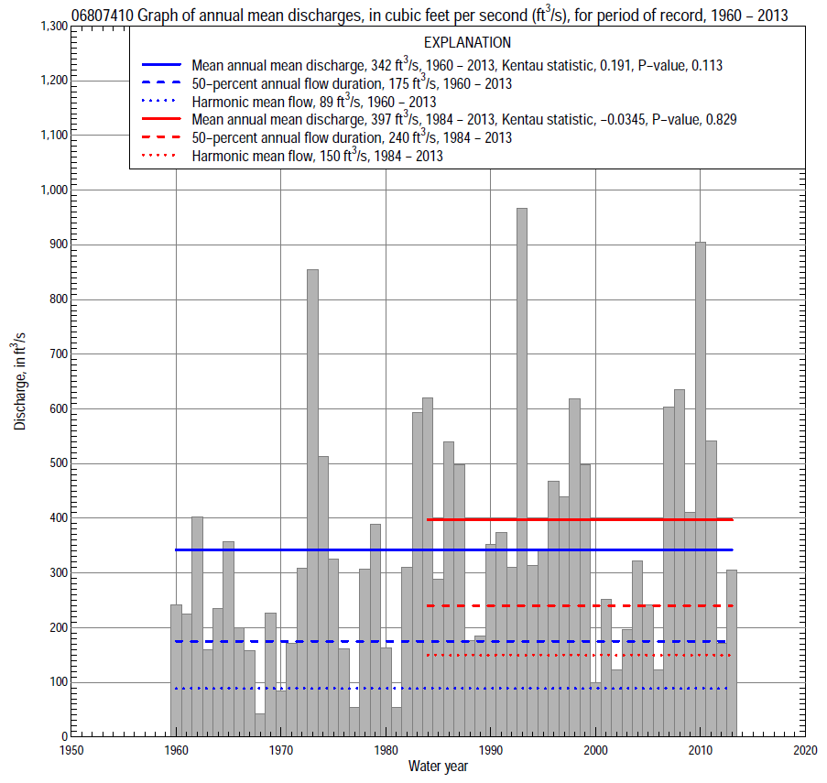

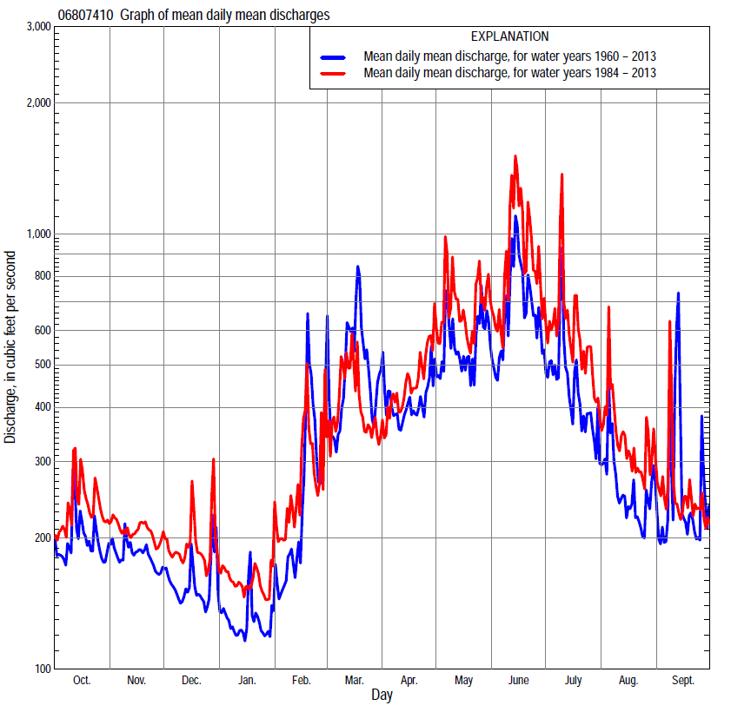

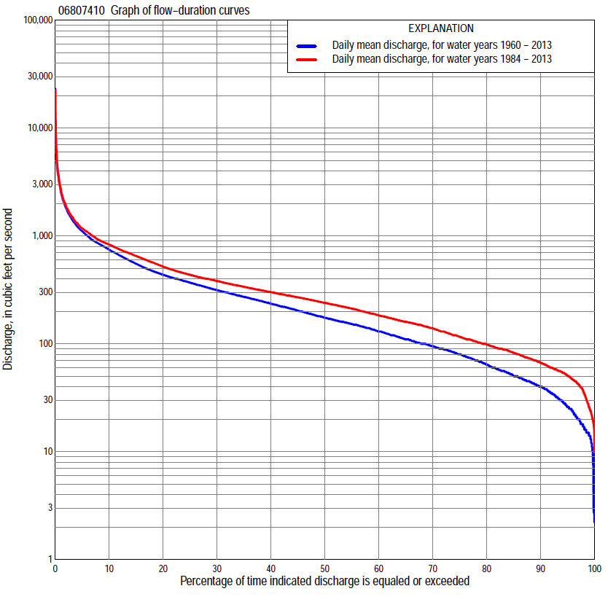

Statistics Based on the Entire Streamflow Period of Record
06807410 Monthly and annual flow durations, based on 1960–2013 period of record (54 years)
Percentage of days discharge equaled or exceeded |  |  |  |  | Discharge (cubic feet per second) |  |  |  |  |  |  |  |  | Annual flow durations
 | Oct | Nov | Dec | Jan | Feb | Mar | Apr | May | June | July | Aug | Sept | Annual | Kentau statistic | P-value
99 | 14 | 22 | 14 | 2.8 | 10 | 33 | 28 | 22 | 15 | 21 | 16 | 13 | 14 | 0.314 | 0.001
98 | 18 | 29 | 15 | 7.5 | 14 | 39 | 34 | 25 | 19 | 29 | 20 | 15 | 17 | 0.321 | 0.001
95 | 29 | 33 | 18 | 15 | 20 | 45 | 45 | 39 | 48 | 40 | 28 | 21 | 26 | 0.322 | 0.001
90 | 36 | 39 | 25 | 19 | 29 | 58 | 65 | 66 | 86 | 73 | 44 | 41 | 40 | 0.314 | 0.001
85 | 45 | 46 | 33 | 25 | 42 | 75 | 84 | 113 | 124 | 93 | 57 | 49 | 50 | 0.307 | 0.001
80 | 51 | 54 | 40 | 31 | 50 | 94 | 107 | 141 | 159 | 109 | 72 | 57 | 64 | 0.294 | 0.002
75 | 62 | 63 | 48 | 41 | 58 | 111 | 131 | 166 | 188 | 126 | 83 | 70 | 80 | 0.268 | 0.004
70 | 75 | 72 | 58 | 48 | 74 | 131 | 153 | 193 | 223 | 147 | 95 | 87 | 95 | 0.258 | 0.006
65 | 87 | 87 | 67 | 56 | 86 | 157 | 173 | 231 | 268 | 179 | 119 | 101 | 110 | 0.266 | 0.005
60 | 96 | 98 | 78 | 64 | 96 | 187 | 195 | 266 | 302 | 210 | 139 | 112 | 130 | 0.270 | 0.004
55 | 108 | 106 | 88 | 74 | 110 | 215 | 230 | 325 | 345 | 238 | 157 | 124 | 153 | 0.271 | 0.004
50 | 122 | 125 | 100 | 85 | 134 | 239 | 266 | 368 | 400 | 267 | 170 | 138 | 175 | 0.247 | 0.008
45 | 139 | 143 | 115 | 95 | 162 | 270 | 300 | 405 | 462 | 303 | 190 | 154 | 203 | 0.224 | 0.017
40 | 155 | 158 | 136 | 105 | 190 | 303 | 349 | 449 | 549 | 339 | 210 | 170 | 235 | 0.231 | 0.014
35 | 177 | 172 | 155 | 120 | 218 | 338 | 410 | 515 | 625 | 385 | 239 | 199 | 272 | 0.243 | 0.010
30 | 198 | 202 | 175 | 150 | 250 | 381 | 480 | 625 | 697 | 443 | 274 | 226 | 314 | 0.242 | 0.010
25 | 224 | 236 | 208 | 192 | 278 | 443 | 553 | 723 | 805 | 510 | 313 | 257 | 369 | 0.243 | 0.010
20 | 268 | 276 | 268 | 231 | 317 | 586 | 647 | 833 | 921 | 623 | 379 | 300 | 437 | 0.245 | 0.009
15 | 348 | 353 | 310 | 271 | 380 | 792 | 775 | 950 | 1,130 | 756 | 445 | 358 | 552 | 0.241 | 0.010
10 | 459 | 405 | 361 | 304 | 480 | 1,100 | 910 | 1,150 | 1,450 | 911 | 559 | 459 | 746 | 0.232 | 0.014
5 | 611 | 512 | 415 | 350 | 836 | 1,840 | 1,230 | 1,580 | 2,110 | 1,350 | 732 | 679 | 1,110 | 0.130 | 0.168
2 | 886 | 752 | 491 | 410 | 1,610 | 3,410 | 1,700 | 2,370 | 3,730 | 2,180 | 1,200 | 1,090 | 1,810 | -0.013 | 0.893
1 | 1,070 | 922 | 703 | 470 | 2,670 | 4,500 | 2,040 | 3,540 | 5,000 | 2,920 | 1,670 | 1,400 | 2,700 | -0.066 | 0.488

06807410 Annual exceedance probability of instantaneous peak discharges, in cubic feet per second (ft³/s), based on the Weighted Independent Estimates method,
Annual exceed-ance probability | Recur-rence interval (years) | Discharge (ft³/s) | 95-percent lower confi-dence interval (ft³/s) | 95-percent upper confi-dence interval (ft³/s)
0.500 | 2 | 8,560 | 7,090 | 10,300
0.200 | 5 | 14,800 | 12,400 | 17,700
0.100 | 10 | 19,100 | 15,800 | 23,100
0.040 | 25 | 24,700 | 19,800 | 30,900
0.020 | 50 | 28,800 | 22,300 | 37,300
0.010 | 100 | 33,000 | 24,700 | 44,200
0.005 | 200 | 37,200 | 26,800 | 51,600
0.002 | 500 | 42,400 | 29,100 | 61,800
and based on the expected moments algorithm/multiple Grubbs-Beck analysis computed using a historical period length of 54 years (1960–2013)
0.500 | 2 | 8,540 | 6,680 | 10,300
0.200 | 5 | 14,700 | 12,200 | 18,300
0.100 | 10 | 18,900 | 15,500 | 24,800
0.040 | 25 | 24,300 | 19,400 | 34,300
0.020 | 50 | 28,200 | 22,000 | 42,300
0.010 | 100 | 32,100 | 24,200 | 51,000
0.005 | 200 | 35,800 | 26,200 | 60,600
0.002 | 500 | 40,600 | 28,500 | 75,000
Kentau statistic |  | -0.117
P-value |  | 0.216
Begin year |  | 1960
End year |  | 2013
Number of peaks |  | 54

06807410 Annual exceedance probability of high discharges, based on 1960–2013 period of record (54 years)
Annual exceedance probability | Recur-rence interval (years) | Maximum average discharge (ft³/s) for indicated number of consecutive days
 |  | 1 | 3 | 7 | 15 | 30
0.990 | 1.01 | 272 | 202 | 157 | 116 | 84
0.950 | 1.05 | 695 | 488 | 362 | 268 | 199
0.900 | 1.11 | 1,100 | 755 | 545 | 402 | 301
0.800 | 1.25 | 1,850 | 1,240 | 868 | 632 | 475
0.500 | 2 | 4,500 | 2,930 | 1,930 | 1,340 | 997
0.200 | 5 | 9,530 | 6,180 | 3,820 | 2,490 | 1,780
0.100 | 10 | 13,400 | 8,720 | 5,230 | 3,260 | 2,280
0.040 | 25 | 18,600 | 12,200 | 7,090 | 4,200 | 2,840
0.020 | 50 | 22,500 | 14,900 | 8,490 | 4,860 | 3,210
0.010 | 100 | 26,500 | 17,700 | 9,870 | 5,470 | 3,540
0.005 | 200 | 30,400 | 20,500 | 11,200 | 6,040 | 3,830
0.002 | 500 | 35,400 | 24,200 | 13,000 | 6,730 | 4,170
Kentau statistic |  | -0.075 | -0.059 | -0.016 | 0.015 | 0.064
P-value |  | 0.425 | 0.531 | 0.870 | 0.881 | 0.502

 | 06807410 Annual nonexceedance probability of low discharges, based on April 1960 to March 2013 period of record (53 years)
Annual nonexceed-ance probability | Recur-rence interval (years) | Minimum average discharge (ft³/s) for indicated number of consecutive days
 |  | 1 | 3 | 7 | 14 | 30 | 60 | 90 | 120 | 183
0.01 | 100 | 2.7 | 2.8 | 3.1 | 3.4 | 3.9 | 6.6 | 10 | 13 | 15
0.02 | 50 | 4.0 | 4.2 | 4.5 | 5.0 | 5.9 | 9.2 | 13 | 17 | 19
0.05 | 20 | 6.9 | 7.4 | 7.9 | 8.8 | 10 | 15 | 20 | 24 | 28
0.10 | 10 | 11 | 12 | 13 | 14 | 17 | 22 | 28 | 33 | 39
0.20 | 5 | 19 | 20 | 22 | 24 | 29 | 36 | 43 | 49 | 59
0.50 | 2 | 46 | 50 | 54 | 60 | 70 | 82 | 91 | 100 | 123
0.80 | 1.25 | 99 | 108 | 118 | 128 | 146 | 171 | 187 | 199 | 250
0.90 | 1.11 | 141 | 154 | 168 | 182 | 202 | 244 | 267 | 283 | 360
0.96 | 1.04 | 198 | 216 | 237 | 253 | 275 | 346 | 385 | 408 | 526
0.98 | 1.02 | 243 | 264 | 291 | 308 | 328 | 428 | 483 | 516 | 669
0.99 | 1.01 | 287 | 312 | 345 | 362 | 380 | 514 | 590 | 635 | 829
Kentau statistic |  | 0.245 | 0.279 | 0.301 | 0.312 | 0.309 | 0.280 | 0.254 | 0.244 | 0.174
P-value |  | 0.010 | 0.003 | 0.001 | 0.001 | 0.001 | 0.003 | 0.007 | 0.010 | 0.067

06807410 Annual nonexceedance probability of seasonal low discharges, based on October 1959 to September 2013 period of record (54 years)
Annual nonexceed-ance probability | Recur-rence interval (years) | Minimum average discharge (cubic feet per second) for indicated number of consecutive days
 |  | 1 | 7 | 14 | 30 |  | 1 | 7 | 14 | 30
 |  | January-February-March |  |  |  |  | April-May-June
0.01 | 100 | 3.0 | 3.4 | 3.6 | 4.5 |  | 7.6 | 9.6 | 12 | 16
0.02 | 50 | 4.5 | 5.1 | 5.4 | 6.7 |  | 12 | 14 | 17 | 23
0.05 | 20 | 7.9 | 9.0 | 9.7 | 12 |  | 21 | 25 | 30 | 38
0.10 | 10 | 13 | 15 | 16 | 19 |  | 35 | 40 | 47 | 60
0.20 | 5 | 22 | 25 | 28 | 34 |  | 61 | 69 | 78 | 99
0.50 | 2 | 55 | 65 | 71 | 84 |  | 153 | 170 | 188 | 235
0.80 | 1.25 | 125 | 146 | 159 | 182 |  | 322 | 365 | 406 | 497
0.90 | 1.11 | 182 | 213 | 230 | 258 |  | 444 | 517 | 579 | 704
0.96 | 1.04 | 263 | 307 | 326 | 359 |  | 598 | 720 | 818 | 988
0.98 | 1.02 | 328 | 382 | 400 | 436 |  | 708 | 876 | 1,010 | 1,210
0.99 | 1.01 | 396 | 460 | 475 | 512 |  | 812 | 1,030 | 1,200 | 1,440
Kentau statistic |  | 0.210 | 0.260 | 0.277 | 0.269 |  | 0.198 | 0.184 | 0.175 | 0.199
P-value |  | 0.025 | 0.006 | 0.003 | 0.004 |  | 0.035 | 0.051 | 0.062 | 0.034
 |  | July-August-September |  |  |  |  | October-November-December
0.01 | 100 | 6.9 | 8.0 | 9.2 | 14 |  | 5.3 | 6.5 | 7.9 | 11
0.02 | 50 | 9.6 | 11 | 13 | 18 |  | 7.1 | 8.7 | 11 | 14
0.05 | 20 | 15 | 18 | 20 | 27 |  | 11 | 13 | 16 | 21
0.10 | 10 | 23 | 26 | 29 | 38 |  | 16 | 20 | 23 | 29
0.20 | 5 | 37 | 41 | 45 | 57 |  | 25 | 31 | 35 | 44
0.50 | 2 | 84 | 91 | 99 | 120 |  | 57 | 70 | 79 | 94
0.80 | 1.25 | 175 | 188 | 204 | 240 |  | 130 | 156 | 171 | 198
0.90 | 1.11 | 249 | 267 | 289 | 339 |  | 199 | 233 | 253 | 291
0.96 | 1.04 | 352 | 378 | 412 | 483 |  | 309 | 356 | 381 | 437
0.98 | 1.02 | 434 | 467 | 512 | 603 |  | 410 | 465 | 494 | 567
0.99 | 1.01 | 520 | 562 | 619 | 732 |  | 527 | 590 | 621 | 716
Kentau statistic |  | 0.282 | 0.272 | 0.265 | 0.226 |  | 0.271 | 0.270 | 0.275 | 0.259
P-value |  | 0.003 | 0.004 | 0.005 | 0.016 |  | 0.004 | 0.004 | 0.003 | 0.006

Statistics Based on the 1984–2013 Streamflow Period of Record
06807410 Monthly and annual flow durations, based on 1984–2013 period of record (30 years)
Percentage of days discharge equaled or exceeded |  |  |  |  | Discharge (cubic feet per second) |  |  |  |  |  |  |  |  | Annual flow durations
 | Oct | Nov | Dec | Jan | Feb | Mar | Apr | May | June | July | Aug | Sept | Annual | Kentau statistic | P-value
99 | 28 | 23 | 18 | 19 | 25 | 47 | 57 | 42 | 52 | 60 | 39 | 21 | 26 | 0.002 | 1.000
98 | 31 | 43 | 22 | 24 | 28 | 55 | 60 | 48 | 56 | 71 | 43 | 24 | 35 | 0.023 | 0.872
95 | 49 | 53 | 37 | 32 | 38 | 69 | 72 | 67 | 96 | 84 | 52 | 43 | 51 | 0.041 | 0.761
90 | 59 | 62 | 50 | 43 | 50 | 82 | 89 | 141 | 155 | 103 | 73 | 57 | 67 | 0.087 | 0.509
85 | 72 | 70 | 60 | 55 | 62 | 101 | 126 | 180 | 209 | 136 | 90 | 73 | 82 | 0.044 | 0.748
80 | 84 | 79 | 68 | 66 | 82 | 122 | 147 | 245 | 270 | 196 | 113 | 89 | 99 | 0.016 | 0.915
75 | 94 | 91 | 76 | 74 | 98 | 146 | 165 | 296 | 304 | 231 | 136 | 102 | 116 | -0.002 | 1.000
70 | 108 | 100 | 86 | 85 | 110 | 173 | 185 | 345 | 347 | 258 | 153 | 112 | 139 | 0.007 | 0.972
65 | 125 | 112 | 97 | 90 | 130 | 208 | 219 | 381 | 410 | 290 | 170 | 122 | 160 | 0.016 | 0.915
60 | 141 | 139 | 113 | 100 | 157 | 222 | 256 | 409 | 459 | 316 | 190 | 136 | 183 | 0.000 | 1.000
55 | 154 | 150 | 130 | 110 | 180 | 242 | 281 | 447 | 527 | 347 | 214 | 159 | 212 | 0.011 | 0.943
50 | 173 | 160 | 145 | 118 | 192 | 269 | 311 | 489 | 605 | 383 | 237 | 180 | 240 | -0.023 | 0.872
45 | 184 | 170 | 160 | 130 | 216 | 290 | 360 | 545 | 660 | 431 | 261 | 209 | 270 | -0.044 | 0.748
40 | 205 | 199 | 173 | 159 | 239 | 313 | 409 | 627 | 715 | 476 | 292 | 229 | 301 | -0.062 | 0.643
35 | 220 | 229 | 200 | 192 | 260 | 333 | 490 | 703 | 810 | 537 | 331 | 254 | 338 | -0.037 | 0.789
30 | 239 | 255 | 233 | 220 | 279 | 362 | 572 | 778 | 895 | 629 | 379 | 285 | 382 | -0.046 | 0.735
25 | 268 | 306 | 278 | 246 | 310 | 400 | 640 | 859 | 1,030 | 711 | 426 | 312 | 436 | -0.044 | 0.748
20 | 318 | 353 | 306 | 273 | 350 | 451 | 738 | 943 | 1,170 | 817 | 473 | 346 | 519 | -0.030 | 0.830
15 | 418 | 380 | 340 | 294 | 401 | 573 | 815 | 1,060 | 1,380 | 915 | 571 | 403 | 652 | -0.007 | 0.972
10 | 503 | 414 | 383 | 317 | 490 | 777 | 934 | 1,260 | 1,790 | 1,180 | 650 | 494 | 833 | 0.021 | 0.887
5 | 622 | 495 | 424 | 349 | 778 | 1,280 | 1,190 | 1,740 | 2,690 | 1,560 | 896 | 686 | 1,180 | 0.021 | 0.887
2 | 899 | 576 | 538 | 400 | 1,380 | 2,340 | 1,700 | 2,410 | 4,690 | 2,490 | 1,310 | 926 | 1,900 | 0.025 | 0.858
1 | 1,160 | 662 | 720 | 450 | 1,700 | 3,210 | 1,920 | 3,240 | 6,510 | 3,660 | 1,800 | 1,130 | 2,730 | -0.025 | 0.858

06807410 Annual exceedance probability of high discharges, based on 1984–2013 period of record (30 years)
Annual exceedance probability | Recur-rence interval (years) | Maximum average discharge (ft³/s) for indicated number of consecutive days
 |  | 1 | 3 | 7 | 15 | 30
0.990 | 1.01 | 200 | 166 | 148 | 139 | 128
0.950 | 1.05 | 559 | 434 | 348 | 300 | 256
0.900 | 1.11 | 923 | 693 | 529 | 439 | 362
0.800 | 1.25 | 1,620 | 1,170 | 852 | 673 | 535
0.500 | 2 | 4,150 | 2,850 | 1,930 | 1,400 | 1,050
0.200 | 5 | 9,050 | 5,970 | 3,870 | 2,600 | 1,890
0.100 | 10 | 12,800 | 8,320 | 5,330 | 3,460 | 2,480
0.040 | 25 | 17,700 | 11,400 | 7,260 | 4,540 | 3,230
0.020 | 50 | 21,400 | 13,700 | 8,710 | 5,330 | 3,770
0.010 | 100 | 25,000 | 15,900 | 10,200 | 6,090 | 4,310
0.005 | 200 | 28,500 | 18,100 | 11,600 | 6,830 | 4,830
0.002 | 500 | 32,900 | 20,800 | 13,400 | 7,770 | 5,500
Kentau statistic |  | -0.133 | -0.122 | -0.044 | -0.021 | -0.007
P-value |  | 0.309 | 0.354 | 0.748 | 0.887 | 0.972

 | 06807410 Annual nonexceedance probability of low discharges, based on April 1983 to March 2013 period of record (30 years)
Annual nonexceed-ance probability | Recur-rence interval (years) | Minimum average discharge (ft³/s) for indicated number of consecutive days
 |  | 1 | 3 | 7 | 14 | 30 | 60 | 90 | 120 | 183
0.01 | 100 | 7.3 | 11 | 12 | 14 | 17 | 20 | 22 | 24 | 24
0.02 | 50 | 10 | 14 | 15 | 18 | 21 | 25 | 28 | 30 | 31
0.05 | 20 | 15 | 20 | 22 | 25 | 30 | 36 | 39 | 42 | 45
0.10 | 10 | 22 | 27 | 30 | 34 | 40 | 48 | 52 | 56 | 62
0.20 | 5 | 34 | 39 | 43 | 49 | 57 | 67 | 73 | 78 | 88
0.50 | 2 | 68 | 74 | 82 | 91 | 104 | 122 | 134 | 142 | 165
0.80 | 1.25 | 123 | 132 | 146 | 160 | 180 | 211 | 231 | 244 | 289
0.90 | 1.11 | 160 | 175 | 193 | 209 | 234 | 275 | 301 | 318 | 378
0.96 | 1.04 | 207 | 233 | 255 | 272 | 304 | 359 | 393 | 415 | 493
0.98 | 1.02 | 240 | 277 | 302 | 321 | 357 | 423 | 463 | 489 | 579
0.99 | 1.01 | 272 | 322 | 350 | 369 | 410 | 488 | 533 | 564 | 666
Kentau statistic |  | -0.067 | -0.034 | -0.023 | -0.025 | -0.039 | -0.039 | -0.062 | -0.039 | -0.085
P-value |  | 0.617 | 0.803 | 0.872 | 0.858 | 0.775 | 0.775 | 0.643 | 0.775 | 0.521

06807410 Annual nonexceedance probability of seasonal low discharges, based on October 1983 to September 2013 period of record (30 years)
Annual nonexceed-ance probability | Recur-rence interval (years) | Minimum average discharge (cubic feet per second) for indicated number of consecutive days
 |  | 1 | 7 | 14 | 30 |  | 1 | 7 | 14 | 30
 |  | January-February-March |  |  |  |  | April-May-June
0.01 | 100 | 7.2 | 13 | 16 | 18 |  | 28 | 29 | 30 | 38
0.02 | 50 | 10 | 16 | 20 | 24 |  | 37 | 38 | 40 | 50
0.05 | 20 | 16 | 24 | 29 | 34 |  | 54 | 55 | 59 | 75
0.10 | 10 | 23 | 33 | 39 | 46 |  | 74 | 77 | 83 | 106
0.20 | 5 | 36 | 48 | 56 | 65 |  | 105 | 113 | 124 | 159
0.50 | 2 | 78 | 95 | 106 | 123 |  | 200 | 226 | 253 | 322
0.80 | 1.25 | 151 | 177 | 191 | 217 |  | 358 | 428 | 486 | 610
0.90 | 1.11 | 205 | 240 | 255 | 286 |  | 474 | 585 | 667 | 828
0.96 | 1.04 | 275 | 324 | 342 | 377 |  | 629 | 805 | 919 | 1,120
0.98 | 1.02 | 328 | 391 | 410 | 447 |  | 748 | 980 | 1,120 | 1,360
0.99 | 1.01 | 380 | 460 | 479 | 517 |  | 868 | 1,160 | 1,330 | 1,590
Kentau statistic |  | -0.069 | -0.055 | -0.016 | -0.034 |  | -0.076 | -0.094 | -0.090 | -0.076
P-value |  | 0.605 | 0.682 | 0.915 | 0.803 |  | 0.568 | 0.475 | 0.498 | 0.568
 |  | July-August-September |  |  |  |  | October-November-December
0.01 | 100 | 18 | 18 | 20 | 23 |  | 9.3 | 13 | 16 | 20
0.02 | 50 | 23 | 24 | 25 | 29 |  | 13 | 17 | 21 | 26
0.05 | 20 | 32 | 34 | 37 | 42 |  | 19 | 25 | 30 | 37
0.10 | 10 | 44 | 47 | 50 | 57 |  | 27 | 35 | 41 | 50
0.20 | 5 | 63 | 67 | 72 | 83 |  | 42 | 52 | 60 | 71
0.50 | 2 | 122 | 131 | 141 | 163 |  | 87 | 104 | 116 | 135
0.80 | 1.25 | 228 | 245 | 265 | 309 |  | 166 | 195 | 215 | 245
0.90 | 1.11 | 312 | 334 | 362 | 426 |  | 227 | 264 | 289 | 328
0.96 | 1.04 | 430 | 459 | 500 | 594 |  | 310 | 358 | 392 | 442
0.98 | 1.02 | 526 | 560 | 611 | 732 |  | 374 | 431 | 473 | 532
0.99 | 1.01 | 627 | 666 | 729 | 881 |  | 440 | 506 | 557 | 625
Kentau statistic |  | 0.021 | 0.030 | 0.021 | -0.007 |  | 0.009 | 0.039 | 0.034 | -0.007
P-value |  | 0.886 | 0.830 | 0.887 | 0.972 |  | 0.957 | 0.775 | 0.803 | 0.972

