LOCATION.--Lat 40°56'36", long 95°35'42" referenced to North American Datum of 1927, in SE 1/4 NE 1/4 NE 1/4 sec.19, T.71 N., R.41 W., Mills County, IA, Hydrologic Unit 10240002, on right bank 170 ft upstream from culvert on County Highway L63, 3.8 mi south of Malvern, and 1.7 mi upstream from mouth.

DRAINAGE AREA.--10.6 mi².

PERIOD OF RECORD.--Discharge records from June 1954 to September 1969.

GAGE.--Water-stage recorder. Datum of gage is 974.20 ft above National Geodetic Vertical Datum of 1929. Prior to October 1, 1964, water-stage recorder at site 180 ft downstream; October 1, 1964, to March 25, 1965, non-recording gage with supplemental water-stage recorder at site 180 ft downstream; March 26 to July 13, 1965, non-recording gages at various locations; all at same datum.

A summary of all available data for this streamgage is provided through the USGS National Water Information System web interface (NWISWeb). The following link provides access to current/historical observations, daily data, daily statistics, monthly statistics, annual statistics, peak streamflow, field measurements, field/lab water-quality samples, and the latest water-year summaries. Data can be filtered by parameter and/or dates, and can be output in various tabular and graphical formats.
http://waterdata.usgs.gov/nwis/inventory/?site_no=06808000

The USGS WaterWatch Toolkit is available at:
http://waterwatch.usgs.gov/?id=ww_toolkit
Tools for summarizing streamflow information include the duration hydrograph builder, the cumulative streamflow hydrograph builder, the streamgage statistics retrieval tool, the rating curve builder, the flood tracking chart builder, the National Weather Service Advanced Hydrologic Prediction Service (AHPS) river forecast hydrograph builder, and the raster-hydrograph builder. Entering the above number for this streamgage into these toolkit webpages will provide streamflow information specific to this streamgage.

A description of the statistics presented for this streamgage is available in the main body of the report at:
http://dx.doi.org/10.3133/ofr20151214
A link to other streamgages included in this report, a map showing the location of the streamgages, information on the programs used to compute the statistical analyses, and references are included in the main body of the report.

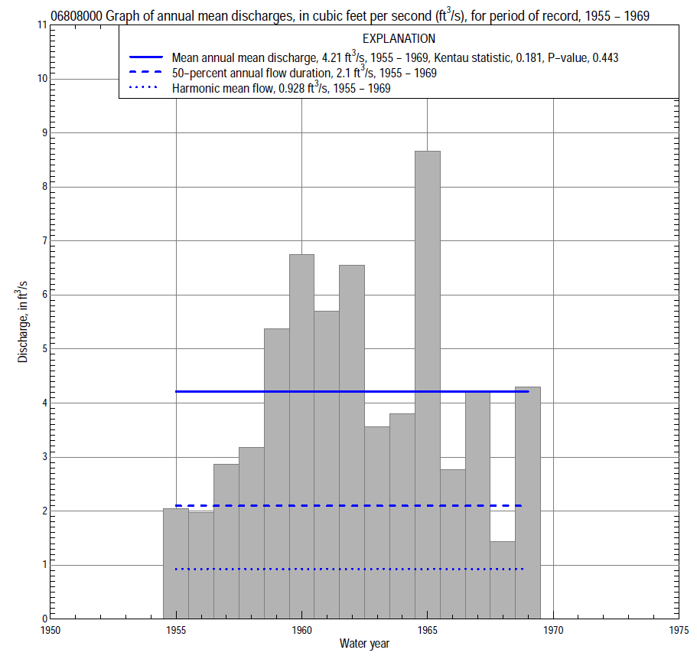

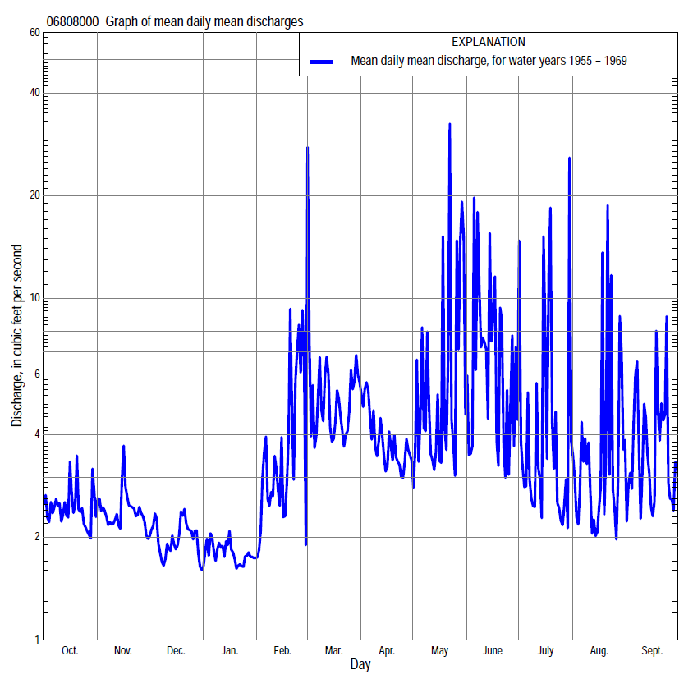

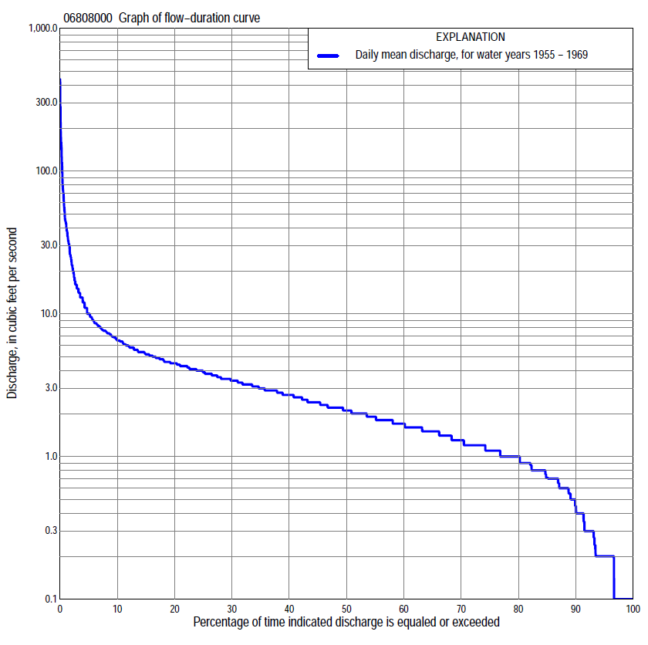

Statistics Based on the Entire Streamflow Period of Record
06808000 Monthly and annual flow durations, based on 1955–69 period of record (15 years)
Percentage of days discharge equaled or exceeded |  |  |  |  | Discharge (cubic feet per second) |  |  |  |  |  |  |  |  | Annual flow durations
 | Oct | Nov | Dec | Jan | Feb | Mar | Apr | May | June | July | Aug | Sept | Annual | Kentau statistic | P-value
99 | 0.10 | 0.10 | 0.10 | 0.00 | 0.10 | 0.40 | 0.10 | 0.10 | 0.10 | 0.10 | 0.10 | 0.10 | 0.10 | -0.010 | 1.000
98 | 0.10 | 0.20 | 0.10 | 0.10 | 0.20 | 0.50 | 0.10 | 0.10 | 0.10 | 0.10 | 0.10 | 0.20 | 0.10 | 0.000 | 1.000
95 | 0.10 | 0.20 | 0.10 | 0.20 | 0.20 | 0.70 | 0.30 | 0.30 | 0.10 | 0.10 | 0.20 | 0.20 | 0.20 | 0.114 | 0.545
90 | 0.20 | 0.70 | 0.50 | 0.20 | 0.30 | 1.0 | 1.0 | 0.50 | 0.55 | 0.27 | 0.30 | 0.30 | 0.40 | 0.190 | 0.308
85 | 0.60 | 1.0 | 0.70 | 0.70 | 0.60 | 1.2 | 1.2 | 0.70 | 0.65 | 0.45 | 0.60 | 0.60 | 0.70 | 0.181 | 0.333
80 | 1.0 | 1.2 | 0.80 | 0.80 | 0.90 | 1.4 | 1.5 | 1.0 | 0.80 | 0.70 | 0.80 | 0.70 | 1.0 | 0.181 | 0.333
75 | 1.2 | 1.3 | 1.0 | 0.90 | 1.0 | 1.6 | 1.6 | 1.2 | 1.0 | 1.1 | 1.0 | 1.1 | 1.1 | 0.190 | 0.318
70 | 1.3 | 1.5 | 1.0 | 1.0 | 1.2 | 1.8 | 1.8 | 1.4 | 1.5 | 1.2 | 1.2 | 1.3 | 1.3 | 0.324 | 0.086
65 | 1.4 | 1.6 | 1.1 | 1.0 | 1.3 | 2.1 | 2.0 | 1.8 | 2.0 | 1.6 | 1.5 | 1.5 | 1.5 | 0.276 | 0.150
60 | 1.6 | 1.7 | 1.2 | 1.1 | 1.5 | 2.5 | 2.2 | 2.1 | 2.3 | 1.8 | 1.6 | 1.6 | 1.7 | 0.210 | 0.275
55 | 1.6 | 1.8 | 1.3 | 1.2 | 1.7 | 2.7 | 2.4 | 2.3 | 2.6 | 2.2 | 1.8 | 1.9 | 1.9 | 0.171 | 0.383
50 | 1.8 | 1.9 | 1.5 | 1.3 | 1.8 | 2.9 | 2.6 | 2.8 | 3.2 | 2.5 | 2.1 | 2.1 | 2.1 | 0.229 | 0.240
45 | 2.0 | 2.0 | 1.7 | 1.5 | 2.2 | 3.1 | 2.9 | 3.2 | 3.9 | 2.9 | 2.2 | 2.3 | 2.4 | 0.210 | 0.283
40 | 2.2 | 2.4 | 1.9 | 1.7 | 2.6 | 3.5 | 3.1 | 3.5 | 4.3 | 3.4 | 2.3 | 2.6 | 2.7 | 0.219 | 0.262
35 | 2.6 | 2.7 | 2.2 | 2.0 | 3.0 | 4.0 | 3.5 | 4.0 | 4.8 | 3.6 | 2.7 | 2.8 | 3.1 | 0.190 | 0.338
30 | 2.9 | 2.9 | 2.4 | 2.3 | 3.4 | 4.4 | 4.3 | 4.9 | 5.3 | 3.8 | 2.9 | 3.2 | 3.5 | 0.152 | 0.449
25 | 3.7 | 3.2 | 2.8 | 2.7 | 4.0 | 4.9 | 5.4 | 5.6 | 5.6 | 4.1 | 3.3 | 3.7 | 4.0 | 0.143 | 0.480
20 | 4.1 | 3.7 | 3.1 | 3.0 | 4.9 | 7.0 | 6.4 | 6.1 | 6.8 | 4.5 | 3.6 | 4.5 | 4.5 | 0.210 | 0.288
15 | 4.4 | 4.1 | 3.5 | 3.3 | 6.0 | 8.4 | 7.2 | 7.2 | 7.7 | 5.2 | 4.3 | 5.4 | 5.3 | 0.229 | 0.249
10 | 4.9 | 4.6 | 4.3 | 3.6 | 7.7 | 12 | 8.2 | 9.0 | 11 | 6.3 | 5.2 | 6.4 | 6.6 | 0.181 | 0.369
5 | 5.6 | 5.2 | 5.1 | 4.5 | 15 | 16 | 10 | 16 | 30 | 8.9 | 9.8 | 13 | 10 | 0.038 | 0.882
2 | 7.6 | 6.5 | 5.8 | 5.2 | 32 | 35 | 15 | 56 | 64 | 38 | 22 | 32 | 23 | 0.076 | 0.728
1 | 9.5 | 6.5 | 6.0 | 5.6 | 55 | 40 | 17 | 112 | 76 | 98 | 29 | 41 | 43 | -0.086 | 0.692

06808000 Annual exceedance probability of instantaneous peak discharges, in cubic feet per second (ft³/s), based on the expected moments algorithm/multiple Grubbs-Beck analysis computed using a historical period length of 34 years (1954–1987)ª
Annual exceed-ance probability | Recur-rence interval (years) | Discharge (ft³/s) | 95-percent lower confi-dence interval (ft³/s) | 95-percent upper confi-dence interval (ft³/s)
0.500 | 2 | 860 | 368 | 1,110
0.200 | 5 | 1,430 | 1,040 | 1,880
0.100 | 10 | 1,820 | 1,340 | 2,550
0.040 | 25 | 2,300 | 1,660 | 3,910
0.020 | 50 | 2,660 | 1,880 | 5,550
0.010 | 100 | 3,010 | 2,080 | 7,970
0.005 | 200 | 3,350 | 2,250 | 11,100
0.002 | 500 | 3,790 | 2,450 | 14,800
Kentau statistic |  | -0.342
P-value |  | 0.071
Begin year |  | 1954
End year |  | 1969
Number of peaks |  | 16
ªWeighted Independent Estimates were not computed because regional regression equations are not considered applicable due to regulation from a number of detention dams within the watershed.

06808000 Annual exceedance probability of high discharges, based on 1955–69 period of record (15 years)
Annual exceedance probability | Recur-rence interval (years) | Maximum average discharge (ft³/s) for indicated number of consecutive days
 |  | 1 | 3 | 7 | 15 | 30
0.990 | 1.01 | 2.3 | 1.7 | 1.6 | 1.4 | 1.4
0.950 | 1.05 | 11 | 6.6 | 5.1 | 4.1 | 3.4
0.900 | 1.11 | 21 | 12 | 8.7 | 6.6 | 5.2
0.800 | 1.25 | 44 | 24 | 15 | 11 | 8.1
0.500 | 2 | 133 | 62 | 35 | 23 | 16
0.200 | 5 | 277 | 116 | 60 | 37 | 24
0.100 | 10 | 359 | 145 | 72 | 44 | 29
0.040 | 25 | 438 | 171 | 84 | 49 | 32
0.020 | 50 | 481 | 185 | 90 | 52 | 34
0.010 | 100 | 513 | 195 | 94 | 53 | 36
0.005 | 200 | 536 | 202 | 98 | 55 | 37
0.002 | 500 | 558 | 208 | 100 | 56 | 38
Kentau statistic |  | -0.152 | -0.219 | -0.086 | -0.086 | -0.086
P-value |  | 0.457 | 0.276 | 0.692 | 0.692 | 0.692

 | 06808000 Annual nonexceedance probability of low discharges, based on April 1955 to March 1969 period of record (14 years)
Annual nonexceed-ance probability | Recur-rence interval (years) | Minimum average discharge (cubic feet per second) for indicated number of consecutive days
 |  | 1 | 3 | 7 | 14 | 30 | 60 | 90 | 120 | 183
0.01 | 100 | 0.00 | 0.00 | 0.01 | 0.02 | 0.03 | 0.05 | 0.06 | 0.09 | 0.18
0.02 | 50 | 0.00 | 0.00 | 0.01 | 0.04 | 0.05 | 0.08 | 0.09 | 0.14 | 0.25
0.05 | 20 | 0.00 | 0.00 | 0.04 | 0.08 | 0.11 | 0.16 | 0.18 | 0.25 | 0.39
0.10 | 10 | 0.06 | 0.07 | 0.08 | 0.14 | 0.19 | 0.28 | 0.32 | 0.41 | 0.58
0.20 | 5 | 0.17 | 0.19 | 0.20 | 0.27 | 0.36 | 0.50 | 0.58 | 0.71 | 0.90
0.50 | 2 | 0.55 | 0.59 | 0.74 | 0.79 | 1.0 | 1.3 | 1.5 | 1.7 | 1.9
0.80 | 1.25 | 1.4 | 1.4 | 1.8 | 1.8 | 2.3 | 2.6 | 3.0 | 3.1 | 3.5
0.90 | 1.11 | 2.1 | 2.2 | 2.4 | 2.6 | 3.2 | 3.5 | 4.0 | 4.1 | 4.6
0.96 | 1.04 | 3.2 | 3.3 | 3.4 | 3.6 | 4.3 | 4.5 | 5.1 | 5.1 | 5.9
0.98 | 1.02 | 4.2 | 4.2 | 4.2 | 4.3 | 5.1 | 5.1 | 5.8 | 5.9 | 6.9
0.99 | 1.01 | 5.2 | 5.2 | 5.2 | 5.2 | 5.8 | 5.9 | 6.5 | 6.6 | 7.9
Kentau statistic |  | 0.121 | 0.121 | 0.143 | 0.121 | 0.143 | 0.187 | 0.187 | 0.187 | 0.121
P-value |  | 0.583 | 0.584 | 0.511 | 0.584 | 0.511 | 0.381 | 0.381 | 0.381 | 0.584

06808000 Annual nonexceedance probability of seasonal low discharges, based on July 1954 to September 1969 period of record (15–16 years)
Annual nonexceed-ance probability | Recur-rence interval (years) | Minimum average discharge (cubic feet per second) for indicated number of consecutive days
 |  | 1 | 7 | 14 | 30 |  | 1 | 7 | 14 | 30
 |  | January-February-March |  |  |  |  | April-May-June
0.01 | 100 | 0.00 | 0.01 | 0.03 | 0.06 |  | 0.03 | 0.05 | 0.05 | 0.06
0.02 | 50 | 0.00 | 0.01 | 0.05 | 0.10 |  | 0.05 | 0.08 | 0.09 | 0.10
0.05 | 20 | 0.00 | 0.05 | 0.11 | 0.19 |  | 0.09 | 0.15 | 0.17 | 0.21
0.10 | 10 | 0.12 | 0.12 | 0.21 | 0.33 |  | 0.16 | 0.25 | 0.30 | 0.39
0.20 | 5 | 0.31 | 0.31 | 0.42 | 0.58 |  | 0.32 | 0.46 | 0.55 | 0.74
0.50 | 2 | 0.96 | 1.1 | 1.2 | 1.4 |  | 0.99 | 1.3 | 1.5 | 2.1
0.80 | 1.25 | 1.8 | 2.2 | 2.3 | 2.7 |  | 2.6 | 3.0 | 3.5 | 4.4
0.90 | 1.11 | 2.3 | 2.6 | 3.0 | 3.5 |  | 4.1 | 4.5 | 5.0 | 6.0
0.96 | 1.04 | 2.8 | 2.9 | 3.7 | 4.3 |  | 6.2 | 6.4 | 6.9 | 7.8
0.98 | 1.02 | 3.1 | 3.2 | 4.0 | 4.8 |  | 7.9 | 7.9 | 8.3 | 8.9
0.99 | 1.01 | 3.4 | 3.7 | 4.3 | 5.1 |  | 9.4 | 9.4 | 9.6 | 9.9
Kentau statistic |  | 0.257 | 0.286 | 0.343 | 0.352 |  | 0.086 | 0.105 | 0.086 | 0.038
P-value |  | 0.196 | 0.151 | 0.083 | 0.075 |  | 0.691 | 0.621 | 0.692 | 0.882
 |  | July-August-September |  |  |  |  | October-November-December
0.01 | 100 | 0.03 | 0.04 | 0.04 | 0.06 |  | 0.03 | 0.04 | 0.05 | 0.06
0.02 | 50 | 0.05 | 0.06 | 0.07 | 0.09 |  | 0.05 | 0.07 | 0.08 | 0.10
0.05 | 20 | 0.09 | 0.12 | 0.14 | 0.18 |  | 0.10 | 0.14 | 0.16 | 0.20
0.10 | 10 | 0.14 | 0.21 | 0.23 | 0.31 |  | 0.18 | 0.24 | 0.30 | 0.35
0.20 | 5 | 0.26 | 0.38 | 0.43 | 0.57 |  | 0.33 | 0.44 | 0.55 | 0.64
0.50 | 2 | 0.70 | 1.0 | 1.2 | 1.5 |  | 0.92 | 1.1 | 1.4 | 1.6
0.80 | 1.25 | 1.7 | 2.2 | 2.5 | 3.1 |  | 2.1 | 2.3 | 2.7 | 2.9
0.90 | 1.11 | 2.6 | 3.1 | 3.5 | 4.1 |  | 3.0 | 3.2 | 3.4 | 3.7
0.96 | 1.04 | 4.0 | 4.2 | 4.8 | 5.3 |  | 4.1 | 4.1 | 4.1 | 4.4
0.98 | 1.02 | 4.8 | 4.9 | 5.7 | 6.1 |  | 4.7 | 4.7 | 4.7 | 4.8
0.99 | 1.01 | 5.5 | 5.6 | 6.5 | 6.8 |  | 5.2 | 5.2 | 5.3 | 5.3
Kentau statistic |  | 0.225 | 0.267 | 0.200 | 0.150 |  | 0.181 | 0.162 | 0.305 | 0.295
P-value |  | 0.239 | 0.163 | 0.300 | 0.444 |  | 0.372 | 0.428 | 0.125 | 0.138

