LOCATION.--Lat 40°52'23", long 95°34'48" referenced to North American Datum of 1927, in NW 1/4 NE 1/4 NE 1/4 sec.17, T.70 N., R.41 W., Fremont County, IA, Hydrologic Unit 10240002, on right bank on upstream side of bridge on State Highway 184, 0.5 mi west of Randolph, 0.3 mi downstream from Deer Creek, 16.0 mi upstream from confluence with East Nishnabotna River, and 30.6 mi upstream from mouth of Nishnabotna River.

DRAINAGE AREA.--1,326 mi².

PERIOD OF RECORD.--Discharge records from June 1948 to current year.

GAGE.--Water-stage recorder. Datum of gage is 932.99 ft above National Geodetic Vertical Datum of 1929. Prior to August 26, 1955, non-recording gage at same site and datum, with supplementary water-stage recorder operating above 8.4 ft gage height from June 30, 1949, to August 25, 1955.

EXTREMES OUTSIDE PERIOD OF RECORD.--Flood in June 1947 reached a stage of about 24 ft, discharge not determined, from information by local residents.

A summary of all available data for this streamgage is provided through the USGS National Water Information System web interface (NWISWeb). The following link provides access to current/historical observations, daily data, daily statistics, monthly statistics, annual statistics, peak streamflow, field measurements, field/lab water-quality samples, and the latest water-year summaries. Data can be filtered by parameter and/or dates, and can be output in various tabular and graphical formats.
http://waterdata.usgs.gov/nwis/inventory/?site_no=06808500

The USGS WaterWatch Toolkit is available at:
http://waterwatch.usgs.gov/?id=ww_toolkit
Tools for summarizing streamflow information include the duration hydrograph builder, the cumulative streamflow hydrograph builder, the streamgage statistics retrieval tool, the rating curve builder, the flood tracking chart builder, the National Weather Service Advanced Hydrologic Prediction Service (AHPS) river forecast hydrograph builder, and the raster-hydrograph builder. Entering the above number for this streamgage into these toolkit webpages will provide streamflow information specific to this streamgage.

A description of the statistics presented for this streamgage is available in the main body of the report at:
http://dx.doi.org/10.3133/ofr20151214
A link to other streamgages included in this report, a map showing the location of the streamgages, information on the programs used to compute the statistical analyses, and references are included in the main body of the report.

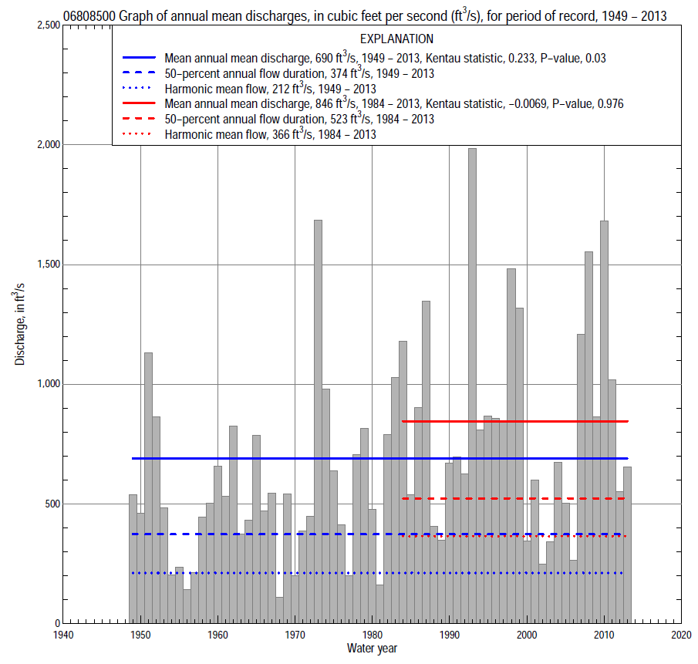

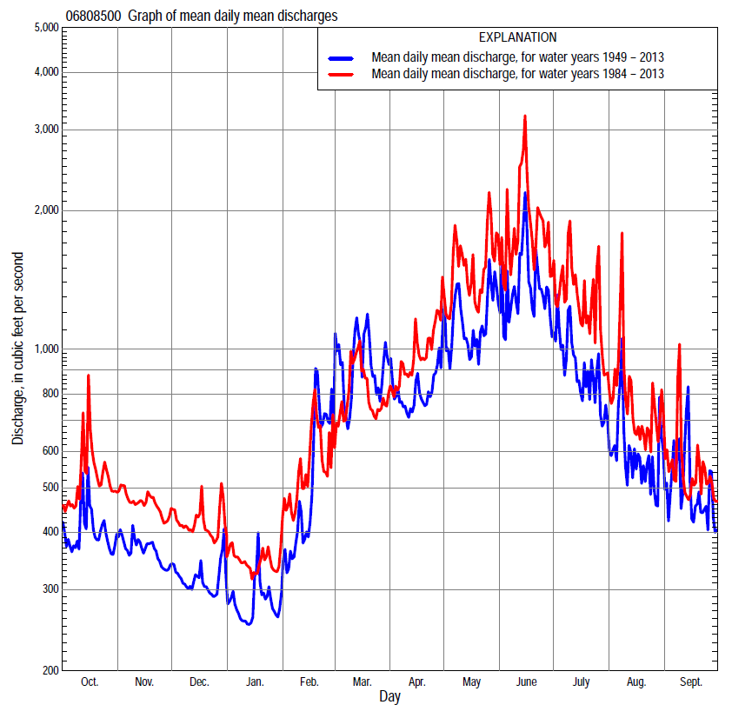

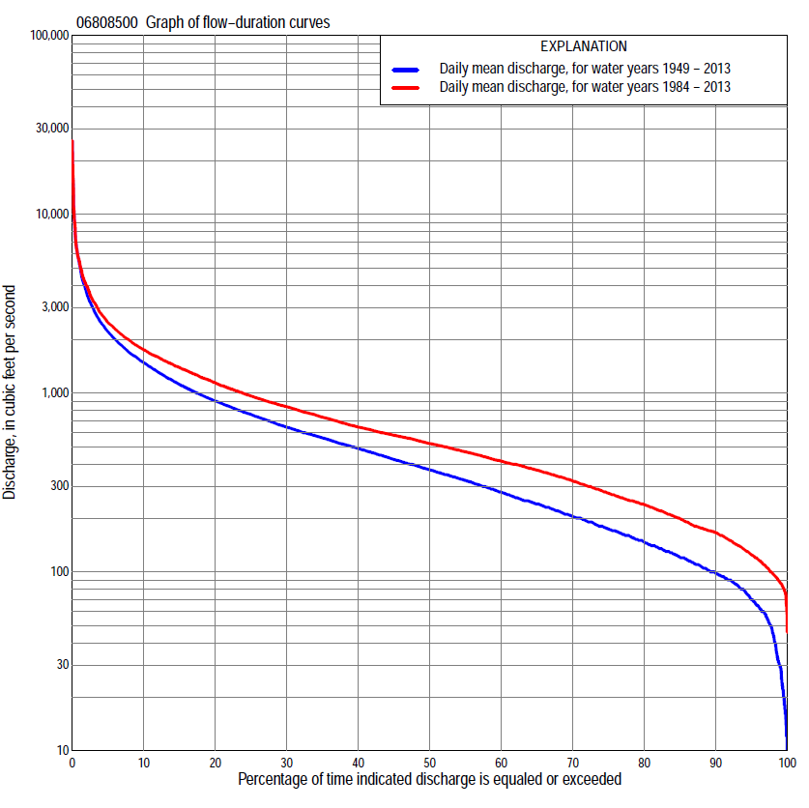

Statistics Based on the Entire Streamflow Period of Record
06808500 Monthly and annual flow durations, based on 1949–2013 period of record (65 years)
Percentage of days discharge equaled or exceeded |  |  |  |  | Discharge (cubic feet per second) |  |  |  |  |  |  |  |  | Annual flow durations
 | Oct | Nov | Dec | Jan | Feb | Mar | Apr | May | June | July | Aug | Sept | Annual | Kentau statistic | P-value
99 | 25 | 33 | 22 | 14 | 19 | 65 | 46 | 44 | 42 | 44 | 24 | 18 | 30 | 0.399 | 0.000
98 | 32 | 41 | 31 | 18 | 35 | 72 | 74 | 72 | 66 | 55 | 41 | 45 | 45 | 0.402 | 0.000
95 | 64 | 87 | 56 | 50 | 60 | 120 | 108 | 99 | 89 | 94 | 72 | 62 | 70 | 0.392 | 0.000
90 | 92 | 102 | 82 | 64 | 80 | 143 | 132 | 142 | 171 | 136 | 100 | 91 | 99 | 0.375 | 0.000
85 | 106 | 113 | 96 | 76 | 100 | 164 | 172 | 216 | 242 | 203 | 132 | 118 | 121 | 0.353 | 0.000
80 | 126 | 131 | 105 | 90 | 125 | 200 | 216 | 272 | 331 | 259 | 173 | 132 | 148 | 0.338 | 0.000
75 | 150 | 150 | 120 | 100 | 150 | 250 | 256 | 325 | 402 | 309 | 208 | 150 | 175 | 0.331 | 0.000
70 | 174 | 162 | 132 | 119 | 175 | 304 | 306 | 407 | 473 | 343 | 240 | 185 | 206 | 0.335 | 0.000
65 | 190 | 173 | 148 | 140 | 198 | 347 | 356 | 482 | 539 | 390 | 274 | 210 | 241 | 0.340 | 0.000
60 | 207 | 192 | 168 | 160 | 220 | 400 | 414 | 581 | 615 | 432 | 306 | 239 | 280 | 0.330 | 0.000
55 | 236 | 223 | 192 | 180 | 250 | 473 | 485 | 673 | 710 | 502 | 339 | 265 | 326 | 0.316 | 0.000
50 | 259 | 250 | 215 | 200 | 310 | 525 | 569 | 767 | 836 | 561 | 365 | 293 | 374 | 0.313 | 0.000
45 | 300 | 286 | 244 | 220 | 371 | 584 | 633 | 870 | 946 | 643 | 408 | 329 | 427 | 0.300 | 0.000
40 | 339 | 328 | 270 | 248 | 415 | 638 | 739 | 966 | 1,100 | 730 | 467 | 376 | 492 | 0.295 | 0.001
35 | 380 | 362 | 310 | 280 | 471 | 703 | 850 | 1,080 | 1,240 | 822 | 526 | 440 | 564 | 0.284 | 0.001
30 | 411 | 402 | 357 | 340 | 522 | 784 | 982 | 1,220 | 1,420 | 923 | 609 | 504 | 647 | 0.300 | 0.000
25 | 456 | 470 | 410 | 404 | 583 | 900 | 1,120 | 1,420 | 1,640 | 1,040 | 679 | 555 | 762 | 0.304 | 0.000
20 | 520 | 545 | 491 | 450 | 660 | 1,120 | 1,280 | 1,670 | 1,900 | 1,200 | 784 | 622 | 905 | 0.303 | 0.000
15 | 630 | 666 | 598 | 501 | 800 | 1,480 | 1,460 | 1,990 | 2,260 | 1,460 | 927 | 711 | 1,120 | 0.293 | 0.001
10 | 800 | 843 | 723 | 600 | 1,070 | 2,020 | 1,730 | 2,420 | 2,970 | 1,850 | 1,210 | 916 | 1,480 | 0.253 | 0.003
5 | 1,280 | 1,100 | 881 | 755 | 1,690 | 3,350 | 2,300 | 3,280 | 4,300 | 2,720 | 1,720 | 1,460 | 2,200 | 0.134 | 0.115
2 | 1,740 | 1,260 | 991 | 960 | 2,750 | 5,740 | 3,160 | 4,930 | 6,840 | 4,420 | 2,640 | 2,380 | 3,670 | 0.021 | 0.808
1 | 2,090 | 1,390 | 1,140 | 1,090 | 4,140 | 6,970 | 4,240 | 6,430 | 10,100 | 6,540 | 4,100 | 3,770 | 5,350 | -0.025 | 0.768

06808500 Annual exceedance probability of instantaneous peak discharges, in cubic feet per second (ft³/s), based on the Weighted Independent Estimates method,
Annual exceed-ance probability | Recur-rence interval (years) | Discharge (ft³/s) | 95-percent lower confi-dence interval (ft³/s) | 95-percent upper confi-dence interval (ft³/s)
0.500 | 2 | 13,600 | 11,600 | 16,000
0.200 | 5 | 22,400 | 19,200 | 26,000
0.100 | 10 | 27,900 | 23,700 | 32,900
0.040 | 25 | 34,900 | 28,700 | 42,400
0.020 | 50 | 39,700 | 31,700 | 49,800
0.010 | 100 | 44,300 | 34,200 | 57,500
0.005 | 200 | 48,700 | 36,400 | 65,300
0.002 | 500 | 54,200 | 38,600 | 76,200
and based on the expected moments algorithm/multiple Grubbs-Beck analysis computed using a historical period length of 65 years (1949–2013)
0.500 | 2 | 13,600 | 10,400 | 15,800
0.200 | 5 | 22,400 | 19,200 | 27,000
0.100 | 10 | 28,300 | 24,000 | 36,000
0.040 | 25 | 35,600 | 29,400 | 49,000
0.020 | 50 | 40,900 | 32,900 | 59,500
0.010 | 100 | 45,900 | 36,000 | 70,400
0.005 | 200 | 50,800 | 38,700 | 81,900
0.002 | 500 | 57,000 | 41,800 | 98,200
Kentau statistic |  | -0.230
P-value |  | 0.007
Begin year |  | 1949
End year |  | 2013
Number of peaks |  | 65

06808500 Annual exceedance probability of high discharges, based on 1949–2013 period of record (65 years)
Annual exceedance probability | Recur-rence interval (years) | Maximum average discharge (ft³/s) for indicated number of consecutive days
 |  | 1 | 3 | 7 | 15 | 30
0.990 | 1.01 | 580 | 460 | 349 | 251 | 212
0.950 | 1.05 | 1,540 | 1,120 | 803 | 574 | 457
0.900 | 1.11 | 2,430 | 1,700 | 1,190 | 849 | 660
0.800 | 1.25 | 4,010 | 2,710 | 1,840 | 1,300 | 991
0.500 | 2 | 8,870 | 5,770 | 3,750 | 2,610 | 1,930
0.200 | 5 | 16,200 | 10,400 | 6,520 | 4,470 | 3,280
0.100 | 10 | 20,600 | 13,400 | 8,240 | 5,600 | 4,120
0.040 | 25 | 25,500 | 16,800 | 10,200 | 6,840 | 5,070
0.020 | 50 | 28,600 | 19,000 | 11,400 | 7,630 | 5,690
0.010 | 100 | 31,200 | 21,000 | 12,500 | 8,320 | 6,250
0.005 | 200 | 33,500 | 22,800 | 13,500 | 8,920 | 6,750
0.002 | 500 | 35,900 | 24,800 | 14,600 | 9,590 | 7,330
Kentau statistic |  | -0.162 | -0.101 | -0.018 | 0.056 | 0.104
P-value |  | 0.058 | 0.237 | 0.834 | 0.515 | 0.224

 | 06808500 Annual nonexceedance probability of low discharges, based on April 1949 to March 2013 period of record (64 years)
Annual nonexceed-ance probability | Recur-rence interval (years) | Minimum average discharge (ft³/s) for indicated number of consecutive days
 |  | 1 | 3 | 7 | 14 | 30 | 60 | 90 | 120 | 183
0.01 | 100 | 11 | 11 | 12 | 13 | 16 | 20 | 26 | 33 | 37
0.02 | 50 | 15 | 16 | 16 | 18 | 22 | 27 | 34 | 42 | 47
0.05 | 20 | 24 | 25 | 26 | 29 | 34 | 42 | 50 | 59 | 69
0.10 | 10 | 35 | 37 | 39 | 43 | 49 | 60 | 70 | 81 | 95
0.20 | 5 | 55 | 58 | 61 | 66 | 76 | 91 | 103 | 116 | 138
0.50 | 2 | 119 | 127 | 134 | 143 | 162 | 189 | 209 | 224 | 272
0.80 | 1.25 | 234 | 249 | 264 | 281 | 312 | 361 | 397 | 417 | 509
0.90 | 1.11 | 320 | 340 | 361 | 386 | 424 | 491 | 541 | 569 | 694
0.96 | 1.04 | 435 | 461 | 490 | 527 | 574 | 665 | 742 | 781 | 951
0.98 | 1.02 | 523 | 552 | 588 | 635 | 688 | 800 | 901 | 953 | 1,160
0.99 | 1.01 | 611 | 644 | 686 | 745 | 802 | 937 | 1,070 | 1,140 | 1,370
Kentau statistic |  | 0.368 | 0.364 | 0.383 | 0.388 | 0.399 | 0.361 | 0.354 | 0.335 | 0.260
P-value |  | 0.000 | 0.000 | 0.000 | 0.000 | 0.000 | 0.000 | 0.000 | 0.000 | 0.002

06808500 Annual nonexceedance probability of seasonal low discharges, based on July 1948 to September 2013 period of record (65–66 years)
Annual nonexceed-ance probability | Recur-rence interval (years) | Minimum average discharge (cubic feet per second) for indicated number of consecutive days
 |  | 1 | 7 | 14 | 30 |  | 1 | 7 | 14 | 30
 |  | January-February-March |  |  |  |  | April-May-June
0.01 | 100 | 13 | 14 | 14 | 16 |  | 18 | 23 | 30 | 37
0.02 | 50 | 20 | 20 | 20 | 23 |  | 26 | 33 | 42 | 52
0.05 | 20 | 30 | 31 | 32 | 37 |  | 47 | 57 | 69 | 85
0.10 | 10 | 43 | 46 | 48 | 55 |  | 76 | 89 | 104 | 129
0.20 | 5 | 66 | 72 | 76 | 88 |  | 129 | 148 | 167 | 207
0.50 | 2 | 139 | 155 | 166 | 194 |  | 313 | 349 | 384 | 479
0.80 | 1.25 | 270 | 304 | 325 | 387 |  | 652 | 725 | 794 | 1,010
0.90 | 1.11 | 370 | 415 | 443 | 533 |  | 900 | 1,010 | 1,120 | 1,430
0.96 | 1.04 | 507 | 563 | 597 | 727 |  | 1,220 | 1,390 | 1,560 | 2,040
0.98 | 1.02 | 614 | 676 | 713 | 876 |  | 1,450 | 1,670 | 1,920 | 2,520
0.99 | 1.01 | 723 | 789 | 827 | 1,030 |  | 1,680 | 1,960 | 2,280 | 3,030
Kentau statistic |  | 0.319 | 0.343 | 0.350 | 0.326 |  | 0.314 | 0.295 | 0.291 | 0.272
P-value |  | 0.000 | 0.000 | 0.000 | 0.000 |  | 0.000 | 0.001 | 0.001 | 0.001
 |  | July-August-September |  |  |  |  | October-November-December
0.01 | 100 | 13 | 18 | 20 | 27 |  | 15 | 17 | 21 | 28
0.02 | 50 | 18 | 24 | 28 | 37 |  | 20 | 23 | 27 | 36
0.05 | 20 | 31 | 39 | 44 | 58 |  | 31 | 35 | 41 | 51
0.10 | 10 | 48 | 58 | 64 | 84 |  | 44 | 50 | 57 | 70
0.20 | 5 | 79 | 92 | 100 | 129 |  | 67 | 77 | 86 | 102
0.50 | 2 | 185 | 204 | 218 | 275 |  | 144 | 166 | 180 | 207
0.80 | 1.25 | 380 | 407 | 435 | 539 |  | 290 | 335 | 359 | 408
0.90 | 1.11 | 526 | 564 | 604 | 743 |  | 408 | 470 | 505 | 578
0.96 | 1.04 | 719 | 775 | 836 | 1,020 |  | 578 | 662 | 718 | 830
0.98 | 1.02 | 864 | 938 | 1,020 | 1,240 |  | 718 | 818 | 894 | 1,050
0.99 | 1.01 | 1,010 | 1,100 | 1,210 | 1,460 |  | 866 | 982 | 1,080 | 1,280
Kentau statistic |  | 0.323 | 0.289 | 0.280 | 0.205 |  | 0.341 | 0.341 | 0.362 | 0.352
P-value |  | 0.000 | 0.001 | 0.001 | 0.015 |  | 0.000 | 0.000 | 0.000 | 0.000

Statistics Based on the 1984–2013 Streamflow Period of Record
06808500 Monthly and annual flow durations, based on 1984–2013 period of record (30 years)
Percentage of days discharge equaled or exceeded |  |  |  |  | Discharge (cubic feet per second) |  |  |  |  |  |  |  |  | Annual flow durations
 | Oct | Nov | Dec | Jan | Feb | Mar | Apr | May | June | July | Aug | Sept | Annual | Kentau statistic | P-value
99 | 93 | 94 | 78 | 82 | 61 | 125 | 119 | 93 | 158 | 149 | 92 | 83 | 87 | 0.099 | 0.454
98 | 96 | 111 | 82 | 86 | 72 | 139 | 132 | 113 | 189 | 166 | 104 | 90 | 97 | 0.078 | 0.556
95 | 106 | 131 | 96 | 100 | 105 | 164 | 193 | 229 | 255 | 204 | 139 | 109 | 125 | 0.062 | 0.643
90 | 143 | 160 | 119 | 118 | 139 | 197 | 239 | 296 | 363 | 280 | 183 | 131 | 166 | 0.057 | 0.669
85 | 177 | 172 | 141 | 140 | 165 | 272 | 280 | 417 | 481 | 354 | 227 | 155 | 199 | 0.034 | 0.803
80 | 192 | 180 | 160 | 154 | 200 | 309 | 319 | 524 | 605 | 429 | 267 | 200 | 238 | 0.034 | 0.803
75 | 228 | 216 | 180 | 170 | 245 | 347 | 379 | 614 | 739 | 530 | 302 | 221 | 275 | 0.044 | 0.748
70 | 248 | 237 | 203 | 186 | 291 | 406 | 459 | 783 | 862 | 609 | 352 | 247 | 322 | 0.030 | 0.830
65 | 267 | 256 | 233 | 210 | 350 | 473 | 526 | 885 | 967 | 696 | 392 | 274 | 371 | 0.011 | 0.943
60 | 302 | 290 | 254 | 250 | 388 | 513 | 581 | 957 | 1,100 | 759 | 454 | 311 | 416 | 0.007 | 0.972
55 | 340 | 335 | 298 | 276 | 413 | 543 | 633 | 1,030 | 1,210 | 833 | 502 | 341 | 469 | 0.007 | 0.972
50 | 380 | 360 | 333 | 320 | 450 | 587 | 731 | 1,110 | 1,350 | 898 | 552 | 387 | 523 | -0.009 | 0.957
45 | 403 | 389 | 361 | 370 | 480 | 622 | 852 | 1,210 | 1,480 | 969 | 609 | 442 | 581 | -0.005 | 0.986
40 | 435 | 436 | 401 | 400 | 517 | 655 | 996 | 1,320 | 1,620 | 1,050 | 658 | 489 | 645 | -0.025 | 0.858
35 | 482 | 482 | 459 | 420 | 545 | 700 | 1,150 | 1,490 | 1,770 | 1,150 | 734 | 538 | 734 | -0.034 | 0.803
30 | 516 | 561 | 521 | 443 | 583 | 747 | 1,280 | 1,700 | 1,950 | 1,260 | 817 | 582 | 839 | -0.014 | 0.929
25 | 581 | 653 | 596 | 473 | 627 | 812 | 1,350 | 1,860 | 2,180 | 1,440 | 895 | 630 | 963 | -0.011 | 0.943
20 | 681 | 746 | 677 | 504 | 700 | 883 | 1,470 | 2,090 | 2,460 | 1,660 | 1,020 | 681 | 1,140 | 0.018 | 0.901
15 | 810 | 824 | 735 | 555 | 809 | 1,090 | 1,620 | 2,390 | 2,970 | 1,960 | 1,210 | 840 | 1,390 | 0.014 | 0.929
10 | 1,020 | 958 | 833 | 600 | 1,010 | 1,400 | 1,870 | 2,820 | 3,800 | 2,460 | 1,470 | 1,030 | 1,750 | 0.041 | 0.762
5 | 1,530 | 1,150 | 945 | 720 | 1,470 | 2,380 | 2,380 | 3,890 | 5,250 | 3,600 | 1,980 | 1,520 | 2,480 | 0.037 | 0.789
2 | 1,970 | 1,260 | 1,120 | 782 | 2,180 | 4,230 | 3,380 | 5,340 | 7,170 | 5,560 | 2,950 | 2,160 | 3,980 | -0.044 | 0.748
1 | 2,490 | 1,380 | 1,360 | 895 | 3,170 | 5,640 | 4,300 | 6,430 | 10,900 | 8,720 | 4,430 | 2,760 | 5,470 | -0.092 | 0.486

06808500 Annual exceedance probability of high discharges, based on 1984–2013 period of record (30 years)
Annual exceed-ance probability | Recur-rence interval (years) | Maximum average discharge (ft³/s) for indicated number of consecutive days
 |  | 1 | 3 | 7 | 15 | 30
0.990 | 1.01 | 589 | 519 | 414 | 359 | 332
0.950 | 1.05 | 1,320 | 1,080 | 833 | 689 | 595
0.900 | 1.11 | 1,990 | 1,560 | 1,180 | 956 | 800
0.800 | 1.25 | 3,180 | 2,390 | 1,780 | 1,390 | 1,130
0.500 | 2 | 7,270 | 5,170 | 3,660 | 2,710 | 2,100
0.200 | 5 | 15,200 | 10,500 | 6,970 | 4,930 | 3,710
0.100 | 10 | 21,700 | 14,800 | 9,500 | 6,550 | 4,900
0.040 | 25 | 30,800 | 20,900 | 12,900 | 8,700 | 6,500
0.020 | 50 | 38,200 | 25,900 | 15,600 | 10,300 | 7,730
0.010 | 100 | 45,900 | 31,200 | 18,400 | 12,000 | 9,000
0.005 | 200 | 53,900 | 36,800 | 21,200 | 13,700 | 10,300
0.002 | 500 | 65,000 | 44,600 | 25,000 | 15,900 | 12,000
Kentau statistic |  | -0.140 | -0.126 | -0.080 | -0.034 | 0.007
P-value |  | 0.284 | 0.335 | 0.544 | 0.803 | 0.972

 | 06808500 Annual nonexceedance probability of low discharges, based on April 1983 to March 2013 period of record (30 years)
Annual nonexceed-ance probability | Recur-rence interval (years) | Minimum average discharge (ft³/s) for indicated number of consecutive days
 |  | 1 | 3 | 7 | 14 | 30 | 60 | 90 | 120 | 183
0.01 | 100 | 37 | 41 | 44 | 45 | 53 | 63 | 68 | 72 | 76
0.02 | 50 | 45 | 49 | 53 | 55 | 65 | 76 | 82 | 87 | 93
0.05 | 20 | 60 | 65 | 71 | 75 | 86 | 101 | 108 | 114 | 123
0.10 | 10 | 77 | 84 | 90 | 97 | 110 | 128 | 137 | 145 | 158
0.20 | 5 | 103 | 112 | 121 | 130 | 147 | 170 | 182 | 192 | 213
0.50 | 2 | 177 | 190 | 205 | 223 | 249 | 284 | 307 | 322 | 367
0.80 | 1.25 | 294 | 313 | 336 | 365 | 405 | 459 | 505 | 528 | 618
0.90 | 1.11 | 380 | 403 | 430 | 465 | 514 | 583 | 648 | 676 | 803
0.96 | 1.04 | 493 | 522 | 553 | 593 | 657 | 744 | 839 | 875 | 1,050
0.98 | 1.02 | 582 | 614 | 648 | 689 | 765 | 867 | 987 | 1,030 | 1,250
0.99 | 1.01 | 672 | 709 | 744 | 785 | 873 | 991 | 1,140 | 1,190 | 1,460
Kentau statistic |  | 0.078 | 0.044 | 0.057 | 0.057 | 0.039 | 0.011 | -0.007 | -0.016 | -0.030
P-value |  | 0.556 | 0.748 | 0.669 | 0.669 | 0.775 | 0.943 | 0.972 | 0.915 | 0.830

06808500 Annual nonexceedance probability of seasonal low discharges, based on October 1983 to September 2013 period of record (30 years)
Annual nonexceed-ance probability | Recur-rence interval (years) | Minimum average discharge (cubic feet per second) for indicated number of consecutive days
 |  | 1 | 7 | 14 | 30 |  | 1 | 7 | 14 | 30
 |  | January-February-March |  |  |  |  | April-May-June
0.01 | 100 | 36 | 46 | 49 | 55 |  | 67 | 69 | 74 | 85
0.02 | 50 | 45 | 57 | 61 | 69 |  | 88 | 91 | 98 | 114
0.05 | 20 | 61 | 78 | 84 | 95 |  | 129 | 135 | 147 | 173
0.10 | 10 | 80 | 101 | 110 | 124 |  | 178 | 189 | 206 | 245
0.20 | 5 | 109 | 136 | 149 | 169 |  | 256 | 276 | 302 | 366
0.50 | 2 | 193 | 231 | 254 | 287 |  | 479 | 534 | 590 | 734
0.80 | 1.25 | 328 | 372 | 402 | 456 |  | 819 | 944 | 1,060 | 1,350
0.90 | 1.11 | 426 | 467 | 497 | 564 |  | 1,050 | 1,230 | 1,390 | 1,780
0.96 | 1.04 | 556 | 585 | 613 | 695 |  | 1,330 | 1,590 | 1,810 | 2,350
0.98 | 1.02 | 656 | 672 | 694 | 787 |  | 1,530 | 1,850 | 2,120 | 2,780
0.99 | 1.01 | 756 | 757 | 771 | 874 |  | 1,730 | 2,110 | 2,430 | 3,190
Kentau statistic |  | 0.074 | 0.037 | 0.048 | 0.044 |  | 0.028 | -0.007 | -0.007 | 0.021
P-value |  | 0.580 | 0.789 | 0.721 | 0.748 |  | 0.844 | 0.972 | 0.972 | 0.887
 |  | July-August-September |  |  |  |  | October-November-December
0.01 | 100 | 51 | 59 | 61 | 72 |  | 41 | 48 | 53 | 61
0.02 | 50 | 63 | 70 | 74 | 86 |  | 50 | 58 | 64 | 74
0.05 | 20 | 84 | 92 | 97 | 111 |  | 67 | 77 | 85 | 98
0.10 | 10 | 109 | 118 | 124 | 141 |  | 86 | 100 | 109 | 126
0.20 | 5 | 149 | 159 | 168 | 191 |  | 117 | 135 | 148 | 170
0.50 | 2 | 272 | 287 | 305 | 350 |  | 209 | 240 | 262 | 302
0.80 | 1.25 | 493 | 525 | 562 | 669 |  | 370 | 423 | 461 | 533
0.90 | 1.11 | 673 | 725 | 778 | 956 |  | 496 | 568 | 619 | 716
0.96 | 1.04 | 936 | 1,030 | 1,110 | 1,420 |  | 677 | 775 | 845 | 978
0.98 | 1.02 | 1,160 | 1,290 | 1,390 | 1,840 |  | 826 | 947 | 1,030 | 1,200
0.99 | 1.01 | 1,400 | 1,590 | 1,710 | 2,340 |  | 987 | 1,130 | 1,240 | 1,430
Kentau statistic |  | 0.021 | 0.011 | 0.021 | -0.002 |  | 0.032 | 0.055 | 0.076 | -0.002
P-value |  | 0.886 | 0.943 | 0.887 | 1.000 |  | 0.816 | 0.682 | 0.568 | 1.000

