LOCATION.--Lat 41°20'46", long 95°04'36" referenced to North American Datum of 1927, in NE 1/4 NW 1/4 NW 1/4 sec.35, T.76 N., R.37 W., Cass County, IA, Hydrologic Unit 10240003, on left bank on downstream side of bridge on Lansing Road, 5.2 mi southwest of intersection of U.S. Highway 6 and State Highway 83 in Atlantic, 1.6 mi upstream from Turkey Creek, 74.3 mi upstream from confluence with West Nishnabotna River, and 89.9 mi upstream from mouth of Nishnabotna River.

DRAINAGE AREA.--436 mi².

PERIOD OF RECORD.--Discharge records from October 1960 to current year.

GAGE.--Water-stage recorder. Datum of gage is 1,105.83 ft above National Geodetic Vertical Datum of 1929. Prior to October 1, 1970, at site 2.2 mi upstream at datum 5.00 ft higher.

EXTREMES OUTSIDE PERIOD OF RECORD.--Flood of July 2, 1958, reached a stage of 22.49 ft, from high-water mark, discharge 34,200 ft³/s.

A summary of all available data for this streamgage is provided through the USGS National Water Information System web interface (NWISWeb). The following link provides access to current/historical observations, daily data, daily statistics, monthly statistics, annual statistics, peak streamflow, field measurements, field/lab water-quality samples, and the latest water-year summaries. Data can be filtered by parameter and/or dates, and can be output in various tabular and graphical formats.
http://waterdata.usgs.gov/nwis/inventory/?site_no=06809210

The USGS WaterWatch Toolkit is available at:
http://waterwatch.usgs.gov/?id=ww_toolkit
Tools for summarizing streamflow information include the duration hydrograph builder, the cumulative streamflow hydrograph builder, the streamgage statistics retrieval tool, the rating curve builder, the flood tracking chart builder, the National Weather Service Advanced Hydrologic Prediction Service (AHPS) river forecast hydrograph builder, and the raster-hydrograph builder. Entering the above number for this streamgage into these toolkit webpages will provide streamflow information specific to this streamgage.

A description of the statistics presented for this streamgage is available in the main body of the report at:
http://dx.doi.org/10.3133/ofr20151214
A link to other streamgages included in this report, a map showing the location of the streamgages, information on the programs used to compute the statistical analyses, and references are included in the main body of the report.

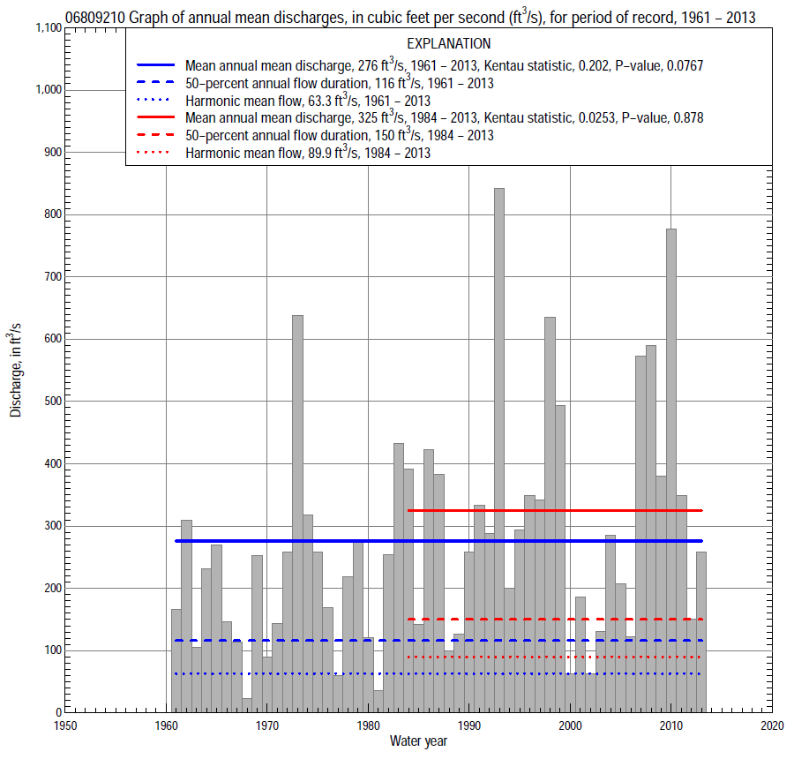

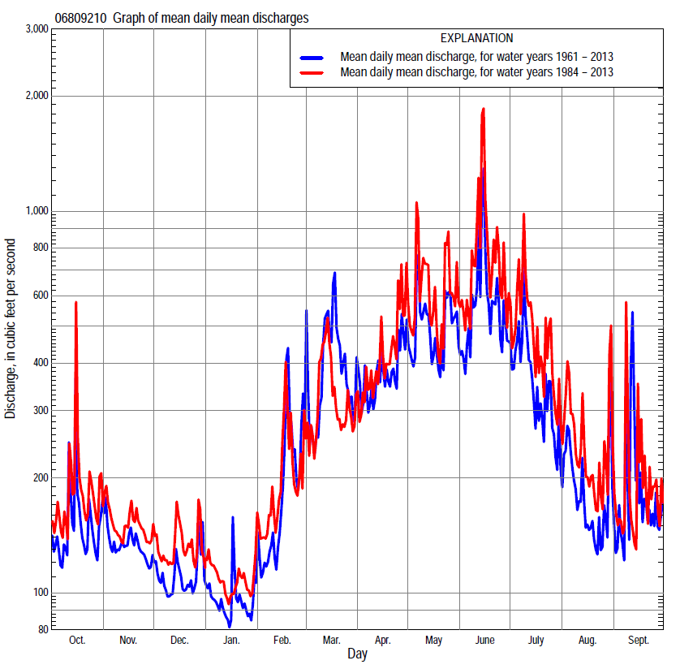

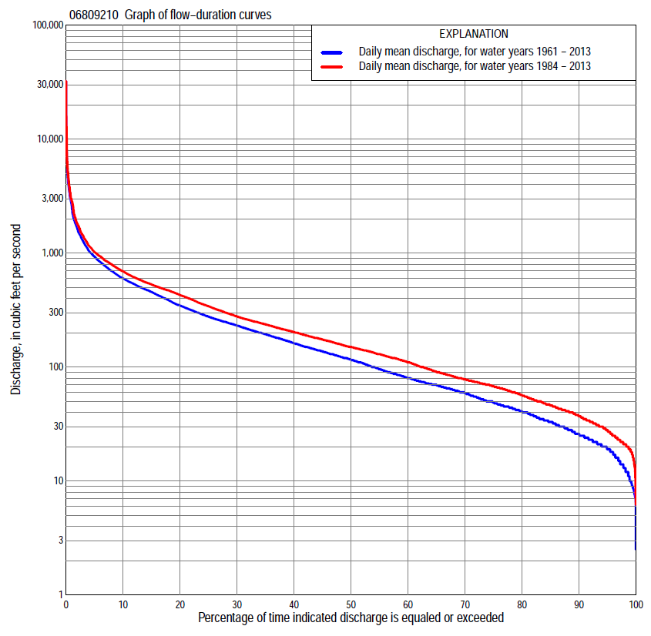
Statistics Based on the Entire Streamflow Period of Record
06809210 Monthly and annual flow durations, based on 1961–2013 period of record (53 years)
Percentage of days discharge equaled or exceeded |  |  |  |  | Discharge (cubic feet per second) |  |  |  |  |  |  |  |  | Annual flow durations
 | Oct | Nov | Dec | Jan | Feb | Mar | Apr | May | June | July | Aug | Sept | Annual | Kentau statistic | P-value
99 | 15 | 15 | 7.6 | 7.4 | 9.0 | 20 | 21 | 14 | 12 | 12 | 8.6 | 10 | 10 | 0.255 | 0.007
98 | 17 | 18 | 9.2 | 8.5 | 10 | 25 | 24 | 17 | 14 | 14 | 12 | 12 | 13 | 0.261 | 0.006
95 | 20 | 22 | 13 | 12 | 15 | 28 | 29 | 24 | 29 | 26 | 21 | 18 | 19 | 0.279 | 0.003
90 | 23 | 28 | 18 | 16 | 20 | 40 | 44 | 43 | 57 | 40 | 28 | 23 | 26 | 0.280 | 0.003
85 | 26 | 32 | 23 | 20 | 25 | 51 | 56 | 74 | 81 | 55 | 34 | 28 | 33 | 0.282 | 0.003
80 | 34 | 35 | 28 | 25 | 30 | 65 | 70 | 112 | 107 | 68 | 43 | 33 | 41 | 0.277 | 0.003
75 | 41 | 40 | 33 | 29 | 38 | 79 | 84 | 134 | 134 | 83 | 52 | 38 | 49 | 0.250 | 0.008
70 | 46 | 47 | 36 | 35 | 45 | 93 | 100 | 165 | 164 | 100 | 60 | 46 | 59 | 0.234 | 0.013
65 | 52 | 52 | 40 | 39 | 50 | 110 | 121 | 200 | 188 | 116 | 69 | 53 | 69 | 0.217 | 0.022
60 | 61 | 60 | 45 | 44 | 60 | 136 | 146 | 241 | 215 | 133 | 77 | 60 | 80 | 0.220 | 0.020
55 | 69 | 68 | 53 | 48 | 68 | 152 | 184 | 277 | 252 | 151 | 87 | 67 | 96 | 0.218 | 0.021
50 | 74 | 75 | 62 | 52 | 80 | 179 | 225 | 315 | 301 | 176 | 98 | 74 | 116 | 0.213 | 0.025
45 | 83 | 85 | 70 | 60 | 100 | 202 | 258 | 351 | 345 | 200 | 110 | 85 | 137 | 0.196 | 0.039
40 | 93 | 96 | 80 | 70 | 127 | 235 | 317 | 408 | 409 | 235 | 124 | 96 | 162 | 0.191 | 0.044
35 | 117 | 117 | 100 | 84 | 153 | 263 | 389 | 460 | 470 | 275 | 141 | 114 | 194 | 0.196 | 0.039
30 | 134 | 132 | 122 | 104 | 183 | 310 | 447 | 517 | 555 | 319 | 162 | 132 | 231 | 0.226 | 0.017
25 | 159 | 159 | 146 | 125 | 208 | 370 | 500 | 575 | 630 | 382 | 197 | 152 | 277 | 0.240 | 0.011
20 | 189 | 202 | 180 | 150 | 250 | 486 | 565 | 664 | 746 | 457 | 234 | 179 | 347 | 0.257 | 0.007
15 | 232 | 249 | 215 | 180 | 300 | 609 | 666 | 785 | 885 | 548 | 282 | 223 | 456 | 0.262 | 0.006
10 | 310 | 296 | 257 | 223 | 402 | 860 | 863 | 981 | 1,150 | 729 | 364 | 343 | 600 | 0.262 | 0.006
5 | 489 | 467 | 329 | 295 | 650 | 1,440 | 1,170 | 1,490 | 1,860 | 1,170 | 578 | 563 | 930 | 0.172 | 0.070
2 | 832 | 669 | 446 | 400 | 1,230 | 2,790 | 1,660 | 2,550 | 3,200 | 2,160 | 895 | 1010 | 1,650 | 0.076 | 0.425
1 | 1,110 | 760 | 603 | 485 | 1,790 | 3,550 | 2,230 | 3,850 | 4,600 | 4,050 | 1,390 | 1,730 | 2,620 | 0.026 | 0.788

06809210 Annual exceedance probability of instantaneous peak discharges, in cubic feet per second (ft³/s), based on the Weighted Independent Estimates method,
Annual exceed-ance probability | Recur-rence interval (years) | Discharge (ft³/s) | 95-percent lower confi-dence interval (ft³/s) | 95-percent upper confi-dence interval (ft³/s)
0.500 | 2 | 8,840 | 7,280 | 10,700
0.200 | 5 | 16,100 | 13,400 | 19,300
0.100 | 10 | 21,000 | 17,300 | 25,400
0.040 | 25 | 27,100 | 21,600 | 34,100
0.020 | 50 | 31,500 | 24,200 | 40,900
0.010 | 100 | 35,700 | 26,500 | 48,200
0.005 | 200 | 39,800 | 28,500 | 55,600
0.002 | 500 | 45,000 | 30,600 | 66,200
and based on the expected moments algorithm/multiple Grubbs-Beck analysis computed using a historical period length of 66 years (1948–2013)
0.500 | 2 | 8,960 | 7,080 | 11,100
0.200 | 5 | 16,500 | 13,400 | 20,600
0.100 | 10 | 22,000 | 17,700 | 28,200
0.040 | 25 | 29,000 | 22,900 | 39,800
0.020 | 50 | 34,300 | 26,300 | 50,000
0.010 | 100 | 39,500 | 29,300 | 61,600
0.005 | 200 | 44,700 | 31,900 | 74,800
0.002 | 500 | 51,400 | 34,800 | 95,100
Kentau statistic |  | 0.000
P-value |  | 1.000
Begin year |  | 1961
End year |  | 2013
Number of peaks |  | 53

06809210 Annual exceedance probability of high discharges, based on 1961–2013 period of record (53 years)
Annual exceedance probability | Recur-rence interval (years) | Maximum average discharge (ft³/s) for indicated number of consecutive days
 |  | 1 | 3 | 7 | 15 | 30
0.990 | 1.01 | 421 | 195 | 110 | 70 | 54
0.950 | 1.05 | 919 | 500 | 309 | 207 | 157
0.900 | 1.11 | 1,360 | 787 | 501 | 341 | 255
0.800 | 1.25 | 2,140 | 1,310 | 847 | 580 | 429
0.500 | 2 | 4,750 | 3,020 | 1,940 | 1,310 | 951
0.200 | 5 | 9,670 | 5,950 | 3,570 | 2,310 | 1,660
0.100 | 10 | 13,600 | 7,990 | 4,550 | 2,860 | 2,040
0.040 | 25 | 19,000 | 10,500 | 5,610 | 3,400 | 2,420
0.020 | 50 | 23,300 | 12,300 | 6,260 | 3,700 | 2,630
0.010 | 100 | 27,800 | 13,900 | 6,810 | 3,940 | 2,790
0.005 | 200 | 32,500 | 15,400 | 7,270 | 4,120 | 2,920
0.002 | 500 | 38,800 | 17,300 | 7,760 | 4,300 | 3,050
Kentau statistic |  | 0.089 | 0.073 | 0.075 | 0.097 | 0.122
P-value |  | 0.349 | 0.448 | 0.434 | 0.308 | 0.200

 | 06809210 Annual nonexceedance probability of low discharges, based on April 1961 to March 2013 period of record (52 years)
Annual nonexceed-ance probability | Recur-rence interval (years) | Minimum average discharge (ft³/s) for indicated number of consecutive days
 |  | 1 | 3 | 7 | 14 | 30 | 60 | 90 | 120 | 183
0.01 | 100 | 2.7 | 3.4 | 4.2 | 4.4 | 5.1 | 6.3 | 8.1 | 10 | 11
0.02 | 50 | 3.7 | 4.5 | 5.5 | 5.7 | 6.7 | 8.1 | 10 | 12 | 14
0.05 | 20 | 5.7 | 6.7 | 8.0 | 8.5 | 10 | 12 | 15 | 17 | 19
0.10 | 10 | 8.3 | 9.5 | 11 | 12 | 14 | 17 | 20 | 23 | 26
0.20 | 5 | 13 | 14 | 17 | 18 | 21 | 25 | 29 | 32 | 38
0.50 | 2 | 29 | 31 | 35 | 38 | 44 | 52 | 60 | 65 | 81
0.80 | 1.25 | 60 | 65 | 70 | 76 | 88 | 108 | 124 | 135 | 175
0.90 | 1.11 | 87 | 93 | 100 | 108 | 125 | 156 | 181 | 199 | 264
0.96 | 1.04 | 125 | 137 | 144 | 156 | 179 | 231 | 271 | 302 | 414
0.98 | 1.02 | 157 | 174 | 182 | 197 | 224 | 296 | 351 | 397 | 556
0.99 | 1.01 | 191 | 215 | 224 | 242 | 273 | 369 | 444 | 509 | 727
Kentau statistic |  | 0.215 | 0.244 | 0.285 | 0.283 | 0.285 | 0.268 | 0.247 | 0.238 | 0.186
P-value |  | 0.025 | 0.011 | 0.003 | 0.003 | 0.003 | 0.005 | 0.010 | 0.013 | 0.053

06809210 Annual nonexceedance probability of seasonal low discharges, based on October 1960 to September 2013 period of record (53 years)
Annual nonexceed-ance probability | Recur-rence interval (years) | Minimum average discharge (cubic feet per second) for indicated number of consecutive days
 |  | 1 | 7 | 14 | 30 |  | 1 | 7 | 14 | 30
 |  | January-February-March |  |  |  |  | April-May-June
0.01 | 100 | 3.9 | 4.6 | 5.1 | 6.5 |  | 4.9 | 6.4 | 7.4 | 9.0
0.02 | 50 | 5.1 | 6.0 | 6.6 | 8.3 |  | 7.6 | 9.6 | 11 | 14
0.05 | 20 | 7.5 | 8.9 | 9.8 | 12 |  | 14 | 17 | 20 | 25
0.10 | 10 | 11 | 13 | 14 | 17 |  | 23 | 28 | 32 | 41
0.20 | 5 | 16 | 19 | 21 | 25 |  | 40 | 47 | 54 | 72
0.50 | 2 | 35 | 42 | 47 | 54 |  | 102 | 118 | 136 | 184
0.80 | 1.25 | 75 | 93 | 102 | 123 |  | 219 | 257 | 297 | 400
0.90 | 1.11 | 110 | 139 | 152 | 190 |  | 306 | 366 | 425 | 566
0.96 | 1.04 | 164 | 212 | 233 | 304 |  | 419 | 512 | 598 | 784
0.98 | 1.02 | 213 | 280 | 306 | 414 |  | 502 | 623 | 733 | 947
0.99 | 1.01 | 267 | 357 | 390 | 549 |  | 581 | 734 | 867 | 1,110
Kentau statistic |  | 0.142 | 0.206 | 0.239 | 0.225 |  | 0.200 | 0.189 | 0.186 | 0.219
P-value |  | 0.135 | 0.030 | 0.012 | 0.018 |  | 0.035 | 0.047 | 0.050 | 0.021
 |  | July-August-September |  |  |  |  | October-November-December
0.01 | 100 | 3.9 | 7.5 | 8.2 | 11 |  | 4.5 | 5.1 | 5.7 | 7.6
0.02 | 50 | 5.4 | 9.3 | 10 | 14 |  | 5.8 | 6.6 | 7.4 | 9.5
0.05 | 20 | 8.7 | 13 | 14 | 19 |  | 8.4 | 9.7 | 11 | 14
0.10 | 10 | 13 | 17 | 19 | 24 |  | 12 | 14 | 15 | 19
0.20 | 5 | 21 | 25 | 27 | 34 |  | 17 | 21 | 23 | 27
0.50 | 2 | 47 | 50 | 54 | 67 |  | 38 | 46 | 51 | 58
0.80 | 1.25 | 98 | 102 | 112 | 138 |  | 83 | 99 | 110 | 127
0.90 | 1.11 | 138 | 149 | 166 | 205 |  | 125 | 148 | 165 | 192
0.96 | 1.04 | 195 | 224 | 252 | 315 |  | 194 | 226 | 253 | 300
0.98 | 1.02 | 240 | 292 | 332 | 420 |  | 258 | 297 | 333 | 402
0.99 | 1.01 | 287 | 371 | 426 | 545 |  | 335 | 378 | 427 | 524
Kentau statistic |  | 0.263 | 0.248 | 0.239 | 0.193 |  | 0.179 | 0.194 | 0.208 | 0.211
P-value |  | 0.006 | 0.009 | 0.012 | 0.042 |  | 0.060 | 0.041 | 0.029 | 0.026

Statistics Based on the 1984–2013 Streamflow Period of Record
06809210 Monthly and annual flow durations, based on 1984–2013 period of record (30 years)
Percentage of days discharge equaled or exceeded |  |  |  |  | Discharge (cubic feet per second) |  |  |  |  |  |  |  |  | Annual flow durations
 | Oct | Nov | Dec | Jan | Feb | Mar | Apr | May | June | July | Aug | Sept | Annual | Kentau statistic | P-value
99 | 20 | 19 | 13 | 12 | 18 | 25 | 27 | 22 | 32 | 29 | 21 | 18 | 19 | 0.044 | 0.748
98 | 20 | 26 | 14 | 18 | 20 | 33 | 29 | 28 | 36 | 33 | 23 | 19 | 21 | 0.053 | 0.695
95 | 22 | 31 | 19 | 22 | 23 | 41 | 39 | 43 | 45 | 47 | 28 | 22 | 28 | 0.055 | 0.681
90 | 30 | 35 | 27 | 27 | 29 | 50 | 56 | 76 | 76 | 58 | 37 | 30 | 37 | 0.067 | 0.617
85 | 40 | 40 | 33 | 34 | 38 | 63 | 76 | 116 | 112 | 77 | 45 | 34 | 46 | 0.083 | 0.532
80 | 43 | 46 | 38 | 40 | 50 | 83 | 92 | 150 | 153 | 102 | 57 | 43 | 57 | 0.069 | 0.605
75 | 52 | 57 | 45 | 45 | 61 | 96 | 107 | 204 | 183 | 120 | 68 | 51 | 68 | 0.053 | 0.695
70 | 63 | 64 | 50 | 50 | 70 | 118 | 122 | 256 | 219 | 140 | 79 | 62 | 78 | 0.039 | 0.775
65 | 70 | 70 | 57 | 54 | 76 | 140 | 149 | 297 | 287 | 162 | 92 | 69 | 91 | -0.009 | 0.957
60 | 75 | 74 | 66 | 60 | 93 | 153 | 187 | 336 | 343 | 189 | 106 | 76 | 110 | 0.000 | 1.000
55 | 81 | 81 | 75 | 66 | 113 | 172 | 227 | 380 | 413 | 221 | 122 | 84 | 130 | -0.011 | 0.943
50 | 88 | 89 | 82 | 75 | 130 | 191 | 264 | 428 | 470 | 257 | 138 | 92 | 150 | -0.023 | 0.872
45 | 99 | 106 | 100 | 85 | 150 | 212 | 333 | 472 | 531 | 298 | 157 | 108 | 174 | -0.037 | 0.789
40 | 124 | 124 | 120 | 96 | 167 | 235 | 409 | 515 | 584 | 347 | 182 | 123 | 203 | -0.041 | 0.762
35 | 137 | 140 | 140 | 112 | 185 | 259 | 463 | 554 | 662 | 396 | 207 | 139 | 237 | -0.032 | 0.817
30 | 159 | 172 | 157 | 135 | 205 | 282 | 497 | 615 | 741 | 448 | 234 | 158 | 278 | -0.002 | 1.000
25 | 182 | 204 | 180 | 150 | 236 | 324 | 548 | 689 | 835 | 507 | 270 | 179 | 341 | -0.007 | 0.972
20 | 216 | 244 | 200 | 171 | 264 | 374 | 627 | 782 | 939 | 590 | 308 | 211 | 428 | 0.030 | 0.830
15 | 262 | 276 | 235 | 199 | 308 | 483 | 736 | 922 | 1,120 | 727 | 376 | 260 | 531 | 0.055 | 0.682
10 | 397 | 332 | 273 | 228 | 393 | 639 | 908 | 1,150 | 1,470 | 973 | 490 | 374 | 690 | 0.067 | 0.617
5 | 625 | 467 | 361 | 290 | 580 | 1,070 | 1,180 | 1,830 | 2,400 | 1,580 | 761 | 620 | 1,020 | 0.057 | 0.669
2 | 986 | 602 | 452 | 350 | 937 | 1,920 | 1,660 | 2,870 | 3,850 | 3,400 | 1,040 | 950 | 1,800 | 0.076 | 0.568
1 | 1,400 | 669 | 623 | 450 | 1,290 | 2,960 | 2,250 | 4,170 | 5,810 | 4,900 | 1,750 | 1,500 | 2,860 | 0.053 | 0.695

06809210 Annual exceedance probability of high discharges, based on 1984–2013 period of record (30 years)
Annual exceedance probability | Recur-rence interval (years) | Maximum average discharge (ft³/s) for indicated number of consecutive days
 |  | 1 | 3 | 7 | 15 | 30
0.990 | 1.01 | 605 | 312 | 170 | 113 | 81
0.950 | 1.05 | 1,160 | 656 | 392 | 269 | 197
0.900 | 1.11 | 1,620 | 955 | 591 | 407 | 300
0.800 | 1.25 | 2,430 | 1,470 | 936 | 648 | 478
0.500 | 2 | 5,130 | 3,190 | 2,040 | 1,390 | 1,030
0.200 | 5 | 10,500 | 6,420 | 3,910 | 2,580 | 1,890
0.100 | 10 | 15,100 | 8,990 | 5,240 | 3,370 | 2,440
0.040 | 25 | 22,100 | 12,600 | 6,920 | 4,310 | 3,090
0.020 | 50 | 28,100 | 15,500 | 8,140 | 4,960 | 3,530
0.010 | 100 | 34,700 | 18,500 | 9,310 | 5,550 | 3,920
0.005 | 200 | 42,100 | 21,700 | 10,400 | 6,090 | 4,270
0.002 | 500 | 53,000 | 26,000 | 11,800 | 6,740 | 4,690
Kentau statistic |  | 0.057 | 0.002 | 0.016 | 0.025 | 0.076
P-value |  | 0.669 | 1.000 | 0.915 | 0.858 | 0.568

 | 06809210 Annual nonexceedance probability of low discharges, based on April 1983 to March 2013 period of record (30 years)
Annual nonexceed-ance probability | Recur-rence interval (years) | Minimum average discharge (ft³/s) for indicated number of consecutive days
 |  | 1 | 3 | 7 | 14 | 30 | 60 | 90 | 120 | 183
0.01 | 100 | 4.8 | 5.7 | 7.5 | 7.9 | 10 | 13 | 14 | 15 | 16
0.02 | 50 | 6.3 | 7.4 | 10 | 10 | 12 | 16 | 17 | 18 | 19
0.05 | 20 | 9.2 | 11 | 14 | 15 | 18 | 21 | 24 | 25 | 27
0.10 | 10 | 13 | 15 | 18 | 20 | 24 | 28 | 32 | 33 | 36
0.20 | 5 | 19 | 22 | 26 | 28 | 33 | 39 | 45 | 46 | 52
0.50 | 2 | 39 | 43 | 49 | 54 | 61 | 72 | 82 | 88 | 104
0.80 | 1.25 | 74 | 80 | 87 | 95 | 107 | 128 | 150 | 165 | 205
0.90 | 1.11 | 101 | 109 | 115 | 125 | 141 | 172 | 204 | 228 | 292
0.96 | 1.04 | 140 | 149 | 153 | 164 | 185 | 232 | 282 | 323 | 425
0.98 | 1.02 | 170 | 181 | 183 | 194 | 219 | 280 | 348 | 403 | 542
0.99 | 1.01 | 203 | 212 | 213 | 224 | 254 | 331 | 419 | 492 | 674
Kentau statistic |  | -0.069 | -0.034 | 0.014 | 0.014 | 0.021 | 0.030 | -0.011 | -0.021 | -0.039
P-value |  | 0.605 | 0.803 | 0.929 | 0.929 | 0.887 | 0.830 | 0.943 | 0.887 | 0.775

06809210 Annual nonexceedance probability of seasonal low discharges, based on October 1983 to September 2013 period of record (30 years)
Annual nonexceed-ance probability | Recur-rence interval (years) | Minimum average discharge (cubic feet per second) for indicated number of consecutive days
 |  | 1 | 7 | 14 | 30 |  | 1 | 7 | 14 | 30
 |  | January-February-March |  |  |  |  | April-May-June
0.01 | 100 | 5.0 | 8.5 | 11 | 13 |  | 10 | 13 | 15 | 18
0.02 | 50 | 6.7 | 11 | 14 | 16 |  | 15 | 18 | 20 | 25
0.05 | 20 | 10 | 15 | 19 | 22 |  | 24 | 29 | 33 | 43
0.10 | 10 | 15 | 21 | 25 | 29 |  | 37 | 43 | 49 | 65
0.20 | 5 | 22 | 30 | 35 | 40 |  | 60 | 68 | 77 | 106
0.50 | 2 | 45 | 58 | 64 | 75 |  | 133 | 152 | 174 | 244
0.80 | 1.25 | 85 | 106 | 116 | 141 |  | 258 | 313 | 360 | 495
0.90 | 1.11 | 114 | 144 | 158 | 194 |  | 347 | 441 | 509 | 684
0.96 | 1.04 | 153 | 198 | 219 | 273 |  | 459 | 622 | 716 | 933
0.98 | 1.02 | 183 | 241 | 269 | 340 |  | 541 | 767 | 882 | 1,120
0.99 | 1.01 | 213 | 286 | 323 | 413 |  | 619 | 918 | 1,050 | 1,310
Kentau statistic |  | -0.087 | -0.034 | -0.005 | -0.016 |  | 0.021 | 0.007 | -0.011 | 0.048
P-value |  | 0.509 | 0.803 | 0.986 | 0.915 |  | 0.886 | 0.972 | 0.943 | 0.721
 |  | July-August-September |  |  |  |  | October-November-December
0.01 | 100 | 10 | 12 | 13 | 15 |  | 5.3 | 7.5 | 8.9 | 12
0.02 | 50 | 13 | 14 | 16 | 18 |  | 7.0 | 9.7 | 11 | 14
0.05 | 20 | 17 | 19 | 21 | 24 |  | 11 | 14 | 16 | 20
0.10 | 10 | 23 | 25 | 27 | 31 |  | 15 | 20 | 23 | 28
0.20 | 5 | 32 | 35 | 37 | 43 |  | 23 | 29 | 33 | 40
0.50 | 2 | 61 | 66 | 72 | 85 |  | 48 | 60 | 67 | 79
0.80 | 1.25 | 122 | 131 | 145 | 177 |  | 98 | 119 | 132 | 155
0.90 | 1.11 | 177 | 190 | 213 | 268 |  | 141 | 168 | 188 | 220
0.96 | 1.04 | 264 | 285 | 325 | 425 |  | 204 | 240 | 271 | 317
0.98 | 1.02 | 344 | 372 | 431 | 578 |  | 258 | 302 | 342 | 401
0.99 | 1.01 | 437 | 475 | 557 | 770 |  | 317 | 368 | 421 | 495
Kentau statistic |  | -0.009 | -0.021 | -0.021 | -0.021 |  | 0.025 | 0.000 | -0.002 | -0.034
P-value |  | 0.957 | 0.887 | 0.887 | 0.887 |  | 0.858 | 1.000 | 1.000 | 0.803

