LOCATION.--Lat 41°00'31", long 95°14'29" referenced to North American Datum of 1927, in NW 1/4 NW 1/4 SE 1/4 sec.29, T.72 N., R.38 W., Montgomery County, IA, Hydrologic Unit 10240003, on downstream side of bridge on Coolbaugh Street in Red Oak, 0.2 mi upstream from Red Oak Creek, 38.1 mi upstream from confluence with West Nishnabotna River, and 53.7 mi upstream from mouth of Nishnabotna River.

DRAINAGE AREA.--894 mi².

PERIOD OF RECORD.--Discharge records from May 1918 to July 1925, May 1936 to current year. May 1918 to July 1925, monthly mean discharge for some periods published in WSP 1310.

GAGE.--Water-stage recorder. Datum of gage is 1,005.45 ft above National Geodetic Vertical Datum of 1929. Prior to July 5, 1925, non-recording gage at same site at datum 4.60 ft higher; May 29, 1936, to November 14, 1952, non-recording gage at site 0.5 mi upstream at datum 5.00 ft higher, with supplementary water-stage recorder in operation above 3.2 ft gage height from March 22, 1951, to November 14, 1952; November 15, 1952, to June 13, 1966, water-stage recorder at site 0.5 mi upstream at datum 5.00 ft higher; June 14, 1966, to September 30, 1969, water-stage recorder at same site at datum 5.00 ft higher.

EXTREMES OUTSIDE PERIOD OF RECORD.--Flood of June 7, 1917, reached a stage of 21.7 ft, discharge 23,500 ft³/s.

A summary of all available data for this streamgage is provided through the USGS National Water Information System web interface (NWISWeb). The following link provides access to current/historical observations, daily data, daily statistics, monthly statistics, annual statistics, peak streamflow, field measurements, field/lab water-quality samples, and the latest water-year summaries. Data can be filtered by parameter and/or dates, and can be output in various tabular and graphical formats.
http://waterdata.usgs.gov/nwis/inventory/?site_no=06809500

The USGS WaterWatch Toolkit is available at:
http://waterwatch.usgs.gov/?id=ww_toolkit
Tools for summarizing streamflow information include the duration hydrograph builder, the cumulative streamflow hydrograph builder, the streamgage statistics retrieval tool, the rating curve builder, the flood tracking chart builder, the National Weather Service Advanced Hydrologic Prediction Service (AHPS) river forecast hydrograph builder, and the raster-hydrograph builder. Entering the above number for this streamgage into these toolkit webpages will provide streamflow information specific to this streamgage.

A description of the statistics presented for this streamgage is available in the main body of the report at:
http://dx.doi.org/10.3133/ofr20151214
A link to other streamgages included in this report, a map showing the location of the streamgages, information on the programs used to compute the statistical analyses, and references are included in the main body of the report.

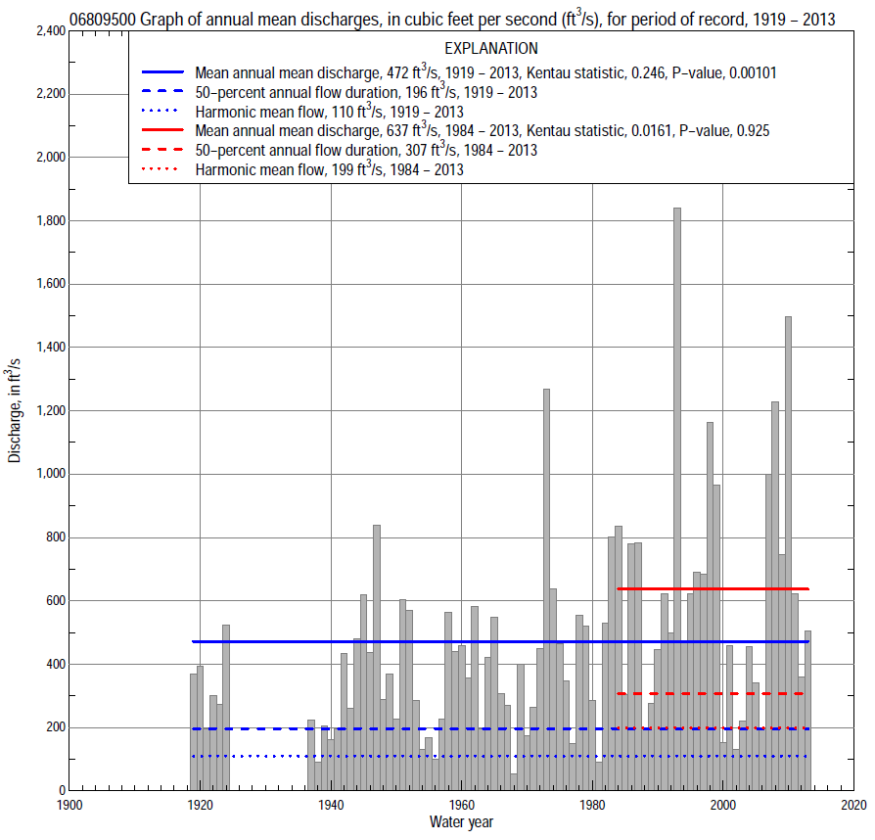

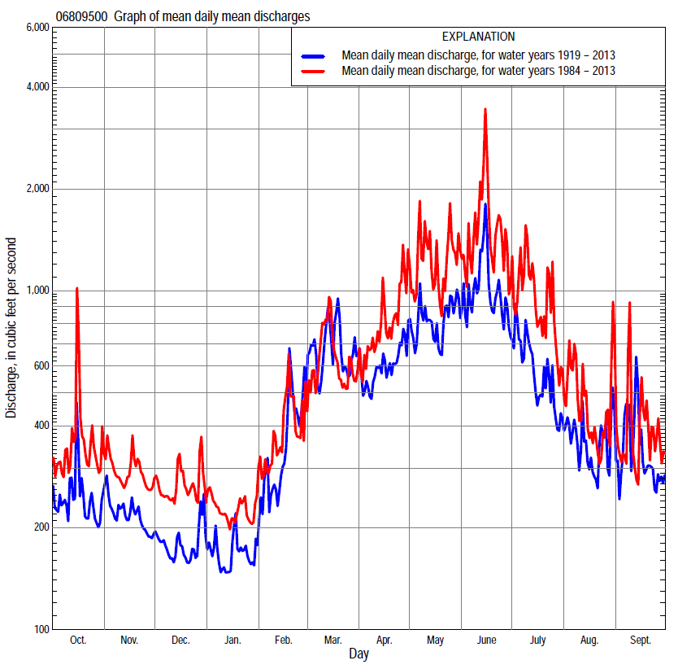

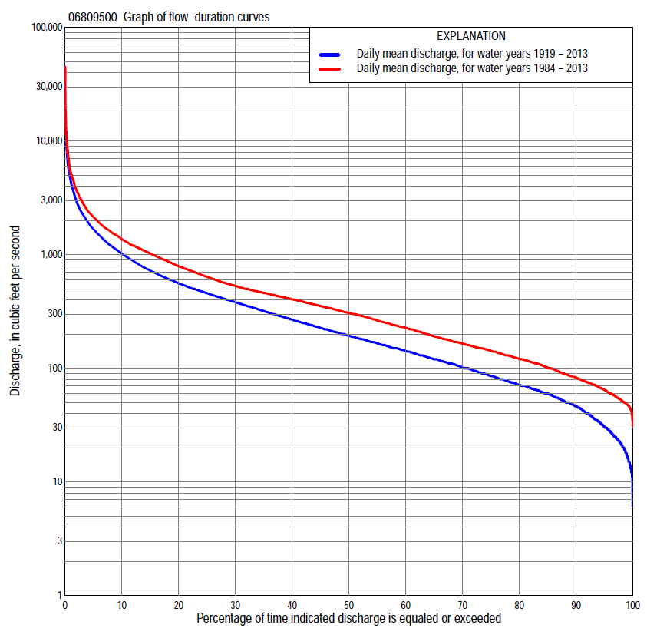

Statistics Based on the Entire Streamflow Period of Record
06809500 Monthly and annual flow durations, based on 1919–24, 1937–2013 period of record (83 years)
Percentage of days discharge equaled or exceeded |  |  |  |  | Discharge (cubic feet per second) |  |  |  |  |  |  |  |  | Annual flow durations
 | Oct | Nov | Dec | Jan | Feb | Mar | Apr | May | June | July | Aug | Sept | Annual | Kentau statistic | P-value
99 | 17 | 19 | 14 | 12 | 14 | 35 | 28 | 28 | 29 | 18 | 17 | 15 | 17 | 0.366 | 0.000
98 | 19 | 21 | 17 | 15 | 17 | 46 | 41 | 35 | 34 | 22 | 24 | 20 | 21 | 0.369 | 0.000
95 | 27 | 33 | 25 | 19 | 25 | 60 | 58 | 50 | 47 | 31 | 34 | 31 | 31 | 0.381 | 0.000
90 | 37 | 45 | 33 | 25 | 40 | 79 | 77 | 67 | 77 | 60 | 49 | 40 | 47 | 0.360 | 0.000
85 | 48 | 55 | 44 | 34 | 55 | 100 | 93 | 92 | 108 | 81 | 64 | 51 | 60 | 0.344 | 0.000
80 | 55 | 66 | 50 | 40 | 65 | 120 | 114 | 125 | 150 | 111 | 80 | 64 | 72 | 0.325 | 0.000
75 | 67 | 75 | 60 | 50 | 74 | 145 | 135 | 171 | 201 | 141 | 99 | 77 | 86 | 0.320 | 0.000
70 | 79 | 84 | 66 | 60 | 90 | 170 | 165 | 210 | 257 | 166 | 115 | 87 | 103 | 0.310 | 0.000
65 | 90 | 94 | 73 | 65 | 110 | 200 | 200 | 266 | 299 | 194 | 131 | 101 | 121 | 0.292 | 0.000
60 | 107 | 105 | 80 | 72 | 122 | 233 | 233 | 325 | 350 | 221 | 149 | 117 | 143 | 0.291 | 0.000
55 | 118 | 119 | 90 | 82 | 145 | 275 | 280 | 389 | 411 | 257 | 166 | 134 | 167 | 0.264 | 0.000
50 | 132 | 138 | 100 | 90 | 170 | 312 | 330 | 458 | 484 | 298 | 184 | 149 | 194 | 0.257 | 0.001
45 | 149 | 152 | 110 | 110 | 200 | 362 | 383 | 533 | 570 | 336 | 210 | 169 | 228 | 0.254 | 0.001
40 | 171 | 170 | 130 | 125 | 230 | 408 | 446 | 616 | 661 | 383 | 236 | 195 | 269 | 0.257 | 0.001
35 | 193 | 184 | 150 | 150 | 267 | 462 | 533 | 704 | 771 | 435 | 272 | 226 | 320 | 0.254 | 0.001
30 | 220 | 209 | 180 | 170 | 310 | 528 | 656 | 822 | 903 | 500 | 320 | 256 | 383 | 0.277 | 0.000
25 | 247 | 246 | 210 | 200 | 361 | 605 | 761 | 979 | 1,090 | 586 | 371 | 292 | 460 | 0.282 | 0.000
20 | 297 | 301 | 260 | 250 | 421 | 762 | 899 | 1,170 | 1,330 | 699 | 433 | 341 | 561 | 0.275 | 0.000
15 | 380 | 383 | 320 | 327 | 528 | 1,020 | 1,090 | 1,420 | 1,660 | 863 | 517 | 438 | 725 | 0.269 | 0.000
10 | 493 | 497 | 430 | 404 | 750 | 1,470 | 1,430 | 1,810 | 2,260 | 1,140 | 700 | 615 | 1,020 | 0.251 | 0.001
5 | 760 | 655 | 533 | 536 | 1,300 | 2,610 | 2,050 | 2,640 | 3,640 | 1,990 | 1,150 | 1,120 | 1,680 | 0.198 | 0.008
2 | 1,390 | 1,170 | 724 | 736 | 2,220 | 4,830 | 2,940 | 4,490 | 6,340 | 3,740 | 1,990 | 2,160 | 2,980 | 0.090 | 0.230
1 | 1,830 | 1,380 | 997 | 900 | 3,690 | 6,170 | 3,890 | 5,600 | 8,590 | 5,610 | 2,760 | 2,860 | 4,480 | 0.072 | 0.339

06809500 Annual exceedance probability of instantaneous peak discharges, in cubic feet per second (ft³/s), based on the Weighted Independent Estimates method,
Annual exceed-ance probability | Recur-rence interval (years) | Discharge (ft³/s) | 95-percent lower confi-dence interval (ft³/s) | 95-percent upper confi-dence interval (ft³/s)
0.500 | 2 | 10,300 | 9,000 | 11,800
0.200 | 5 | 17,500 | 15,200 | 20,000
0.100 | 10 | 22,500 | 19,300 | 26,300
0.040 | 25 | 29,400 | 24,400 | 35,400
0.020 | 50 | 34,400 | 27,700 | 42,800
0.010 | 100 | 39,600 | 30,900 | 50,800
0.005 | 200 | 44,700 | 33,700 | 59,200
0.002 | 500 | 51,400 | 36,900 | 71,400
and based on the expected moments algorithm/multiple Grubbs-Beck analysis computed using a historical period length of 97 years (1917–2013)
0.500 | 2 | 10,300 | 8,810 | 11,800
0.200 | 5 | 17,500 | 15,100 | 20,500
0.100 | 10 | 22,700 | 19,400 | 27,400
0.040 | 25 | 29,800 | 24,900 | 38,100
0.020 | 50 | 35,300 | 28,900 | 47,600
0.010 | 100 | 41,100 | 32,700 | 58,800
0.005 | 200 | 47,000 | 36,300 | 72,000
0.002 | 500 | 55,100 | 40,800 | 93,000
Kentau statistic |  | 0.199
P-value |  | 0.007
Begin year |  | 1918
End year |  | 2013
Number of peaks |  | 86

06809500 Annual exceedance probability of high discharges, based on 1919–24, 1937–2013 period of record (83 years)
Annual exceedance probability | Recur-rence interval (years) | Maximum average discharge (ft³/s) for indicated number of consecutive days
 |  | 1 | 3 | 7 | 15 | 30
0.990 | 1.01 | 533 | 384 | 257 | 195 | 154
0.950 | 1.05 | 1,420 | 1,010 | 664 | 469 | 348
0.900 | 1.11 | 2,240 | 1,580 | 1,030 | 707 | 513
0.800 | 1.25 | 3,670 | 2,560 | 1,650 | 1,100 | 789
0.500 | 2 | 7,950 | 5,460 | 3,440 | 2,240 | 1,590
0.200 | 5 | 14,000 | 9,520 | 5,820 | 3,790 | 2,740
0.100 | 10 | 17,500 | 11,800 | 7,130 | 4,680 | 3,460
0.040 | 25 | 21,100 | 14,200 | 8,450 | 5,610 | 4,270
0.020 | 50 | 23,300 | 15,700 | 9,220 | 6,180 | 4,790
0.010 | 100 | 25,100 | 16,800 | 9,830 | 6,660 | 5,260
0.005 | 200 | 26,500 | 17,800 | 10,300 | 7,060 | 5,670
0.002 | 500 | 28,100 | 18,800 | 10,800 | 7,480 | 6,140
Kentau statistic |  | 0.267 | 0.259 | 0.284 | 0.318 | 0.329
P-value |  | 0.000 | 0.000 | 0.000 | 0.000 | 0.000

 | 06809500 Annual nonexceedance probability of low discharges, based on April 1919 to March 1925, July 1936 to March 2013 period of record (81 years)
Annual nonexceed-ance probability | Recur-rence interval (years) | Minimum average discharge (ft³/s) for indicated number of consecutive days
 |  | 1 | 3 | 7 | 14 | 30 | 60 | 90 | 120 | 183
0.01 | 100 | 6.4 | 6.8 | 7.4 | 8.8 | 11 | 13 | 16 | 17 | 20
0.02 | 50 | 8.2 | 8.7 | 10 | 11 | 13 | 16 | 20 | 22 | 25
0.05 | 20 | 12 | 13 | 14 | 16 | 19 | 23 | 27 | 30 | 37
0.10 | 10 | 17 | 18 | 19 | 21 | 25 | 30 | 37 | 41 | 51
0.20 | 5 | 24 | 26 | 28 | 31 | 36 | 44 | 52 | 58 | 74
0.50 | 2 | 51 | 54 | 57 | 62 | 72 | 88 | 102 | 114 | 151
0.80 | 1.25 | 103 | 108 | 116 | 125 | 143 | 174 | 200 | 224 | 298
0.90 | 1.11 | 148 | 155 | 165 | 178 | 204 | 249 | 285 | 317 | 421
0.96 | 1.04 | 217 | 227 | 240 | 261 | 298 | 365 | 415 | 459 | 603
0.98 | 1.02 | 276 | 289 | 305 | 334 | 381 | 466 | 529 | 583 | 757
0.99 | 1.01 | 343 | 358 | 377 | 416 | 474 | 580 | 659 | 722 | 926
Kentau statistic |  | 0.477 | 0.482 | 0.498 | 0.498 | 0.484 | 0.461 | 0.444 | 0.414 | 0.353
P-value |  | 0.000 | 0.000 | 0.000 | 0.000 | 0.000 | 0.000 | 0.000 | 0.000 | 0.000

06809500 Annual nonexceedance probability of seasonal low discharges, based on July 1918 to September March 1925, July 1936 to September 2013 period of record (83–85 years)
Annual nonexceed-ance probability | Recur-rence interval (years) | Minimum average discharge (cubic feet per second) for indicated number of consecutive days
 |  | 1 | 7 | 14 | 30 |  | 1 | 7 | 14 | 30
 |  | January-February-March |  |  |  |  | April-May-June
0.01 | 100 | 7.8 | 8.2 | 8.6 | 10 |  | 11 | 14 | 16 | 20
0.02 | 50 | 10 | 11 | 11 | 13 |  | 16 | 19 | 22 | 27
0.05 | 20 | 15 | 15 | 16 | 19 |  | 26 | 30 | 36 | 44
0.10 | 10 | 20 | 22 | 23 | 27 |  | 39 | 45 | 53 | 67
0.20 | 5 | 30 | 33 | 35 | 41 |  | 64 | 73 | 86 | 110
0.50 | 2 | 64 | 72 | 77 | 94 |  | 153 | 175 | 205 | 271
0.80 | 1.25 | 135 | 160 | 173 | 215 |  | 337 | 397 | 468 | 629
0.90 | 1.11 | 200 | 242 | 264 | 333 |  | 493 | 596 | 707 | 956
0.96 | 1.04 | 303 | 379 | 414 | 533 |  | 721 | 906 | 1,080 | 1,470
0.98 | 1.02 | 397 | 506 | 556 | 725 |  | 911 | 1,180 | 1,420 | 1,920
0.99 | 1.01 | 506 | 657 | 723 | 956 |  | 1,110 | 1,480 | 1,800 | 2,430
Kentau statistic |  | 0.303 | 0.325 | 0.330 | 0.297 |  | 0.308 | 0.282 | 0.257 | 0.260
P-value |  | 0.000 | 0.000 | 0.000 | 0.000 |  | 0.000 | 0.000 | 0.001 | 0.000
 |  | July-August-September |  |  |  |  | October-November-December
0.01 | 100 | 6.4 | 8.7 | 11 | 14 |  | 8.1 | 9.3 | 11 | 15
0.02 | 50 | 8.9 | 12 | 15 | 19 |  | 10 | 12 | 13 | 19
0.05 | 20 | 14 | 18 | 21 | 28 |  | 15 | 17 | 19 | 25
0.10 | 10 | 22 | 26 | 30 | 39 |  | 21 | 24 | 26 | 34
0.20 | 5 | 35 | 40 | 45 | 58 |  | 30 | 35 | 39 | 48
0.50 | 2 | 79 | 87 | 96 | 125 |  | 64 | 75 | 82 | 97
0.80 | 1.25 | 164 | 179 | 198 | 260 |  | 136 | 160 | 176 | 205
0.90 | 1.11 | 232 | 257 | 284 | 376 |  | 200 | 238 | 262 | 309
0.96 | 1.04 | 327 | 372 | 415 | 554 |  | 303 | 365 | 402 | 483
0.98 | 1.02 | 403 | 468 | 527 | 707 |  | 397 | 480 | 530 | 650
0.99 | 1.01 | 482 | 572 | 651 | 879 |  | 505 | 615 | 681 | 852
Kentau statistic |  | 0.326 | 0.304 | 0.298 | 0.210 |  | 0.312 | 0.348 | 0.355 | 0.332
P-value |  | 0.000 | 0.000 | 0.000 | 0.004 |  | 0.000 | 0.000 | 0.000 | 0.000

Statistics Based on the 1984–2013 Streamflow Period of Record
06809500 Monthly and annual flow durations, based on 1984–2013 period of record (30 years)
Percentage of days discharge equaled or exceeded |  |  |  |  | Discharge (cubic feet per second) |  |  |  |  |  |  |  |  | Annual flow durations
 | Oct | Nov | Dec | Jan | Feb | Mar | Apr | May | June | July | Aug | Sept | Annual | Kentau statistic | P-value
99 | 48 | 52 | 40 | 42 | 43 | 64 | 61 | 54 | 80 | 74 | 49 | 46 | 48 | 0.074 | 0.580
98 | 50 | 54 | 44 | 46 | 47 | 71 | 70 | 60 | 88 | 83 | 55 | 49 | 52 | 0.071 | 0.592
95 | 53 | 67 | 53 | 51 | 58 | 86 | 91 | 107 | 107 | 103 | 65 | 59 | 65 | 0.097 | 0.464
90 | 72 | 83 | 64 | 61 | 69 | 110 | 126 | 151 | 170 | 140 | 87 | 72 | 83 | 0.085 | 0.520
85 | 80 | 89 | 72 | 70 | 87 | 135 | 148 | 241 | 240 | 171 | 108 | 81 | 101 | 0.060 | 0.656
80 | 95 | 100 | 81 | 84 | 111 | 158 | 168 | 311 | 326 | 212 | 123 | 93 | 121 | 0.060 | 0.656
75 | 112 | 114 | 94 | 98 | 131 | 190 | 203 | 378 | 417 | 255 | 146 | 106 | 143 | 0.048 | 0.721
70 | 121 | 134 | 106 | 113 | 150 | 232 | 257 | 493 | 516 | 305 | 165 | 122 | 165 | 0.021 | 0.886
65 | 131 | 155 | 120 | 124 | 180 | 278 | 312 | 595 | 600 | 350 | 186 | 136 | 191 | 0.000 | 1.000
60 | 152 | 168 | 140 | 137 | 219 | 308 | 374 | 678 | 680 | 392 | 222 | 147 | 227 | 0.005 | 0.986
55 | 175 | 180 | 154 | 150 | 250 | 347 | 429 | 752 | 769 | 446 | 246 | 162 | 264 | -0.034 | 0.803
50 | 193 | 188 | 170 | 170 | 280 | 387 | 495 | 865 | 884 | 492 | 274 | 185 | 307 | -0.034 | 0.803
45 | 213 | 221 | 200 | 200 | 305 | 418 | 637 | 967 | 1020 | 546 | 321 | 217 | 354 | -0.041 | 0.762
40 | 237 | 241 | 234 | 220 | 334 | 450 | 736 | 1,070 | 1,160 | 611 | 356 | 245 | 405 | -0.034 | 0.803
35 | 277 | 281 | 279 | 250 | 364 | 482 | 831 | 1,200 | 1,320 | 713 | 395 | 267 | 462 | -0.034 | 0.803
30 | 303 | 323 | 312 | 300 | 401 | 533 | 906 | 1,320 | 1,500 | 808 | 436 | 304 | 530 | -0.021 | 0.887
25 | 369 | 413 | 374 | 340 | 438 | 589 | 1,040 | 1,510 | 1,680 | 929 | 483 | 342 | 640 | -0.009 | 0.957
20 | 420 | 481 | 428 | 371 | 497 | 710 | 1,190 | 1,690 | 1,960 | 1,090 | 570 | 420 | 790 | -0.014 | 0.929
15 | 498 | 522 | 480 | 404 | 570 | 916 | 1,460 | 2,000 | 2,400 | 1,340 | 682 | 533 | 1,020 | -0.007 | 0.972
10 | 726 | 595 | 523 | 440 | 751 | 1,200 | 1,820 | 2,470 | 3,130 | 2,000 | 913 | 743 | 1,370 | 0.030 | 0.830
5 | 1,200 | 756 | 647 | 500 | 1,090 | 2,140 | 2,350 | 3,640 | 4,770 | 3,500 | 1,390 | 1,250 | 2,140 | 0.034 | 0.803
2 | 1,860 | 1,100 | 840 | 632 | 1,690 | 3,980 | 3,560 | 5,180 | 7,930 | 5,660 | 2,000 | 2,350 | 3,700 | 0.057 | 0.669
1 | 2,300 | 1,300 | 1,390 | 786 | 2,310 | 5,430 | 4,540 | 7,480 | 10,900 | 8,970 | 3,810 | 3,200 | 5,300 | 0.007 | 0.972

06809500 Annual exceedance probability of high discharges, based on 1984–2013 period of record (30 years)
Annual exceed-ance probability | Recur-rence interval (years) | Maximum average discharge (ft³/s) for indicated number of consecutive days
 |  | 1 | 3 | 7 | 15 | 30
0.990 | 1.01 | 819 | 546 | 347 | 259 | 191
0.950 | 1.05 | 1,690 | 1,150 | 763 | 554 | 409
0.900 | 1.11 | 2,440 | 1,670 | 1,120 | 806 | 596
0.800 | 1.25 | 3,740 | 2,560 | 1,740 | 1,230 | 914
0.500 | 2 | 7,970 | 5,450 | 3,680 | 2,550 | 1,900
0.200 | 5 | 15,800 | 10,700 | 6,940 | 4,760 | 3,570
0.100 | 10 | 22,000 | 14,700 | 9,280 | 6,330 | 4,760
0.040 | 25 | 30,600 | 20,200 | 12,300 | 8,340 | 6,290
0.020 | 50 | 37,500 | 24,500 | 14,500 | 9,810 | 7,430
0.010 | 100 | 44,700 | 28,900 | 16,600 | 11,300 | 8,530
0.005 | 200 | 52,100 | 33,400 | 18,700 | 12,700 | 9,620
0.002 | 500 | 62,400 | 39,500 | 21,300 | 14,500 | 11,000
Kentau statistic |  | 0.002 | 0.021 | 0.030 | 0.016 | 0.025
P-value |  | 1.000 | 0.887 | 0.830 | 0.915 | 0.858

 | 06809500 Annual nonexceedance probability of low discharges, based on April 1983 to March 2013 period of record (30 years)
Annual nonexceed-ance probability | Recur-rence interval (years) | Minimum average discharge (ft³/s) for indicated number of consecutive days
 |  | 1 | 3 | 7 | 14 | 30 | 60 | 90 | 120 | 183
0.01 | 100 | 18 | 20 | 24 | 26 | 29 | 33 | 34 | 36 | 38
0.02 | 50 | 22 | 24 | 29 | 31 | 35 | 39 | 42 | 44 | 46
0.05 | 20 | 29 | 32 | 37 | 40 | 45 | 51 | 55 | 58 | 62
0.10 | 10 | 37 | 41 | 47 | 51 | 56 | 65 | 71 | 75 | 81
0.20 | 5 | 50 | 55 | 62 | 67 | 75 | 87 | 96 | 101 | 112
0.50 | 2 | 89 | 96 | 104 | 113 | 127 | 149 | 170 | 181 | 209
0.80 | 1.25 | 154 | 163 | 174 | 190 | 215 | 256 | 297 | 322 | 392
0.90 | 1.11 | 203 | 214 | 226 | 248 | 283 | 338 | 395 | 435 | 545
0.96 | 1.04 | 271 | 284 | 298 | 328 | 378 | 455 | 535 | 600 | 775
0.98 | 1.02 | 326 | 341 | 356 | 392 | 456 | 550 | 650 | 738 | 975
0.99 | 1.01 | 384 | 400 | 416 | 460 | 540 | 653 | 772 | 888 | 1,200
Kentau statistic |  | 0.028 | 0.025 | 0.053 | 0.080 | 0.080 | 0.080 | 0.011 | -0.011 | -0.016
P-value |  | 0.844 | 0.858 | 0.695 | 0.544 | 0.544 | 0.544 | 0.943 | 0.943 | 0.915

06809500 Annual nonexceedance probability of seasonal low discharges, based on October 1983 to September 2013 period of record (30 years)
Annual nonexceed-ance probability | Recur-rence interval (years) | Minimum average discharge (cubic feet per second) for indicated number of consecutive days
 |  | 1 | 7 | 14 | 30 |  | 1 | 7 | 14 | 30
 |  | January-February-March |  |  |  |  | April-May-June
0.01 | 100 | 17 | 23 | 26 | 29 |  | 32 | 33 | 35 | 38
0.02 | 50 | 21 | 28 | 32 | 36 |  | 43 | 44 | 47 | 53
0.05 | 20 | 29 | 39 | 44 | 49 |  | 64 | 66 | 72 | 86
0.10 | 10 | 39 | 51 | 58 | 65 |  | 90 | 94 | 104 | 130
0.20 | 5 | 56 | 71 | 80 | 90 |  | 133 | 142 | 160 | 208
0.50 | 2 | 106 | 131 | 144 | 166 |  | 267 | 301 | 350 | 474
0.80 | 1.25 | 194 | 233 | 252 | 296 |  | 494 | 601 | 719 | 976
0.90 | 1.11 | 264 | 312 | 335 | 396 |  | 663 | 844 | 1,020 | 1,370
0.96 | 1.04 | 362 | 423 | 450 | 537 |  | 887 | 1,190 | 1,470 | 1,910
0.98 | 1.02 | 441 | 512 | 542 | 651 |  | 1,060 | 1,480 | 1,830 | 2,340
0.99 | 1.01 | 526 | 607 | 638 | 771 |  | 1,230 | 1,790 | 2,220 | 2,780
Kentau statistic |  | 0.044 | 0.000 | -0.005 | 0.002 |  | 0.011 | -0.007 | -0.057 | 0.048
P-value |  | 0.748 | 1.000 | 0.986 | 1.000 |  | 0.943 | 0.972 | 0.669 | 0.721
 |  | July-August-September |  |  |  |  | October-November-December
0.01 | 100 | 35 | 38 | 40 | 45 |  | 20 | 25 | 28 | 30
0.02 | 50 | 40 | 43 | 45 | 50 |  | 25 | 30 | 34 | 36
0.05 | 20 | 49 | 52 | 54 | 61 |  | 32 | 40 | 44 | 49
0.10 | 10 | 59 | 62 | 66 | 73 |  | 42 | 50 | 56 | 63
0.20 | 5 | 76 | 79 | 84 | 95 |  | 57 | 68 | 76 | 87
0.50 | 2 | 126 | 134 | 145 | 168 |  | 103 | 124 | 138 | 163
0.80 | 1.25 | 226 | 246 | 273 | 339 |  | 191 | 233 | 257 | 312
0.90 | 1.11 | 314 | 350 | 394 | 514 |  | 266 | 327 | 360 | 442
0.96 | 1.04 | 456 | 524 | 600 | 835 |  | 379 | 473 | 520 | 643
0.98 | 1.02 | 587 | 691 | 800 | 1,170 |  | 479 | 605 | 662 | 823
0.99 | 1.01 | 742 | 895 | 1,050 | 1,610 |  | 591 | 756 | 826 | 1,030
Kentau statistic |  | -0.016 | -0.025 | -0.034 | -0.048 |  | 0.018 | 0.014 | 0.021 | -0.007
P-value |  | 0.915 | 0.858 | 0.803 | 0.721 |  | 0.901 | 0.929 | 0.887 | 0.972

