LOCATION.--Lat 40°03'13.1", long 95°25'20.7" referenced to North American Datum of 1983, in NW 1/4 NW 1/4 sec.17, T.1 N., R.18 E., Richardson County, NE, Hydrologic Unit 10240005, on right bank on downstream side of bridge on U.S. Highway 159 in Rulo, 3.2 mi upstream from Big Nemaha River, and 498.0 mi upstream from mouth.

DRAINAGE AREA.--414,900 mi².

PERIOD OF RECORD.--Discharge records from October 1949 to current year. Stage-only records collected at site 80 ft upstream from January 1886 to December 1899 in reports of Missouri River Commission, and from September 1929 to September 1950 in files of Kansas City office of the U.S. Army Corps of Engineers.

GAGE.--Water-stage recorder. Datum of gage is 837.23 ft above National Geodetic Vertical Datum of 1929. October 1, 1949, to September 12, 1950, non-recording gage at site 80 ft upstream at same datum; September 13, 1950, to April 19, 1983, water-stage recorder on downstream end of middle pier at same datum.

REMARKS.--Flow regulated by upstream main-stem reservoirs. Fort Randall Dam was completed in July 1952, with storage beginning in December 1952. Gavins Point Dam was completed in July 1955, with storage beginning in December 1955.

EXTREMES OUTSIDE PERIOD OF RECORD.--Flood in 1881 reached a stage of 22.9 ft, from high-water mark, discharge not determined.

A summary of all available data for this streamgage is provided through the USGS National Water Information System web interface (NWISWeb). The following link provides access to current/historical observations, daily data, daily statistics, monthly statistics, annual statistics, peak streamflow, field measurements, field/lab water-quality samples, and the latest water-year summaries. Data can be filtered by parameter and/or dates, and can be output in various tabular and graphical formats.
http://waterdata.usgs.gov/nwis/inventory/?site_no=06813500

The USGS WaterWatch Toolkit is available at:
http://waterwatch.usgs.gov/?id=ww_toolkit
Tools for summarizing streamflow information include the duration hydrograph builder, the cumulative streamflow hydrograph builder, the streamgage statistics retrieval tool, the rating curve builder, the flood tracking chart builder, the National Weather Service Advanced Hydrologic Prediction Service (AHPS) river forecast hydrograph builder, and the raster-hydrograph builder. Entering the above number for this streamgage into these toolkit webpages will provide streamflow information specific to this streamgage.

A description of the statistics presented for this streamgage is available in the main body of the report at:
http://dx.doi.org/10.3133/ofr20151214
A link to other streamgages included in this report, a map showing the location of the streamgages, information on the programs used to compute the statistical analyses, and references are included in the main body of the report.

Statistics Based on the Regulated Streamflow Period of Record
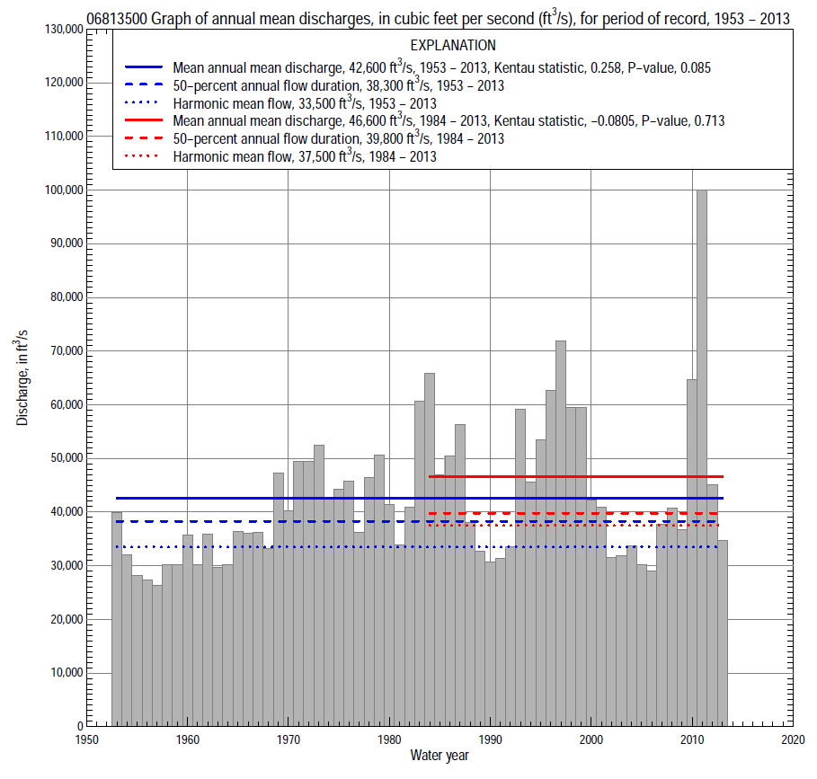

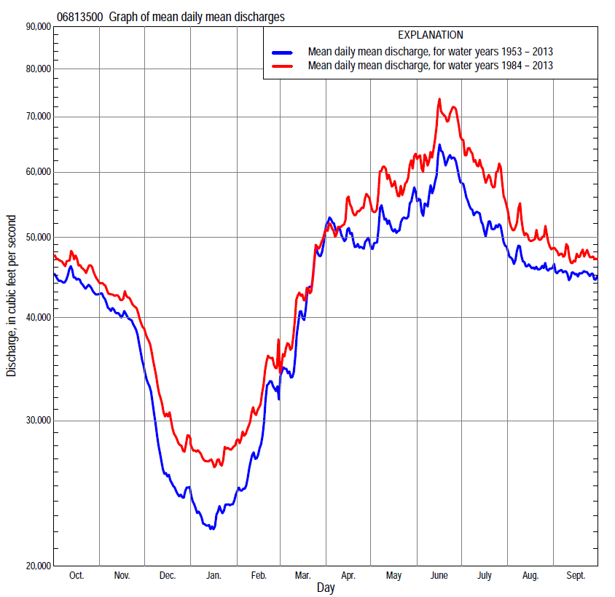

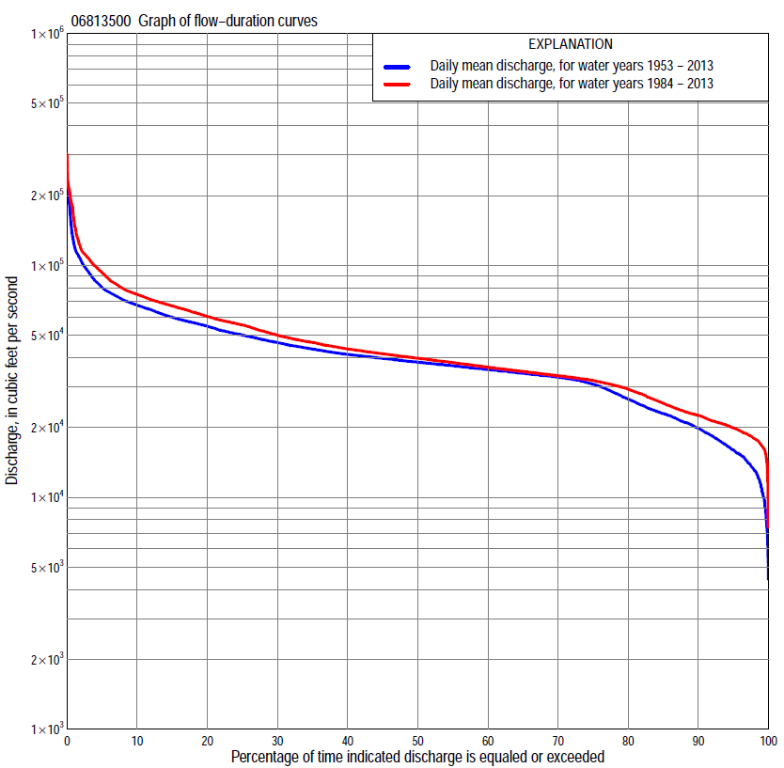

Statistics Based on the Regulated Streamflow Period of Record
06813500 Monthly and annual flow durations, based on 1953–2013 regulated period of record (61 years)
Percentage of days discharge equaled or exceeded |  |  |  |  | Discharge (cubic feet per second) |  |  |  |  |  |  |  |  | Annual flow durations
 | Oct | Nov | Dec | Jan | Feb | Mar | Apr | May | June | July | Aug | Sept | Annual | Kentau statistic | P-value
99 | 18,500 | 13,300 | 6,500 | 7,200 | 10,600 | 13,500 | 19,000 | 31,400 | 31,300 | 29,700 | 27,700 | 29,500 | 11,000 | 0.495 | 0.000
98 | 19,500 | 15,100 | 8,500 | 8,500 | 12,200 | 14,400 | 30,400 | 32,300 | 32,200 | 30,500 | 29,700 | 30,400 | 13,000 | 0.473 | 0.000
95 | 28,100 | 16,400 | 11,400 | 10,500 | 13,500 | 17,300 | 32,000 | 33,400 | 34,100 | 32,300 | 31,200 | 31,700 | 16,000 | 0.426 | 0.000
90 | 32,600 | 17,800 | 14,200 | 12,900 | 15,200 | 20,200 | 33,000 | 34,700 | 35,900 | 33,500 | 32,600 | 33,200 | 19,800 | 0.361 | 0.000
85 | 33,500 | 19,200 | 15,500 | 14,000 | 17,000 | 22,100 | 34,300 | 35,800 | 36,900 | 34,400 | 33,600 | 33,900 | 23,000 | 0.317 | 0.000
80 | 34,100 | 21,700 | 16,500 | 15,300 | 18,800 | 23,800 | 35,400 | 36,800 | 38,100 | 35,700 | 34,600 | 34,500 | 26,500 | 0.292 | 0.001
75 | 34,700 | 25,300 | 17,900 | 16,600 | 20,500 | 26,200 | 36,400 | 37,800 | 40,200 | 36,800 | 35,300 | 35,100 | 30,700 | 0.231 | 0.009
70 | 35,600 | 29,200 | 19,500 | 18,300 | 21,400 | 28,400 | 37,700 | 39,000 | 42,200 | 37,500 | 36,200 | 36,000 | 32,900 | 0.187 | 0.033
65 | 36,600 | 33,800 | 20,900 | 19,500 | 22,500 | 30,300 | 38,900 | 40,200 | 44,200 | 38,300 | 37,000 | 37,100 | 34,300 | 0.160 | 0.069
60 | 38,200 | 35,200 | 22,000 | 20,400 | 23,300 | 32,400 | 40,400 | 41,900 | 46,000 | 39,600 | 37,700 | 37,900 | 35,600 | 0.167 | 0.058
55 | 39,400 | 36,800 | 23,300 | 21,300 | 24,300 | 34,800 | 41,800 | 43,700 | 47,900 | 41,100 | 38,600 | 38,600 | 36,900 | 0.180 | 0.041
50 | 40,200 | 38,600 | 24,400 | 22,200 | 25,800 | 37,200 | 43,900 | 46,000 | 50,000 | 42,500 | 39,600 | 39,400 | 38,300 | 0.191 | 0.030
45 | 41,000 | 40,000 | 25,400 | 23,000 | 27,200 | 39,200 | 45,700 | 47,900 | 52,200 | 44,200 | 40,700 | 40,400 | 39,700 | 0.200 | 0.023
40 | 41,900 | 41,100 | 26,700 | 23,800 | 28,500 | 40,900 | 47,900 | 50,400 | 55,000 | 46,400 | 41,900 | 41,800 | 41,300 | 0.227 | 0.010
35 | 44,000 | 43,400 | 28,600 | 24,900 | 29,700 | 43,300 | 50,000 | 53,100 | 57,700 | 49,400 | 44,200 | 43,600 | 43,600 | 0.237 | 0.007
30 | 47,500 | 46,400 | 31,200 | 26,500 | 32,000 | 45,500 | 53,100 | 56,400 | 61,400 | 52,600 | 47,300 | 46,200 | 46,500 | 0.237 | 0.007
25 | 51,500 | 51,100 | 33,300 | 28,700 | 34,800 | 48,000 | 56,400 | 60,300 | 66,500 | 56,700 | 50,600 | 50,400 | 50,000 | 0.236 | 0.007
20 | 55,600 | 57,200 | 36,400 | 31,200 | 37,600 | 50,800 | 61,000 | 65,700 | 73,500 | 61,000 | 55,300 | 55,500 | 54,600 | 0.240 | 0.006
15 | 58,100 | 61,600 | 39,900 | 33,300 | 40,600 | 58,000 | 68,200 | 71,000 | 80,500 | 67,000 | 58,600 | 58,800 | 59,800 | 0.248 | 0.005
10 | 65,800 | 65,100 | 46,400 | 35,500 | 44,800 | 67,000 | 77,900 | 82,300 | 95,600 | 76,800 | 65,000 | 67,000 | 67,400 | 0.225 | 0.011
5 | 71,800 | 69,200 | 55,400 | 38,800 | 52,700 | 80,500 | 97,200 | 96,200 | 118,000 | 99,500 | 75,000 | 74,400 | 80,300 | 0.180 | 0.041
2 | 79,300 | 75,500 | 61,800 | 43,000 | 68,200 | 109,000 | 112,000 | 107,000 | 148,000 | 187,000 | 111,000 | 90,000 | 105,000 | 0.085 | 0.338
1 | 85,600 | 83,400 | 65,200 | 46,800 | 74,800 | 122,000 | 115,000 | 111,000 | 178,000 | 218,000 | 182,000 | 108,000 | 123,000 | 0.104 | 0.237

06813500 Annual exceedance probability of instantaneous peak discharges, in cubic feet per second (ft³/s), based on U.S. Army Corps of Engineers regulated flow frequency studyª, analysis computed using a record length of 100 years (1898–1997)
USACE Regulated Flow Frequency Analysis
[ND, not determined]
Annual exceedance probability | Recurrence interval (years) | Discharge (ft³/s) | 95-percent lower confidence interval (ft³/s) | 95-percent upper confidence interval (ft³/s)
0.500 | 2 | 94,700 | ND | ND
0.200 | 5 | 132,000 | ND | ND
0.100 | 10 | 161,000 | ND | ND
0.040 | 25 | ND | ND | ND
0.020 | 50 | 217,000 | ND | ND
0.010 | 100 | 252,000 | ND | ND
0.005 | 200 | 297,000 | ND | ND
0.002 | 500 | 371,000 | ND | ND
ªU.S. Army Corps of Engineers, 2003, Upper Mississippi River System Flow Frequency Study, Hydrology and Hydraulics Appendix F Missouri River, Omaha District: U.S. Army Corps of Engineers, 488 p., accessed September 16, 2014, at http://www.mvr.usace.army.mil/Portals/48/docs/FRM/UpperMissFlowFreq/App.%20F%20Omaha%20Dist.%20Hydrology_Hydraulics%20Report.pdf.
USGS Kendall's Tau Trend Analysis
Kentau statistic |  | 0.060
P-value |  | 0.501
Begin year |  | 1953^{b}
End year |  | 2013^{b}
Number of peaks |  | 61
^{b}Kendall's tau trend analysis computed using the regulated period of record which is not the same period of record used for the above regulated flow frequency analysis.

06813500 Annual exceedance probability of high discharges, based on 1953–2013 regulated period of recordª (61 years)
[ND, not determined]
Annual exceedance probability | Recur-rence interval (years) | Maximum average discharge (cubic feet per second) for indicated number of consecutive days
 |  | 1 | 3 | 7 | 15 | 30
0.990 | 1.01 | ND | ND | ND | ND | ND
0.950 | 1.05 | ND | ND | ND | ND | ND
0.900 | 1.11 | ND | ND | ND | ND | ND
0.800 | 1.25 | ND | ND | ND | ND | ND
0.500 | 2 | ND | ND | ND | ND | ND
0.200 | 5 | ND | ND | ND | ND | ND
0.100 | 10 | ND | ND | ND | ND | ND
0.040 | 25 | ND | ND | ND | ND | ND
0.020 | 50 | ND | ND | ND | ND | ND
0.010 | 100 | ND | ND | ND | ND | ND
0.005 | 200 | ND | ND | ND | ND | ND
0.002 | 500 | ND | ND | ND | ND | ND
Kentau statistic |  | 0.059 | 0.105 | 0.130 | 0.154 | 0.190
P-value |  | 0.505 | 0.232 | 0.140 | 0.080 | 0.031
ªContact the U.S. Army Corps of Engineers, Omaha District, for the annual exceedance probability of high discharges.

 | 06813500 Annual nonexceedance probability of low discharges, based on April 1953 to March 2013 regulated period of record (60 years)
Annual nonexceed-ance probability | Recur-rence interval (years) | Minimum average discharge (cubic feet per second) for indicated number of consecutive days
 |  | 1 | 3 | 7 | 14 | 30 | 60 | 90 | 120 | 183
0.01 | 100 | 3,370 | 3,680 | 4,390 | 6,250 | 8,140 | 9,210 | 9,910 | 11,000 | 15,700
0.02 | 50 | 4,050 | 4,420 | 5,250 | 7,190 | 9,120 | 10,200 | 11,000 | 12,200 | 16,900
0.05 | 20 | 5,290 | 5,750 | 6,810 | 8,820 | 10,800 | 12,000 | 12,800 | 14,300 | 19,000
0.10 | 10 | 6,660 | 7,220 | 8,480 | 10,500 | 12,500 | 13,700 | 14,700 | 16,300 | 21,100
0.20 | 5 | 8,730 | 9,410 | 10,900 | 12,900 | 14,800 | 16,200 | 17,400 | 19,200 | 24,000
0.50 | 2 | 14,300 | 15,100 | 17,000 | 18,700 | 20,500 | 22,000 | 23,700 | 26,200 | 31,200
0.80 | 1.25 | 22,500 | 23,400 | 25,200 | 26,300 | 27,900 | 29,800 | 32,300 | 35,500 | 41,200
0.90 | 1.11 | 28,200 | 29,000 | 30,400 | 31,100 | 32,700 | 34,700 | 37,800 | 41,500 | 47,900
0.96 | 1.04 | 35,500 | 36,000 | 36,500 | 36,900 | 38,400 | 40,800 | 44,700 | 49,100 | 56,500
0.98 | 1.02 | 40,900 | 40,900 | 40,900 | 41,000 | 42,600 | 45,200 | 49,800 | 54,600 | 63,000
0.99 | 1.01 | 44,900 | 44,900 | 44,900 | 44,900 | 46,700 | 49,600 | 54,900 | 60,100 | 69,700
Kentau statistic |  | 0.507 | 0.506 | 0.498 | 0.497 | 0.458 | 0.401 | 0.331 | 0.306 | 0.271
P-value |  | 0.000 | 0.000 | 0.000 | 0.000 | 0.000 | 0.000 | 0.000 | 0.001 | 0.002

06813500 Annual nonexceedance probability of seasonal low discharges, based on October 1952 to September 2013 regulated period of record (61 years)
Annual nonexceed-ance probability | Recur-rence interval (years) | Minimum average discharge (cubic feet per second) for indicated number of consecutive days
 |  | 1 | 7 | 14 | 30 |  | 1 | 7 | 14 | 30
 |  | January-February-March |  |  |  |  | April-May-June
0.01 | 100 | 3,920 | 5,240 | 7,200 | 8,930 |  | 20,300 | 21,700 | 22,600 | 26,500
0.02 | 50 | 4,690 | 6,170 | 8,160 | 9,920 |  | 21,800 | 23,300 | 24,100 | 27,700
0.05 | 20 | 6,100 | 7,810 | 9,800 | 11,600 |  | 24,400 | 25,800 | 26,700 | 29,700
0.10 | 10 | 7,620 | 9,540 | 11,500 | 13,300 |  | 26,900 | 28,300 | 29,300 | 31,800
0.20 | 5 | 9,870 | 12,000 | 13,800 | 15,700 |  | 30,300 | 31,700 | 32,800 | 34,800
0.50 | 2 | 15,700 | 18,100 | 19,500 | 21,300 |  | 38,000 | 39,400 | 40,700 | 42,400
0.80 | 1.25 | 23,800 | 26,000 | 26,900 | 28,800 |  | 47,400 | 49,000 | 50,800 | 53,600
0.90 | 1.11 | 29,100 | 31,000 | 31,500 | 33,600 |  | 53,100 | 55,000 | 57,100 | 61,500
0.96 | 1.04 | 35,700 | 36,800 | 37,200 | 39,500 |  | 59,900 | 62,300 | 64,800 | 72,100
0.98 | 1.02 | 40,400 | 40,900 | 41,200 | 43,800 |  | 64,800 | 67,500 | 70,400 | 80,400
0.99 | 1.01 | 45,000 | 45,000 | 45,200 | 48,000 |  | 69,400 | 72,500 | 75,900 | 89,000
Kentau statistic |  | 0.512 | 0.509 | 0.508 | 0.481 |  | 0.272 | 0.242 | 0.250 | 0.260
P-value |  | 0.000 | 0.000 | 0.000 | 0.000 |  | 0.002 | 0.006 | 0.005 | 0.003
 |  | July-August-September |  |  |  |  | October-November-December
0.01 | 100 | 18,500 | 22,600 | 26,600 | 28,700 |  | 3,660 | 5,000 | 7,020 | 8,800
0.02 | 50 | 20,000 | 23,600 | 27,200 | 29,100 |  | 4,590 | 6,090 | 8,150 | 9,930
0.05 | 20 | 22,600 | 25,400 | 28,200 | 29,900 |  | 6,320 | 8,050 | 10,100 | 11,900
0.10 | 10 | 25,200 | 27,200 | 29,400 | 30,900 |  | 8,260 | 10,200 | 12,200 | 13,900
0.20 | 5 | 28,800 | 29,900 | 31,400 | 32,700 |  | 11,200 | 13,200 | 15,100 | 16,900
0.50 | 2 | 37,100 | 37,100 | 37,400 | 38,500 |  | 18,600 | 20,800 | 22,200 | 24,400
0.80 | 1.25 | 47,700 | 47,800 | 48,000 | 49,400 |  | 28,600 | 30,400 | 31,400 | 35,200
0.90 | 1.11 | 54,300 | 55,700 | 56,500 | 58,600 |  | 34,800 | 36,200 | 37,100 | 42,600
0.96 | 1.04 | 62,500 | 66,500 | 69,000 | 72,400 |  | 41,900 | 42,700 | 43,900 | 52,100
0.98 | 1.02 | 68,400 | 75,100 | 79,700 | 84,600 |  | 46,700 | 47,100 | 48,700 | 59,400
0.99 | 1.01 | 74,200 | 84,300 | 91,600 | 98,600 |  | 51,100 | 51,100 | 53,300 | 66,800
Kentau statistic |  | 0.122 | 0.114 | 0.116 | 0.103 |  | 0.345 | 0.346 | 0.345 | 0.308
P-value |  | 0.167 | 0.196 | 0.189 | 0.245 |  | 0.000 | 0.000 | 0.000 | 0.000

Statistics Based on the 1984–2013 Regulated Streamflow Period of Record
06813500 Monthly and annual flow durations, based on 1984–2013 regulated period of record (30 years)
Percentage of days discharge equaled or exceeded |  |  |  |  | Discharge (cubic feet per second) |  |  |  |  |  |  |  |  | Annual flow durations
 | Oct | Nov | Dec | Jan | Feb | Mar | Apr | May | June | July | Aug | Sept | Annual | Kentau statistic | P-value
99 | 18,800 | 15,900 | 11,500 | 16,000 | 17,500 | 17,700 | 30,900 | 32,900 | 32,100 | 28,400 | 27,700 | 27,200 | 16,700 | 0.023 | 0.872
98 | 19,600 | 16,400 | 14,100 | 16,700 | 18,800 | 18,200 | 31,500 | 33,400 | 32,400 | 29,700 | 28,900 | 29,500 | 17,900 | -0.009 | 0.957
95 | 22,500 | 17,300 | 16,400 | 18,100 | 19,700 | 19,700 | 32,300 | 34,500 | 35,000 | 31,300 | 30,400 | 30,700 | 19,900 | -0.060 | 0.655
90 | 30,900 | 18,200 | 18,500 | 19,100 | 20,700 | 21,200 | 33,400 | 35,900 | 36,600 | 33,000 | 31,700 | 32,100 | 22,500 | -0.097 | 0.464
85 | 32,800 | 19,200 | 19,800 | 20,300 | 21,400 | 23,000 | 34,700 | 37,300 | 38,400 | 34,400 | 32,800 | 33,400 | 25,400 | -0.092 | 0.486
80 | 33,600 | 21,500 | 20,600 | 21,300 | 22,400 | 26,100 | 35,600 | 39,100 | 41,700 | 36,000 | 34,200 | 34,100 | 29,200 | -0.099 | 0.453
75 | 34,500 | 25,800 | 21,300 | 22,000 | 23,000 | 28,700 | 36,600 | 40,300 | 43,900 | 37,200 | 34,900 | 34,800 | 31,900 | -0.138 | 0.292
70 | 35,600 | 28,600 | 22,300 | 22,600 | 23,800 | 30,500 | 38,200 | 42,100 | 46,100 | 38,200 | 35,500 | 36,000 | 33,500 | -0.108 | 0.412
65 | 37,800 | 33,500 | 23,300 | 23,200 | 25,100 | 32,200 | 40,200 | 44,100 | 47,700 | 39,500 | 36,400 | 37,700 | 34,900 | -0.133 | 0.309
60 | 39,800 | 36,200 | 24,700 | 23,700 | 26,200 | 34,000 | 42,000 | 46,700 | 50,000 | 41,300 | 37,400 | 38,600 | 36,400 | -0.147 | 0.261
55 | 40,500 | 38,200 | 25,700 | 24,300 | 28,000 | 37,200 | 43,600 | 48,100 | 52,200 | 42,800 | 38,700 | 39,400 | 38,100 | -0.149 | 0.253
50 | 41,100 | 40,000 | 26,800 | 25,200 | 28,800 | 39,300 | 45,300 | 50,500 | 54,800 | 44,500 | 40,200 | 40,100 | 39,800 | -0.145 | 0.269
45 | 42,100 | 41,300 | 29,300 | 26,600 | 29,800 | 41,500 | 47,800 | 52,800 | 57,700 | 47,000 | 41,700 | 41,500 | 41,600 | -0.122 | 0.354
40 | 44,000 | 43,100 | 31,700 | 28,100 | 31,100 | 43,500 | 51,800 | 56,300 | 61,700 | 50,300 | 43,400 | 42,900 | 43,600 | -0.078 | 0.556
35 | 47,100 | 45,400 | 33,300 | 29,800 | 33,700 | 45,500 | 56,100 | 60,600 | 66,600 | 56,900 | 46,600 | 45,000 | 46,500 | -0.083 | 0.532
30 | 51,500 | 52,200 | 35,200 | 31,500 | 36,200 | 47,400 | 59,100 | 65,100 | 72,400 | 61,900 | 51,100 | 52,200 | 50,000 | -0.069 | 0.605
25 | 57,000 | 57,500 | 37,700 | 33,000 | 38,500 | 49,200 | 62,500 | 69,600 | 77,400 | 67,400 | 56,100 | 56,200 | 55,400 | -0.067 | 0.617
20 | 62,000 | 61,700 | 40,800 | 33,700 | 40,900 | 51,900 | 67,300 | 77,100 | 81,900 | 73,200 | 59,900 | 60,400 | 60,200 | -0.067 | 0.617
15 | 67,700 | 64,900 | 46,200 | 35,300 | 43,700 | 57,800 | 74,700 | 86,400 | 94,600 | 82,100 | 68,900 | 66,600 | 67,000 | -0.076 | 0.568
10 | 70,800 | 68,200 | 52,400 | 36,900 | 46,100 | 65,500 | 85,800 | 94,400 | 116,000 | 99,100 | 75,000 | 73,400 | 75,000 | -0.041 | 0.762
5 | 77,800 | 73,800 | 58,900 | 39,300 | 52,700 | 80,000 | 100,000 | 104,000 | 143,000 | 156,000 | 101,000 | 80,300 | 93,100 | 0.021 | 0.887
2 | 84,300 | 83,400 | 64,000 | 43,300 | 64,200 | 107,000 | 112,000 | 111,000 | 178,000 | 218,000 | 182,000 | 108,000 | 118,000 | -0.041 | 0.762
1 | 91,300 | 84,500 | 69,400 | 46,800 | 72,200 | 114,000 | 115,000 | 120,000 | 201,000 | 230,000 | 191,000 | 116,000 | 155,000 | 0.023 | 0.872

06813500 Annual exceedance probability of high discharges, based on 1984–2013 regulated period of recordª (30 years)
[ND, not determined]
Annual exceedance probability | Recur-rence interval (years) | Maximum average discharge (cubic feet per second) for indicated number of consecutive days
 |  | 1 | 3 | 7 | 15 | 30
0.990 | 1.01 | ND | ND | ND | ND | ND
0.950 | 1.05 | ND | ND | ND | ND | ND
0.900 | 1.11 | ND | ND | ND | ND | ND
0.800 | 1.25 | ND | ND | ND | ND | ND
0.500 | 2 | ND | ND | ND | ND | ND
0.200 | 5 | ND | ND | ND | ND | ND
0.100 | 10 | ND | ND | ND | ND | ND
0.040 | 25 | ND | ND | ND | ND | ND
0.020 | 50 | ND | ND | ND | ND | ND
0.010 | 100 | ND | ND | ND | ND | ND
0.005 | 200 | ND | ND | ND | ND | ND
0.002 | 500 | ND | ND | ND | ND | ND
Kentau statistic |  | -0.021 | 0.002 | 0.034 | 0.011 | 0.002
P-value |  | 0.886 | 1.000 | 0.803 | 0.943 | 1.000
ªContact the U.S. Army Corps of Engineers, Omaha District, for the annual exceedance probability of high discharges.

 | 06813500 Annual nonexceedance probability of low discharges, based on April 1983 to March 2013 regulated period of record (30 years)
Annual nonexceed-ance probability | Recur-rence interval (years) | Minimum average discharge (cubic feet per second) for indicated number of consecutive days
 |  | 1 | 3 | 7 | 14 | 30 | 60 | 90 | 120 | 183
0.01 | 100 | 6,400 | 7,020 | 9,150 | 11,200 | 12,700 | 13,600 | 14,100 | 14,700 | 17,300
0.02 | 50 | 7,520 | 8,180 | 10,300 | 12,300 | 13,800 | 14,700 | 15,200 | 15,900 | 18,600
0.05 | 20 | 9,440 | 10,100 | 12,200 | 14,200 | 15,600 | 16,500 | 17,000 | 17,900 | 20,800
0.10 | 10 | 11,400 | 12,100 | 14,100 | 16,000 | 17,300 | 18,200 | 18,800 | 19,900 | 23,100
0.20 | 5 | 14,100 | 14,900 | 16,700 | 18,300 | 19,600 | 20,600 | 21,400 | 22,700 | 26,300
0.50 | 2 | 20,100 | 20,900 | 22,300 | 23,600 | 24,800 | 25,900 | 27,400 | 29,400 | 34,000
0.80 | 1.25 | 27,000 | 27,700 | 28,800 | 29,700 | 31,200 | 32,700 | 35,300 | 38,300 | 44,700
0.90 | 1.11 | 30,800 | 31,500 | 32,500 | 33,200 | 35,000 | 37,000 | 40,400 | 44,300 | 51,900
0.96 | 1.04 | 34,800 | 35,500 | 36,600 | 37,300 | 39,500 | 42,100 | 46,800 | 51,700 | 61,100
0.98 | 1.02 | 37,300 | 38,100 | 39,300 | 40,100 | 42,600 | 45,800 | 51,500 | 57,200 | 68,100
0.99 | 1.01 | 39,500 | 40,300 | 41,800 | 42,600 | 45,600 | 49,400 | 56,200 | 62,800 | 75,100
Kentau statistic |  | -0.007 | -0.002 | 0.041 | -0.011 | -0.051 | -0.053 | -0.094 | -0.085 | -0.094
P-value |  | 0.972 | 1.000 | 0.762 | 0.943 | 0.708 | 0.695 | 0.475 | 0.521 | 0.475

06813500 Annual nonexceedance probability of seasonal low discharges, based on October 1983 to September 2013 regulated period of record (30 years)
Annual nonexceed-ance probability | Recur-rence interval (years) | Minimum average discharge (cubic feet per second) for indicated number of consecutive days
 |  | 1 | 7 | 14 | 30 |  | 1 | 7 | 14 | 30
 |  | January-February-March |  |  |  |  | April-May-June
0.01 | 100 | 8,720 | 12,900 | 14,800 | 15,600 |  | 25,700 | 25,900 | 26,200 | 26,900
0.02 | 50 | 9,930 | 13,800 | 15,600 | 16,500 |  | 26,700 | 26,900 | 27,400 | 28,300
0.05 | 20 | 11,900 | 15,400 | 17,000 | 17,900 |  | 28,400 | 28,800 | 29,500 | 30,600
0.10 | 10 | 13,900 | 16,900 | 18,400 | 19,300 |  | 30,200 | 30,800 | 31,600 | 33,100
0.20 | 5 | 16,500 | 18,900 | 20,200 | 21,300 |  | 32,800 | 33,700 | 34,800 | 36,700
0.50 | 2 | 22,100 | 23,600 | 24,500 | 25,700 |  | 39,800 | 41,200 | 42,900 | 45,900
0.80 | 1.25 | 28,200 | 29,400 | 29,900 | 31,500 |  | 50,400 | 52,600 | 55,000 | 59,700
0.90 | 1.11 | 31,500 | 32,900 | 33,400 | 35,200 |  | 58,100 | 60,700 | 63,600 | 69,600
0.96 | 1.04 | 34,900 | 37,300 | 37,700 | 39,700 |  | 68,600 | 71,900 | 75,100 | 82,900
0.98 | 1.02 | 37,100 | 40,300 | 40,800 | 43,000 |  | 77,000 | 80,800 | 84,200 | 93,500
0.99 | 1.01 | 39,000 | 43,300 | 43,900 | 46,300 |  | 85,900 | 90,200 | 93,800 | 105,000
Kentau statistic |  | -0.037 | -0.041 | -0.041 | -0.037 |  | -0.179 | -0.168 | -0.131 | -0.108
P-value |  | 0.789 | 0.762 | 0.762 | 0.789 |  | 0.169 | 0.199 | 0.318 | 0.412
 |  | July-August-September |  |  |  |  | October-November-December
0.01 | 100 | 22,900 | 23,900 | 24,600 | 25,700 |  | 7,130 | 9,150 | 10,900 | 11,700
0.02 | 50 | 23,700 | 24,600 | 25,300 | 26,400 |  | 8,360 | 10,400 | 12,100 | 12,900
0.05 | 20 | 25,200 | 26,000 | 26,700 | 27,700 |  | 10,500 | 12,500 | 14,100 | 15,000
0.10 | 10 | 26,900 | 27,600 | 28,300 | 29,300 |  | 12,700 | 14,700 | 16,100 | 17,200
0.20 | 5 | 29,500 | 30,200 | 30,900 | 31,800 |  | 15,800 | 17,700 | 19,000 | 20,300
0.50 | 2 | 37,100 | 37,800 | 38,500 | 39,700 |  | 23,100 | 24,700 | 25,800 | 28,100
0.80 | 1.25 | 50,100 | 51,200 | 52,300 | 54,300 |  | 32,100 | 33,600 | 35,000 | 39,500
0.90 | 1.11 | 60,500 | 62,100 | 63,500 | 66,400 |  | 37,400 | 39,100 | 40,900 | 47,400
0.96 | 1.04 | 75,800 | 78,500 | 80,600 | 85,000 |  | 43,400 | 45,500 | 48,400 | 57,800
0.98 | 1.02 | 89,000 | 92,800 | 95,500 | 102,000 |  | 47,400 | 50,000 | 53,800 | 65,900
0.99 | 1.01 | 104,000 | 109,000 | 112,000 | 121,000 |  | 51,200 | 54,300 | 59,200 | 74,200
Kentau statistic |  | -0.186 | -0.182 | -0.163 | -0.163 |  | -0.030 | -0.067 | -0.067 | -0.069
P-value |  | 0.154 | 0.164 | 0.212 | 0.212 |  | 0.830 | 0.617 | 0.617 | 0.605

