LOCATION.--Lat 40°44'35.8", long 95°00'51.1" referenced to North American Datum of 1983, in SE 1/4 SE 1/4 SW 1/4 sec.29, T.69 N., R.36 W., Page County, IA, Hydrologic Unit 10240009, on right bank 500 ft upstream from dam, at eastern edge of Clarinda, 1300 ft downstream from North Branch, 7.8 mi upstream from East Nodaway River, and 12.3 mi upstream from Iowa-Missouri state line.

DRAINAGE AREA.--762 mi².

PERIOD OF RECORD.--Discharge records from May 1918 to July 1925 (no winter records), May 1936 to current year. May 1918 to July 1925, monthly mean discharge for some periods published in WSP 1310.

GAGE.--Water-stage recorder. Datum of gage is 955.36 ft above National Geodetic Vertical Datum of 1929. Prior to July 5, 1925, and May 28, 1936, to March 26, 1957, non-recording gage, and March 27, 1957, to September 30, 2010, water-stage recorder, all at site 1,500 ft downstream and 1,000 ft below dam. Prior to October 1, 1987, at datum 5.00 ft higher.

COOPERATION.--Average pumpage provided by Clarinda Water Treatment Plant.

REMARKS.--Clarinda municipal water supply is withdrawn from Nodaway River, 500 ft downstream from gage. Average daily pumpage was 1.65 ft³/s.

EXTREMES OUTSIDE PERIOD OF RECORD.--Flood in August 1903 reached a stage of 25.4 ft, from high-water mark, discharge not determined.

A summary of all available data for this streamgage is provided through the USGS National Water Information System web interface (NWISWeb). The following link provides access to current/historical observations, daily data, daily statistics, monthly statistics, annual statistics, peak streamflow, field measurements, field/lab water-quality samples, and the latest water-year summaries. Data can be filtered by parameter and/or dates, and can be output in various tabular and graphical formats.
http://waterdata.usgs.gov/nwis/inventory/?site_no=06817000

The USGS WaterWatch Toolkit is available at:
http://waterwatch.usgs.gov/?id=ww_toolkit
Tools for summarizing streamflow information include the duration hydrograph builder, the cumulative streamflow hydrograph builder, the streamgage statistics retrieval tool, the rating curve builder, the flood tracking chart builder, the National Weather Service Advanced Hydrologic Prediction Service (AHPS) river forecast hydrograph builder, and the raster-hydrograph builder. Entering the above number for this streamgage into these toolkit webpages will provide streamflow information specific to this streamgage.

A description of the statistics presented for this streamgage is available in the main body of the report at:
http://dx.doi.org/10.3133/ofr20151214
A link to other streamgages included in this report, a map showing the location of the streamgages, information on the programs used to compute the statistical analyses, and references are included in the main body of the report.

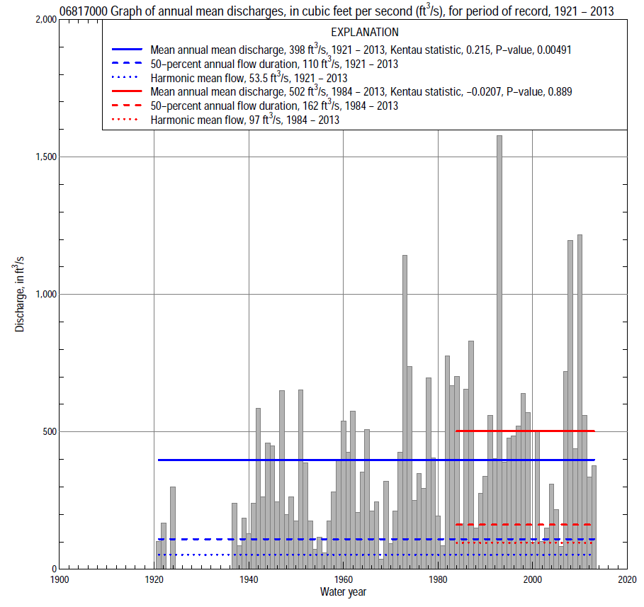

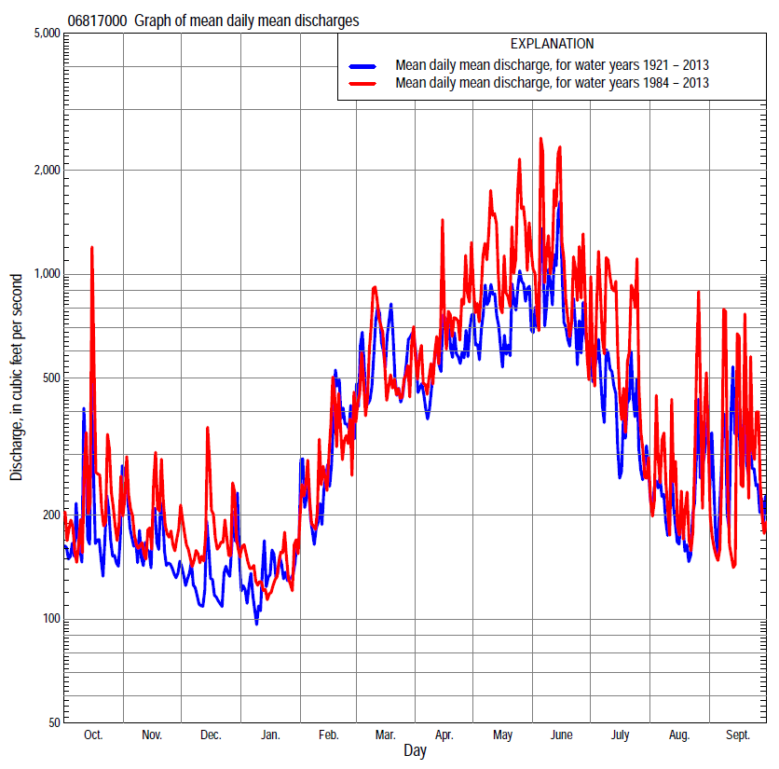

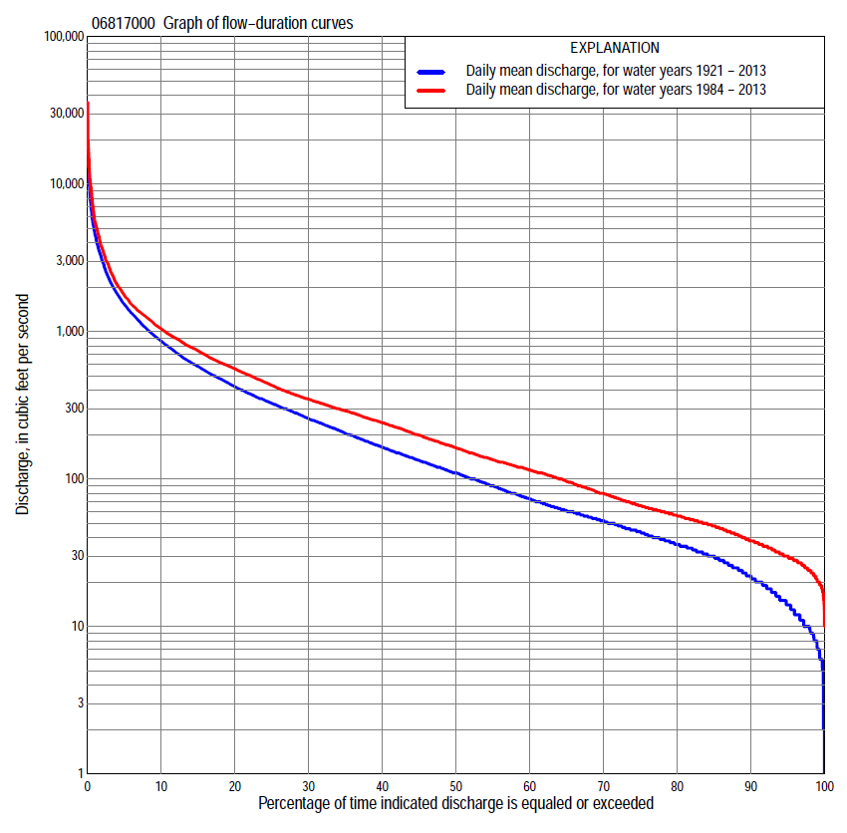

Statistics Based on the Entire Streamflow Period of Record
06817000 Monthly and annual flow durations, based on 1921–22, 1924, 1937–2013 period of record (80 years)
Percentage of days discharge equaled or exceeded |  |  |  |  | Discharge (cubic feet per second) |  |  |  |  |  |  |  |  | Annual flow durations
 | Oct | Nov | Dec | Jan | Feb | Mar | Apr | May | June | July | Aug | Sept | Annual | Kentau statistic | P-value
99 | 8.0 | 8.0 | 3.0 | 6.0 | 9.0 | 16 | 13 | 10 | 13 | 10 | 8.0 | 7.0 | 8.0 | 0.432 | 0.000
98 | 9.0 | 10 | 6.0 | 6.0 | 10 | 22 | 18 | 13 | 16 | 11 | 11 | 8.0 | 10 | 0.428 | 0.000
95 | 12 | 14 | 10 | 8.0 | 14 | 32 | 26 | 24 | 23 | 14 | 16 | 13 | 14 | 0.413 | 0.000
90 | 17 | 22 | 15 | 12 | 22 | 43 | 41 | 36 | 34 | 24 | 22 | 19 | 22 | 0.400 | 0.000
85 | 22 | 29 | 19 | 15 | 30 | 53 | 57 | 45 | 52 | 35 | 31 | 24 | 30 | 0.379 | 0.000
80 | 28 | 32 | 23 | 20 | 36 | 66 | 72 | 62 | 82 | 52 | 38 | 29 | 36 | 0.362 | 0.000
75 | 31 | 37 | 29 | 25 | 45 | 84 | 89 | 86 | 118 | 67 | 45 | 34 | 44 | 0.348 | 0.000
70 | 35 | 41 | 34 | 30 | 52 | 106 | 110 | 122 | 150 | 83 | 52 | 39 | 52 | 0.317 | 0.000
65 | 39 | 47 | 38 | 35 | 65 | 133 | 130 | 161 | 179 | 102 | 59 | 44 | 61 | 0.278 | 0.000
60 | 44 | 53 | 44 | 40 | 83 | 164 | 153 | 211 | 210 | 120 | 67 | 50 | 73 | 0.263 | 0.001
55 | 49 | 58 | 50 | 47 | 100 | 190 | 190 | 257 | 253 | 141 | 77 | 56 | 90 | 0.246 | 0.001
50 | 57 | 64 | 56 | 55 | 115 | 223 | 232 | 313 | 308 | 160 | 87 | 63 | 110 | 0.236 | 0.002
45 | 67 | 70 | 62 | 62 | 140 | 268 | 281 | 389 | 369 | 186 | 99 | 73 | 133 | 0.233 | 0.002
40 | 80 | 80 | 70 | 75 | 160 | 312 | 349 | 478 | 443 | 217 | 114 | 92 | 163 | 0.232 | 0.002
35 | 97 | 93 | 80 | 90 | 190 | 364 | 431 | 590 | 538 | 251 | 130 | 111 | 201 | 0.242 | 0.002
30 | 114 | 112 | 98 | 110 | 236 | 441 | 520 | 710 | 640 | 300 | 151 | 135 | 254 | 0.235 | 0.002
25 | 140 | 144 | 125 | 130 | 300 | 532 | 624 | 847 | 806 | 354 | 180 | 168 | 324 | 0.236 | 0.002
20 | 183 | 190 | 165 | 170 | 354 | 652 | 753 | 1,030 | 1000 | 426 | 228 | 212 | 420 | 0.240 | 0.002
15 | 244 | 276 | 267 | 230 | 470 | 904 | 953 | 1,320 | 1,290 | 558 | 290 | 307 | 575 | 0.241 | 0.002
10 | 361 | 377 | 333 | 292 | 645 | 1,300 | 1,290 | 1,760 | 1,770 | 799 | 422 | 495 | 850 | 0.203 | 0.008
5 | 694 | 631 | 494 | 436 | 1,200 | 2,310 | 1,990 | 2,980 | 3,430 | 1,600 | 751 | 943 | 1,510 | 0.174 | 0.022
2 | 1,290 | 1,270 | 724 | 800 | 2,250 | 4,140 | 3,250 | 5,160 | 6,560 | 3,490 | 1,680 | 2,150 | 2,990 | 0.103 | 0.176
1 | 1,820 | 1,790 | 1,160 | 1,360 | 3,050 | 5,700 | 4,600 | 7,710 | 9,530 | 5,770 | 2,630 | 4,000 | 4,620 | 0.078 | 0.309

06817000 Annual exceedance probability of instantaneous peak discharges, in cubic feet per second (ft³/s), based on the Weighted Independent Estimates method,
Annual exceed-ance probability | Recur-rence interval (years) | Discharge (ft³/s) | 95-percent lower confi-dence interval (ft³/s) | 95-percent upper confi-dence interval (ft³/s)
0.500 | 2 | 12,100 | 10,600 | 13,700
0.200 | 5 | 20,200 | 17,800 | 22,800
0.100 | 10 | 25,600 | 22,400 | 29,300
0.040 | 25 | 32,600 | 27,600 | 38,300
0.020 | 50 | 37,600 | 31,000 | 45,600
0.010 | 100 | 42,600 | 34,100 | 53,300
0.005 | 200 | 47,500 | 36,800 | 61,400
0.002 | 500 | 53,800 | 39,800 | 72,700
and based on the expected moments algorithm/multiple Grubbs-Beck analysis computed using a historical period length of 110 years (1904–2013)
0.500 | 2 | 12,100 | 10,300 | 13,900
0.200 | 5 | 20,300 | 17,600 | 23,400
0.100 | 10 | 25,900 | 22,400 | 30,600
0.040 | 25 | 33,000 | 28,100 | 40,600
0.020 | 50 | 38,300 | 32,000 | 49,000
0.010 | 100 | 43,500 | 35,500 | 58,200
0.005 | 200 | 48,700 | 38,700 | 68,400
0.002 | 500 | 55,400 | 42,500 | 83,800
Kentau statistic |  | 0.308
P-value |  | 0.000
Begin year |  | 1918
End year |  | 2013
Number of peaks |  | 86

06817000 Annual exceedance probability of high discharges, based on 1921–22, 1924, 1937–2013 period of record (80 years)
Annual exceedance probability | Recur-rence interval (years) | Maximum average discharge (ft³/s) for indicated number of consecutive days
 |  | 1 | 3 | 7 | 15 | 30
0.990 | 1.01 | 507 | 360 | 238 | 166 | 125
0.950 | 1.05 | 1,470 | 967 | 605 | 413 | 295
0.900 | 1.11 | 2,400 | 1,540 | 940 | 634 | 445
0.800 | 1.25 | 4,040 | 2,540 | 1,520 | 1,020 | 702
0.500 | 2 | 9,000 | 5,600 | 3,290 | 2,160 | 1,480
0.200 | 5 | 15,800 | 10,100 | 5,920 | 3,850 | 2,670
0.100 | 10 | 19,500 | 12,800 | 7,540 | 4,880 | 3,440
0.040 | 25 | 23,200 | 15,600 | 9,330 | 6,020 | 4,330
0.020 | 50 | 25,300 | 17,400 | 10,500 | 6,750 | 4,920
0.010 | 100 | 26,900 | 18,900 | 11,400 | 7,380 | 5,460
0.005 | 200 | 28,200 | 20,100 | 12,300 | 7,930 | 5,940
0.002 | 500 | 29,400 | 21,500 | 13,200 | 8,540 | 6,500
Kentau statistic |  | 0.366 | 0.340 | 0.370 | 0.379 | 0.391
P-value |  | 0.000 | 0.000 | 0.000 | 0.000 | 0.000

 | 06817000 Annual nonexceedance probability of low discharges, based on April 1920 to March 1922, April 1923 to March 1924, April 1937 to March 2013 period of record (79 years)
Annual nonexceed-ance probability | Recur-rence interval (years) | Minimum average discharge (ft³/s) for indicated number of consecutive days
 |  | 1 | 3 | 7 | 14 | 30 | 60 | 90 | 120 | 183
0.01 | 100 | 2.1 | 2.3 | 2.7 | 3.3 | 4.0 | 5.9 | 7.7 | 10 | 12
0.02 | 50 | 2.8 | 3.1 | 3.5 | 4.3 | 5.1 | 7.2 | 9.4 | 12 | 14
0.05 | 20 | 4.3 | 4.7 | 5.3 | 6.2 | 7.5 | 10 | 13 | 16 | 20
0.10 | 10 | 6.2 | 6.9 | 7.6 | 8.7 | 10 | 14 | 17 | 20 | 27
0.20 | 5 | 10 | 11 | 12 | 13 | 16 | 20 | 25 | 29 | 39
0.50 | 2 | 22 | 24 | 26 | 28 | 33 | 42 | 51 | 60 | 86
0.80 | 1.25 | 47 | 51 | 55 | 61 | 71 | 93 | 115 | 133 | 203
0.90 | 1.11 | 70 | 74 | 81 | 90 | 104 | 145 | 179 | 208 | 327
0.96 | 1.04 | 105 | 110 | 120 | 138 | 157 | 236 | 293 | 341 | 556
0.98 | 1.02 | 136 | 141 | 155 | 182 | 204 | 326 | 407 | 477 | 794
0.99 | 1.01 | 171 | 176 | 195 | 233 | 259 | 438 | 551 | 649 | 1,100
Kentau statistic |  | 0.543 | 0.542 | 0.555 | 0.545 | 0.541 | 0.515 | 0.480 | 0.455 | 0.362
P-value |  | 0.000 | 0.000 | 0.000 | 0.000 | 0.000 | 0.000 | 0.000 | 0.000 | 0.000

06817000 Annual nonexceedance probability of seasonal low discharges, based on July 1919 to June 1925, July 1936 to September 2013 period of record (80–84 years)
Annual nonexceed-ance probability | Recur-rence interval (years) | Minimum average discharge (cubic feet per second) for indicated number of consecutive days
 |  | 1 | 7 | 14 | 30 |  | 1 | 7 | 14 | 30
 |  | January-February-March |  |  |  |  | April-May-June
0.01 | 100 | 3.2 | 3.3 | 3.4 | 4.4 |  | 3.4 | 4.8 | 6.9 | 8.4
0.02 | 50 | 4.2 | 4.3 | 4.5 | 5.9 |  | 5.1 | 6.9 | 9.7 | 12
0.05 | 20 | 6.3 | 6.6 | 7.1 | 9.1 |  | 8.9 | 12 | 16 | 21
0.10 | 10 | 8.9 | 9.6 | 11 | 14 |  | 15 | 19 | 25 | 35
0.20 | 5 | 14 | 15 | 17 | 22 |  | 26 | 33 | 43 | 61
0.50 | 2 | 32 | 37 | 42 | 56 |  | 73 | 90 | 114 | 175
0.80 | 1.25 | 78 | 92 | 106 | 147 |  | 193 | 231 | 293 | 477
0.90 | 1.11 | 126 | 150 | 172 | 246 |  | 312 | 371 | 474 | 791
0.96 | 1.04 | 215 | 251 | 289 | 428 |  | 507 | 603 | 781 | 1,340
0.98 | 1.02 | 305 | 352 | 403 | 615 |  | 688 | 818 | 1,070 | 1,870
0.99 | 1.01 | 419 | 478 | 545 | 852 |  | 897 | 1,070 | 1,420 | 2,500
Kentau statistic |  | 0.323 | 0.345 | 0.341 | 0.284 |  | 0.304 | 0.279 | 0.257 | 0.232
P-value |  | 0.000 | 0.000 | 0.000 | 0.000 |  | 0.000 | 0.000 | 0.001 | 0.002
 |  | July-August-September |  |  |  |  | October-November-December
0.01 | 100 | 3.1 | 5.1 | 5.8 | 7.0 |  | 2.3 | 2.9 | 3.7 | 4.5
0.02 | 50 | 4.0 | 6.3 | 7.1 | 8.8 |  | 3.1 | 3.8 | 4.9 | 5.9
0.05 | 20 | 6.1 | 8.8 | 9.9 | 12 |  | 4.8 | 5.9 | 7.3 | 8.8
0.10 | 10 | 8.7 | 12 | 13 | 17 |  | 7.1 | 8.6 | 10 | 13
0.20 | 5 | 13 | 17 | 19 | 25 |  | 11 | 14 | 16 | 20
0.50 | 2 | 30 | 35 | 40 | 55 |  | 28 | 34 | 39 | 48
0.80 | 1.25 | 65 | 75 | 86 | 125 |  | 67 | 83 | 93 | 119
0.90 | 1.11 | 98 | 112 | 130 | 195 |  | 106 | 133 | 150 | 194
0.96 | 1.04 | 149 | 174 | 203 | 315 |  | 173 | 220 | 249 | 329
0.98 | 1.02 | 196 | 232 | 272 | 434 |  | 237 | 306 | 347 | 466
0.99 | 1.01 | 249 | 302 | 355 | 580 |  | 313 | 410 | 468 | 640
Kentau statistic |  | 0.392 | 0.326 | 0.288 | 0.211 |  | 0.340 | 0.356 | 0.378 | 0.351
P-value |  | 0.000 | 0.000 | 0.000 | 0.004 |  | 0.000 | 0.000 | 0.000 | 0.000

Statistics Based on the 1984–2013 Streamflow Period of Record
06817000 Monthly and annual flow durations, based on 1984–2013 period of record (30 years)
Percentage of days discharge equaled or exceeded |  |  |  |  | Discharge (cubic feet per second) |  |  |  |  |  |  |  |  | Annual flow durations
 | Oct | Nov | Dec | Jan | Feb | Mar | Apr | May | June | July | Aug | Sept | Annual | Kentau statistic | P-value
99 | 19 | 24 | 21 | 16 | 16 | 35 | 35 | 27 | 25 | 26 | 20 | 20 | 21 | 0.087 | 0.509
98 | 20 | 27 | 25 | 19 | 20 | 38 | 38 | 31 | 29 | 29 | 21 | 22 | 24 | 0.069 | 0.605
95 | 23 | 30 | 28 | 25 | 27 | 48 | 50 | 50 | 37 | 39 | 29 | 24 | 30 | 0.037 | 0.789
90 | 30 | 38 | 32 | 30 | 37 | 61 | 64 | 81 | 71 | 54 | 37 | 28 | 38 | 0.028 | 0.844
85 | 36 | 48 | 36 | 35 | 52 | 79 | 89 | 123 | 137 | 73 | 45 | 32 | 48 | 0.016 | 0.915
80 | 41 | 53 | 42 | 40 | 75 | 109 | 114 | 186 | 175 | 102 | 52 | 39 | 56 | 0.007 | 0.972
75 | 46 | 57 | 48 | 46 | 90 | 134 | 138 | 251 | 230 | 124 | 59 | 45 | 66 | 0.005 | 0.986
70 | 50 | 62 | 54 | 57 | 106 | 159 | 179 | 314 | 296 | 141 | 65 | 49 | 80 | -0.021 | 0.886
65 | 54 | 66 | 61 | 66 | 117 | 187 | 222 | 392 | 344 | 167 | 76 | 54 | 96 | -0.032 | 0.817
60 | 59 | 74 | 68 | 78 | 130 | 216 | 256 | 475 | 404 | 194 | 86 | 59 | 115 | -0.039 | 0.775
55 | 65 | 81 | 75 | 90 | 141 | 253 | 315 | 576 | 471 | 222 | 96 | 66 | 135 | -0.046 | 0.735
50 | 76 | 91 | 83 | 100 | 153 | 286 | 372 | 664 | 532 | 246 | 112 | 73 | 162 | -0.048 | 0.721
45 | 85 | 107 | 97 | 110 | 171 | 312 | 490 | 765 | 610 | 277 | 122 | 86 | 198 | -0.041 | 0.762
40 | 98 | 128 | 120 | 124 | 200 | 345 | 552 | 844 | 710 | 315 | 143 | 104 | 240 | -0.025 | 0.858
35 | 114 | 157 | 141 | 140 | 229 | 384 | 636 | 939 | 831 | 355 | 163 | 118 | 290 | 0.007 | 0.972
30 | 132 | 185 | 185 | 160 | 272 | 455 | 731 | 1,070 | 946 | 407 | 185 | 138 | 348 | 0.007 | 0.972
25 | 177 | 218 | 255 | 179 | 319 | 524 | 833 | 1,250 | 1,070 | 493 | 229 | 169 | 431 | -0.023 | 0.872
20 | 230 | 300 | 288 | 220 | 383 | 599 | 1,010 | 1,460 | 1,320 | 631 | 272 | 202 | 559 | -0.021 | 0.887
15 | 303 | 359 | 322 | 250 | 460 | 787 | 1,220 | 1,860 | 1,640 | 827 | 353 | 315 | 739 | -0.005 | 0.986
10 | 534 | 427 | 373 | 290 | 600 | 1,180 | 1,540 | 2,560 | 2,350 | 1,200 | 480 | 535 | 1,040 | -0.037 | 0.789
5 | 874 | 601 | 484 | 352 | 958 | 2,080 | 2,300 | 4,180 | 3,760 | 2,200 | 768 | 923 | 1,760 | 0.000 | 1.000
2 | 1,590 | 915 | 724 | 540 | 1,800 | 3,920 | 3,550 | 7,230 | 7,670 | 6,320 | 1,660 | 2,080 | 3,660 | -0.062 | 0.643
1 | 2,170 | 1,400 | 1,190 | 643 | 2,400 | 4,970 | 5,210 | 9,810 | 12,900 | 9,680 | 4,100 | 4,000 | 5,560 | -0.103 | 0.432

06817000 Annual exceedance probability of high discharges, based on 1984–2013 period of record (30 years)
Annual exceed-ance probability | Recur-rence interval (years) | Maximum average discharge (ft³/s) for indicated number of consecutive days
 |  | 1 | 3 | 7 | 15 | 30
0.990 | 1.01 | 493 | 378 | 278 | 215 | 180
0.950 | 1.05 | 1,480 | 1,020 | 715 | 519 | 396
0.900 | 1.11 | 2,470 | 1,640 | 1,120 | 789 | 581
0.800 | 1.25 | 4,280 | 2,750 | 1,820 | 1,250 | 893
0.500 | 2 | 10,100 | 6,330 | 3,980 | 2,660 | 1,840
0.200 | 5 | 18,700 | 12,000 | 7,250 | 4,800 | 3,370
0.100 | 10 | 23,800 | 15,700 | 9,280 | 6,160 | 4,410
0.040 | 25 | 29,100 | 20,000 | 11,500 | 7,720 | 5,690
0.020 | 50 | 32,200 | 22,700 | 13,000 | 8,750 | 6,590
0.010 | 100 | 34,800 | 25,200 | 14,200 | 9,670 | 7,440
0.005 | 200 | 36,900 | 27,300 | 15,300 | 10,500 | 8,250
0.002 | 500 | 39,100 | 29,800 | 16,500 | 11,400 | 9,250
Kentau statistic |  | 0.037 | -0.025 | 0.034 | -0.007 | -0.025
P-value |  | 0.789 | 0.858 | 0.803 | 0.972 | 0.858

 | 06817000 Annual nonexceedance probability of low discharges, based on April 1983 to March 2013 period of record (30 years)
Annual nonexceed-ance probability | Recur-rence interval (years) | Minimum average discharge (ft³/s) for indicated number of consecutive days
 |  | 1 | 3 | 7 | 14 | 30 | 60 | 90 | 120 | 183
0.01 | 100 | 7.6 | 9.2 | 11 | 12 | 13 | 15 | 16 | 18 | 20
0.02 | 50 | 8.9 | 11 | 12 | 14 | 15 | 17 | 19 | 21 | 23
0.05 | 20 | 12 | 13 | 15 | 17 | 19 | 22 | 25 | 28 | 31
0.10 | 10 | 15 | 17 | 19 | 21 | 24 | 28 | 32 | 35 | 39
0.20 | 5 | 19 | 22 | 25 | 28 | 32 | 37 | 43 | 48 | 55
0.50 | 2 | 35 | 39 | 43 | 47 | 55 | 66 | 79 | 89 | 110
0.80 | 1.25 | 68 | 73 | 78 | 86 | 99 | 123 | 151 | 174 | 239
0.90 | 1.11 | 98 | 104 | 110 | 119 | 137 | 174 | 215 | 252 | 371
0.96 | 1.04 | 147 | 155 | 162 | 173 | 197 | 255 | 318 | 380 | 608
0.98 | 1.02 | 194 | 204 | 210 | 222 | 251 | 330 | 411 | 500 | 850
0.99 | 1.01 | 249 | 262 | 268 | 279 | 313 | 418 | 521 | 644 | 1,160
Kentau statistic |  | 0.037 | 0.018 | 0.046 | 0.034 | 0.025 | 0.021 | -0.039 | -0.053 | -0.108
P-value |  | 0.789 | 0.901 | 0.735 | 0.803 | 0.858 | 0.887 | 0.775 | 0.695 | 0.412

06817000 Annual nonexceedance probability of seasonal low discharges, based on October 1983 to September 2013 period of record (30 years)
Annual nonexceed-ance probability | Recur-rence interval (years) | Minimum average discharge (cubic feet per second) for indicated number of consecutive days
 |  | 1 | 7 | 14 | 30 |  | 1 | 7 | 14 | 30
 |  | January-February-March |  |  |  |  | April-May-June
0.01 | 100 | 6.6 | 9.4 | 12 | 14 |  | 10 | 12 | 13 | 14
0.02 | 50 | 8.6 | 12 | 15 | 18 |  | 15 | 17 | 19 | 22
0.05 | 20 | 13 | 18 | 22 | 25 |  | 24 | 28 | 32 | 39
0.10 | 10 | 18 | 24 | 29 | 34 |  | 37 | 42 | 49 | 64
0.20 | 5 | 27 | 35 | 41 | 48 |  | 60 | 68 | 81 | 114
0.50 | 2 | 54 | 68 | 78 | 92 |  | 139 | 161 | 200 | 312
0.80 | 1.25 | 104 | 127 | 139 | 174 |  | 296 | 348 | 458 | 753
0.90 | 1.11 | 144 | 173 | 186 | 239 |  | 423 | 502 | 684 | 1,140
0.96 | 1.04 | 200 | 237 | 251 | 335 |  | 602 | 724 | 1,030 | 1,720
0.98 | 1.02 | 246 | 288 | 302 | 415 |  | 745 | 905 | 1,320 | 2,190
0.99 | 1.01 | 294 | 341 | 354 | 502 |  | 894 | 1,100 | 1,640 | 2,700
Kentau statistic |  | -0.092 | -0.048 | -0.055 | -0.030 |  | 0.076 | 0.085 | 0.044 | 0.136
P-value |  | 0.486 | 0.721 | 0.682 | 0.830 |  | 0.568 | 0.521 | 0.748 | 0.301
 |  | July-August-September |  |  |  |  | October-November-December
0.01 | 100 | 13 | 16 | 17 | 20 |  | 9.0 | 13 | 14 | 15
0.02 | 50 | 14 | 17 | 19 | 22 |  | 11 | 14 | 16 | 17
0.05 | 20 | 17 | 20 | 22 | 25 |  | 13 | 18 | 21 | 22
0.10 | 10 | 21 | 24 | 26 | 30 |  | 17 | 22 | 25 | 28
0.20 | 5 | 27 | 30 | 32 | 38 |  | 22 | 28 | 33 | 38
0.50 | 2 | 48 | 52 | 57 | 69 |  | 42 | 52 | 59 | 75
0.80 | 1.25 | 96 | 106 | 118 | 153 |  | 88 | 108 | 120 | 159
0.90 | 1.11 | 145 | 163 | 186 | 256 |  | 133 | 167 | 183 | 247
0.96 | 1.04 | 237 | 272 | 319 | 473 |  | 215 | 277 | 299 | 405
0.98 | 1.02 | 332 | 391 | 468 | 733 |  | 299 | 395 | 420 | 569
0.99 | 1.01 | 458 | 551 | 675 | 1,120 |  | 405 | 550 | 578 | 780
Kentau statistic |  | 0.051 | 0.060 | 0.080 | 0.048 |  | -0.034 | -0.025 | -0.002 | -0.046
P-value |  | 0.708 | 0.656 | 0.544 | 0.721 |  | 0.803 | 0.858 | 1.000 | 0.735

