LOCATION.--Lat 40°46'09", long 94°24'18" referenced to North American Datum of 1927, in NW 1/4 NW 1/4 NE 1/4 sec.22, T.69 N., R.31 W., Ringgold County, IA, Hydrologic Unit 10240012, at bridge on 190th Street, 4.6 mi southwest of Diagonal, 2.2 mi upstream from Turkey Creek, and 4.9 mi downstream from Gard Creek.

DRAINAGE AREA.--217 mi².

PERIOD OF RECORD.--Discharge records from April 1968 to September 1991; annual maximum discharge, water years 1997 to current year.

GAGE.—Water-stage recorder. Datum of gage is 1,095.27 ft above sea level.

EXTREMES FOR PERIOD OF RECORD.--Maximum discharge, 13,400 ft³/s, July 25, 2008, gage height, 25.97 ft.

A summary of all available data for this streamgage is provided through the USGS National Water Information System web interface (NWISWeb). The following link provides access to current/historical observations, daily data, daily statistics, monthly statistics, annual statistics, peak streamflow, field measurements, field/lab water-quality samples, and the latest water-year summaries. Data can be filtered by parameter and/or dates, and can be output in various tabular and graphical formats.
http://waterdata.usgs.gov/nwis/inventory/?site_no=06818750

The USGS WaterWatch Toolkit is available at:
http://waterwatch.usgs.gov/?id=ww_toolkit
Tools for summarizing streamflow information include the duration hydrograph builder, the cumulative streamflow hydrograph builder, the streamgage statistics retrieval tool, the rating curve builder, the flood tracking chart builder, the National Weather Service Advanced Hydrologic Prediction Service (AHPS) river forecast hydrograph builder, and the raster-hydrograph builder. Entering the above number for this streamgage into these toolkit webpages will provide streamflow information specific to this streamgage.

A description of the statistics presented for this streamgage is available in the main body of the report at:
http://dx.doi.org/10.3133/ofr20151214
A link to other streamgages included in this report, a map showing the location of the streamgages, information on the programs used to compute the statistical analyses, and references are included in the main body of the report.

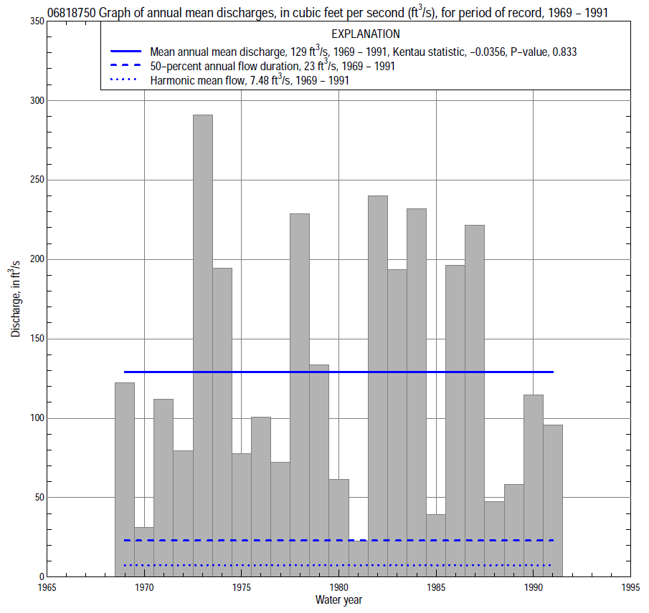

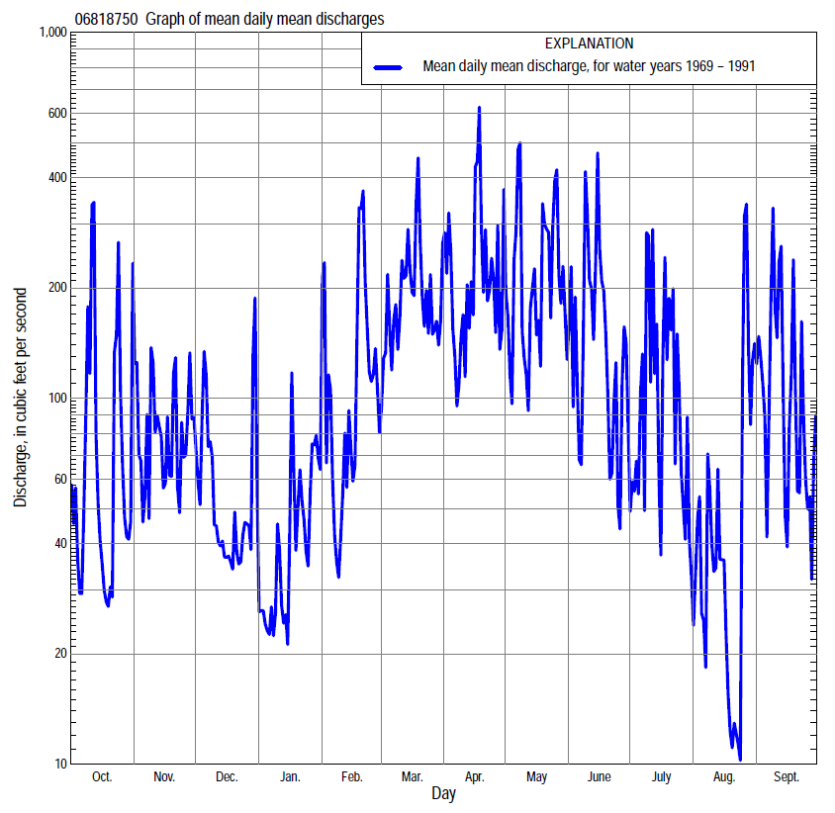

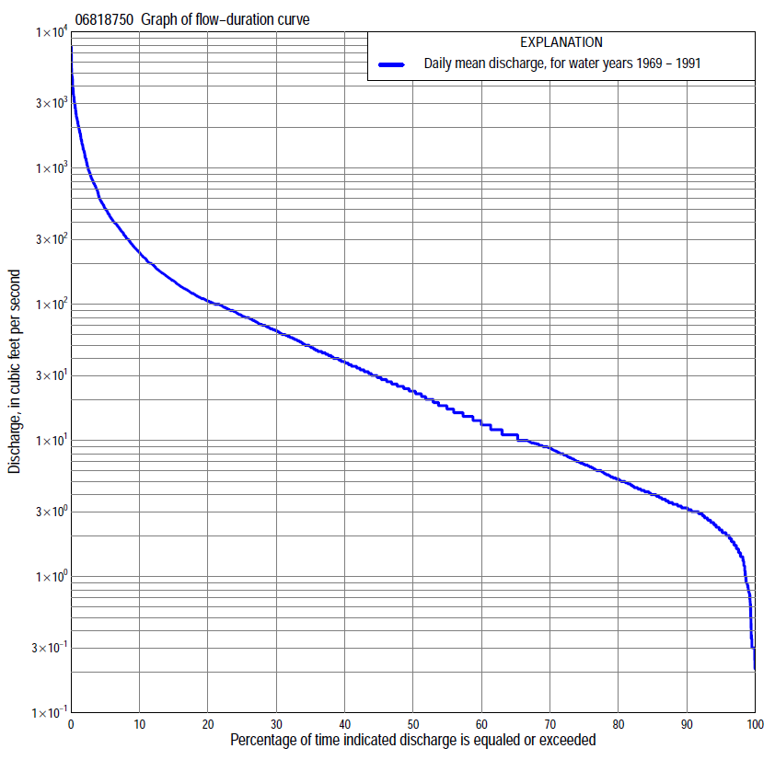

Statistics Based on the Entire Streamflow Period of Record
06818750 Monthly and annual flow durations, based on 1969–91 period of record (23 years)
Percentage of days discharge equaled or exceeded |  |  |  |  | Discharge (cubic feet per second) |  |  |  |  |  |  |  |  | Annual flow durations
 | Oct | Nov | Dec | Jan | Feb | Mar | Apr | May | June | July | Aug | Sept | Annual | Kentau statistic | P-value
99 | 1.5 | 2.5 | 1.0 | 0.28 | 0.30 | 4.4 | 2.7 | 2.1 | 1.8 | 1.2 | 0.65 | 1.4 | 0.78 | 0.174 | 0.244
98 | 1.5 | 2.9 | 1.4 | 0.30 | 0.30 | 5.3 | 3.2 | 2.6 | 2.1 | 1.2 | 0.90 | 1.6 | 1.4 | 0.126 | 0.401
95 | 1.8 | 3.0 | 2.0 | 0.74 | 1.5 | 8.0 | 6.0 | 5.0 | 3.0 | 1.8 | 1.7 | 1.8 | 2.2 | 0.123 | 0.416
90 | 2.2 | 3.4 | 3.0 | 1.6 | 3.0 | 13 | 11 | 11 | 4.4 | 2.7 | 2.4 | 2.4 | 3.2 | 0.107 | 0.481
85 | 2.6 | 4.8 | 4.0 | 3.2 | 4.0 | 18 | 17 | 15 | 6.8 | 3.2 | 3.3 | 3.0 | 4.0 | 0.115 | 0.452
80 | 3.1 | 6.2 | 5.0 | 4.0 | 5.0 | 24 | 22 | 18 | 10 | 3.9 | 4.3 | 3.3 | 5.2 | -0.012 | 0.957
75 | 3.4 | 7.8 | 6.4 | 4.5 | 6.8 | 28 | 28 | 22 | 14 | 5.1 | 5.0 | 3.7 | 6.7 | -0.016 | 0.937
70 | 3.9 | 9.5 | 7.4 | 5.4 | 9.0 | 34 | 35 | 28 | 18 | 7.1 | 5.5 | 4.2 | 8.9 | -0.012 | 0.958
65 | 4.7 | 11 | 9.0 | 6.4 | 10 | 38 | 41 | 36 | 24 | 9.7 | 6.0 | 4.4 | 11 | 0.008 | 0.979
60 | 6.1 | 13 | 10 | 9.0 | 11 | 48 | 51 | 45 | 29 | 13 | 6.7 | 5.0 | 14 | -0.024 | 0.895
55 | 7.8 | 15 | 12 | 9.4 | 16 | 58 | 62 | 57 | 36 | 16 | 7.6 | 5.9 | 18 | -0.055 | 0.731
50 | 9.2 | 19 | 15 | 11 | 21 | 70 | 72 | 67 | 44 | 18 | 8.9 | 7.0 | 23 | -0.059 | 0.711
45 | 11 | 25 | 23 | 14 | 26 | 87 | 86 | 80 | 55 | 23 | 10 | 8.6 | 30 | -0.071 | 0.653
40 | 13 | 33 | 27 | 17 | 35 | 102 | 100 | 98 | 64 | 31 | 12 | 10 | 38 | -0.040 | 0.812
35 | 17 | 44 | 33 | 25 | 41 | 119 | 113 | 115 | 78 | 38 | 15 | 13 | 50 | 0.000 | 1.000
30 | 23 | 53 | 45 | 30 | 60 | 140 | 144 | 150 | 91 | 50 | 18 | 21 | 65 | 0.024 | 0.895
25 | 43 | 73 | 58 | 38 | 91 | 174 | 175 | 181 | 108 | 62 | 22 | 37 | 84 | 0.012 | 0.958
20 | 65 | 90 | 70 | 46 | 110 | 229 | 229 | 235 | 134 | 77 | 27 | 54 | 107 | -0.012 | 0.958
15 | 92 | 118 | 95 | 60 | 160 | 305 | 335 | 330 | 170 | 107 | 34 | 92 | 150 | 0.004 | 1.000
10 | 135 | 213 | 121 | 84 | 282 | 444 | 492 | 541 | 282 | 173 | 53 | 147 | 243 | 0.004 | 1.000
5 | 323 | 356 | 200 | 144 | 500 | 786 | 948 | 1,000 | 773 | 402 | 135 | 384 | 508 | 0.016 | 0.937
2 | 786 | 742 | 400 | 461 | 1,100 | 1,630 | 2,500 | 2,080 | 1,740 | 1,460 | 425 | 1,340 | 1,290 | -0.043 | 0.792
1 | 1,600 | 1,140 | 694 | 700 | 1,800 | 2,050 | 3,010 | 3,150 | 2,110 | 2,370 | 1,180 | 3,060 | 2,180 | -0.063 | 0.692

06818750 Annual exceedance probability of instantaneous peak discharges, in cubic feet per second (ft³/s), based on the Weighted Independent Estimates method,
Annual exceed-ance probability | Recur-rence interval (years) | Discharge (ft³/s) | 95-percent lower confi-dence interval (ft³/s) | 95-percent upper confi-dence interval (ft³/s)
0.500 | 2 | 4,940 | 4,300 | 5,670
0.200 | 5 | 7,300 | 6,370 | 8,360
0.100 | 10 | 8,840 | 7,630 | 10,300
0.040 | 25 | 10,900 | 9,160 | 13,000
0.020 | 50 | 12,500 | 10,200 | 15,200
0.010 | 100 | 14,100 | 11,200 | 17,700
0.005 | 200 | 15,800 | 12,200 | 20,500
0.002 | 500 | 17,800 | 13,200 | 24,100
and based on the expected moments algorithm/multiple Grubbs-Beck analysis computed using a historical period length of 47 years (1967–2013)
0.500 | 2 | 4,930 | 4,120 | 5,710
0.200 | 5 | 7,150 | 6,180 | 8,490
0.100 | 10 | 8,540 | 7,320 | 10,500
0.040 | 25 | 10,200 | 8,560 | 13,300
0.020 | 50 | 11,300 | 9,350 | 15,400
0.010 | 100 | 12,400 | 10,000 | 17,700
0.005 | 200 | 13,400 | 10,600 | 20,100
0.002 | 500 | 14,700 | 11,300 | 23,600
Kentau statistic |  | 0.121
P-value |  | 0.279
Begin year |  | 1968
End year |  | 2013
Number of peaks |  | 40

06818750 Annual exceedance probability of high discharges, based on 1969–91 period of record (23 years)
Annual exceedance probability | Recur-rence interval (years) | Maximum average discharge (ft³/s) for indicated number of consecutive days
 |  | 1 | 3 | 7 | 15 | 30
0.990 | 1.01 | 398 | 302 | 175 | 101 | 64
0.950 | 1.05 | 943 | 615 | 372 | 234 | 146
0.900 | 1.11 | 1,390 | 862 | 527 | 340 | 213
0.800 | 1.25 | 2,100 | 1,250 | 765 | 500 | 317
0.500 | 2 | 3,860 | 2,270 | 1,360 | 873 | 567
0.200 | 5 | 5,750 | 3,590 | 2,050 | 1,230 | 829
0.100 | 10 | 6,610 | 4,360 | 2,400 | 1,380 | 945
0.040 | 25 | 7,340 | 5,170 | 2,740 | 1,500 | 1,040
0.020 | 50 | 7,710 | 5,670 | 2,920 | 1,550 | 1,090
0.010 | 100 | 7,970 | 6,110 | 3,070 | 1,580 | 1,120
0.005 | 200 | 8,150 | 6,480 | 3,180 | 1,610 | 1,150
0.002 | 500 | 8,310 | 6,890 | 3,300 | 1,620 | 1,170
Kentau statistic |  | -0.051 | -0.107 | -0.028 | -0.020 | 0.028
P-value |  | 0.751 | 0.492 | 0.874 | 0.916 | 0.874

 | 06818750 Annual nonexceedance probability of low discharges, based on April 1968 to March 1991 period of record (23 years)
Annual nonexceed-ance probability | Recur-rence interval (years) | Minimum average discharge (cubic feet per second) for indicated number of consecutive days
 |  | 1 | 3 | 7 | 14 | 30 | 60 | 90 | 120 | 183
0.01 | 100 | 0.16 | 0.16 | 0.16 | 0.21 | 0.35 | 0.86 | 1.4 | 1.5 | 1.5
0.02 | 50 | 0.22 | 0.22 | 0.22 | 0.28 | 0.46 | 1.0 | 1.6 | 1.8 | 2.1
0.05 | 20 | 0.33 | 0.34 | 0.36 | 0.44 | 0.69 | 1.4 | 2.2 | 2.5 | 3.4
0.10 | 10 | 0.47 | 0.50 | 0.55 | 0.66 | 1.0 | 1.9 | 3.0 | 3.5 | 5.2
0.20 | 5 | 0.73 | 0.82 | 0.91 | 1.1 | 1.6 | 2.9 | 4.5 | 5.3 | 8.8
0.50 | 2 | 1.8 | 2.0 | 2.3 | 2.7 | 3.8 | 7.0 | 10 | 13 | 25
0.80 | 1.25 | 4.4 | 4.9 | 5.6 | 6.8 | 9.6 | 20 | 27 | 34 | 72
0.90 | 1.11 | 7.2 | 7.8 | 8.8 | 11 | 16 | 37 | 48 | 61 | 126
0.96 | 1.04 | 12 | 13 | 14 | 18 | 26 | 75 | 90 | 115 | 231
0.98 | 1.02 | 17 | 17 | 19 | 25 | 37 | 122 | 139 | 179 | 342
0.99 | 1.01 | 24 | 24 | 24 | 34 | 51 | 192 | 209 | 269 | 489
Kentau statistic |  | -0.020 | 0.032 | 0.079 | 0.091 | -0.036 | 0.028 | -0.004 | 0.012 | 0.004
P-value |  | 0.916 | 0.853 | 0.616 | 0.561 | 0.833 | 0.874 | 1.000 | 0.958 | 1.000

06818750 Annual nonexceedance probability of seasonal low discharges, based on April 1968 to September 1991 period of record (23–24 years)
Annual nonexceed-ance probability | Recur-rence interval (years) | Minimum average discharge (cubic feet per second) for indicated number of consecutive days
 |  | 1 | 7 | 14 | 30 |  | 1 | 7 | 14 | 30
 |  | January-February-March |  |  |  |  | April-May-June
0.01 | 100 | 0.10 | 0.11 | 0.12 | 0.25 |  | 0.63 | 0.84 | 1.0 | 1.8
0.02 | 50 | 0.16 | 0.19 | 0.21 | 0.41 |  | 0.90 | 1.2 | 1.5 | 2.6
0.05 | 20 | 0.36 | 0.41 | 0.48 | 0.83 |  | 1.5 | 2.1 | 2.5 | 4.4
0.10 | 10 | 0.70 | 0.80 | 0.94 | 1.6 |  | 2.4 | 3.2 | 4.0 | 7.2
0.20 | 5 | 1.5 | 1.7 | 2.1 | 3.2 |  | 4.0 | 5.5 | 7.1 | 13
0.50 | 2 | 5.8 | 6.7 | 8.1 | 12 |  | 11 | 14 | 20 | 38
0.80 | 1.25 | 20 | 22 | 28 | 43 |  | 26 | 34 | 54 | 111
0.90 | 1.11 | 35 | 40 | 50 | 80 |  | 42 | 52 | 90 | 192
0.96 | 1.04 | 62 | 70 | 89 | 152 |  | 66 | 80 | 152 | 342
0.98 | 1.02 | 89 | 100 | 126 | 228 |  | 89 | 105 | 213 | 497
0.99 | 1.01 | 120 | 135 | 171 | 326 |  | 115 | 132 | 286 | 692
Kentau statistic |  | 0.130 | 0.130 | 0.146 | -0.028 |  | 0.134 | 0.116 | 0.156 | 0.087
P-value |  | 0.398 | 0.398 | 0.342 | 0.874 |  | 0.371 | 0.442 | 0.297 | 0.568
 |  | July-August-September |  |  |  |  | October-November-December
0.01 | 100 | 0.51 | 0.56 | 0.73 | 1.6 |  | 0.06 | 0.61 | 0.69 | 1.0
0.02 | 50 | 0.59 | 0.66 | 0.85 | 1.7 |  | 0.06 | 0.73 | 0.86 | 1.3
0.05 | 20 | 0.76 | 0.87 | 1.1 | 1.9 |  | 0.39 | 0.98 | 1.2 | 1.8
0.10 | 10 | 0.97 | 1.1 | 1.4 | 2.1 |  | 0.79 | 1.3 | 1.8 | 2.5
0.20 | 5 | 1.3 | 1.5 | 1.8 | 2.7 |  | 1.4 | 2.0 | 2.7 | 3.9
0.50 | 2 | 2.5 | 2.9 | 3.5 | 4.9 |  | 3.7 | 4.8 | 7.0 | 9.8
0.80 | 1.25 | 5.0 | 5.9 | 7.4 | 12 |  | 11 | 14 | 20 | 28
0.90 | 1.11 | 7.5 | 8.7 | 11 | 22 |  | 21 | 26 | 38 | 52
0.96 | 1.04 | 12 | 13 | 18 | 47 |  | 45 | 54 | 75 | 102
0.98 | 1.02 | 16 | 18 | 26 | 82 |  | 75 | 90 | 120 | 163
0.99 | 1.01 | 21 | 23 | 35 | 139 |  | 120 | 145 | 185 | 252
Kentau statistic |  | -0.018 | -0.004 | -0.014 | -0.029 |  | 0.063 | 0.083 | -0.012 | -0.083
P-value |  | 0.921 | 1.000 | 0.941 | 0.862 |  | 0.692 | 0.597 | 0.958 | 0.597

