LOCATION.--Lat 40°39'38", long 94°42'59" referenced to North American Datum of 1927, in NE 1/4 NE 1/4 NW 1/4 sec.35, T.68 N., R.34 W., Taylor County, IA, Hydrologic Unit 10240013, on left bank on downstream side of bridge on County Highway N44, at southern edge of Bedford, 0.4 mi upstream from concrete stablization dam, 3.0 mi upstream from Daugherty Creek, and 9.1 mi upstream from Iowa-Missouri state line.

DRAINAGE AREA.--85.4 mi².

PERIOD OF RECORD.--Discharge records from October 1983 to current year. September 1959 to September 1983, at site 2.0 mi downstream published as "near Bedford" (station 06819190). Records are not equivalent because of difference in drainage area.

GAGE.--Water-stage recorder. Datum of gage is 1,069.16 ft above National Geodetic Vertical Datum of 1929.

REMARKS.--Slight regulation at low flow by low dam used for water supply in Bedford.

A summary of all available data for this streamgage is provided through the USGS National Water Information System web interface (NWISWeb). The following link provides access to current/historical observations, daily data, daily statistics, monthly statistics, annual statistics, peak streamflow, field measurements, field/lab water-quality samples, and the latest water-year summaries. Data can be filtered by parameter and/or dates, and can be output in various tabular and graphical formats.
http://waterdata.usgs.gov/nwis/inventory/?site_no=06819185

The USGS WaterWatch Toolkit is available at:
http://waterwatch.usgs.gov/?id=ww_toolkit
Tools for summarizing streamflow information include the duration hydrograph builder, the cumulative streamflow hydrograph builder, the streamgage statistics retrieval tool, the rating curve builder, the flood tracking chart builder, the National Weather Service Advanced Hydrologic Prediction Service (AHPS) river forecast hydrograph builder, and the raster-hydrograph builder. Entering the above number for this streamgage into these toolkit webpages will provide streamflow information specific to this streamgage.

A description of the statistics presented for this streamgage is available in the main body of the report at:
http://dx.doi.org/10.3133/ofr20151214
A link to other streamgages included in this report, a map showing the location of the streamgages, information on the programs used to compute the statistical analyses, and references are included in the main body of the report.

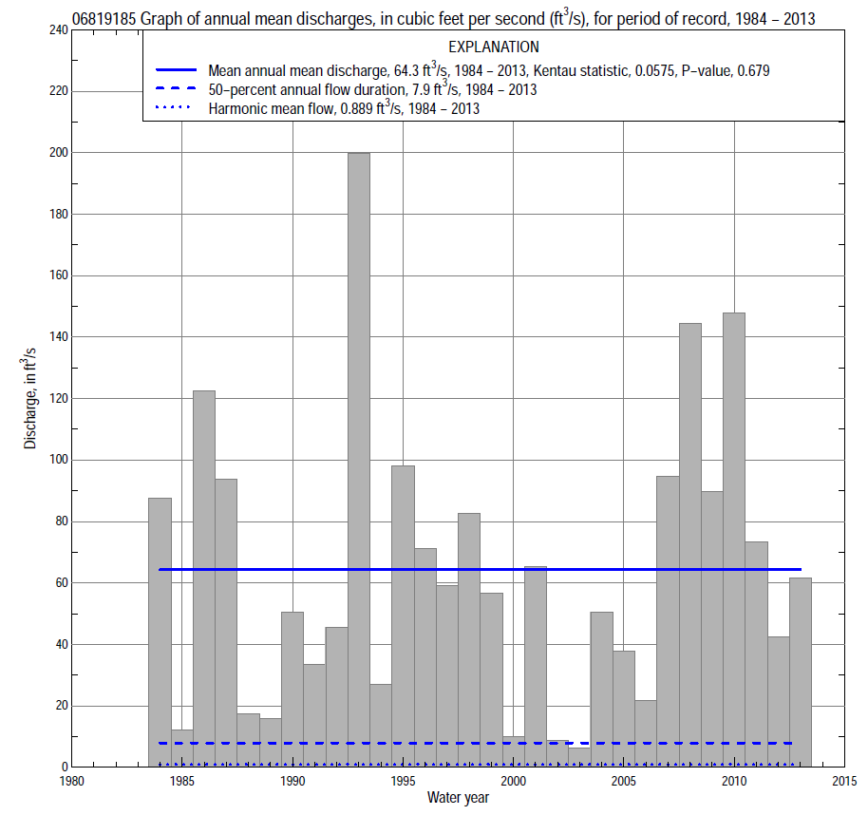

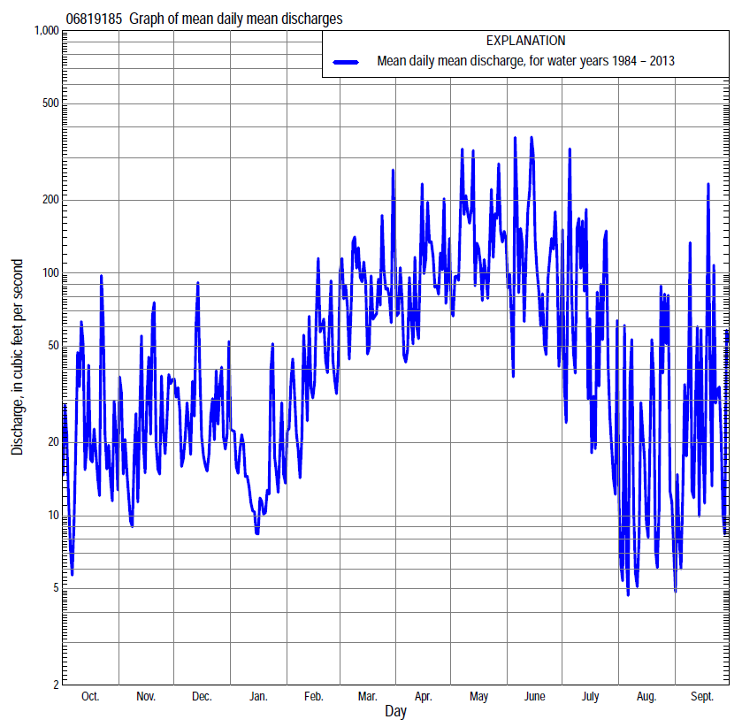

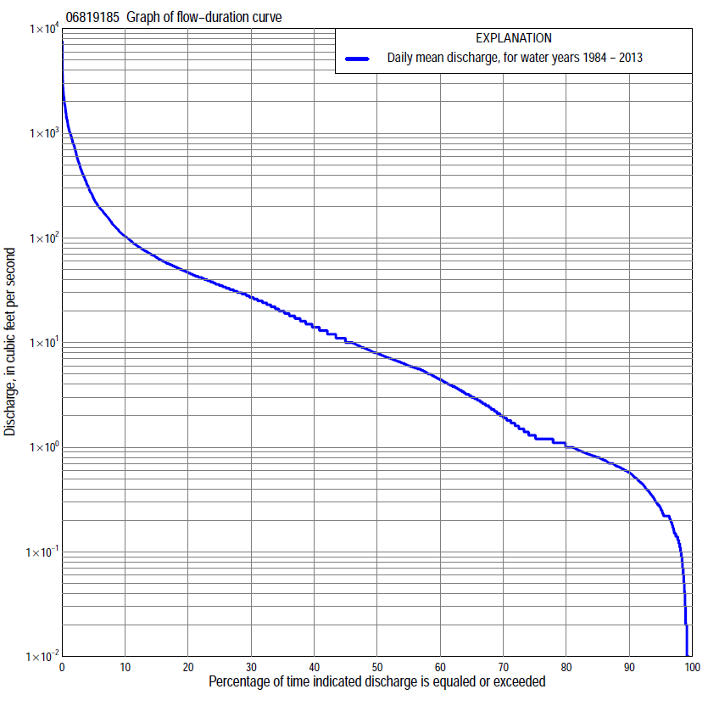

Statistics Based on the Entire Streamflow Period of Record
06819185 Monthly and annual flow durations, based on 1984–2013 period of record (30 years)
Percentage of days discharge equaled or exceeded |  |  |  |  | Discharge (cubic feet per second) |  |  |  |  |  |  |  |  | Annual flow durations
 | Oct | Nov | Dec | Jan | Feb | Mar | Apr | May | June | July | Aug | Sept | Annual | Kentau statistic | P-value
99 | 0.00 | 0.05 | 0.11 | 0.15 | 0.09 | 0.74 | 0.31 | 0.22 | 0.22 | 0.00 | 0.00 | 0.00 | 0.02 | -0.131 | 0.150
98 | 0.00 | 0.15 | 0.22 | 0.18 | 0.12 | 1.1 | 1.1 | 0.65 | 0.54 | 0.13 | 0.03 | 0.01 | 0.12 | -0.099 | 0.332
95 | 0.07 | 0.22 | 0.30 | 0.36 | 0.40 | 1.2 | 1.8 | 1.5 | 1.1 | 0.35 | 0.15 | 0.05 | 0.26 | -0.064 | 0.572
90 | 0.17 | 0.41 | 0.50 | 0.70 | 0.95 | 3.0 | 5.3 | 4.3 | 1.7 | 0.61 | 0.34 | 0.20 | 0.57 | -0.009 | 0.953
85 | 0.29 | 0.59 | 0.74 | 0.80 | 1.2 | 4.4 | 6.8 | 5.9 | 3.2 | 0.86 | 0.52 | 0.33 | 0.80 | -0.076 | 0.548
80 | 0.40 | 0.76 | 0.85 | 0.87 | 1.8 | 6.6 | 8.6 | 8.4 | 4.7 | 1.1 | 0.66 | 0.45 | 1.0 | -0.014 | 0.927
75 | 0.55 | 0.87 | 1.0 | 1.1 | 3.0 | 8.7 | 11 | 12 | 6.8 | 1.3 | 0.80 | 0.55 | 1.3 | 0.014 | 0.927
70 | 0.66 | 0.99 | 1.2 | 1.4 | 4.2 | 11 | 14 | 17 | 8.7 | 2.0 | 1.0 | 0.66 | 1.9 | 0.028 | 0.842
65 | 0.81 | 1.1 | 1.9 | 2.1 | 5.5 | 14 | 19 | 22 | 11 | 2.9 | 1.1 | 0.80 | 3.0 | -0.002 | 1.000
60 | 0.93 | 2.0 | 2.9 | 3.0 | 6.8 | 18 | 24 | 28 | 14 | 3.8 | 1.2 | 1.0 | 4.4 | 0.016 | 0.914
55 | 1.1 | 3.4 | 4.7 | 4.0 | 8.5 | 21 | 28 | 33 | 18 | 5.0 | 1.4 | 1.2 | 6.0 | 0.037 | 0.788
50 | 1.3 | 5.0 | 6.0 | 5.5 | 11 | 26 | 32 | 38 | 23 | 6.3 | 1.8 | 1.2 | 7.9 | 0.037 | 0.788
45 | 1.9 | 6.0 | 7.8 | 6.8 | 13 | 32 | 37 | 44 | 31 | 7.9 | 2.2 | 1.4 | 10 | 0.055 | 0.681
40 | 2.6 | 7.5 | 10 | 7.9 | 17 | 38 | 43 | 52 | 39 | 10 | 2.9 | 1.7 | 14 | 0.057 | 0.668
35 | 3.5 | 9.3 | 14 | 9.6 | 23 | 44 | 50 | 60 | 47 | 13 | 3.7 | 2.2 | 20 | 0.067 | 0.616
30 | 4.8 | 13 | 20 | 12 | 29 | 53 | 59 | 74 | 58 | 19 | 4.8 | 3.2 | 27 | 0.062 | 0.642
25 | 9.0 | 17 | 26 | 14 | 36 | 68 | 70 | 93 | 77 | 26 | 6.1 | 4.5 | 35 | 0.046 | 0.734
20 | 14 | 26 | 33 | 19 | 48 | 88 | 90 | 121 | 103 | 35 | 8.5 | 6.5 | 47 | 0.044 | 0.748
15 | 25 | 34 | 42 | 26 | 60 | 123 | 130 | 184 | 153 | 50 | 14 | 10 | 65 | 0.053 | 0.695
10 | 44 | 53 | 60 | 34 | 94 | 197 | 202 | 315 | 254 | 92 | 26 | 29 | 103 | 0.021 | 0.887
5 | 83 | 101 | 99 | 53 | 183 | 418 | 439 | 752 | 623 | 293 | 68 | 92 | 238 | -0.009 | 0.957
2 | 245 | 218 | 206 | 112 | 389 | 976 | 1,000 | 1,390 | 1,370 | 964 | 188 | 428 | 724 | 0.122 | 0.354
1 | 552 | 372 | 469 | 198 | 528 | 1,210 | 1,140 | 1,900 | 2,000 | 1,820 | 648 | 915 | 1,140 | 0.080 | 0.544

06819185 Annual exceedance probability of instantaneous peak discharges, in cubic feet per second (ft³/s), based on the Weighted Independent Estimates method,
Annual exceed-ance probability | Recur-rence interval (years) | Discharge (ft³/s) | 95-percent lower confi-dence interval (ft³/s) | 95-percent upper confi-dence interval (ft³/s)
0.500 | 2 | 4,720 | 4,110 | 5,430
0.200 | 5 | 7,040 | 6,170 | 8,040
0.100 | 10 | 8,480 | 7,360 | 9,780
0.040 | 25 | 10,300 | 8,710 | 12,200
0.020 | 50 | 11,700 | 9,590 | 14,200
0.010 | 100 | 13,000 | 10,400 | 16,400
0.005 | 200 | 14,500 | 11,200 | 18,700
0.002 | 500 | 16,200 | 12,000 | 21,800
and based on the expected moments algorithm/multiple Grubbs-Beck analysis computed using a historical period length of 54 years (1960–2013)ª
0.500 | 2 | 4,790 | 3,840 | 5,460
0.200 | 5 | 7,090 | 6,210 | 8,330
0.100 | 10 | 8,510 | 7,380 | 10,500
0.040 | 25 | 10,200 | 8,630 | 13,400
0.020 | 50 | 11,300 | 9,410 | 15,600
0.010 | 100 | 12,400 | 10,100 | 17,900
0.005 | 200 | 13,400 | 10,600 | 20,200
0.002 | 500 | 14,600 | 11,300 | 23,400
Kentau statistic |  | 0.218
P-value |  | 0.094
Begin year |  | 1984
End year |  | 2013
Number of peaks |  | 30
ªAnalysis includes interval annual-peak discharges (1960-83) from streamgage 06819190 East Fork 102 River near Bedford.

06819185 Annual exceedance probability of high discharges, based on 1984–2013 period of record (30 years)
Annual exceedance probability | Recur-rence interval (years) | Maximum average discharge (ft³/s) for indicated number of consecutive days
 |  | 1 | 3 | 7 | 15 | 30
0.990 | 1.01 | 111 | 80 | 59 | 40 | 26
0.950 | 1.05 | 339 | 205 | 129 | 83 | 54
0.900 | 1.11 | 566 | 320 | 189 | 119 | 79
0.800 | 1.25 | 974 | 517 | 289 | 180 | 119
0.500 | 2 | 2,210 | 1,100 | 588 | 364 | 245
0.200 | 5 | 3,870 | 1,910 | 1,060 | 664 | 458
0.100 | 10 | 4,740 | 2,370 | 1,370 | 874 | 613
0.040 | 25 | 5,560 | 2,860 | 1,750 | 1,140 | 813
0.020 | 50 | 6,010 | 3,150 | 2,010 | 1,330 | 962
0.010 | 100 | 6,350 | 3,390 | 2,250 | 1,520 | 1,110
0.005 | 200 | 6,610 | 3,590 | 2,480 | 1,700 | 1,260
0.002 | 500 | 6,850 | 3,800 | 2,760 | 1,940 | 1,440
Kentau statistic |  | 0.099 | 0.048 | 0.030 | 0.030 | 0.108
P-value |  | 0.454 | 0.721 | 0.830 | 0.830 | 0.412

 | 06819185 Annual nonexceedance probability of low discharges, based on April 1984 to March 2013 period of record (29 years)
Annual nonexceed-ance probability | Recur-rence interval (years) | Minimum average discharge (cubic feet per second) for indicated number of consecutive days
 |  | 1 | 3 | 7 | 14 | 30 | 60 | 90 | 120 | 183
0.01 | 100 | 0.00 | 0.00 | 0.00 | 0.00 | 0.02 | 0.05 | 0.07 | 0.07 | 0.12
0.02 | 50 | 0.00 | 0.00 | 0.00 | 0.00 | 0.04 | 0.08 | 0.10 | 0.11 | 0.20
0.05 | 20 | 0.00 | 0.00 | 0.00 | 0.00 | 0.07 | 0.15 | 0.20 | 0.22 | 0.43
0.10 | 10 | 0.00 | 0.00 | 0.00 | 0.02 | 0.13 | 0.26 | 0.36 | 0.42 | 0.84
0.20 | 5 | 0.03 | 0.05 | 0.07 | 0.10 | 0.26 | 0.49 | 0.73 | 0.91 | 1.8
0.50 | 2 | 0.56 | 0.57 | 0.63 | 0.67 | 0.89 | 1.7 | 2.8 | 3.8 | 7.6
0.80 | 1.25 | 1.4 | 1.4 | 1.8 | 2.3 | 2.8 | 5.7 | 11 | 16 | 28
0.90 | 1.11 | 1.7 | 1.9 | 2.4 | 3.5 | 5.0 | 11 | 22 | 32 | 54
0.96 | 1.04 | 2.0 | 2.3 | 2.9 | 4.9 | 8.9 | 21 | 47 | 69 | 106
0.98 | 1.02 | 2.1 | 2.5 | 3.1 | 5.7 | 13 | 32 | 76 | 112 | 160
0.99 | 1.01 | 2.2 | 2.6 | 3.3 | 6.4 | 17 | 46 | 118 | 173 | 231
Kentau statistic |  | -0.094 | -0.096 | -0.062 | -0.103 | -0.079 | -0.044 | 0.005 | -0.015 | 0.059
P-value |  | 0.486 | 0.475 | 0.652 | 0.442 | 0.561 | 0.750 | 0.985 | 0.925 | 0.666

06819185 Annual nonexceedance probability of seasonal low discharges, based on October 1983 to September 2013 period of record (30 years)
Annual nonexceed-ance probability | Recur-rence interval (years) | Minimum average discharge (cubic feet per second) for indicated number of consecutive days
 |  | 1 | 7 | 14 | 30 |  | 1 | 7 | 14 | 30
 |  | January-February-March |  |  |  |  | April-May-June
0.01 | 100 | 0.01 | 0.06 | 0.07 | 0.07 |  | 0.09 | 0.18 | 0.27 | 0.27
0.02 | 50 | 0.03 | 0.10 | 0.11 | 0.12 |  | 0.15 | 0.30 | 0.47 | 0.50
0.05 | 20 | 0.08 | 0.20 | 0.24 | 0.28 |  | 0.31 | 0.59 | 0.96 | 1.2
0.10 | 10 | 0.19 | 0.36 | 0.44 | 0.56 |  | 0.58 | 1.0 | 1.7 | 2.6
0.20 | 5 | 0.46 | 0.70 | 0.91 | 1.2 |  | 1.2 | 2.0 | 3.4 | 6.0
0.50 | 2 | 1.8 | 2.3 | 3.1 | 4.8 |  | 3.8 | 6.0 | 10 | 24
0.80 | 1.25 | 4.8 | 6.5 | 8.7 | 15 |  | 10 | 15 | 26 | 76
0.90 | 1.11 | 6.9 | 11 | 14 | 26 |  | 16 | 24 | 39 | 127
0.96 | 1.04 | 9.2 | 17 | 22 | 43 |  | 24 | 36 | 58 | 205
0.98 | 1.02 | 11 | 23 | 29 | 57 |  | 31 | 46 | 72 | 270
0.99 | 1.01 | 12 | 30 | 36 | 74 |  | 38 | 57 | 87 | 338
Kentau statistic |  | -0.005 | 0.094 | 0.034 | 0.007 |  | 0.057 | 0.034 | 0.034 | 0.140
P-value |  | 0.986 | 0.475 | 0.803 | 0.972 |  | 0.668 | 0.803 | 0.803 | 0.284
 |  | July-August-September |  |  |  |  | October-November-December
0.01 | 100 | 0.00 | 0.00 | 0.00 | 0.05 |  | 0.00 | 0.00 | 0.00 | 0.05
0.02 | 50 | 0.00 | 0.00 | 0.01 | 0.07 |  | 0.00 | 0.00 | 0.00 | 0.07
0.05 | 20 | 0.00 | 0.00 | 0.02 | 0.12 |  | 0.00 | 0.00 | 0.04 | 0.14
0.10 | 10 | 0.00 | 0.03 | 0.06 | 0.18 |  | 0.00 | 0.03 | 0.11 | 0.25
0.20 | 5 | 0.10 | 0.13 | 0.16 | 0.33 |  | 0.06 | 0.12 | 0.26 | 0.51
0.50 | 2 | 0.57 | 0.69 | 0.81 | 1.1 |  | 0.77 | 0.94 | 1.1 | 2.1
0.80 | 1.25 | 1.6 | 2.0 | 2.8 | 4.6 |  | 3.2 | 4.1 | 4.6 | 9.4
0.90 | 1.11 | 2.5 | 3.1 | 4.6 | 10 |  | 5.6 | 7.5 | 9.3 | 21
0.96 | 1.04 | 3.5 | 4.4 | 7.1 | 25 |  | 9.3 | 13 | 20 | 50
0.98 | 1.02 | 4.2 | 5.3 | 8.9 | 46 |  | 12 | 17 | 32 | 89
0.99 | 1.01 | 4.8 | 6.0 | 11 | 82 |  | 15 | 21 | 48 | 151
Kentau statistic |  | -0.097 | -0.087 | -0.122 | -0.126 |  | -0.069 | -0.080 | -0.085 | -0.021
P-value |  | 0.464 | 0.509 | 0.354 | 0.335 |  | 0.604 | 0.544 | 0.521 | 0.887

