LOCATION.--Lat 40°38'01", long 94°44'54" referenced to North American Datum of 1927, in NE 1/4 sec.09, T.67 N., R.34 W., Taylor County, IA, Hydrologic Unit 10240013, on left bank on downstream side of bridge on 290th Street, 2.1 mi southwest from Bedford, and 0.3 mi upstream from Daugherty Creek.

DRAINAGE AREA.--92.1 mi².

PERIOD OF RECORD.--Discharge records from September 1959 to September 1983.

GAGE.--Water-stage recorder. Datum of gage is 1,057.51 ft above National Geodetic Vertical Datum of 1929. Prior to October 1, 1968, at datum 5.00 ft higher.

REMARKS.--Slight regulation at low flow by low dam used for water supply in Bedford.

A summary of all available data for this streamgage is provided through the USGS National Water Information System web interface (NWISWeb). The following link provides access to current/historical observations, daily data, daily statistics, monthly statistics, annual statistics, peak streamflow, field measurements, field/lab water-quality samples, and the latest water-year summaries. Data can be filtered by parameter and/or dates, and can be output in various tabular and graphical formats.
http://waterdata.usgs.gov/nwis/inventory/?site_no=06819190

The USGS WaterWatch Toolkit is available at:
http://waterwatch.usgs.gov/?id=ww_toolkit
Tools for summarizing streamflow information include the duration hydrograph builder, the cumulative streamflow hydrograph builder, the streamgage statistics retrieval tool, the rating curve builder, the flood tracking chart builder, the National Weather Service Advanced Hydrologic Prediction Service (AHPS) river forecast hydrograph builder, and the raster-hydrograph builder. Entering the above number for this streamgage into these toolkit webpages will provide streamflow information specific to this streamgage.

A description of the statistics presented for this streamgage is available in the main body of the report at:
http://dx.doi.org/10.3133/ofr20151214
A link to other streamgages included in this report, a map showing the location of the streamgages, information on the programs used to compute the statistical analyses, and references are included in the main body of the report.

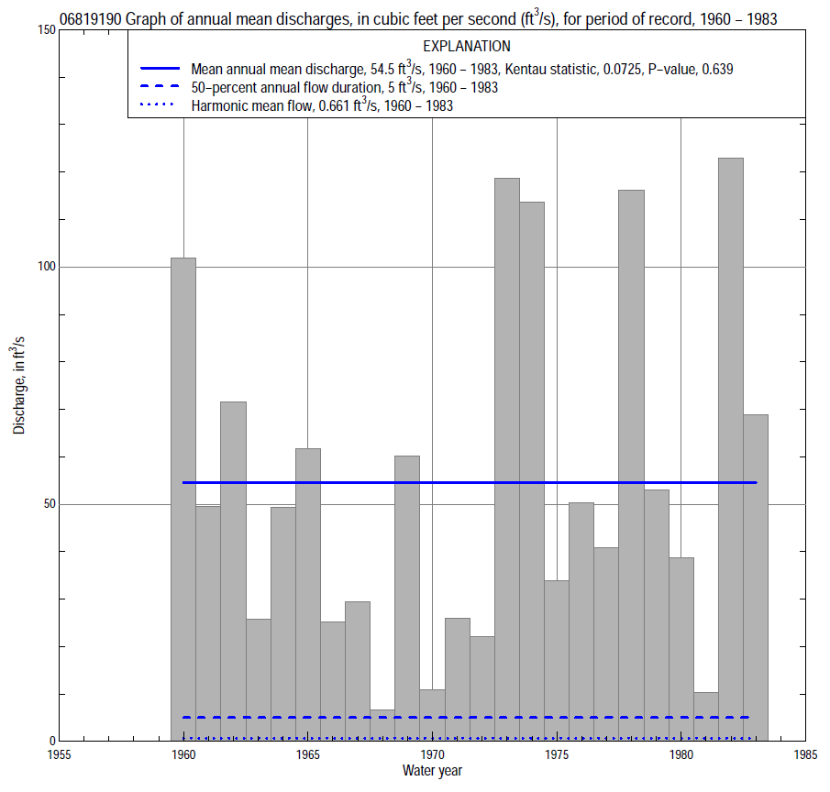

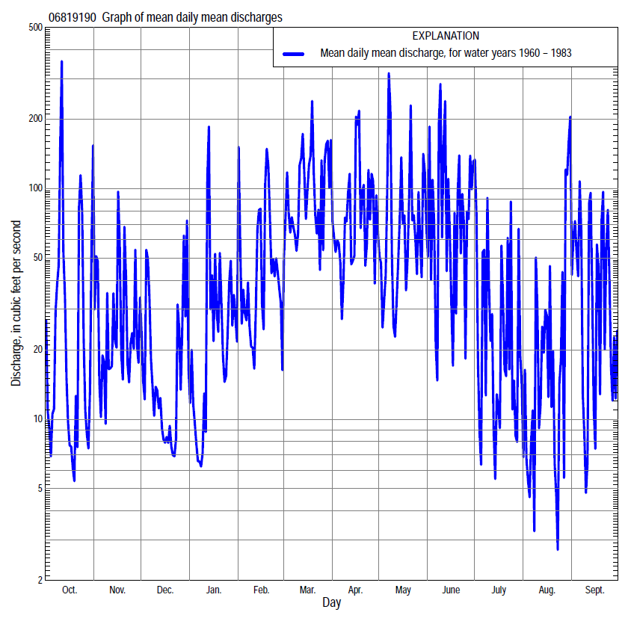

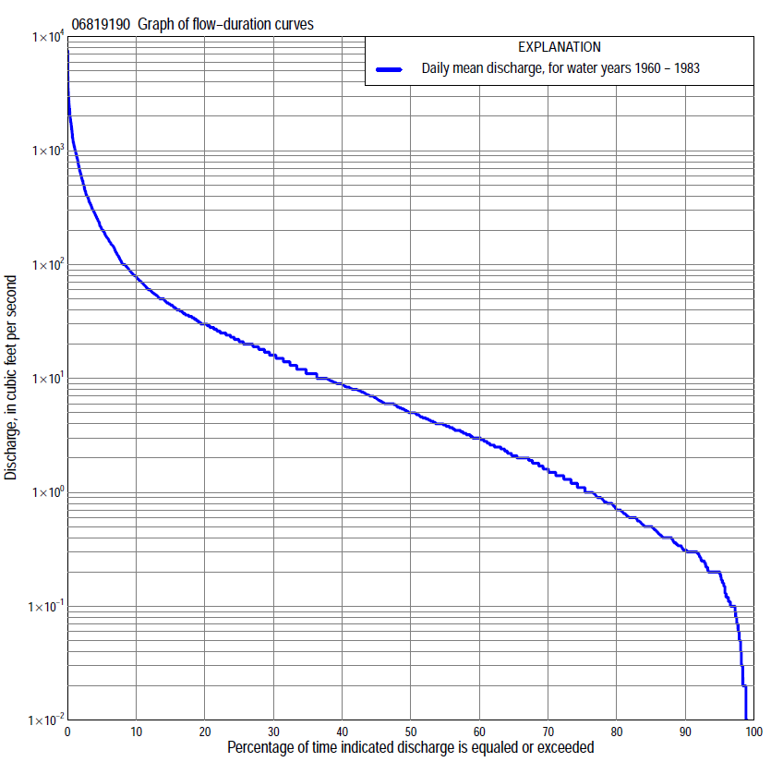

Statistics Based on the Entire Streamflow Period of Record
06819190 Monthly and annual flow durations, based on 1960–83 period of record (24 years)
[ND, not determined]
Percentage of days discharge equaled or exceeded |  |  |  |  | Discharge (cubic feet per second) |  |  |  |  |  |  |  |  | Annual flow durations
 | Oct | Nov | Dec | Jan | Feb | Mar | Apr | May | June | July | Aug | Sept | Annual | Kentau statistic | P-value
99 | 0.02 | 0.10 | 0.00 | 0.00 | 0.03 | 0.18 | 0.26 | 0.36 | 0.20 | 0.02 | 0.01 | 0.06 | 0.01 | 0.000 | ND
98 | 0.04 | 0.10 | 0.00 | 0.00 | 0.11 | 0.30 | 0.47 | 0.52 | 0.22 | 0.03 | 0.02 | 0.12 | 0.05 | 0.076 | 0.149
95 | 0.10 | 0.20 | 0.08 | 0.00 | 0.24 | 0.65 | 1.6 | 0.96 | 0.32 | 0.10 | 0.12 | 0.20 | 0.20 | -0.004 | 1.000
90 | 0.20 | 0.29 | 0.20 | 0.11 | 0.40 | 1.5 | 2.9 | 2.1 | 0.97 | 0.30 | 0.20 | 0.26 | 0.31 | 0.018 | 0.900
85 | 0.30 | 0.38 | 0.30 | 0.30 | 0.62 | 2.7 | 4.1 | 3.7 | 1.5 | 0.46 | 0.31 | 0.34 | 0.50 | 0.040 | 0.772
80 | 0.40 | 0.50 | 0.65 | 0.40 | 0.98 | 4.0 | 5.9 | 4.6 | 2.0 | 0.64 | 0.40 | 0.40 | 0.71 | 0.141 | 0.309
75 | 0.47 | 0.82 | 1.3 | 0.60 | 1.3 | 6.0 | 7.9 | 5.5 | 2.5 | 0.90 | 0.46 | 0.50 | 1.1 | 0.065 | 0.664
70 | 0.60 | 1.2 | 1.8 | 1.2 | 2.0 | 9.0 | 10 | 7.6 | 3.3 | 1.1 | 0.55 | 0.60 | 1.6 | 0.058 | 0.704
65 | 0.72 | 1.6 | 2.0 | 1.8 | 2.7 | 10 | 12 | 9.2 | 4.3 | 1.3 | 0.65 | 0.70 | 2.1 | 0.043 | 0.782
60 | 0.90 | 2.5 | 2.5 | 2.0 | 3.7 | 13 | 15 | 11 | 5.5 | 1.5 | 0.80 | 0.82 | 3.0 | 0.087 | 0.565
55 | 1.4 | 3.2 | 3.2 | 2.6 | 5.0 | 17 | 18 | 12 | 6.8 | 1.9 | 0.99 | 1.0 | 3.9 | 0.083 | 0.582
50 | 2.1 | 4.0 | 4.0 | 3.0 | 6.9 | 20 | 21 | 15 | 7.9 | 2.3 | 1.1 | 1.4 | 5.0 | 0.087 | 0.567
45 | 2.8 | 5.0 | 5.0 | 3.7 | 9.0 | 23 | 24 | 19 | 9.5 | 2.9 | 1.3 | 1.9 | 6.7 | 0.065 | 0.672
40 | 3.8 | 6.5 | 6.0 | 4.0 | 12 | 30 | 28 | 22 | 12 | 3.8 | 1.4 | 2.8 | 8.9 | 0.069 | 0.654
35 | 5.2 | 8.0 | 7.0 | 6.0 | 16 | 40 | 32 | 27 | 16 | 5.3 | 1.8 | 3.7 | 11 | 0.072 | 0.636
30 | 7.2 | 11 | 9.0 | 8.0 | 21 | 50 | 39 | 33 | 22 | 7.0 | 2.4 | 4.8 | 16 | 0.058 | 0.710
25 | 8.8 | 14 | 10 | 10 | 28 | 69 | 47 | 41 | 29 | 9.3 | 3.2 | 9.0 | 22 | 0.058 | 0.709
20 | 13 | 23 | 15 | 19 | 39 | 93 | 64 | 56 | 42 | 12 | 5.2 | 15 | 30 | 0.062 | 0.691
15 | 18 | 36 | 20 | 24 | 59 | 140 | 95 | 87 | 69 | 19 | 9.5 | 21 | 44 | 0.054 | 0.728
10 | 28 | 57 | 36 | 32 | 102 | 210 | 157 | 154 | 159 | 34 | 20 | 44 | 78 | 0.036 | 0.823
5 | 71 | 104 | 60 | 72 | 281 | 500 | 337 | 386 | 387 | 97 | 58 | 170 | 204 | 0.033 | 0.843
2 | 394 | 305 | 200 | 300 | 772 | 980 | 738 | 926 | 1,110 | 234 | 337 | 650 | 600 | -0.014 | 0.941
1 | 881 | 501 | 324 | 576 | 1,240 | 1,600 | 1,510 | 1,290 | 1,550 | 904 | 949 | 1,150 | 1,070 | 0.051 | 0.747

06819190 Annual exceedance probability of instantaneous peak discharges, in cubic feet per second (ft³/s), based on the Weighted Independent Estimates method,
Annual exceed-ance probability | Recur-rence interval (years) | Discharge (ft³/s) | 95-percent lower confi-dence interval (ft³/s) | 95-percent upper confi-dence interval (ft³/s)
0.500 | 2 | 4,760 | 4,120 | 5,500
0.200 | 5 | 7,210 | 6,280 | 8,280
0.100 | 10 | 8,740 | 7,540 | 10,100
0.040 | 25 | 10,700 | 8,960 | 12,700
0.020 | 50 | 12,100 | 9,880 | 14,900
0.010 | 100 | 13,700 | 10,800 | 17,300
0.005 | 200 | 15,000 | 11,500 | 19,600
0.002 | 500 | 16,900 | 12,400 | 23,000
and based on the expected moments algorithm/multiple Grubbs-Beck analysis computed using a historical period length of 54 years (1960–2013)ª
0.500 | 2 | 4,840 | 3,860 | 5,550
0.200 | 5 | 7,280 | 6,340 | 8,610
0.100 | 10 | 8,810 | 7,590 | 10,900
0.040 | 25 | 10,600 | 8,950 | 14,100
0.020 | 50 | 11,900 | 9,790 | 16,600
0.010 | 100 | 13,000 | 10,500 | 19,100
0.005 | 200 | 14,100 | 11,100 | 21,600
0.002 | 500 | 15,500 | 11,800 | 25,200
Kentau statistic |  | 0.225
P-value |  | 0.130
Begin year |  | 1960
End year |  | 1983
Number of peaks |  | 24
ªAnalysis includes interval annual-peak discharges (1984-2013) from streamgage 06819185 East Fork 102 River at Bedford.

06819190 Annual exceedance probability of high discharges, based on 1960–83 period of record (24 years)
Annual exceedance probability | Recur-rence interval (years) | Maximum average discharge (ft³/s) for indicated number of consecutive days
 |  | 1 | 3 | 7 | 15 | 30
0.990 | 1.01 | 256 | 119 | 63 | 38 | 20
0.950 | 1.05 | 552 | 273 | 149 | 91 | 53
0.900 | 1.11 | 795 | 404 | 222 | 137 | 82
0.800 | 1.25 | 1,190 | 617 | 341 | 212 | 130
0.500 | 2 | 2,280 | 1,210 | 669 | 411 | 260
0.200 | 5 | 3,800 | 2,000 | 1,090 | 653 | 412
0.100 | 10 | 4,710 | 2,450 | 1,330 | 777 | 485
0.040 | 25 | 5,710 | 2,930 | 1,560 | 894 | 550
0.020 | 50 | 6,360 | 3,210 | 1,700 | 958 | 583
0.010 | 100 | 6,920 | 3,450 | 1,820 | 1,010 | 607
0.005 | 200 | 7,410 | 3,650 | 1,910 | 1,040 | 624
0.002 | 500 | 7,970 | 3,870 | 2,000 | 1,080 | 640
Kentau statistic |  | 0.076 | 0.029 | 0.036 | 0.101 | 0.109
P-value |  | 0.620 | 0.862 | 0.823 | 0.503 | 0.472

 | 06819190 Annual nonexceedance probability of low discharges, based on April 1960 to March 1983 period of record (23 years)
Annual nonexceed-ance probability | Recur-rence interval (years) | Minimum average discharge (cubic feet per second) for indicated number of consecutive days
 |  | 1 | 3 | 7 | 14 | 30 | 60 | 90 | 120 | 183
0.01 | 100 | 0.00 | 0.00 | 0.00 | 0.00 | 0.00 | 0.03 | 0.05 | 0.08 | 0.11
0.02 | 50 | 0.00 | 0.00 | 0.00 | 0.00 | 0.00 | 0.04 | 0.08 | 0.12 | 0.19
0.05 | 20 | 0.00 | 0.00 | 0.00 | 0.00 | 0.00 | 0.08 | 0.14 | 0.22 | 0.41
0.10 | 10 | 0.00 | 0.00 | 0.00 | 0.00 | 0.07 | 0.15 | 0.26 | 0.39 | 0.79
0.20 | 5 | 0.00 | 0.00 | 0.02 | 0.04 | 0.11 | 0.32 | 0.51 | 0.76 | 1.7
0.50 | 2 | 0.14 | 0.18 | 0.24 | 0.28 | 0.59 | 1.2 | 1.9 | 2.8 | 7.2
0.80 | 1.25 | 0.52 | 0.59 | 0.71 | 0.88 | 1.8 | 4.7 | 7.0 | 9.9 | 28
0.90 | 1.11 | 0.83 | 0.93 | 1.1 | 1.4 | 2.7 | 9.3 | 14 | 19 | 54
0.96 | 1.04 | 1.3 | 1.4 | 1.5 | 2.1 | 3.8 | 19 | 28 | 40 | 108
0.98 | 1.02 | 1.6 | 1.7 | 1.8 | 2.7 | 4.5 | 31 | 44 | 63 | 166
0.99 | 1.01 | 1.9 | 2.0 | 2.1 | 3.3 | 5.0 | 46 | 66 | 95 | 242
Kentau statistic |  | 0.024 | 0.043 | 0.043 | 0.063 | 0.020 | 0.091 | 0.059 | 0.099 | 0.067
P-value |  | 0.894 | 0.791 | 0.791 | 0.692 | 0.916 | 0.561 | 0.712 | 0.526 | 0.673

06819190 Annual nonexceedance probability of seasonal low discharges, based on October 1959 to September 1983 period of record (24 years)
Annual nonexceed-ance probability | Recur-rence interval (years) | Minimum average discharge (cubic feet per second) for indicated number of consecutive days
 |  | 1 | 7 | 14 | 30 |  | 1 | 7 | 14 | 30
 |  | January-February-March |  |  |  |  | April-May-June
0.01 | 100 | 0.00 | 0.00 | 0.00 | 0.00 |  | 0.02 | 0.10 | 0.22 | 0.36
0.02 | 50 | 0.00 | 0.00 | 0.00 | 0.01 |  | 0.03 | 0.15 | 0.31 | 0.57
0.05 | 20 | 0.00 | 0.00 | 0.00 | 0.03 |  | 0.08 | 0.25 | 0.51 | 1.1
0.10 | 10 | 0.00 | 0.00 | 0.00 | 0.19 |  | 0.16 | 0.41 | 0.80 | 1.9
0.20 | 5 | 0.11 | 0.17 | 0.21 | 0.44 |  | 0.36 | 0.74 | 1.4 | 3.6
0.50 | 2 | 1.1 | 1.2 | 1.6 | 3.7 |  | 1.4 | 2.2 | 3.7 | 11
0.80 | 1.25 | 4.6 | 5.1 | 6.7 | 17 |  | 4.3 | 6.3 | 10 | 28
0.90 | 1.11 | 9.2 | 10 | 13 | 31 |  | 7.0 | 11 | 17 | 44
0.96 | 1.04 | 19 | 21 | 26 | 50 |  | 11 | 19 | 28 | 67
0.98 | 1.02 | 30 | 33 | 38 | 64 |  | 14 | 27 | 40 | 87
0.99 | 1.01 | 45 | 50 | 55 | 77 |  | 18 | 37 | 53 | 108
Kentau statistic |  | 0.076 | 0.076 | 0.083 | 0.072 |  | 0.185 | 0.134 | 0.174 | 0.123
P-value |  | 0.619 | 0.619 | 0.585 | 0.637 |  | 0.215 | 0.372 | 0.244 | 0.413
 |  | July-August-September |  |  |  |  | October-November-December
0.01 | 100 | 0.00 | 0.00 | 0.01 | 0.07 |  | 0.00 | 0.00 | 0.01 | 0.03
0.02 | 50 | 0.00 | 0.01 | 0.02 | 0.09 |  | 0.00 | 0.00 | 0.02 | 0.06
0.05 | 20 | 0.01 | 0.02 | 0.04 | 0.14 |  | 0.00 | 0.01 | 0.05 | 0.12
0.10 | 10 | 0.03 | 0.05 | 0.08 | 0.21 |  | 0.01 | 0.05 | 0.10 | 0.24
0.20 | 5 | 0.08 | 0.12 | 0.18 | 0.33 |  | 0.06 | 0.14 | 0.22 | 0.51
0.50 | 2 | 0.27 | 0.40 | 0.55 | 0.90 |  | 0.37 | 0.73 | 1.0 | 2.0
0.80 | 1.25 | 0.62 | 0.85 | 1.1 | 2.7 |  | 2.0 | 3.2 | 4.5 | 7.2
0.90 | 1.11 | 0.85 | 1.1 | 1.4 | 5.0 |  | 4.7 | 6.7 | 9.6 | 13
0.96 | 1.04 | 1.1 | 1.3 | 1.7 | 10 |  | 12 | 14 | 21 | 25
0.98 | 1.02 | 1.3 | 1.4 | 1.9 | 16 |  | 21 | 23 | 35 | 36
0.99 | 1.01 | 1.4 | 1.5 | 2.0 | 25 |  | 35 | 36 | 47 | 50
Kentau statistic |  | 0.043 | 0.036 | -0.014 | 0.080 |  | -0.007 | -0.069 | -0.069 | -0.058
P-value |  | 0.785 | 0.823 | 0.941 | 0.602 |  | 0.980 | 0.655 | 0.655 | 0.710

