LOCATION.--Lat 40°41'45", long 93°38'07" referenced to North American Datum of 1927, Decatur County, IA, Hydrologic Unit 10280102, on left bank 10 ft downstream from bridge on County Highway J46, 6.0 mi southeast of Leon, and 1.4 mi downstream from Brush Creek.

DRAINAGE AREA.--104 mi².

PERIOD OF RECORD.--Discharge records from October 1958 to September 1991.

GAGE.--Water-stage recorder. Datum of gage is 906.26 ft above National Geodetic Vertical Datum of 1929.

A summary of all available data for this streamgage is provided through the USGS National Water Information System web interface (NWISWeb). The following link provides access to current/historical observations, daily data, daily statistics, monthly statistics, annual statistics, peak streamflow, field measurements, field/lab water-quality samples, and the latest water-year summaries. Data can be filtered by parameter and/or dates, and can be output in various tabular and graphical formats.
http://waterdata.usgs.gov/nwis/inventory/?site_no=06898400

The USGS WaterWatch Toolkit is available at:
http://waterwatch.usgs.gov/?id=ww_toolkit
Tools for summarizing streamflow information include the duration hydrograph builder, the cumulative streamflow hydrograph builder, the streamgage statistics retrieval tool, the rating curve builder, the flood tracking chart builder, the National Weather Service Advanced Hydrologic Prediction Service (AHPS) river forecast hydrograph builder, and the raster-hydrograph builder. Entering the above number for this streamgage into these toolkit webpages will provide streamflow information specific to this streamgage.

A description of the statistics presented for this streamgage is available in the main body of the report at:
http://dx.doi.org/10.3133/ofr20151214
A link to other streamgages included in this report, a map showing the location of the streamgages, information on the programs used to compute the statistical analyses, and references are included in the main body of the report.

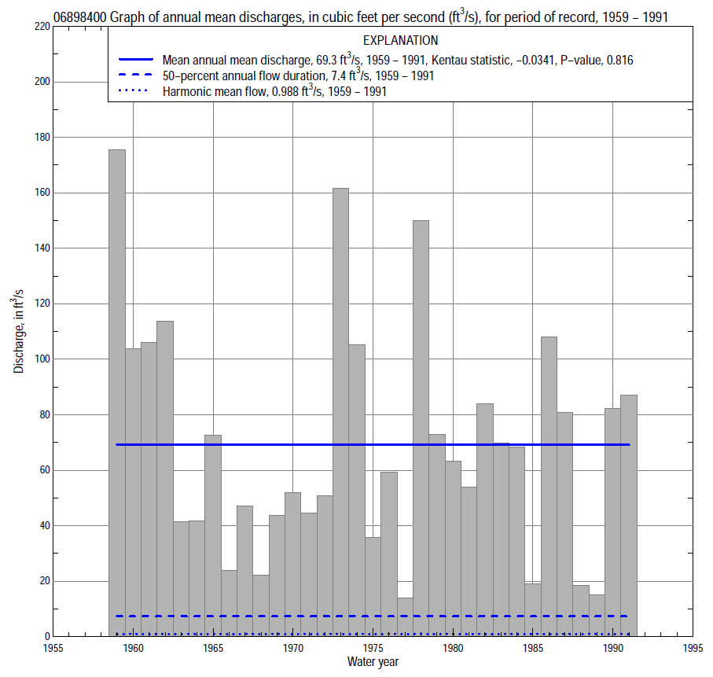

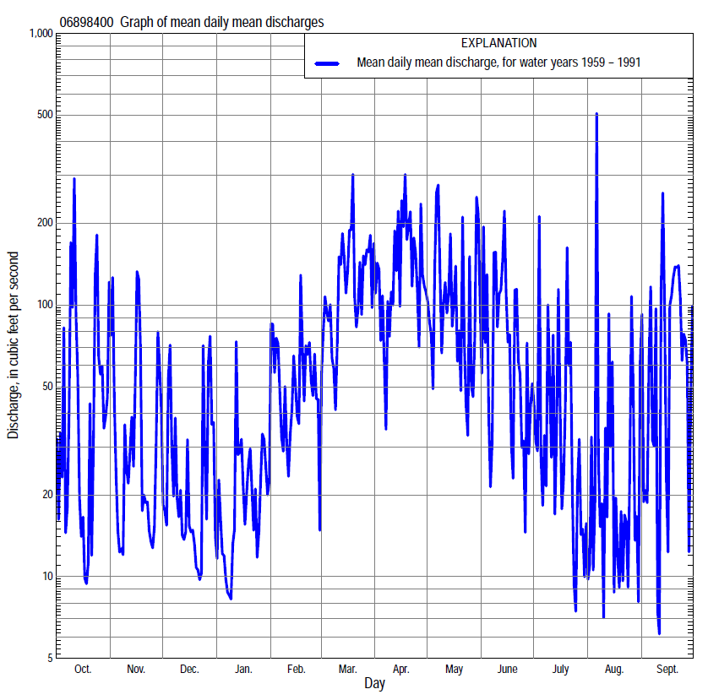

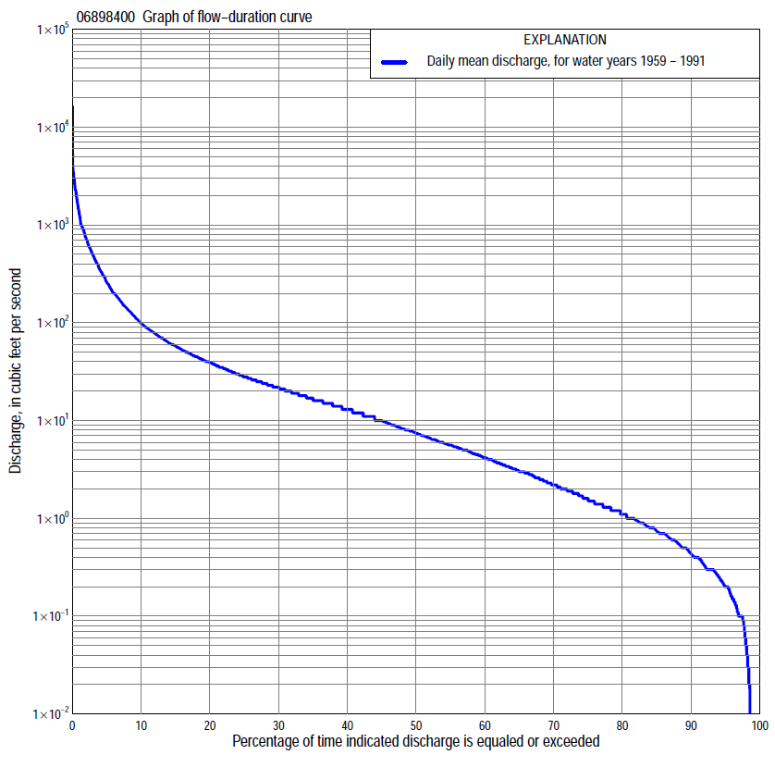

Statistics Based on the Entire Streamflow Period of Record
06898400 Monthly and annual flow durations, based on 1959–91 period of record (33 years)
Percentage of days discharge equaled or exceeded |  |  |  |  | Discharge (cubic feet per second) |  |  |  |  |  |  |  |  | Annual flow durations
 | Oct | Nov | Dec | Jan | Feb | Mar | Apr | May | June | July | Aug | Sept | Annual | Kentau statistic | P-value
99 | 0.06 | 0.19 | 0.11 | 0.00 | 0.05 | 0.52 | 0.18 | 0.12 | 0.00 | 0.00 | 0.00 | 0.00 | 0.00 | -0.015 | 0.792
98 | 0.10 | 0.25 | 0.14 | 0.00 | 0.13 | 0.70 | 0.40 | 0.45 | 0.04 | 0.00 | 0.00 | 0.00 | 0.05 | -0.068 | 0.273
95 | 0.15 | 0.39 | 0.28 | 0.12 | 0.70 | 1.6 | 1.6 | 1.1 | 0.40 | 0.05 | 0.10 | 0.04 | 0.20 | 0.057 | 0.563
90 | 0.23 | 0.62 | 0.35 | 0.30 | 1.0 | 3.5 | 5.8 | 1.8 | 0.73 | 0.30 | 0.24 | 0.10 | 0.44 | -0.013 | 0.913
85 | 0.35 | 0.90 | 0.56 | 0.70 | 1.5 | 6.6 | 7.5 | 2.9 | 1.1 | 0.50 | 0.38 | 0.20 | 0.74 | -0.002 | 1.000
80 | 0.50 | 1.1 | 0.94 | 1.0 | 2.1 | 9.6 | 9.4 | 4.3 | 1.8 | 0.69 | 0.46 | 0.33 | 1.1 | -0.053 | 0.661
75 | 0.70 | 1.5 | 1.4 | 1.3 | 2.6 | 12 | 12 | 6.0 | 2.4 | 0.90 | 0.59 | 0.54 | 1.6 | -0.015 | 0.912
70 | 1.0 | 2.2 | 2.0 | 2.0 | 3.2 | 15 | 15 | 8.6 | 3.6 | 1.2 | 0.77 | 0.80 | 2.2 | 0.059 | 0.636
65 | 1.3 | 3.0 | 3.0 | 2.9 | 4.6 | 17 | 18 | 11 | 5.0 | 1.5 | 0.95 | 0.91 | 3.0 | 0.036 | 0.779
60 | 1.7 | 4.8 | 4.5 | 3.4 | 6.6 | 20 | 22 | 13 | 6.3 | 1.9 | 1.2 | 1.2 | 4.2 | 0.004 | 0.988
55 | 2.4 | 6.0 | 5.6 | 4.0 | 10 | 24 | 26 | 16 | 7.8 | 2.4 | 1.4 | 1.4 | 5.6 | 0.011 | 0.938
50 | 2.9 | 7.6 | 6.4 | 4.6 | 13 | 28 | 30 | 18 | 9.6 | 3.0 | 1.8 | 1.7 | 7.4 | 0.006 | 0.975
45 | 3.3 | 9.2 | 7.5 | 5.3 | 16 | 35 | 35 | 22 | 12 | 3.7 | 2.2 | 2.1 | 10 | 0.002 | 1.000
40 | 4.2 | 12 | 8.6 | 6.4 | 20 | 42 | 42 | 25 | 15 | 4.8 | 2.9 | 2.8 | 13 | 0.011 | 0.938
35 | 6.1 | 14 | 11 | 8.2 | 25 | 52 | 51 | 32 | 18 | 6.2 | 3.7 | 4.1 | 17 | 0.011 | 0.938
30 | 9.4 | 17 | 14 | 11 | 33 | 67 | 62 | 39 | 22 | 8.5 | 4.7 | 5.4 | 22 | 0.011 | 0.938
25 | 14 | 21 | 18 | 14 | 45 | 91 | 78 | 47 | 27 | 12 | 6.1 | 8.6 | 28 | 0.011 | 0.938
20 | 22 | 27 | 23 | 16 | 60 | 126 | 100 | 66 | 39 | 20 | 8.3 | 14 | 39 | -0.011 | 0.938
15 | 33 | 36 | 30 | 21 | 78 | 190 | 142 | 103 | 58 | 35 | 13 | 26 | 58 | -0.053 | 0.676
10 | 60 | 56 | 40 | 30 | 125 | 311 | 262 | 218 | 109 | 60 | 30 | 67 | 100 | -0.042 | 0.745
5 | 198 | 109 | 70 | 70 | 200 | 537 | 755 | 489 | 329 | 152 | 74 | 221 | 260 | -0.030 | 0.816
2 | 737 | 400 | 162 | 200 | 485 | 979 | 1,580 | 1,210 | 828 | 466 | 301 | 970 | 730 | -0.121 | 0.329
1 | 1,100 | 750 | 560 | 300 | 700 | 1,580 | 2,050 | 2,240 | 1,870 | 730 | 496 | 2,020 | 1,340 | -0.182 | 0.141

06898400 Annual exceedance probability of instantaneous peak discharges, in cubic feet per second (ft³/s), based on the Weighted Independent Estimates method,
Annual exceed-ance probability | Recur-rence interval (years) | Discharge (ft³/s) | 95-percent lower confi-dence interval (ft³/s) | 95-percent upper confi-dence interval (ft³/s)
0.500 | 2 | 6,320 | 5,400 | 7,400
0.200 | 5 | 11,700 | 9,890 | 13,800
0.100 | 10 | 15,700 | 13,000 | 18,800
0.040 | 25 | 21,200 | 17,000 | 26,600
0.020 | 50 | 25,700 | 19,800 | 33,300
0.010 | 100 | 30,300 | 22,600 | 40,800
0.005 | 200 | 35,100 | 25,200 | 48,900
0.002 | 500 | 41,700 | 28,400 | 61,200
and based on the expected moments algorithm/multiple Grubbs-Beck analysis computed using a historical period length of 95 years (1919–2013)
0.500 | 2 | 6,470 | 4,880 | 8,500
0.200 | 5 | 12,100 | 9,190 | 16,400
0.100 | 10 | 16,700 | 12,400 | 23,500
0.040 | 25 | 23,300 | 16,500 | 35,200
0.020 | 50 | 28,900 | 19,600 | 46,400
0.010 | 100 | 34,900 | 22,700 | 60,400
0.005 | 200 | 41,500 | 25,700 | 77,800
0.002 | 500 | 51,000 | 29,700 | 107,000
Kentau statistic |  | -0.254
P-value |  | 0.039
Begin year |  | 1959
End year |  | 1991
Number of peaks |  | 33

06898400 Annual exceedance probability of high discharges, based on 1959–91 period of record (33 years)
Annual exceedance probability | Recur-rence interval (years) | Maximum average discharge (ft³/s) for indicated number of consecutive days
 |  | 1 | 3 | 7 | 15 | 30
0.990 | 1.01 | 391 | 259 | 140 | 92 | 57
0.950 | 1.05 | 751 | 457 | 246 | 160 | 99
0.900 | 1.11 | 1,040 | 607 | 326 | 210 | 129
0.800 | 1.25 | 1,510 | 843 | 448 | 284 | 175
0.500 | 2 | 2,900 | 1,500 | 779 | 472 | 293
0.200 | 5 | 5,170 | 2,500 | 1,260 | 718 | 453
0.100 | 10 | 6,780 | 3,190 | 1,580 | 866 | 552
0.040 | 25 | 8,880 | 4,050 | 1,970 | 1,030 | 667
0.020 | 50 | 10,400 | 4,690 | 2,240 | 1,140 | 745
0.010 | 100 | 12,000 | 5,310 | 2,510 | 1,240 | 817
0.005 | 200 | 13,500 | 5,930 | 2,760 | 1,330 | 884
0.002 | 500 | 15,600 | 6,730 | 3,080 | 1,440 | 966
Kentau statistic |  | -0.098 | -0.163 | -0.121 | -0.072 | -0.125
P-value |  | 0.429 | 0.188 | 0.329 | 0.566 | 0.314

 | 06898400 Annual nonexceedance probability of low discharges, based on April 1959 to March 1991 period of record (32 years)
Annual nonexceed-ance probability | Recur-rence interval (years) | Minimum average discharge (cubic feet per second) for indicated number of consecutive days
 |  | 1 | 3 | 7 | 14 | 30 | 60 | 90 | 120 | 183
0.01 | 100 | 0.00 | 0.00 | 0.00 | 0.00 | 0.00 | 0.05 | 0.08 | 0.09 | 0.16
0.02 | 50 | 0.00 | 0.00 | 0.00 | 0.00 | 0.00 | 0.08 | 0.13 | 0.16 | 0.29
0.05 | 20 | 0.00 | 0.00 | 0.00 | 0.00 | 0.03 | 0.15 | 0.26 | 0.36 | 0.68
0.10 | 10 | 0.00 | 0.00 | 0.00 | 0.03 | 0.09 | 0.27 | 0.48 | 0.71 | 1.4
0.20 | 5 | 0.00 | 0.00 | 0.02 | 0.09 | 0.21 | 0.54 | 1.0 | 1.6 | 3.2
0.50 | 2 | 0.13 | 0.17 | 0.26 | 0.43 | 0.81 | 2.1 | 3.9 | 6.4 | 13
0.80 | 1.25 | 0.58 | 0.70 | 1.1 | 1.4 | 2.6 | 8.2 | 15 | 22 | 46
0.90 | 1.11 | 1.1 | 1.3 | 1.9 | 2.5 | 4.4 | 17 | 29 | 41 | 82
0.96 | 1.04 | 1.9 | 2.2 | 3.0 | 4.4 | 7.6 | 35 | 60 | 75 | 145
0.98 | 1.02 | 2.6 | 3.1 | 3.8 | 6.4 | 11 | 57 | 96 | 108 | 205
0.99 | 1.01 | 3.4 | 4.0 | 4.8 | 9.0 | 14 | 88 | 144 | 148 | 275
Kentau statistic |  | -0.123 | -0.105 | -0.097 | -0.063 | -0.036 | -0.036 | -0.048 | -0.105 | -0.073
P-value |  | 0.325 | 0.405 | 0.445 | 0.627 | 0.783 | 0.783 | 0.709 | 0.408 | 0.570

06898400 Annual nonexceedance probability of seasonal low discharges, based on October 1958 to September 1991 period of record (33 years)
Annual nonexceed-ance probability | Recur-rence interval (years) | Minimum average discharge (cubic feet per second) for indicated number of consecutive days
 |  | 1 | 7 | 14 | 30 |  | 1 | 7 | 14 | 30
 |  | January-February-March |  |  |  |  | April-May-June
0.01 | 100 | 0.00 | 0.00 | 0.00 | 0.00 |  | 0.00 | 0.00 | 0.07 | 0.16
0.02 | 50 | 0.00 | 0.00 | 0.00 | 0.00 |  | 0.00 | 0.00 | 0.13 | 0.31
0.05 | 20 | 0.00 | 0.03 | 0.06 | 0.31 |  | 0.00 | 0.04 | 0.31 | 0.76
0.10 | 10 | 0.06 | 0.13 | 0.20 | 0.68 |  | 0.11 | 0.20 | 0.61 | 1.6
0.20 | 5 | 0.33 | 0.44 | 0.56 | 1.4 |  | 0.33 | 0.68 | 1.3 | 3.5
0.50 | 2 | 2.1 | 2.3 | 2.6 | 4.6 |  | 1.5 | 3.3 | 4.6 | 13
0.80 | 1.25 | 6.9 | 7.6 | 8.8 | 15 |  | 4.5 | 8.2 | 13 | 38
0.90 | 1.11 | 11 | 12 | 16 | 27 |  | 7.5 | 11 | 20 | 59
0.96 | 1.04 | 16 | 18 | 27 | 51 |  | 12 | 14 | 29 | 89
0.98 | 1.02 | 19 | 22 | 37 | 77 |  | 16 | 16 | 37 | 112
0.99 | 1.01 | 22 | 26 | 48 | 111 |  | 20 | 20 | 45 | 134
Kentau statistic |  | -0.011 | 0.038 | 0.040 | -0.034 |  | 0.068 | 0.078 | 0.114 | 0.030
P-value |  | 0.938 | 0.768 | 0.757 | 0.792 |  | 0.588 | 0.535 | 0.361 | 0.816
 |  | July-August-September |  |  |  |  | October-November-December
0.01 | 100 | 0.00 | 0.00 | 0.00 | 0.03 |  | 0.00 | 0.02 | 0.05 | 0.06
0.02 | 50 | 0.00 | 0.00 | 0.00 | 0.04 |  | 0.00 | 0.04 | 0.07 | 0.10
0.05 | 20 | 0.00 | 0.00 | 0.01 | 0.09 |  | 0.00 | 0.07 | 0.13 | 0.21
0.10 | 10 | 0.00 | 0.01 | 0.05 | 0.17 |  | 0.02 | 0.13 | 0.23 | 0.38
0.20 | 5 | 0.00 | 0.06 | 0.13 | 0.36 |  | 0.14 | 0.27 | 0.45 | 0.79
0.50 | 2 | 0.16 | 0.36 | 0.56 | 1.3 |  | 0.73 | 1.1 | 1.6 | 2.9
0.80 | 1.25 | 0.63 | 1.2 | 1.8 | 4.2 |  | 2.9 | 4.1 | 5.8 | 9.7
0.90 | 1.11 | 1.1 | 2.0 | 2.9 | 7.3 |  | 5.7 | 8.3 | 11 | 18
0.96 | 1.04 | 1.9 | 3.2 | 4.6 | 13 |  | 12 | 18 | 23 | 32
0.98 | 1.02 | 2.5 | 4.3 | 6.5 | 18 |  | 19 | 28 | 37 | 47
0.99 | 1.01 | 3.2 | 5.5 | 8.6 | 24 |  | 28 | 44 | 56 | 66
Kentau statistic |  | -0.205 | -0.121 | -0.091 | -0.023 |  | -0.068 | -0.034 | -0.061 | -0.023
P-value |  | 0.095 | 0.329 | 0.466 | 0.865 |  | 0.587 | 0.792 | 0.631 | 0.865

