LOCATION.--Lat 40°57'06.8", long 93°15'34.7" referenced to North American Datum of 1927, in NW 1/4 SW 1/4 NE 1/4 sec.15, T.71 N., R.21 W., Lucas County, IA, Hydrologic Unit 10280201, on right bank 15 ft downstream from bridge on County Highway S43, 5.0 mi southeast of Chariton, 0.1 mi downstream from Wolf Creek, and 63.2 mi upstream from Iowa-Missouri state line.

DRAINAGE AREA.--182 mi².

PERIOD OF RECORD.--Occasional low-flow measurements, water years 1958-1960, 1962, 1964; discharge records from October 1965 to current year.

GAGE.--Water-stage recorder. Datum of gage is 917.90 ft above National Geodetic Vertical Datum of 1929 (U.S. Army Corps of Engineers benchmark).

EXTREMES OUTSIDE PERIOD OF RECORD.--Flood in March 1960 reached a stage of about 23 ft, discharge about 15,000 ft³/s. Flood of June 5, 1947, reached a stage of 21.65 ft, from high-water mark, discharge 11,000 ft³/s.

A summary of all available data for this streamgage is provided through the USGS National Water Information System web interface (NWISWeb). The following link provides access to current/historical observations, daily data, daily statistics, monthly statistics, annual statistics, peak streamflow, field measurements, field/lab water-quality samples, and the latest water-year summaries. Data can be filtered by parameter and/or dates, and can be output in various tabular and graphical formats.
http://waterdata.usgs.gov/nwis/inventory/?site_no=06903400

The USGS WaterWatch Toolkit is available at:
http://waterwatch.usgs.gov/?id=ww_toolkit
Tools for summarizing streamflow information include the duration hydrograph builder, the cumulative streamflow hydrograph builder, the streamgage statistics retrieval tool, the rating curve builder, the flood tracking chart builder, the National Weather Service Advanced Hydrologic Prediction Service (AHPS) river forecast hydrograph builder, and the raster-hydrograph builder. Entering the above number for this streamgage into these toolkit webpages will provide streamflow information specific to this streamgage.

A description of the statistics presented for this streamgage is available in the main body of the report at:
http://dx.doi.org/10.3133/ofr20151214
A link to other streamgages included in this report, a map showing the location of the streamgages, information on the programs used to compute the statistical analyses, and references are included in the main body of the report.

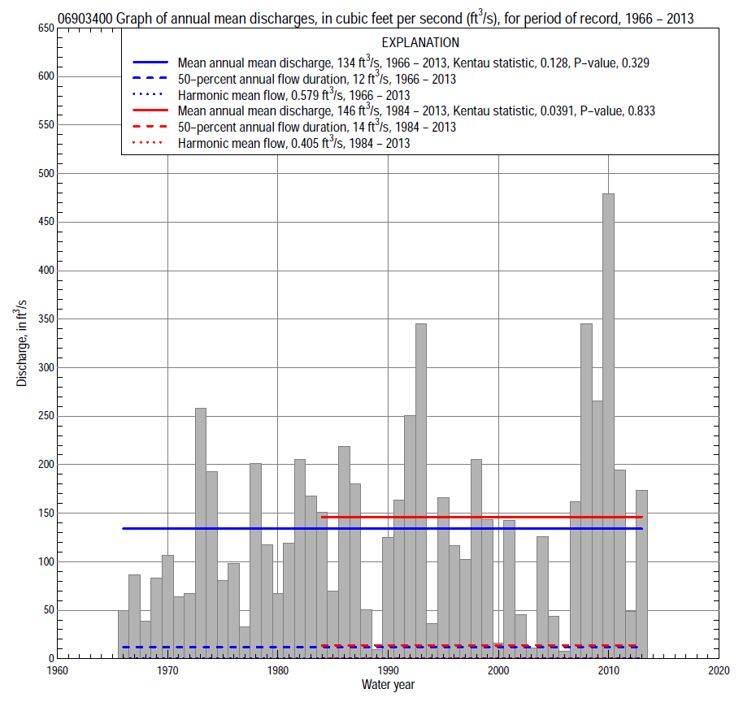

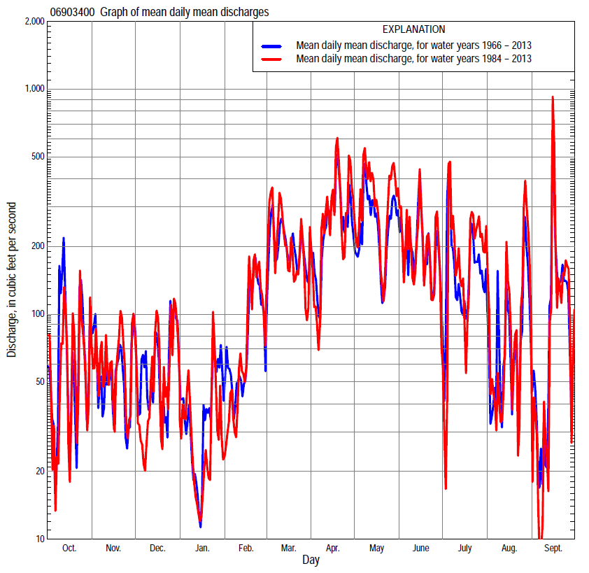

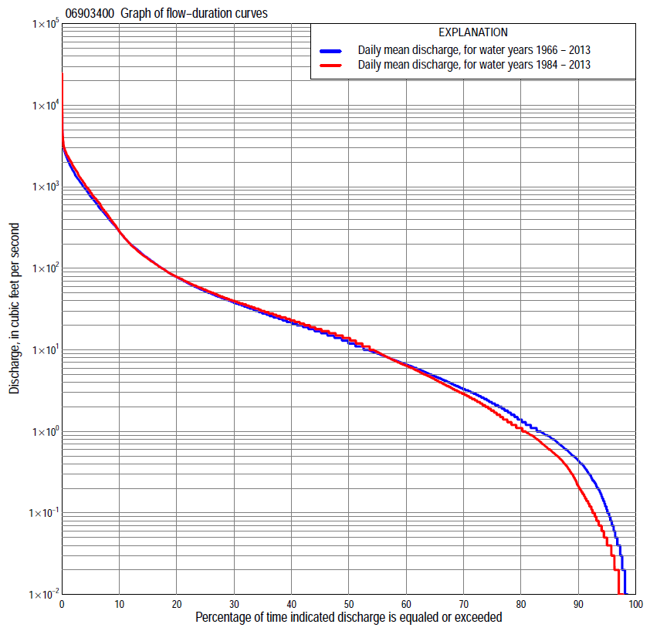

Statistics Based on the Entire Streamflow Period of Record
06903400 Monthly and annual flow durations, based on 1966–2013 period of record (48 years)
Percentage of days discharge equaled or exceeded |  |  |  |  | Discharge (cubic feet per second) |  |  |  |  |  |  |  |  | Annual flow durations
 | Oct | Nov | Dec | Jan | Feb | Mar | Apr | May | June | July | Aug | Sept | Annual | Kentau statistic | P-value
99 | 0.00 | 0.00 | 0.00 | 0.01 | 0.01 | 0.40 | 0.03 | 0.52 | 0.08 | 0.00 | 0.00 | 0.00 | 0.00 | 0.099 | 0.178
98 | 0.00 | 0.00 | 0.00 | 0.04 | 0.06 | 0.75 | 0.25 | 1.2 | 0.21 | 0.00 | 0.00 | 0.01 | 0.02 | 0.100 | 0.174
95 | 0.02 | 0.06 | 0.09 | 0.16 | 0.25 | 1.8 | 2.4 | 2.2 | 0.64 | 0.05 | 0.03 | 0.03 | 0.11 | 0.098 | 0.232
90 | 0.10 | 0.29 | 0.25 | 0.40 | 1.5 | 4.5 | 7.7 | 4.0 | 1.3 | 0.29 | 0.13 | 0.09 | 0.44 | 0.087 | 0.327
85 | 0.25 | 0.66 | 0.74 | 0.90 | 2.3 | 11 | 11 | 5.8 | 2.5 | 0.58 | 0.37 | 0.27 | 0.86 | 0.003 | 0.985
80 | 0.43 | 1.0 | 1.1 | 1.5 | 3.2 | 16 | 14 | 8.2 | 3.7 | 0.96 | 0.59 | 0.40 | 1.4 | 0.022 | 0.827
75 | 0.58 | 1.6 | 2.2 | 2.3 | 4.8 | 20 | 19 | 11 | 5.0 | 1.3 | 0.87 | 0.54 | 2.2 | 0.036 | 0.719
70 | 0.72 | 2.6 | 3.5 | 3.0 | 6.4 | 25 | 24 | 14 | 6.5 | 1.8 | 1.0 | 0.67 | 3.3 | -0.028 | 0.782
65 | 1.0 | 3.8 | 4.8 | 3.7 | 8.0 | 30 | 28 | 19 | 9.2 | 2.4 | 1.3 | 0.88 | 4.7 | -0.045 | 0.655
60 | 1.5 | 5.2 | 6.4 | 4.9 | 10 | 35 | 33 | 24 | 13 | 3.2 | 1.9 | 1.1 | 6.6 | -0.033 | 0.748
55 | 2.3 | 6.6 | 8.4 | 6.0 | 15 | 42 | 40 | 29 | 18 | 4.1 | 2.5 | 1.3 | 9.0 | -0.018 | 0.866
50 | 3.2 | 8.9 | 10 | 7.0 | 18 | 48 | 48 | 37 | 24 | 5.2 | 3.0 | 1.7 | 12 | -0.008 | 0.943
45 | 4.5 | 11 | 13 | 8.0 | 23 | 57 | 58 | 46 | 32 | 7.2 | 3.8 | 2.3 | 17 | 0.001 | 1.000
40 | 5.9 | 15 | 15 | 9.9 | 28 | 66 | 74 | 58 | 41 | 11 | 4.8 | 3.2 | 22 | 0.017 | 0.873
35 | 8.4 | 19 | 18 | 13 | 35 | 82 | 95 | 74 | 54 | 16 | 6.6 | 5.3 | 28 | 0.023 | 0.824
30 | 12 | 24 | 23 | 18 | 44 | 108 | 123 | 105 | 79 | 22 | 9.1 | 8.3 | 38 | 0.020 | 0.845
25 | 15 | 30 | 32 | 20 | 59 | 150 | 166 | 149 | 112 | 36 | 13 | 13 | 52 | 0.050 | 0.625
20 | 20 | 41 | 41 | 24 | 80 | 228 | 252 | 253 | 176 | 63 | 21 | 20 | 78 | 0.056 | 0.582
15 | 34 | 58 | 62 | 35 | 117 | 356 | 478 | 477 | 324 | 127 | 39 | 36 | 133 | 0.038 | 0.709
10 | 73 | 100 | 107 | 50 | 190 | 559 | 755 | 861 | 666 | 313 | 87 | 107 | 282 | 0.050 | 0.625
5 | 336 | 263 | 257 | 160 | 400 | 1,070 | 1,470 | 1,410 | 1,230 | 942 | 380 | 522 | 761 | 0.121 | 0.230
2 | 1,010 | 678 | 700 | 450 | 925 | 1,570 | 2,150 | 2,360 | 1,870 | 2,100 | 1,300 | 1,450 | 1,560 | 0.226 | 0.024
1 | 1,710 | 1,080 | 996 | 692 | 1,330 | 2,180 | 2,630 | 2,940 | 2,290 | 2,790 | 2,270 | 2,020 | 2,150 | 0.235 | 0.019

06903400 Annual exceedance probability of instantaneous peak discharges, in cubic feet per second (ft³/s), based on the Weighted Independent Estimates method,
Annual exceed-ance probability | Recur-rence interval (years) | Discharge (ft³/s) | 95-percent lower confi-dence interval (ft³/s) | 95-percent upper confi-dence interval (ft³/s)
0.500 | 2 | 3,730 | 3,080 | 4,520
0.200 | 5 | 7,290 | 5,970 | 8,910
0.100 | 10 | 10,200 | 8,170 | 12,700
0.040 | 25 | 14,600 | 11,200 | 18,900
0.020 | 50 | 18,200 | 13,500 | 24,500
0.010 | 100 | 22,000 | 15,700 | 30,700
0.005 | 200 | 26,000 | 17,900 | 37,700
0.002 | 500 | 31,200 | 20,400 | 47,800
and based on the expected moments algorithm/multiple Grubbs-Beck analysis computed using a historical period length of 67 years (1947–2013)
0.500 | 2 | 3,670 | 2,900 | 4,580
0.200 | 5 | 7,040 | 5,590 | 8,950
0.100 | 10 | 9,810 | 7,700 | 13,100
0.040 | 25 | 13,900 | 10,600 | 20,600
0.020 | 50 | 17,400 | 12,800 | 28,100
0.010 | 100 | 21,200 | 15,000 | 37,700
0.005 | 200 | 25,300 | 17,200 | 49,800
0.002 | 500 | 31,400 | 20,000 | 70,700
Kentau statistic |  | 0.020
P-value |  | 0.845
Begin year |  | 1966
End year |  | 2013
Number of peaks |  | 48

06903400 Annual exceedance probability of high discharges, based on 1966–2013 period of record (48 years)
Annual exceedance probability | Recur-rence interval (years) | Maximum average discharge (ft³/s) for indicated number of consecutive days
 |  | 1 | 3 | 7 | 15 | 30
0.990 | 1.01 | 555 | 358 | 206 | 99 | 51
0.950 | 1.05 | 861 | 622 | 379 | 207 | 119
0.900 | 1.11 | 1,100 | 826 | 513 | 296 | 177
0.800 | 1.25 | 1,480 | 1,160 | 729 | 440 | 275
0.500 | 2 | 2,690 | 2,130 | 1,350 | 848 | 559
0.200 | 5 | 5,050 | 3,800 | 2,330 | 1,440 | 972
0.100 | 10 | 7,100 | 5,070 | 3,020 | 1,820 | 1,220
0.040 | 25 | 10,300 | 6,820 | 3,910 | 2,260 | 1,510
0.020 | 50 | 13,200 | 8,210 | 4,570 | 2,550 | 1,690
0.010 | 100 | 16,500 | 9,660 | 5,220 | 2,820 | 1,840
0.005 | 200 | 20,300 | 11,200 | 5,870 | 3,060 | 1,980
0.002 | 500 | 26,300 | 13,300 | 6,720 | 3,340 | 2,140
Kentau statistic |  | 0.040 | 0.130 | 0.128 | 0.129 | 0.144
P-value |  | 0.696 | 0.194 | 0.204 | 0.197 | 0.152

 | 06903400 Annual nonexceedance probability of low discharges, based on April 1966 to March 2013 period of record (47 years)
Annual nonexceed-ance probability | Recur-rence interval (years) | Minimum average discharge (cubic feet per second) for indicated number of consecutive days
 |  | 1 | 3 | 7 | 14 | 30 | 60 | 90 | 120 | 183
0.01 | 100 | 0.00 | 0.00 | 0.00 | 0.00 | 0.00 | 0.00 | 0.00 | 0.03 | 0.07
0.02 | 50 | 0.00 | 0.00 | 0.00 | 0.00 | 0.00 | 0.01 | 0.01 | 0.06 | 0.14
0.05 | 20 | 0.00 | 0.00 | 0.00 | 0.00 | 0.00 | 0.02 | 0.04 | 0.16 | 0.41
0.10 | 10 | 0.00 | 0.00 | 0.00 | 0.01 | 0.03 | 0.07 | 0.13 | 0.40 | 1.0
0.20 | 5 | 0.02 | 0.03 | 0.05 | 0.07 | 0.13 | 0.25 | 0.52 | 1.1 | 2.8
0.50 | 2 | 0.26 | 0.28 | 0.38 | 0.56 | 0.99 | 2.1 | 4.8 | 7.4 | 16
0.80 | 1.25 | 1.3 | 1.4 | 1.8 | 2.6 | 4.5 | 13 | 28 | 39 | 73
0.90 | 1.11 | 2.7 | 3.0 | 3.6 | 4.8 | 8.5 | 28 | 58 | 87 | 145
0.96 | 1.04 | 5.6 | 6.4 | 7.5 | 8.6 | 16 | 60 | 112 | 193 | 282
0.98 | 1.02 | 8.9 | 10 | 12 | 12 | 22 | 93 | 161 | 314 | 418
0.99 | 1.01 | 13 | 15 | 17 | 18 | 29 | 132 | 215 | 477 | 582
Kentau statistic |  | -0.064 | -0.066 | -0.068 | -0.048 | -0.077 | -0.064 | -0.040 | -0.043 | -0.032
P-value |  | 0.532 | 0.521 | 0.509 | 0.640 | 0.452 | 0.533 | 0.700 | 0.673 | 0.755

06903400 Annual nonexceedance probability of seasonal low discharges, based on October 1965 to September 2013 period of record (48 years)
Annual nonexceed-ance probability | Recur-rence interval (years) | Minimum average discharge (cubic feet per second) for indicated number of consecutive days
 |  | 1 | 7 | 14 | 30 |  | 1 | 7 | 14 | 30
 |  | January-February-March |  |  |  |  | April-May-June
0.01 | 100 | 0.00 | 0.00 | 0.01 | 0.01 |  | 0.00 | 0.00 | 0.01 | 0.09
0.02 | 50 | 0.00 | 0.00 | 0.02 | 0.04 |  | 0.00 | 0.00 | 0.04 | 0.21
0.05 | 20 | 0.02 | 0.09 | 0.10 | 0.15 |  | 0.07 | 0.12 | 0.16 | 0.70
0.10 | 10 | 0.16 | 0.27 | 0.28 | 0.45 |  | 0.27 | 0.42 | 0.54 | 1.9
0.20 | 5 | 0.55 | 0.73 | 0.82 | 1.5 |  | 0.85 | 1.3 | 1.9 | 5.5
0.50 | 2 | 2.9 | 3.4 | 5.0 | 8.5 |  | 4.1 | 5.8 | 12 | 32
0.80 | 1.25 | 9.7 | 11 | 15 | 28 |  | 12 | 16 | 37 | 122
0.90 | 1.11 | 16 | 19 | 21 | 44 |  | 17 | 23 | 54 | 214
0.96 | 1.04 | 24 | 30 | 31 | 62 |  | 22 | 32 | 71 | 354
0.98 | 1.02 | 31 | 40 | 41 | 73 |  | 26 | 37 | 80 | 466
0.99 | 1.01 | 37 | 49 | 50 | 82 |  | 28 | 41 | 86 | 579
Kentau statistic |  | 0.013 | 0.051 | 0.074 | -0.073 |  | 0.174 | 0.181 | 0.215 | 0.181
P-value |  | 0.901 | 0.612 | 0.466 | 0.472 |  | 0.083 | 0.071 | 0.032 | 0.071
 |  | July-August-September |  |  |  |  | October-November-December
0.01 | 100 | 0.00 | 0.00 | 0.00 | 0.00 |  | 0.00 | 0.00 | 0.00 | 0.00
0.02 | 50 | 0.00 | 0.00 | 0.00 | 0.00 |  | 0.00 | 0.00 | 0.00 | 0.00
0.05 | 20 | 0.00 | 0.00 | 0.00 | 0.02 |  | 0.00 | 0.00 | 0.01 | 0.03
0.10 | 10 | 0.00 | 0.01 | 0.03 | 0.07 |  | 0.02 | 0.03 | 0.06 | 0.12
0.20 | 5 | 0.04 | 0.07 | 0.10 | 0.21 |  | 0.09 | 0.14 | 0.20 | 0.45
0.50 | 2 | 0.32 | 0.48 | 0.70 | 1.5 |  | 0.76 | 1.1 | 1.6 | 3.3
0.80 | 1.25 | 1.6 | 2.4 | 3.6 | 10 |  | 4.4 | 6.2 | 9.2 | 16
0.90 | 1.11 | 3.6 | 5.1 | 8.0 | 27 |  | 10 | 14 | 20 | 32
0.96 | 1.04 | 8.1 | 11 | 18 | 76 |  | 23 | 30 | 43 | 59
0.98 | 1.02 | 14 | 18 | 29 | 146 |  | 37 | 47 | 68 | 85
0.99 | 1.01 | 21 | 28 | 45 | 262 |  | 57 | 71 | 99 | 113
Kentau statistic |  | -0.057 | -0.060 | -0.042 | -0.075 |  | -0.070 | -0.066 | -0.053 | -0.021
P-value |  | 0.575 | 0.551 | 0.683 | 0.455 |  | 0.488 | 0.516 | 0.600 | 0.838

Statistics Based on the 1984–2013 Streamflow Period of Record
06903400 Monthly and annual flow durations, based on 1984–2013 period of record (30 years)
Percentage of days discharge equaled or exceeded |  |  |  |  | Discharge (cubic feet per second) |  |  |  |  |  |  |  |  | Annual flow durations
 | Oct | Nov | Dec | Jan | Feb | Mar | Apr | May | June | July | Aug | Sept | Annual | Kentau statistic | P-value
99 | 0.00 | 0.00 | 0.00 | 0.00 | 0.00 | 0.24 | 0.02 | 0.12 | 0.00 | 0.00 | 0.00 | 0.00 | 0.00 | 0.074 | 0.475
98 | 0.00 | 0.00 | 0.00 | 0.01 | 0.03 | 0.54 | 0.05 | 0.79 | 0.17 | 0.00 | 0.00 | 0.00 | 0.00 | 0.078 | 0.447
95 | 0.00 | 0.02 | 0.04 | 0.10 | 0.16 | 1.0 | 1.2 | 1.6 | 0.62 | 0.03 | 0.02 | 0.01 | 0.04 | 0.076 | 0.494
90 | 0.04 | 0.13 | 0.12 | 0.36 | 0.46 | 2.1 | 3.8 | 2.9 | 1.2 | 0.08 | 0.04 | 0.05 | 0.21 | 0.113 | 0.319
85 | 0.09 | 0.35 | 0.32 | 0.79 | 1.7 | 7.3 | 9.0 | 5.2 | 2.3 | 0.41 | 0.12 | 0.09 | 0.60 | 0.018 | 0.895
80 | 0.18 | 0.70 | 0.90 | 1.2 | 2.7 | 17 | 13 | 8.6 | 3.7 | 0.85 | 0.34 | 0.25 | 1.1 | -0.002 | 1.000
75 | 0.38 | 1.1 | 1.4 | 1.7 | 3.8 | 22 | 17 | 13 | 5.4 | 1.4 | 0.52 | 0.37 | 1.8 | -0.007 | 0.971
70 | 0.58 | 2.0 | 2.3 | 2.5 | 7.2 | 26 | 22 | 19 | 7.8 | 2.0 | 0.86 | 0.50 | 2.9 | -0.041 | 0.759
65 | 0.76 | 3.0 | 3.9 | 3.5 | 10 | 30 | 26 | 25 | 13 | 2.7 | 1.1 | 0.62 | 4.3 | -0.076 | 0.565
60 | 1.1 | 4.1 | 5.4 | 4.4 | 14 | 37 | 32 | 32 | 17 | 3.6 | 1.7 | 0.85 | 6.4 | -0.055 | 0.680
55 | 1.8 | 5.8 | 7.3 | 5.8 | 17 | 43 | 37 | 40 | 22 | 4.7 | 2.5 | 1.1 | 9.4 | -0.048 | 0.721
50 | 3.1 | 7.1 | 12 | 6.9 | 20 | 51 | 46 | 50 | 28 | 5.7 | 3.2 | 1.4 | 14 | -0.037 | 0.789
45 | 4.9 | 10 | 14 | 9.2 | 25 | 59 | 56 | 61 | 37 | 7.6 | 4.1 | 1.9 | 18 | -0.069 | 0.604
40 | 6.8 | 14 | 16 | 11 | 30 | 68 | 68 | 75 | 46 | 12 | 5.9 | 2.6 | 23 | -0.046 | 0.734
35 | 10 | 20 | 20 | 15 | 38 | 85 | 88 | 97 | 64 | 16 | 8.1 | 4.2 | 30 | -0.021 | 0.886
30 | 13 | 25 | 26 | 18 | 45 | 109 | 115 | 141 | 87 | 21 | 11 | 6.6 | 40 | -0.018 | 0.901
25 | 16 | 31 | 33 | 20 | 60 | 139 | 158 | 223 | 121 | 34 | 18 | 9.6 | 55 | 0.016 | 0.915
20 | 19 | 41 | 41 | 23 | 80 | 200 | 242 | 405 | 181 | 58 | 30 | 17 | 79 | 0.048 | 0.721
15 | 33 | 59 | 58 | 32 | 113 | 320 | 487 | 646 | 359 | 135 | 55 | 25 | 130 | 0.046 | 0.735
10 | 64 | 105 | 87 | 42 | 175 | 539 | 824 | 1,130 | 721 | 419 | 112 | 51 | 282 | 0.011 | 0.943
5 | 304 | 293 | 172 | 80 | 378 | 1,140 | 1,630 | 1,830 | 1,250 | 1,190 | 543 | 505 | 853 | 0.039 | 0.775
2 | 937 | 790 | 459 | 300 | 800 | 2,100 | 2,400 | 2,710 | 1,870 | 2,300 | 1,740 | 1,590 | 1,780 | 0.140 | 0.284
1 | 1,250 | 1,090 | 1,100 | 573 | 1,330 | 2,430 | 2,800 | 3,130 | 2,220 | 3,090 | 2,670 | 2,240 | 2,390 | 0.140 | 0.284

06903400 Annual exceedance probability of high discharges, based on 1984–2013 period of record (30 years)
Annual exceedance probability | Recur-rence interval (years) | Maximum average discharge (ft³/s) for indicated number of consecutive days
 |  | 1 | 3 | 7 | 15 | 30
0.990 | 1.01 | 463 | 270 | 154 | 69 | 34
0.950 | 1.05 | 768 | 532 | 319 | 166 | 94
0.900 | 1.11 | 1,010 | 749 | 458 | 254 | 152
0.800 | 1.25 | 1,420 | 1,120 | 694 | 407 | 257
0.500 | 2 | 2,760 | 2,270 | 1,420 | 885 | 596
0.200 | 5 | 5,480 | 4,340 | 2,670 | 1,640 | 1,130
0.100 | 10 | 7,910 | 5,930 | 3,580 | 2,150 | 1,460
0.040 | 25 | 11,800 | 8,130 | 4,780 | 2,740 | 1,830
0.020 | 50 | 15,300 | 9,870 | 5,680 | 3,150 | 2,070
0.010 | 100 | 19,400 | 11,700 | 6,580 | 3,520 | 2,270
0.005 | 200 | 24,100 | 13,500 | 7,470 | 3,860 | 2,450
0.002 | 500 | 31,500 | 16,100 | 8,640 | 4,260 | 2,640
Kentau statistic |  | 0.021 | 0.062 | 0.053 | 0.034 | 0.007
P-value |  | 0.887 | 0.643 | 0.695 | 0.803 | 0.972

 | 06903400 Annual nonexceedance probability of low discharges, based on April 1983 to March 2013 period of record (30 years)
Annual nonexceed-ance probability | Recur-rence interval (years) | Minimum average discharge (cubic feet per second) for indicated number of consecutive days
 |  | 1 | 3 | 7 | 14 | 30 | 60 | 90 | 120 | 183
0.01 | 100 | 0.00 | 0.00 | 0.00 | 0.00 | 0.00 | 0.00 | 0.00 | 0.02 | 0.04
0.02 | 50 | 0.00 | 0.00 | 0.00 | 0.00 | 0.00 | 0.00 | 0.00 | 0.03 | 0.09
0.05 | 20 | 0.00 | 0.00 | 0.00 | 0.00 | 0.00 | 0.01 | 0.02 | 0.10 | 0.29
0.10 | 10 | 0.00 | 0.00 | 0.00 | 0.00 | 0.01 | 0.04 | 0.07 | 0.25 | 0.73
0.20 | 5 | 0.01 | 0.01 | 0.01 | 0.02 | 0.06 | 0.15 | 0.30 | 0.73 | 2.1
0.50 | 2 | 0.19 | 0.22 | 0.29 | 0.39 | 0.72 | 1.6 | 3.6 | 5.3 | 14
0.80 | 1.25 | 1.1 | 1.3 | 1.6 | 2.4 | 4.1 | 11 | 25 | 34 | 68
0.90 | 1.11 | 2.5 | 2.9 | 3.6 | 4.9 | 8.6 | 26 | 58 | 84 | 143
0.96 | 1.04 | 5.8 | 6.4 | 7.5 | 9.4 | 17 | 57 | 123 | 214 | 296
0.98 | 1.02 | 9.8 | 11 | 12 | 14 | 25 | 89 | 188 | 386 | 456
0.99 | 1.01 | 16 | 16 | 17 | 18 | 34 | 129 | 263 | 645 | 657
Kentau statistic |  | 0.011 | 0.021 | 0.025 | 0.051 | -0.041 | 0.002 | 0.025 | 0.062 | -0.021
P-value |  | 0.943 | 0.886 | 0.858 | 0.708 | 0.762 | 1.000 | 0.858 | 0.643 | 0.887

06903400 Annual nonexceedance probability of seasonal low discharges, based on October 1983 to September 2013 period of record (30 years)
Annual nonexceed-ance probability | Recur-rence interval (years) | Minimum average discharge (cubic feet per second) for indicated number of consecutive days
 |  | 1 | 7 | 14 | 30 |  | 1 | 7 | 14 | 30
 |  | January-February-March |  |  |  |  | April-May-June
0.01 | 100 | 0.00 | 0.00 | 0.00 | 0.01 |  | 0.00 | 0.00 | 0.00 | 0.04
0.02 | 50 | 0.00 | 0.00 | 0.01 | 0.02 |  | 0.00 | 0.00 | 0.01 | 0.12
0.05 | 20 | 0.00 | 0.03 | 0.04 | 0.08 |  | 0.02 | 0.04 | 0.09 | 0.49
0.10 | 10 | 0.05 | 0.18 | 0.19 | 0.30 |  | 0.17 | 0.29 | 0.36 | 1.6
0.20 | 5 | 0.39 | 0.64 | 0.70 | 1.1 |  | 0.74 | 1.2 | 1.6 | 5.4
0.50 | 2 | 3.1 | 3.7 | 5.4 | 7.8 |  | 4.7 | 6.8 | 13 | 39
0.80 | 1.25 | 12 | 13 | 17 | 26 |  | 15 | 21 | 52 | 167
0.90 | 1.11 | 19 | 23 | 24 | 39 |  | 22 | 30 | 81 | 298
0.96 | 1.04 | 29 | 36 | 37 | 52 |  | 30 | 40 | 113 | 489
0.98 | 1.02 | 36 | 46 | 47 | 59 |  | 34 | 46 | 131 | 635
0.99 | 1.01 | 43 | 56 | 57 | 64 |  | 37 | 51 | 144 | 774
Kentau statistic |  | -0.099 | -0.076 | -0.041 | -0.034 |  | 0.195 | 0.209 | 0.264 | 0.214
P-value |  | 0.453 | 0.568 | 0.762 | 0.803 |  | 0.134 | 0.108 | 0.042 | 0.101
 |  | July-August-September |  |  |  |  | October-November-December
0.01 | 100 | 0.00 | 0.00 | 0.00 | 0.00 |  | 0.00 | 0.00 | 0.00 | 0.00
0.02 | 50 | 0.00 | 0.00 | 0.00 | 0.00 |  | 0.00 | 0.00 | 0.00 | 0.00
0.05 | 20 | 0.00 | 0.00 | 0.00 | 0.01 |  | 0.00 | 0.00 | 0.00 | 0.01
0.10 | 10 | 0.00 | 0.00 | 0.01 | 0.03 |  | 0.00 | 0.01 | 0.02 | 0.05
0.20 | 5 | 0.02 | 0.03 | 0.06 | 0.12 |  | 0.04 | 0.07 | 0.11 | 0.27
0.50 | 2 | 0.24 | 0.37 | 0.55 | 1.2 |  | 0.57 | 0.84 | 1.3 | 2.8
0.80 | 1.25 | 1.5 | 2.3 | 3.5 | 11 |  | 4.5 | 6.4 | 9.6 | 17
0.90 | 1.11 | 3.7 | 5.4 | 8.2 | 33 |  | 12 | 17 | 24 | 39
0.96 | 1.04 | 9.4 | 13 | 19 | 105 |  | 31 | 44 | 60 | 81
0.98 | 1.02 | 17 | 22 | 33 | 223 |  | 55 | 78 | 102 | 123
0.99 | 1.01 | 28 | 35 | 51 | 434 |  | 91 | 129 | 161 | 174
Kentau statistic |  | -0.009 | 0.002 | 0.009 | -0.076 |  | -0.074 | -0.064 | -0.071 | -0.053
P-value |  | 0.957 | 1.000 | 0.957 | 0.568 |  | 0.580 | 0.630 | 0.592 | 0.695

