LOCATION.--Lat 40°55'25", long 93°07'55" referenced to North American Datum of 1927, Lucas County, IA, Hydrologic Unit 10280201, on left bank 15 ft downstream from bridge on 420th Street, 4.6 mi southeast of Russell, and 0.7 mi upstream from mouth.

DRAINAGE AREA.--13.2 mi².

PERIOD OF RECORD.--Discharge records from June 1952 to September 1962.

GAGE.--Water-stage recorder and concrete control. Datum of gage is 901.73 ft above National Geodetic Vertical Datum of 1929 (levels by U.S. Soil Conservation Service).

A summary of all available data for this streamgage is provided through the USGS National Water Information System web interface (NWISWeb). The following link provides access to current/historical observations, daily data, daily statistics, monthly statistics, annual statistics, peak streamflow, field measurements, field/lab water-quality samples, and the latest water-year summaries. Data can be filtered by parameter and/or dates, and can be output in various tabular and graphical formats.
http://waterdata.usgs.gov/nwis/inventory/?site_no=06903500

The USGS WaterWatch Toolkit is available at:
http://waterwatch.usgs.gov/?id=ww_toolkit
Tools for summarizing streamflow information include the duration hydrograph builder, the cumulative streamflow hydrograph builder, the streamgage statistics retrieval tool, the rating curve builder, the flood tracking chart builder, the National Weather Service Advanced Hydrologic Prediction Service (AHPS) river forecast hydrograph builder, and the raster-hydrograph builder. Entering the above number for this streamgage into these toolkit webpages will provide streamflow information specific to this streamgage.

A description of the statistics presented for this streamgage is available in the main body of the report at:
http://dx.doi.org/10.3133/ofr20151214
A link to other streamgages included in this report, a map showing the location of the streamgages, information on the programs used to compute the statistical analyses, and references are included in the main body of the report.

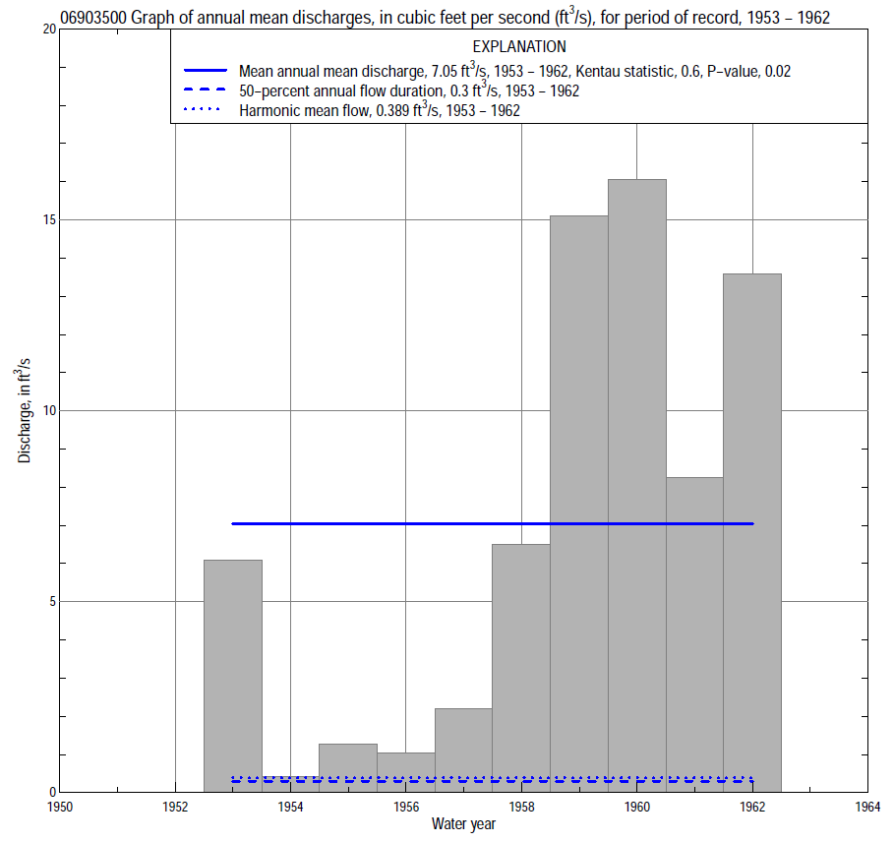

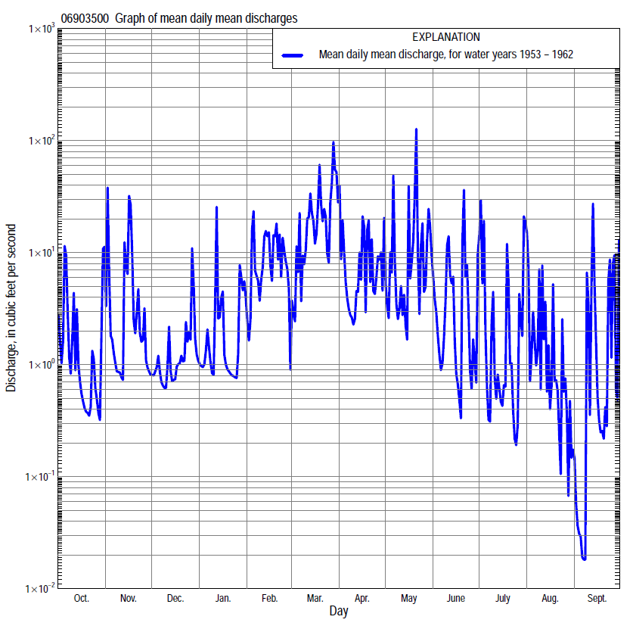

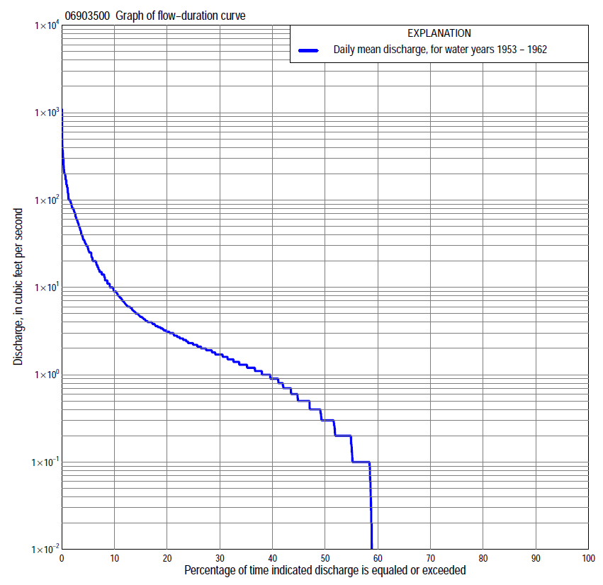

Statistics Based on the Entire Streamflow Period of Record
06903500 Monthly and annual flow durations, based on 1953–62 period of record (10 years)
[ND, not determined]
Percentage of days discharge equaled or exceeded |  |  |  |  | Discharge (cubic feet per second) |  |  |  |  |  |  |  |  | Annual flow durations
 | Oct | Nov | Dec | Jan | Feb | Mar | Apr | May | June | July | Aug | Sept | Annual | Kentau statistic | P-value
99 | 0.00 | 0.00 | 0.00 | 0.00 | 0.00 | 0.00 | 0.00 | 0.00 | 0.00 | 0.00 | 0.00 | 0.00 | 0.00 | 0.000 | ND
98 | 0.00 | 0.00 | 0.00 | 0.00 | 0.00 | 0.00 | 0.00 | 0.00 | 0.00 | 0.00 | 0.00 | 0.00 | 0.00 | 0.000 | ND
95 | 0.00 | 0.00 | 0.00 | 0.00 | 0.00 | 0.00 | 0.00 | 0.00 | 0.00 | 0.00 | 0.00 | 0.00 | 0.00 | 0.000 | ND
90 | 0.00 | 0.00 | 0.00 | 0.00 | 0.00 | 0.00 | 0.00 | 0.00 | 0.00 | 0.00 | 0.00 | 0.00 | 0.00 | 0.000 | ND
85 | 0.00 | 0.00 | 0.00 | 0.00 | 0.00 | 0.00 | 0.00 | 0.10 | 0.00 | 0.00 | 0.00 | 0.00 | 0.00 | 0.000 | ND
80 | 0.00 | 0.00 | 0.00 | 0.00 | 0.00 | 0.00 | 0.50 | 0.20 | 0.00 | 0.00 | 0.00 | 0.00 | 0.00 | 0.000 | ND
75 | 0.00 | 0.00 | 0.00 | 0.00 | 0.00 | 0.00 | 1.1 | 0.30 | 0.10 | 0.00 | 0.00 | 0.00 | 0.00 | 0.111 | 0.486
70 | 0.00 | 0.00 | 0.00 | 0.00 | 0.00 | 1.0 | 1.4 | 0.40 | 0.10 | 0.00 | 0.00 | 0.00 | 0.00 | 0.311 | 0.090
65 | 0.00 | 0.00 | 0.00 | 0.00 | 0.00 | 1.5 | 1.9 | 0.60 | 0.20 | 0.00 | 0.00 | 0.00 | 0.00 | 0.311 | 0.090
60 | 0.00 | 0.00 | 0.00 | 0.00 | 0.30 | 1.7 | 2.3 | 0.90 | 0.20 | 0.00 | 0.00 | 0.00 | 0.00 | 0.333 | 0.070
55 | 0.00 | 0.00 | 0.30 | 0.20 | 0.50 | 1.7 | 2.6 | 1.3 | 0.20 | 0.00 | 0.00 | 0.00 | 0.20 | 0.333 | 0.070
50 | 0.00 | 0.40 | 0.50 | 0.40 | 1.1 | 1.9 | 3.0 | 1.5 | 0.30 | 0.00 | 0.00 | 0.00 | 0.30 | 0.378 | 0.073
45 | 0.00 | 0.60 | 0.60 | 0.50 | 1.9 | 2.6 | 3.2 | 2.0 | 0.40 | 0.10 | 0.00 | 0.00 | 0.60 | 0.511 | 0.034
40 | 0.00 | 1.0 | 0.80 | 0.60 | 2.6 | 3.8 | 3.5 | 2.2 | 0.70 | 0.10 | 0.00 | 0.00 | 1.0 | 0.511 | 0.034
35 | 0.40 | 1.2 | 0.90 | 0.90 | 3.4 | 5.6 | 4.1 | 2.6 | 0.90 | 0.20 | 0.00 | 0.00 | 1.3 | 0.511 | 0.037
30 | 0.70 | 1.5 | 1.1 | 1.1 | 5.0 | 8.8 | 4.6 | 3.4 | 1.1 | 0.40 | 0.10 | 0.10 | 1.7 | 0.489 | 0.051
25 | 1.0 | 1.8 | 1.3 | 1.4 | 9.0 | 12 | 5.3 | 4.3 | 1.5 | 0.60 | 0.30 | 0.20 | 2.3 | 0.533 | 0.032
20 | 1.4 | 2.2 | 1.6 | 2.0 | 12 | 18 | 6.2 | 6.0 | 1.9 | 1.2 | 0.60 | 0.40 | 3.2 | 0.533 | 0.037
15 | 1.6 | 3.1 | 2.4 | 2.8 | 16 | 33 | 9.0 | 8.0 | 2.5 | 1.9 | 1.3 | 1.0 | 4.7 | 0.578 | 0.025
10 | 2.7 | 5.0 | 3.3 | 3.8 | 25 | 60 | 14 | 16 | 4.8 | 3.8 | 2.6 | 1.9 | 9.0 | 0.556 | 0.030
5 | 8.0 | 20 | 5.0 | 9.0 | 40 | 100 | 32 | 63 | 20 | 14 | 6.2 | 5.3 | 28 | 0.533 | 0.039
2 | 30 | 72 | 6.7 | 30 | 100 | 210 | 140 | 150 | 36 | 57 | 27 | 57 | 80 | 0.600 | 0.020
1 | 80 | 95 | 16 | 40 | 110 | 290 | 150 | 180 | 64 | 190 | 65 | 85 | 140 | 0.644 | 0.012

06903500 Annual exceedance probability of instantaneous peak discharges, in cubic feet per second (ft³/s), based on the Weighted Independent Estimates method,
Annual exceed-ance probability | Recur-rence interval (years) | Discharge (ft³/s) | 95-percent lower confi-dence interval (ft³/s) | 95-percent upper confi-dence interval (ft³/s)
0.500 | 2 | 734 | 459 | 1,170
0.200 | 5 | 1,870 | 1,220 | 2,860
0.100 | 10 | 2,840 | 1,860 | 4,330
0.040 | 25 | 4,420 | 2,860 | 6,850
0.020 | 50 | 5,710 | 3,580 | 9,100
0.010 | 100 | 7,100 | 4,330 | 11,600
0.005 | 200 | 8,600 | 5,100 | 14,500
0.002 | 500 | 10,400 | 5,860 | 18,600
and based on the expected moments algorithm/multiple Grubbs-Beck analysis computed using a historical period length of 11 years (1952–1962)
0.500 | 2 | 609 | 313 | 1,130
0.200 | 5 | 1,350 | 742 | 3,120
0.100 | 10 | 2,010 | 1,090 | 5,940
0.040 | 25 | 3,050 | 1,580 | 12,800
0.020 | 50 | 3,980 | 1,950 | 22,000
0.010 | 100 | 5,030 | 2,330 | 36,500
0.005 | 200 | 6,220 | 2,700 | 59,100
0.002 | 500 | 8,020 | 3,180 | 109,000
Kentau statistic |  | 0.418
P-value |  | 0.087
Begin year |  | 1952
End year |  | 1962
Number of peaks |  | 11

06903500 Annual exceedance probability of high discharges, based on 1953–62 period of record (10 years)
Annual exceedance probability | Recur-rence interval (years) | Maximum average discharge (ft³/s) for indicated number of consecutive days
 |  | 1 | 3 | 7 | 15 | 30
0.990 | 1.01 | 19 | 9.1 | 4.5 | 2.6 | 1.1
0.950 | 1.05 | 39 | 20 | 10 | 6.4 | 3.5
0.900 | 1.11 | 58 | 29 | 16 | 10 | 6.0
0.800 | 1.25 | 92 | 48 | 25 | 17 | 11
0.500 | 2 | 226 | 118 | 63 | 42 | 29
0.200 | 5 | 554 | 286 | 149 | 93 | 64
0.100 | 10 | 886 | 451 | 230 | 135 | 89
0.040 | 25 | 1,460 | 726 | 359 | 195 | 120
0.020 | 50 | 2,020 | 984 | 476 | 244 | 142
0.010 | 100 | 2,700 | 1,290 | 610 | 294 | 163
0.005 | 200 | 3,530 | 1,650 | 762 | 347 | 182
0.002 | 500 | 4,880 | 2,220 | 994 | 419 | 205
Kentau statistic |  | 0.556 | 0.422 | 0.600 | 0.556 | 0.600
P-value |  | 0.032 | 0.107 | 0.020 | 0.032 | 0.020

(Annual and seasonal nonexceedance probability of low discharges not determined because of insufficient data.)

