LOCATION.--Lat 40°48'02", long 93°11'32" referenced to North American Datum of 1927, in NW 1/4 SW 1/4 SW 1/4 sec.05, T.69 N., R.20 W., Wayne County, IA, Hydrologic Unit 10280201, on right bank 20 ft downstream from bridge on County Highway S50, 4.3 mi northwest of Promise City, 1.3 mi downstream from Jordan Creek, 16.0 mi upstream from confluence with Chariton River, and 54.0 mi upstream from Iowa-Missouri state line.

DRAINAGE AREA.--168 mi².

PERIOD OF RECORD.--Occasional low-flow measurements, water years 1958-1966, published as "near Bethlehem"; monthly discharge measurements, March 1965 to September 1967; discharge records from October 1967 to current year.

GAGE.--Water-stage recorder. Datum of gage is 913.70 ft above National Geodetic Vertical Datum of 1929 (U.S. Army Corps of Engineers benchmark).

EXTREMES OUTSIDE PERIOD OF RECORD.--Flood of September 21, 1965, reached a stage of 25.5 ft, from high-water mark, discharge about 18,000 ft³/s.

A summary of all available data for this streamgage is provided through the USGS National Water Information System web interface (NWISWeb). The following link provides access to current/historical observations, daily data, daily statistics, monthly statistics, annual statistics, peak streamflow, field measurements, field/lab water-quality samples, and the latest water-year summaries. Data can be filtered by parameter and/or dates, and can be output in various tabular and graphical formats.
http://waterdata.usgs.gov/nwis/inventory/?site_no=06903700

The USGS WaterWatch Toolkit is available at:
http://waterwatch.usgs.gov/?id=ww_toolkit
Tools for summarizing streamflow information include the duration hydrograph builder, the cumulative streamflow hydrograph builder, the streamgage statistics retrieval tool, the rating curve builder, the flood tracking chart builder, the National Weather Service Advanced Hydrologic Prediction Service (AHPS) river forecast hydrograph builder, and the raster-hydrograph builder. Entering the above number for this streamgage into these toolkit webpages will provide streamflow information specific to this streamgage.

A description of the statistics presented for this streamgage is available in the main body of the report at:
http://dx.doi.org/10.3133/ofr20151214
A link to other streamgages included in this report, a map showing the location of the streamgages, information on the programs used to compute the statistical analyses, and references are included in the main body of the report.

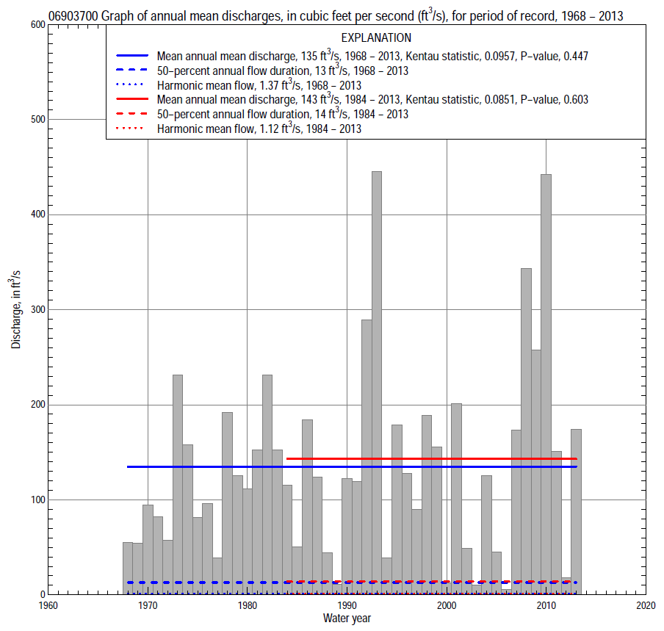

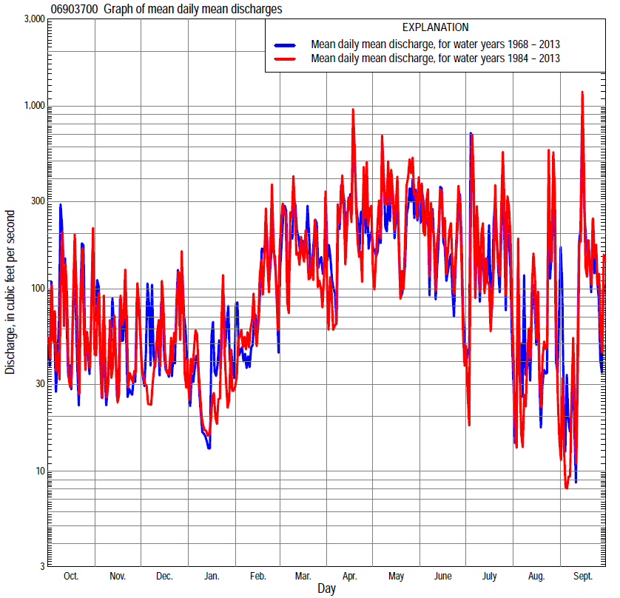

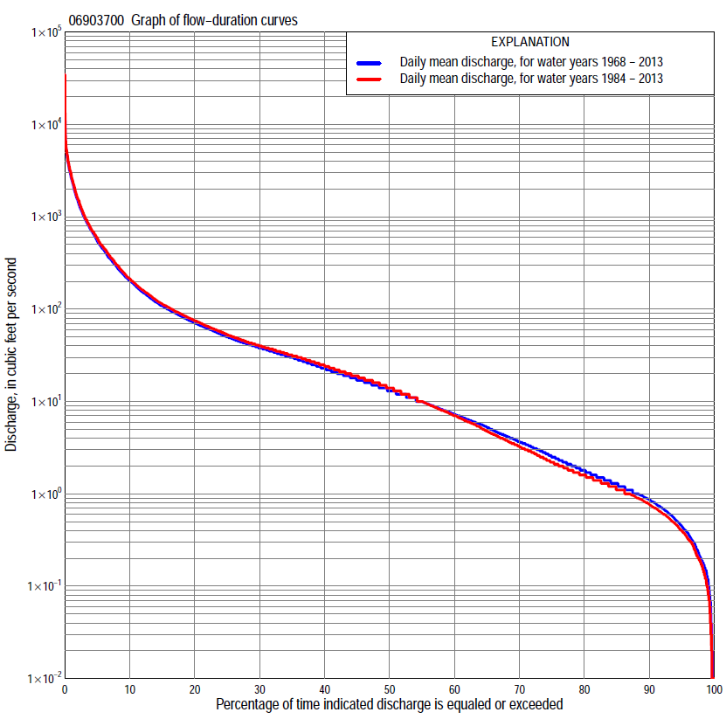

Statistics Based on the Entire Streamflow Period of Record
06903700 Monthly and annual flow durations, based on 1968–2013 period of record (46 years)
Percentage of days discharge equaled or exceeded |  |  |  |  | Discharge (cubic feet per second) |  |  |  |  |  |  |  |  | Annual flow durations
 | Oct | Nov | Dec | Jan | Feb | Mar | Apr | May | June | July | Aug | Sept | Annual | Kentau statistic | P-value
99 | 0.07 | 0.12 | 0.11 | 0.18 | 0.16 | 1.1 | 1.0 | 0.37 | 0.40 | 0.02 | 0.03 | 0.01 | 0.12 | 0.068 | 0.420
98 | 0.11 | 0.31 | 0.18 | 0.24 | 0.54 | 1.6 | 1.5 | 1.1 | 0.49 | 0.09 | 0.13 | 0.09 | 0.20 | 0.095 | 0.267
95 | 0.18 | 0.56 | 0.41 | 0.42 | 1.0 | 2.5 | 3.0 | 2.8 | 0.83 | 0.19 | 0.25 | 0.25 | 0.45 | 0.053 | 0.568
90 | 0.33 | 0.98 | 0.70 | 0.80 | 1.6 | 7.4 | 8.2 | 4.7 | 1.4 | 0.54 | 0.49 | 0.46 | 0.87 | 0.104 | 0.286
85 | 0.52 | 1.3 | 1.0 | 1.1 | 2.8 | 13 | 12 | 7.0 | 2.2 | 0.96 | 0.70 | 0.63 | 1.3 | 0.075 | 0.452
80 | 0.82 | 1.8 | 1.5 | 1.6 | 4.2 | 17 | 15 | 8.6 | 3.3 | 1.4 | 0.98 | 0.76 | 1.8 | 0.020 | 0.847
75 | 1.1 | 2.3 | 2.9 | 2.5 | 6.0 | 22 | 20 | 13 | 5.0 | 1.6 | 1.2 | 0.90 | 2.5 | -0.006 | 0.962
70 | 1.4 | 3.3 | 4.0 | 3.3 | 8.2 | 26 | 24 | 16 | 6.5 | 2.0 | 1.5 | 1.1 | 3.7 | 0.006 | 0.962
65 | 1.9 | 4.6 | 5.0 | 4.3 | 9.8 | 30 | 30 | 21 | 8.4 | 2.6 | 1.7 | 1.2 | 5.3 | -0.017 | 0.872
60 | 2.3 | 6.0 | 6.8 | 5.6 | 12 | 34 | 34 | 25 | 12 | 3.5 | 1.9 | 1.4 | 7.3 | -0.032 | 0.761
55 | 3.0 | 7.5 | 9.4 | 6.4 | 16 | 38 | 41 | 30 | 15 | 4.4 | 2.3 | 1.7 | 10 | -0.014 | 0.902
50 | 3.7 | 9.4 | 11 | 8.0 | 20 | 44 | 48 | 36 | 19 | 5.7 | 2.8 | 2.0 | 13 | 0.010 | 0.932
45 | 5.3 | 13 | 13 | 9.4 | 25 | 52 | 57 | 42 | 24 | 7.1 | 3.5 | 2.6 | 17 | 0.018 | 0.864
40 | 9.5 | 16 | 15 | 12 | 34 | 64 | 69 | 51 | 32 | 9.0 | 4.3 | 3.5 | 23 | 0.038 | 0.719
35 | 14 | 21 | 19 | 14 | 42 | 78 | 85 | 62 | 43 | 12 | 5.8 | 5.5 | 30 | 0.038 | 0.719
30 | 18 | 25 | 25 | 18 | 54 | 97 | 102 | 79 | 61 | 17 | 8.0 | 9.0 | 38 | 0.026 | 0.805
25 | 24 | 32 | 32 | 23 | 68 | 124 | 133 | 106 | 87 | 28 | 12 | 14 | 50 | 0.043 | 0.677
20 | 35 | 40 | 41 | 32 | 90 | 166 | 185 | 162 | 125 | 44 | 19 | 23 | 71 | 0.048 | 0.643
15 | 49 | 53 | 58 | 43 | 121 | 273 | 261 | 260 | 212 | 77 | 32 | 34 | 109 | 0.055 | 0.596
10 | 108 | 82 | 100 | 63 | 188 | 427 | 525 | 498 | 420 | 174 | 62 | 75 | 201 | 0.041 | 0.698
5 | 370 | 200 | 210 | 110 | 383 | 917 | 1,190 | 1,240 | 955 | 703 | 212 | 415 | 546 | 0.061 | 0.557
2 | 884 | 550 | 450 | 350 | 840 | 1,670 | 2,250 | 3,080 | 2,370 | 2,300 | 734 | 1,300 | 1,500 | 0.129 | 0.211
1 | 2,130 | 903 | 988 | 560 | 1,510 | 2,690 | 3,910 | 4,330 | 3,130 | 4,520 | 1,220 | 2,280 | 2,630 | 0.090 | 0.384

06903700 Annual exceedance probability of instantaneous peak discharges, in cubic feet per second (ft³/s), based on the Weighted Independent Estimates method,
Annual exceed-ance probability | Recur-rence interval (years) | Discharge (ft³/s) | 95-percent lower confi-dence interval (ft³/s) | 95-percent upper confi-dence interval (ft³/s)
0.500 | 2 | 6,420 | 5,600 | 7,350
0.200 | 5 | 12,700 | 11,000 | 14,600
0.100 | 10 | 17,700 | 15,100 | 20,700
0.040 | 25 | 24,900 | 20,600 | 30,200
0.020 | 50 | 30,800 | 24,600 | 38,600
0.010 | 100 | 37,000 | 28,600 | 48,000
0.005 | 200 | 43,500 | 32,400 | 58,400
0.002 | 500 | 52,400 | 37,100 | 74,000
and based on the expected moments algorithm/multiple Grubbs-Beck analysis computed using a historical period length of 162 years (1852–2013)
0.500 | 2 | 6,460 | 4,970 | 8,290
0.200 | 5 | 12,800 | 9,940 | 16,700
0.100 | 10 | 18,100 | 13,800 | 24,200
0.040 | 25 | 25,900 | 19,000 | 36,300
0.020 | 50 | 32,400 | 22,900 | 47,800
0.010 | 100 | 39,600 | 26,700 | 61,800
0.005 | 200 | 47,300 | 30,400 | 79,100
0.002 | 500 | 58,600 | 35,200 | 108,000
Kentau statistic |  | 0.107
P-value |  | 0.298
Begin year |  | 1968
End year |  | 2013
Number of peaks |  | 46

06903700 Annual exceedance probability of high discharges, based on 1968–2013 period of record (46 years)
Annual exceedance probability | Recur-rence interval (years) | Maximum average discharge (ft³/s) for indicated number of consecutive days
 |  | 1 | 3 | 7 | 15 | 30
0.990 | 1.01 | 373 | 189 | 110 | 59 | 32
0.950 | 1.05 | 863 | 448 | 254 | 148 | 88
0.900 | 1.11 | 1,310 | 682 | 384 | 230 | 141
0.800 | 1.25 | 2,090 | 1,100 | 612 | 375 | 236
0.500 | 2 | 4,700 | 2,460 | 1,360 | 833 | 543
0.200 | 5 | 9,430 | 4,870 | 2,690 | 1,580 | 1,030
0.100 | 10 | 13,000 | 6,630 | 3,680 | 2,070 | 1,340
0.040 | 25 | 17,700 | 8,910 | 4,970 | 2,660 | 1,700
0.020 | 50 | 21,400 | 10,600 | 5,930 | 3,060 | 1,930
0.010 | 100 | 24,900 | 12,200 | 6,880 | 3,430 | 2,140
0.005 | 200 | 28,500 | 13,800 | 7,820 | 3,760 | 2,320
0.002 | 500 | 33,200 | 15,900 | 9,030 | 4,150 | 2,520
Kentau statistic |  | 0.062 | 0.080 | 0.049 | 0.059 | 0.069
P-value |  | 0.551 | 0.438 | 0.636 | 0.570 | 0.507

 | 06903700 Annual nonexceedance probability of low discharges, based on April 1968 to March 2013 period of record (45 years)
Annual nonexceed-ance probability | Recur-rence interval (years) | Minimum average discharge (cubic feet per second) for indicated number of consecutive days
 |  | 1 | 3 | 7 | 14 | 30 | 60 | 90 | 120 | 183
0.01 | 100 | 0.00 | 0.00 | 0.00 | 0.01 | 0.03 | 0.10 | 0.14 | 0.22 | 0.31
0.02 | 50 | 0.00 | 0.00 | 0.01 | 0.02 | 0.05 | 0.14 | 0.21 | 0.33 | 0.51
0.05 | 20 | 0.00 | 0.01 | 0.02 | 0.04 | 0.10 | 0.24 | 0.38 | 0.61 | 1.1
0.10 | 10 | 0.03 | 0.04 | 0.05 | 0.09 | 0.19 | 0.39 | 0.65 | 1.1 | 2.0
0.20 | 5 | 0.10 | 0.11 | 0.13 | 0.21 | 0.40 | 0.72 | 1.3 | 2.1 | 4.2
0.50 | 2 | 0.51 | 0.57 | 0.66 | 0.93 | 1.5 | 2.7 | 5.0 | 8.3 | 17
0.80 | 1.25 | 2.0 | 2.3 | 2.7 | 3.3 | 4.7 | 11 | 21 | 34 | 65
0.90 | 1.11 | 3.9 | 4.3 | 5.0 | 5.9 | 8.2 | 26 | 47 | 72 | 129
0.96 | 1.04 | 7.5 | 8.3 | 9.2 | 11 | 14 | 64 | 112 | 163 | 263
0.98 | 1.02 | 11 | 12 | 13 | 15 | 21 | 118 | 200 | 279 | 415
0.99 | 1.01 | 16 | 17 | 18 | 20 | 28 | 210 | 341 | 455 | 621
Kentau statistic |  | 0.052 | 0.058 | 0.047 | 0.030 | -0.006 | -0.022 | -0.046 | -0.065 | -0.069
P-value |  | 0.625 | 0.584 | 0.653 | 0.777 | 0.961 | 0.837 | 0.660 | 0.538 | 0.512

06903700 Annual nonexceedance probability of seasonal low discharges, based on October 1967 to September 2013 period of record (46 years)
Annual nonexceed-ance probability | Recur-rence interval (years) | Minimum average discharge (cubic feet per second) for indicated number of consecutive days
 |  | 1 | 7 | 14 | 30 |  | 1 | 7 | 14 | 30
 |  | January-February-March |  |  |  |  | April-May-June
0.01 | 100 | 0.04 | 0.07 | 0.11 | 0.17 |  | 0.08 | 0.11 | 0.18 | 0.39
0.02 | 50 | 0.08 | 0.12 | 0.17 | 0.28 |  | 0.13 | 0.18 | 0.30 | 0.67
0.05 | 20 | 0.17 | 0.26 | 0.35 | 0.57 |  | 0.27 | 0.39 | 0.62 | 1.5
0.10 | 10 | 0.34 | 0.49 | 0.65 | 1.1 |  | 0.52 | 0.73 | 1.2 | 3.0
0.20 | 5 | 0.74 | 1.0 | 1.3 | 2.2 |  | 1.1 | 1.5 | 2.4 | 6.8
0.50 | 2 | 2.8 | 3.6 | 4.6 | 7.9 |  | 3.6 | 5.3 | 8.5 | 29
0.80 | 1.25 | 9.0 | 11 | 14 | 27 |  | 9.9 | 15 | 28 | 113
0.90 | 1.11 | 15 | 18 | 24 | 49 |  | 16 | 25 | 48 | 220
0.96 | 1.04 | 26 | 31 | 42 | 91 |  | 25 | 39 | 86 | 433
0.98 | 1.02 | 35 | 42 | 59 | 133 |  | 32 | 52 | 122 | 660
0.99 | 1.01 | 46 | 54 | 79 | 187 |  | 40 | 65 | 166 | 952
Kentau statistic |  | 0.013 | 0.031 | 0.020 | -0.059 |  | 0.186 | 0.244 | 0.252 | 0.183
P-value |  | 0.910 | 0.769 | 0.850 | 0.570 |  | 0.069 | 0.017 | 0.014 | 0.075
 |  | July-August-September |  |  |  |  | October-November-December
0.01 | 100 | 0.00 | 0.01 | 0.02 | 0.10 |  | 0.01 | 0.02 | 0.02 | 0.08
0.02 | 50 | 0.00 | 0.01 | 0.03 | 0.13 |  | 0.01 | 0.03 | 0.04 | 0.13
0.05 | 20 | 0.01 | 0.03 | 0.06 | 0.19 |  | 0.03 | 0.06 | 0.10 | 0.28
0.10 | 10 | 0.05 | 0.07 | 0.12 | 0.29 |  | 0.07 | 0.14 | 0.22 | 0.53
0.20 | 5 | 0.13 | 0.17 | 0.26 | 0.51 |  | 0.19 | 0.33 | 0.52 | 1.1
0.50 | 2 | 0.63 | 0.85 | 1.1 | 1.8 |  | 1.1 | 1.6 | 2.5 | 4.7
0.80 | 1.25 | 2.6 | 3.5 | 4.6 | 8.0 |  | 5.3 | 7.1 | 11 | 18
0.90 | 1.11 | 5.4 | 6.9 | 9.5 | 20 |  | 11 | 15 | 23 | 36
0.96 | 1.04 | 11 | 13 | 21 | 56 |  | 24 | 31 | 49 | 73
0.98 | 1.02 | 18 | 20 | 34 | 114 |  | 39 | 50 | 79 | 114
0.99 | 1.01 | 28 | 28 | 52 | 227 |  | 59 | 75 | 119 | 168
Kentau statistic |  | 0.043 | 0.037 | 0.007 | -0.024 |  | -0.014 | -0.004 | -0.020 | -0.011
P-value |  | 0.684 | 0.726 | 0.955 | 0.820 |  | 0.895 | 0.977 | 0.850 | 0.925

Statistics Based on the 1984–2013 Streamflow Period of Record
06903700 Monthly and annual flow durations, based on 1984–2013 period of record (30 years)
Percentage of days discharge equaled or exceeded |  |  |  |  | Discharge (cubic feet per second) |  |  |  |  |  |  |  |  | Annual flow durations
 | Oct | Nov | Dec | Jan | Feb | Mar | Apr | May | June | July | Aug | Sept | Annual | Kentau statistic | P-value
99 | 0.05 | 0.03 | 0.09 | 0.31 | 0.41 | 0.85 | 0.65 | 0.30 | 0.42 | 0.07 | 0.02 | 0.01 | 0.09 | 0.069 | 0.520
98 | 0.08 | 0.24 | 0.14 | 0.35 | 0.54 | 1.4 | 1.2 | 0.50 | 0.49 | 0.12 | 0.08 | 0.01 | 0.17 | 0.099 | 0.368
95 | 0.17 | 0.43 | 0.35 | 0.50 | 0.95 | 1.9 | 1.6 | 2.4 | 0.75 | 0.19 | 0.21 | 0.19 | 0.40 | 0.021 | 0.873
90 | 0.27 | 0.82 | 0.65 | 0.77 | 1.4 | 3.2 | 5.5 | 4.2 | 1.2 | 0.52 | 0.49 | 0.40 | 0.77 | 0.101 | 0.419
85 | 0.37 | 1.1 | 0.81 | 1.1 | 2.2 | 12 | 9.4 | 6.9 | 2.0 | 1.1 | 0.70 | 0.59 | 1.1 | 0.090 | 0.482
80 | 0.53 | 1.4 | 1.1 | 1.6 | 5.6 | 18 | 13 | 8.7 | 3.1 | 1.4 | 0.97 | 0.72 | 1.6 | 0.051 | 0.702
75 | 0.92 | 1.8 | 2.1 | 2.3 | 7.8 | 22 | 18 | 15 | 5.2 | 1.7 | 1.2 | 0.84 | 2.2 | -0.051 | 0.705
70 | 1.2 | 2.3 | 3.2 | 3.5 | 9.6 | 27 | 22 | 20 | 7.3 | 2.1 | 1.4 | 0.96 | 3.3 | -0.034 | 0.801
65 | 1.6 | 3.2 | 4.0 | 4.7 | 12 | 31 | 27 | 26 | 11 | 2.7 | 1.7 | 1.1 | 4.8 | -0.083 | 0.531
60 | 2.0 | 4.3 | 5.1 | 5.7 | 16 | 35 | 32 | 32 | 15 | 3.6 | 1.9 | 1.2 | 7.0 | -0.115 | 0.381
55 | 2.7 | 6.1 | 7.6 | 6.6 | 20 | 40 | 37 | 38 | 18 | 4.4 | 2.3 | 1.4 | 10 | -0.101 | 0.442
50 | 3.2 | 7.9 | 10 | 8.5 | 24 | 46 | 44 | 46 | 23 | 5.6 | 2.9 | 1.7 | 14 | -0.110 | 0.400
45 | 4.9 | 11 | 13 | 10 | 30 | 55 | 53 | 53 | 31 | 6.9 | 3.5 | 2.1 | 19 | -0.087 | 0.509
40 | 10 | 15 | 17 | 13 | 38 | 66 | 67 | 65 | 40 | 8.6 | 4.4 | 3.0 | 24 | -0.055 | 0.681
35 | 14 | 19 | 20 | 16 | 48 | 78 | 82 | 79 | 56 | 12 | 5.9 | 5.4 | 32 | -0.064 | 0.630
30 | 18 | 25 | 26 | 20 | 58 | 95 | 100 | 97 | 79 | 16 | 9.3 | 9.2 | 40 | -0.014 | 0.929
25 | 25 | 32 | 32 | 24 | 72 | 117 | 124 | 149 | 113 | 23 | 14 | 15 | 53 | 0.009 | 0.957
20 | 36 | 40 | 41 | 31 | 97 | 150 | 175 | 205 | 164 | 40 | 26 | 23 | 75 | 0.023 | 0.872
15 | 51 | 54 | 58 | 42 | 130 | 237 | 256 | 350 | 276 | 70 | 41 | 33 | 114 | 0.028 | 0.844
10 | 122 | 86 | 95 | 56 | 193 | 400 | 475 | 677 | 506 | 197 | 86 | 60 | 214 | 0.000 | 1.000
5 | 361 | 203 | 210 | 95 | 439 | 813 | 1,190 | 1,640 | 1,180 | 1,060 | 256 | 402 | 590 | 0.030 | 0.830
2 | 748 | 550 | 420 | 220 | 840 | 1,600 | 2,480 | 3,740 | 2,490 | 2,790 | 800 | 1,300 | 1,570 | 0.110 | 0.402
1 | 1,490 | 966 | 673 | 476 | 1,230 | 2,690 | 3,510 | 4,850 | 3,120 | 4,740 | 1,510 | 2,280 | 2,780 | 0.103 | 0.432

06903700 Annual exceedance probability of high discharges, based on 1984–2013 period of record (30 years)
Annual exceedance probability | Recur-rence interval (years) | Maximum average discharge (ft³/s) for indicated number of consecutive days
 |  | 1 | 3 | 7 | 15 | 30
0.990 | 1.01 | 247 | 131 | 78 | 41 | 22
0.950 | 1.05 | 635 | 339 | 191 | 110 | 65
0.900 | 1.11 | 1,020 | 542 | 300 | 179 | 109
0.800 | 1.25 | 1,740 | 926 | 504 | 309 | 196
0.500 | 2 | 4,440 | 2,340 | 1,260 | 779 | 516
0.200 | 5 | 10,100 | 5,240 | 2,860 | 1,690 | 1,130
0.100 | 10 | 14,800 | 7,630 | 4,220 | 2,410 | 1,580
0.040 | 25 | 21,700 | 11,000 | 6,230 | 3,370 | 2,160
0.020 | 50 | 27,300 | 13,700 | 7,880 | 4,100 | 2,580
0.010 | 100 | 33,100 | 16,500 | 9,650 | 4,830 | 2,980
0.005 | 200 | 39,200 | 19,300 | 11,500 | 5,550 | 3,360
0.002 | 500 | 47,600 | 23,200 | 14,100 | 6,480 | 3,820
Kentau statistic |  | 0.103 | 0.122 | 0.085 | 0.071 | 0.021
P-value |  | 0.432 | 0.354 | 0.521 | 0.592 | 0.887

 | 06903700 Annual nonexceedance probability of low discharges, based on April 1983 to March 2013 period of record (30 years)
Annual nonexceed-ance probability | Recur-rence interval (years) | Minimum average discharge (cubic feet per second) for indicated number of consecutive days
 |  | 1 | 3 | 7 | 14 | 30 | 60 | 90 | 120 | 183
0.01 | 100 | 0.00 | 0.00 | 0.00 | 0.01 | 0.02 | 0.09 | 0.11 | 0.19 | 0.24
0.02 | 50 | 0.00 | 0.00 | 0.01 | 0.01 | 0.04 | 0.13 | 0.16 | 0.27 | 0.38
0.05 | 20 | 0.01 | 0.01 | 0.02 | 0.03 | 0.08 | 0.21 | 0.30 | 0.49 | 0.78
0.10 | 10 | 0.03 | 0.03 | 0.04 | 0.07 | 0.16 | 0.35 | 0.51 | 0.83 | 1.5
0.20 | 5 | 0.08 | 0.10 | 0.11 | 0.18 | 0.36 | 0.65 | 1.0 | 1.6 | 3.2
0.50 | 2 | 0.48 | 0.54 | 0.65 | 0.90 | 1.4 | 2.4 | 4.2 | 6.4 | 14
0.80 | 1.25 | 2.1 | 2.3 | 2.8 | 3.4 | 4.7 | 10 | 20 | 28 | 58
0.90 | 1.11 | 4.2 | 4.6 | 5.2 | 6.2 | 8.3 | 24 | 46 | 64 | 125
0.96 | 1.04 | 8.3 | 9.2 | 9.5 | 11 | 14 | 62 | 118 | 158 | 280
0.98 | 1.02 | 13 | 14 | 14 | 15 | 20 | 116 | 222 | 291 | 472
0.99 | 1.01 | 18 | 20 | 20 | 20 | 26 | 210 | 396 | 509 | 754
Kentau statistic |  | 0.064 | 0.067 | 0.071 | 0.053 | 0.002 | 0.025 | 0.025 | 0.062 | 0.007
P-value |  | 0.630 | 0.617 | 0.592 | 0.695 | 1.000 | 0.858 | 0.858 | 0.643 | 0.972

06903700 Annual nonexceedance probability of seasonal low discharges, based on October 1983 to September 2013 period of record (30 years)
Annual nonexceed-ance probability | Recur-rence interval (years) | Minimum average discharge (cubic feet per second) for indicated number of consecutive days
 |  | 1 | 7 | 14 | 30 |  | 1 | 7 | 14 | 30
 |  | January-February-March |  |  |  |  | April-May-June
0.01 | 100 | 0.03 | 0.06 | 0.12 | 0.20 |  | 0.06 | 0.07 | 0.13 | 0.23
0.02 | 50 | 0.06 | 0.11 | 0.20 | 0.32 |  | 0.10 | 0.13 | 0.24 | 0.45
0.05 | 20 | 0.15 | 0.25 | 0.41 | 0.64 |  | 0.23 | 0.31 | 0.54 | 1.2
0.10 | 10 | 0.32 | 0.50 | 0.77 | 1.2 |  | 0.46 | 0.65 | 1.1 | 2.6
0.20 | 5 | 0.76 | 1.1 | 1.6 | 2.3 |  | 1.0 | 1.5 | 2.5 | 6.7
0.50 | 2 | 3.3 | 4.2 | 5.4 | 8.2 |  | 3.8 | 5.9 | 10 | 35
0.80 | 1.25 | 11 | 13 | 16 | 26 |  | 12 | 19 | 36 | 151
0.90 | 1.11 | 19 | 22 | 26 | 47 |  | 20 | 32 | 66 | 304
0.96 | 1.04 | 31 | 36 | 43 | 85 |  | 32 | 52 | 119 | 608
0.98 | 1.02 | 41 | 49 | 57 | 123 |  | 42 | 70 | 170 | 928
0.99 | 1.01 | 53 | 62 | 73 | 170 |  | 54 | 88 | 231 | 1,330
Kentau statistic |  | -0.172 | -0.163 | -0.195 | -0.163 |  | 0.234 | 0.292 | 0.278 | 0.182
P-value |  | 0.186 | 0.212 | 0.134 | 0.212 |  | 0.071 | 0.025 | 0.032 | 0.164
 |  | July-August-September |  |  |  |  | October-November-December
0.01 | 100 | 0.00 | 0.00 | 0.01 | 0.07 |  | 0.00 | 0.01 | 0.02 | 0.06
0.02 | 50 | 0.00 | 0.01 | 0.02 | 0.10 |  | 0.01 | 0.02 | 0.03 | 0.10
0.05 | 20 | 0.01 | 0.02 | 0.04 | 0.16 |  | 0.02 | 0.05 | 0.08 | 0.21
0.10 | 10 | 0.04 | 0.05 | 0.09 | 0.25 |  | 0.05 | 0.10 | 0.17 | 0.41
0.20 | 5 | 0.12 | 0.15 | 0.22 | 0.46 |  | 0.14 | 0.26 | 0.42 | 0.93
0.50 | 2 | 0.65 | 0.89 | 1.1 | 1.8 |  | 0.95 | 1.5 | 2.3 | 4.3
0.80 | 1.25 | 3.1 | 4.2 | 5.1 | 9.0 |  | 5.4 | 7.4 | 12 | 19
0.90 | 1.11 | 6.7 | 8.6 | 11 | 23 |  | 13 | 17 | 27 | 42
0.96 | 1.04 | 15 | 17 | 22 | 69 |  | 29 | 38 | 62 | 92
0.98 | 1.02 | 25 | 27 | 35 | 148 |  | 50 | 63 | 105 | 154
0.99 | 1.01 | 37 | 38 | 52 | 300 |  | 78 | 99 | 167 | 243
Kentau statistic |  | 0.028 | -0.002 | -0.007 | -0.030 |  | -0.037 | -0.016 | -0.007 | 0.016
P-value |  | 0.844 | 1.000 | 0.972 | 0.830 |  | 0.789 | 0.915 | 0.972 | 0.915

