LOCATION.--Lat 40°49'18.7", long 92°53'27.8" referenced to North American Datum of 1927, in NW 1/4 SE 1/4 NW 1/4 sec.35, T.70 N., R.18 W., Appanoose County, IA, Hydrologic Unit 10280201, on left bank 600 ft downstream from outlet of Rathbun Dam, 1.7 mi north of Rathbun, 3.8 mi upstream from Walnut Creek, and 30.0 mi upstream from Iowa-Missouri state line.

DRAINAGE AREA.--549 mi².

PERIOD OF RECORD.--Discharge records from October 1956 to current year. Prior to March 1957, monthly mean discharge for some periods published in WSP 1730.

GAGE.--Water-stage recorder. Datum of gage is 847.92 ft above National Geodetic Vertical Datum of 1929. Prior to November 16, 1960, non-recording gage, and November 17, 1960, to September 30, 1969, water-stage recorder, both at site 3.1 mi downstream at datum 4.65 ft lower.

REMARKS.--Flow regulated by Rathbun Lake (station 06903880) since November 21, 1969. Records of discharge include flow diverted from the reservoir to Rathbun Fish Hatchery ponds. Diverted flow returns to the stream 0.1 mi downstream from gage. Rathbun Regional Water Association permit #3663-R4 allows withdrawal from Rathbun Dam immediately downstream from gage at a maximum rate of 6,181 gpm (13.7 ft³/s).

A summary of all available data for this streamgage is provided through the USGS National Water Information System web interface (NWISWeb). The following link provides access to current/historical observations, daily data, daily statistics, monthly statistics, annual statistics, peak streamflow, field measurements, field/lab water-quality samples, and the latest water-year summaries. Data can be filtered by parameter and/or dates, and can be output in various tabular and graphical formats.
http://waterdata.usgs.gov/nwis/inventory/?site_no=06903900

The USGS WaterWatch Toolkit is available at:
http://waterwatch.usgs.gov/?id=ww_toolkit
Tools for summarizing streamflow information include the duration hydrograph builder, the cumulative streamflow hydrograph builder, the streamgage statistics retrieval tool, the rating curve builder, the flood tracking chart builder, the National Weather Service Advanced Hydrologic Prediction Service (AHPS) river forecast hydrograph builder, and the raster-hydrograph builder. Entering the above number for this streamgage into these toolkit webpages will provide streamflow information specific to this streamgage.

A description of the statistics presented for this streamgage is available in the main body of the report at:
http://dx.doi.org/10.3133/ofr20151214
A link to other streamgages included in this report, a map showing the location of the streamgages, information on the programs used to compute the statistical analyses, and references are included in the main body of the report.

Statistics Based on the Pre-regulated Streamflow Period of Record

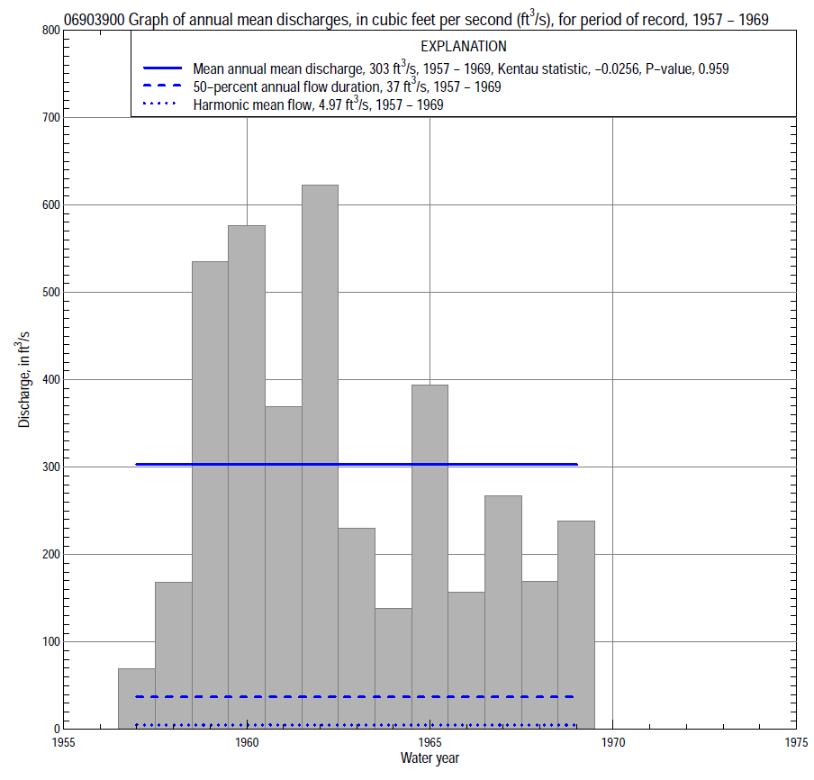

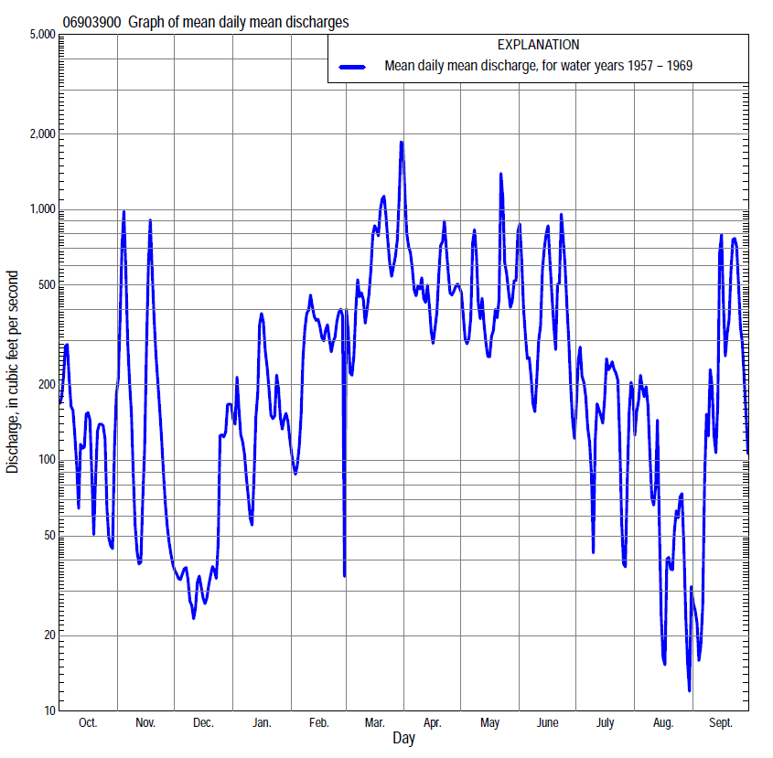

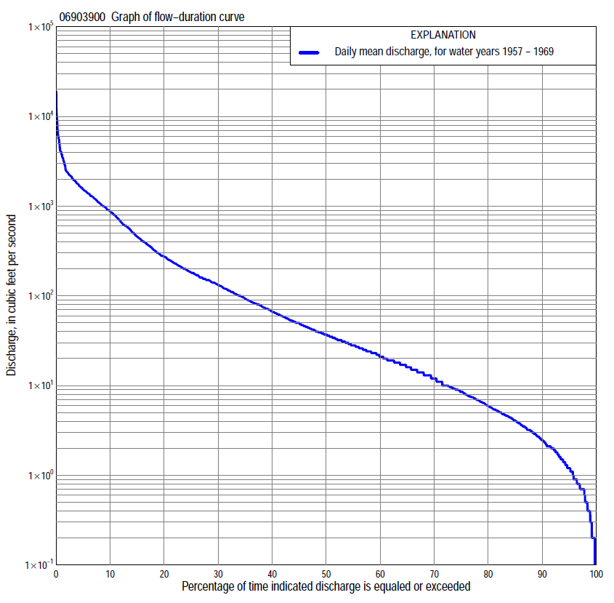

Statistics Based on the Pre-regulated Streamflow Period of Record
06903900 Monthly and annual flow durations, based on 1957–69 pre-regulated period of record (13 years)
Percentage of days discharge equaled or exceeded |  |  |  |  | Discharge (cubic feet per second) |  |  |  |  |  |  |  |  | Annual flow durations
 | Oct | Nov | Dec | Jan | Feb | Mar | Apr | May | June | July | Aug | Sept | Annual | Kentau statistic | P-value
99 | 0.10 | 0.50 | 1.3 | 0.70 | 0.50 | 0.20 | 18 | 7.5 | 2.9 | 0.40 | 1.2 | 1.1 | 0.30 | 0.000 | 1.000
98 | 0.10 | 0.50 | 1.4 | 0.70 | 0.70 | 0.70 | 28 | 8.8 | 3.5 | 0.90 | 1.4 | 1.4 | 0.50 | -0.051 | 0.849
95 | 0.20 | 0.70 | 1.5 | 0.80 | 3.5 | 1.9 | 35 | 12 | 5.0 | 2.3 | 1.9 | 2.4 | 1.2 | 0.038 | 0.901
90 | 0.30 | 0.90 | 1.9 | 1.2 | 5.3 | 7.8 | 47 | 22 | 6.4 | 3.8 | 2.4 | 3.1 | 2.5 | -0.103 | 0.665
85 | 0.40 | 1.4 | 2.1 | 1.6 | 6.4 | 13 | 64 | 32 | 8.9 | 4.6 | 2.9 | 3.5 | 4.1 | -0.103 | 0.667
80 | 0.70 | 1.9 | 3.1 | 3.4 | 7.4 | 26 | 79 | 42 | 12 | 5.9 | 3.2 | 4.0 | 5.9 | -0.103 | 0.668
75 | 1.6 | 3.9 | 4.5 | 9.2 | 12 | 40 | 96 | 50 | 15 | 7.5 | 3.8 | 4.8 | 8.5 | -0.103 | 0.668
70 | 2.4 | 8.5 | 5.9 | 13 | 17 | 53 | 114 | 57 | 18 | 9.6 | 4.4 | 5.9 | 12 | 0.051 | 0.854
65 | 4.1 | 10 | 9.0 | 15 | 22 | 80 | 130 | 66 | 23 | 13 | 5.1 | 7.2 | 16 | 0.090 | 0.714
60 | 5.8 | 12 | 11 | 17 | 30 | 94 | 147 | 76 | 27 | 16 | 5.7 | 9.2 | 21 | 0.103 | 0.668
55 | 7.9 | 13 | 17 | 19 | 54 | 123 | 160 | 90 | 33 | 19 | 7.3 | 11 | 28 | 0.051 | 0.855
50 | 11 | 23 | 20 | 19 | 84 | 143 | 190 | 110 | 41 | 23 | 8.8 | 16 | 37 | 0.013 | 1.000
45 | 16 | 31 | 24 | 23 | 110 | 189 | 216 | 141 | 60 | 27 | 11 | 22 | 49 | 0.000 | 1.000
40 | 23 | 38 | 27 | 27 | 140 | 235 | 254 | 180 | 83 | 37 | 14 | 27 | 67 | -0.026 | 0.951
35 | 31 | 45 | 30 | 39 | 180 | 284 | 318 | 237 | 128 | 53 | 18 | 32 | 93 | -0.077 | 0.760
30 | 39 | 52 | 34 | 90 | 230 | 412 | 401 | 329 | 203 | 64 | 28 | 47 | 132 | -0.077 | 0.760
25 | 50 | 62 | 42 | 130 | 300 | 886 | 555 | 441 | 338 | 102 | 39 | 74 | 182 | -0.077 | 0.760
20 | 86 | 84 | 54 | 180 | 450 | 1,300 | 784 | 615 | 490 | 170 | 57 | 136 | 272 | -0.154 | 0.502
15 | 160 | 160 | 80 | 280 | 700 | 1,620 | 1,080 | 906 | 702 | 303 | 86 | 232 | 455 | -0.077 | 0.760
10 | 354 | 401 | 106 | 500 | 1,000 | 1,920 | 1,400 | 1,270 | 1,410 | 630 | 173 | 462 | 869 | -0.128 | 0.583
5 | 1,010 | 1,110 | 170 | 800 | 1,550 | 2,500 | 2,320 | 2,150 | 2,500 | 1,030 | 393 | 1,370 | 1,540 | -0.141 | 0.541
2 | 1,500 | 3,000 | 668 | 1,300 | 1,800 | 3,780 | 3,780 | 2,800 | 4,020 | 1,440 | 1,060 | 3,400 | 2,410 | -0.103 | 0.669
1 | 1,630 | 5,900 | 982 | 2,000 | 1,950 | 5,700 | 4,130 | 5,580 | 4,500 | 1,460 | 1,660 | 6,650 | 3,790 | -0.103 | 0.669

06903900 Annual exceedance probability of instantaneous peak discharges, in cubic feet per second (ft³/s), for the pre-regulated period of record based on the Weighted Independent Estimates method,
Annual exceed-ance probability | Recur-rence interval (years) | Discharge (ft³/s) | 95-percent lower confidence interval (ft³/s) | 95-percent upper confidence interval (ft³/s)
0.500 | 2 | 5,450 | 4,180 | 7,090
0.200 | 5 | 11,400 | 8,810 | 14,800
0.100 | 10 | 16,100 | 12,200 | 21,300
0.040 | 25 | 23,100 | 16,900 | 31,500
0.020 | 50 | 28,400 | 20,000 | 40,200
0.010 | 100 | 33,800 | 23,000 | 49,700
0.005 | 200 | 39,300 | 25,800 | 59,800
0.002 | 500 | 46,200 | 28,700 | 74,300
and based on the expected moments algorithm/multiple Grubbs-Beck analysis computed using a historical period length of 41 years (1929–1969)ª
0.500 | 2 | 5,110 | 3,660 | 6,960
0.200 | 5 | 10,400 | 7,600 | 14,600
0.100 | 10 | 14,800 | 10,700 | 22,200
0.040 | 25 | 21,300 | 14,800 | 36,400
0.020 | 50 | 26,700 | 17,900 | 51,100
0.010 | 100 | 32,500 | 20,900 | 70,300
0.005 | 200 | 38,800 | 23,800 | 95,000
0.002 | 500 | 47,800 | 27,300 | 139,000
Kentau statistic |  | -0.308
P-value |  | 0.161
Begin year |  | 1957
End year |  | 1969
Number of peaks |  | 13
ªAnalysis includes interval annual-peak discharges (1938-56) from streamgage 06904000 Chariton River near Centerville.
Note: The above discharges are for the pre-regulated period of record and they are not applicable for flood-plain management regulation or for design purposes.

06903900 Annual exceedance probability of high discharges, based on 1957-69 pre-regulated period of record (13 years)
[ND, not determined]
Annual exceedance probability | Recur-rence interval (years) | Maximum average discharge (cubic feet per second) for indicated number of consecutive days
 |  | 1 | 3 | 7 | 15 | 30
0.990 | 1.01 | ND | ND | 530 | 323 | 200
0.950 | 1.05 | ND | ND | 926 | 591 | 383
0.900 | 1.11 | ND | ND | 1,200 | 797 | 527
0.800 | 1.25 | ND | ND | 1,630 | 1,120 | 755
0.500 | 2 | ND | ND | 2,930 | 2,040 | 1,390
0.200 | 5 | ND | ND | 5,220 | 3,430 | 2,320
0.100 | 10 | ND | ND | 7,050 | 4,370 | 2,930
0.040 | 25 | ND | ND | 9,690 | 5,560 | 3,660
0.020 | 50 | ND | ND | 11,900 | 6,410 | 4,170
0.010 | 100 | ND | ND | 14,300 | 7,250 | 4,650
0.005 | 200 | ND | ND | 16,800 | 8,060 | 5,100
0.002 | 500 | ND | ND | 20,600 | 9,090 | 5,650
Kentau statistic |  | -0.218 | -0.205 | -0.128 | -0.077 | -0.077
P-value |  | 0.328 | 0.360 | 0.583 | 0.760 | 0.760
Note: The above discharges are for the pre-regulated period of record and they are not applicable for flood-plain management regulation or for design purposes.

06903900 Annual nonexceedance probability of low discharges, based on April 1957 to March 1969 pre-regulated period of record (12 years)
Annual nonexceed-ance probability | Recur-rence interval (years) | Minimum average discharge (cubic feet per second) for indicated number of consecutive days
 |  | 1 | 3 | 7 | 14 | 30 | 60 | 90 | 120 | 183
0.01 | 100 | 0.02 | 0.02 | 0.03 | 0.04 | 0.25 | 0.94 | 0.94 | 0.96 | 1.0
0.02 | 50 | 0.04 | 0.04 | 0.05 | 0.09 | 0.36 | 1.2 | 1.3 | 1.4 | 1.8
0.05 | 20 | 0.08 | 0.10 | 0.13 | 0.22 | 0.62 | 1.9 | 2.2 | 2.5 | 3.9
0.10 | 10 | 0.15 | 0.18 | 0.25 | 0.44 | 0.99 | 2.7 | 3.6 | 4.9 | 7.5
0.20 | 5 | 0.30 | 0.37 | 0.53 | 0.91 | 1.7 | 4.3 | 6.5 | 10 | 16
0.50 | 2 | 0.95 | 1.2 | 1.7 | 2.6 | 4.7 | 10 | 20 | 35 | 57
0.80 | 1.25 | 2.4 | 2.8 | 3.8 | 4.8 | 12 | 26 | 60 | 95 | 170
0.90 | 1.11 | 3.6 | 4.1 | 5.1 | 5.9 | 19 | 43 | 108 | 147 | 282
0.96 | 1.04 | 5.2 | 5.7 | 6.6 | 6.8 | 30 | 72 | 200 | 221 | 461
0.98 | 1.02 | 6.4 | 6.8 | 7.4 | 7.5 | 40 | 102 | 297 | 330 | 618
0.99 | 1.01 | 7.6 | 7.8 | 8.1 | 8.5 | 51 | 139 | 424 | 470 | 791
Kentau statistic |  | -0.030 | -0.091 | -0.045 | -0.121 | -0.242 | -0.394 | -0.394 | -0.303 | -0.152
P-value |  | 0.945 | 0.732 | 0.891 | 0.631 | 0.304 | 0.086 | 0.086 | 0.193 | 0.537

06903900 Annual nonexceedance probability of seasonal low discharges, based on October 1956 to September 1969 pre-regulated period of record (13 years)
Annual nonexceed-ance probability | Recur-rence interval (years) | Minimum average discharge (cubic feet per second) for indicated number of consecutive days
 |  | 1 | 7 | 14 | 30 |  | 1 | 7 | 14 | 30
 |  | January-February-March |  |  |  |  | April-May-June
0.01 | 100 | 0.07 | 0.12 | 0.19 | 0.29 |  | 1.3 | 2.7 | 3.2 | 8.0
0.02 | 50 | 0.14 | 0.20 | 0.31 | 0.54 |  | 1.6 | 2.9 | 3.8 | 9.9
0.05 | 20 | 0.34 | 0.45 | 0.64 | 1.3 |  | 2.1 | 3.5 | 5.0 | 14
0.10 | 10 | 0.74 | 0.91 | 1.2 | 2.8 |  | 2.8 | 4.3 | 6.5 | 19
0.20 | 5 | 1.8 | 2.0 | 2.5 | 6.6 |  | 3.8 | 5.5 | 9.2 | 28
0.50 | 2 | 8.2 | 8.6 | 10 | 30 |  | 7.7 | 10 | 20 | 66
0.80 | 1.25 | 31 | 32 | 38 | 117 |  | 16 | 23 | 48 | 167
0.90 | 1.11 | 59 | 62 | 75 | 222 |  | 25 | 38 | 80 | 283
0.96 | 1.04 | 108 | 118 | 152 | 416 |  | 41 | 68 | 145 | 511
0.98 | 1.02 | 156 | 177 | 238 | 610 |  | 56 | 103 | 218 | 762
0.99 | 1.01 | 214 | 251 | 353 | 846 |  | 75 | 152 | 321 | 1,100
Kentau statistic |  | -0.090 | -0.051 | -0.051 | 0.231 |  | 0.051 | 0.077 | 0.179 | -0.026
P-value |  | 0.714 | 0.855 | 0.855 | 0.300 |  | 0.855 | 0.760 | 0.428 | 0.951
 |  | July-August-September |  |  |  |  | October-November-December
0.01 | 100 | 0.16 | 0.32 | 0.88 | 1.1 |  | 0.01 | 0.01 | 0.02 | 0.08
0.02 | 50 | 0.22 | 0.43 | 1.0 | 1.3 |  | 0.02 | 0.03 | 0.04 | 0.15
0.05 | 20 | 0.33 | 0.65 | 1.2 | 1.6 |  | 0.05 | 0.08 | 0.12 | 0.38
0.10 | 10 | 0.48 | 0.93 | 1.5 | 2.1 |  | 0.11 | 0.18 | 0.28 | 0.84
0.20 | 5 | 0.75 | 1.4 | 2.0 | 3.2 |  | 0.28 | 0.50 | 0.75 | 2.1
0.50 | 2 | 1.7 | 3.0 | 3.8 | 8.1 |  | 1.6 | 3.0 | 4.6 | 9.9
0.80 | 1.25 | 3.6 | 6.2 | 8.4 | 27 |  | 8.3 | 15 | 24 | 39
0.90 | 1.11 | 5.3 | 8.7 | 13 | 57 |  | 19 | 32 | 55 | 74
0.96 | 1.04 | 7.8 | 12 | 23 | 141 |  | 47 | 68 | 126 | 137
0.98 | 1.02 | 10 | 15 | 33 | 265 |  | 82 | 108 | 211 | 200
0.99 | 1.01 | 12 | 19 | 47 | 486 |  | 134 | 161 | 332 | 275
Kentau statistic |  | 0.026 | -0.064 | -0.103 | -0.179 |  | 0.026 | 0.051 | 0.103 | 0.077
P-value |  | 0.951 | 0.807 | 0.669 | 0.428 |  | 0.951 | 0.855 | 0.669 | 0.760

Statistics Based on the Regulated Streamflow Period of Record

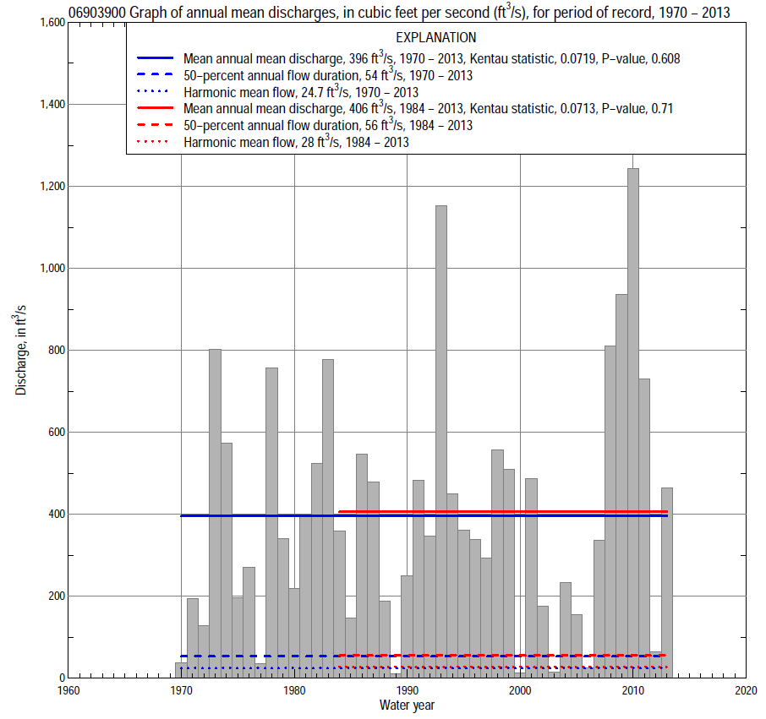

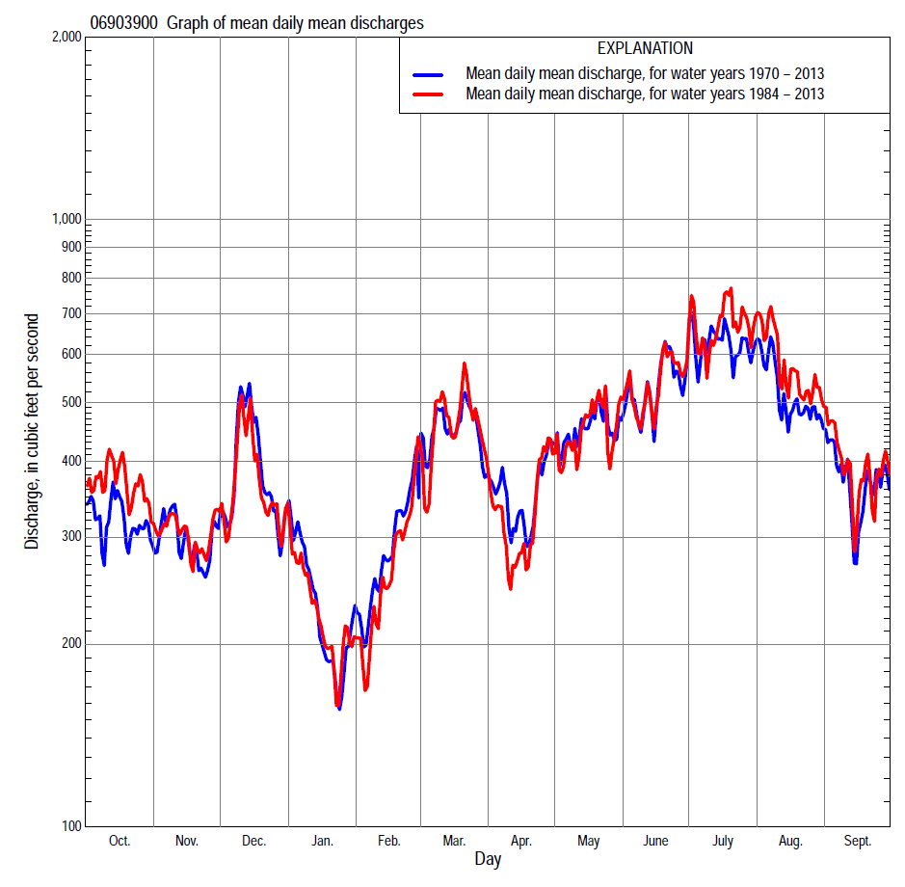

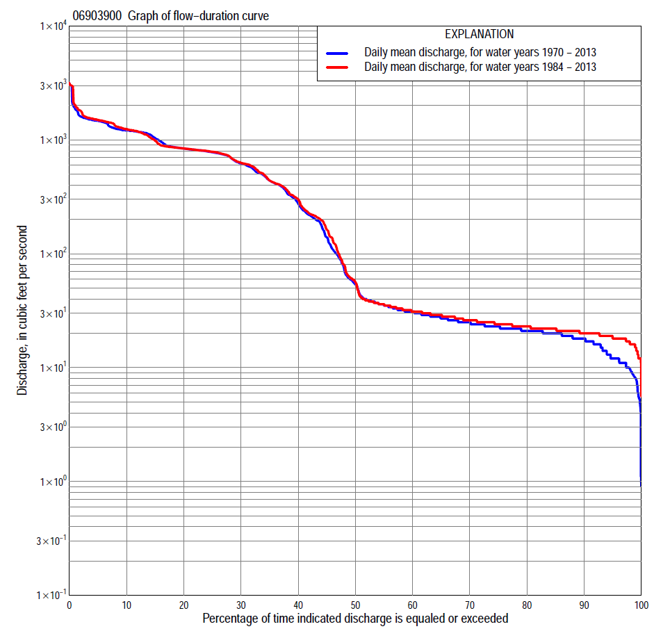
Statistics Based on the Regulated Streamflow Period of Record
06903900 Monthly and annual flow durations, based on 1970–2013 regulated period of record (44 years)
Percentage of days discharge equaled or exceeded |  |  |  |  | Discharge (cubic feet per second) |  |  |  |  |  |  |  |  | Annual flow durations
 | Oct | Nov | Dec | Jan | Feb | Mar | Apr | May | June | July | Aug | Sept | Annual | Kentau statistic | P-value
99 | 9.2 | 9.6 | 5.8 | 8.4 | 4.9 | 8.2 | 5.7 | 11 | 9.6 | 6.7 | 7.9 | 9.0 | 7.7 | 0.459 | 0.000
98 | 10 | 11 | 6.8 | 10 | 7.3 | 9.9 | 11 | 16 | 12 | 7.6 | 9.4 | 9.9 | 9.6 | 0.431 | 0.000
95 | 12 | 13 | 14 | 14 | 12 | 15 | 15 | 18 | 16 | 10 | 11 | 12 | 13 | 0.371 | 0.000
90 | 16 | 16 | 17 | 17 | 17 | 18 | 18 | 21 | 19 | 18 | 16 | 17 | 17 | 0.370 | 0.000
85 | 18 | 17 | 19 | 18 | 18 | 21 | 21 | 23 | 22 | 21 | 19 | 20 | 19 | 0.352 | 0.001
80 | 20 | 19 | 21 | 20 | 20 | 23 | 23 | 25 | 25 | 24 | 21 | 23 | 22 | 0.308 | 0.003
75 | 21 | 20 | 22 | 21 | 22 | 26 | 27 | 27 | 32 | 26 | 24 | 24 | 24 | 0.254 | 0.015
70 | 23 | 22 | 25 | 23 | 24 | 31 | 31 | 33 | 47 | 30 | 26 | 25 | 26 | 0.238 | 0.023
65 | 25 | 24 | 27 | 26 | 26 | 41 | 35 | 52 | 160 | 37 | 28 | 26 | 28 | 0.217 | 0.039
60 | 26 | 25 | 29 | 29 | 28 | 58 | 45 | 149 | 286 | 128 | 32 | 28 | 32 | 0.195 | 0.064
55 | 28 | 27 | 34 | 31 | 31 | 124 | 62 | 253 | 391 | 333 | 37 | 31 | 37 | 0.178 | 0.091
50 | 31 | 29 | 38 | 34 | 34 | 202 | 125 | 362 | 493 | 494 | 57 | 34 | 53 | 0.131 | 0.213
45 | 34 | 32 | 107 | 36 | 37 | 268 | 190 | 492 | 614 | 701 | 207 | 39 | 140 | 0.108 | 0.307
40 | 37 | 36 | 297 | 40 | 51 | 431 | 248 | 611 | 669 | 851 | 348 | 60 | 274 | 0.073 | 0.492
35 | 49 | 63 | 443 | 56 | 104 | 578 | 404 | 669 | 723 | 1,030 | 686 | 225 | 444 | 0.063 | 0.551
30 | 217 | 263 | 576 | 96 | 229 | 712 | 559 | 728 | 778 | 1,140 | 961 | 475 | 623 | 0.075 | 0.479
25 | 477 | 450 | 734 | 218 | 329 | 844 | 666 | 786 | 849 | 1,200 | 1,130 | 663 | 750 | 0.113 | 0.284
20 | 712 | 685 | 938 | 378 | 570 | 990 | 754 | 865 | 945 | 1,260 | 1,210 | 824 | 902 | 0.099 | 0.347
15 | 910 | 899 | 1,140 | 611 | 804 | 1,150 | 868 | 958 | 1,040 | 1,320 | 1,300 | 1,000 | 1,080 | 0.140 | 0.185
10 | 1,080 | 1,100 | 1,290 | 803 | 1,200 | 1,360 | 1,030 | 1,050 | 1,210 | 1,380 | 1,380 | 1,210 | 1,270 | 0.134 | 0.202
5 | 1,620 | 1,380 | 1,490 | 1,480 | 1,540 | 1,620 | 1,320 | 1,410 | 1,560 | 1,620 | 1,700 | 1,500 | 1,540 | 0.141 | 0.182
2 | 2,230 | 1,880 | 1,740 | 1,730 | 1,760 | 1,790 | 1,660 | 1,710 | 1,860 | 1,830 | 2,350 | 1,900 | 1,810 | 0.205 | 0.051
1 | 2,570 | 2,180 | 1,820 | 1,820 | 1,830 | 1,840 | 1,780 | 1,800 | 2,120 | 1,900 | 2,880 | 2,770 | 1,900 | 0.203 | 0.053

06903900 Annual exceedance probability of instantaneous peak discharges, in cubic feet per second (ft³/s), based on an approximate regulated flow frequency methodª, analysis computed using a record length of 34 years (1980–2013)
USACE Regulated Flow Frequency Analysis
[ND, not determined]
Annual exceed-ance probability | Recur-rence interval (years) | Discharge (ft³/s) | 95-percent lower confi-dence interval (ft³/s) | 95-percent upper confi-dence interval (ft³/s)
0.500 | 2 | 1,200 | ND | ND
0.200 | 5 | 1,500 | ND | ND
0.100 | 10 | 1,800 | ND | ND
0.040 | 25 | 3,000 | ND | ND
0.020 | 50 | 5,500 | ND | ND
0.010 | 100 | 10,000 | ND | ND
0.005 | 200 | 17,000 | ND | ND
0.002 | 500 | 30,000 | ND | ND
ªU.S. Army Corps of Engineers, Kansas City District, Hydrologic Engineering Branch, written commun., 2014.
USGS Kendall's Tau Trend Analysis
Kentau statistic |  | 0.141 |  | 0.149
P-value |  | 0.247 |  | 0.157
Begin year |  | 1980 |  | 1970^{b}
End year |  | 2013 |  | 2013^{b}
Number of peaks |  | 34 |  | 44
^{b}Kendall's tau trend analysis computed using the regulated period of record which is not the same period of record used to compute the above regulated flow frequency analysis.

06903900 Annual exceedance probability of high discharges, based on 1970–2013 regulated period of recordª (44 years)
[ND, not determined]
Annual exceedance probability | Recur-rence interval (years) | Maximum average discharge (cubic feet per second) for indicated number of consecutive days
 |  | 1 | 3 | 7 | 15 | 30
0.990 | 1.01 | ND | ND | ND | ND | ND
0.950 | 1.05 | ND | ND | ND | ND | ND
0.900 | 1.11 | ND | ND | ND | ND | ND
0.800 | 1.25 | ND | ND | ND | ND | ND
0.500 | 2 | ND | ND | ND | ND | ND
0.200 | 5 | ND | ND | ND | ND | ND
0.100 | 10 | ND | ND | ND | ND | ND
0.040 | 25 | ND | ND | ND | ND | ND
0.020 | 50 | ND | ND | ND | ND | ND
0.010 | 100 | ND | ND | ND | ND | ND
0.005 | 200 | ND | ND | ND | ND | ND
0.002 | 500 | ND | ND | ND | ND | ND
Kentau statistic |  | 0.123 | 0.140 | 0.195 | 0.249 | 0.178
P-value |  | 0.245 | 0.185 | 0.064 | 0.017 | 0.091
ªContact the U.S. Army Corps of Engineers, Kansas City District, for the annual exceedance probability of high discharges.

 | 06903900 Annual nonexceedance probability of low discharges, based on April 1970 to March 2013 regulated period of record (43 years)
Annual nonexceed-ance probability | Recur-rence interval (years) | Minimum average discharge (cubic feet per second) for indicated number of consecutive days
 |  | 1 | 3 | 7 | 14 | 30 | 60 | 90 | 120 | 183
0.01 | 100 | 0.00 | 1.7 | 2.1 | 4.4 | 4.5 | 4.6 | 4.7 | 4.8 | 5.2
0.02 | 50 | 0.00 | 2.6 | 3.0 | 5.1 | 5.2 | 5.3 | 5.4 | 5.5 | 7.2
0.05 | 20 | 2.2 | 4.7 | 5.0 | 6.6 | 9.0 | 9.1 | 9.2 | 9.3 | 12
0.10 | 10 | 4.7 | 7.3 | 7.4 | 8.4 | 10 | 11 | 11 | 12 | 19
0.20 | 5 | 8.9 | 11 | 11 | 11 | 12 | 14 | 18 | 20 | 34
0.50 | 2 | 17 | 19 | 21 | 21 | 22 | 29 | 49 | 61 | 102
0.80 | 1.25 | 22 | 25 | 32 | 42 | 52 | 84 | 160 | 210 | 324
0.90 | 1.11 | 23 | 26 | 37 | 62 | 93 | 173 | 322 | 424 | 602
0.96 | 1.04 | 24 | 27 | 41 | 96 | 195 | 423 | 722 | 933 | 1,180
0.98 | 1.02 | 24 | 27 | 43 | 129 | 335 | 811 | 1,260 | 1,590 | 1,830
0.99 | 1.01 | 24 | 27 | 45 | 169 | 569 | 1,530 | 2,130 | 2,620 | 2,730
Kentau statistic |  | 0.347 | 0.336 | 0.340 | 0.331 | 0.312 | 0.260 | 0.227 | 0.200 | 0.085
P-value |  | 0.001 | 0.002 | 0.001 | 0.002 | 0.003 | 0.014 | 0.033 | 0.060 | 0.426

06903900 Annual nonexceedance probability of seasonal low discharges, based on October 1969 to September 2013 regulated period of record (44 years)
Annual nonexceed-ance probability | Recur-rence interval (years) | Minimum average discharge (cubic feet per second) for indicated number of consecutive days
 |  | 1 | 7 | 14 | 30 |  | 1 | 7 | 14 | 30
 |  | January-February-March |  |  |  |  | April-May-June
0.01 | 100 | 2.0 | 8.5 | 8.6 | 8.7 |  | 1.1 | 2.4 | 2.8 | 3.0
0.02 | 50 | 3.0 | 9.0 | 9.1 | 9.2 |  | 1.9 | 3.3 | 3.9 | 4.7
0.05 | 20 | 5.4 | 10 | 10 | 10 |  | 3.8 | 5.3 | 6.6 | 9.2
0.10 | 10 | 8.4 | 11 | 11 | 11 |  | 6.4 | 8.2 | 11 | 16
0.20 | 5 | 13 | 14 | 14 | 15 |  | 11 | 14 | 19 | 32
0.50 | 2 | 25 | 25 | 28 | 36 |  | 23 | 38 | 58 | 114
0.80 | 1.25 | 38 | 54 | 74 | 117 |  | 35 | 107 | 187 | 377
0.90 | 1.11 | 43 | 92 | 143 | 247 |  | 39 | 186 | 350 | 689
0.96 | 1.04 | 46 | 177 | 320 | 610 |  | 42 | 336 | 692 | 1,290
0.98 | 1.02 | 48 | 286 | 577 | 1,160 |  | 43 | 495 | 1,080 | 1,910
0.99 | 1.01 | 49 | 456 | 1,020 | 2,170 |  | 44 | 704 | 1,620 | 2,710
Kentau statistic |  | 0.072 | 0.096 | 0.142 | 0.121 |  | 0.319 | 0.098 | 0.104 | 0.123
P-value |  | 0.497 | 0.362 | 0.178 | 0.253 |  | 0.002 | 0.352 | 0.327 | 0.245
 |  | July-August-September |  |  |  |  | October-November-December
0.01 | 100 | 4.0 | 4.1 | 4.2 | 4.3 |  | 0.00 | 5.8 | 5.9 | 6.0
0.02 | 50 | 4.8 | 4.9 | 5.0 | 5.1 |  | 0.00 | 6.3 | 6.4 | 6.5
0.05 | 20 | 6.7 | 6.8 | 6.9 | 7.0 |  | 6.4 | 6.6 | 6.7 | 6.8
0.10 | 10 | 10 | 10 | 10 | 10 |  | 9.0 | 9.4 | 9.5 | 9.5
0.20 | 5 | 14 | 14 | 15 | 18 |  | 12 | 12 | 13 | 15
0.50 | 2 | 20 | 28 | 43 | 66 |  | 20 | 23 | 30 | 45
0.80 | 1.25 | 35 | 86 | 164 | 279 |  | 29 | 60 | 102 | 175
0.90 | 1.11 | 48 | 180 | 376 | 637 |  | 34 | 119 | 224 | 399
0.96 | 1.04 | 70 | 451 | 1,000 | 1,620 |  | 40 | 281 | 594 | 1,050
0.98 | 1.02 | 92 | 876 | 2,000 | 3,070 |  | 43 | 528 | 1,200 | 2,070
0.99 | 1.01 | 119 | 1,680 | 3,860 | 5,560 |  | 46 | 982 | 2,360 | 3,940
Kentau statistic |  | 0.363 | 0.336 | 0.283 | 0.259 |  | 0.338 | 0.317 | 0.188 | 0.127
P-value |  | 0.001 | 0.001 | 0.007 | 0.014 |  | 0.001 | 0.002 | 0.073 | 0.229

Statistics Based on the 1984–2013 Regulated Streamflow Period of Record
06903900 Monthly and annual flow durations, based on 1984–2013 regulated period of record (30 years)
Percentage of days discharge equaled or exceeded |  |  |  |  | Discharge (cubic feet per second) |  |  |  |  |  |  |  |  | Annual flow durations
 | Oct | Nov | Dec | Jan | Feb | Mar | Apr | May | June | July | Aug | Sept | Annual | Kentau statistic | P-value
99 | 14 | 13 | 13 | 16 | 16 | 16 | 16 | 16 | 16 | 17 | 16 | 17 | 16 | 0.239 | 0.065
98 | 16 | 14 | 15 | 16 | 17 | 17 | 16 | 17 | 17 | 17 | 17 | 17 | 16 | 0.234 | 0.070
95 | 17 | 16 | 17 | 17 | 18 | 18 | 18 | 19 | 18 | 19 | 19 | 20 | 18 | 0.172 | 0.185
90 | 19 | 18 | 19 | 19 | 19 | 20 | 20 | 22 | 21 | 22 | 22 | 22 | 20 | 0.163 | 0.210
85 | 21 | 19 | 21 | 20 | 21 | 23 | 22 | 24 | 23 | 24 | 24 | 24 | 22 | 0.177 | 0.174
80 | 22 | 21 | 23 | 21 | 23 | 25 | 24 | 26 | 27 | 26 | 26 | 25 | 24 | 0.207 | 0.112
75 | 24 | 22 | 24 | 23 | 24 | 27 | 26 | 27 | 34 | 29 | 27 | 26 | 25 | 0.193 | 0.137
70 | 25 | 24 | 26 | 25 | 25 | 30 | 29 | 33 | 46 | 35 | 30 | 27 | 27 | 0.172 | 0.186
65 | 27 | 25 | 27 | 27 | 27 | 36 | 33 | 68 | 200 | 44 | 34 | 28 | 30 | 0.122 | 0.353
60 | 28 | 27 | 29 | 29 | 28 | 48 | 36 | 179 | 342 | 175 | 38 | 31 | 33 | 0.094 | 0.475
55 | 30 | 28 | 33 | 31 | 31 | 125 | 45 | 269 | 439 | 346 | 53 | 34 | 37 | 0.053 | 0.694
50 | 33 | 31 | 36 | 33 | 34 | 209 | 60 | 359 | 546 | 538 | 190 | 36 | 53 | 0.062 | 0.642
45 | 35 | 33 | 91 | 36 | 36 | 264 | 146 | 491 | 632 | 748 | 284 | 42 | 163 | 0.071 | 0.592
40 | 37 | 36 | 208 | 38 | 50 | 415 | 212 | 613 | 684 | 997 | 487 | 58 | 286 | 0.071 | 0.592
35 | 115 | 122 | 393 | 54 | 106 | 582 | 263 | 673 | 735 | 1,130 | 837 | 190 | 448 | 0.060 | 0.656
30 | 371 | 368 | 552 | 86 | 224 | 720 | 476 | 733 | 787 | 1,190 | 1,030 | 428 | 636 | 0.097 | 0.464
25 | 650 | 487 | 716 | 237 | 320 | 859 | 614 | 793 | 852 | 1,240 | 1,160 | 699 | 755 | 0.156 | 0.232
20 | 825 | 685 | 874 | 389 | 518 | 1,030 | 706 | 868 | 929 | 1,300 | 1,250 | 842 | 895 | 0.133 | 0.309
15 | 962 | 839 | 1,060 | 620 | 709 | 1,200 | 798 | 949 | 1,010 | 1,350 | 1,340 | 985 | 1,060 | 0.138 | 0.292
10 | 1,100 | 1,000 | 1,260 | 755 | 953 | 1,390 | 1,000 | 1,030 | 1,080 | 1,430 | 1,500 | 1,220 | 1,280 | 0.110 | 0.402
5 | 1,850 | 1,630 | 1,510 | 1,480 | 1,340 | 1,640 | 1,420 | 1,430 | 1,580 | 1,700 | 1,800 | 1,710 | 1,610 | 0.117 | 0.372
2 | 2,420 | 2,070 | 1,750 | 1,730 | 1,670 | 1,800 | 1,710 | 1,710 | 1,990 | 1,870 | 2,730 | 2,580 | 1,850 | 0.228 | 0.080
1 | 2,800 | 2,280 | 1,820 | 1,820 | 1,790 | 1,850 | 1,800 | 1,810 | 2,240 | 2,680 | 3,010 | 2,940 | 2,240 | 0.216 | 0.097

06903900 Annual exceedance probability of high discharges, based on 1984–2013 regulated period of recordª (30 years)
[ND, not determined]
Annual exceedance probability | Recur-rence interval (years) | Maximum average discharge (cubic feet per second) for indicated number of consecutive days
 |  | 1 | 3 | 7 | 15 | 30
0.990 | 1.01 | ND | ND | ND | ND | ND
0.950 | 1.05 | ND | ND | ND | ND | ND
0.900 | 1.11 | ND | ND | ND | ND | ND
0.800 | 1.25 | ND | ND | ND | ND | ND
0.500 | 2 | ND | ND | ND | ND | ND
0.200 | 5 | ND | ND | ND | ND | ND
0.100 | 10 | ND | ND | ND | ND | ND
0.040 | 25 | ND | ND | ND | ND | ND
0.020 | 50 | ND | ND | ND | ND | ND
0.010 | 100 | ND | ND | ND | ND | ND
0.005 | 200 | ND | ND | ND | ND | ND
0.002 | 500 | ND | ND | ND | ND | ND
Kentau statistic |  | 0.186 | 0.202 | 0.218 | 0.255 | 0.200
P-value |  | 0.153 | 0.121 | 0.093 | 0.050 | 0.125
ªContact the U.S. Army Corps of Engineers, Kansas City District, for the annual exceedance probability of high discharges.

 | 06903900 Annual nonexceedance probability of low discharges, based on April 1983 to March 2013 regulated period of record (30 years)
Annual nonexceed-ance probability | Recur-rence interval (years) | Minimum average discharge (cubic feet per second) for indicated number of consecutive days
 |  | 1 | 3 | 7 | 14 | 30 | 60 | 90 | 120 | 183
0.01 | 100 | 6.0 | 10 | 10 | 10 | 10 | 10 | 10 | 10 | 10
0.02 | 50 | 7.0 | 11 | 11 | 11 | 11 | 11 | 11 | 11 | 11
0.05 | 20 | 8.8 | 12 | 12 | 12 | 12 | 12 | 12 | 12 | 12
0.10 | 10 | 11 | 13 | 13 | 14 | 14 | 14 | 15 | 15 | 19
0.20 | 5 | 13 | 14 | 15 | 16 | 16 | 17 | 22 | 25 | 34
0.50 | 2 | 18 | 18 | 19 | 21 | 24 | 32 | 57 | 72 | 105
0.80 | 1.25 | 22 | 25 | 29 | 35 | 49 | 89 | 177 | 231 | 341
0.90 | 1.11 | 25 | 31 | 41 | 53 | 82 | 177 | 342 | 448 | 645
0.96 | 1.04 | 27 | 41 | 64 | 90 | 161 | 421 | 732 | 942 | 1,290
0.98 | 1.02 | 28 | 50 | 89 | 136 | 265 | 793 | 1,230 | 1,550 | 2,040
0.99 | 1.01 | 29 | 60 | 125 | 204 | 436 | 1,480 | 2,010 | 2,470 | 3,110
Kentau statistic |  | 0.205 | 0.170 | 0.202 | 0.186 | 0.159 | 0.122 | 0.099 | 0.080 | 0.076
P-value |  | 0.115 | 0.192 | 0.120 | 0.153 | 0.225 | 0.354 | 0.454 | 0.544 | 0.568

06903900 Annual nonexceedance probability of seasonal low discharges, based on October 1983 to September 2013 regulated period of record (30 years)
Annual nonexceed-ance probability | Recur-rence interval (years) | Minimum average discharge (cubic feet per second) for indicated number of consecutive days
 |  | 1 | 7 | 14 | 30 |  | 1 | 7 | 14 | 30
 |  | January-February-March |  |  |  |  | April-May-June
0.01 | 100 | 7.7 | 9.5 | 10 | 10 |  | 6.8 | 8.2 | 8.3 | 8.4
0.02 | 50 | 8.7 | 10 | 11 | 11 |  | 8.8 | 8.9 | 9.0 | 9.1
0.05 | 20 | 10 | 11 | 12 | 13 |  | 10 | 10 | 11 | 12
0.10 | 10 | 12 | 15 | 15 | 15 |  | 13 | 13 | 14 | 20
0.20 | 5 | 15 | 16 | 17 | 19 |  | 16 | 16 | 21 | 37
0.50 | 2 | 22 | 23 | 26 | 37 |  | 22 | 33 | 51 | 119
0.80 | 1.25 | 34 | 47 | 64 | 107 |  | 32 | 91 | 154 | 366
0.90 | 1.11 | 42 | 85 | 126 | 218 |  | 42 | 174 | 303 | 648
0.96 | 1.04 | 53 | 190 | 311 | 528 |  | 56 | 383 | 671 | 1,180
0.98 | 1.02 | 62 | 355 | 619 | 1,010 |  | 69 | 677 | 1,170 | 1,720
0.99 | 1.01 | 71 | 668 | 1,230 | 1,890 |  | 83 | 1,170 | 1,990 | 2,400
Kentau statistic |  | 0.041 | 0.092 | 0.117 | 0.021 |  | 0.237 | 0.115 | 0.136 | 0.159
P-value |  | 0.761 | 0.486 | 0.372 | 0.887 |  | 0.067 | 0.382 | 0.301 | 0.225
 |  | July-August-September |  |  |  |  | October-November-December
0.01 | 100 | 7.9 | 8.0 | 8.1 | 8.2 |  | 7.7 | 7.8 | 7.9 | 8.0
0.02 | 50 | 12 | 12 | 12 | 12 |  | 11 | 11 | 11 | 11
0.05 | 20 | 14 | 14 | 14 | 14 |  | 12 | 12 | 12 | 12
0.10 | 10 | 15 | 15 | 15 | 15 |  | 13 | 13 | 13 | 13
0.20 | 5 | 17 | 17 | 18 | 25 |  | 16 | 16 | 16 | 17
0.50 | 2 | 21 | 30 | 44 | 76 |  | 21 | 27 | 33 | 48
0.80 | 1.25 | 32 | 80 | 149 | 285 |  | 29 | 70 | 111 | 184
0.90 | 1.11 | 45 | 163 | 332 | 616 |  | 35 | 143 | 248 | 421
0.96 | 1.04 | 69 | 409 | 885 | 1,490 |  | 43 | 357 | 680 | 1,130
0.98 | 1.02 | 95 | 812 | 1,790 | 2,750 |  | 49 | 709 | 1,420 | 2,250
0.99 | 1.01 | 132 | 1,600 | 3,550 | 4,870 |  | 56 | 1,400 | 2,910 | 4,370
Kentau statistic |  | 0.287 | 0.216 | 0.223 | 0.143 |  | 0.154 | 0.140 | 0.090 | 0.044
P-value |  | 0.026 | 0.097 | 0.087 | 0.276 |  | 0.237 | 0.284 | 0.497 | 0.748

