LOCATION.--Lat 40°41'33", long 92°46'20" referenced to North American Datum of 1927, in NW 1/4 SW 1/4 NW 1/4 sec.13, T.68 N., R.17 W., Appanoose County, IA, Hydrologic Unit 10280201, on right bank 6 ft downstream from bridge on County Highway J45 (543rd Street), 5.0 mi west of Moulton, 0.7 mi downstream from Hickory Creek, 21.7 mi downstream from Rathbun Dam, and 8.4 mi upstream from Iowa-Missouri state line.

DRAINAGE AREA.--740 mi².

PERIOD OF RECORD.--Discharge records from August 1979 to current year.

GAGE.--Water stage recorder. Datum of gage is 800.00 ft above National Geodetic Vertical Datum of 1929 (U.S. Army Corps of Engineers benchmark).

REMARKS.--Flow regulated by Rathbun Reservoir (station 06903880), 20.8 mi upstream, since November 21, 1969.

EXTREMES OUTSIDE PERIOD OF RECORD.--Flood in June 1947 reached a stage of about 45 ft, from information by U.S. Army Corps of Engineers, discharge not determined.

A summary of all available data for this streamgage is provided through the USGS National Water Information System web interface (NWISWeb). The following link provides access to current/historical observations, daily data, daily statistics, monthly statistics, annual statistics, peak streamflow, field measurements, field/lab water-quality samples, and the latest water-year summaries. Data can be filtered by parameter and/or dates, and can be output in various tabular and graphical formats.
http://waterdata.usgs.gov/nwis/inventory/?site_no=06904010

The USGS WaterWatch Toolkit is available at:
http://waterwatch.usgs.gov/?id=ww_toolkit
Tools for summarizing streamflow information include the duration hydrograph builder, the cumulative streamflow hydrograph builder, the streamgage statistics retrieval tool, the rating curve builder, the flood tracking chart builder, the National Weather Service Advanced Hydrologic Prediction Service (AHPS) river forecast hydrograph builder, and the raster-hydrograph builder. Entering the above number for this streamgage into these toolkit webpages will provide streamflow information specific to this streamgage.

A description of the statistics presented for this streamgage is available in the main body of the report at:
http://dx.doi.org/10.3133/ofr20151214
A link to other streamgages included in this report, a map showing the location of the streamgages, information on the programs used to compute the statistical analyses, and references are included in the main body of the report.

Statistics Based on the Regulated Streamflow Period of Record

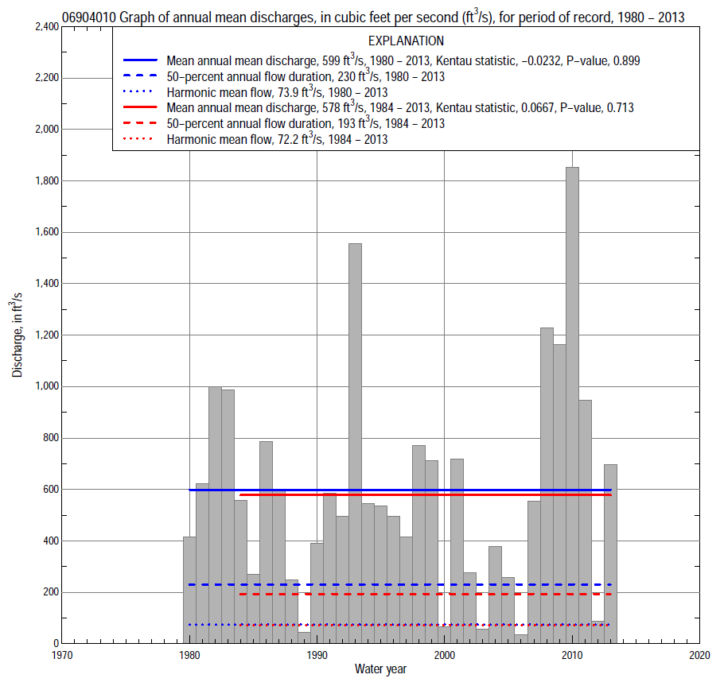

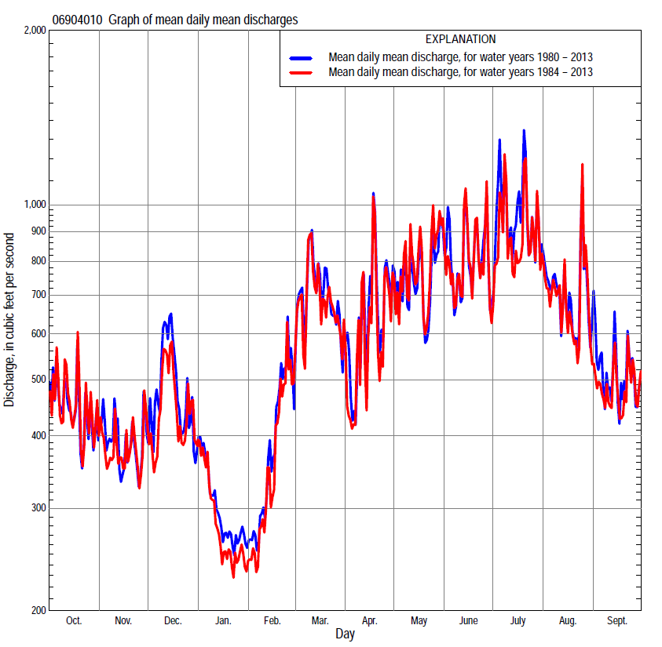

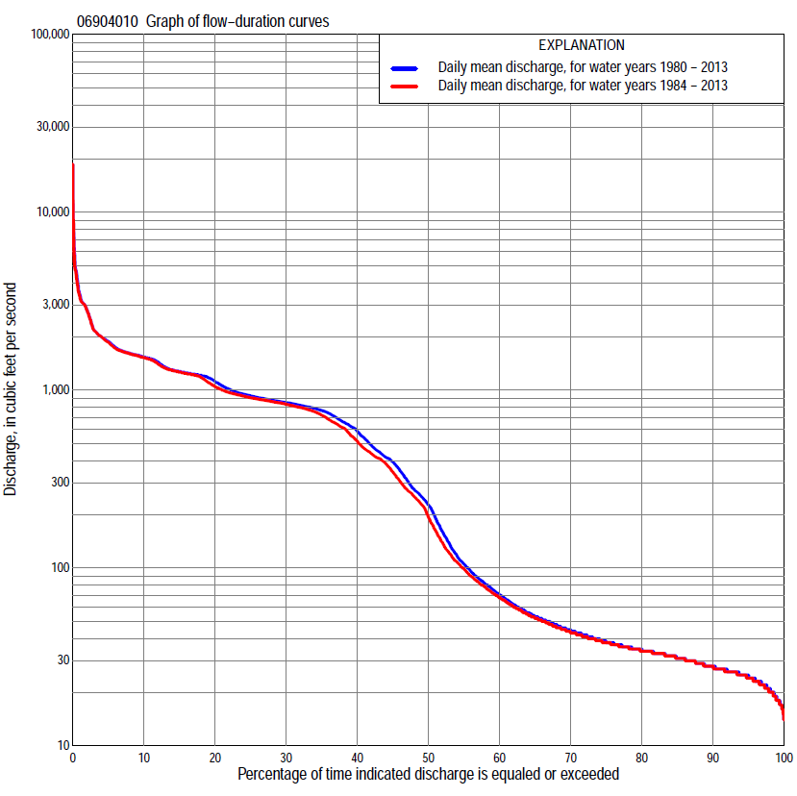

Statistics Based on the Regulated Streamflow Period of Record
06904010 Monthly and annual flow durations, based on 1980–2013 regulated period of record (34 years)
Percentage of days discharge equaled or exceeded |  |  |  |  | Discharge (cubic feet per second) |  |  |  |  |  |  |  |  | Annual flow durations
 | Oct | Nov | Dec | Jan | Feb | Mar | Apr | May | June | July | Aug | Sept | Annual | Kentau statistic | P-value
99 | 19 | 18 | 17 | 20 | 20 | 22 | 23 | 19 | 16 | 17 | 18 | 22 | 18 | 0.159 | 0.191
98 | 22 | 20 | 18 | 21 | 21 | 23 | 23 | 22 | 18 | 18 | 19 | 24 | 21 | 0.139 | 0.252
95 | 24 | 23 | 20 | 25 | 26 | 36 | 35 | 28 | 25 | 23 | 23 | 25 | 25 | 0.087 | 0.475
90 | 26 | 25 | 24 | 28 | 32 | 45 | 40 | 32 | 31 | 27 | 27 | 27 | 28 | 0.103 | 0.397
85 | 28 | 26 | 26 | 30 | 35 | 53 | 46 | 37 | 38 | 32 | 32 | 29 | 31 | 0.066 | 0.593
80 | 29 | 28 | 28 | 33 | 37 | 63 | 53 | 46 | 61 | 40 | 35 | 31 | 35 | 0.021 | 0.870
75 | 31 | 29 | 34 | 35 | 40 | 78 | 61 | 81 | 187 | 50 | 37 | 33 | 39 | -0.007 | 0.964
70 | 32 | 32 | 42 | 38 | 46 | 100 | 73 | 147 | 373 | 106 | 41 | 34 | 45 | -0.045 | 0.722
65 | 33 | 34 | 53 | 41 | 51 | 146 | 89 | 302 | 518 | 350 | 49 | 36 | 54 | -0.027 | 0.836
60 | 35 | 38 | 64 | 45 | 61 | 236 | 130 | 434 | 620 | 539 | 67 | 39 | 71 | -0.037 | 0.767
55 | 38 | 41 | 84 | 48 | 73 | 273 | 227 | 576 | 741 | 765 | 141 | 45 | 107 | -0.012 | 0.929
50 | 45 | 47 | 112 | 52 | 90 | 423 | 278 | 758 | 790 | 834 | 278 | 61 | 230 | -0.027 | 0.836
45 | 55 | 61 | 221 | 60 | 120 | 607 | 483 | 802 | 815 | 1,100 | 527 | 85 | 398 | -0.041 | 0.744
40 | 104 | 112 | 410 | 69 | 182 | 720 | 659 | 852 | 845 | 1,220 | 845 | 248 | 596 | -0.048 | 0.700
35 | 314 | 232 | 500 | 85 | 309 | 850 | 786 | 881 | 862 | 1,240 | 1,040 | 509 | 770 | -0.002 | 1.000
30 | 640 | 469 | 697 | 150 | 443 | 1,040 | 883 | 906 | 900 | 1,280 | 1,190 | 817 | 851 | 0.027 | 0.836
25 | 787 | 795 | 900 | 370 | 613 | 1,230 | 937 | 950 | 950 | 1,300 | 1,220 | 853 | 930 | 0.023 | 0.859
20 | 852 | 882 | 1,050 | 525 | 760 | 1,310 | 1,020 | 987 | 1,000 | 1,350 | 1,260 | 911 | 1,120 | 0.034 | 0.790
15 | 1,000 | 925 | 1,220 | 796 | 895 | 1,530 | 1,300 | 1,210 | 1,280 | 1,520 | 1,330 | 1,230 | 1,270 | 0.007 | 0.965
10 | 1,400 | 1,190 | 1,460 | 1,100 | 1,270 | 1,630 | 1,600 | 1,640 | 1,620 | 1,680 | 1,620 | 1,480 | 1,530 | 0.000 | 1.000
5 | 1,980 | 1,600 | 1,570 | 1,550 | 1,620 | 1,870 | 1,950 | 2,200 | 2,200 | 2,500 | 2,030 | 1,960 | 1,880 | 0.030 | 0.812
2 | 2,860 | 2,020 | 1,670 | 1,640 | 1,890 | 2,430 | 2,850 | 3,190 | 3,370 | 4,090 | 3,070 | 3,180 | 2,810 | -0.002 | 1.000
1 | 3,100 | 2,100 | 1,880 | 1,700 | 2,190 | 3,120 | 3,970 | 4,300 | 4,470 | 7,230 | 3,190 | 3,870 | 3,430 | -0.005 | 0.976

06904010 Annual exceedance probability of instantaneous peak discharges, based on 1980–2013 regulated period of recordª, in cubic feet per second (ft³/s)
[ND, not determined]
Annual exceed-ance probability | Recur-rence interval (years) | Discharge (ft³/s) | 95-percent lower confi-dence interval (ft³/s) | 95-percent upper confi-dence interval (ft³/s)
0.500 | 2 | ND | ND | ND
0.200 | 5 | ND | ND | ND
0.100 | 10 | ND | ND | ND
0.040 | 25 | ND | ND | ND
0.020 | 50 | ND | ND | ND
0.010 | 100 | ND | ND | ND
0.005 | 200 | ND | ND | ND
0.002 | 500 | ND | ND | ND
Kentau statistic |  | 0.005
P-value |  | 0.976
Begin year |  | 1980^{b}
End year |  | 2013^{b}
Number of peaks |  | 34
ªContact the U.S. Army Corps of Engineers, Kansas City District, for the annual exceedance probability of instantaneous peak discharges.
^{b}Kendall's tau trend analysis computed using the regulated period of record.

06904010 Annual exceedance probability of high discharges, based on 1980–2013 regulated period of recordª (34 years)
[ND, not determined]
Annual exceedance probability | Recur-rence interval (years) | Maximum average discharge (cubic feet per second) for indicated number of consecutive days
 |  | 1 | 3 | 7 | 15 | 30
0.990 | 1.01 | ND | ND | ND | ND | ND
0.950 | 1.05 | ND | ND | ND | ND | ND
0.900 | 1.11 | ND | ND | ND | ND | ND
0.800 | 1.25 | ND | ND | ND | ND | ND
0.500 | 2 | ND | ND | ND | ND | ND
0.200 | 5 | ND | ND | ND | ND | ND
0.100 | 10 | ND | ND | ND | ND | ND
0.040 | 25 | ND | ND | ND | ND | ND
0.020 | 50 | ND | ND | ND | ND | ND
0.010 | 100 | ND | ND | ND | ND | ND
0.005 | 200 | ND | ND | ND | ND | ND
0.002 | 500 | ND | ND | ND | ND | ND
Kentau statistic |  | -0.027 | -0.048 | -0.023 | 0.009 | 0.048
P-value |  | 0.836 | 0.700 | 0.859 | 0.953 | 0.700
ªContact the U.S. Army Corps of Engineers, Kansas City District, for the annual exceedance probability of high discharges.

 | 06904010 Annual nonexceedance probability of low discharges, based on April 1980 to March 2013 regulated period of record (33 years)
Annual nonexceed-ance probability | Recur-rence interval (years) | Minimum average discharge (cubic feet per second) for indicated number of consecutive days
 |  | 1 | 3 | 7 | 14 | 30 | 60 | 90 | 120 | 183
0.01 | 100 | 8.3 | 8.3 | 8.3 | 8.3 | 8.3 | 8.3 | 8.3 | 8.3 | 8.3
0.02 | 50 | 11 | 11 | 11 | 11 | 11 | 11 | 11 | 11 | 12
0.05 | 20 | 15 | 16 | 17 | 17 | 17 | 17 | 17 | 17 | 20
0.10 | 10 | 16 | 17 | 18 | 19 | 19 | 19 | 22 | 26 | 32
0.20 | 5 | 18 | 19 | 20 | 20 | 22 | 26 | 35 | 43 | 57
0.50 | 2 | 25 | 26 | 28 | 30 | 37 | 54 | 93 | 122 | 172
0.80 | 1.25 | 39 | 41 | 49 | 63 | 89 | 154 | 280 | 373 | 518
0.90 | 1.11 | 53 | 57 | 71 | 108 | 163 | 304 | 526 | 688 | 921
0.96 | 1.04 | 77 | 86 | 116 | 221 | 351 | 703 | 1,070 | 1,350 | 1,700
0.98 | 1.02 | 100 | 116 | 165 | 379 | 617 | 1,280 | 1,740 | 2,120 | 2,530
0.99 | 1.01 | 129 | 156 | 235 | 650 | 1,070 | 2,300 | 2,740 | 3,210 | 3,610
Kentau statistic |  | 0.131 | 0.155 | 0.106 | 0.087 | 0.027 | 0.008 | -0.080 | -0.114 | -0.117
P-value |  | 0.291 | 0.209 | 0.394 | 0.486 | 0.840 | 0.963 | 0.525 | 0.361 | 0.345

06904010 Annual nonexceedance probability of seasonal low discharges, based on October 1979 to September 2013 regulated period of record (34 years)
Annual nonexceed-ance probability | Recur-rence interval (years) | Minimum average discharge (cubic feet per second) for indicated number of consecutive days
 |  | 1 | 7 | 14 | 30 |  | 1 | 7 | 14 | 30
 |  | January-February-March |  |  |  |  | April-May-June
0.01 | 100 | 14 | 14 | 14 | 14 |  | 8.0 | 8.0 | 8.0 | 8.0
0.02 | 50 | 18 | 18 | 18 | 18 |  | 9.9 | 9.9 | 9.9 | 9.9
0.05 | 20 | 21 | 21 | 21 | 21 |  | 14 | 14 | 14 | 18
0.10 | 10 | 22 | 22 | 22 | 22 |  | 19 | 19 | 23 | 33
0.20 | 5 | 23 | 26 | 26 | 30 |  | 25 | 30 | 40 | 69
0.50 | 2 | 34 | 39 | 47 | 64 |  | 50 | 79 | 122 | 248
0.80 | 1.25 | 73 | 88 | 124 | 189 |  | 120 | 249 | 392 | 761
0.90 | 1.11 | 135 | 164 | 244 | 385 |  | 205 | 487 | 734 | 1,290
0.96 | 1.04 | 304 | 370 | 575 | 921 |  | 385 | 1,050 | 1,450 | 2,180
0.98 | 1.02 | 569 | 686 | 1,080 | 1,730 |  | 600 | 1,790 | 2,270 | 2,980
0.99 | 1.01 | 1,070 | 1,270 | 2,030 | 3,180 |  | 914 | 2,960 | 3,410 | 3,900
Kentau statistic |  | -0.011 | -0.032 | -0.032 | -0.023 |  | 0.143 | 0.094 | 0.112 | 0.159
P-value |  | 0.941 | 0.801 | 0.801 | 0.859 |  | 0.241 | 0.441 | 0.358 | 0.192
 |  | July-August-September |  |  |  |  | October-November-December
0.01 | 100 | 9.1 | 9.1 | 9.1 | 9.1 |  | 10 | 10 | 10 | 10
0.02 | 50 | 10 | 10 | 10 | 10 |  | 11 | 11 | 11 | 11
0.05 | 20 | 12 | 12 | 12 | 12 |  | 12 | 12 | 12 | 12
0.10 | 10 | 15 | 15 | 16 | 19 |  | 15 | 15 | 15 | 15
0.20 | 5 | 20 | 21 | 25 | 35 |  | 19 | 19 | 21 | 25
0.50 | 2 | 33 | 54 | 75 | 125 |  | 32 | 42 | 55 | 75
0.80 | 1.25 | 95 | 203 | 307 | 510 |  | 71 | 135 | 194 | 287
0.90 | 1.11 | 211 | 488 | 735 | 1,130 |  | 122 | 292 | 430 | 639
0.96 | 1.04 | 615 | 1,430 | 2,070 | 2,750 |  | 239 | 763 | 1,120 | 1,620
0.98 | 1.02 | 1,390 | 3,120 | 4,300 | 5,010 |  | 388 | 1,540 | 2,220 | 3,100
0.99 | 1.01 | 3,130 | 6,640 | 8,650 | 8,760 |  | 624 | 3,040 | 4,280 | 5,720
Kentau statistic |  | 0.091 | 0.070 | 0.077 | -0.005 |  | 0.091 | 0.005 | 0.002 | -0.030
P-value |  | 0.457 | 0.573 | 0.534 | 0.976 |  | 0.458 | 0.976 | 1.000 | 0.813

Statistics Based on the 1984–2013 Regulated Streamflow Period of Record
06904010 Monthly and annual flow durations, based on 1984–2013 regulated period of record (30 years)
Percentage of days discharge equaled or exceeded |  |  |  |  | Discharge (cubic feet per second) |  |  |  |  |  |  |  |  | Annual flow durations
 | Oct | Nov | Dec | Jan | Feb | Mar | Apr | May | June | July | Aug | Sept | Annual | Kentau statistic | P-value
99 | 19 | 18 | 17 | 20 | 20 | 21 | 23 | 19 | 16 | 17 | 18 | 22 | 18 | 0.191 | 0.142
98 | 22 | 19 | 18 | 20 | 20 | 23 | 23 | 22 | 17 | 18 | 19 | 24 | 20 | 0.175 | 0.179
95 | 24 | 22 | 20 | 25 | 29 | 35 | 34 | 27 | 24 | 23 | 22 | 25 | 24 | 0.117 | 0.371
90 | 26 | 25 | 25 | 28 | 34 | 44 | 39 | 32 | 30 | 27 | 27 | 27 | 28 | 0.115 | 0.381
85 | 27 | 26 | 26 | 31 | 35 | 55 | 44 | 39 | 35 | 30 | 33 | 30 | 31 | 0.055 | 0.681
80 | 29 | 27 | 28 | 33 | 38 | 63 | 51 | 54 | 47 | 38 | 35 | 31 | 34 | 0.032 | 0.816
75 | 30 | 29 | 34 | 36 | 42 | 79 | 57 | 96 | 98 | 44 | 37 | 33 | 38 | 0.011 | 0.943
70 | 32 | 31 | 41 | 40 | 47 | 99 | 67 | 198 | 307 | 59 | 40 | 34 | 43 | -0.041 | 0.761
65 | 33 | 33 | 50 | 42 | 52 | 128 | 78 | 342 | 469 | 185 | 46 | 36 | 52 | -0.011 | 0.943
60 | 34 | 37 | 60 | 45 | 63 | 222 | 100 | 468 | 604 | 412 | 58 | 38 | 68 | -0.021 | 0.886
55 | 36 | 40 | 80 | 49 | 76 | 259 | 155 | 647 | 713 | 618 | 117 | 41 | 99 | 0.016 | 0.915
50 | 41 | 46 | 109 | 54 | 95 | 387 | 245 | 767 | 798 | 790 | 256 | 49 | 193 | 0.011 | 0.943
45 | 55 | 56 | 173 | 65 | 120 | 520 | 323 | 813 | 826 | 1,040 | 378 | 72 | 345 | 0.025 | 0.858
40 | 120 | 115 | 350 | 72 | 180 | 693 | 567 | 863 | 852 | 1,220 | 661 | 97 | 514 | 0.021 | 0.887
35 | 322 | 234 | 456 | 94 | 287 | 831 | 735 | 886 | 880 | 1,240 | 1,010 | 307 | 721 | 0.074 | 0.580
30 | 640 | 464 | 650 | 163 | 420 | 1,010 | 828 | 912 | 923 | 1,280 | 1,170 | 627 | 831 | 0.126 | 0.335
25 | 775 | 750 | 799 | 362 | 532 | 1,230 | 909 | 954 | 958 | 1,300 | 1,210 | 823 | 904 | 0.129 | 0.326
20 | 849 | 869 | 945 | 490 | 732 | 1,290 | 996 | 1,010 | 1,040 | 1,340 | 1,250 | 868 | 1,050 | 0.131 | 0.318
15 | 884 | 902 | 1,190 | 700 | 847 | 1,530 | 1,220 | 1,360 | 1,310 | 1,500 | 1,290 | 990 | 1,260 | 0.090 | 0.498
10 | 1,500 | 1,010 | 1,330 | 936 | 1,200 | 1,630 | 1,580 | 1,680 | 1,670 | 1,650 | 1,610 | 1,490 | 1,520 | 0.078 | 0.556
5 | 2,020 | 1,610 | 1,530 | 1,480 | 1,580 | 1,830 | 1,860 | 2,320 | 2,200 | 2,030 | 2,030 | 1,960 | 1,850 | 0.126 | 0.335
2 | 3,030 | 2,020 | 1,590 | 1,650 | 1,750 | 2,430 | 2,790 | 3,240 | 3,230 | 3,400 | 3,080 | 3,140 | 2,810 | 0.136 | 0.301
1 | 3,120 | 2,050 | 1,680 | 1,730 | 1,940 | 3,120 | 3,730 | 4,490 | 4,110 | 5,230 | 3,520 | 3,870 | 3,310 | 0.177 | 0.175

06904010 Annual exceedance probability of high discharges, based on 1984–2013 regulated period of recordª (30 years)
[ND, not determined]
Annual exceedance probability | Recur-rence interval (years) | Maximum average discharge (cubic feet per second) for indicated number of consecutive days
 |  | 1 | 3 | 7 | 15 | 30
0.990 | 1.01 | ND | ND | ND | ND | ND
0.950 | 1.05 | ND | ND | ND | ND | ND
0.900 | 1.11 | ND | ND | ND | ND | ND
0.800 | 1.25 | ND | ND | ND | ND | ND
0.500 | 2 | ND | ND | ND | ND | ND
0.200 | 5 | ND | ND | ND | ND | ND
0.100 | 10 | ND | ND | ND | ND | ND
0.040 | 25 | ND | ND | ND | ND | ND
0.020 | 50 | ND | ND | ND | ND | ND
0.010 | 100 | ND | ND | ND | ND | ND
0.005 | 200 | ND | ND | ND | ND | ND
0.002 | 500 | ND | ND | ND | ND | ND
Kentau statistic |  | 0.136 | 0.131 | 0.149 | 0.177 | 0.191
P-value |  | 0.301 | 0.318 | 0.254 | 0.175 | 0.143
ªContact the U.S. Army Corps of Engineers, Kansas City District, for the annual exceedance probability of high discharges.

 | 06904010 Annual nonexceedance probability of low discharges, based on April 1983 to March 2013 regulated period of record (30 years)
Annual nonexceed-ance probability | Recur-rence interval (years) | Minimum average discharge (cubic feet per second) for indicated number of consecutive days
 |  | 1 | 3 | 7 | 14 | 30 | 60 | 90 | 120 | 183
0.01 | 100 | 7.4 | 7.5 | 7.6 | 7.7 | 7.8 | 7.9 | 8.0 | 8.1 | 8.2
0.02 | 50 | 9.8 | 9.9 | 10 | 10 | 10 | 10 | 11 | 11 | 11
0.05 | 20 | 13 | 14 | 14 | 14 | 15 | 15 | 15 | 17 | 19
0.10 | 10 | 17 | 17 | 18 | 18 | 18 | 19 | 21 | 24 | 29
0.20 | 5 | 18 | 19 | 20 | 21 | 22 | 25 | 32 | 39 | 51
0.50 | 2 | 24 | 25 | 28 | 29 | 36 | 49 | 81 | 105 | 150
0.80 | 1.25 | 39 | 41 | 45 | 55 | 78 | 136 | 244 | 317 | 455
0.90 | 1.11 | 53 | 58 | 63 | 86 | 134 | 265 | 467 | 592 | 823
0.96 | 1.04 | 78 | 88 | 96 | 155 | 264 | 606 | 985 | 1,190 | 1,560
0.98 | 1.02 | 103 | 121 | 130 | 240 | 435 | 1,100 | 1,650 | 1,910 | 2,380
0.99 | 1.01 | 135 | 164 | 176 | 371 | 710 | 1,980 | 2,660 | 2,960 | 3,480
Kentau statistic |  | 0.200 | 0.211 | 0.168 | 0.195 | 0.136 | 0.113 | 0.011 | -0.021 | -0.030
P-value |  | 0.125 | 0.104 | 0.199 | 0.134 | 0.301 | 0.392 | 0.943 | 0.887 | 0.830

06904010 Annual nonexceedance probability of seasonal low discharges, based on October 1983 to September 2013 regulated period of record (30 years)
Annual nonexceed-ance probability | Recur-rence interval (years) | Minimum average discharge (cubic feet per second) for indicated number of consecutive days
 |  | 1 | 7 | 14 | 30 |  | 1 | 7 | 14 | 30
 |  | January-February-March |  |  |  |  | April-May-June
0.01 | 100 | 15 | 15 | 15 | 15 |  | 8.7 | 8.7 | 8.7 | 8.7
0.02 | 50 | 16 | 16 | 16 | 16 |  | 11 | 11 | 11 | 11
0.05 | 20 | 20 | 20 | 20 | 20 |  | 14 | 14 | 14 | 17
0.10 | 10 | 21 | 24 | 23 | 23 |  | 19 | 20 | 23 | 33
0.20 | 5 | 23 | 26 | 27 | 31 |  | 25 | 30 | 40 | 69
0.50 | 2 | 35 | 39 | 47 | 64 |  | 49 | 76 | 120 | 251
0.80 | 1.25 | 79 | 88 | 116 | 180 |  | 119 | 234 | 379 | 777
0.90 | 1.11 | 148 | 166 | 222 | 352 |  | 206 | 457 | 706 | 1,320
0.96 | 1.04 | 342 | 386 | 510 | 797 |  | 397 | 994 | 1,390 | 2,210
0.98 | 1.02 | 648 | 738 | 948 | 1,430 |  | 631 | 1,700 | 2,170 | 3,020
0.99 | 1.01 | 1,230 | 1,410 | 1,750 | 2,530 |  | 983 | 2,830 | 3,250 | 3,940
Kentau statistic |  | -0.064 | -0.064 | -0.080 | -0.085 |  | 0.182 | 0.117 | 0.145 | 0.191
P-value |  | 0.630 | 0.630 | 0.544 | 0.521 |  | 0.164 | 0.372 | 0.269 | 0.143
 |  | July-August-September |  |  |  |  | October-November-December
0.01 | 100 | 11 | 11 | 11 | 11 |  | 10 | 10 | 10 | 10
0.02 | 50 | 12 | 12 | 12 | 12 |  | 11 | 11 | 11 | 11
0.05 | 20 | 13 | 13 | 13 | 13 |  | 12 | 12 | 12 | 12
0.10 | 10 | 16 | 16 | 16 | 19 |  | 15 | 15 | 15 | 15
0.20 | 5 | 19 | 20 | 23 | 32 |  | 18 | 19 | 21 | 24
0.50 | 2 | 31 | 44 | 60 | 104 |  | 32 | 41 | 54 | 70
0.80 | 1.25 | 88 | 158 | 232 | 416 |  | 73 | 129 | 189 | 269
0.90 | 1.11 | 203 | 384 | 566 | 938 |  | 128 | 279 | 416 | 604
0.96 | 1.04 | 631 | 1,180 | 1,690 | 2,390 |  | 257 | 733 | 1,070 | 1,560
0.98 | 1.02 | 1,510 | 2,700 | 3,710 | 4,550 |  | 427 | 1,480 | 2,110 | 3,020
0.99 | 1.01 | 3,610 | 6,080 | 7,980 | 8,330 |  | 699 | 2,950 | 4,030 | 5,660
Kentau statistic |  | 0.211 | 0.186 | 0.205 | 0.090 |  | 0.122 | 0.039 | 0.030 | 0.002
P-value |  | 0.103 | 0.154 | 0.116 | 0.498 |  | 0.352 | 0.775 | 0.830 | 1.000

