Revision History for OFR 2016-1154

Josh Adams, Emily C. Kelsey, Jonathan J. Felis, and David M. Pereksta

Collision and Displacement Vulnerability among Marine Birds of the California Current System Associated with Offshore Wind Energy Infrastructure
-----------------------------------------------------
Posted online October 27, 2016
-----------------------------------------------------
Revised and reposted July 28, 2017

Statement of Updates:
In the first published version of this OFR (Adams and others, 2016), there were some minor errors in values and calculations. Here we outline these errors and provide the updated, accurate values. The errors found were three-fold.

(1) Small errors occurred in reported metric values for four species: Western Gull, Black Skimmer, Surf Scoter, and Red-throated Loon.

In the Population Vulnerability (PV) calculation, Breeding Score (BR) recorded for Western Gull was updated because the original score was inaccurate. The update to Western Gull BR, and the resulting changes to Population Vulnerability (PV), Population Collision Vulnerability (PCV), and Population Displacement Vulnerability (PDV) are outlined in table A.

Similarly, for Black Skimmer, Annual Occurrence in the CCS (AO) was updated because the original score was erroneous. The update to Black Skimmer AO, and the resulting changes to PV, PCV, and PDV are outlined in table B.

In the Collision Vulnerability (CV) calculation, the Diurnal Flight Activity (DFA) score for Surf Scoter was updated with better understanding of the species’ flight behavior. The update to DFA, which had minimal effect on CV and PCV due to the structure of the calculation, is outlined in table C. For Red-throated Loon, the Percent Time Spent in the Rotor Sweep Zone (RSZt) was corrected because the original value did not fit within our set scoring parameters. The change in RSZt, and the resulting changes in CV and PCV are outlined in table 4. Changes to metric values for these species has been updated in the appendix tables of the OFR. Changes to PCV and PDV for Western Gull, Black Skimmer, and Red-throated Loon are also seen in figure 3 of the OFR; PCV Best Estimate did not change for the Surf Scoter. These changes to OFR figure 3 are depicted here in figure A.

Table A. The “BR Score” for Western Gull was incorrect. Here is the updated BR for Western Gull and the resulting changes in PV, PCV, and PDV. These changes are updated in figure 3, table 4, and table 7 of the OFR.

Western Gull | BR Score | PV Lower | PV Best-Estimate | PV Upper | PCV  Lower | PCV Best-Estimate | PCV Upper | PDV Lower | PDV Best-Estimate | PDV Upper
original | 1 | 9.6 | 16.0 | 20.4 | 63.4 | 144.0 | 265.2 | 18.2 | 64.0 | 124.4
update | 2 | 10.6 | 19.0 | 25.4 | 69.9 | 171.0 | 330.2 | 21.2 | 76.0 | 162.6

Table B. The “AO Score” for Black Skimmer was incorrect. Here is the updated AO for Black Skimmer and the resulting changes in PV, PCV, and PDV. These changes are updated in figure 3, table 4, and table 7 of the OFR.

Black Skimmer | AO Score | PV Lower | PV Best-Estimate | PV Upper | PCV Best-Estimate | PCV Upper | PCV Upper | PDV Lower | PDV Best-Estimate | PDV Upper
original | 1 | 11.2 | 15.0 | 17.3 | 56.0 | 135.0 | 224.9 | 56.0 | 135.0 | 190.3
update | 2 | 12.8 | 17.0 | 19.7 | 64.0 | 153.0 | 256.1 | 64.0 | 153.0 | 197.0

Table C. The “DFA_Score” for Surf Scoter in was incorrect. Here is the updated DFA for Surf Scoter and the resulting changes in CV and PCV. These changes are updated in table 5 and table 7 of the OFR.

Surf Scoter | DFA Score | DFA Uncertainty | DFA Lower | DFA Upper | CV Lower | CV Best-Estimate | CV Upper | PCV Lower | PCV Best-Estimate | PCV Upper
original | 2.0 | 2.0 | 1.0 | 4.0 | 3.7 | 7.0 | 12.0 | 25.7 | 84.0 | 216.0
update | 3.0 | 2.0 | 1.0 | 5.0 | 3.7 | 7.0 | 11.3 | 25.7 | 84.0 | 204.0

TableD. The “RSZt Score” for Red-throated Loon was incorrect. Here is the updated RSZt for Red-throated Loon and the resulting changes in CV and PCV. These changes are updated of figure 3, table 5, and Table 7 in the OFR.

Red-throated Loon | RSZt Score | RSZt Uncertainty | RSZt Lower | RSZt Upper | CV Lower | CV Best-Estimate | CV Upper | PCV Lower | PCV Best-Estimate | PCV Upper
original | 2.0 | 2.0 | 1.0 | 4.0 | 3.0 | 4.3 | 8.9 | 28.5 | 56.3 | 146.9
update | 3.0 | 2.0 | 1.0 | 5.0 | 3.0 | 5.3 | 8.7 | 28.5 | 69.3 | 144.1

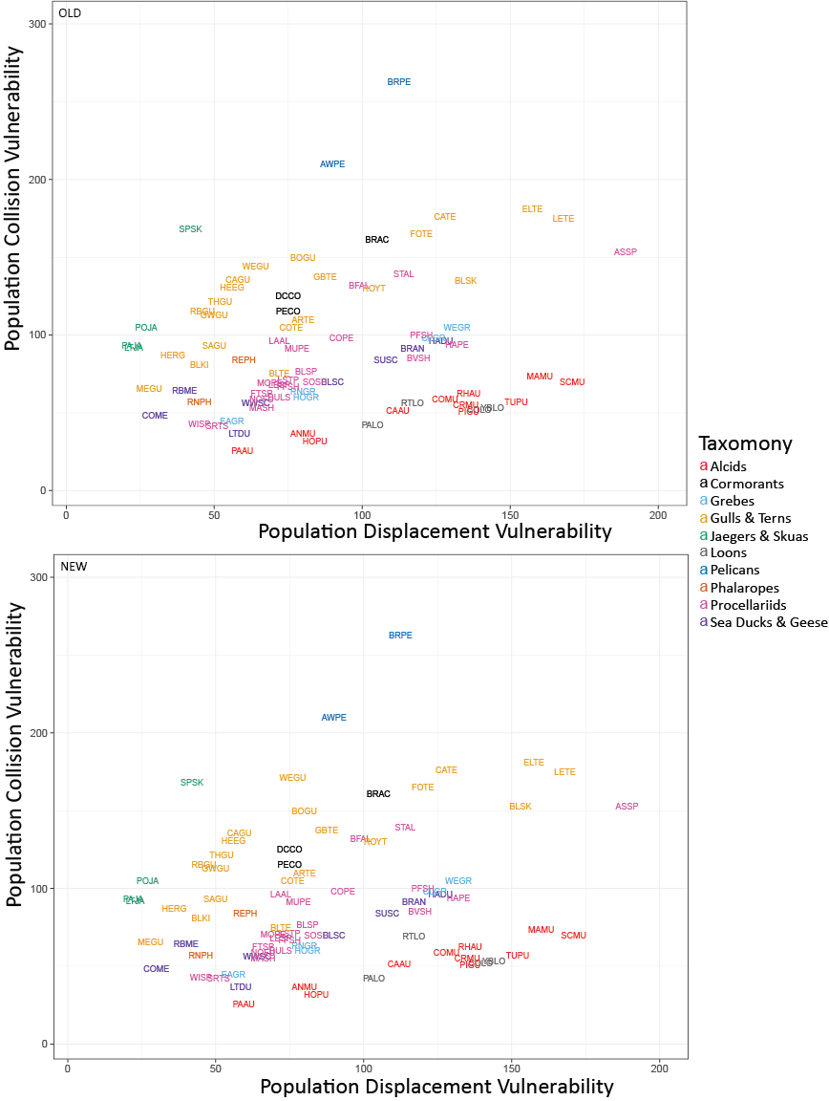

Figure A. Comparison between original OFR figure 3 (upper panel) and current, updated figure 3 (bottom panel). Changes can be seen in the plots of Western Gull (WEGU), Black Skimmer (BLSK), and Red-throated Loon (RTLO). Final values did not change for Surf Scoter.

(2) Errors occurred uncertainty scores and relative rankings.

These errors had minimal impact on the OFR outcomes, as they did not impact the more meaningful “best estimate” scores. Calculation errors occurred in the uncertainty calculations for Global Population Size (POP), Flight Activity, and Habitat Flexibility (HF). For POP in the PV calculation, the lower POP value was corrected because the lower “cap” was missing (values erroneously fell below 1). This error had no effect on PV, CV, DV, PCV and PDV “best estimate” scores, but the final “PV Lower,” “PCV Lower,” and “PDV Lower” were corrected for 20 species (table E). For weighted flight activity (the calculation of Diurnal Flight Activity [DFA] and Nocturnal Flight Activity [(NFA]), there was an error in how the upper uncertainty was calculated. This error affected the upper uncertainty for 32 species but had no affect on PV, CV, DV, PCV, and PDV “best estimate” scores. For HF, there was an error in the uncertainty calculation for 74 of the 81 species. This error had no affect on PV, CV, DV, PCV, and PDV “best estimate” scores.

Table E. The species for which “POP Lower” was incorrect. The updated columns show the updated values for “POP Lower” as well as the resulting updates to “PV Lower,” “PCV Lower,” and “PDV Lower.” These changes are corrected in table 4 and table 7 in the revised OFR.

Species Name | POP Lower |  | PV Lower |  | PCV Lower |  | PDV Lower
 | original | updated | original | updated | original | updated | original | updated
White-winged Scoter | 0.0 | 1.0 | 3.5 | 4.5 | 14.0 | 18.0 | 19.3 | 22.5
Long-tailed Duck | 0.6 | 1.0 | 6.1 | 6.5 | 24.4 | 26.0 | 46.4 | 49.4
Eared Grebe | 0.6 | 1.0 | 4.6 | 5.0 | 13.8 | 15.0 | 20.7 | 20.0
Northern Fulmar | 0.6 | 1.0 | 8.2 | 8.6 | 35.5 | 37.3 | 40.2 | 43.0
Sooty Shearwater | 0.6 | 1.0 | 9.6 | 10.0 | 38.4 | 40.0 | 47.0 | 50.0
Short-tailed Shearwater | 0.6 | 1.0 | 6.1 | 6.5 | 18.3 | 19.5 | 21.4 | 26.0
Wilson's Storm-Petrel | 0.6 | 1.0 | 6.1 | 6.5 | 28.5 | 30.3 | 27.5 | 32.5
Fork-tailed Storm-Petrel | 0.0 | 1.0 | 7.0 | 8.0 | 25.7 | 29.3 | 24.5 | 32.0
Leach's Storm-Petrel | 0.6 | 1.0 | 6.6 | 7.0 | 30.8 | 32.7 | 32.3 | 35.0
Red-necked Phalarope | 0.6 | 1.0 | 7.1 | 7.5 | 21.3 | 22.5 | 17.8 | 15.0
Pomarine Jaeger | 0.0 | 1.0 | 3.5 | 4.5 | 31.5 | 40.5 | 7.0 | 9.0
Parasitic Jaeger | 0.0 | 1.0 | 4.5 | 5.5 | 43.5 | 53.2 | 12.6 | 14.3
Long-tailed Jaeger | 0.0 | 1.0 | 4.5 | 5.5 | 45.0 | 55.0 | 9.0 | 11.0
Common Murre | 0.6 | 1.0 | 12.8 | 13.2 | 38.4 | 39.6 | 93.4 | 95.0
Cassin's Auklet | 0.0 | 1.0 | 7.0 | 8.0 | 21.0 | 24.0 | 43.8 | 48.0
Tufted Puffin | 0.0 | 1.0 | 12.5 | 13.5 | 37.5 | 40.5 | 78.1 | 81.0
Black-legged Kittiwake | 0.6 | 1.0 | 6.0 | 6.4 | 42.0 | 44.8 | 16.8 | 16.6
Mew Gull | 0.0 | 1.0 | 3.5 | 4.5 | 21.0 | 27.0 | 5.3 | 9.0
Herring Gull | 0.0 | 1.0 | 4.0 | 5.0 | 29.1 | 36.3 | 7.6 | 10.0
Black Tern | 0.0 | 1.0 | 5.0 | 6.0 | 30.0 | 36.0 | 26.3 | 30.0

PCV Rank and PDV Rank classified vulnerability scores as ‘high’, ‘medium’, or ‘low’ vulnerability based on if they were in the bottom, middle, or top one-third of all scores (table 7 in the OFR). Post-publication we realized that some of the rank categories in columns were erroneous. Errors in PCV Rank and PDV Rank resulted from not re-calculating rankings after changes were made to the array of updated values for PCV and PDV (see Red-throated Loon and Western Gull above; table E). Similar errors were also seen in Population Uncertainty Rank, Collision Uncertainty Rank, and Displacement Uncertainty Rank—the relative uncertainty rankings that were used to classify uncertainty levels for species’ PV, CV, and DV as ‘high’, ‘medium’, or ‘low’ based on if they were in the bottom, middle, or top one-third of all uncertainty ranges (tables 7 and 8 of the OFR). These changes have no effect on PV, CV, DV, PCV, and PDV “best estimate” scores. We have revised the OFR to reflect the accurate ‘high’, ‘medium’, and ‘low’ rankings for all species in tables 7 and 8 of the OFR; however, we have removed the color from table 7. The updated rankings are outlined here in tables F and G.

Table F. Corrections in PCV and PDV rankings in table 7 of the OFR.

Species Name | Column | Original OFR | Updated
Black Scoter | PCV Rank | LOW | MEDIUM
Red-throated Loon | PCV Rank | LOW | MEDIUM
Horned Grebe | PCV Rank | MEDIUM | LOW
Red-necked Grebe | PCV Rank | MEDIUM | LOW
Common Tern | PCV Rank | MEDIUM | HIGH
Arctic Tern | PCV Rank | MEDIUM | HIGH
Western Gull | PDV Rank | LOW | MEDIUM
Thayer’s Gull | PDV Rank | MEDIUM | LOW
Glaucous-winged Gull | PDV Rank | MEDIUM | LOW
Royal Tern | PDV Rank | HIGH | MEDIUM

Table G. Corrections in the Uncertainty Ranks in table 8 of the OFR.

Species Name | Column | Original OFR | Updated
Fork-tailed Storm-Petrel | Population Uncertainty Rank | MEDIUM | LOW
Leach's Storm-Petrel | Population Uncertainty Rank | HIGH | MEDIUM
Black Skimmer | Population Uncertainty Rank | LOW | MEDIUM
Brant | Collision Uncertainty Rank | MEDIUM | LOW
Black Scoter | Collision Uncertainty Rank | LOW | MEDIUM
Red-throated Loon | Collision Uncertainty Rank | MEDIUM | LOW
Pacific Loon | Collision Uncertainty Rank | HIGH | MEDIUM
Common Loon | Collision Uncertainty Rank | HIGH | MEDIUM
Yellow-billed Loon | Collision Uncertainty Rank | HIGH | MEDIUM
Laysan Albatross | Collision Uncertainty Rank | MEDIUM | HIGH
Black-footed Albatross | Collision Uncertainty Rank | MEDIUM | HIGH
Short-tailed Albatross | Collision Uncertainty Rank | MEDIUM | HIGH
Mottled Petrel | Collision Uncertainty Rank | MEDIUM | HIGH
Hawaiian Petrel | Collision Uncertainty Rank | MEDIUM | HIGH
Flesh-footed Shearwater | Collision Uncertainty Rank | MEDIUM | HIGH
Wilson's Storm-Petrel | Collision Uncertainty Rank | LOW | MEDIUM
Fork-tailed Storm-Petrel | Collision Uncertainty Rank | MEDIUM | HIGH
Ashy Storm-Petrel | Collision Uncertainty Rank | MEDIUM | HIGH
Black Storm-Petrel | Collision Uncertainty Rank | MEDIUM | HIGH
Least Storm-Petrel | Collision Uncertainty Rank | MEDIUM | HIGH
Brandt's Cormorant | Collision Uncertainty Rank | HIGH | MEDIUM
Pelagic Cormorant | Collision Uncertainty Rank | HIGH | MEDIUM
Brown Pelican | Collision Uncertainty Rank | LOW | MEDIUM
Common Murre | Collision Uncertainty Rank | HIGH | MEDIUM
Marbled Murrelet | Collision Uncertainty Rank | HIGH | MEDIUM
Scripps's Murrelet | Collision Uncertainty Rank | HIGH | MEDIUM
Craveri’s murrelet | Collision Uncertainty Rank | HIGH | MEDIUM
Ancient Murrelet | Collision Uncertainty Rank | HIGH | MEDIUM
Cassin's Auklet | Collision Uncertainty Rank | HIGH | MEDIUM
Sabine's Gull | Collision Uncertainty Rank | MEDIUM | LOW
Bonaparte's Gull | Collision Uncertainty Rank | MEDIUM | LOW
Heermann's Gull | Collision Uncertainty Rank | MEDIUM | LOW
Mew Gull | Collision Uncertainty Rank | MEDIUM | LOW
Ring-billed Gull | Collision Uncertainty Rank | LOW | MEDIUM
Western Gull | Collision Uncertainty Rank | LOW | MEDIUM
California Gull | Collision Uncertainty Rank | MEDIUM | LOW
Thayer's Gull | Collision Uncertainty Rank | MEDIUM | LOW
Glaucous-winged Gull | Collision Uncertainty Rank | LOW | MEDIUM
Least Tern | Collision Uncertainty Rank | MEDIUM | LOW
Black Skimmer | Collision Uncertainty Rank | LOW | MEDIUM
Brant | Displacement Uncertainty Rank | MEDIUM | LOW
Common Merganser | Displacement Uncertainty Rank | LOW | LOW
Surf Scoter | Displacement Uncertainty Rank | MEDIUM | MEDIUM
Black Scoter | Displacement Uncertainty Rank | LOW | MEDIUM
Laysan Albatross | Displacement Uncertainty Rank | MEDIUM | HIGH
Black-footed Albatross | Displacement Uncertainty Rank | MEDIUM | HIGH
Short-tailed Albatross | Displacement Uncertainty Rank | MEDIUM | HIGH
Mottled Petrel | Displacement Uncertainty Rank | MEDIUM | HIGH
Cook's Petrel | Displacement Uncertainty Rank | MEDIUM | MEDIUM
Pink-footed Shearwater | Displacement Uncertainty Rank | HIGH | HIGH
Flesh-footed Shearwater | Displacement Uncertainty Rank | MEDIUM | HIGH
Buller's Shearwater | Displacement Uncertainty Rank | HIGH | HIGH
Short-tailed Shearwater | Displacement Uncertainty Rank | HIGH | HIGH
Black-vented Shearwater | Displacement Uncertainty Rank | HIGH | HIGH
Fork-tailed Storm-Petrel | Displacement Uncertainty Rank | MEDIUM | HIGH
Ashy Storm-Petrel | Displacement Uncertainty Rank | MEDIUM | HIGH
Black Storm-Petrel | Displacement Uncertainty Rank | MEDIUM | HIGH
Least Storm-Petrel | Displacement Uncertainty Rank | MEDIUM | HIGH
Brandt's Cormorant | Displacement Uncertainty Rank | HIGH | MEDIUM
Double-crested Cormorant | Displacement Uncertainty Rank | MEDIUM | MEDIUM
Pelagic Cormorant | Displacement Uncertainty Rank | HIGH | MEDIUM
American White Pelican | Displacement Uncertainty Rank | MEDIUM | MEDIUM
Brown Pelican | Displacement Uncertainty Rank | LOW | MEDIUM
Pomarine Jaeger | Displacement Uncertainty Rank | LOW | LOW
Long-tailed Jaeger | Displacement Uncertainty Rank | LOW | LOW
Craveri’s murrelet | Displacement Uncertainty Rank | HIGH | MEDIUM
Rhinoceros Auklet | Displacement Uncertainty Rank | HIGH | HIGH
Black-legged Kittiwake | Displacement Uncertainty Rank | LOW | LOW
Heermann's Gull | Displacement Uncertainty Rank | MEDIUM | LOW
Mew Gull | Displacement Uncertainty Rank | MEDIUM | LOW
Ring-billed Gull | Displacement Uncertainty Rank | LOW | MEDIUM
Western Gull | Displacement Uncertainty Rank | LOW | MEDIUM
California Gull | Displacement Uncertainty Rank | MEDIUM | LOW
Herring Gull | Displacement Uncertainty Rank | LOW | LOW
Thayer's Gull | Displacement Uncertainty Rank | MEDIUM | LOW
Gull-billed Tern | Displacement Uncertainty Rank | LOW | LOW
Black Tern | Displacement Uncertainty Rank | LOW | LOW

(3) Some typos were identified and corrected in the text.

Some of these typos occurred in the PCV and PDV scores that were repeated within the text of the species accounts for Yellow-billed Loon, Horned Grebe, Red-necked Grebe, Clark’s Grebe, Western Grebe, Fork-tailed Storm-Petrel, Black Storm-Petrel, South Polar Skua, Common Murre, Pigeon Guillemot, Craveri’s Murrelet, Cassin’s Auklet, and Sabine’s Gull. The text errors for these 13 species resulted from failure to update values in the text as values were updated during versioning. The values in species accounts have now been updated and these changes have no effect on PV, CV, DV, PCV and PDV “best estimate” scores that were tabulated and analyzed.

