TEM Data Processing–Flow and Files
To better understand the time-domain electromagnetic (TEM) data that are archived with this report, this description of the data processing flow and file formats is included (figs. 1 and 2).

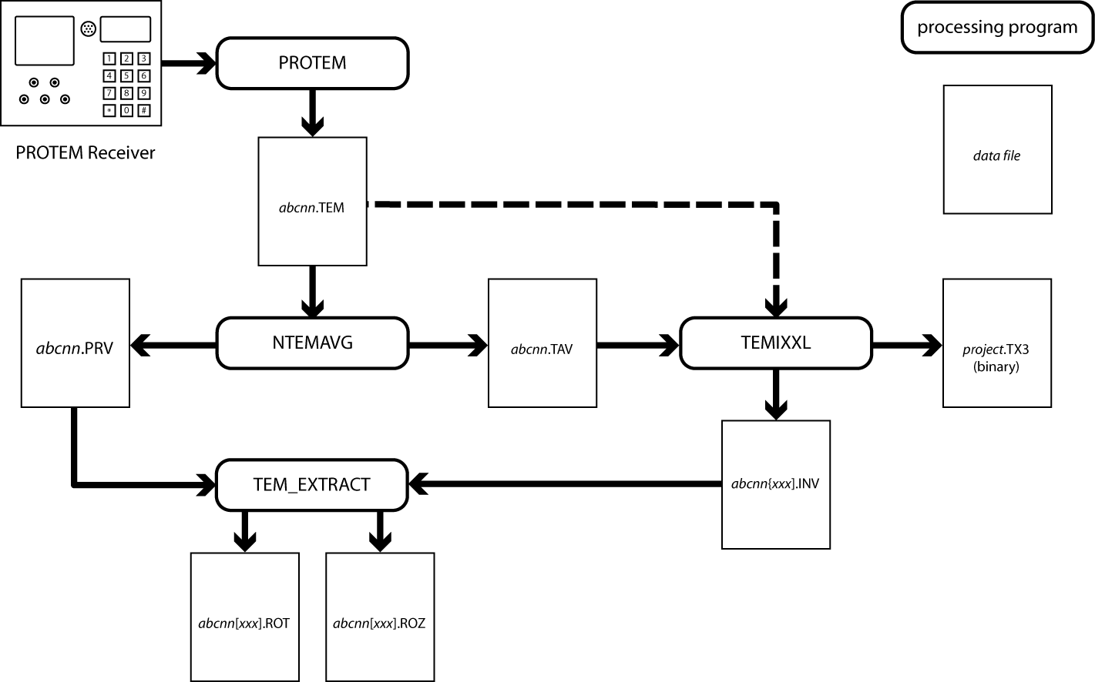
Figure 1. Data processing programs, files, and flow. Solid arrows indicate processing flow. Dashed arrow indicates an alternate path.

The data in the Geonics PROTEM receiver are downloaded to a PC using program PROTEM, which is supplied by Geonics. Typically data from one sounding location are downloaded into a single raw-data file. The file format is referred to as Geonics TEM File Format (GTFF). Following downloading, selected data records from the raw data file are averaged using program NTEMAVG. The averaged data files are also in GTFF format. In addition to the averaged data file, a file containing a summary of the averaging process is saved.
Both the raw and averaged data files can be read into TEMIXXL, a program commercially available from Interpex Ltd. (Golden, CO, USA) that is used for data interpretation. TEMIXXL stores a copy of the data, the model, and the calculated response of the model in a proprietary, binary database file. The database can hold a large number of soundings, so one database is usually enough for an entire survey. Sometimes it is helpful to retain several alternative models for a given data set. These are stored as separate soundings in the TEMIXXL database. Typically these alternative models have the original sounding name with up to 3 characters added at the end. For example, a sounding called ABC01, might have variants ABC01L4 and ABC01L5 to indicate models with four and five layers, respectively. There are no restrictions on the extra characters added to the sounding name other than the total number of characters in the sounding name can not exceed 8. The results of the inversion are reported in an inversion output file. Program TEM_EXTRACT is used to extract apparent-resistivity-time and interpreted-resistivity-depth files for plotting.

File Naming Conventions

GTFF Files
The downloaded GTFF files are given a name of the form aaann.TEM, where aaa is a three character identifier, typically associated the survey and nn is a two digit number. The sounding "name" would be considered aaann.
Averaged data files are named aaann.TAV. The printed summary of the averaging process is written to a file named aaann.PRV
TEMIXXL database file are binary files in a proprietary format. They are named following DOS conventions with the suffix .TX3. Data sets include the observed data, the calculated model response, and the model parameters. A data set is identified by a name of up to 8 characters.
A summary of the inversion is written to a file name aaann[xxx].INV, where [xxx] represents optional characters added to the sounding name in TEMIXXL to identify alternative models.
Extracted apparent-resistivity-time and interpreted-resistivity-depth files suitable for plotting are named aaann[xxx].ROT and aaann[xxx].ROZ, respectively.

File Formats and Contents

Geonics TEM File Format
GTTF files consist of 256-character long records, containing of a 50-character header field followed by 25 eight-character data fields. The last two characters of the record are a carriage return and a line feed. Two types of records are created during PROTEM receiver downloading. The record type is indicated by characters 19-21 of the header field: "HDR" for a header record and “OPR for a data record. A header record is created every time a change is made in certain measurement parameters in the PROTEM receiver. For example, changes in the sounding name, transmitter current, transmitter loop size, turnoff time, or receiver moment will produce a new header record. Figure 2 shows the structure of the header fields for header (HDR) and data (OPR) records; descriptions for these two types of header fields are given in tables 1 and 2, respectively.
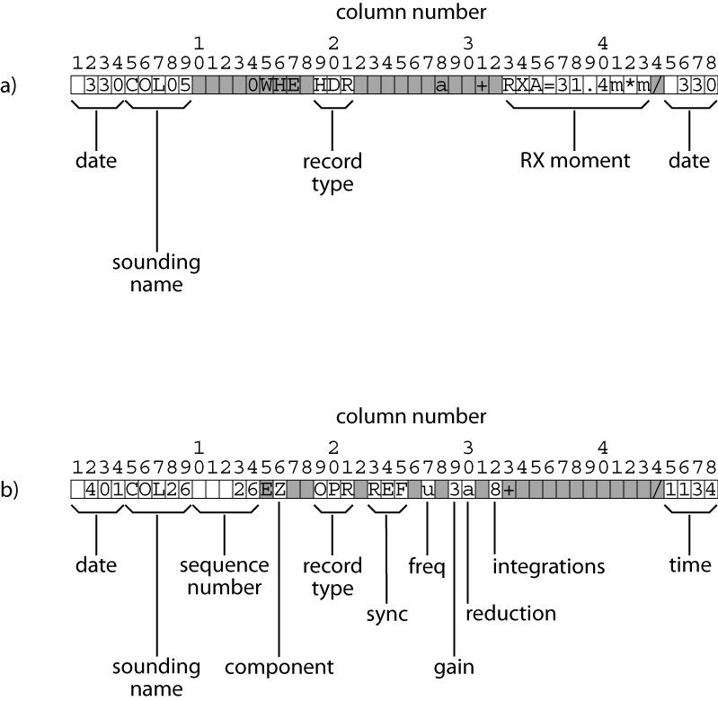
Figure 2. a) Diagram showing contents of header record (HDR) header fields. b) Diagram showing contents of data record (OPR) header fields. The contents of shaded cells are ignored in further processing.

Table 1. Description of header record (HDR) header fields.
Field | Columns | Description
Date | 1-4 | Date of measurement [mmdd]
sounding name | 5-9 | Sounding name
Record | 19-21 | "HDR" to indicate header record
RX moment | 33-43 | RX coil moment [turn-m²]
Date | 45-48 | Date of measurement [mmdd]

Table 2. Description of data record (OPR) header fields.
Field | Columns | Description
date | 1-4 | Date of measurement [mmdd]
sounding name | 5-9 | Sounding name
sequence number | 10-14 | Sequence number of sounding. Requires operator to manually update or values will not be significant
record type | 19-21 | "OPR" to indicate data record
Sync | 23-25 | Synchronization method; REF indicates reference cable, XTL indicates crystal oscillators
Freq | 27 | Transmitter repetition frequency; determines measurement times:  u= ultra high, v= very high, h = high, m = medium, l = low
Gain | 29 | additional PROTEM gain factor of 2^{gain}
reduction | 30 | Value of "a" indicates that values in data field gates have had x4 and x10 amplification removed.
integrations | 32 | PROTEM integration time setting
Time | 45-48 | Time of measurement [hhmm]

The data fields of header and data records contain 25 eight-character data fields. Geonics' documentation refers to these data fields as gates. The contents of the gates are given in tables 3 and 4.
Table 3. Description of header record (HDR) data fields (gates).
Field (Gate) | Contents
0 | Date of measurement [ddmm]
2 | Time of measurement [hhmm]
4 | TX current [A]
5 | TX turnoff time [μs]
6, 7 | TX loop side length [m] LX and LY
8. 9 | RX coil position XR and YR relative to center of TX loop [m]
10 | RX coil moment [turn-m²]
11 | TX number
22 | Logger record number for this header record

Table 4. Description of data record (OPR) data fields (gates).
Field (Gate) | Contents
0 | Logger record number for this data record
1-20 | Channels 1-20 TEM data
21 | TX turnoff time [ms]
22 | First RX gate time [ms]
23 | TX current [A]
24 | TX moment [[turn-m²], may include trailing "/"
25 | Time of measurement [hhmm]

PRV Files
PRV files are text files that summarize the data averaging process. The first page of the file consists of a listing of all of the header record (HDR) and data record (OPR) header fields. The first line is a descriptive header indicating that the data came from a PROTEM logger. The second line usually contains HDR header fields. Subsequent lines are OPR header fields associated with recorded data. Additional HDR header fields are present whenever the operator made a change in the header information on the PROTEM receiver. The output concludes with two records whose headers contain X's to indicate the end of the data processing.
Following the summary page, a separate page is devoted to data collected for each transmitter repetition frequency used for the sounding. The first line of these pages indicates the program version used to average the data, the averaged output file name, the record number of the averaged output file to which this page corresponds, and the input file name.
Each data page of the PRV file contains a summary of all of the data recorded by the PROTEM receiver for a single frequency. For each measurement there is a data record number, frequency, transmitter current, receiver gain, integration value NSTK, transmitter turnoff time, and a time shift. The time shift is applied during data averaging to adjust for incorrect turnoff time settings during data recording. If no adjustment was made this value will be zero. This part of the output is followed by a list of the various reported quantities (in SI units), the TEM system used, the receiver coil moment (RXA), the transmitter loop dimensions (LX and LY), and the location of the receiver coil with respect to the center of the transmitter loop (XR and YR).
The next section of the data page gives the channel number and the voltage induced in the receiver coil in units of μV/m2. The average of these voltages computed and expressed as PROTEM receiver units in mV. The standard deviation as a percentage of the average data value is also reported.
The last section of the data page presents the voltages after they have been transformed to apparent resistivity. The print out includes the channel number, the receiver channel time, the square root of the time in seconds (s1/2), the late stage apparent resistivity, the average of the resistivity values, and the percentage deviation of the apparent resistivity.

TAV Files
The averaged data are contained in TAV files and use the GTTF format described above. The header of the first record indicates the type of instrument the data came from, and whether the data have been averaged. The data fields of this record are all set to zero. The second record is an HDR record with header fields and data fields as described in tables 1 and 3. Next is an OPR record for each frequency average by program NTEMAVG. If different groups of data records were averaged, there will be multiple output records, one for each group. Following the last OPR record, is a record with "XXXXX" in the header field. The numbers in the data fields is meaningless.

INV Files
The INV file is a report generated by TEM inversion program TEMIXGL. It provides information on the sounding location, the measurement geometry, the model misfit error, the model parameter estimates, the measured resistivity and calculated model response, and usually a resolution matrix.

ROT and ROZ Files
These are text files that contain data and models in a form for plotting. The ROT file contains the following information:
- The sounding name.
- Tab-delimited titles for the data that follow.
- Tab-delimited data time and apparent resistivity data consisting of 6, 9, or 12 columns when there are 1, 2, or 3 transmitter repetition frequencies, respectively. Typically the data are given in order of decreasing repetition frequency. The contents of the columns are specified below in table 5.
Table 5. Description of plottable data in ROT files.
Column | Contents | Description
1 | time [msec] | time of data point after TX turnoff
2 | freq1_avg | averaged apparent resistivity, FREQ1
3 | freq1_std | standard error in FREQ1 averaged apparent resistivity
4 | freq1_cal | calculated FREQ1 apparent resistivity
5 | freq2_avg | averaged apparent resistivity, FREQ2
6 | freq2_std | standard error in FREQ2 averaged apparent resistivity
7 | freq2_cal | calculated FREQ2 apparent resistivity
8 | freq3_avg | averaged apparent resistivity, FREQ3
9 | freq3_std | standard error in FREQ3 averaged apparent resistivity
10 | freq3_cal | calculated FREQ3 apparent resistivity
11 | masked | apparent resistivity of a masked data point
12 | m_err | standard error of a masked data point

The ROZ files contain the following information:
- The sounding name.
- Tab-delimited titles for the data that follow: Depth (m) Resistivity (ohm-m).
- Tab-delimited data for plotting a resistivity depth plot. Depths are given as positive values below the surface. The depth sequence will be: 0, z1, z1, z2, z2, . . . ,zn-1 ,zn-1, 1.2*zn-1. The resistivity sequence will be ρ1, ρ1, ρ2, ρ2, . . . ρn-1, ρn-1, ρn, ρn.

